# Lab: Kanban Board – Jira Reports

To create a Kanban project with sample data in Jira Cloud, you would need to create a new board, and while doing so, you'll have the option to populate it with sample data.

**Navigation to Boards:**

Navigate to the boards section in Jira. You can do this by clicking on the three dots in the top right corner of Jira and selecting the "Create board" option from the menu.

Alternatively, you can go to the magnifying glass in the left side navigation bar, search the term "boards", and then select "View All Boards".

**Creating a New Board:**

Once you are in the boards section, click on the "Create Board" button or the "Create new board" option depending on the interface.

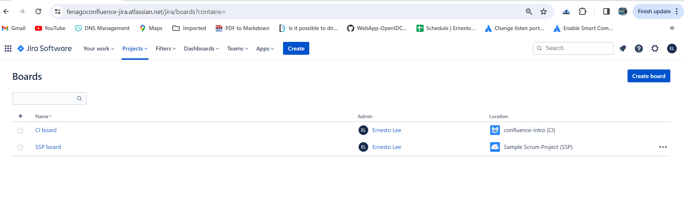

In the pop-up or the next screen, you will have options regarding the type of board you want to create. Select the option to "Create a Kanban board with sample data".

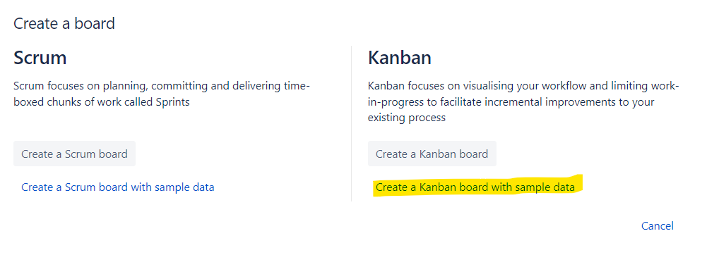

**Selection for New Project:**

After selecting to create a Scrum board, you will get menu to enter project details.

**Entering Project Details:**

You will be prompted to enter the name and project key for the new project. Fill in these details and click on the "Create Board" button.

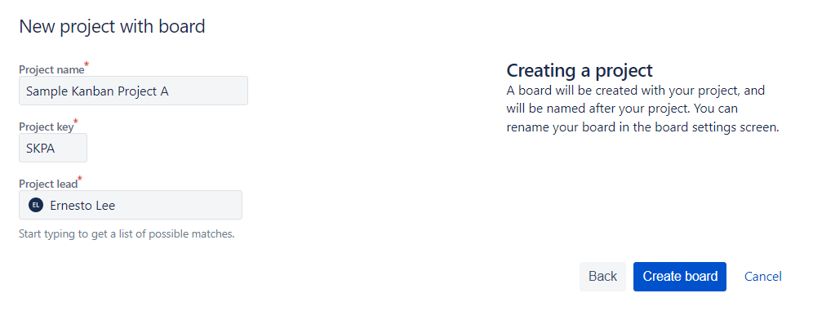

After successfully creating the board, you will see following screen:

