# Lab: Jira and Confluence Cloud Sign up

Confluence and Jira are powerful tools on their own. Together, they transform the way that your team collaborates on projects, builds software, tracks key decisions, and more.

Open following URL in browser and you will see following screen:

<https://www.atlassian.com/software/jira/free>

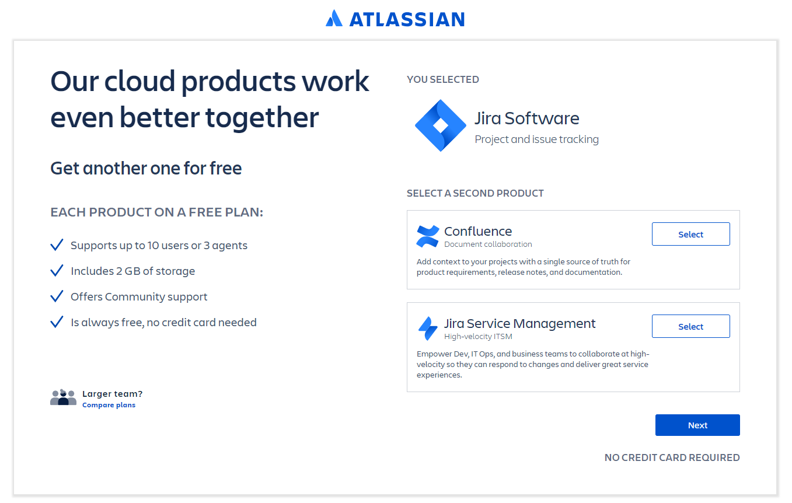

Select **‘Confluence’** as second product by clicking **Select** button and click **Next**.

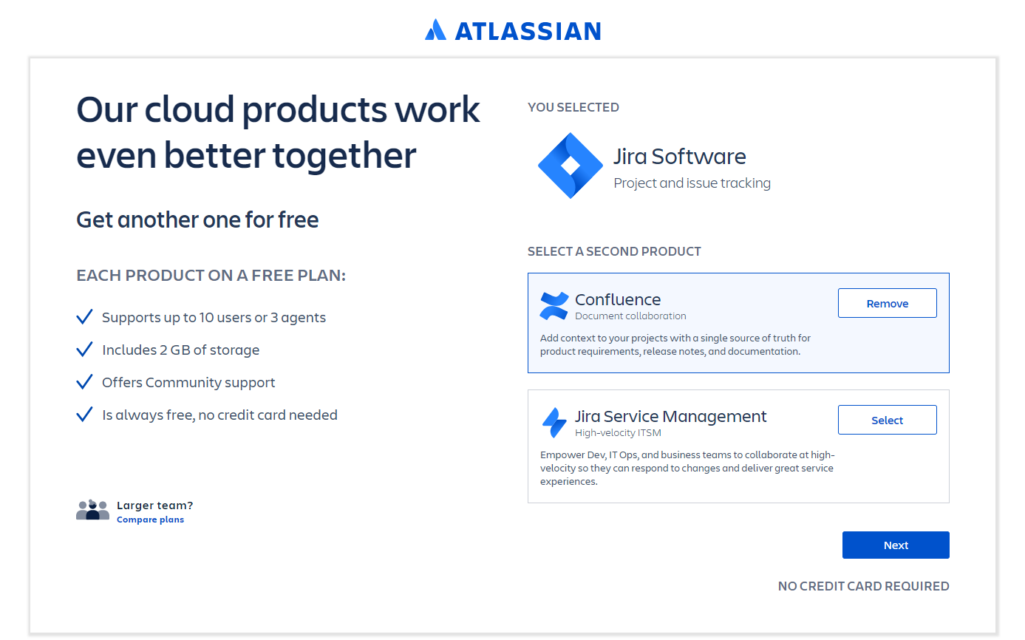

Next, you will need to signup on Atlassian cloud as shown below:



Next, you will need to create new site on Atlassian cloud as shown below:

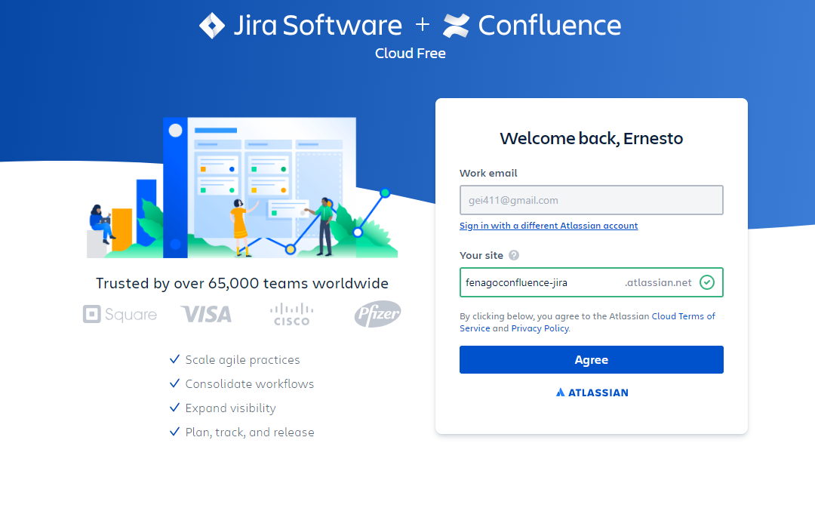

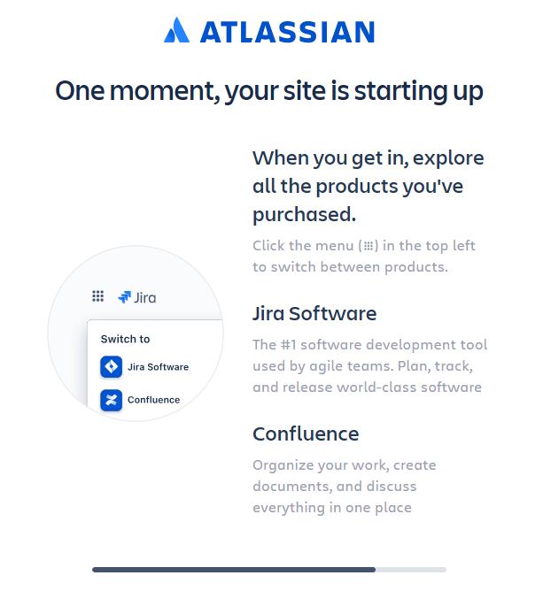

After site is ready, you will see following screen. Click **Next** to create new jira project.

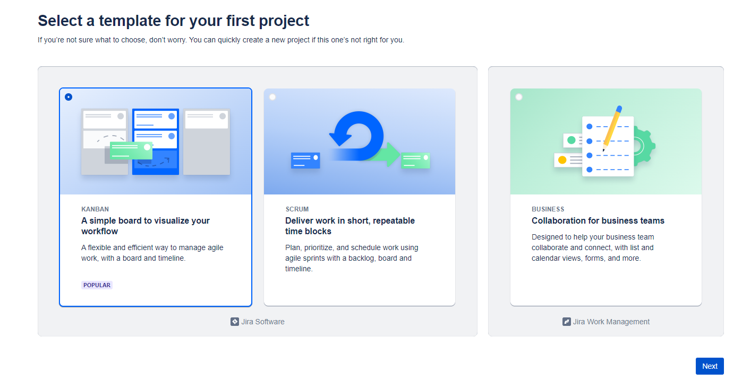

Enter ***Name*** and click **Create project**:

