# Lab: Scrum Board – Jira Reports

To create a Scrum project with sample data in Jira Cloud, you would need to create a new board, and while doing so, you'll have the option to populate it with sample data.

**Navigation to Boards:**

Navigate to the boards section in Jira. You can do this by clicking on the three dots in the top right corner of Jira and selecting the "Create board" option from the menu.

Alternatively, you can go to the magnifying glass in the left side navigation bar, search the term "boards", and then select "View All Boards".

**Creating a New Board:**

Once you are in the boards section, click on the "Create Board" button or the "Create new board" option depending on the interface.

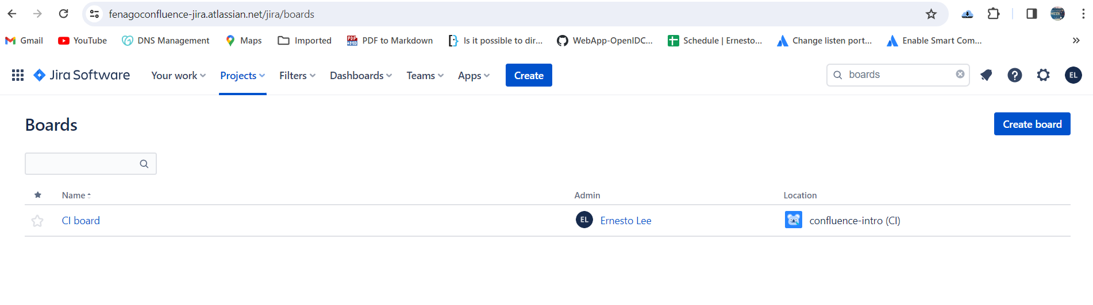

In the pop-up or the next screen, you will have options regarding the type of board you want to create. Select the option to "Create a Scrum board with sample data".

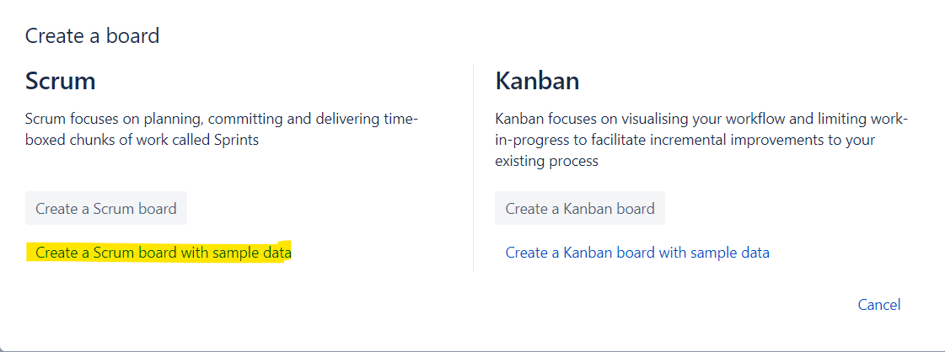

**Selection for New Project:**

After selecting to create a Scrum board, you will get menu to enter project details.

**Entering Project Details:**

You will be prompted to enter the name and project key for the new project. Fill in these details and click on the "Create Board" button.

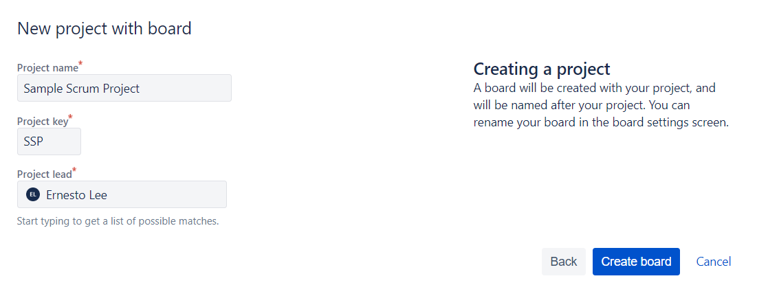

After successfully creating the board, you will see following screen:

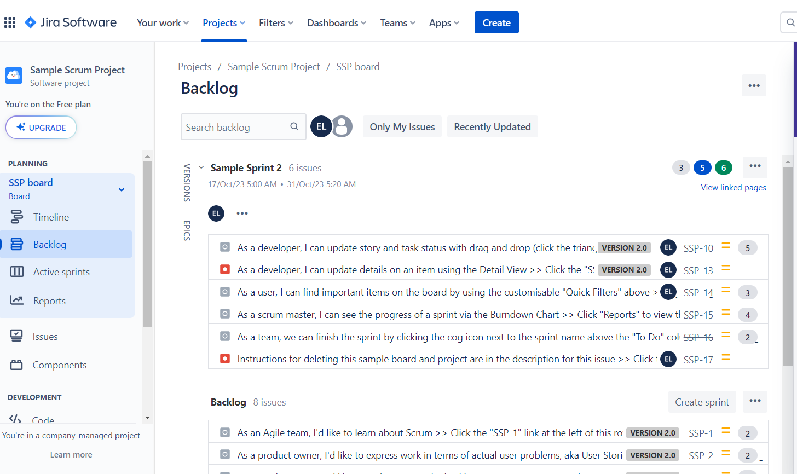

**Exercise 1: Version Report for the Product Owner**

The Version Report in Jira provides a view of the team's progress towards the completion of a version. It displays a predicted release date based on the team's average rate of progress and the amount of work remaining. This report is crucial for Product Owners to track the progress and adjust plans accordingly.

**Step 1: Access Your Project**

Navigate to your project in Jira Cloud.

You can do this by clicking on “Projects” in the navigation bar and selecting the relevant project.

**Step 2: Create a Version (if necessary)**

If your project does not have any versions created yet, you will need to create one.

Click on 'Releases' from the project menu, and then press 'Create version'. Name your version and save it.

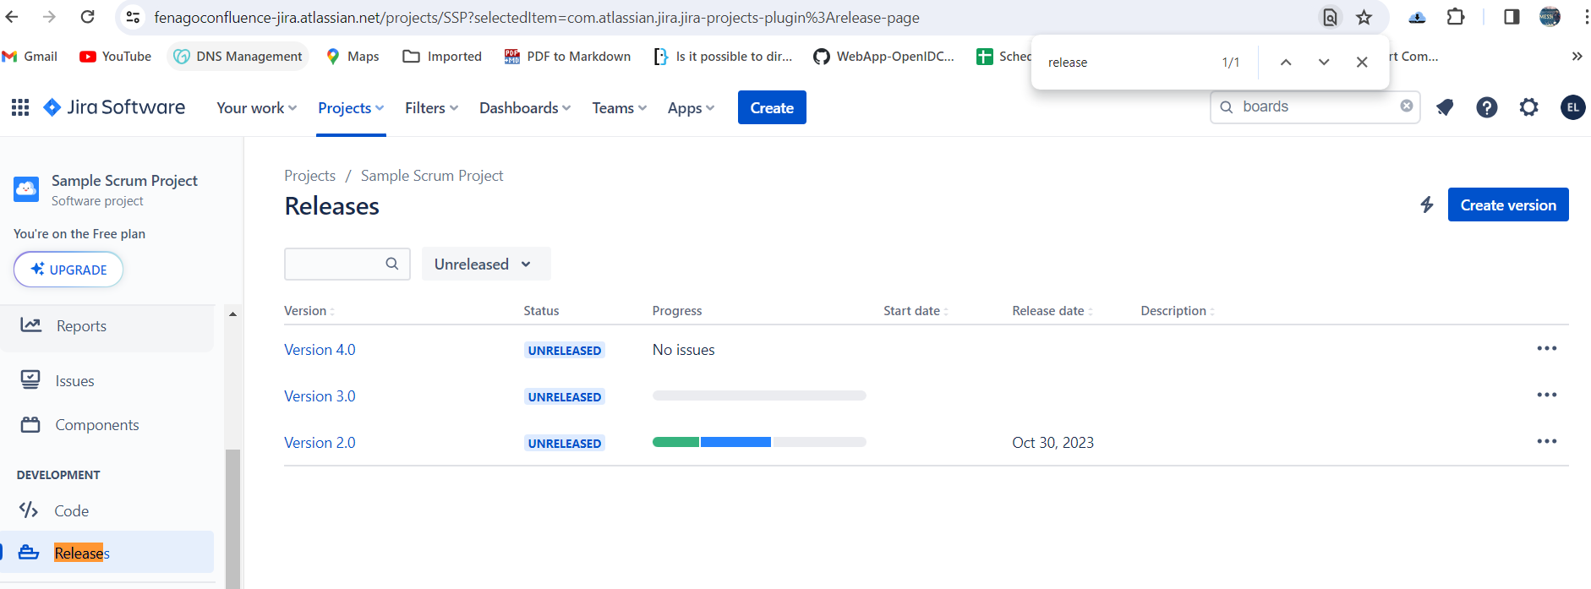

**Step 3: Navigate to Reports Section**

Once inside the project, click on "Reports" which can be found in the project sidebar or in the navigation bar.

**Step 4: Access the Version Report**

From the list of reports, select "Version Report".

You may need to select the relevant version from the Version Report drop-down if you have multiple versions.

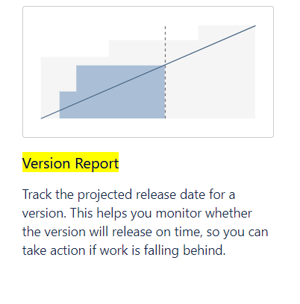

**Step 5: Understanding the Version Report**

The Version Report is board-specific and will only include issues that match your board's saved filter.

It excludes issues of a 'sub-task type' and shows 'Released' versions but not 'Archived' versions.

The report is based on your board's column mapping, so understanding the mapping is crucial for accurately interpreting the report.

The graph in the report shows the state of your version at any given point in time in terms of total and completed Story Points or other Estimation Statistics of your choice.

It provides predictions like the Predicted Release Date, which is based on your average daily velocity and the amount of estimated work remaining.

**Step 6: Analyze and Share Insights**

Analyze the data presented in the Version Report, focusing on the predicted release dates and the progress towards completion of the estimated work.

Share your insights with your team and stakeholders to ensure everyone is aligned on the project's status and any necessary adjustments to the plan.

This exercise helps the Product Owner to understand the progress of the version, analyze the predicted release dates, and share valuable insights with the team and stakeholders.

