# Lab: Interpreting Reports for the Scrum Master (Burndown Chart)

The Burndown Chart in Jira provides a visual representation of the team's progress in a sprint by showing the actual and estimated amount of work to be done. Here's a step-by-step lab on how to interpret a Burndown Chart in Jira, tailored for a Scrum Master:

**Step 1: Set Estimation Statistic**

Before creating a Burndown Chart, ensure that your team's estimation statistic is set. In Jira, you can measure work using story points, hours, or a custom statistic of your choice.

**Step 2: Access Your Project**

Click on "Projects" in the navigation bar and select the relevant project.

**Step 3: Navigate to Reports Section**

Click on "Reports", then select "Burndown Chart" from the list of reports available.

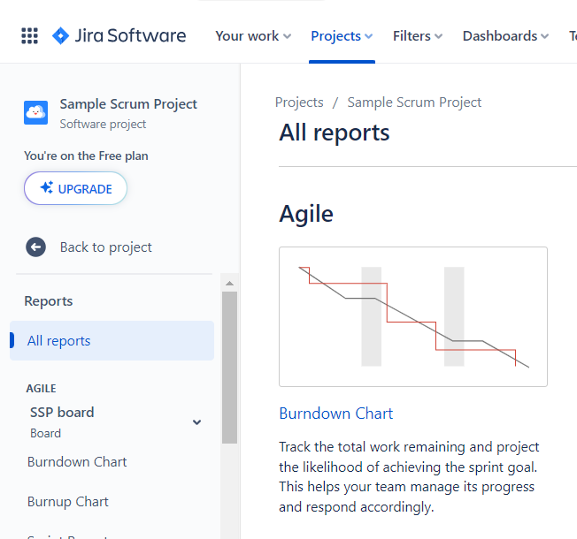

**Step 4: Choose Sprint and Estimation Statistic**

From the Burndown Chart view, select the desired sprint from the sprint drop-down menu.

If necessary, select a different estimation statistic from the estimation statistic drop-down menu. This change will be saved for your next visit to this chart.

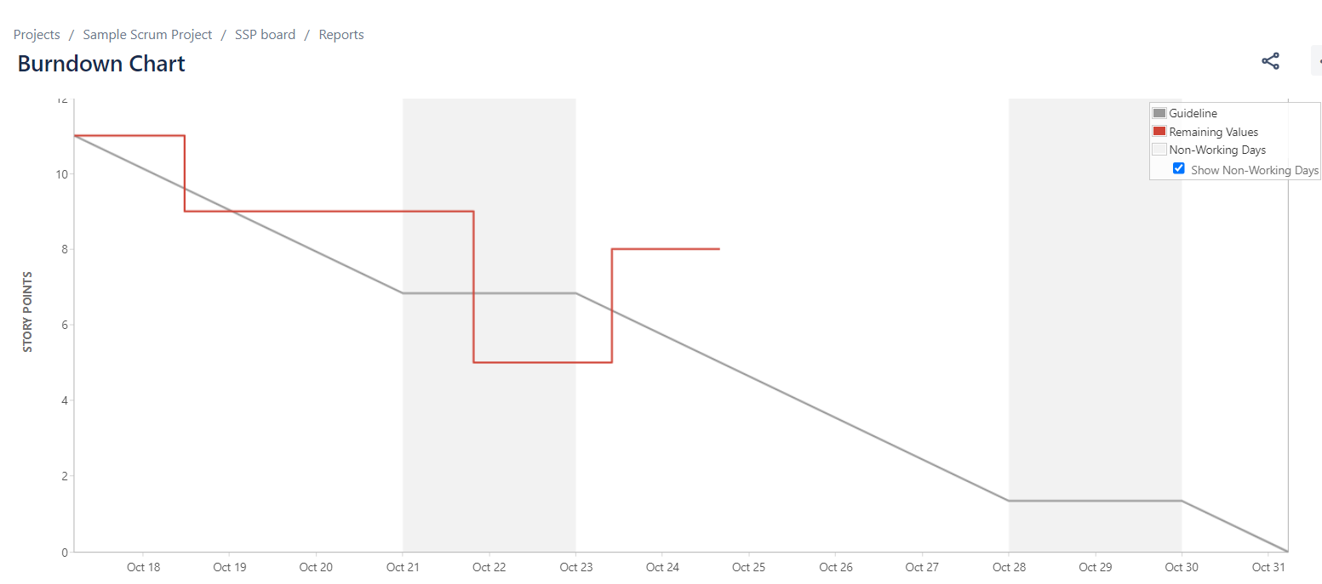

**Step 5: Understanding the Burndown Chart**

The Burndown Chart is board-specific and includes only issues that match your board's saved filter.

The vertical axis represents the estimation statistic that you've configured for your board, such as story points or hours.

The chart is based on your board's column mapping, indicating the status of issues as 'To Do' or 'Done' based on their position in the workflow.

Understand the representation of actual work versus estimated work, and how scope changes, like adding subtasks to issues in an active sprint, affect the chart.

**Step 6: Analyze and Share Insights**

Analyze the data presented in the Burndown Chart to understand the team's progress and identify any deviations from the planned work.

Share your insights with the team to ensure everyone is aligned on the sprint's progress and discuss any necessary adjustments to stay on track.

This lab provides a structured way for Scrum Masters to interpret the Burndown Chart in Jira, helping them to understand the team's progress in a sprint and share insights for better sprint management.