# Lab: Interpreting Reports for the Scrum Master (Sprint Report)

The Sprint Report in Jira provides a comprehensive view of the work completed and the work not completed during a particular sprint, making it an essential tool for Sprint Retrospective meetings and mid-sprint progress checks. It is board-specific and includes only the issues that match the board's saved filter3. Here's a step-by-step lab to interpret the Sprint Report as a Scrum Master:

**Step 1: Access Your Project**

Select "Projects" in the navigation bar, then select the relevant project.

**Step 2: Navigate to Reports Section**

Select "Reports", then "Sprint Report".

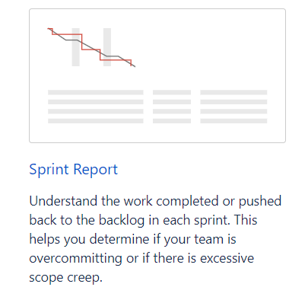

**Step 3: Select the Relevant Sprint**

From the Sprint Report view, select the relevant sprint from the sprint dropdown menu.

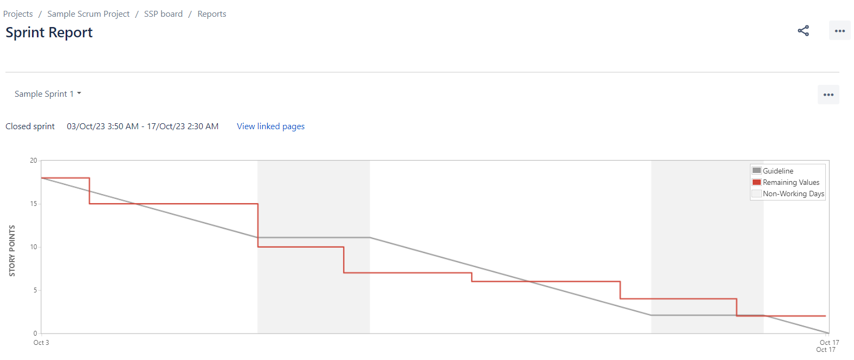

**Step 4: Understanding the Sprint Report**

Below the report, the sprint’s issues are listed based on their completion. Under ‘Completed Issues’, the ‘Story Points' column indicates how many story points your team completed during the sprint. If displayed with two values and an arrow between them (e.g., 3 → 3.5), this indicates that the story point estimation was adjusted during the sprint.

Issues added after the sprint starts are indicated with an asterisk.

An issue is considered ‘To Do' when it’s in a status that’s mapped to the left-most column of your board. Similarly, an issue is considered ‘Done' when it’s in a status that’s mapped to the right-most column of your board.

The grey line is a guideline drawn from the total estimate of the issues at the start of the sprint, to 0 at the end of the sprint. It stays flat during non-working days.

The red line represents actual work done during the sprint, drawn from the total estimate of the issues at the start of the sprint, and goes higher or lower as your team works on the issues in the sprint. The red line shows the current total estimate for unresolved issues at any point in the sprint and reflects issues that are added or removed from the sprint.

If your board is configured to track remaining estimates and time spent, a green line will display in the Sprint Report, indicating work logged on issues.

**Step 5: Analyze and Share Insights**

Analyze the data presented in the Sprint Report, focusing on the completed issues, unresolved issues, and any adjustments made in story point estimations during the sprint.

Share your insights with the team to ensure everyone is aligned on the sprint's progress and discuss any necessary adjustments for future sprints.

This lab provides a structured way for Scrum Masters to interpret the Sprint Report in Jira, helping them to understand the team's performance during a sprint, identify areas of improvement, and share valuable insights for better sprint management.