# Lab: Interpreting Reports for the Scrum Master (Velocity Chart)

The Velocity Chart in Jira shows the amount of value delivered in each sprint, enabling you to predict the amount of work the team can get done in future sprints. It's an essential tool during sprint planning meetings to help decide how much work to commit to. Teams can estimate their velocity based on the total estimate for all issues planned for the sprint, and the chart visualizes forecasted and completed work over several sprints, which is particularly useful for dealing with backlogs. Here's a step-by-step lab to interpret the Velocity Chart as a Scrum Master:

**Step 1: Access Your Project**

Navigate to your company-managed Jira Software project.

**Step 2: Navigate to Reports Section**

From your project’s sidebar, select "Reports" then "Velocity Chart" to view the Velocity Chart. It will display the last 7 sprints completed by the team.

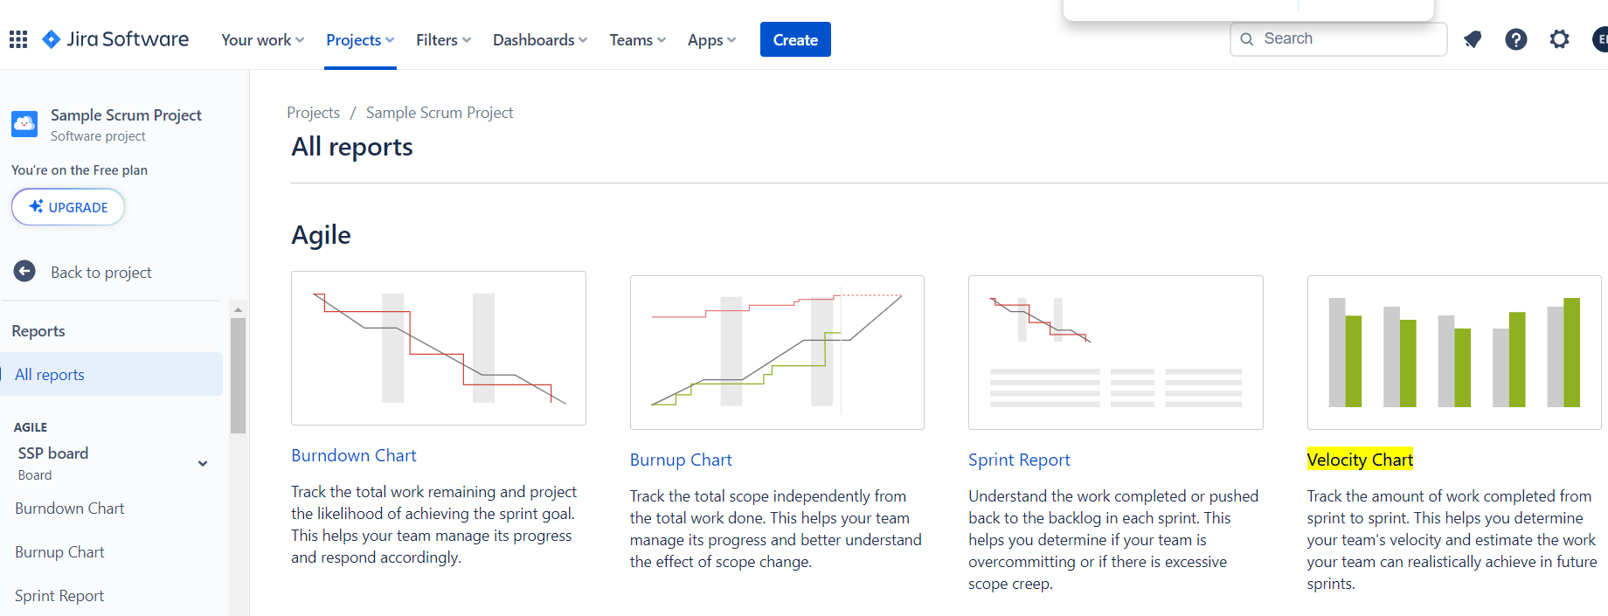

**Step 3: Understanding the Velocity Chart**

The Y-axis represents the amount of work, often measured in story points, although other units of estimation can be used.

The X-axis represents the sprints.

Each sprint bar is divided into two segments:

The dark-colored segment represents the amount of work completed.

The light-colored segment represents the work committed but not completed.

The grey line represents the average velocity, which is the average amount of work completed in recent sprints. This line helps to predict the amount of work that can be done in future sprints.

­­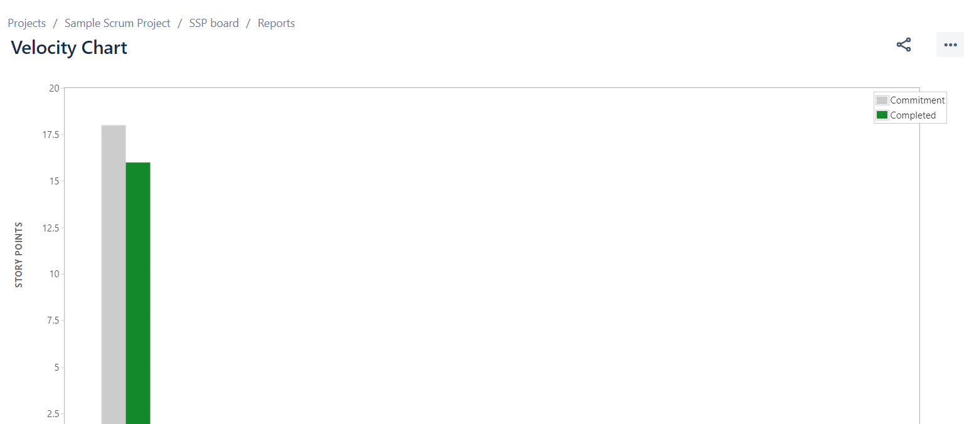

**Step 4: Adjusting the View (if necessary)**

If needed, you can adjust the view of the Velocity Chart to better suit your needs. For instance, you might want to change the SCRUM filter, or select a different report if your project has multiple reports available.

**Step 5: Analyze and Share Insights**

Analyze the data presented in the Velocity Chart, focusing on the average velocity, and the consistency in the amount of work completed across sprints.

Share your insights with the team to ensure everyone is aligned on the project's velocity and discuss any necessary adjustments for future sprints.

This lab provides a structured way for Scrum Masters to interpret the Velocity Chart in Jira, helping them to understand the team's velocity, predict future work capacity, and share valuable insights for better sprint planning and management.