# Lab: View and understand the Burnup chart or report

**Step 1: Access Your Project**

Navigate to your company-managed Jira Software project.

**Step 2: Navigate to Reports Section**

From your project’s sidebar, select "Reports" then "Burnup chart" to view the Chart.

To choose a different sprint or a different measurement for the vertical axis, click the drop-down menus.

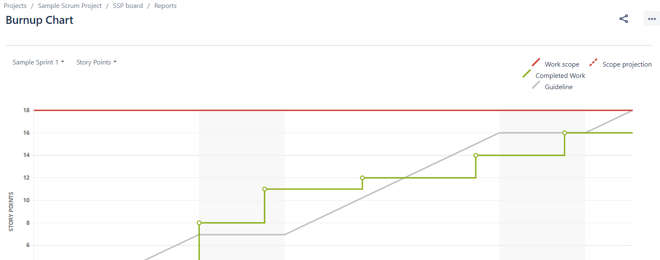

## **Step 3: Understanding the Burnup Chart**

* The vertical axis represents the amount of work and can be measured in different ways such as story points, issue count, or estimates. The horizontal axis represents time in days.
* The distance between the lines on the chart is the amount of work remaining. When the project has been completed, the lines will meet.
* Examine the 'Work scope' line to identify any scope creep.