Lab: View and understand the version report

The Version Report shows your team's progress towards the completion of a version. The Version Report also shows you the predicted Release Date, based on your team's average rate of progress (velocity) since the start of the version, and the estimated amount of work remaining.

Before you begin

This page only applies to Scrum boards.

Viewing the Version Report

1. Click **Projects** in the navigation bar and select the relevant project
2. Click **Reports**, then select **Version Report**
3. Select the relevant version from the Version Report drop-down

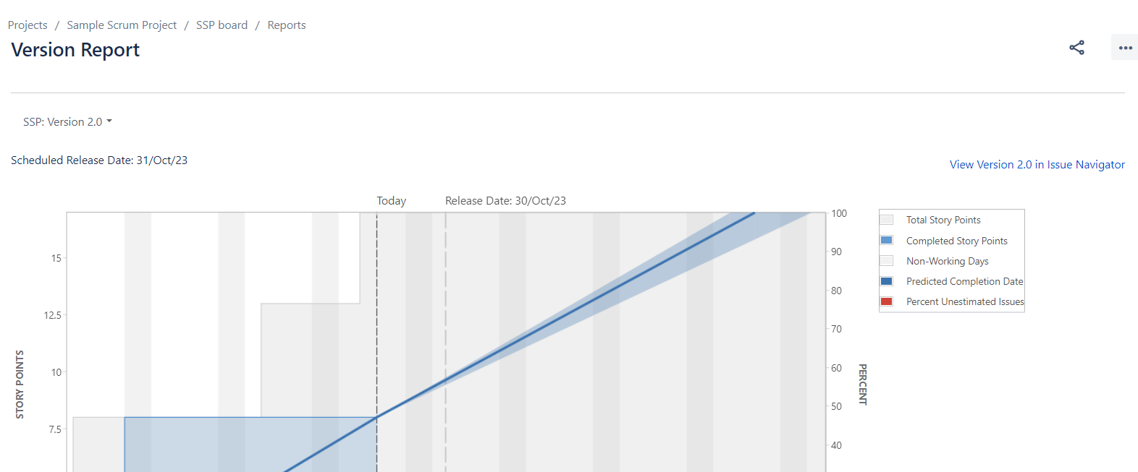

Understanding the Version Report

Before you start using the Version Report, you should get to know how it works. The following information will help you understand the key functionalities of the Version Report:

* The Version Report is board-specific – that is, it will only include issues that match your board's saved filter.
* The Version Report will exclude issues of a 'sub-task type'.
* The Version Report shows 'Released' versions but not 'Archived' versions.
* The Version Report is based on your board's column mapping. An issue is considered to be 'To Do' when it is in a status that has been mapped to the left-most column of your board. Similarly, an issue is considered to be 'Done' when it is in a status that has been mapped to the right-most column of your board.
* The horizontal axis starts on the version's Start Date; or if no Start Date is specified, the date on which an issue was first added to the version. The graph shows the state your version was in at any given point in time, in terms of your total and completed Story Points (or other Estimation Statistic of your choice), so that you can see how the scope may have changed, and how you are progressing towards completion of the estimated work.
* The graph shows you the following predictions:
  + the **Predicted Release Date***(blue line)* – that is, the date at which you can expect all issues in your version to be complete, based on your average daily velocity and the amount of estimated work remaining.
  + the **Predicted Release Date (Optimistic)***(shaded area to the left of the blue line)* – that is, the earliest date by which you might expect the version to be complete. (The 'optimistic' date is calculated by adding 10% to the average daily velocity.)
  + the **Predicted Release Date (Pessimistic)***(shaded area to the right of the blue line)* – that is, the latest date by which you might expect the version to be complete. (The 'pessimistic' date is calculated by subtracting 10% from the average daily velocity.)
* 10% of the estimated work for the version will need to be complete before the predictions can be calculated.