# Lab: Pie Chart Report

A pie chart report shows a pie chart of issues for a project/filter grouped by a specified field. This helps you see the breakdown of a set of issues, at a glance.

Generate a Report

To generate a report, the user should follow the steps given below.

**Step 1** − Go to Project → choose the Specific project. Click on the Report icon on the left side of the menu. Go to ‘Issue Analysis’ section and click on Pie Chart Report as shown in the following screenshot.

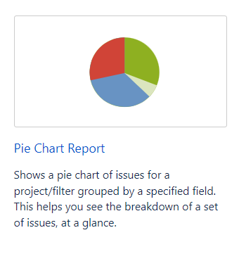

**Step 2** − Select Project or issue filter for which to generate the report. In the Statistic Type, select the field name on which the pie chart will be formed.

The following screenshot shows how to generate a report by providing details.

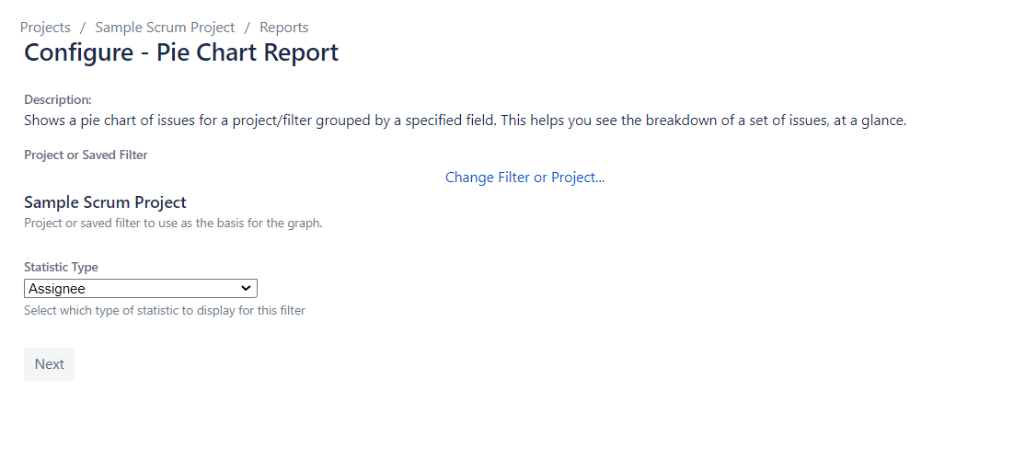

**Step 3** − Click on **Next** to generate the report. The following screenshot shows how the generated report looks like.

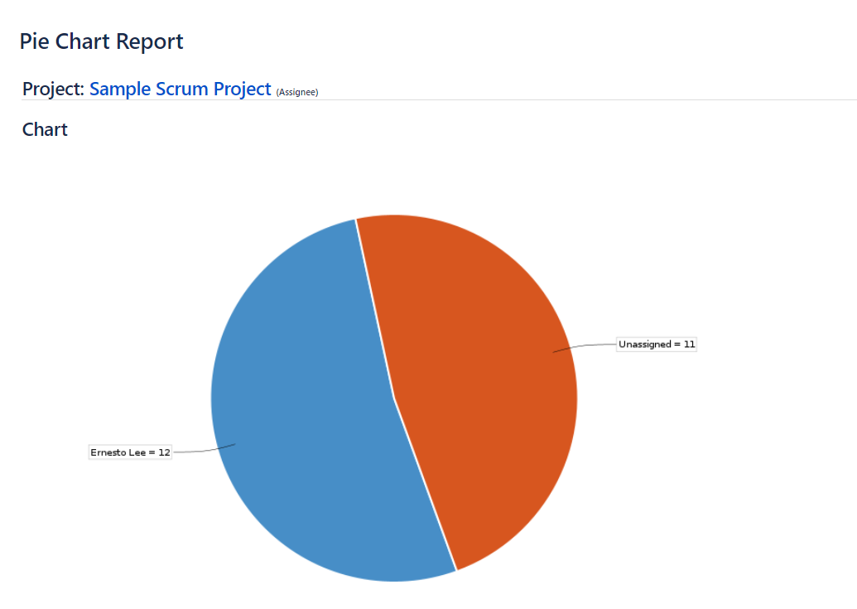

**Task: Generate Pie Chart Report for Sprint**

In this task, you will get need to generate report for Sprint. 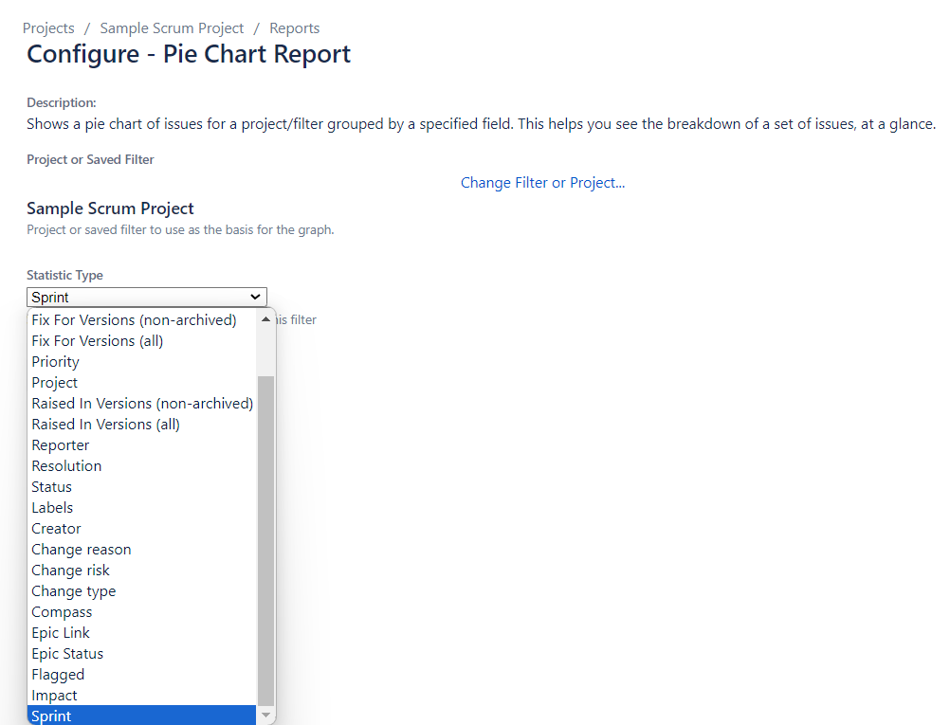

Your report should look similar:

