# **IntelliJ IDE**

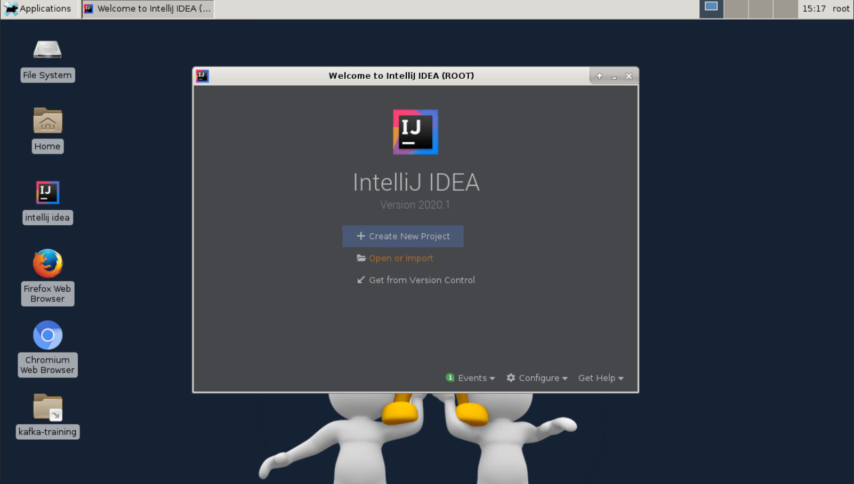

Figure : Open IDE

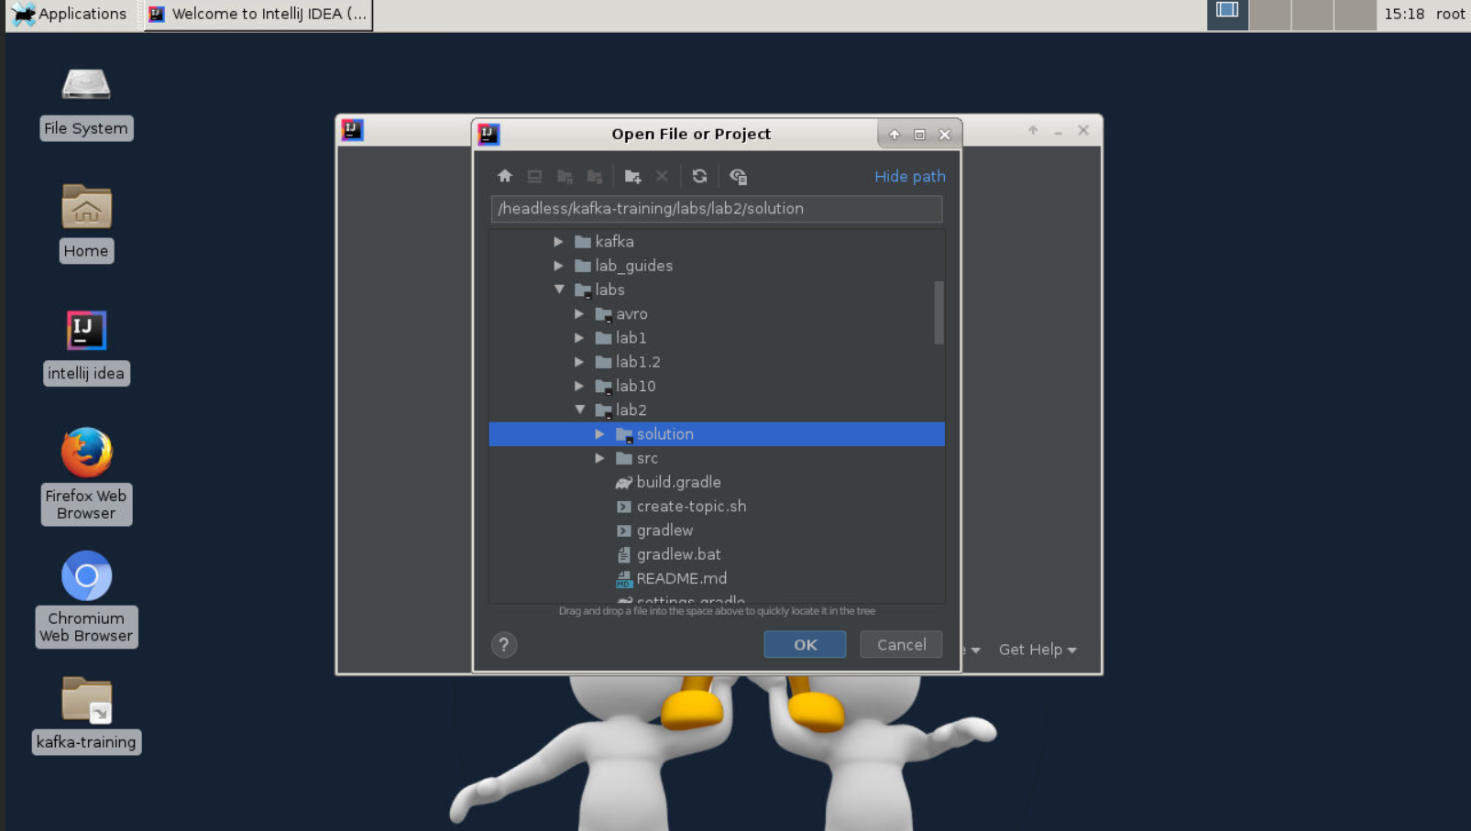

Figure : Select project from path /headless/kafka-training/labs/<select-lab>. Folders with projects will have icon

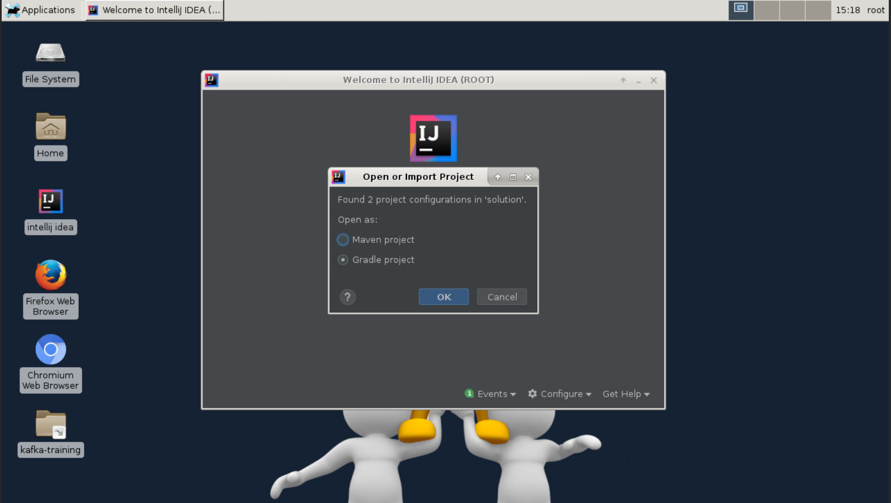

Figure : Select build tool

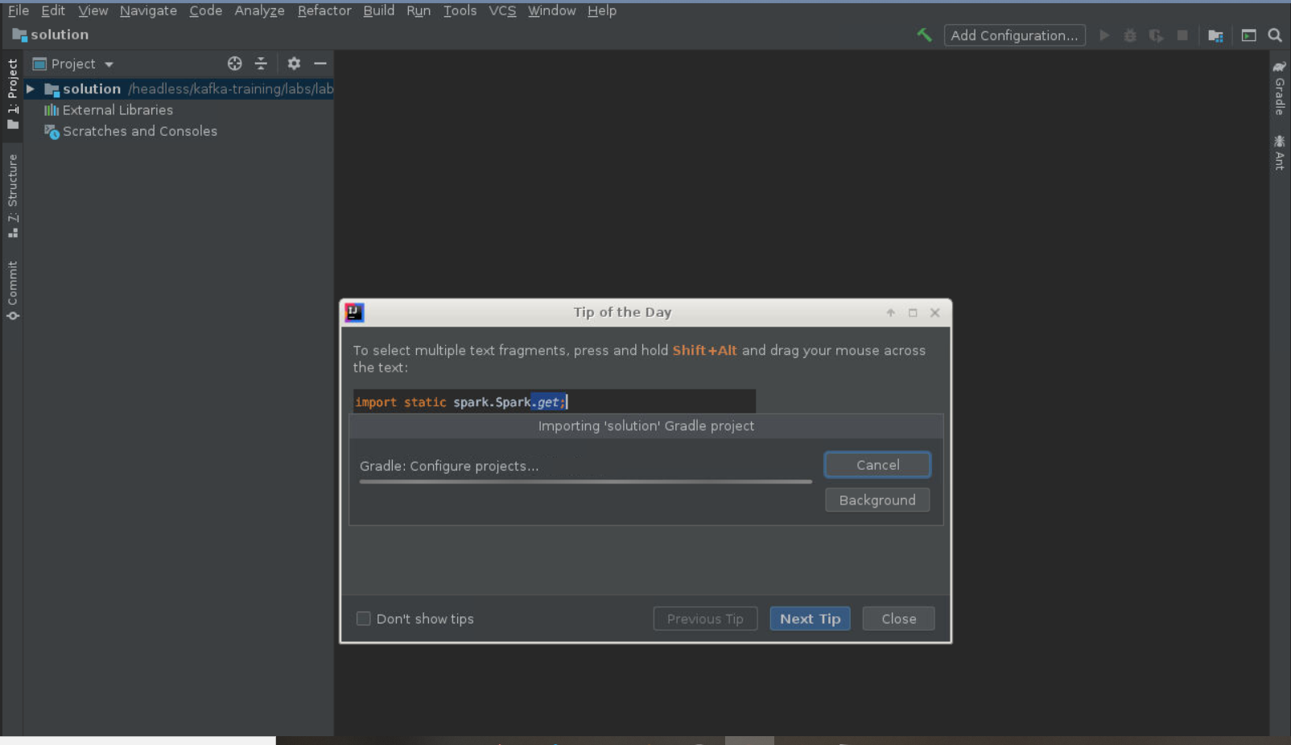

Figure : Wait for project import

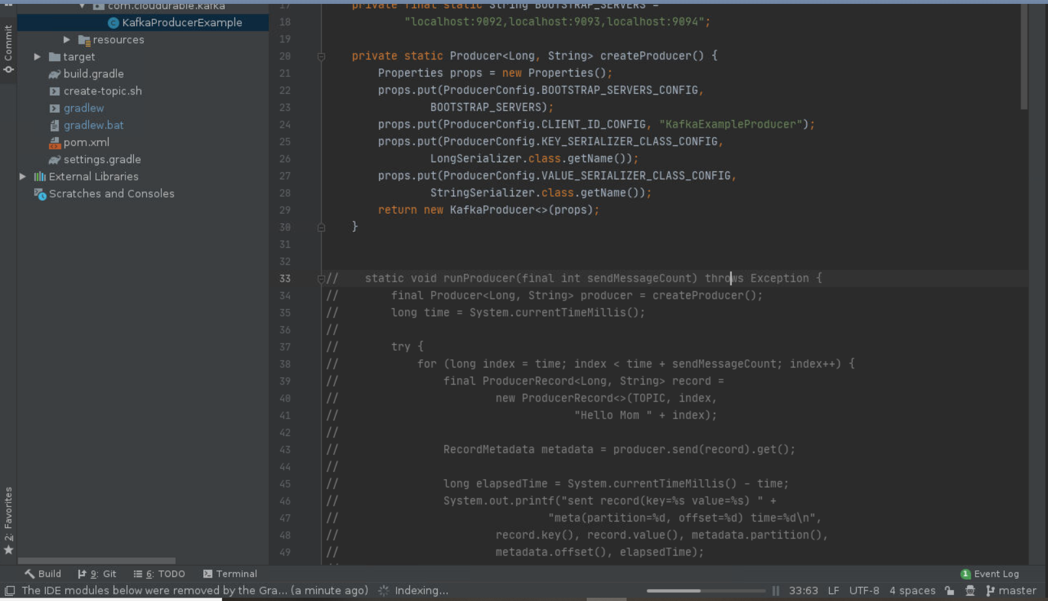

Figure : Open source files in IDE

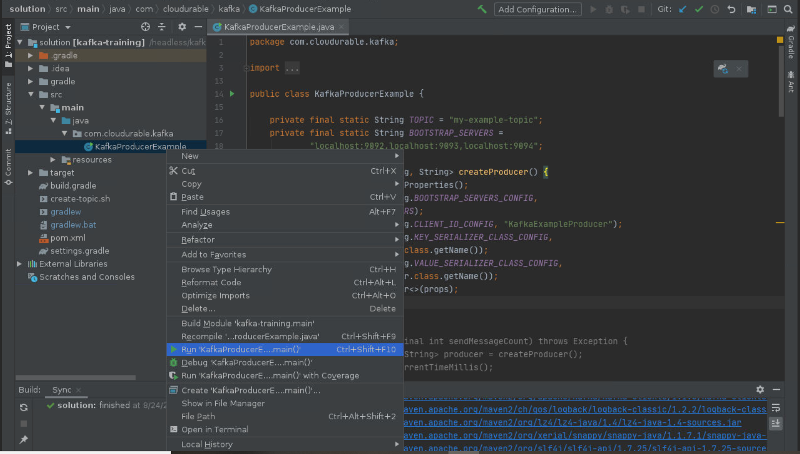

Figure : Run or Debug Main Program

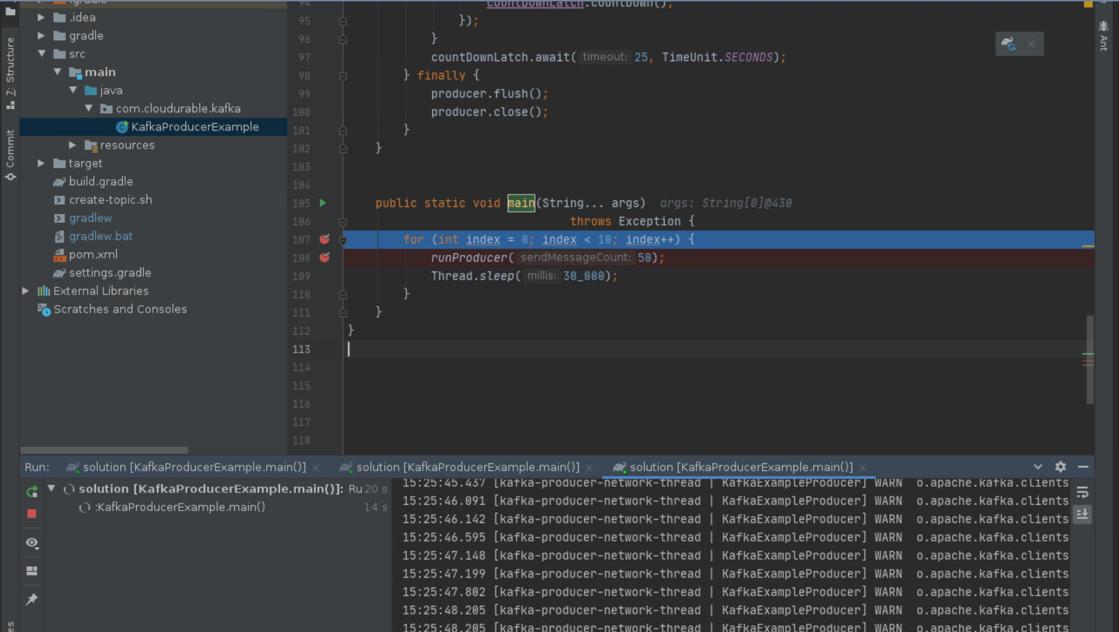

Figure : Debug and Output Console