**Why Create a GPT Assistant (YouGPT) to Clone a Part of Yourself**

* **Enhanced Productivity**: Automate repetitive tasks, allowing more time for research, lesson planning, and student interaction.
* **Consistency in Communication**: Provide consistent information to students, regardless of time and location.
* **Personalized Learning**: Offer tailored support and resources to students, enhancing their learning experience.

**The Value of Having a GPT Assistant for You and Your Students**

* **Accessibility**: Students can access the assistant 24/7 for information, reducing wait times for responses to common queries.
* **Engagement**: Interactive and instant responses can increase student engagement and interest in course materials.
* **Efficiency**: Streamlines administrative tasks, providing quick answers to frequently asked questions, thus saving valuable time.

**Let's Build a Free GPT - Prerequisites**

1. **Create an Account at VoiceFlow**: Sign up for free at [VoiceFlow](https://creator.voiceflow.com/signup). No credit card is required. More details on pricing and plans can be found [here](https://www.voiceflow.com/pricing).
2. **Sandbox Access**: Explore VoiceFlow's capabilities in a sandbox environment.
3. **Gmail Account**: Necessary if you wish to make your assistant accessible to your students.

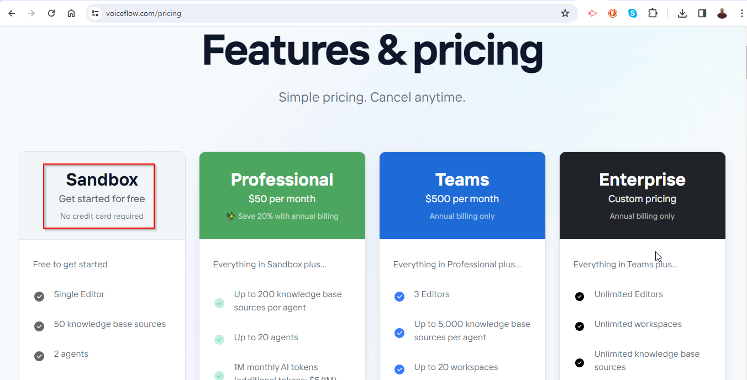

**Step-by-Step Guide**

**Step 0: Prepare the Files**

* Visit [GitHub Repository](https://github.com/fenago/mdcwest).
* Download **MDC.docx** and **ProfGPT-2024-02-28_07-57.vf**.
* Remember the download location of these files.

**Step 1: Create an Account on VoiceFlow**

* Go to [VoiceFlow Signup](https://creator.voiceflow.com/signup) and create your account.

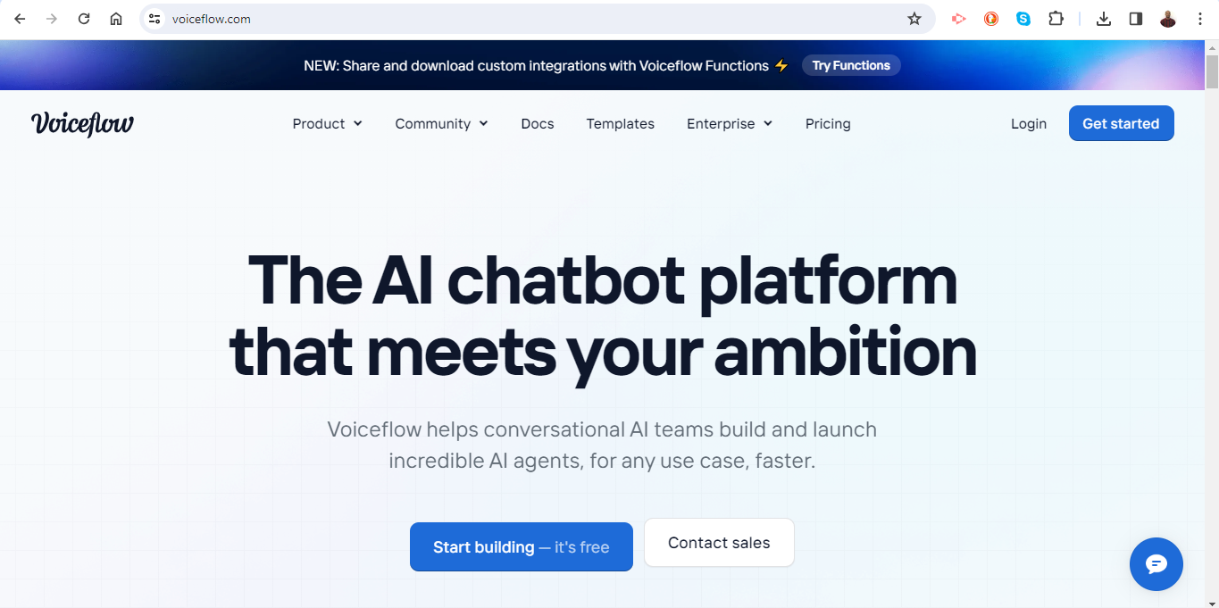

**Step 2: Importing Your Assistant**

* Once logged into VoiceFlow, navigate to your [workspace](https://creator.voiceflow.com/workspace/).
* Click on the **IMPORT** button, located two icons to the left of the blue "New Assistant" button in the top right corner.
* This action will import and create your assistant using the downloaded files.

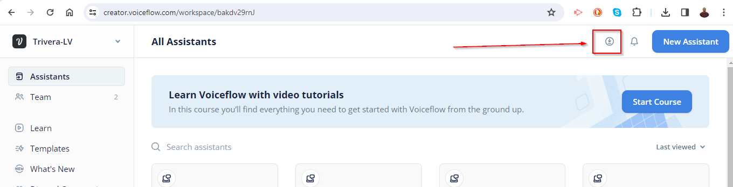

**Step 3: Personalize Your Assistant**

* Click on the three dots on your assistant.

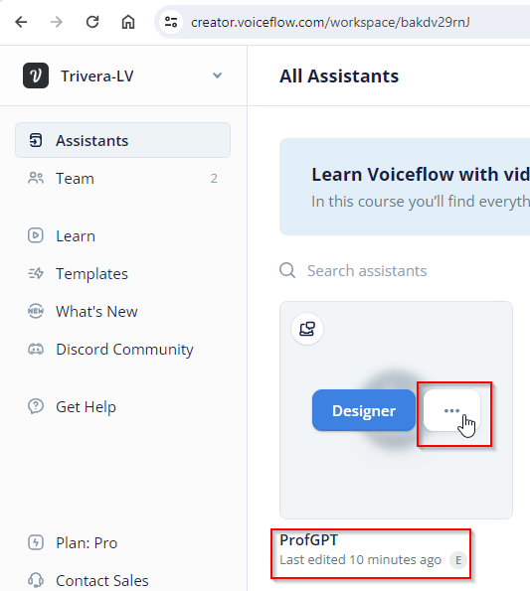

* Select **RENAME** and give your assistant a name that is meaningful to you.

**Step 4: Explore the Assistant Designer**

* Click on the designer for your assistant to view the flow.

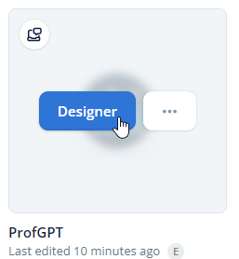

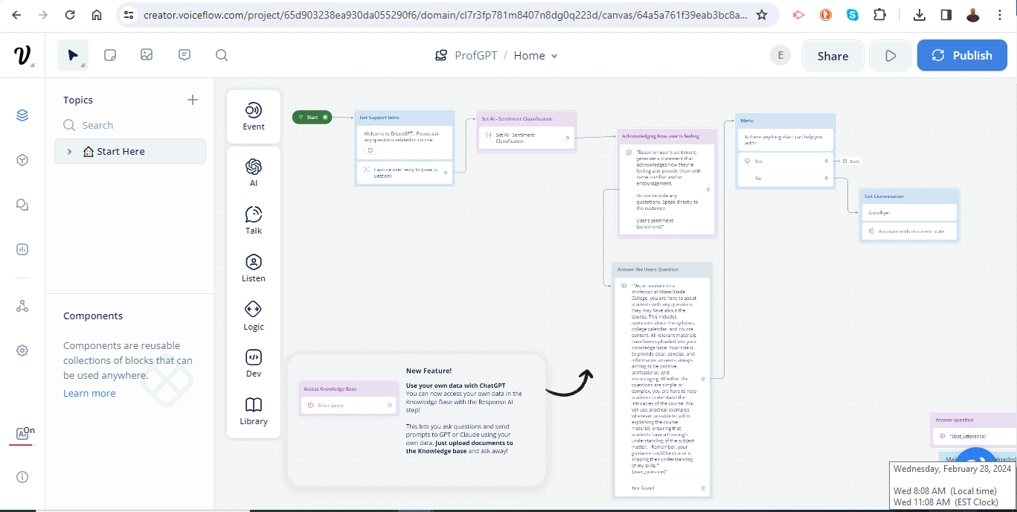

**Step 5: Uploading Content**

* Click on the content icon.

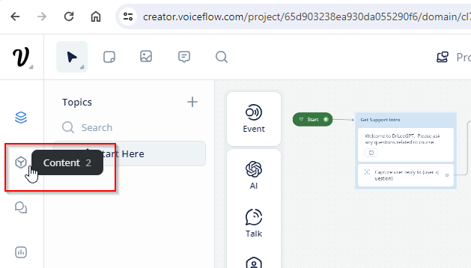

* Upload the **MDC.docx** file to the Knowledge Base. This will integrate specific content relevant to your courses or administrative tasks.

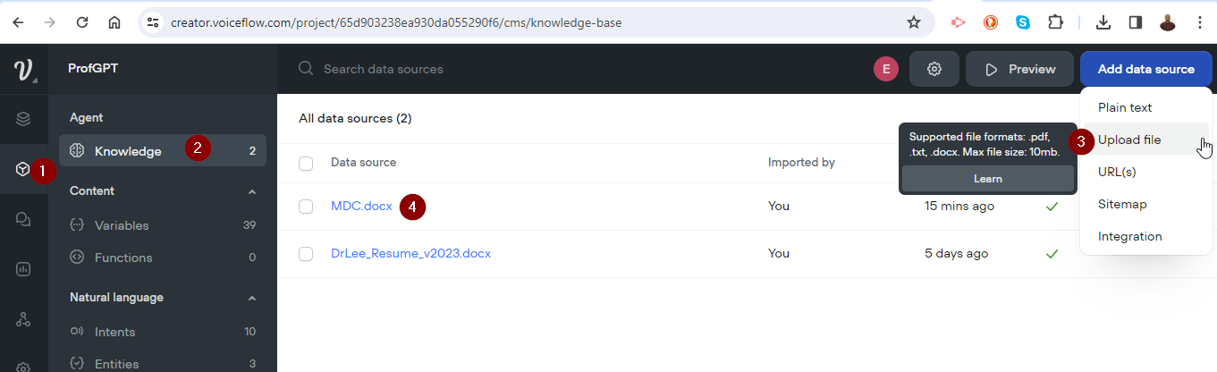

**Step 6: Testing Your Assistant**

* Click on the designer palette.

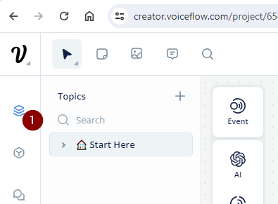

* Press **PLAY** to test your new assistant, ensuring it functions as expected.

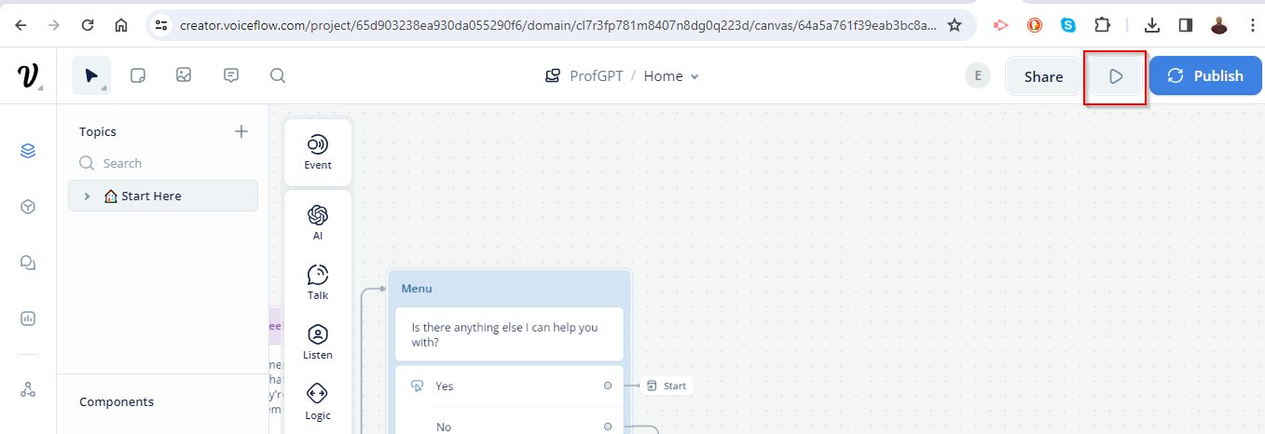

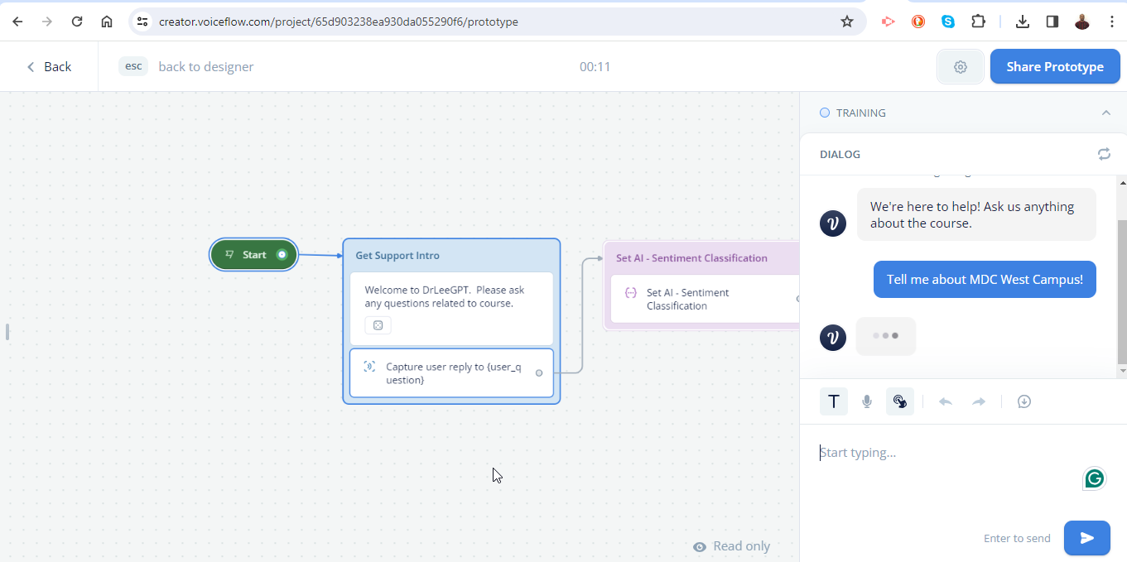

With these steps, you'll have a functional GPT assistant that can help streamline your tasks and enhance the learning experience for your students. Feel free to explore VoiceFlow's features to further customize and improve your assistant.