**ABOUT MIAMI DADE COLLEGE**

Miami Dade College is among the most diverse institution in the nation. There are 167 nations and 63 languages represented in its student body. The College's eight campuses and multiple outreach centers offer more than 300 distinct degree pathways including associate and baccalaureate degrees, career certificates and apprenticeships. Baccalaureate degree offerings include biological sciences, engineering, data analytics, information systems technology, artifical intelligence (the first in Florida), education, public safety, supervision and management, nursing, physician assistant studies, film and others. MDC is the recipient of many top national awards including the Aspen Prize. As Democracy's College, MDC changes lives through accessible, high quality-teaching and learning experiences. It is the home of the Artifical Intelligence Centers, Miami Culinary Institute, Miami Animation & Gaming International Complex (MAGIC), Miami Fashion Institute, Eig-Watson School of Aviation, The Idea Center, Cybersecurity Center of the Americas, Cloud Computing Center, Center for Learning, Innovation and Simulation, School for Advanced Studies and New World School of the Arts, to name a few of its most innovative programs.

MDC has been named among the nation's "Great Colleges to Work For" since the program's inception. The College embraces its responsibility to serve as an economic, cultural and civic leader for the advancement of our diverse global community. Its alumni and employees contribute more than $3 billion annually to the local economy and MDC graduates occupy top leadership positions in every major industry. MDC is renowned for its rich cultural programming. It is the home of the Miami Book Fair, Miami Film Festival, the National Historic Landmark Miami Freedom Tower, Dyer Building, Koubek Center, MDC Live Arts, the Lynn and Louis Wolfson II Florida Moving Image Archives, the Museum of Art and Design, campus art galleries and theaters; and a sculpture park. MDC has admitted more than 2.5 million students and counting, since it opened its doors in 1960. More than 100,000 students are currently enrolled.

**HISTORY OF MDC**

**MISSION & VISION**

Mission

As democracy’s college, Miami Dade College changes lives through accessible, high-quality teaching and learning experiences. The College embraces its responsibility to serve as an economic, cultural and civic leader for the advancement of our diverse global community.

Vision

To be the recognized leader in student learning, achievement and success while enriching our community

Core Values

* An exceptional learning environment that challenges students and empowers them to attain their academic goals
* An international perspective that makes our students civically engaged and globally competitive
* A commitment to evidence-informed decision making and accountability
* Innovation and efficiency that ensure affordability while optimizing educational quality
* An exceptional work environment that engages an exemplary and diverse workforce
* Quality community partnerships that serve as the foundation for the development of relevant workforce, cultural and civic programs
* Cultural initiatives that capture the richness of Miami-Dade County’s multicultural fabric
* Environmental awareness that results in intentional sustainability practices

The [Southern Association of Colleges and Schools Commission on Colleges](http://www.sacscoc.org/) is the regional body for the accreditation of degree-granting higher education institutions in the Southern states. It serves as the common denominator of shared values and practices among the diverse institutions in Alabama, Florida, Georgia, Kentucky, Louisiana, Mississippi, North Carolina, South Carolina, Tennessee, Texas, Virginia and Latin America and other international sites accredited by the Commission on Colleges that award associate, baccalaureate, master’s, or doctoral degrees.

Miami Dade College was first accredited by SACSCOC in the 1960s and celebrates the opportunity to continually engage its students, faculty, staff and administrators in a comprehensive self-study focused on institutional effectiveness and quality enhancement.

Why Accreditation Matters

Miami Dade College is institutionally accredited by the Southern Association of Colleges and Schools Commission on Colleges and meets the educational standards of the Department of Education, just like many of the nation’s most respected universities and colleges.

Because the College meets the strict requirements imposed by institutional accreditation:

* You can be sure that you will receive high quality education
* Credits you earn are more easily transferred to other institutions, allowing you to continue your education and pursue advanced degrees at prestigious colleges and state schools across the nation
* Employers know the value of your education. Institutional accreditation is a reputable, recognized standard in higher education.

Accreditation



**Miami Dade College is accredited by the Southern Association of Colleges and Schools Commission on Colleges (SACSCOC) to award associate and baccalaureate degrees. Miami Dade College also may offer credentials such as certificates and diplomas at approved degree levels. Questions about the accreditation of Miami Dade College may be directed in writing to the Southern Association of Colleges and Schools Commission on Colleges at 1866 Southern Lane, Decatur, GA 30033-4097, by calling (404) 679-4500, or by using information available on SACSCOC’s website (**[**www.sacscoc.org**](http://www.sacscoc.org/)**).**

The Commission’s contact information is provided to enable interested constituents to (1) learn about the accreditation status of the institution, (2) file a third-party comment at the time of the institution’s decennial review, or (3) file a complaint against the institution for alleged non-compliance with a standard or requirement. Normal inquiries about the College, such as admission requirements, financial aid, educational programs, etc., should be addressed directly to the appropriate department at the College and not to the Commission’s office. For information about the Southern Association of Colleges and Schools Commission on Colleges or the accreditation process, visit the [SACSCOC site](http://www.sacscoc.org/).

SACSCOC reaffirmed MDC’s accreditation on June 11, 2015. The College maintains the standards specified by SACSCOC’s Principles of Accreditation and notifies SACSCOC of any substantive change.

## **Campuses**

### Hialeah Campus 1780 W 49th Street Hialeah, Florida 33012

[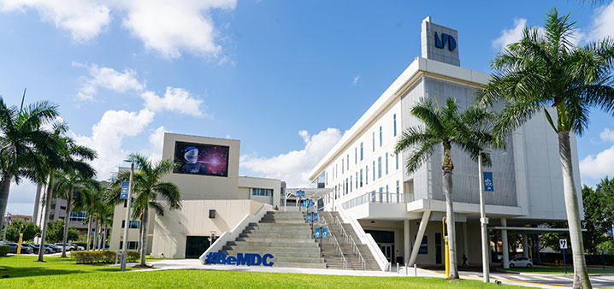](https://www.mdc.edu/hialeah/)

The Hialeah Campus became MDC’s seventh campus in 2005, serving the Greater Hialeah-Miami Lakes area. Offered courses support careers in Computer Technology, Office Technology, Electronics and Early Childhood Development, among others. The campus houses a large and comprehensive English language training program for speakers of other languages in various instructional formats.

* [Hialeah Campus 360º Tour](https://tour.concept3d.com/share/yzUYtIjlI/stop/1)
* [Visit the Hialeah Campus Website](https://www.mdc.edu/hialeah/)
* [Get driving directions to the Hialeah Campus](https://www.mdc.edu/hialeah/campus-information/directions.aspx)

### Homestead Campus  500 College Terrace Homestead, Florida 33030

[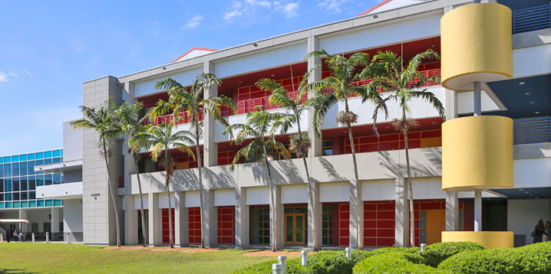](https://www.mdc.edu/homestead/)

In 1990, Homestead became the College’s fifth campus. It was opened in the historic downtown district of the City of Homestead with the mission to deliver a full range of higher education programs for the Homestead/Florida City communities. The campus also enhances the community’s cultural and social footprint. It played an important role in the rebuilding effort after Hurricane Andrew.

* [Homestead Campus 360º Tour](https://tour.concept3d.com/share/rzom7vl1L/stop/1)
* [Visit the Homestead Campus Website](https://www.mdc.edu/homestead/)
* [Get driving directions to the Homestead Campus](https://www.mdc.edu/homestead/campus-information/directions.aspx)

### Kendall Campus  11011 SW 104 Street Miami, FL 33176-3393

[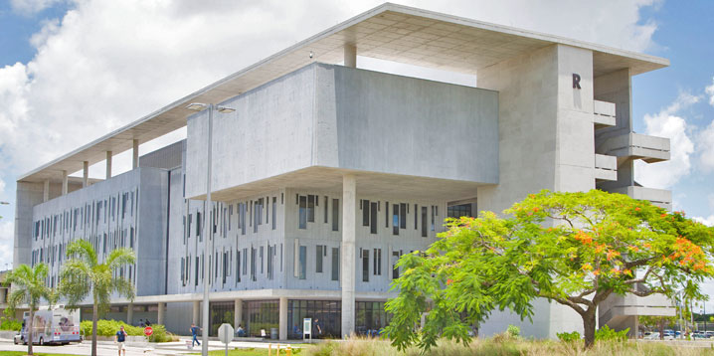](https://www.mdc.edu/kendall/)

The Kendall Campus, situated on a 185-acre tract of trees and lakes, opened in 1967. It is home to a wide variety of academic programs and specialized institutes. The campus features 13 buildings equipped with the latest technologies,a wellness center, athletic fields and an Olympic-sized pool. The campus offers acomprehensive range of learning opportunities. Kendall provides students with transfer programs designed to facilitate the move to four-year institutions, programs that enhance and modernize professional and technical skills, and preparatory programs for licensing or certification. The campus is the home of MDC athletics.

* [Kendall Campus 360º Tour](https://tour.concept3d.com/share/KF4ATywT2/stop/1)
* [Visit the Kendall Campus Website](https://www.mdc.edu/kendall/)
* [Get driving directions to the Kendall Campus](https://www.mdc.edu/kendall/campus-information/directions.aspx)

### Medical Campus  950 NW 20th St. Miami, FL 33127

[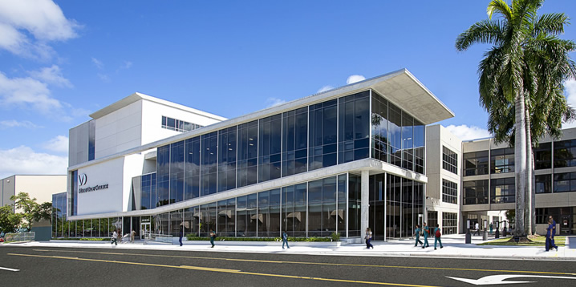](https://www.mdc.edu/medical/)

In 1977, MDC opened its Medical Campus on 4.3 acres within the city’s medical/civic center complex. Along with the University of Miami School of Medicine, Jackson Memorial Hospital and the Veterans Administration Hospital, the campus forms the backbone of Miami’s health care community. The campus highlight is its new Center for Learning, Innovation and Simulation, a state-of-the-art facility designed to provide students with the training needed to excel in today’s fast-changing health care industry. The campus offers specialty disciplines in nursing and allied health.

* [Medical Campus 360º Tour](https://tour.concept3d.com/share/WPd4Ood1v/stop/1)
* [Visit the Medical Campus Website](https://www.mdc.edu/medical/)
* [Get driving directions to the Medical Campus](https://www.mdc.edu/medical/campus-information/directions.aspx)

### North Campus  11380 NW 27th Ave. Miami, FL 33167-3495

[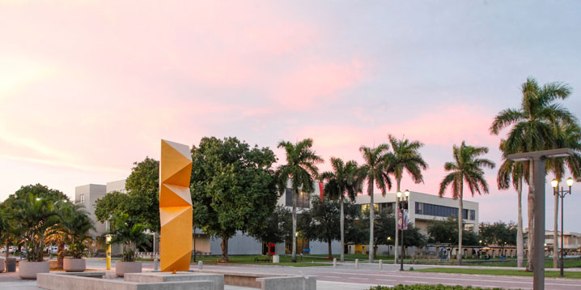](https://www.mdc.edu/north/)

Located on 245 acres in northern Miami-Dade County, this beautifully landscaped campus was the College’s first. It was built in 1960, on land that once hosted a World War II Naval air station. The main academic buildings of the campus surround a serene lake and lush walking paths. The campus is a gateway for students wishing to upgrade skills and complete one-year certificate programs, prepare for licensing exams or start working on a bachelor’s degree.

* [North Campus 360º Tour](https://tour.concept3d.com/share/FjOLRguUm/stop/1)
* [Visit the North Campus Website](https://www.mdc.edu/north/)
* [Get driving directions to the North Campus](https://www.mdc.edu/north/campus-information/directions.aspx)

### Padrón Campus  627 SW 27th Ave. Miami, FL 33135

[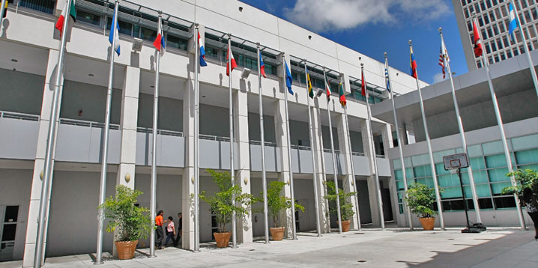](https://www.mdc.edu/padron/)

Padrón Campus (formerly Inter-American Campus) is located in the lively neighborhood of Little Havana. The campus is home of the School of Education, Dual Language Honors College, and the Translation and Interpretation Studies program. The campus offers comprehensive academic programs in business, accounting, computer information technology, transfer degrees, pre-nursing classes, and credit and non-credit opportunities to learn English or upgrade professional skills.

* [Padrón Campus 360º Tour](https://tour.concept3d.com/share/iErMILYfX/stop/1)
* [Visit Padrón Campus Website](https://www.mdc.edu/padron/)
* [Get driving directions to Padrón Campus](https://www.mdc.edu/padron/campus-information/directions.aspx)

### West Campus  3800 NW 115th Ave. Doral, FL 33178

[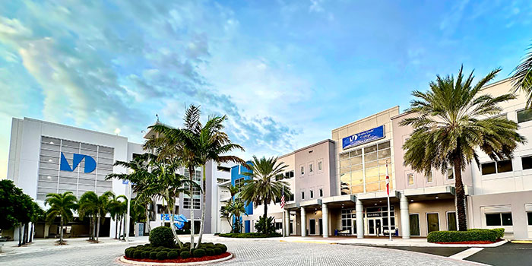](https://www.mdc.edu/west/)

The West Campus opened for classes on March 1, 2006 and became a designated campus of Miami Dade College in June 2018, with the approval of the Southern Association of Colleges and Schools Commission on Colleges. It serves one of the fastest-growing locales in Miami-Dade County, including Doral and surrounding areas. Academic classes and corporate training programs are offered at the campus, which promises to be the next exciting learning environment for the Greater Miami community.

* [West Campus 360º Tour](https://tour.concept3d.com/share/1QGMlUdL7/stop/1)
* [Visit the West Campus Website](https://www.mdc.edu/west/)
* [Get driving directions to the West Campus](https://www.mdc.edu/west/campus-information/directions.aspx)

### Wolfson Campus  300 NE Second Ave. Miami, FL 33132

[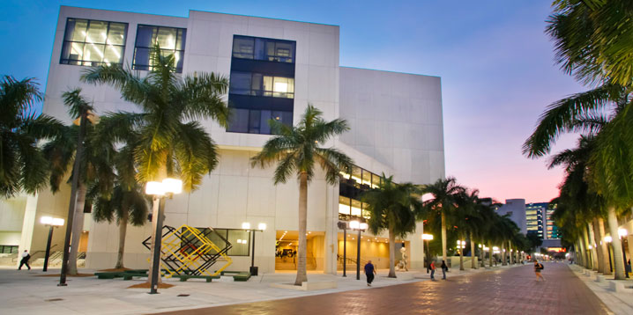](https://www.mdc.edu/wolfson/)

The Wolfson Campus opened in 1970 by holding classes in the storefronts of downtown Miami. With the completion of the campus’ first permanent facility in 1973, Wolfson catalyzed a downtown renaissance by hosting all manner of civic and cultural discourse. It is the only comprehensive urban campus in the city. Located within the city’s financial, governmental, technological and cultural hubs, the campus capitalizes on its unique geographic resource by offering programs in banking/financial services, business, computer technology, paralegal studies, architecture, economics, hospitality management, engineering, the arts, humanities and social sciences. Wolfson is credited with helping spark Miami’s cultural rebirth.

* [Wolfson Campus 360º Tour](https://tour.concept3d.com/share/yvZCbn-Pe/stop/1)
* [Visit the Wolfson Campus Website](https://www.mdc.edu/wolfson/)
* [Get driving directions to the Wolfson Campus](https://www.mdc.edu/wolfson/campus-information/directions.aspx)

## **Education Centers**

### Gibson Education Center  3629 Grand Ave. Miami, Florida 33133

[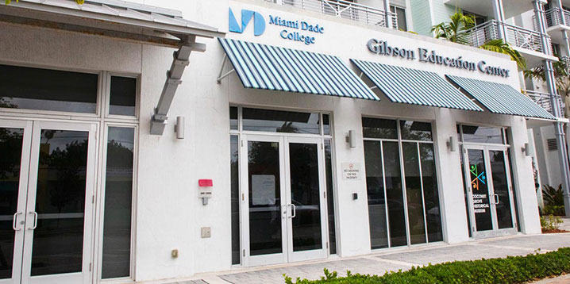](https://www.mdc.edu/gibson/)

MDC’s Gibson Education Center is an outreach facility offering a wide range of traditional credit courses, career readiness training, college preparedness programs and personal enrichment seminars at a location that is open to all, but especially convenient to the community of Coconut Grove and surrounding neighborhoods. The Gibson Educational Center is nestled in the heart of Coconut Grove just six blocks south from the business district of Coco Walk and equipped with three state of the art classrooms with a fully modern computer lab. Whether students are looking to upskill, prepare for industry certifications and exams such as the ACT, SAT, or PERT, or simply get a head start through dual enrollment, the Gibson Education Center is here to help.

* [Visit the Gibson Education Center Website](https://www.mdc.edu/gibson/)
* [Get driving directions to the Gibson Education Center](https://www.google.com/maps/dir/25.7279408,-80.2520173/@25.7278107,-80.2520629,20.54z/data=!4m2!4m1!3e0)

### Meek Entrepreneurial Education Center  6300 NW Seventh Ave. Miami, FL 33150

[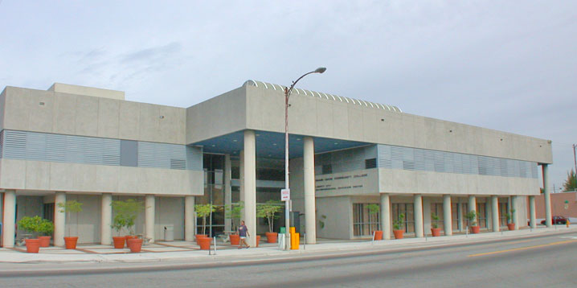](https://www.mdc.edu/north/campus-information/eec.aspx)

The Carrie P. Meek Entrepreneurial Education Center (MEEC) is a major outreach center of the North Campus, founded in 1989. The Center offers a vast array of college credit and non-credit courses. There are opportunities to pursue certificate and vocational programs as well as take part in a variety of seminars, conferences and workshops. Students at the MEEC can obtain workforce and business skills training to enter the labor market or become successful entrepreneurs.

* [Visit the Entrepreneurial Education Center Website](https://www.mdc.edu/north/campus-information/eec.aspx)
* [Get driving directions to the Entrepreneurial Education Center Campus](https://www.mdc.edu/north/campus-information/directions.aspx)

The accreditation of MDC’s campuses and centers falls under the College’s institutional accreditation by the Southern Association of College and Schools Commission on Colleges (SACSCOC). For more information about MDC’s accreditation, visit the [Accreditation](https://www.mdc.edu/accreditation/).

Spring 2024 Calendar

|  |  |
| --- | --- |
| October 2023 | |
| October 23 (Monday) | Priority registration for Spring term 2024 begins. |
| October 25 (Wednesday) | Open registration for Spring term 2024 begins. |
| December 2023 | |
| Dec. 16 (Saturday) | Student Services offices open on Saturday from 9:00 am to 1:00 pm. |
| Dec. 18- Jan 1, 2024 | Winter Recess. The College will be closed for winter recess. Student Services offices open Tuesday, December 19th and Wednesday, December 20th from 8:00 am to 7:00 pm. |
| January 2024 | |
| Jan. 2 (Tuesday) | State employee tuition waiver applicants must register for eligible courses no earlier than one business day prior to class start date. |
| Jan. 3 (Wednesday) | Classes begin: 16 weeks. |
| Jan. 3 (Wednesday) | Classes begin: 8-week miniterm. |
| Jan. 5 (Friday) | Weekend classes begin on Friday at 5 pm. |
| Jan. 6 (Saturday) | Student Services offices open on Saturday from 9:00 am to 1:00 pm. |
| Jan. 8 (Monday) | 8-week miniterm. Last day to drop with refund; change courses without financial penalty; register, add a course or change sections without instructor and/or department approval; change from audit status to credit status or from credit status to audit status. |
| Jan. 8 (Monday) | Classes begin: 4-week miniterm. |
| Jan. 8 (Monday) | Monday classes begin. |
| Jan. 9 (Tuesday) | 16-week classes. Last day to drop with refund; change courses without financial penalty; register, add a course or change sections without instructor and/or department approval; change from audit status to credit status or from credit status to audit status. |
| Jan. 10 (Wednesday) | Weekend classes. Last day to drop with refund; change courses without financial penalty; register, add a course or change sections without instructor and/or department approval; change from audit status to credit status or from credit status to audit status. |
| Jan. 10 (Wednesday) | 4-week miniterm. Last day to drop with refund; change courses without financial penalty; register, add a course or change sections without instructor and/or department approval; change from audit status to credit status or from credit status to audit status. |
| Jan. 13 - 15 (Saturday-Monday) | Holiday – Martin Luther King Jr. Day |
| Jan. 16 (Tuesday) | 14-week miniterm begins. |
| Jan. 16 (Tuesday) | 10-week miniterm begins. |
| Jan. 19 (Friday) | 10-week miniterm. Last day to drop with refund; change courses without financial penalty; register, add a course or change sections without instructor and/or department approval; change from audit status to credit status or from credit status to audit status. |
| Jan. 22 (Monday) | 14-week miniterm. Last day to drop with refund; change courses without financial penalty; register, add a course or change sections without instructor and/or department approval; change from audit status to credit status or from credit status to audit status. |
| Jan. 22 (Monday) | 6-week miniterm begins. |
| Jan. 24 (Wednesday) | 6-week miniterm. Last day to drop with refund; change courses without financial penalty; register, add a course or change sections without instructor and/or department approval; change from audit status to credit status or from credit status to audit status. |
| Jan. 29 (Monday) | 12-week miniterm begins. |
| February 2024 | |
| Feb. 1 (Thursday) | 12-week miniterm. Last day to drop with refund; change courses without financial penalty; register, add a course or change sections without instructor and/or department approval; change from audit status to credit status or from credit status to audit status. |
| Feb. 5 (Monday) | 8-week miniterm. Last day to withdraw from courses with a “W” grade; register for institutional credit-by-exam. |
| Feb. 12 (Monday) | 4-week second miniterm begins. |
| Feb. 14 (Wednesday) | 4-week second miniterm. Last day to drop with refund; change courses without financial penalty; register, add a course or change sections without instructor and/or department approval; change from audit status to credit status or from credit status to audit status. |
| Feb. 14 (Wednesday) | 6-week miniterm. Last day to withdraw from courses with a “W” grade; register for institutional credit-by-exam. |
| Feb. 17-19 (Saturday – Monday) | Holiday – Presidents Day |
| Feb. 26 (Monday) | 8-week second miniterm begins. |
| Feb. 26 (Monday) | 10-week second miniterm. Last day to withdraw from courses with a “W” grade; register for institutional credit-by-exam. |
| Feb. 28 (Wednesday) | 4-week second miniterm. Last day to withdraw from courses with a “W” grade; register for institutional credit-by-exam. |
| Feb. 29 (Thursday) | 8-week second miniterm. Last day to drop with refund; change courses without financial penalty; register, add a course or change sections without instructor and/or department approval; change from audit status to credit status or from credit status to audit status. |
| March 2024 | |
| Mar. 7 (Thursday) | Employee Retreat No Classes. The college will be open. |
| Mar. 11 (Monday) | 6-week second miniterm begins. |
| Mar. 11 (Monday) | Priority registration for Summer term 2024 begins. |
| Mar. 13 (Wednesday) | Open registration for Summer term 2024 begins. |
| Mar. 13 (Wednesday) | 6-week second miniterm. Last day to drop with refund; change courses without financial penalty; register, add a course or change sections without instructor and/or department approval; change from audit status to credit status or from credit status to audit status. |
| Mar. 13 (Wednesday) | 16-week classes. Last day to withdraw from courses with a “W” grade; register for institutional credit-by-exam. |
| Mar. 14 (Thursday) | 14-week miniterm. Last day to withdraw from courses with a “W” grade; register for institutional credit-by-exam. |
| Mar. 18 (Monday) | Last day to apply for graduation and have your name appear in the commencement program. |
| Mar. 20 (Wednesday) | 12-week miniterm. Last day to withdraw from courses with a “W” grade; register for institutional credit-by-exam. |
| Mar. 25 – 31 (Mon – Sun) | Spring Break - College Closed |
| April 2024 | |
| Apr. 1 (Monday) | 4-week third miniterm begins. |
| Apr. 3 (Wednesday) | 4-week third miniterm. Last day to drop with refund; change courses without financial penalty; register, add a course or change sections without instructor and/or department approval; change from audit status to credit status or from credit status to audit status. |
| Apr. 5 (Friday) | 8-week second mini-term. Last day to withdraw from courses with a “W” grade; register for institutional credit-by-exam. |
| Apr. 8 (Monday) | Priority registration for Fall 2024 begins. |
| Apr. 10 (Wednesday) | Open registration for Fall 2024 begins. |
| Apr. 11 (Thursday) | 6-week second miniterm. Last day to withdraw from courses with a “W” grade; register for institutional credit-by-exam. |
| Apr. 17 (Wednesday) | 4-week third miniterm. Last day to withdraw from courses with a “W” grade; register for institutional credit-by-exam. |
| Apr. 20 (Saturday) | Commencement Ceremony |
| Apr. 26 (Friday) | Last day of classes and final exams. |
| Apr. 29 (Monday) | Final course grades available. |

Miami Dade College reserves the right to change the academic calendar or to make other changes deemed necessary, giving advance notice of change when possible.

## **Academic Schools**

Miami Dade College’s Academic Schools are truly in tune with the global industry environment that is changing at a more rapid pace than ever before as a result of emerging technologies and occupations. MDC collaborates regularly with industry partners to identify trends and challenges, creating strategies for these evolving opportunities.



### [Benjamín León School of Nursing](https://mdc.edu/nursing/)

More than 57 years ago, Miami Dade College created a nursing program to meet the rapidly growing need for registered nurses in Miami-Dade County and has since graduated over 23,000 nurses. The Benjamín León School of Nursing is one of the top 100 associate degree producers for all minorities in the U.S.



### Miguel B. Fernandez Family School of Global Business, Trade and Transportation

The Miguel B. Fernandez Family School of Global Business, Trade and Transportation combines programs led by dynamic faculty with real-world experience to prepare students for the jobs of today. The school is also home to the Miami Hospitality Center, Miami Culinary Institute, and Miami Dade College’s renowned Eig-Watson School of Aviation.



#### [Eig-Watson School of Aviation](https://mdc.edu/aviation/)



#### [Miami Culinary Institute](https://mdc.edu/culinary/)



#### [Miami Hospitality Center](https://mdc.edu/hospitality/)



#### [Business](https://mdc.edu/business/)



### [School of Education](https://mdc.edu/education/)

The School of Education provides training for teachers at all levels. It offers bachelor’s degrees in Early Childhood Education (birth to Grade 3); Exceptional Student Education (kindergarten to Grade 12); Mathematics Education (Grades 6-12); and Biology Education. The school also offers workforce credentials: the Florida Child Care Professional Certificate and the National Child Development Associate credential. It offers teacher certification courses for career changers; teacher recertification courses for certificate maintenance; extra licensing through endorsement courses; and the Educator Preparation Institute (EPI), the alternate pathway to teaching.



### [School of Engineering, Technology and Design](https://mdc.edu/entec/)

The School of Engineering, Technology and Design (ENTEC) at Miami Dade College has designed its programs and curricula to provide students with exciting opportunities, the highest quality education and a variety of options to achieve success. This school is home to subsidiary departments including the Miami Animation and Gaming International Complex (MAGIC); Miami Fashion Institute; School of Architecture and Interior Design; School of Engineering and Technology; and the School of Entertainment and Design Technology (SEDT).



#### [Architecture and Interior Design](https://mdc.edu/architecture-interior-design/)



#### [Entertainment & Design Technology](https://mdc.edu/sedt/)

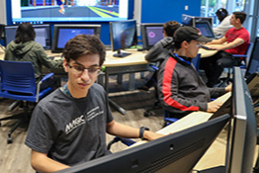

#### [MAGIC](https://mdc.edu/magic/)



#### [Miami Fashion Institute](https://mdc.edu/fashion/)



### [School of Health Sciences](https://mdc.edu/health-sciences/)

Strategically located in the heart of Miami-Dade County’s Health District, the School of Health Sciences at the Medical Campus of Miami Dade College is committed to providing life-changing opportunities for individuals looking to join the health care profession. By disseminating foundational knowledge in state-of-the-art facilities, such as the Center for Learning, Innovation and Simulation, students can participate in more than 23 educational options.



### [School of Justice, Public Safety and Law Studies](https://mdc.edu/justice/)

The School of Justice, Public Safety and Law Studies offers certificates, associate and bachelor’s degrees, which are all stackable for progressive academic advancement. Home to crime scene technology, fire science, public safety and criminal justice programs, the school fosters successful graduates. In fact, more than 80% of all public safety professionals in Miami-Dade County have been trained at the School of Justice. Hands-on classes and other options – including web-enhanced courses and weekend classes – allow students to gain the experience they need on a schedule that works for them.



### [School of Science](https://mdc.edu/science/)

Miami Dade College’s School of Science is committed to providing its diverse student population with high quality and innovative learning experiences that prepare them to question, investigate and formulate conclusions about the natural world. Offering a variety of degrees and certificate programs, the School of Science builds a strong foundation in the study of life and physical sciences. Whether starting a journey to an advanced degree or building skills for today’s workforce, students of the School of Science benefit from a modern approach to learning that opens doors to discovery and success.



### [School of Continuing Education and Professional Development](https://mdc.edu/ce/)

Learning is a lifelong endeavor, and Miami Dade College is committed to bringing a wide variety of learning opportunities to the local community through non-credit classes at its School of Continuing Education and Professional Development. Areas of instruction include continuing workforce education, corporate training, recreation, language skills and test preparation.

## **Tuition & Fees**

* [Other Fees & Common Terms](https://www.mdc.edu/student-financial-services/tuition-fees/other-fees/default.aspx)
* [FOA – Financial Obligation Agreement](https://www.mdc.edu/student-financial-services/tuition-fees/foa/default.aspx)

### Overview

Tuition is set annually by the Florida Legislature, with additional local and institutional fees set by the Miami Dade College Board of Trustees and the Florida Board of Governors. Below are the regulatory references for tuition and fee assessment:

* [Title XLVIII, Chapter 1009, Part II](http://www.leg.state.fl.us/statutes/index.cfm?App_mode=Display_Statute&Search_String=&URL=1000-1099/1009/Sections/1009.24.html) of Florida's Statutes
* BOG Regulation [7.001](https://www.flbog.edu/wp-content/uploads/7-001-tuition-and-associated-fees-regulation.pdf) and [7.003](https://www.flbog.edu/wp-content/uploads/7.003Amended_FINAL10-30-2019.pdf) of the State University System of Florida Board of Governors

The following rate tables apply to the current academic year and are subject to change based on legislative and internal policy change.

Some courses are assessed additional costs for online fees, labs, materials and supplies, and general cost recovery.

### Tuition and Fees for the 2023-2024 Academic Year

**Financial Obligation Agreement (FOA):**

All MDC students are required to read and e-sign our Financial Obligation Agreement prior to enrolling for courses each term. The agreement is available to read and sign during the registration process. Read a sample of the [Financial Obligation Agreement](https://www.mdc.edu/about/pdf/financial-obligation-agreement.pdf) and [view the steps to complete it](https://www.mdc.edu/about/pdf/steps-to-complete-financial-agreement.pdf).

### College Credit Programs

**Associate Programs, College Credit Certificate (C.C.C.), Advanced Technical Certificate (A.T.C.), Developmental Education and Educator Preparatory**

#### Fee Per Credit Hour

|  |  |
| --- | --- |
| **Resident Students** | |
| **Financials** | **Amount** |
| Tuition | $82.78 |
| Student Services | $8.28 |
| Financial Aid | $4.14 |
| Capital Improvement | $15.88 |
| Technology | $4.14 |
| Parking* | $3.00 |
| **Total Cost Per Credit** | **$118.22** |
| **Cost per Term (12 credits)** | $1,418.64 |
| **Non-Resident Students** | |
| **Financials** | **Amount** |
| Tuition + Out-of-State | $331.11 |
| Student Services | $8.28 |
| Financial Aid | $16.56 |
| Capital Improvement | $27.00 |
| Technology | $16.56 |
| Parking* | $3.00 |
| **Total Cost Per Credit** | **$402.51** |
| **Cost per Term (12 credits)** | $4,830.12 |

*Parking fees are waived for MDC Live, MDC Online, and Independent Study courses.

### Baccalaureate Programs

**Bachelor of Applied Science (BAS), Bachelor of Science (BS), and Bachelor of Science in Nursing (BSN)**

#### Fee Per Credit Hour

|  |  |
| --- | --- |
| **Resident Students** | |
| **Financials** | **Amount** |
| Tuition | $91.79 |
| Student Services | $9.18 |
| Financial Aid | $4.59 |
| Capital Improvement | $16.74 |
| Technology | $4.59 |
| Parking* | $3.00 |
| **Total Cost Per Credit** | **$129.89** |
| **Cost per Term (12 credits)** | $1,558.68 |
| **Non-Resident Students** | |
| **Financials** | **Amount** |
| Tuition + Out-of-State | $448.79 |
| Student Services | $9.18 |
| Financial Aid | $22.44 |
| Capital Improvement | $30.12 |
| Technology | $22.44 |
| Parking* | $3.00 |
| **Total Cost Per Credit** | **$535.97** |
| **Cost per Term (12 credits)** | $6,431.64 |

*Parking fees are waived for MDC Live, MDC Online, and Independent Study courses.

### Career and Technical Education Programs

**Career Technical Certificate (C.T.E./V.C.C.)**

#### Fee Per Credit Hour

|  |  |
| --- | --- |
| **Resident Students** | |
| **Financials** | **Amount** |
| Tuition | $73.40 |
| Student Services | $0.00 |
| Financial Aid | $7.34 |
| Capital Improvement | $3.67 |
| Technology | $3.67 |
| Parking | $3.00 |
| **Total Cost Per Credit** | **$91.08** |
| **Cost per Term (12 credits)** | $1,092.96 |
| **Non-Resident Students** | |
| **Financials** | **Amount** |
| Tuition + Out-of-State | $293.59 |
| Student Services | $0.00 |
| Financial Aid | $29.36 |
| Capital Improvement | $14.68 |
| Technology | $14.68 |
| Parking | $3.00 |
| **Total Cost Per Credit** | **$355.31** |
| **Cost per Term (12 credits)** | $4,263.72 |

### Non-Credit Adult Basic Education

##### **Resident and Non-Resident Students**

Total fees per term is $30.00

MDC West

[[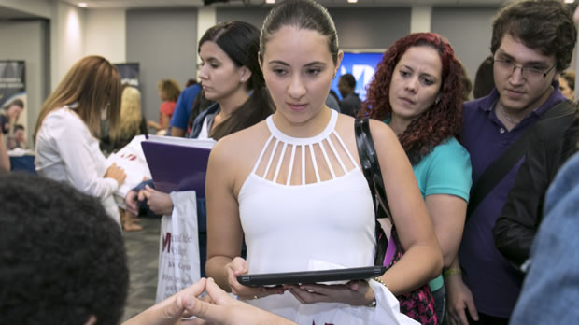](https://mdc.edu/west/registration-help.aspx)](https://mdc.edu/west/registration-help.aspx)

[**Need Help Registering for Classes?**](https://mdc.edu/west/registration-help.aspx)

[Fill out this registration help form and have a representative guide you.](https://mdc.edu/west/registration-help.aspx)

[‹›](https://mdc.edu/west/#myCarousel)

**West Campus**

3800 NW 115th Ave.  
Doral, FL 33178

|  |  |
| --- | --- |
| **Operator** | **305-237-8000** |
| [Public Safety](https://mdc.edu/safety/) | 305-237-8100 |
| [Admissions](https://mdc.edu/admissions/) | 305-237-9100 |
| [Registration](https://mdc.edu/main/register/default.aspx) | 305-237-9100 |
| [Advisement](https://mdc.edu/main/advisement/) | 305-237-8947 |
| [Financial Aid](https://mdc.edu/financialaid/) | 305-237-9300 |
| [Student Life](https://mdc.edu/west/student-life.aspx) | 305-237-8904 |
| [Library](https://mdc.edu/main/library/) | 305-237-8931 |
| [Media Services](https://mdc.edu/campus-information/campus-services-mediaservices.aspx) | 305-237-8310 |

[Complete Campus Directory](https://mdc.edu/west/campus-information/directory.aspx)

**About Our Campus**

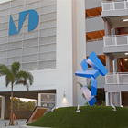

Welcome to Miami Dade College West Campus, conveniently located just off the Florida Turnpike, amidst the City of Doral logistics hub. Doral is the leader in logistics businesses in Miami and is a rapidly-expanding community in Miami Dade County.

[Read more about West Campus >>](https://mdc.edu/west/campus-information/default.aspx)

**West Campus Programs**

* + - [Miguel B. Fernandez Family School of Global Business](https://www.mdc.edu/globalbusiness/)
    - [School of Engineering + Technology](https://www.mdc.edu/entec/)
    - [School of Justice](https://www.mdc.edu/justice/)
    - [School of Entertainment and Design Technology](https://www.mdc.edu/sedt/)
    - [School of Continuing Education & Professional Development](https://ce.mdc.edu/)
    - [Tesla Start Program](https://www.mdc.edu/tesla/)

**Campus Highlights**

* [](https://mdc.edu/west/campus-information/west-gallery.aspx)

[**Art Gallery**](https://mdc.edu/west/campus-information/west-gallery.aspx)

The West Gallery allows visitors the opportunity to experience art from a wide variety of artists and styles, and to submit their own work to annual juried student exhibitions as well. It also serves as a vital and vibrant art space for the community to view defined key movements and tendencies in the arts through exhibitions, workshops, and gallery walks.

* [](http://www.mdc.edu/science)

[**School of Science**](http://www.mdc.edu/science)

Offering a variety of degrees and certificate programs, the Miami Dade College School of Science builds a strong foundation in the study of natural sciences. Start your journey to an advanced degree or build your skills for the cutting-edge workplace. At the School of Science, you'll find innovative learning experiences that open doors to discovery and success

**Quick Links**

[Parking Lot](https://mdc.edu/west/campus-information/directions.aspx)

[**Parking at West Campus**](https://mdc.edu/west/campus-information/directions.aspx)

Stay up to date with parking information for the campus.

[Public Safety Officer](https://mdc.edu/safety/)

[**Public Safety**](https://mdc.edu/safety/)

Public Safety creates a safe environment.

[Books](https://www.bkstr.com/miamidadeweststore)

[**Bookstore**](https://www.bkstr.com/miamidadeweststore)

Get your books (and lots more) before you need to hit the books.

[Libraries and Labs](https://mdc.edu/libraries/)

[**Libraries and Labs**](https://mdc.edu/libraries/)

Find the resources you need to succeed.

**Important Dates**

**Enroll now for the Spring Term**

View classes on the [Student Portal](https://my.mdc.edu/). [Meet with an advisor](https://www.mdc.edu/main/advisement/contact)to discuss your academic plan and determine which courses to take.  
  
Spring term classes begin Wednesday, January 3, 2024.

**Featured Events**

* FEB**28**

[**#KnowYourStatus**](https://calendar.mdc.edu/event/knowyourstatus_3115)

* FEB**28**

[**Get the Scoop!**](https://calendar.mdc.edu/event/get_the_scoop)

* FEB**28**

[**West Campus Academic Exhibition and Networking Event**](https://calendar.mdc.edu/event/academic_exhibition_and_networking_event_4393)

* MAR**05**

[**Women You Need to Meet**](https://calendar.mdc.edu/event/women_you_need_to_meet)

* MAR**05**

[**Donuts with Doc! featuring Dr. Calderon**](https://calendar.mdc.edu/event/donuts_with_doc_featuring_dr_calderon)

* MAR**06**

[**Awaken Your Inner Power: Celebrating Voices Across Cultures**](https://calendar.mdc.edu/event/awaken_your_inner_power_celebrating_voices_across_cultures)

* MAR**06**

[**#EmpowHER Watch Party**](https://calendar.mdc.edu/event/empowher_watch_party)

* MAR**08**

[**Wonder Women Wave**](https://calendar.mdc.edu/event/wonder_women_wave)

**Find us on Facebook**

## Campus Information

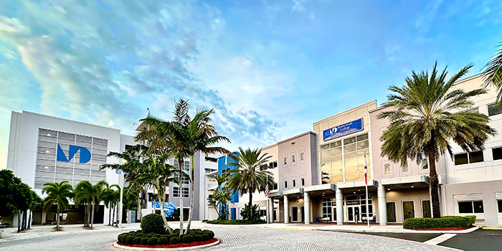

#### West Campus

Welcome to Miami Dade College West Campus, conveniently located just off the Florida Turnpike, amidst the City of Doral logistics hub. Doral is the leader in logistics businesses in Miami and is a rapidly-expanding community in Miami Dade County.  
  
As you browse through our website, you will learn about the various programs we offer, including Business, Accounting, Computer Science, and Criminal Justice. These programs meet both the educational and training needs of the community we serve.  
  
At the core of our mission is to help students excel and succeed. Our highly qualified faculty and staff are committed to providing a quality education and serving the community. Our faculty provide a support system through which students receive free tutoring services and are mentored by faculty who truly guide them on pathways to success. Our staff is dedicated to students and provides support with financial aid, registration, advisement, career services, and technology to ensure that their time at West Campus is enjoyable and one they will never forget.  
  
Come and visit West Campus today and see for yourself! Engage! Experience! Excel!