Multi-Factor Authentication Implementation
Agentic Voice, Inc. — d/b/a MFunding.net | Momentum Funding
Prepared July 28, 2026 · Owner: Ernesto Lee, CEO & Security Officer
Per Section 5 of our Information Security Policy (v1.0) and Section 4 of our Access Control Policy (v1.0), multi-factor authentication is required for administrative access to the critical systems that store or process consumer financial data. The evidence below documents the enrolled authenticator-app (TOTP) factor on our primary production data platform.

Supabase — production database, storage & secrets vault (primary system holding Plaid-derived data)
MFA is enabled on the administrative account via an authenticator app (TOTP). Screenshot of the account security settings showing the configured factor:
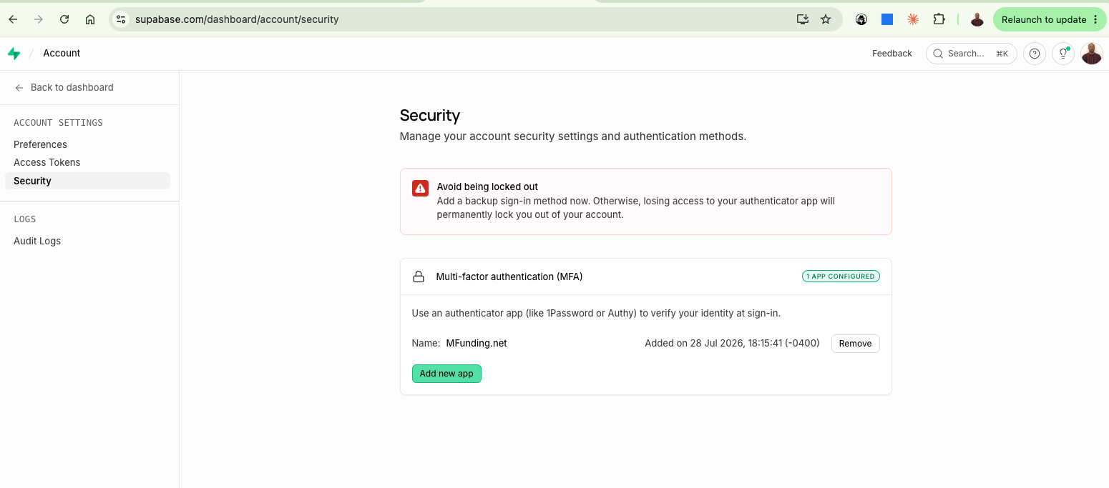
Supabase → Account → Security: "Multi-factor authentication (MFA) — 1 APP CONFIGURED", authenticator app "MFunding.net", added 28 Jul 2026 18:15 (UTC-4).
Administrative access to the supporting platforms in scope (GitHub — source control; Google Workspace — email/identity) is protected by authenticator-app two-step verification under the same policy requirement.

