## Access the Console in Oracle Analytics Server

Use the Console to manage user permissions, back up everyone's content to a snapshot, configure various aspects of Oracle Analytics Server, and perform other administrative tasks.

1. In the Home page, click the **Navigator** bar and click **Console**.

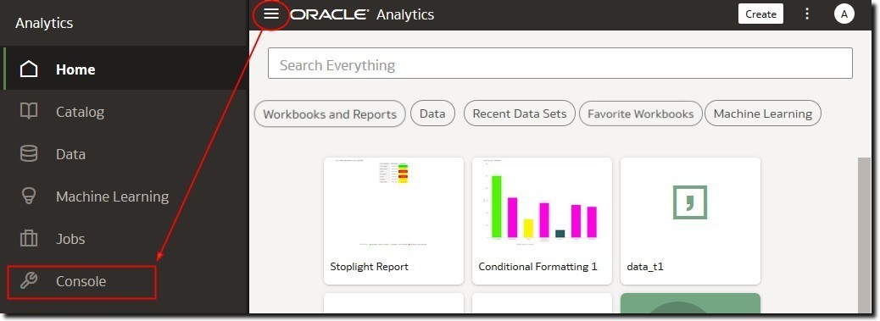

1. Under **Configuration and Administration**, click the option you want to configure.

You must have the **BI Service Administrator** role to configure Oracle Analytics.

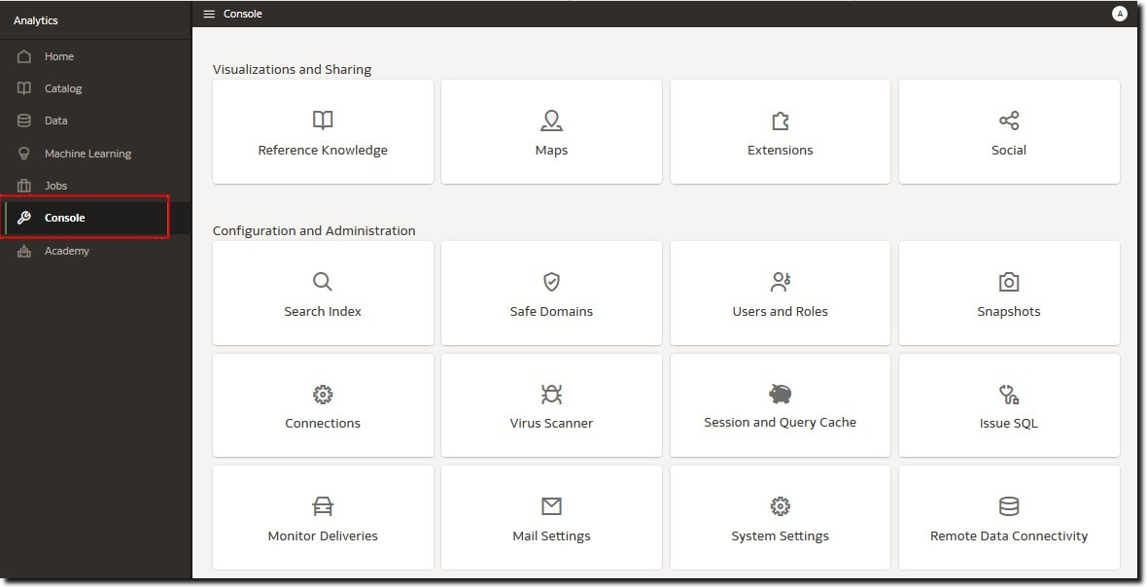

## Access the Classic Administration Page

Use the Classic Administration page if you're familiar with on-premises products that use a similar page.

1. In the Home page, click the **Page Menu** and select **Open Classic Home**.

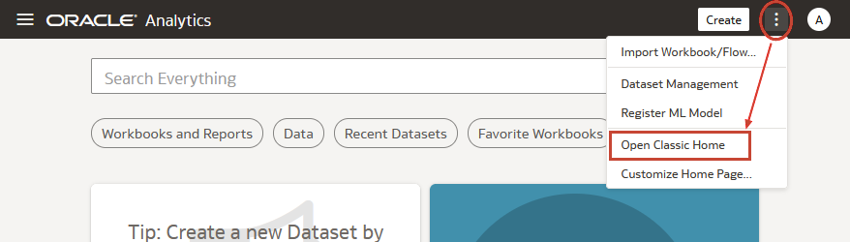

1. Click **My Profile**, and select **Administration**.

You must have the **BI Service Administrator** role to see the Administration menu.

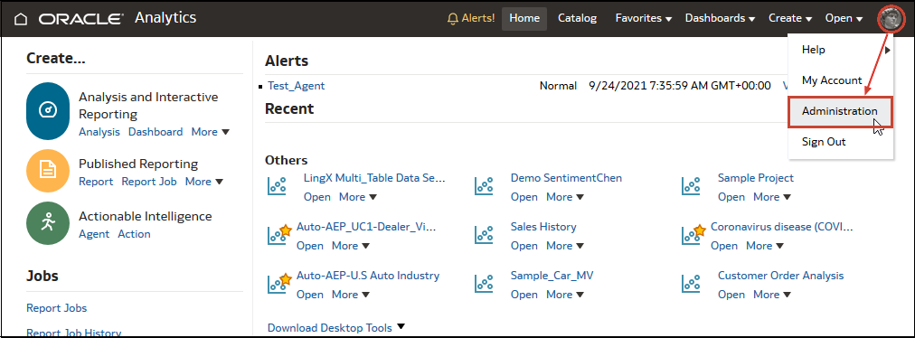

1. Click the link for the feature you want to configure.

## Download, Install, and Start the Client Tools for Oracle Analytics Server

Download, install, and start the Client Tools for Oracle Analytics Server to manage and develop your data models.

You install Client Tools on a Windows machine in your Oracle Analytics Server environment. The Client Tools software pack installs Administration Tool, Catalog Manager, and Job Manager.

1. Download the latest Client Tools.
   1. In a browser, go to the [Download page for Oracle Analytics Server](http://www.oracle.com/pls/topic/lookup?ctx=en/middleware/bi/analytics-server&id=oas_sw_download).
   2. Under **Oracle Analytics Client Tools**, click **Oracle Analytics Client Tools <version>**.
   3. Accept the Oracle license agreement, and click the download link to copy the ZIP file to your local machine.
2. Install Client Tools.
   1. From the downloaded ZIP file, extract the OAC-Client_<version>.exe file.
   2. In the local download area, execute the OAC-Client_<version>.exe file as administrator to start the installer.
   3. Follow the on-screen instructions.
3. To start the tools, from the Windows Start menu, click <*Windows Start menu name*>, click **Oracle Analytics Client Tools**, and then select one of the tools. For example, to start the Administration Tool, click **Model Administration Tool**.