## Manage System Components Using Fusion Middleware Control

You can use Fusion Middleware Control to manage, monitor, and configure system components (for example, the BI Server, Presentation Services, and Oracle BI Scheduler). You can also use Fusion Middleware Control to manage the Administration Server and Managed Servers.

This section contains the following topics:

* Log into Fusion Middleware Control
* Display Oracle Analytics Server Pages in Fusion Middleware Control
* Use the Navigation Tree in Fusion Middleware Control
* Tips for Using Fusion Middleware Control

### **Log into Fusion Middleware Control**

To log in to Fusion Middleware Control, open a web browser and enter the Fusion Middleware Control URL.

Enter the URL in the following format:

Copy

http://*hostname*.*domain*:*port*/em

The port number is the number of the Administration Server, and the default port number is 9500.

## Conditions to Start the System

The system starts with the Administration Server, then the Managed Servers, and then the system components.

If the computer that hosts the Administration Server isn't running or is rebooted, then you must ensure that the computer is running and you must start the system.

To start the system, the repository database (which contains Scheduler schemas) specified during installation must be running, and a network connection to it must be available. Otherwise, error messages are displayed.

Fusion Middleware Control is available only if the Administration Server is running, as described above.

1. Enter the URL in a web browser. For example:

Copy

http://host1.example.com:9500/em

1. Enter the system administrator user name and password and click **Sign in**.

This systemwide administration user name and password was specified during the installation process, and you can use it to log in to WebLogic Server Administration Console, Fusion Middleware Control, and Oracle Analytics Server.

Alternatively, enter any other user name and password that has been granted the Oracle BI Administrator application role. Fusion Middleware Control is displayed.

Note: If you have the browser configured to send HTTP requests to a proxy server, then you might have to configure the browser to not send Administration Server HTTP requests to the proxy server. If the Administration Server is on the same computer as the browser, then ensure that requests that are sent to localhost or 127.0.0.1 are not sent to the proxy server.

### **Display Oracle Analytics Server Pages in Fusion Middleware Control**

Use this topic to display Oracle Analytics Server pages that enable you to manage system components.

1. Log in to Fusion Middleware Control.
2. Expand the **Business Intelligence** folder and select the **biinstance** node.

Fusion Middleware Control displays the Overview page, as shown below.

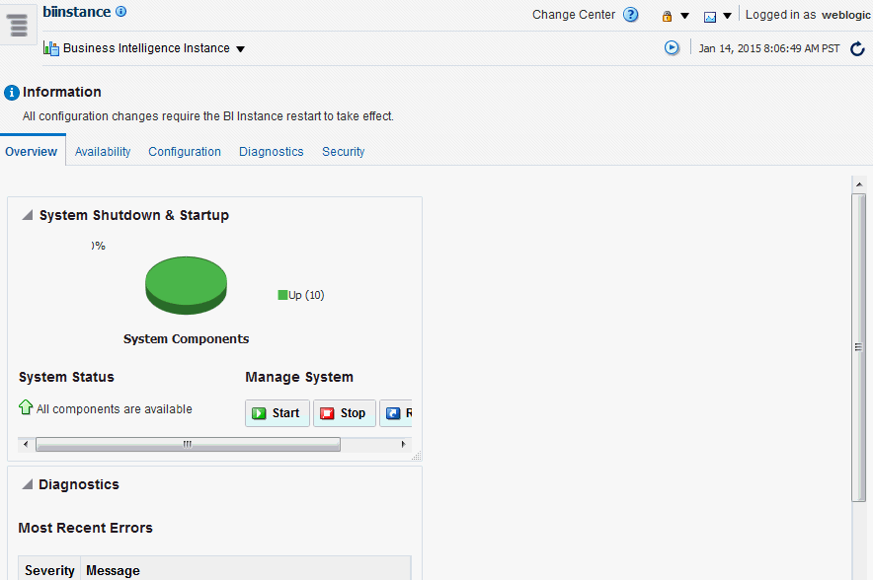  
[Description of the illustration emhome1.gif](https://docs.oracle.com/en/middleware/bi/analytics-server/administer-oas/img_text/emhome1.html)

Note:

If the Business Intelligence folder isn't visible or there is no **biinstance** node under it, then Oracle Analytics Server system components haven't been installed. See Installing and Configuring Oracle Analytics Server.

The Overview page displays the current system status, by providing information about availability, and issues identified within the BI domain. The Overview page also enables you to start and stop Oracle Analytics Server.

1. From the Overview page, select an appropriate tab to perform management tasks.

### **Use the Navigation Tree in Fusion Middleware Control**

The navigation tree enables you to navigate and select nodes within the BI domain that can be managed by Fusion Middleware Control.

Depending on the choices made during installation, the following domain components can be displayed as nodes in the navigation tree:

* **Application Deployments**

The Application Deployments node shows all the applications that are deployed into the BI domain (for example, analytics, Oracle Analytics Server for Microsoft Office, Oracle BI Publisher).

* **WebLogic Domain**

These nodes display summary information for the WebLogic server. Select a node and click the **Oracle WebLogic Server Administration Console** menu option to display the WebLogic Server Administration Console, where you can administer Oracle WebLogic Server.

* + **bidomain**

This node represents the WebLogic server domain for Oracle Analytics Server with an AdminServer node that contains the Administration Server and a bi_cluster node that contains Managed Servers (a single node cluster by default, for example, bi_server1)..

* + - **AdminServer**
    - **bi_cluster**
* **Business Intelligence**
  + **biinstance**

This node represents the Oracle Analytics Server system components that can be managed using Fusion Middleware Control.

Select this node to display the Overview page and manage the system components.

* **Metadata Repositories**

This node represents the Metadata Services (MDS) schema repositories that can be managed using Fusion Middleware Control.

## Use Fusion Middleware Control to Start and Stop System Component Processes

If the system processes are running, then you can start, stop, and restart the system component processes, using Fusion Middleware Control.

1. Go to the Overview page.
2. Display the Processes tab of the Availability page, then either click **Start All**, or **Stop All**, **Restart All** buttons for all processes, or select a process row and use the appropriate button to start, stop, or restart an individual process as appropriate, as shown in the following illustration.

You also use this page to view the status of system components.

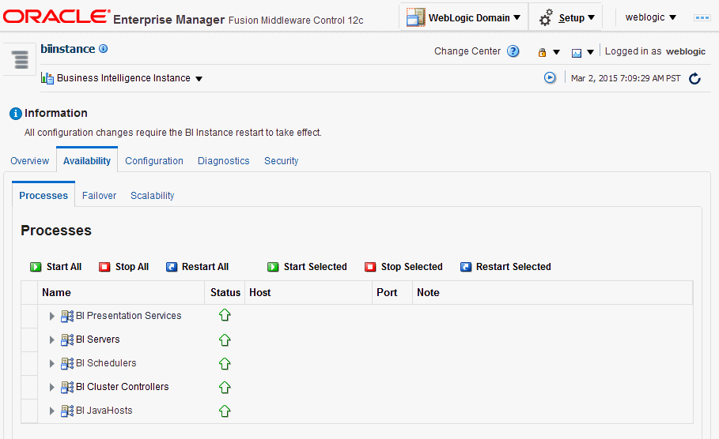

You can use other methods to start and stop processes:

* Use Commands to Start, Stop, and View Status of Processes
* Use Oracle WebLogic Server Administration Console to Start and Stop Java Components

## Use Fusion Middleware Control to Start and Stop Java Components

Use this topic to monitor status and start and stop Java components (Administration Server and Managed Servers) using Fusion Middleware Control.

You can also display the WebLogic Server Administration Console to manage Java components by choosing a menu option on the WebLogic Domain menu.

1. Log in to Fusion Middleware Control.
2. Expand the **WebLogic Domain** folder and select the bidomain node.

Fusion Middleware Control displays the WebLogic Domain home page, as shown in the following illustration.

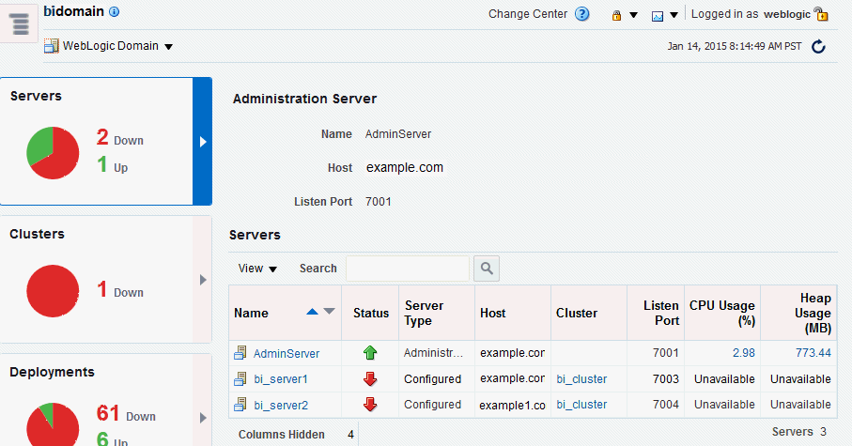

The WebLogic Domain home page is the starting point for monitoring status of servers, clusters, deployments, and partitions and for starting and stopping Java components using Fusion Middleware Control. You can also click a menu option to display the WebLogic Server Administration Console, where you can manage and configure Java components.

1. Using the WebLogic Domain home page, you can perform the following management tasks:
   * View the status of Administration Server (AdminServer) and Managed Servers (for example, bi_server1).
   * Start and stop selected Java components (for example, AdminServer or bi_server1) using the WebLogic Domain menu **Control** option.
   * Manage or configure the WebLogic server domain using the WebLogic Server Administration Console by clicking a link on the WebLogic Domain menu.

## Use Oracle WebLogic Server Administration Console to Start and Stop Java Components

In the event that you can't use the standard methods to start and stop Java components, you can use the Oracle WebLogic Server Administration Console.

Don't use Oracle WebLogic Server Administration Console to start and stop Java components. You can use Fusion Middleware Control to start and stop Java components.

1. Start the Oracle WebLogic Server Administration Console.
2. In the Domain Structure region, click **Deployments**.
3. The Oracle WebLogic Server Administration Console displays the Summary of Deployments page.
4. Display the Control tab.
5. Select a check box for each component to start or stop.
6. Click **Start** or **Stop** to start or stop the selected components, as shown here:

