Manage Content

Administrators can manage Oracle Analytics content from the Console. For example, if an employee leaves an organization, you might assign ownership of their workbooks and machine learning models to a different employee.

**Topics**

* Overview of Content Management
* Change Ownership of Content
* Change Ownership of Content in a User's Private Folder
* Frequently Asked Questions About Content Management

Overview of Content Management

Oracle Analytics enables you to view and manage Oracle Analytics content. For example, if an employee leaves an organization, you can reassign their workbooks and machine learning models to a different employee.

As an administrator, you can use the Content Management page to view, manage, and change ownership for all content types.  
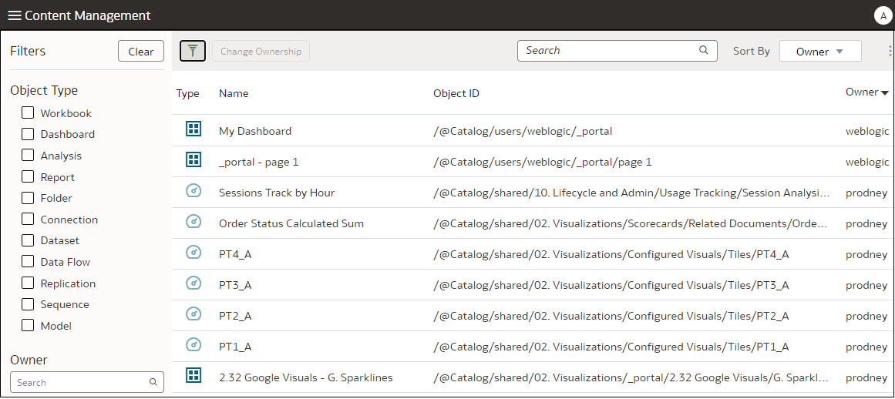

You can also display the Classic Catalog folder where the item is stored using the **Open in Classic Catalog** option. Hover over over the item, click the **Actions menu** Click to display the Actions menu for the itemat the far right-hand side, and click **Open in Classic Catalog**. **Note**: You need to own the item to see the **Open in Classic Catalog** option.

**About Content Ownership**

As an administrator, you can change ownership to:

* Yourself, as administrator.
* A different user.
* Every user with a specific application role (some restrictions apply.

If you own content, you have these privileges:

* If you own an object with an Object ID prefixed with /@Catalog/, you can review the properties of that object and change permissions even if you have no other permissions on it.
* If you own an object with an Object ID prefixed with /@default/, you always have full permissions on that object.
* Some types of object, such as data flows, can only be used by the owner of the object. Therefore, changing ownership using the Content Management page is the only way to allow another user to use a data flow.

Change Ownership of Content

Change the ownership of Oracle Analytics content from the Console. For example, if an employee leaves your organization, you can reassign their workbooks and machine learning models to a different employee.

To change ownership of content in a user's private folder.

1. In the Oracle Analytics Home page, click the **Navigator**, and then click **Console**.
2. Click **Content** to display the Content Management page.



1. Locate the items whose ownership you'd like to reassign:
   * To locate all objects belonging to a user, click **Filters**, then enter the user's username in the **Owner** field. You can further refine the selection using the **Object Type** options.
   * Use the **Object Type** options to restrict the list to specific types (click **Filters** to display).
   * Use the **Search** box to locate text in the **Name** field. For example, enter 'cluster' to display objects with cluster in the name.
2. Select one or more items to reassign.

To select multiple items, you can use the object check boxes or use function keys (for example, Ctrl + click, or Shift + click).

1. Click **Change Ownership** to display the Change Ownership dialog.

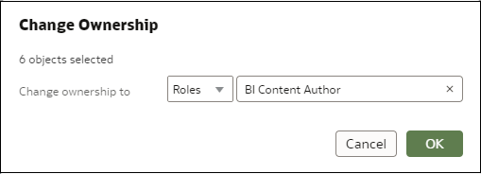

1. Specify a new owner (or owners) for the objects.

Depending on the object, you can assign ownership to yourself, another user, or a role:

* + If you select an object with an object ID that starts with /@default/, you can assign it to another user.
  + If you select an object with an object ID that starts with /@Catalog/, you can assign it to another user or to an application role.
  + If you want to assign multiple objects to an application role, make sure you select only objects with object IDs starting with /@Catalog/.

1. Click **OK**.

Oracle Analytics reassigns ownership for the selected objects. If you're updating a large number of objects, this process might take a few minutes.

Change Ownership of Content in a User's Private Folder

You can transfer ownership of content that users save in private folders. For example, if an employee leaves your organization, you might move their private workbooks and machine learning models from the \User Folders\<*User*>\ folder to a different folder so that other users can edit and deploy them.

1. In Console, change the ownership of the private objects to the administrator:
   1. In the Oracle Analytics Home page, click the **Navigator**, and then click **Console**.
   2. Click **Content** to display the Content Management page.



* 1. Click **Filters**, and then enter the name of the user in the **Owner** field.

You see all content owned by that user. Private objects are prefixed with /@Catalog/users/<*username*>/ in the **Object ID**). For example, private content owned by someone with the username "john.smith" is prefixed with /@Catalog/users/john.smith/.

* 1. Select one or more private objects owned by the user.
  2. Click **Change Ownership** to display the Change Ownership dialog.
  3. Under **Change ownership to**, click **Users**, and enter your username or Admin, then click **OK**.

1. In the Catalog, change the permissions for the private objects and move them to a new folder:
   1. Click **Navigator**, then click **Home**, and from the **Page Menu** select **Open Classic Home**.
   2. Click **Catalog**, then click **Admin View** in the top left-hand corner.
   3. Under **User Folders**, click **My Folders**, then select the user's private folder.
   4. In the **Tasks** panel, click **Permissions**, and assign control of the folder and its contents to the a different user.

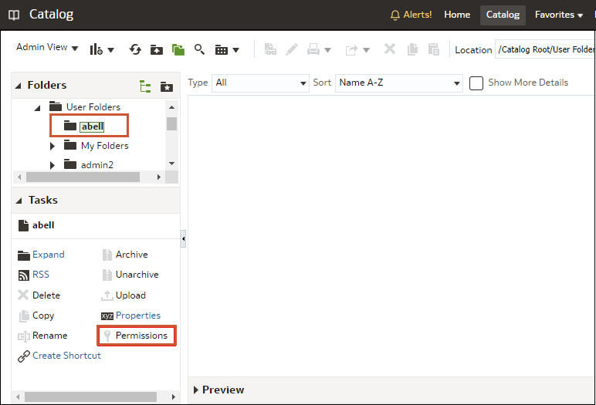

* 1. Move the content from the user's private folder to a different folder that other users can access.

In the source folder, select the objects you want to move, then click **Copy**. Then, in the target folder, click **Paste**.

For example, you might move workbooks and machine learning models from the \User Folders\USER1\ to \User Folders\USER2\, or to a shared folder that multiple users can access.

Frequently Asked Questions About Content Management

Find the answers to common questions about content management in Oracle Analytics.

**What restrictions apply when reassigning ownership to roles?**

* You can assign objects with an object ID prefixed with /@Catalog/ to users or roles.
* You can assign objects with an object ID prefixed with /@default/ to users only.

If you want to reassign multiple items to a role, then first deselect items with an object ID prefixed with /@default/).

To see how object IDs are prefixed, look at the **Object ID** column on the content management page.  
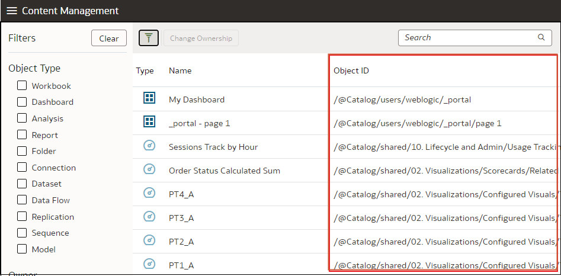

**What does @default prefix or @Catalog prefix mean in an object ID?**

A @Catalog prefix indicates a workbook, connection, dataset, data flow, replication, sequence, or model. A @default prefix indicates an analysis, dashboard, report, or folder.