## Analyze Your Data in Oracle Analytics

Before You Begin

This lab shows you how to analyze data from a file source dataset and curated dataset.

What Do You Need?

* Access to Oracle Analytics Cloud or Oracle Analytics Desktop
* Access to the **donation** and **Donations by School** Datasets

Create Analyses with the Donation Dataset

This section uses the donation dataset that you added in the *Explore Data Flows* tutorial.

1. Sign in to Oracle Analytics.
2. On the Home page, click **Create**, and then select **Workbook**.
3. In Add Data, click **donation**, and then click **Add to Workbook**.
4. In the Auto Insights panel, click **X** to close the panel.
5. In the Data panel, expand **DATE_COMPLETED**, hold down the **Ctrl** key, select **Year** and **TOTAL_DONATIONS**, and then drag them to the canvas.

The line view shows that 2013 had the largest number of donations.

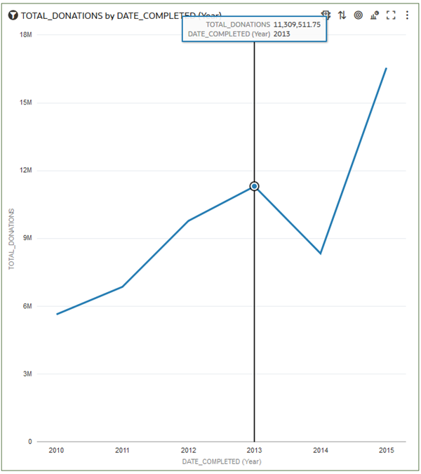

1. In the Data panel, hold down the **Ctrl** key, and then select **SCH_CITY**, **TOTAL_DONATIONS**, and **NUM_DONORS**. Right-click and select **Create Best Visualization**.

A scatter view is added to the canvas that shows the total number of donors and total donations by city.

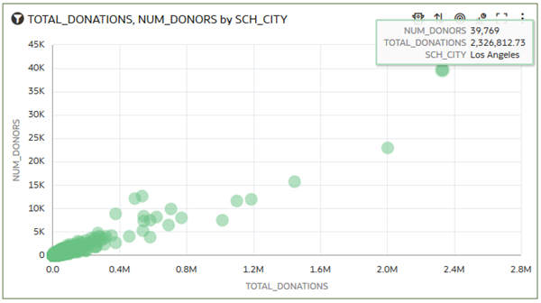

1. In the Data panel, select **SCHOOL_ID** and drag it to **Category (Points)** to replace SCH_CITY.

The scatter view shows that 480 donors gave more than $76,000 in donations to the selected school.

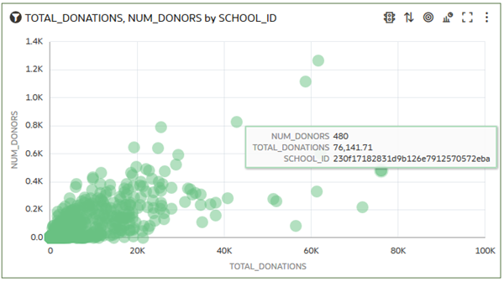

1. Click **Save**. In Save Workbook, enter Donation Analyses, and then click **Save**.
2. Click **Go Back** Back icon to return to the Home page.

Create Visualizations with the Curated Dataset

In this section, you use the curated Donations by School dataset to gain insights.

You can see the donations patterns related to grade-level and poverty in the grid heat map views.

1. On the Home page, click the **Data** search tag, enter Donations by School, and then click **Search**.
2. In Donations by School, click **Actions menu** Action Menu icon, and then select **Create Workbook**.
3. In the Data panel, hold down the **Ctrl** key, select **POVERTY_LEVEL**, **GRADE_LEVEL**, and **Donation by Population**, and then right-click and select **Create Best Visualization**.

The bar visualization shows the grades 3 through 5 levels as different colors.

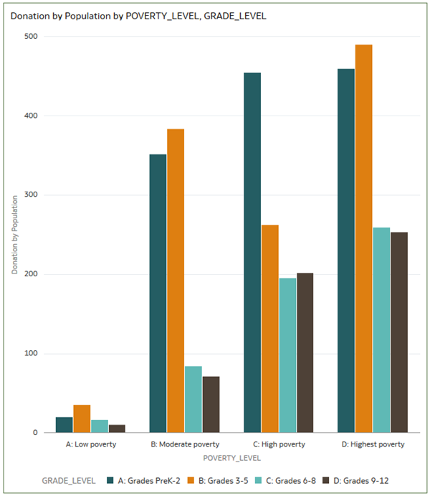

1. In the Data panel, select **Average School Donation by Income**, and drag it to **Values (Y-axis)** to replace Donation by Population.

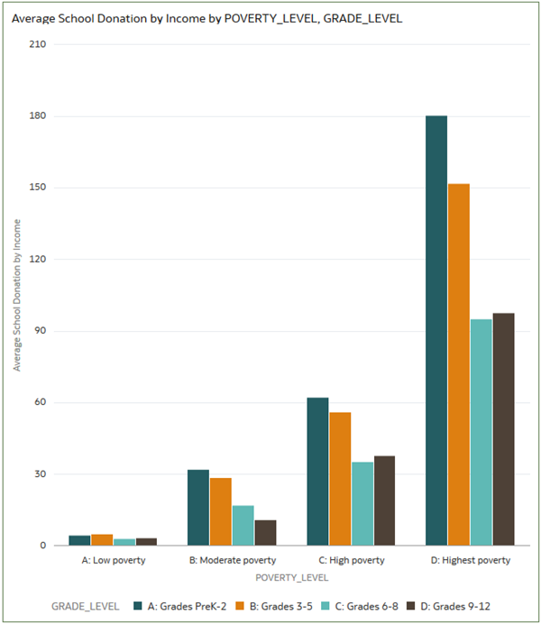

1. In the Data panel, select **TOTAL_DONATIONS**, and drag it to **Values (Y-axis)** to replace Average School Donation by Income.

