## Assign a Map Layer to a Data Column in Oracle Analytics

Before You Begin

This lab shows you how to add a map layer to the Console, and then assign a map layer to a data column in a dataset.

Background

You can add a custom map layer using a geographic data file with the .json extension that conforms to GeoJSON format. You use the custom map layer to view geometric map data in a workbook map visualization. When adding the map layer, you select layer keys that correspond with your data. The layer keys are property attributes for map features in the original JSON file.

You can assign a map layer to a column containing text or numeric attributes. When you select a data column with a map layer assignment for a visualization, Oracle Analytics automatically creates a map visualization.

What Do You Need?

* Access to one of the following:
  + Oracle Analytics Cloud
  + Oracle Analytics Desktop
* Download the following to your computer:
  + airport_data.xlsx
  + world_airports.json

Add a Map Layer

1. Sign in to Oracle Analytics.
2. On the Home page, click **Navigator** Navigator icon, and then click **Console**. In the Console, click **Maps**.
3. On the Map Layers page, click **Add Custom Layer** Add Custome Layer icon. In File Upload, select the world_airports.json file, and then click **Open**.
4. In Map Layer, under the Layer Keys section, select **name**, and then click **Add**.
5. In the Maps page, click **Go back** Go back icon. In the Console page, click **Navigator** Navigotor icon, and then click **Home**.

Assign a Map Layer to a Data Column

1. On the Home page, click **Create**, and then select **Dataset**.
2. In Create Dataset, click **Drop data file here or click to browse**.
3. In File Upload, select airport_data.xlsx, and then click **Open**.
4. In Create Dataset Table from airport_data.xlsx, click **OK**.
5. Click the **airport_data** tab.
6. In the airport_data page, click the **Airport Name** column, select **Options** Options menu icon, and then select **Location Details**.

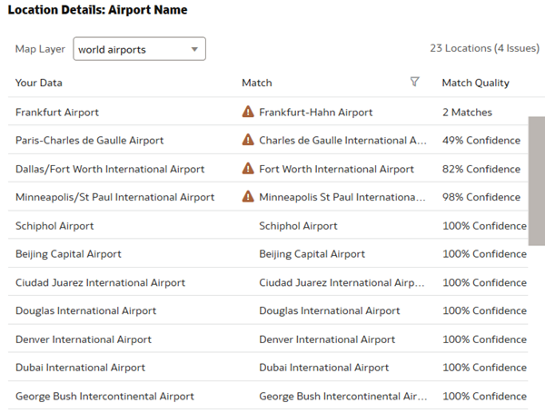

1. If not selected, from the Map Layer list, select **world airports**, and then click **OK**.
2. Click **Save** Save icon. In Save Dataset As, enter Airport Data in **Name**, and then click **OK**.

Visualize the Data

1. Click **Create Workbook**. Click **Apply Changes**.
2. In the Visualize page, select **Airport Name**, and drag it to the canvas.

Oracle Analytics automatically creates a map with the data points representing airports.

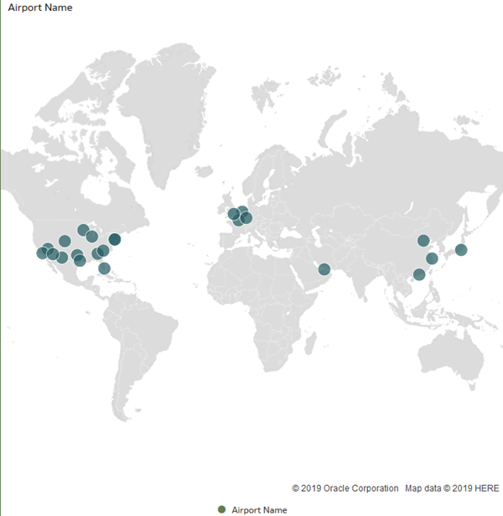

1. In the Data pane, select **Traffic Movement**, and drag it to **Color** in the Grammar panel.

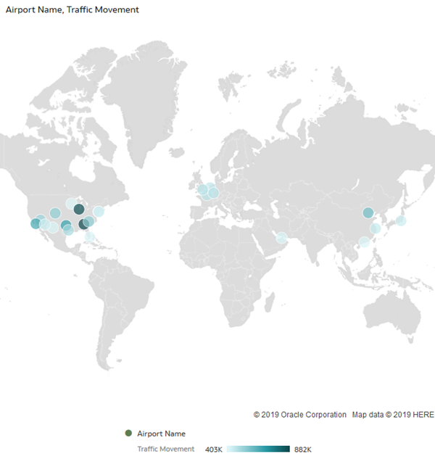

1. In the Data pane, select **Passengers**, and drag it to the visualization.

