## Create Aggregated Datasets in Oracle Analytics

Before You Begin

This lab shows you how to output multiple datasets from a data flow, add columns, and execute a data flow sequence. You also use the datasets output from executing the sequence to create analyses to verify that your results.

Background

In a data flow, you can add a branch to any node, except the train machine learning model node, to output multiple datasets from a single data flow. You can apply different transformations on each branch to create unique datasets.

In this tutorial, you create a sequence to execute multiple data flows using a specific order in a transaction.

You also create visualizations to verify your results.

What Do You Need?

* Access to Oracle Analytics
* Access to the Donations by School dataset

Create Multiple Datasets

In this section, you create a data flow that has a branch step so that when the data flow is executed, you have two distinct datasets.

1. Sign in to Oracle Analytics.
2. On the Home page, click **Create**, and then click **Data Flow**.
3. In Add Dataset, click **Donations by School**, and then click **Add**.
4. In Data Flow Steps, double-click **Branch**.

The Branch step adds two Save Data steps to the data flow.

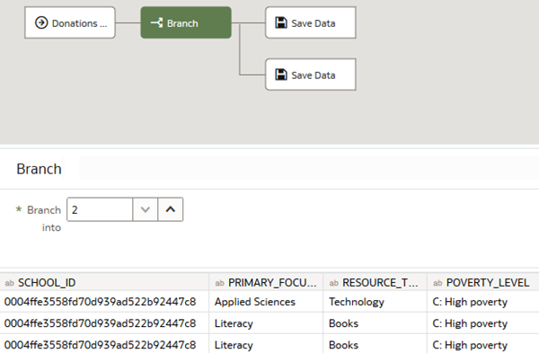 Click **Add a step** Add a step icon on the branch before the first Save Data step, and then select **Select Columns**. In Select Columns, click **Remove all**.

1. Hold down the **Ctrl** key, and select the following:
   * **PRIMARY_FOCUS_SUBJECT**
   * **Donation by Population**
   * **Average School Donation by Income**
2. Click **Add a step** Add a step icon between Select Columns and Save Data, and then click **Aggregate**. In Aggregate, select **Average** under Function in both rows.
3. Click **Save Data** on the first branch. In Save Dataset, enter Donations by Primary Subject Area in **Name**. In Save data to, select **Dataset Storage** to save the data in Oracle Analytics.

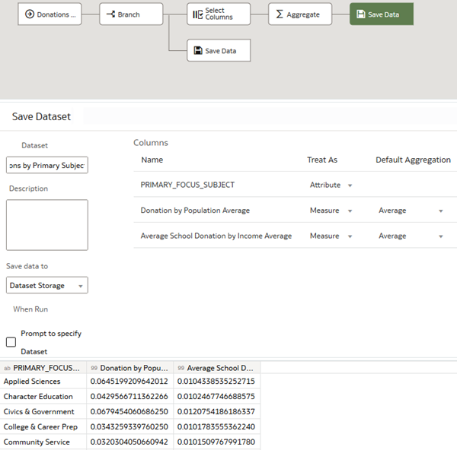

Define the Second Branch

1. In the data flow, select the Add a step node on the second branch, and then click **Select Columns**. In Select Columns, click **Remove all**.
2. Hold down the **Ctrl** key, and select the following:
   * **SCH_STATE**
   * **Donation by Population**
   * **Average School Donation by Income**
3. Click **Add a step** Add a step icon on the Select Columns node, and select **Aggregate**. In Aggregate, select **Average** from Function in both rows.

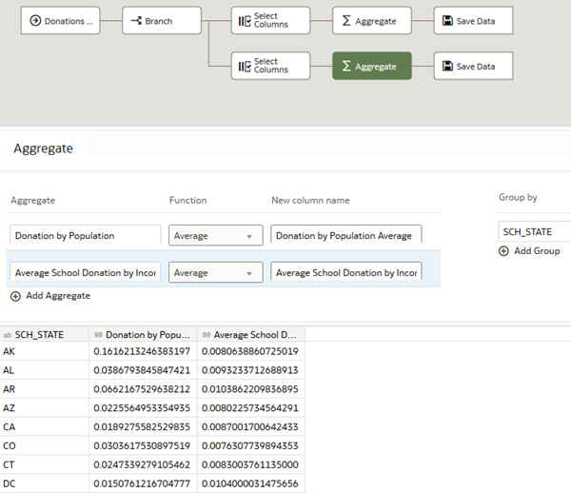

1. Click **Save Data** on the second branch. In Save Dataset, enter Donations by State in **Name**. In Save data to, select **Dataset Storage**.
2. Click **Save** Save icon. Click **Run Data Flow**. After the data flow completed message appears, click **Go back** Back icon.

Inspect the Datasets

1. On the Home page, search for the **Donations by Primary Subject Area** dataset. Select the **Donations by Primary Subject Area** dataset, click the **Actions menu** Actions menu icon, and then select **Inspect**.
2. In the Donations by Primary Subject Area dataset, click **Data Elements** to view the columns, and then click **Close**.
3. On the Home page, search for or select the **Donations by State** dataset. Select the **Donations by State** dataset, click the **Actions menu** Actions Menu icon, and then select **Inspect**.
4. In the Donations by State dataset, click **Data Elements** to view the columns, and then click **Close**.

Create a Data Flow Execution Sequence

When you use dynamic data sources the data flows in the sequence, you can create a schedule to run the sequence.

1. On the Home page, click **Create**, and then click **Sequence**.
2. In the Data Flows panel, drag **Donations by School** to Selections.
3. Right-click **Aggregate Donations**, and then select **Add Data Flow**.

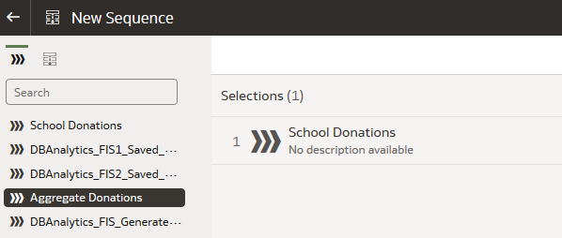

1. Click **Save** Save icon. In Save Sequence As, enter Donations Sequence in **Name**, and then click **OK**. Click **Execute Sequence** Execute Sequence icon.
2. Click **Go back** Back icon. On the Home page, enter Donations and click **Search** to view Donations Sequence and its output.

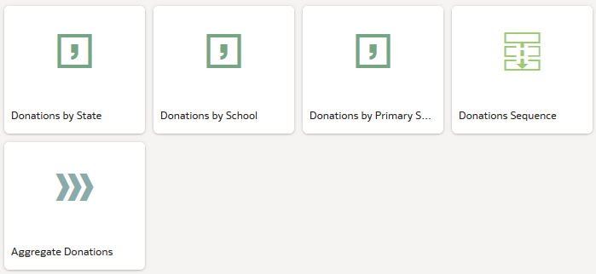

Create Visualizations

1. On the Home page, select **Donations by Primary Subject Area** dataset, click the **Actions menu** Actions Menu icon, and then select **Create Workbook**.
2. In the Data Elements pane, hold down the **Ctrl** key, and then select the following:
   * **PRIMARY_FOCUS_SUBJECT**
   * **Donation by Population Average**
   * **Average School Donation by Income Average**
3. Drag the data elements to the canvas.

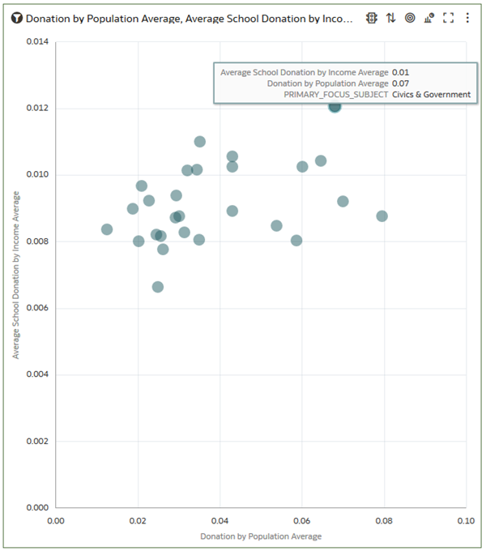

1. Click **Go back** Back icon.
2. On the Home page, select the **Donations by State** dataset, click the **Actions menu** Actions Menu icon, and then select **Create Workbook**.
3. In the Data Elements pane, hold down the **Ctrl** key, and then select the following:
   * **SCH_STATE**
   * **Donation by Population Average**
   * **Average School Donation by Income Average**
4. Drag the data elements to the canvas.

