## Create Your First Visualization with Data from Oracle Autonomous Data Warehouse

Before you Begin

This lab shows you how to use a connection to an Oracle Autonomous Data Warehouse to create a multiple table dataset and visualizations.

Background

This tutorial uses a connection to Oracle Autonomous Data Warehouse from Oracle Analytics. You create a dataset using the sample SH schema in Oracle Autonomous Data Warehouse, and then you create visualizations to analyze the sales history data of an electronics store.

What Do You Need?

* Access to Oracle Analytics
* Access to Oracle Autonomous Data Warehouse SH schema

Create an Oracle Autonomous Data Warehouse Dataset

This section shows you how to create a dataset from a connection to Oracle Autonomous Data Warehouse. The sample SH schema uses well-defined relationships so that you can create the dataset with the Auto Join Tables option enabled.

1. Sign in to Oracle Analytics.
2. On the Home page, click **Create**, and then click **Dataset**.
3. In Create Dataset, click your Oracle Autonomous Data Warehouse connection.
4. In the Connections panel, expand the **SH** schema.
5. Hold down the **Ctrl** key, click the **CUSTOMERS**, **SALES**, **PRODUCTS**, **COUNTRIES** and **TIMES** tables, and then drag and drop them on the Join Diagram.
6. Click **Save**. In Save Dataset As, enter Sales_History, and then click **OK**.

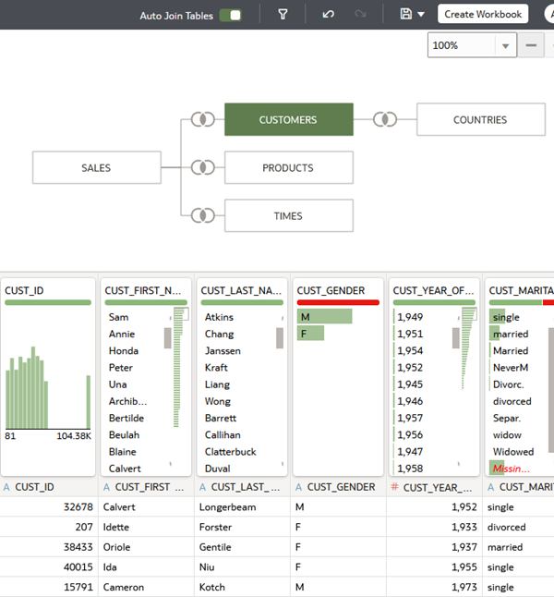

Create Your First Visualization

1. Click **Create Workbook**.
2. In the Data pane, expand the folders to show the data elements.

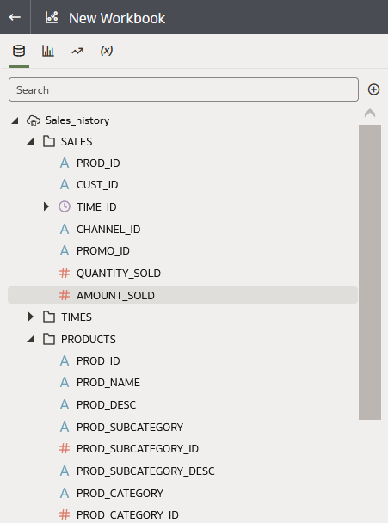

1. Hold down the **Ctrl** key, and select the following data elements:
   * **PROD_NAME** and **PROD_CATEGORY** from the PRODUCTS folder
   * **AMOUNT_SOLD** and **QUANTITY_SOLD** from the SALES folder
   * **Year** from the TIME_ID folder under the TIMES folder
2. Right-click, select **Pick Visualization**, and then select **Scatter**. In Category (Points), select **TIME_ID (Year)** and move it to Color to switch places with **PROD_NAME**.

Oracle Analytics automatically creates a legend for the visualization.

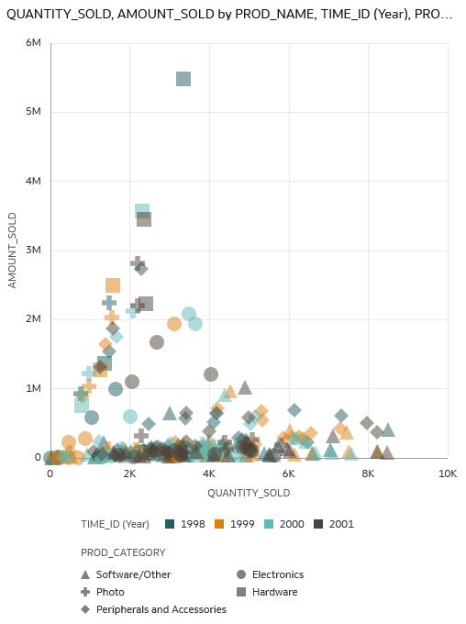

1. Click **Properties** Properties pane icon, click **Auto** in the Title row, select **Custom**, and then enter Sales Summary.
2. Click **Save**. In Save Workbook, enter Sales History WBK in **Name**, and then click **Save**.

Create a Visualization to Sales for Each Month

In this section you create a visualization that answers the question, "What are my monthly sales by dollar and quantity sold?"

1. In the Data pane, hold down the **Ctrl** key, and select the following:
   * **AMOUNT_SOLD**
   * **QUANTITY_SOLD**
   * **Month**
2. Drag the data elements next to the existing visualization, and release when a thick green line appears in the canvas.

Oracle Analytics automatically creates a Stacked Area visualization.

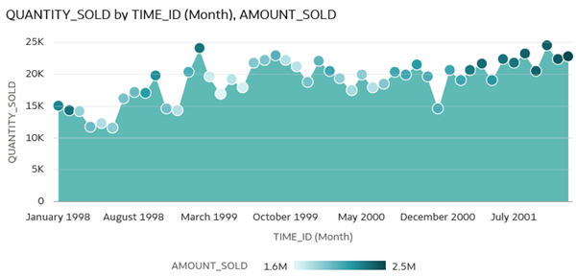

1. Click **Visualization Type** Visualization Type icon, and select **Combo** Combo visualization icon.
2. In the Grammar panel, right-click **QUANTITY_SOLD**, and select **Bar** and **Y-Axis**.
3. Click **Properties** Properties icon. In the General tab, click **Auto** in the Title row, click **Custom**, and then enter Sales by Month.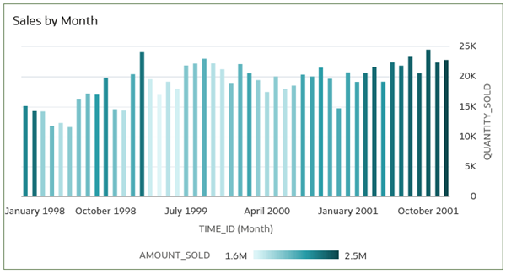
4. In the Sales by Month visualization, click **Menu** Menu icon, select **Add Statistics**, and then click **Add Trend Line**. Click **Save**.