## Create Landing Pages in Oracle Analytics

Before you Begin

This lab shows you how to create a dashboard landing page in Oracle Analytics Cloud. Landing pages are also called start page, default page, default dashboard page, and home page.

Background

You can use a landing page to organize content into sections for your specific enterprise communities. For example, you can create different sections for departments in your organization such as Sales, Human Resources, and Accounts Receivable.

You can create secondary landing pages that enable navigation from the Home (landing) page sections. To control access, assign sections to users based on groups and roles.

What Do You Need?

* Access to Oracle Analytics Cloud
* Download the products.png to use as the company logo
* Access to images, 50K or less, to use in the landing page sections, or download the placeholder_icon.png

Enable HTML Content

Administrator privileges are required to configure the **Allow HTML Content** system setting. This security option in system configuration settings enables using HTML markup.

1. Sign in to Oracle Analytics Cloud using Administrator credentials.
2. On the Home page, click **Navigator** Navigator icon, and then click **Console**.
3. On the Console page, click **System Settings**.
4. In System Settings, click Security. In the Allow HTML/JavaScript/CSS Content row, click the slider to enable the configuration.
5. Click **Restart** located at the top of the page. In Restart, click **OK** to restart the OBI Presentation Server. Wait for the message indicating that the Restart is complete, and then close the Systems Settings page.
6. In the Console, click the Navigator Navigator icon, and then click **Home**.

Create a Folder for Your Landing Pages

1. On the Home page, click the **Page Menu** Page Menu icon , and then select **Open Classic Home**.
2. On the Classic Home page, click **Catalog**. On the Catalog page under the Folders pane, select the **Shared Folders**. Click **New** New menu icon, and select **Folder** New Folder icon.
3. In New Folder, enter Landing Pages in **Name**, and then click **OK**.

Create a Dashboard Page

In this section, you create a header for the page that includes the company name, logo, and marketing slogan.

If the **Contains HTML Markup** check box is not available in Column Properties, you need to complete the steps in Section 1 of this tutorial. Save your work so that you can continue creating your Home page from where you stopped.

1. Expand Shared Folders, select the **Landing Pages** folder, click **New**, and then select **Dashboard**.
2. In New Dashboard, enter Home in **Name**. Review the **Location** field to verify that you are saving the dashboard in the Landing Pages folder (/Shared Folders/Landing Pages/Dashboards).
3. From **Content**, click **Add content later (create empty dashboard)**, and then click **OK**.

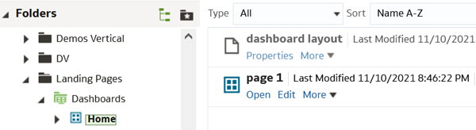

1. Click **Dashboards** Dashboard icon. Under the Home page, click **Edit**.
2. From Dashboard Objects, drag a **Column** Column icon, and release it inside the dashboard page.
3. From Dashboard Objects, drag a **Section** Section icon, and release it inside the column. Drag another **Section** and release it inside the column.
4. In each section, click **Properties** Properties icon, and then select **Collapsible** to remove the check.
5. In each section, click **Properties** Properties icon, and then select **Format Section**. In Section Properties, select **Center** from the **Horizontal Alignment** and **Vertical Alignment** lists. Select **None** from the **Position** list under the Border area, and then click **OK**.
6. From Dashboard Objects, drag the **Text** Text icon object and release it in Section 1. In the Text object, click **Properties** Object Properties icon. In Text Properties, click the **Contains HTML/JavaScript/CSS Markup** check box. In the **Text** field, enter the following:

Copy

<font face=’Arial’ size=20 color=’#000094′> <b>Vision Corporation</b></font><br><b>Making Tomorrow Today</b>

1. In Text Properties, click **Preview** to see the HTML formatting, and then click **OK**.
2. From Dashboard Objects, drag **Link or Image**Link and Image icon, and release it inside of Section 2.
3. In the Link or Image object, click **Properties** Object Properties icon. In **Caption**, enter Artificial Intelligence, Robotics, Drones, Smart Devices, and more. Click **Select Image**. In Select Image, click **Upload Image**. Navigate to the location where you downloaded the products.png, and then select it. From the **Position** list, select **Above caption**, and then click **OK**.

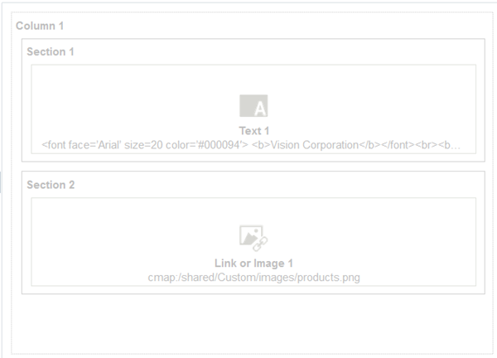

1. Click **Preview** Preview icon to see the dashboard page layout. After reviewing the Preview, close **Preview**, and then click **Save**.

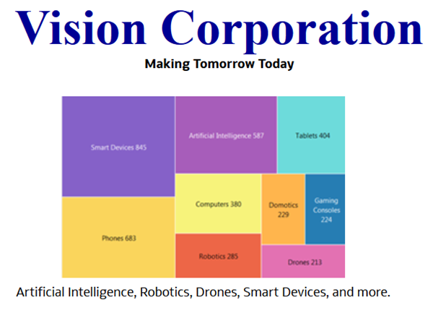

Format Column and Section Layout

In this section, you design the layout for the page's content. This layout uses three vertical columns that contain sections for the content.

1. From Dashboard Objects, drag a **Column** Column icon and release it under the first column when a thick blue line appears. Drag two more **Columns** to the page, and release the column when a thick blue line appears to the right of the previous column.
2. In each column, click **Properties** Properties icon, and then select **Column Properties**.
3. In Column Properties, in the **Horizontal Alignment** and **Vertical Alignment**lists, select **Center**. Under Border, select **None** from the **Position** list. Expand **Additional Formatting Options**, select **Specific Size**, and then enter 33% in **Width**. Click **OK**.
4. From Dashboard Objects, drag a **Section** Section icon, and release the section in columns 2, 3, and 4.

You can add more sections to each column as needed for the groups in your organization that access Oracle Analytics.

1. In each section, click **Properties** Properties icon, and then select **Collapsible** to remove the check.
2. In each section, click **Format Section**. In Section Properties, select **Center** from the **Horizontal Alignment** and **Vertical Alignment** lists. Under Border, select **None** from the **Position** list, and then click **OK**.

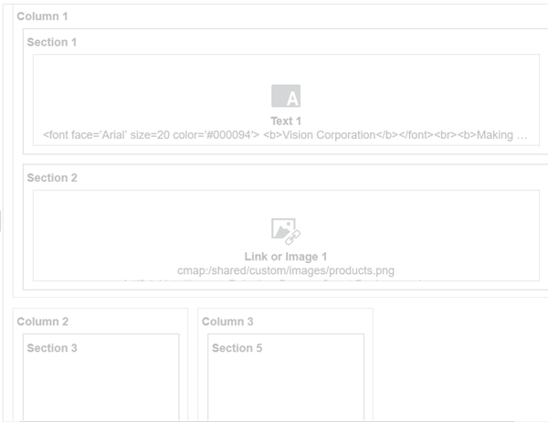

1. Click **Save** Save icon.

Add Images or Icons

In this section, you use a placeholder for your images or icons that represent the access for different groups or user roles in your organization inside the column sections. Use sections in columns to hold the specific dashboard object type to meet your needs. Users click the icons to access subsequent pages and analyses.

1. From Dashboard Objects, drag a **Link or Image** Link or Image icon object and release it in sections within columns 2, 3, and 4.
2. Click **Properties** Object Properties icon in the Link or Image dashboard object inside of each section. Click **Select Image**. In **Caption**, enter a caption for the image such as Human Resources, Sales, or Accounts Receivable.
3. Click **Upload Image**. Navigate to the location where you downloaded the placeholder_icon.png, and then select it. From the **Position** list, select **Above caption**, and then click **OK**.

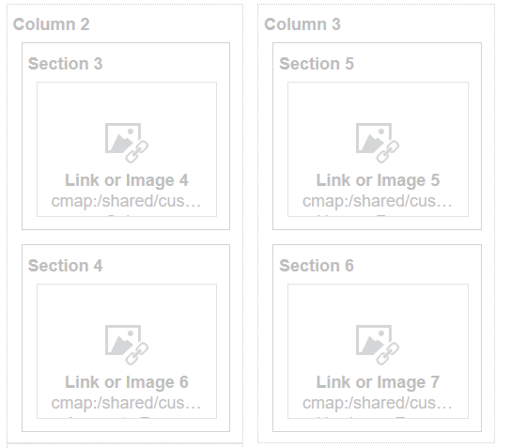

1. Click **Preview** to verify that the layout is correct.

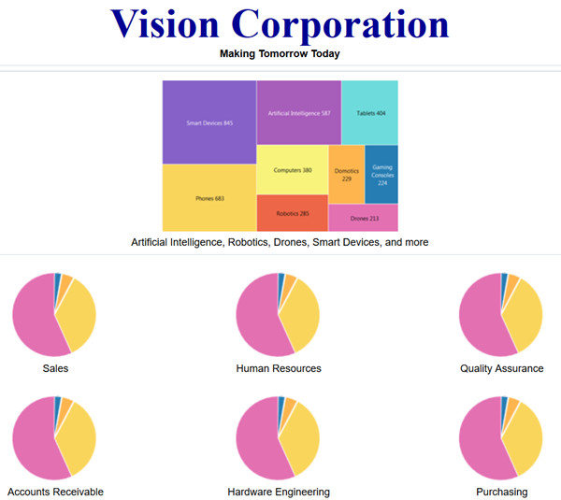

Set Landing Page as Your Home Page

Encourage your users to set your new Home landing page as their starting page.

1. Click menu Menu icon next to **Signed In As <user ID>**, and select **My Account**.
2. In the My Account page, on the Preference tab, select **Landing Pages: Home** from the **Starting Page** list, and then click **OK**.