## Capture Insights in Oracle Analytics

Before You Begin

This lab shows how to create insights from data visualizations in Oracle Analytics.

Background

While developing data visualizations, you can capture memorable information in an insight. An insight is a snapshot of any information that you determine is pertinent in a visualization. You can change and refine insights as needed and share your insights with others. You share insights in the form of a story.

This is the first lab in the series *Capture Insights and Build Stories*. Complete the lab in the order listed.

* Capture Insights
* Build Stories

What Do You Need?

* Access to Oracle Analytics
* Download customer_sales.csv to your computer

Create a Dataset and Project

In this section, you add a customer_sales spreadsheet as the dataset to use in this tutorial.

1. Sign in to Oracle Analytics.
2. On the Home page, click **Create**, and then select **Dataset**.
3. In Create Dataset, click **Drop data file here or click to browse**. In File Upload, select the customer_sales.csv file, and then click **Open**.
4. In Create Dataset Table from customer_sales.csv, click **OK**.
5. Click **Save**. In Save Dataset As, enter customer_sales, and then click **OK**.

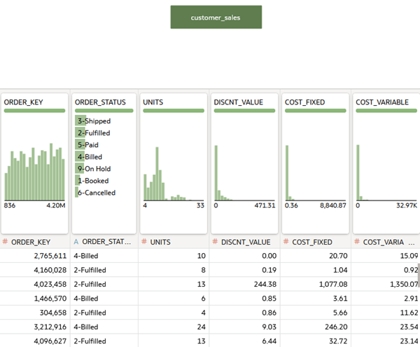

Create Visualizations

In this section, you create visualizations to gain insights about the revenue data.

1. Click **Create Workbook**.
2. Review the automatically generated insights, and then close the Auto Insights panel.
3. In the Data panel, hold down the **Ctrl** key, select **CUST_SEGMENT** and **REVENUE**, and then drag them to the canvas.

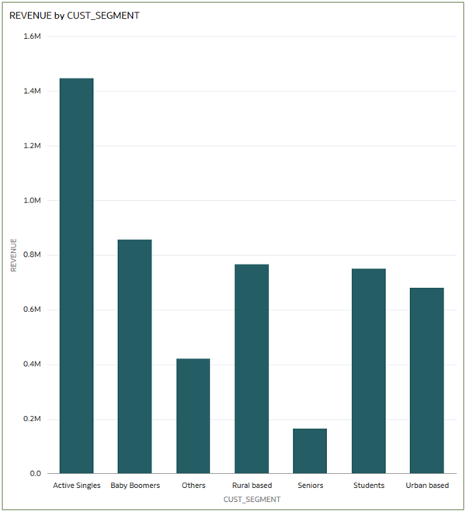

1. In the Grammar panel, select **Donut** Donut view icon from the visualization type menu Visualization menu icon.

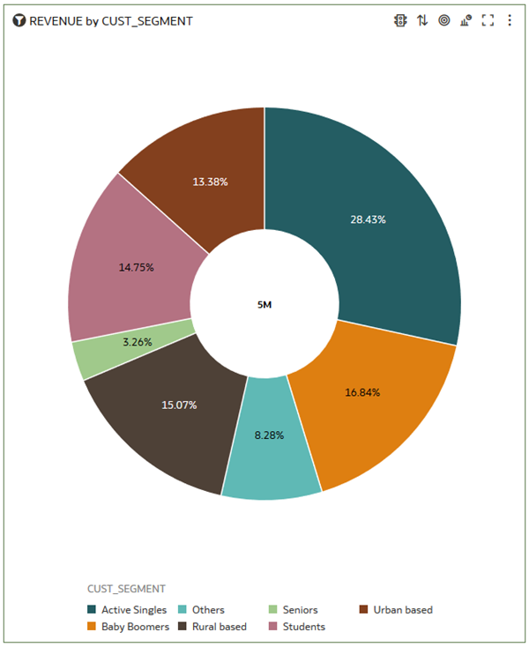

1. Click **Save** Save icon. In Save Workbook, enter Revenue Insights in **Name**, and then click **Save**.

Create a Filter

In this section, you create a filter to restricts the data to values from a specific region. You apply to filter to all visualizations created in the workbook.

1. Click **Add Filter** Add Filter icon. From the customer_sales list, click **Region**. From the Region list, click **Americas**, and then click the **Filter Bar**.
2. Hover over **Region** in the Filter Bar, click **Pin to All Canvases** Pin filter to all canvases icon.

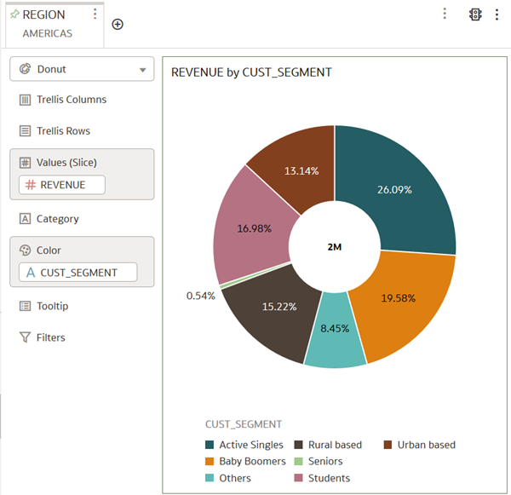

Add Revenue Visualizations

In this section, you create a donut visualization of revenue by product type.

1. In the Data panel, hold down the **Ctrl** key, and then select **REVENUE** and **PROD_TYPE**. Right-click, select **Pick Visualization**, and then select **Donut** Donut visualization icon.

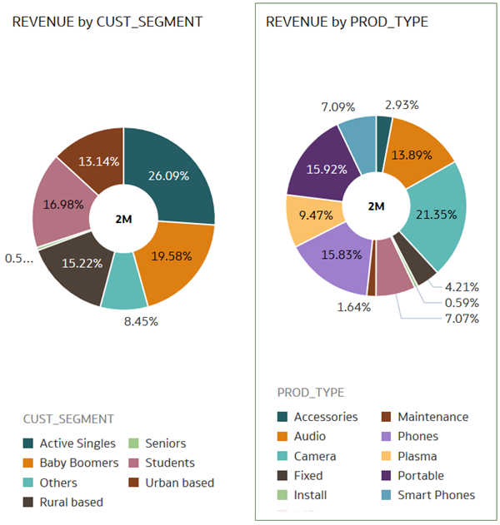

1. Click **Save**.

Duplicate a Visualization

1. Select the REVENUE by CUST_SEGMENT **Menu** Menu icon, select **Edit**, and then select **Duplicate Visualization**.
2. Select **CUST_GENDER** from the Data panel, and drag it to **Color** to replace CUST_SEGMENT.

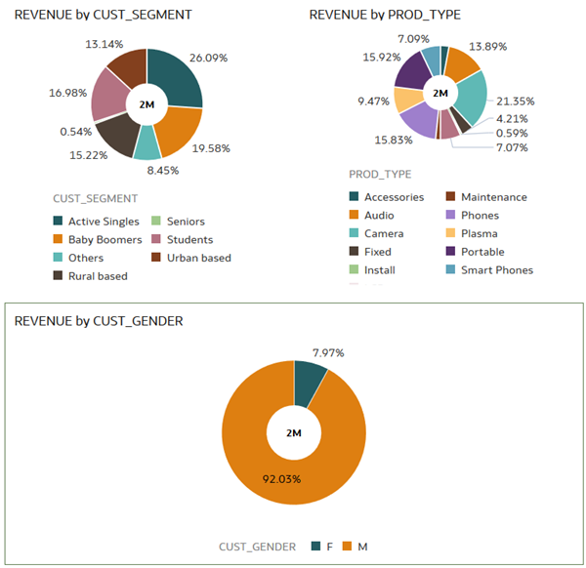

1. In the Revenue by Gender visualization, select **Menu** Canvas Menu icon, select **Edit**, and then select **Duplicate Visualization**.
2. In the Data panel, select **COUNTRY_NAME**, drag it to **Color** to replace CUST_GENDER.

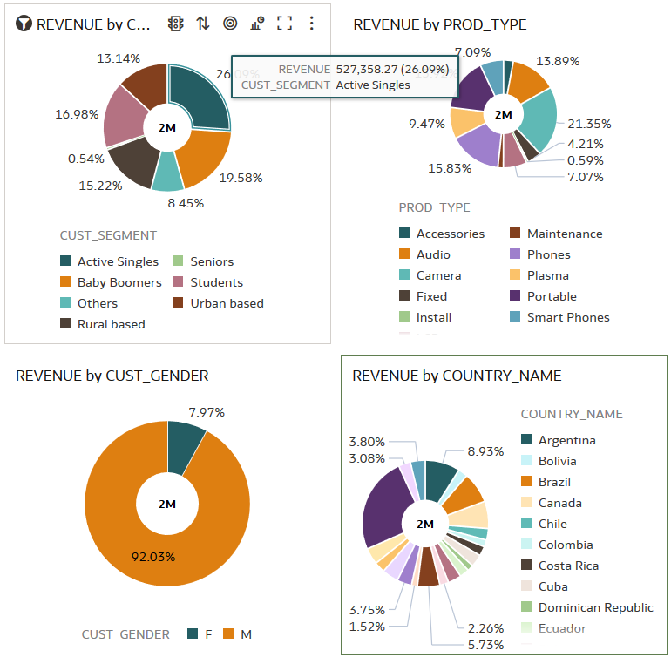

1. Click **Add Note** Add Note icon. In the note , enter the following:

Males and active singles are our primary customers. Argentina has our second largest customer-revenue base after the United States.

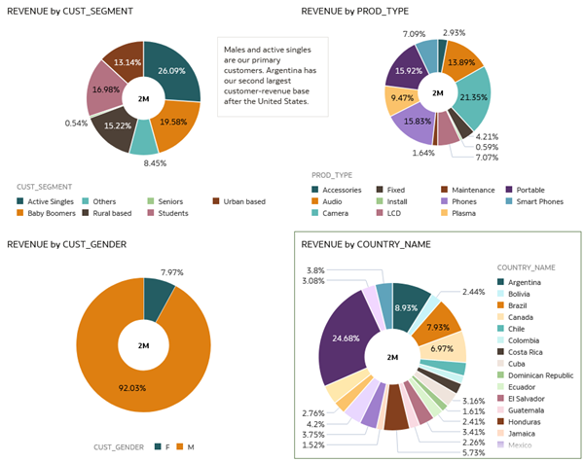

1. Click **Save** Save icon.

Create Insights

1. Click **Present**.
2. In the Canvases pane, drag **Canvas 1** to Drag a Canvas Here to Begin.
3. Click **Canvas 1** in the page title bar, enter Revenue Insights Americas in the page title to replace Canvas 1.
4. Use your cursor to select the **Revenue Insights** in the page title, click **Font** in Formatting Styles, and then select Verdana. Click the **Font Size** list and select **36**.
5. Click **Save** Save icon.

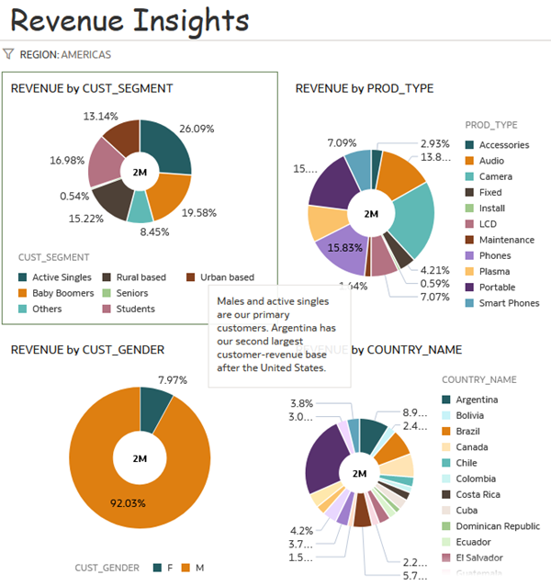

1. Click **Preview** Preview icon to review your changes.