## Build Stories in Oracle Analytics

Before you Begin

This lab shows you how to build and narrate a story from insights created with data visualizations.

Background

An insight takes a snapshot of the information in your workbook. You compose a story with multiple insights and then arrange the insights to reveal the story. Your insights are automatically included in the story. A workbook can contain only one story.

In this tutorial, you complete the story by creating insights about revenue, customers, and products.

This is the second lab in *Capture Insights and Build Stories* series. Complete the labs in the order listed.

* [Capture Insights](https://apexapps.oracle.com/pls/apex/f?p=44785:112:0::::P112_CONTENT_ID:22653)
* Build Stories

What Do You Need?

* Access to one of the following:
  + Oracle Analytics Cloud
  + Oracle Analytics Desktop
* Access to the Revenue Insights workbook

Create Visualizations about Customers

1. Sign in to Oracle Analytics.
2. On the Home page, enter Revenue Insights in the search bar, and click **Search**.
3. Select the **Revenue Insights** workbook, click the **Actions** menu, and then select **Open**.
4. In Revenue Insights, click **Visualize**. Click **Add Canvas** Add Canvas icon.
5. From the Data panel, hold down the **Ctrl** key, select the following data elements in the order listed, and then drag the data elements to the canvas:
   * **REVENUE**
   * **PROD_TYPE**
   * **CUST_GENDER**
6. In the bar visualization, click **Menu** Visualization Menu icon, select **Sort by**, select **REVENUE**, and then select **High to Low**.

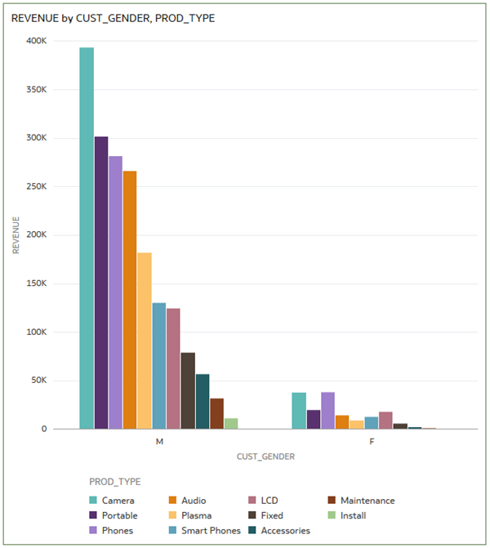

Add Customer Visualizations

1. In the bar visualization, click **Menu** Visualization Menu icon, select **Edit**, and then select **Duplicate Visualization**.
2. In the Data panel, select **CUST_MARITAL_STATUS**, drag it to **Category (X-Axis)** to replace CUST_GENDER.

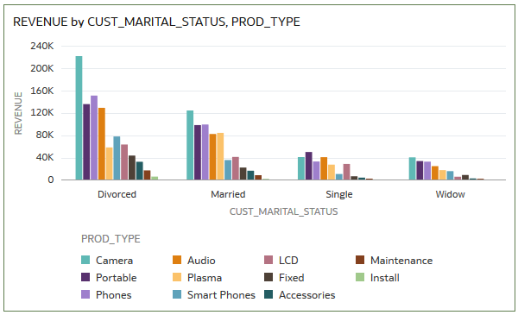

1. Select the REVENUE by CUST_MARITAL_STATUS, PROD_TYPE visualization, select **Menu** Visualization Menu icon, select **Edit**, and then select **Duplicate Visualization**.
2. In the Data panel, select **CUST_GENDER**, and drag it to **Color** to replace PROD_TYPE in the Grammar pane.
3. In the visualization, select **Menu** Visualization Menu icon, select **Sort by**, select **REVENUE**, and then select **High to Low**.

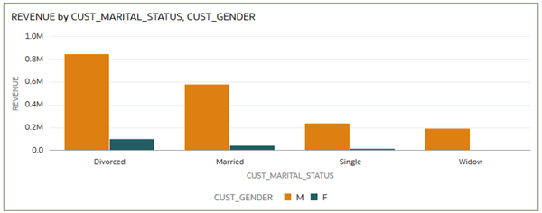

1. Click **Add Note** Add Note icon. In the note, enter the following:

Customers from every marital status and gender buy cameras, portables, and phones. Maintenance and installation services are the least purchased products by customers in all categories.

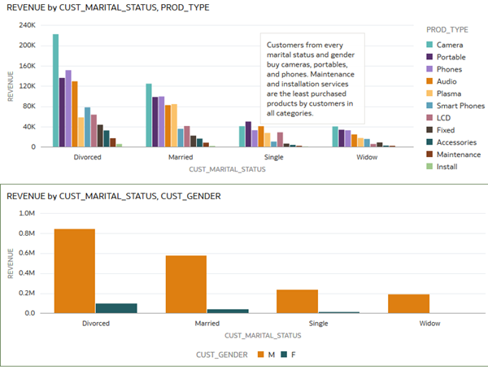

Capture Customer Insights

1. From the Visualize page, click **Present**.
2. In the Present page, select **Canvas 2**, and drag it to the drop canvas area next to Canvas 1.



1. Click the menu Canvas menu icon in Canvas 2, and select **Rename Page**.
2. Enter Customer Insights in the page title to replace Canvas 2.

Add Product Visualizations

1. Click **Visualize**. In the Visualize page, click **Add Canvas** Add Canvas icon.
2. In the Data panel, hold down the **Ctrl** key, select the following data elements, and drag them to the canvas:
   * **UNITS**
   * **REVENUE**
   * **PROD_BRAND**
3. Move **PROD_BRAND** from Category to **Color** in the Grammar panel.

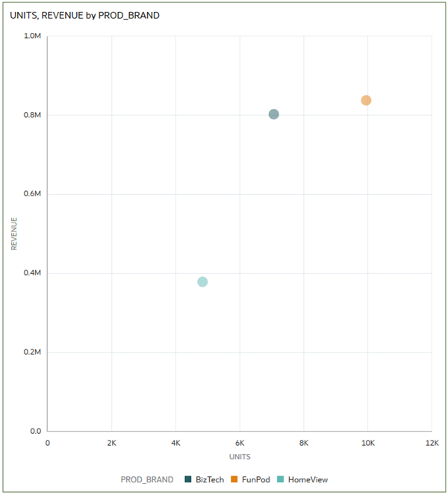

1. In the scatter visualization, click **Menu** Visualiztion menu icon, select **Edit**, and then select **Duplicate Visualization**.
2. In the Data panel, select **PROD_TYPE**, and drag it to **Color** to replace PROD_BRAND.

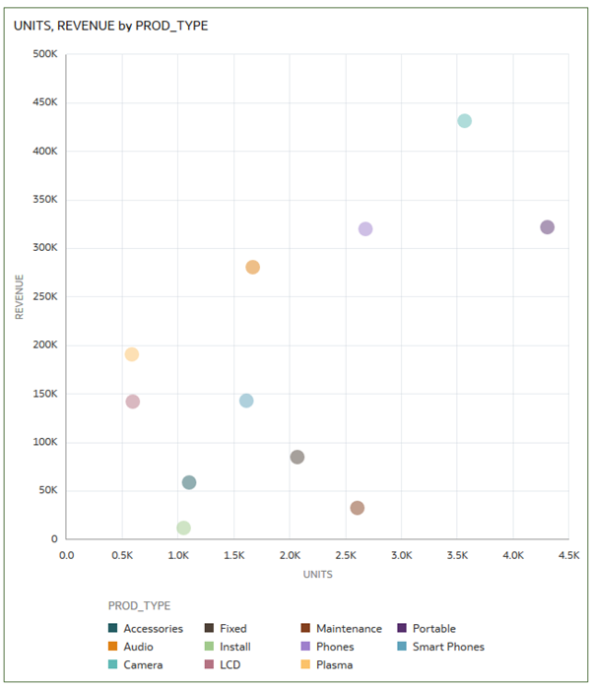

1. In the Data panel, hold down the **Ctrl** key, and select the following:
   * **PROD_TYPE**
   * **REVENUE**
   * **PROD_BRAND**
2. Drag the data elements to the canvas, and release them when a thick green line appears under the visualizations.
3. In the REVENUE by PROD_BRAND, PROD_TYPE visualization, select the **Menu** Visualization Menu icon, select **Sort by**, select **REVENUE**, and then select **High to Low**.

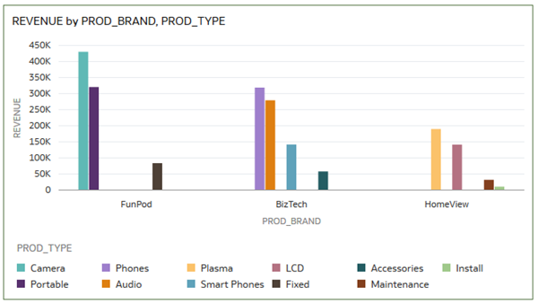

1. Click **Add Note** Add Note icon. In the note text box, enter the following:

FunPod sold the most products of the three brands, with cameras and portables leading in number of units sold and revenue. Installation services, by HomeView, provided the smallest revenue stream.

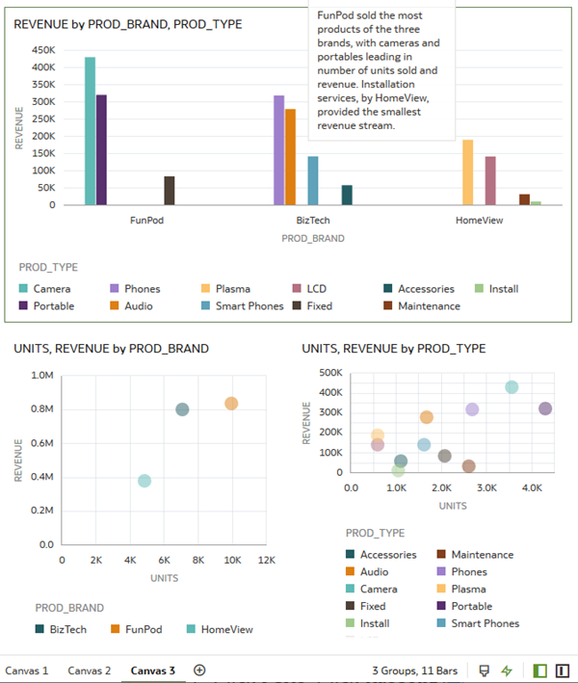

1. Click **Save**. Click **Present** Present icon.

Capture Product Insights

In Present, you can move the canvases to change the order displayed in the presentation mode.

1. In the Present page, select **Canvas 3**, and drag it to the drop canvas area next to Canvas 2.
2. Click the **Menu** Narrate menu icon in Canvas 3, and select **Rename Page**. Enter Product Insights in the page title to replace Canvas 3.

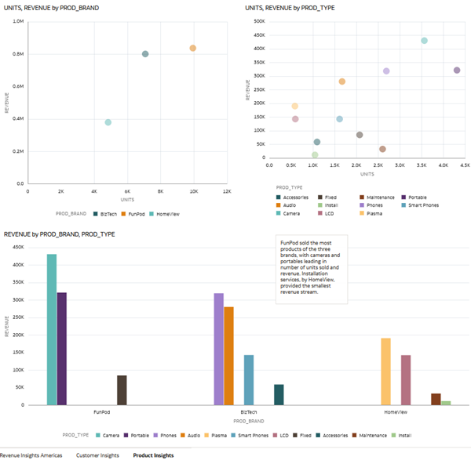

1. Click **Save**.