## Apply a Predictive Model in Oracle Analytics

Before you Begin

This lab shows you how to use a CART predictive model, inspect the results of running the data flow to create the CART model, apply a predictive model to your dataset, and visualize the impact in a workbook.

Background

You can create a different predictive model using a classification and regression tree (CART) for numeric prediction with the random sample donation dataset. The CART predictive model classifies all of the records in the dataset based on inputs, and assigns an expected record for each class. In this lab, you use the CART model to predict the total donations.

You also score a dataset using the trained model by applying the predictive model. You run analysis and create visualizations using the predictive measure along with other metrics, dimensions, or dataset mash-ups.

This is the third lab in *Train and Apply Predictive Models* in Oracle Analytics. Read the labs in the order listed.

* [Create a Random Sample Dataset and Train a Prediction Model](https://apexapps.oracle.com/pls/apex/f?p=44785:112:0::::P112_CONTENT_ID:28070)
* [Inspect and Modify the Prediction Model](https://apexapps.oracle.com/pls/apex/f?p=44785:112:0::::P112_CONTENT_ID:28071)
* Apply a Predictive Model

What Do You Need?

* Oracle Analytics

When using Oracle Analytics Desktop, you must install machine learning (DVML) to use Diagnostics Analytics (Explain), Machine Learning Studio, or advanced analytics.

* Access to the following:
  + **elastic_train_df** data flow
  + **sample_donation_data** dataset
  + **donations_random_sample** workbook

Modify the Predictive Model

1. On the Home page, click **Data**, enter elastic_train_df in the Search bar, and then click **Search**.
2. In the elastic_train_df, click the **Actions menu** Actions menu icon, and then select **Open**.
3. In the data flow, click the **Train Numeric Prediction** step.
4. In Train Numeric Prediction, click **Elastic Net Linear Regression for model training** in the Model Training Script row.
5. In Select Train Numeric Prediction Model Script, click **CART for Numeric Prediction training**, and then click **OK**.
6. In Train Numeric Prediction, click **Select a column** in the Target row, and then select **TOTAL_DONATIONS** from Available Data.
7. Click the **Save Model** step. In Save Model, enter cart_model_1. Click **Save**.
8. Click **Run Data Flow** Run Data Flow icon.

Review the CART Model Related Datasets

1. Click **Go back** Back icon. On the Home page, click **Machine Learning**.
2. In the cart_model_1, click the **Actions menu** Actions menu icon, and then select **Inspect**.
3. In cart_model_1, click **Quality** to see the distribution of residual values and overall statistics.

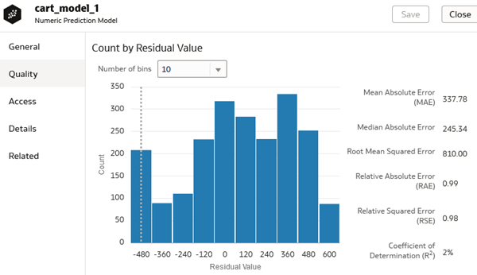

1. Click **Related** to view the generated datasets.
2. Click **Close**.

Add the CART Scenario to the Workbook

1. On the Home page, enter donations_random_sample workbook, and then click **Search**.
2. In the donations_random_sample workbook, click the **Actions menu** Actions menu icon, and then select **Open**.
3. In the Data panel, right-click **elastic_model_1**, and then select **Remove From Workbook**. In Remove Scenario, click **Yes**.

The TOTAL_DONATIONS by POSTED_DATE line visualization refreshes to remove the prediction line related to the scenario.

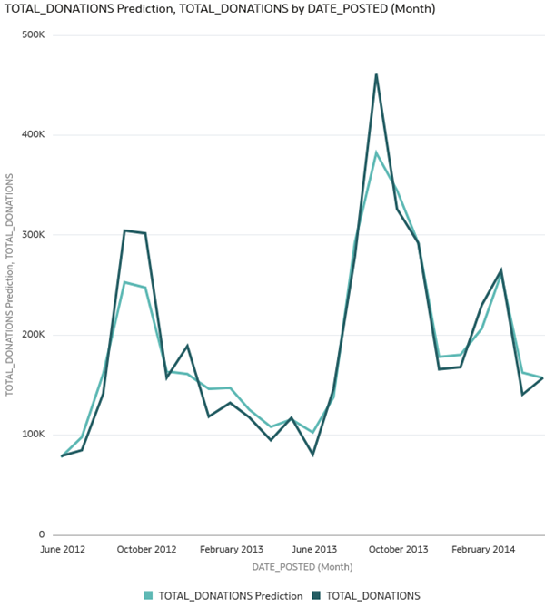

1. In the Data panel, click **Add** Add icon, and then select **Create Scenario**.
2. In Create Scenario, select **cart_model_1**, and then click **OK**.
3. In the Data panel, expand the **cart_model_1** node. Select **TOTAL_DONATIONS**, and then drag it to **Values (Y-Axis)** in the Grammar panel.

The CART numeric prediction model produces results similar to the elastic model.

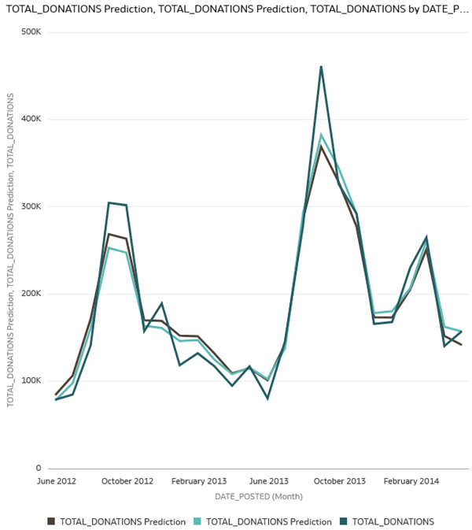

1. Click **Save**.

Review CART Numeric Model Segments

1. Click **Add Canvas** Add Canvas icon. In the Data panel under the cart_model_1 node, select and drag **Segments** to **Canvas 2**.

The CART model segment objects show the leaf branches of the tree.

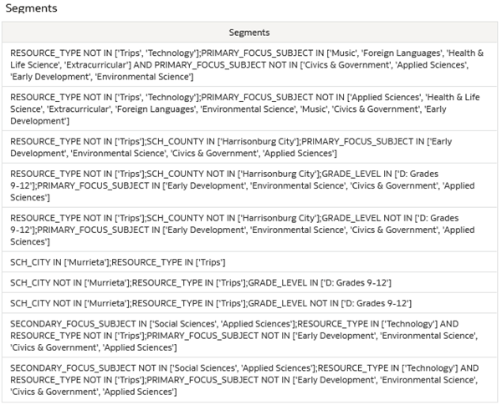

1. In the Data panel under the cart_model_1 node, select and drag **TOTAL_DONATIONS** to **Rows** in the Grammar panel.

The table shows the distribution of donations to the CART branches.

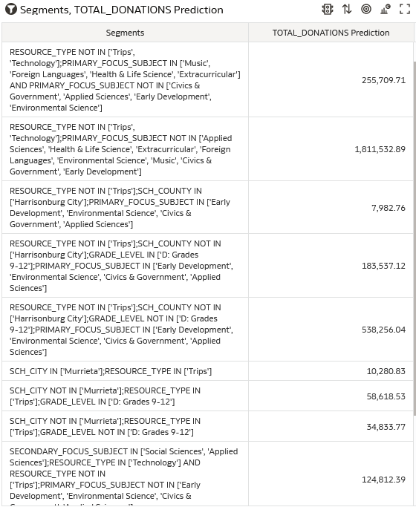

Modify the CART Model

1. Click **Go back** Back icon. In Save Changes, click **Don't Save**.
2. On the Home page, enter elastic_train_df, and then click **Search**.
3. In the elastic_train_df, click the **Actions menu**, and then select **Open**.
4. In the data flow, click the **Train Numeric Prediction** step.
5. In **Maximum Depth**, click the up arrow to increase the value to **7**.
6. Click the **Save Model** step. In Save Model, enter cart_model_2.
7. Click **Run Data Flow**.
8. On the Home page, enter donations_random_sample workbook, and then click **Search**. In the donations_random_sample workbook, click the **Actions menu** Actions menu icon, and then select **Open**.
9. In the Data panel, click **Add** Add icon, and then select **Create Scenario**. In Create Scenario, select **cart_model_2**, and then click **OK**.
10. Click Canvas 1, in the Data panel expand the **cart_model_2** node. Select **TOTAL_DONATIONS** and drag it to **Values (Y-Axis)** in the Grammar panel.

The results are similar to the other prediction models.

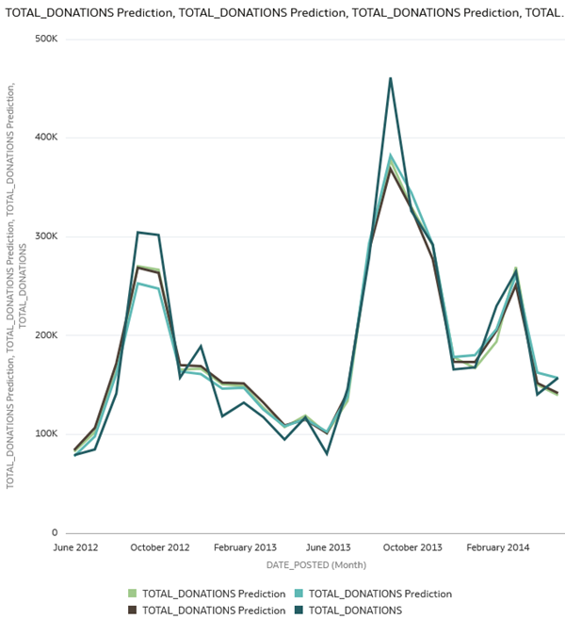

1. Click **Add Canvas** Add Canvas icon. In the Data panel under the cart_model_2 node, select and drag **Segments** to **Canvas 2**.
2. In the Data panel under the cart_model_2 node, select and drag **TOTAL_DONATIONS** to **Rows** in the Grammar panel.

Increasing the maximum depth in cart_model_2 provides more granular leaf levels in the tree.

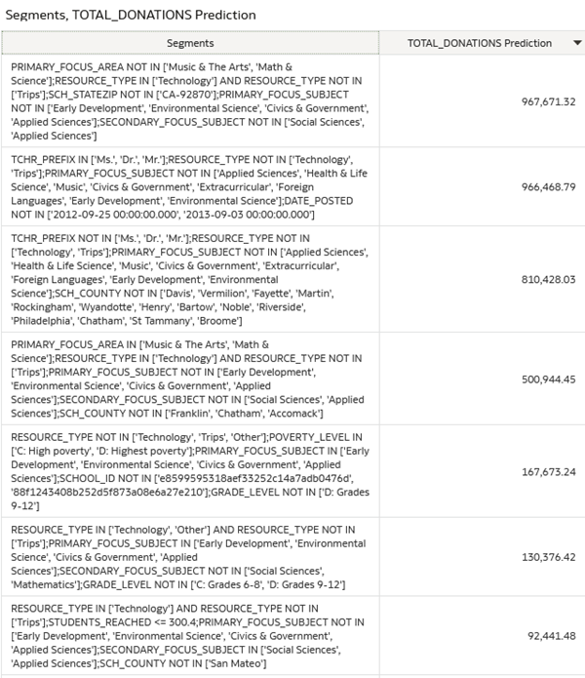

Score a Dataset

1. Click **Go back** Back icon. On the Home page, click **Create**, and then select **Data Flow**. In Add Dataset, select **sample_donation_data**, and then click **Add**.
2. Double-click **Apply Model** in the Data Flow Steps panel. In Select Model, click **cart_model_1**, and then click **OK**.
3. Double-click **Save Dataset** to add it to the data flow. In Save Dataset, enter scored_donation_dataset in **Name**.
4. Click **Save**, and select **Save As**. In Save Data Flow As, enter scored_donation_dataset_df, and then click **OK**.
5. Click **Run Data Flow** Run Data Flow icon.

Create a Workbook with the Scored Dataset

1. Click **Go back** Back icon. On the Home page, click **Create**, and then click **Workbook**.
2. In Add Dataset, click **scored_donation_dataset**, and then click **Add to Workbook**.
3. In the Data panel, hold down the **Ctrl** key select **PredictedValue** and **TOTAL_DONATIONS** and **DATE_POSTED**. Right-click, select **Pick Visualization**, and then select **Line**.
4. Select **TOTAL_DONATIONS**, and move it to **Values (Y-Axis)** in the Grammar panel.

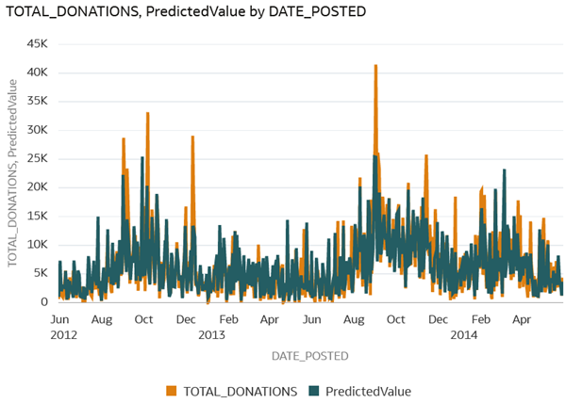

1. Right-click **DATE_POSTED** in the Grammar panel, select **Show by**, and then select **Week**.

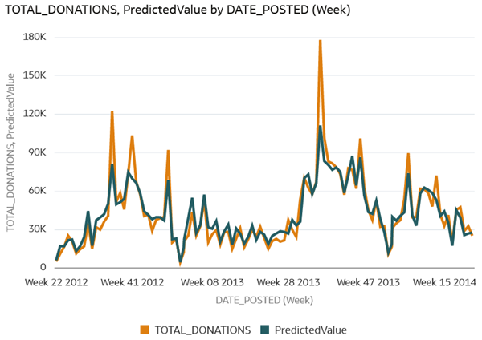

1. Select **SCH_METRO** in the Data panel, and drag it to **Trellis Columns** in the Grammar panel.

