## Review and Manage Location Matches in Oracle Analytics

Before You Begin

This lab shows you how to use location matches to check the accuracy of map results.

Background

You can view match results of the geographical locations in your map visualization. The Location Match dialog shows these types of matches:

* 100% confidence
* Multiple possible locations (ambiguous matches)
* Low confidence with matches in the map layer (partial matches)
* No location found in the map layer that matches your data point

You might want to:

* Correct spelling of cities, states, or countries in your data source.
* Add data such as county or province to resolve matches with multiple possible map locations.
* Add filters to the map visualization to increase the match quality.
* Create a custom map layer such as a postal code map layer that provides additional details about the data that isn't available in the default map layer.

Creating a custom map layer requires administrator privileges and an understanding of map layers.

In this tutorial, you create a map visualization, correct and remove data, and create a filter using the available data.

What Do You Need?

* Access to Oracle Analytics Cloud or Oracle Analytics Desktop
* Download the following files to your computer:
  + superstore_data.xlsx
  + world_cities_data.xlsx

Create a Dataset

In this section, you review location matches in your map visualization of sales by cities in the United States.

1. Sign in to Oracle Analytics.
2. On the Home page, click **Create**, and then select **Dataset**.
3. In Create Dataset, click **Drop data file here or click to browse**, select the superstore_data.xlsx file, and then click **Open**.
4. In Create Dataset From superstore_data.xlsx, click **OK**.
5. Click **Save** Save icon. In Save Dataset As, enter superstore_data, and then click **OK**.

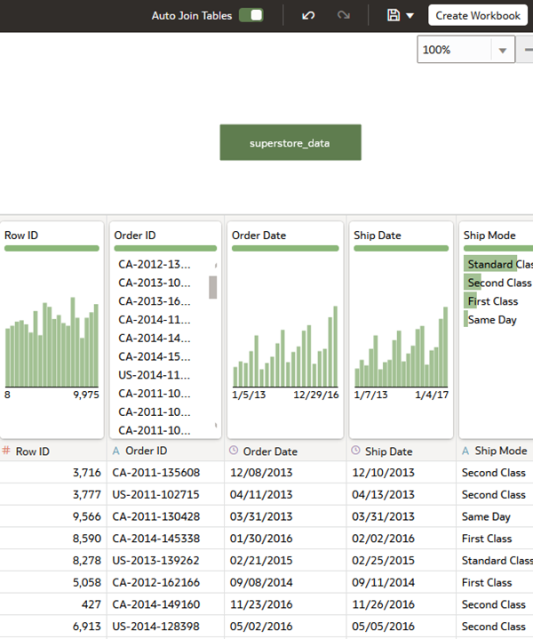

Create a Map Visualization

In this section, you create a map visualization with sales from cities around the world.

1. Click **Create Workbook**. Close the Auto Insights panel.
2. From the Data panel, hold down the **Ctrl** key, select **City** and **Sales**, and then right-click **Pick Visualization**. Select **Map** Map view icon.

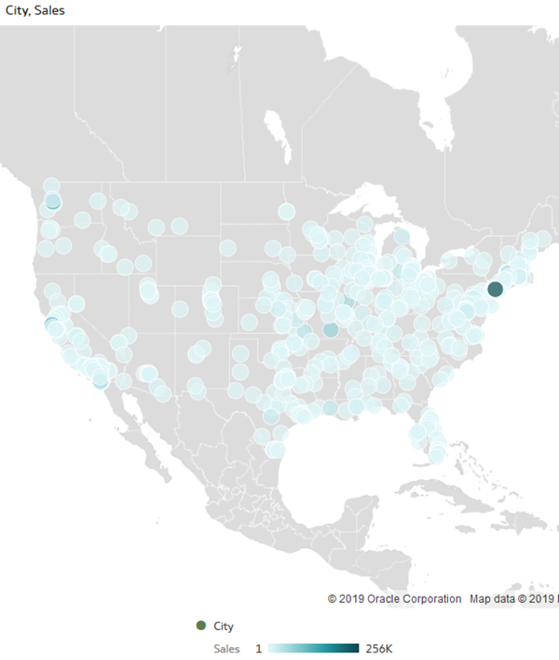

1. Click the visualization **Menu** Menu icon and select **Location Matches**.

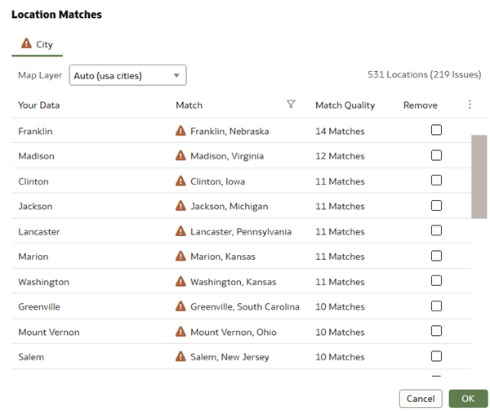

Location Matches shows 219 ambiguous matches because the United States includes multiple cities with the same name.

1. Click **OK**.
2. From the Data panel, drag **State** to **Category (Location)** in the Grammar panel to add more detail to the map.

The map appears the same as the map visualization that just used City.

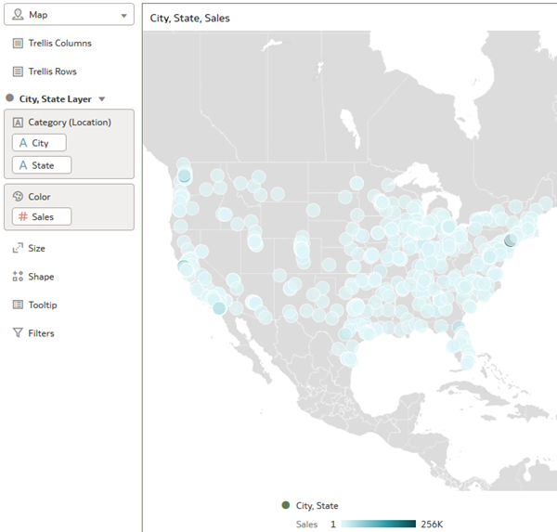

1. Right-click the map visualization and select **Location Matches**.

The addition of State to the map layer resolved all but 5 of the location match issues.

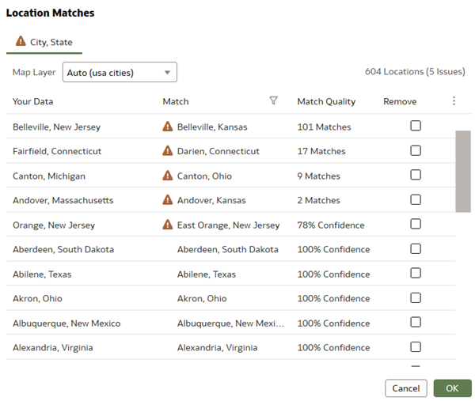

Create a Filter

In this section, you use a filter in the visualization to narrow your map view to a specific area of interest, and possibly reduce the number of location mismatches.

1. In the canvas, click **Add Filter** Add Filter icon. From superstore_data, select **Region**. From Region, select **East**, and then click outside of the selection dialog.

The map visualization changes to show the data points in the East region. However, a couple of data points appear in the mid-west.

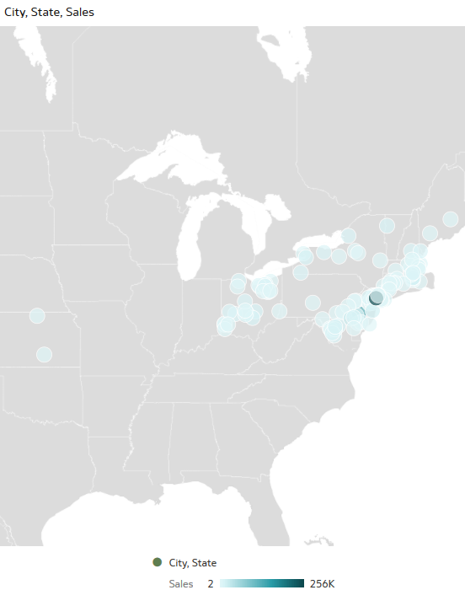

1. Click the visualization **Menu** Menu icon and select **Location Matches**.

The region filter reduced the location match issues to four. If you added county to your dataset, the out of region location match issues might disappear. Because the City of Orange, New Jersey, and East Orange, New Jersey are in the same county, the location matches issues probably won't totally disappear without a custom map layer of New England cities. A custom New England cities layer would also resolve the Darien and Fairfield, Connecticut location match issues.

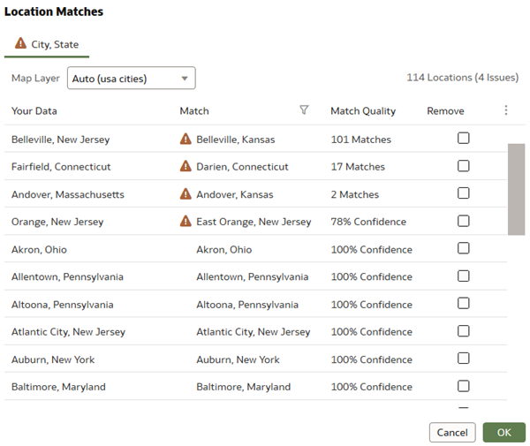

1. Click **Save**. In Save Workbook, enter Cities Location Matches in **Name**, and then click **Save**. Click **Go back** Back icon to return to the Home page.

Create a Map Visualization with World Cities

In this section, you create a new workbook with a different data source.

1. On the Home page, click **Create**, and then select **Dataset**.
2. In Create Dataset, click **Drop data file here or click to browse**, select the world_cities_data.xlsx file, and then click **Open**.
3. In Create Dataset table from world_cities_data, click **OK**.
4. Click **Save** Save icon. In Save Dataset As, enter world_cities_data, and then click **OK**
5. Click **Create Workbook**. Close the Auto Insights panel.
6. From the Data panel, hold down the **Ctrl** key, select **City** and **Sales**, and then right-click **Pick Visualization**. Select **Map** Map view icon.

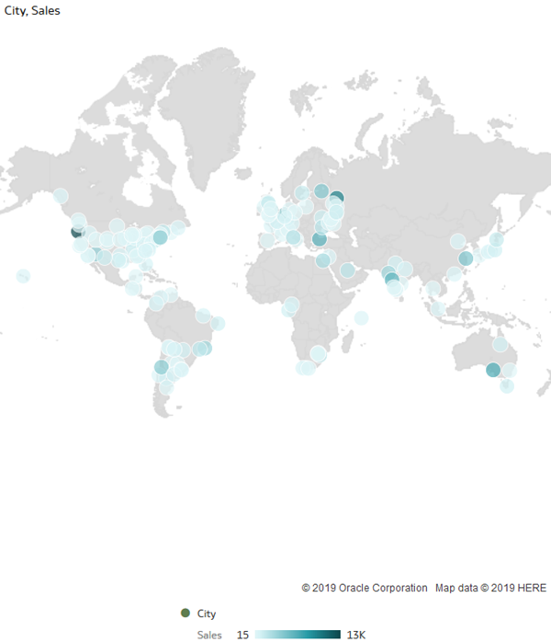

1. Click the visualization **Menu** Menu icon and select **Location Matches**.

Location Matches can't find the small French village of Eze and Riccione, Italy on the default map.

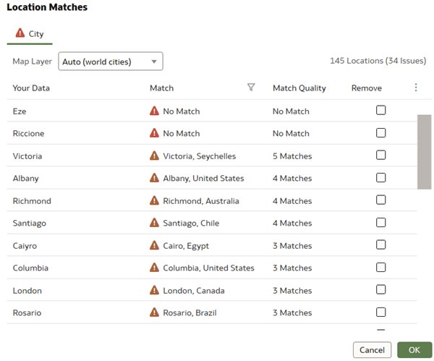

1. From the Data panel, drag **Country** to **Category (Location)** in the Grammar panel to possibly improve matches.

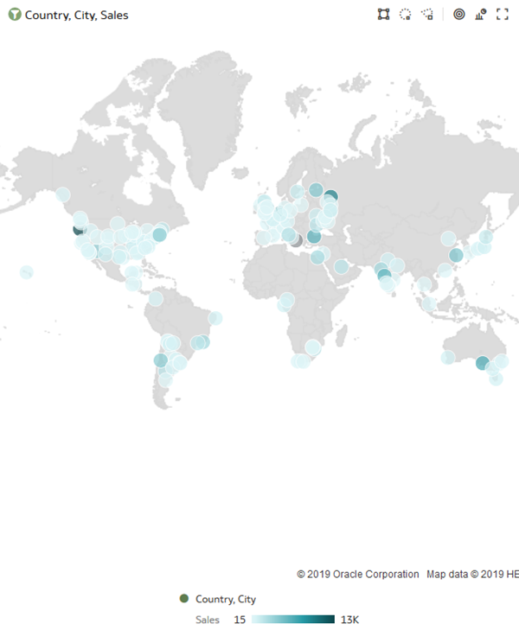

1. Click the visualization **Menu** Menu icon and select **Location Matches**.

With the addition of Country to the world cities map layer, the village of Eze has four matches and Riccione has 22 matches. The number of location match issues are reduced from 21 to 16.

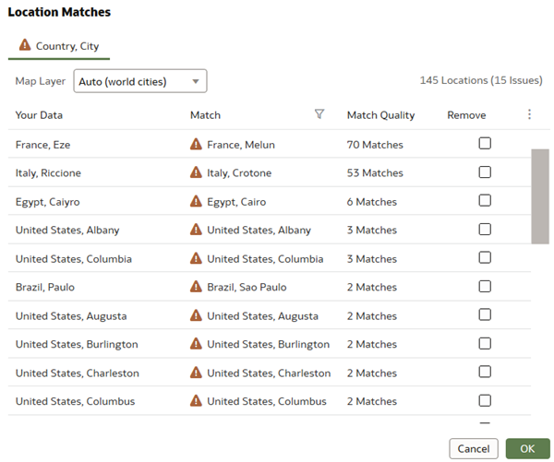

1. In Location Matches, click the check box in the Riccione row, and then click **Remove** to create a filter to remove the selected item. Click **OK**.
2. Right-click the map view, and then click **Location Matches**.

Adding country removed some of the ambiguous matches, and Riccione no longer appears in Locations Matches. In your workbook, scroll through the dialog to review the location matches.

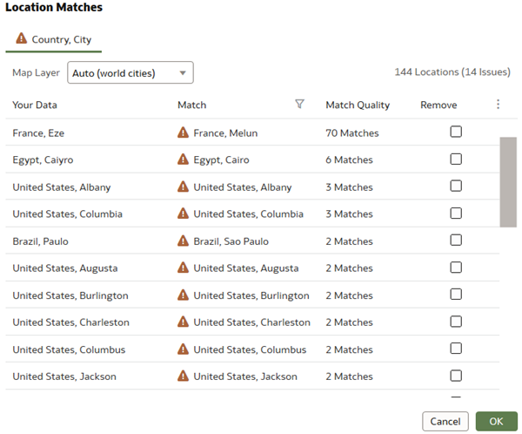

Correct Data Source Issues

In the Location Matches, under the Your Data column, the City of *Caiyro* is spelled incorrectly.

1. In the workbook, click **Save**. In Save Workbook, enter World Sales in **Name**, and then click **Save**.
2. Open the world_cities_data.xlsx file. In the spreadsheet, use **Ctrl + F**, and then in **Find What**, enter Caiyro. Close the Find dialog.
3. In the row with Caiyro, enter Cairo, click **Save**, and then close the file.

Update the Data in Your Workbook

In this section, you reload the updated data source and refresh the workbook.

1. On the Home page, click **Data** in the search bar, enter world_cities_data, and then click **Search**. In world_cities_data, click **Actions menu** Menu icon, and then select **Reload Data**.
2. On the Home page, click **Workbooks**, enter World Sales, and then click **Search**.
3. In the World Sales workbook, click the **Actions menu** menu icon, and then select **Open**.
4. In the workbook, click **Menu** Menu icon, and then select **Refresh Data**.
5. Click the visualization **Menu** Menu icon and select **Location Matches**.
6. In Location Matches, scroll to **Cairo** to view the correction made in the dataset.

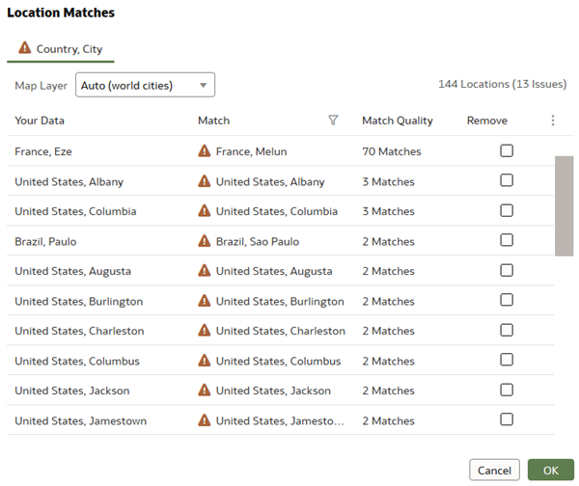

Create a Pivot Table

In the Location Matches dialog, some data points had multiple matches. In this section, you create a pivot table that enables viewing all of your City sales data points.

1. In the Data panel, hold down the **Ctrl** key, and select the following:
   * **Country**
   * **City**
   * **Sales**
2. Right-click, select **Pick Visualization**, and then select **Pivot** Pivot view icon.
3. In the Grammar panel, drag **City** to Color, and then drag **County** to Rows.

You can scroll through the list in the pivot table to review the data.

