## Assign Map Layer to Latitude and Longitude Columns

Before You Begin

This lab shows you how to assign the Latitude, Longitude map layer to latitude and longitude data columns in your dataset and workbook.

Background

When you assign the Latitude, Longitude map layer, the data columns must use numeric or text data types as attributes. If your latitude and longitude data columns are treated as measures, change the columns to attributes before assigning the Latitude, Longitude map layer to the columns.

What Do You Need?

* Access to Oracle Analytics
* Download [sample_orders_states.csv](https://docs.oracle.com/en/cloud/paas/analytics-cloud/tutorial-assign-map-layer-to-lat-long-columns/files/sample_orders_states.csv) to your computer

Create a Dataset

In this section, you create a dataset and assign the Latitude, Longitude map layer to the dataset's latitude and longitude columns.

1. Sign in to Oracle Analytics.
2. On the Home page, click **Create**, and then click **Dataset**.
3. In Create Dataset, click **Drop data file here or click browse**. In File Upload, select sample_orders_states.csv, and then click **Open**. In Create Dataset Table from sample_orders_states.csv, click **OK**.
4. Click **Save** Save icon. In Save Dataset As, enter sample_orders_states in **Name**, and then click **OK**.
5. Click the sample_orders_states tab, select **Options** Options menu icon in the Latitude column, and then select **Location Details**.
6. In Location Details: Latitude, select **Latitude, Longitude** from the Map Layer list, and then click **OK**.

Latitude is automatically added as the value in the Location Type field.

1. In the Longitude column, select **Options** Options menu icon, and then select **Location Details**.
2. In Location Details: Longitude, select **Latitude, Longitude** from the Map Layer list, and then click **OK**.

Longitude is automatically added as the value in the Location Type field.

1. Click **Save** Save icon.

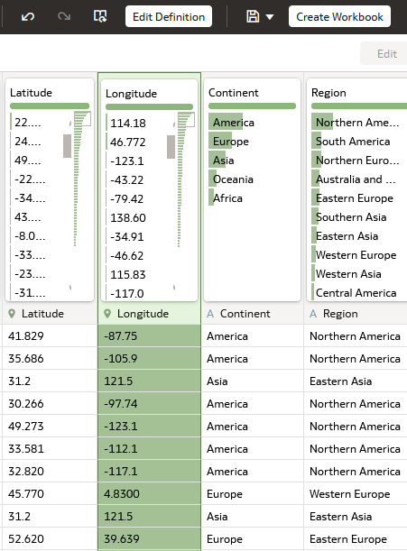

Create a Map Visualization

1. Click **Create Workbook**.
2. In the Data pane, hold down the **Ctrl** key, select **Sales**, **Latitude**, and **Longitude** data elements, and then drag and drop them on the canvas.

