## Create Your First Visualization

Before You Begin

This lab shows you how to create a workbook, select data to use in the visualization, and modify the visualization. You learn how to filter, modify data properties, and change the visualization type.

Background

You use a spreadsheet file as the data source for the workbook's visualization.

What Do You Need?

* Access to Oracle Analytics
* Download sample_revenue.xlsx file to a location on your computer

Create a Dataset

In this section, you add the sample_revenue.xlsx file to Oracle Analytics to create a dataset. The dataset provides the data for creating visualizations.

1. Sign in to Oracle Analytics.
2. On the Home page, click **Create**, and then click **Dataset**.
3. In Create Dataset, click **Drop data file here or click to browse**. In File Upload, click **sample_revenue.xlsx**, and then click **Open**.
4. In Create Dataset Table from sample_revenue.xlsx, click **OK**. Click **Save** Save icon. In Save Dataset As, enter Sample Revenue in **Name**, and then click **OK**.
5. In the Join Diagram, click **Create Workbook**.

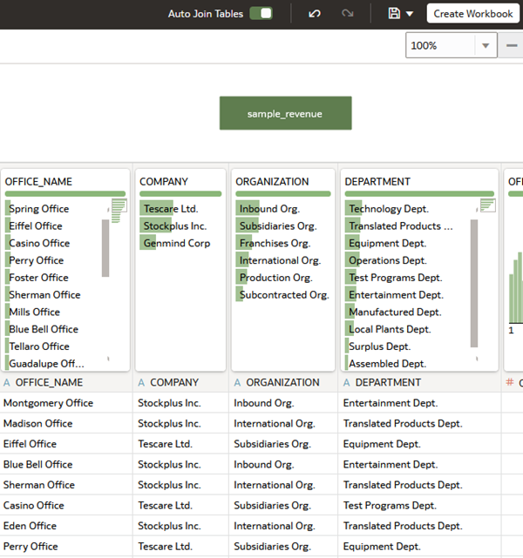

Create Visualizations

In this section, you create a visualization, change the visualization type, and change the data elements used in the visualization.

1. In Data panel, hold down the **Ctrl** key, select and drag the following to the canvas:
   * **PROD_TYPE**
   * **REVENUE**
   * **DEPARTMENT**

Oracle Analytics chooses the best visualization type for the selected data elements.

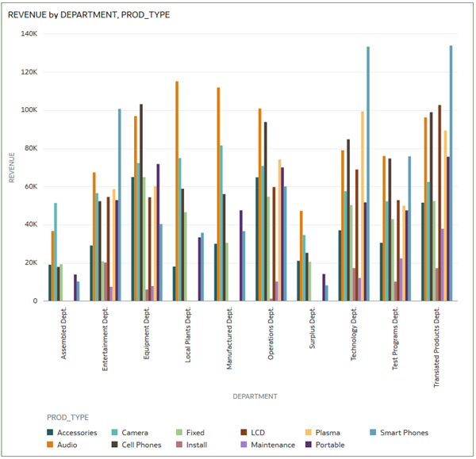

1. Click the **visualization type** list List icon and select **Horizontal Stacked** Horizontal Stacked icon as the visualization type.

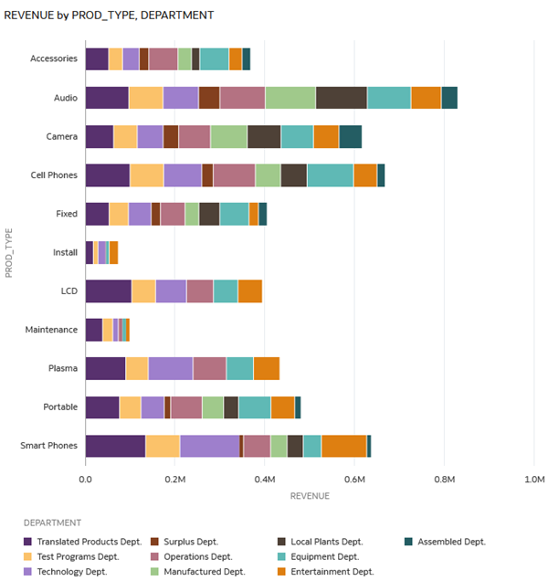

1. Select **PROD_TYPE** and drag it to **Color** so that PROD_TYPE and DEPARTMENT exchange places in the Grammar pane.

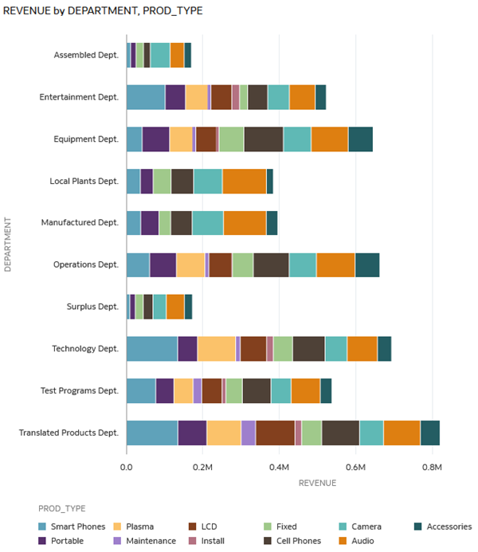

Filter the Data

In this section, you add a filter to the visualization to see the changes that result in the visualization.

1. In the filter bar, click **Add Filter** Create Filter Icon.
2. From the **SAMPLE_REVENUE** list, select **PROD_TYPE.**
3. From the **PROD_TYPE** list, select **Cell Phones** and **Smart Phones**, and then click outside the dialog to close the list.

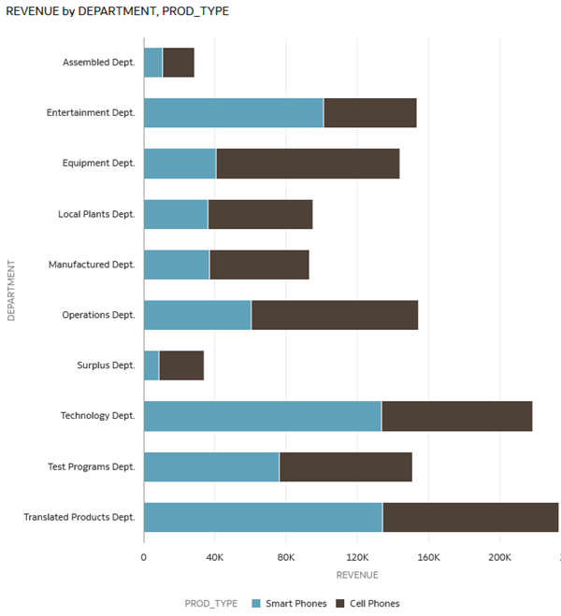

1. From the Data panel, select **COMPANY**, and then drag it to **Category Y-axis** to replace DEPARTMENT.
2. In the filter bar, click **Filter Bar Menu** filter bar menu icon, and then select **Remove All Filters**.

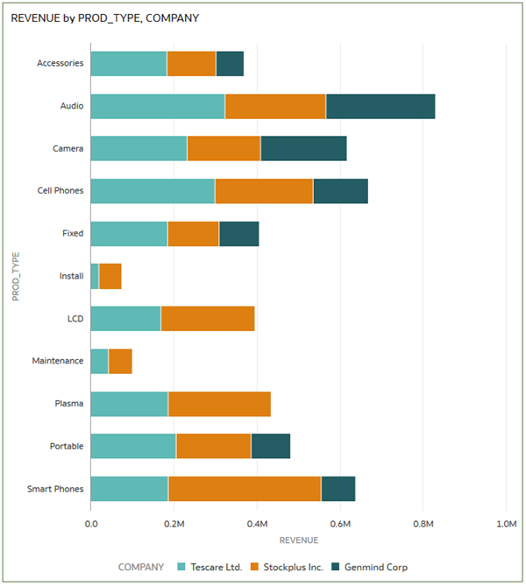

Change the Properties in a Visualization

In this section, you change a property of a data element in the visualization.

1. In the Revenue by PROD_TYPE, COMPANY visualization, click **Properties** Properties icon and click **Values** Values icon. Click **Auto** in the Number Format row and select **Currency**.

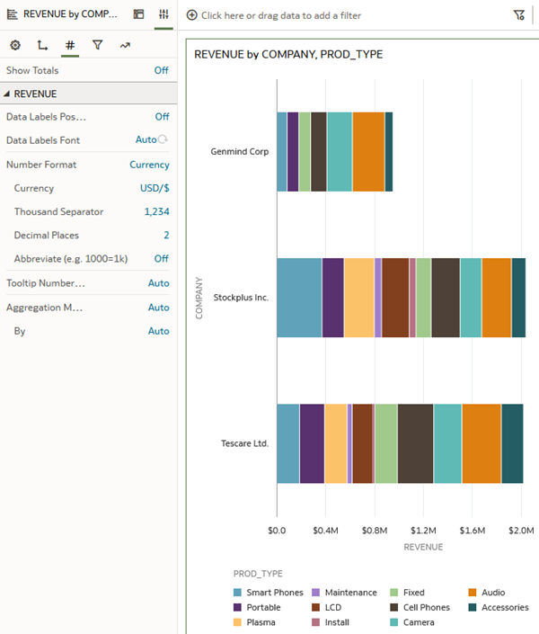

1. In visualization, click the **Menu** Menu Icon, select **Sort By**, select **Revenue**, and then select **High to Low**.

