Lab 1: Oracle Database Basics
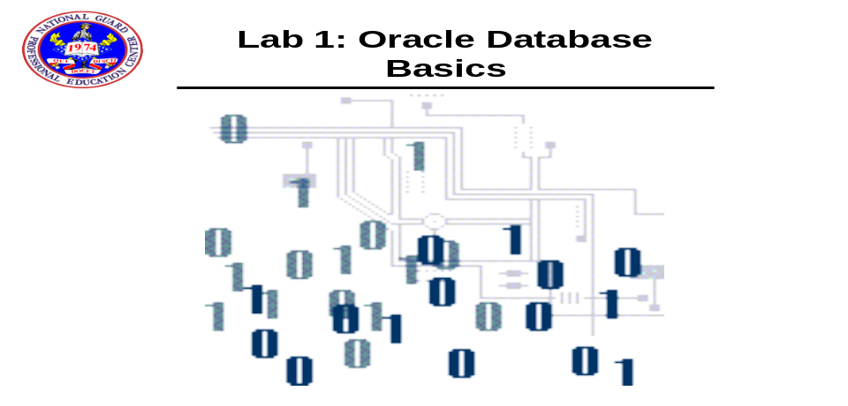

- Open command-line SQL*Plus first then SQL Developer and connect to the user account hr with a password of hr with a database name of fenago.
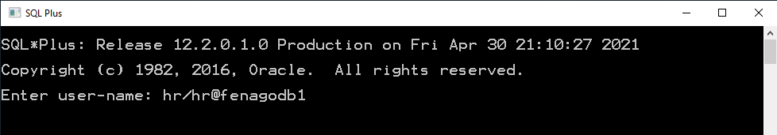
- Perform the following query in both SQL*PLUS.

select * From Tab;
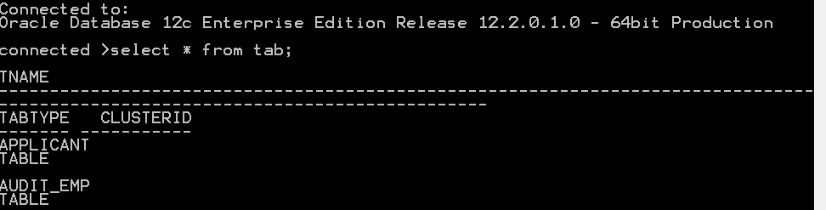

- Connect as system with a password of fenago as follows in SQL*PLUS. You can connect as different users at the SQL*PLUS prompt with the connect command.

connect system/fenago@fenago
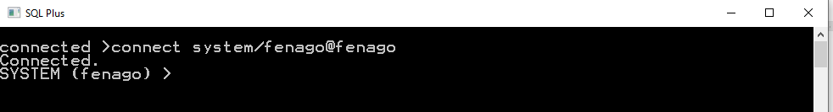
You are automatically disconnected as the hr user.

- Perform a describe on employees in SQL*PLUS.
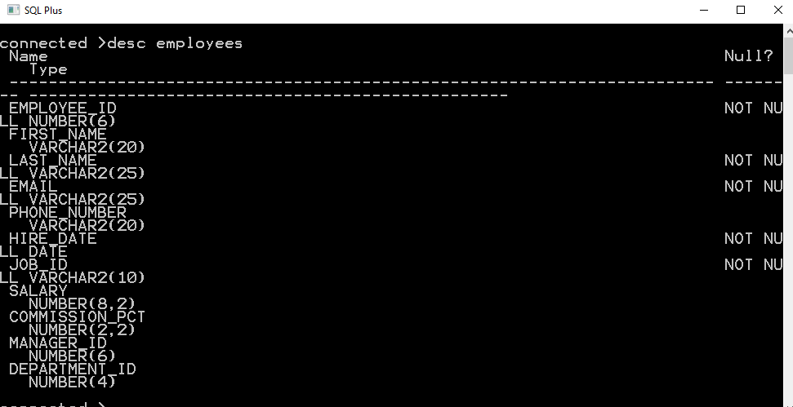

- Execute a sql command to retrieve all the employee data.
SQL> SELECT * FROM EMPLOYEES;.
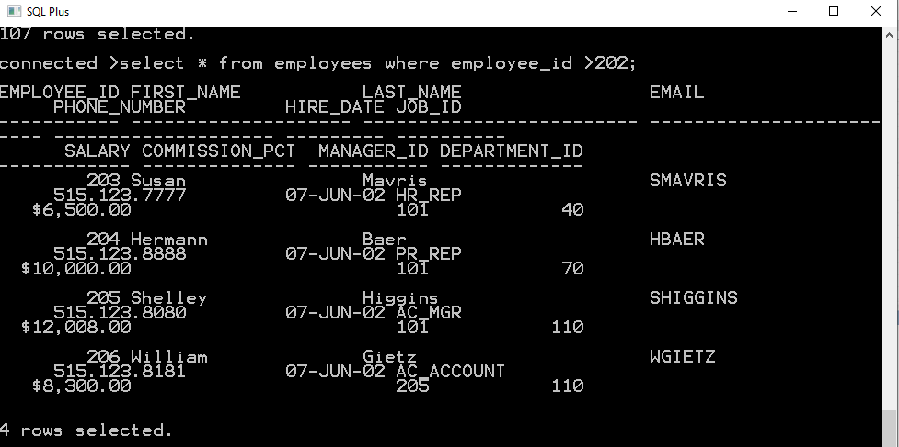

- In SQL*PLUS describe the departments table. Do this in SQL Developer also in order to familiarize yourself with the data. Select the data tab to see all the data.
- Exit from SQL*Plus by typing “EXIT” at the command prompt. Let's sign on to SQL Developer.

- Then perform the same function in SQL Developer. First connect as the hr user in SQL Developer with a password of hr.
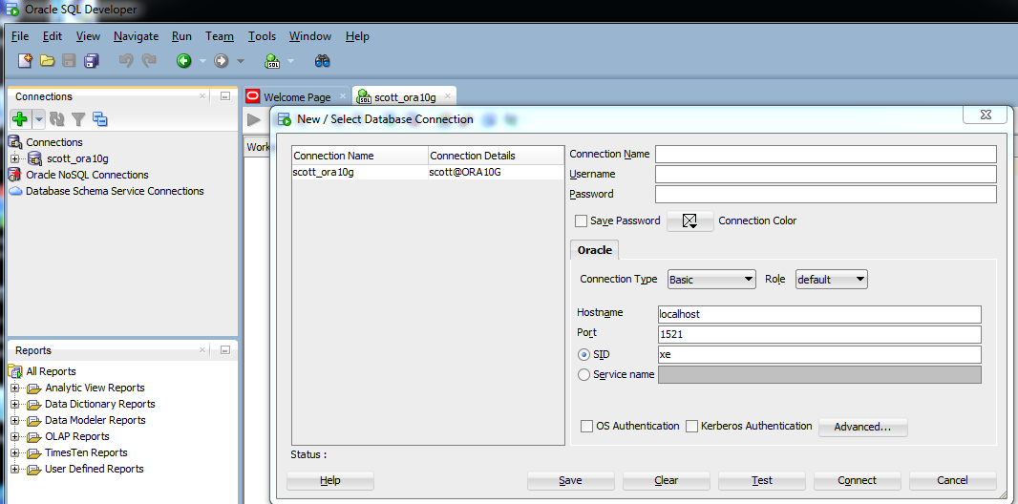

- Now desc employees in SQL Developer as shown below.
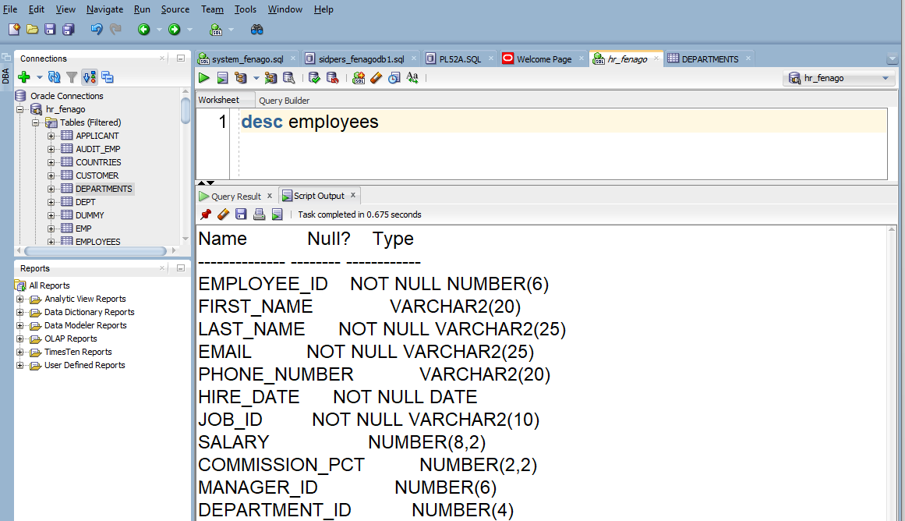

- In SQLDeveloper select all the rows from the employees table.

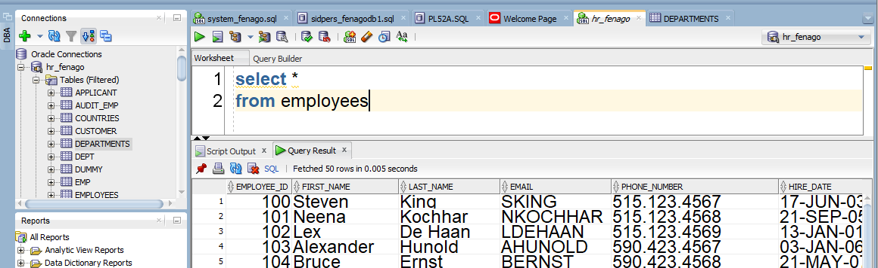

- In your SQL Developer session, logged on as HR with a password of hr, type the following code: (NOTE: the following command purposely contains misspellings) Type the code EXACTLY as it is written here, including the line breaks.

SELECT lat_nam
FROM employes;

- Notice the error messages and let's correct the mistakes.
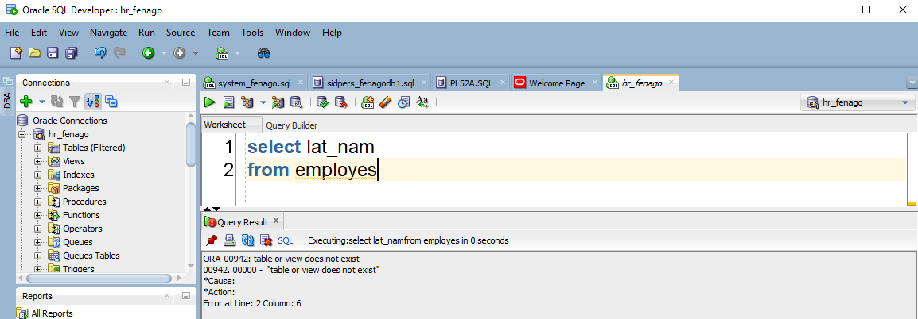

- Make the changes to the lat_nam (should be last_name) and employes (should be employees). When you are finished, re-execute the script by clicking on the green arrow.
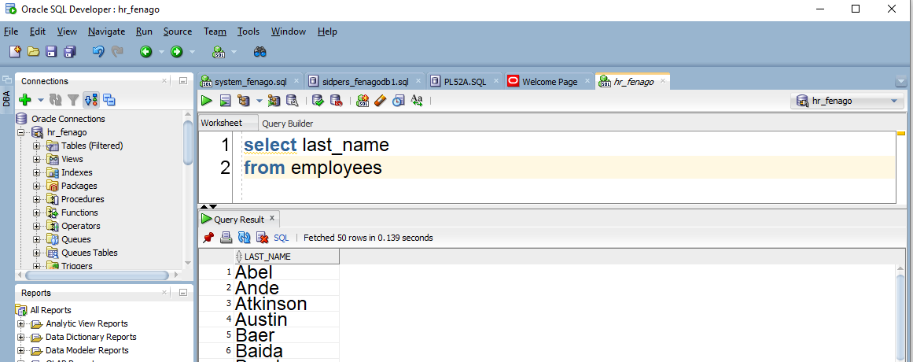

- Now, click on the table icon for DEPARTMENTS
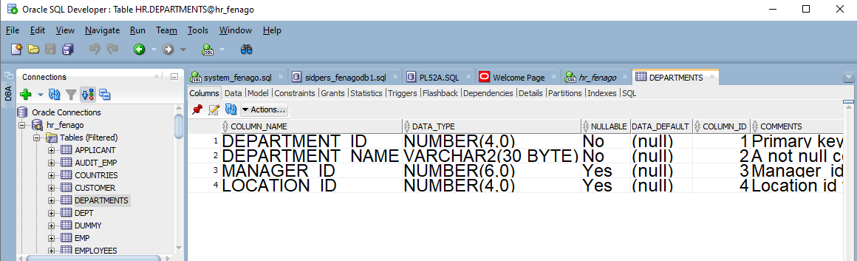

Notice that is shows the columns that belong to the DEPARTMENTS table.Now, click on the Data button to see the data.
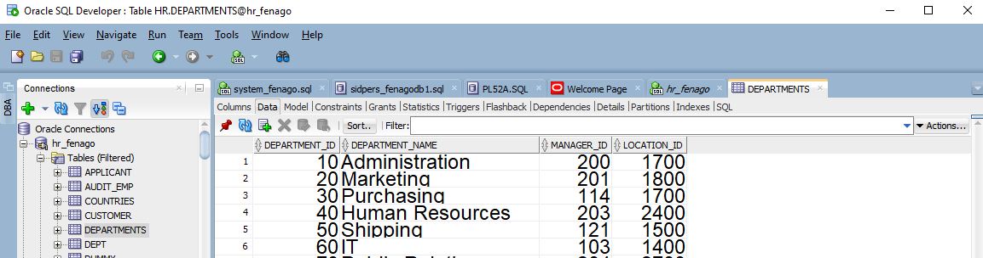
- You can see the data is presented to you as if you have written a sql statement

- Click on the DEPARTMENT_ID Heading and you can change the sort pattern for the SQL statement. Do the same for LOCATION_ID. Notice how you can sort from high to low or low to high.

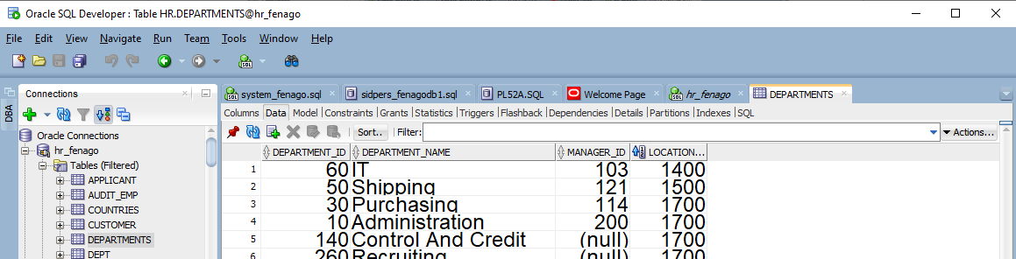

THIS ENDS EXERCISE 1
- Now execute the sql code using the execute script button. Notice the difference in the output?
