Lab 1: Oracle Database Basics
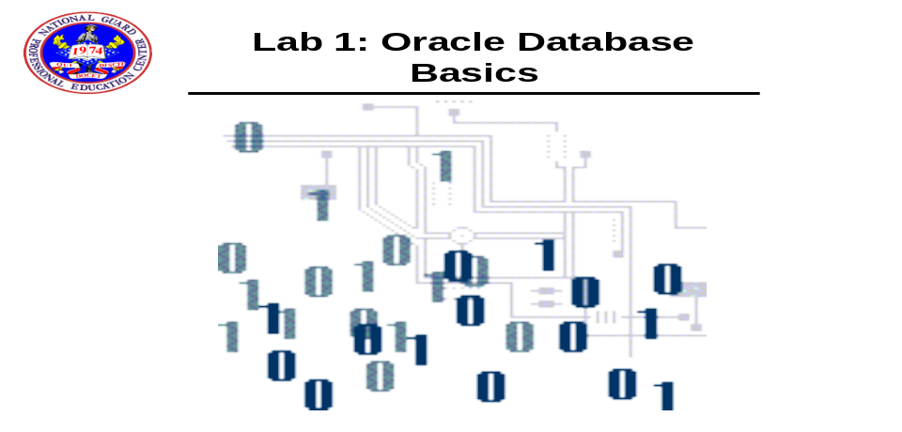

- Open Toad and connect as a Toad User called SCOTT1 using an oracle account user called scott with a password of tiger.

- Perform the following query.

select * From Tab;

- Connect as sidpers with a password of password as follows in TOAD.

- In TOAD and make the connection for sidpers using the Editor Icon
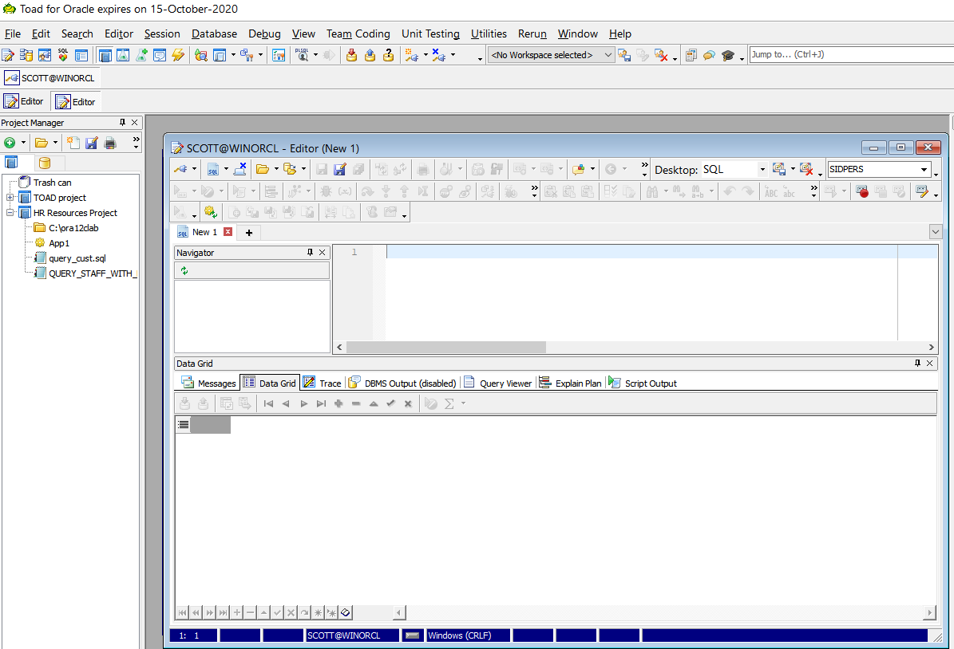

- Perform a describe on pers_person_tbl in TOAD

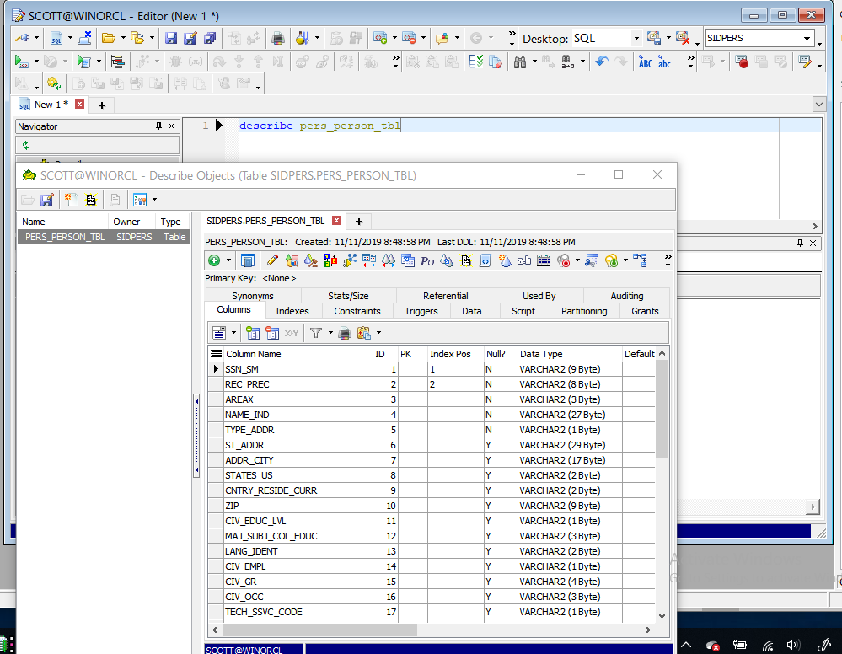

- Perform a describe on pers_svcmbr_tbl.

- In TOAD Editor select all the rows from the Pers_Person_tbl.

- In TOAD describe the Pers_Unit_Tbl.

- In TOAD, find a file called demobld.sql as the scott user and run this as a script.:
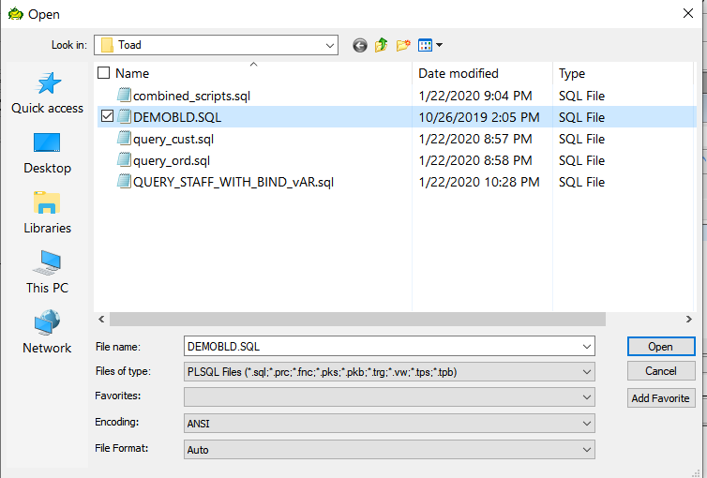

- When you get the Toad for Oracle – Error ORA-00942 just select ignore ALL
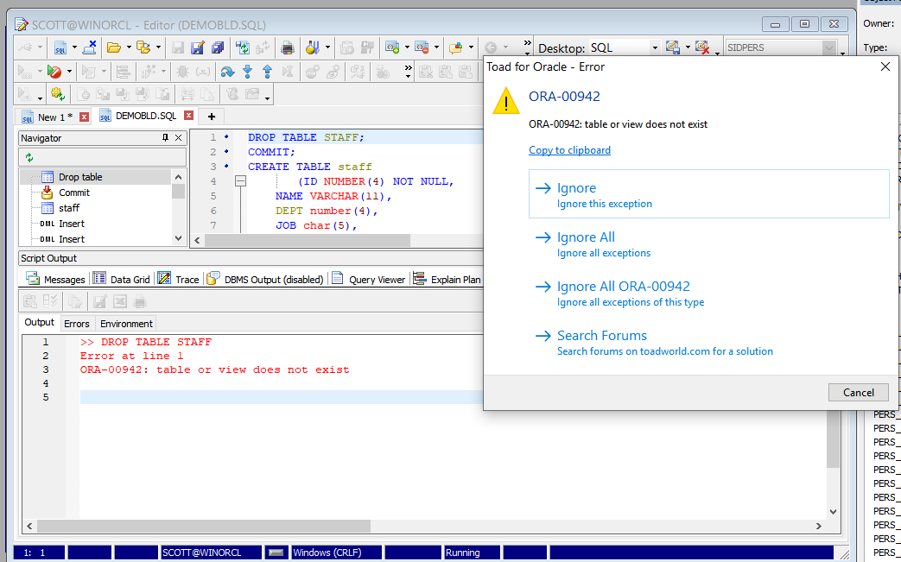

- The error occurs because the table being dropped does not exist. This script is creating it.

