Lab 3-1: Use Character Functions
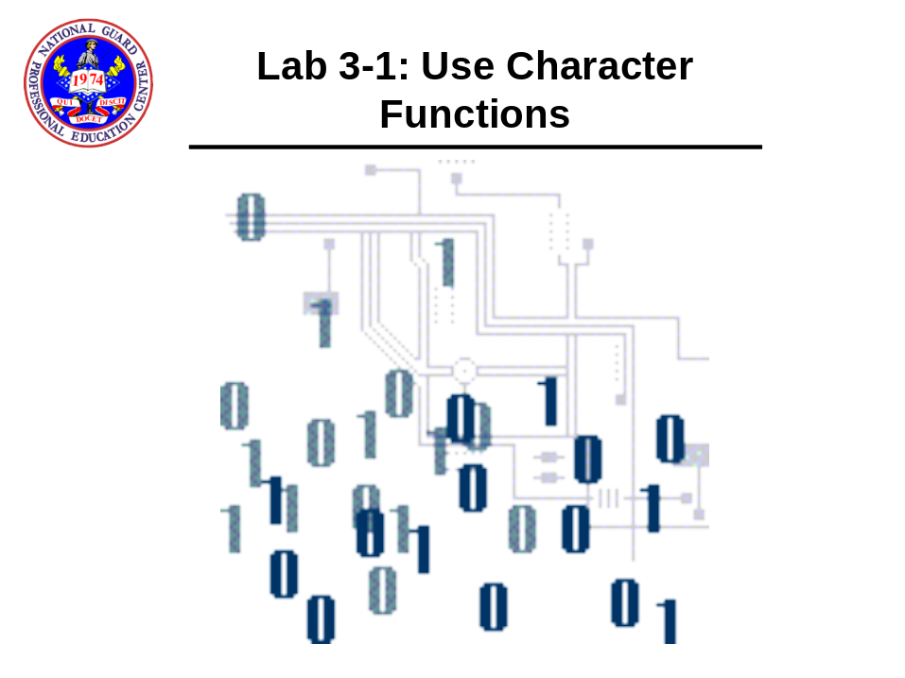

- Perform the following select statements concatenating two columns. Notice the differences.

select concat(addr_city, states_us) from pers_person_tbl where zip = '10302';

select addr_city || ', ' || states_us from
pers_person_tbl where zip = '10302';

- Perform the following select statements and notice the differences:

select name_ind from
pers_person_tbl
where zip = '10302';

select initcap(name_ind) from pers_person_tbl
where zip = '10302';

SELECT UPPER(name_ind) FROM pers_person_tbl
where zip = '10302';

SELECT LOWER(name_ind) FROM pers_person_tbl
where zip = '10302';

- Next, use both INSTR() and SUBSTR() to separate the last name and first name from the name_ind column in the pers_person_tbl: NOTE: There are two spaces between the single quotes below (' '). You might want to save this query for future use.

col "First Name" format a20
col "Last Name" format a20
col name_ind format a20

SELECT name_ind,
SUBSTR(name_ind,
1,
INSTR(name_ind,
' ',
1
) -1
) "Last Name",
SUBSTR(name_ind,
INSTR(name_ind,
' ',
1
) +2,
99
) "First Name"
FROM pers_person_tbl
where zip = '10302';

