Oracle Transactional Business Intelligence

## Contents

Part I Introduction to Oracle Transactional Business Intelligence

1. Get Started with Creating Analyses and Dashboards

About Oracle Transactional Business Intelligence 1-1

About Reports and Dashboards 1-1

View Content on Mobile Devices 1-2

Certification - Supported Browsers 1-2

Part II Report Data

1. Create Analyses

Typical Workflow to Create Analyses 2-1

Create Your First Analysis 2-2

Set Properties for Columns 2-3

Apply Formatting to Content 2-4

Format Columns 2-5

General Custom Format Strings 2-6

Make Your Analyses Dynamic 2-8

Add Interactivity to Analyses 2-8

Make Interactions Available 2-9

Set Default Formats for Your System 2-10

Export Content from Analyses and Dashboards 2-10

Export the Results of Analyses 2-11

Export Dashboards and Dashboard Pages 2-11

Tips for Exporting 2-11

Edit Formulas or Calculated Measures 2-12

Edit the Formula for a Column 2-12

Edit Calculated Measures 2-14

Set Properties for Analyses 2-14

Set Your Preferences 2-15

Combine Subject Areas in Analyses 2-16

About Cross-Subject Area Joins 2-16

Create a Cross-Subject Area Analysis 2-16

Manage Briefing Books 2-17

Add Content to New Briefing Books 2-17

Add Content to Existing Briefing Books 2-18

Download Briefing Books 2-18

Advanced Techniques: Import Formatting from Another Analysis 2-18

About Applying Formatting from Columns 2-18

About Applying Formatting from Views 2-19

About Applying Formatting from Containers 2-19

Import Formatting from a Saved Analysis to a Target Analysis 2-19

Advanced Techniques: Format with HTML Tags 2-19

Advanced Techniques: Combine Columns to Display Data Differently 2-20

Advanced Techniques: Examine the Logical SQL Statements for Analyses 2-21

Advanced Techniques: Set Caching Options for Your Analysis 2-22

Advanced Techniques: Reference Stored Values in Variables 2-22

About Session Variables 2-23

System Session Variables 2-23

Non-System Session Variables 2-24

About Repository Variables 2-24

About Presentation Variables 2-24

About Request Variables 2-25

About Global Variables 2-25

Create Global Variables 2-25

Syntax for Referencing Variables 2-27

Session Variables 2-29

Presentation Variables 2-29

Repository Variables 2-29

1. View Data in Different Ways

Typical Workflow to View Data in Different Ways 3-1

About Views 3-2

Add Views 3-4

Edit Views 3-5

Edit Various Types of Views 3-5

Edit Table and Pivot Table Views 3-6

Edit Performance Tile Views 3-7

Edit Treemap Views 3-8

Edit Heat Matrix Views 3-9

About Heat Matrix Views 3-10

Edit Trellis Views 3-12

About the Functions of Trellis Views 3-14

About Simple Trellis Versus Advanced Trellis 3-14

Design Considerations for Trellis Views and Microcharts 3-16

Edit Gauge Views 3-17

Set Thresholds 3-18

Edit Map Views 3-19

About Map Views 3-19

About Formats and Layers in Map Views 3-21

Edit Formats and Layers in Map Views 3-24

Apply Formats to Layers in Map Views 3-25

Move Around in Map Views 3-25

Set the Initial View Ports for Map Views 3-27

Edit Narrative Views 3-28

Edit Non-Data Views 3-29

About Column Selector Views 3-29

About View Selector Views 3-29

About Filters Views 3-29

About Selection Steps Views 3-30

About Static Text Views 3-30

About Title Views 3-30

Graph Data in Analyses 3-30

Edit Graph Views 3-30

Zoom and Scroll in Graphs 3-31

Format the Visual Appearance of Graphs 3-32

Format Graphs Based on Position 3-33

Format Graphs Based on Columns 3-33

Rules to Apply Conditional Formats in Graphs 3-34

Graph Exceptions for Conditional Formatting on Columns 3-34

Limit Data Displayed in Graphs and Gauges 3-35

Define Section Sliders in Graphs and Gauges 3-35

Use Section Sliders in Graphs and Gauges 3-35

Save Views 3-36

Rearrange Views 3-36

Refresh the Results in Views 3-37

Print Views 3-37

Change Print Options for Views 3-37

Preview How Views Are Displayed on Dashboards 3-38

Remove Views 3-38

Sort Values in Views 3-39

Clear Sorts in Views 3-40

Drill in Results 3-40

About Drilling 3-41

Drill in Tables and Other Views 3-41

Drill in Graphs 3-42

Drill in Map Views 3-43

Resize Rows and Columns in Views 3-43

Configure to Resize in Views 3-44

Resize in Views 3-44

Suppress Null Values in Views 3-45

Assemble Views for Display 3-45

Link Views in Master-Detail Relationships 3-46

Define Master Views 3-47

Define Detail Views 3-47

Modify the Layout of Data in Views 3-49

Add and Rearrange Columns in Views 3-49

Add Columns to Views 3-49

Remove Columns from Views 3-49

Rearrange Columns in Views 3-49

Set Properties for Sections of Data in Views 3-50

Add Totals to Tables and Pivot Tables 3-51

Display Running Sums and Relative Values in Pivot Tables 3-52

Display Running Sums for Measure Columns in Pivot Tables 3-52

Display Relative Values for Measure Columns in Pivot Tables 3-53

About Drop Targets in the Layout Pane 3-53

About the Types of Drop Targets 3-54

About the Excluded Drop Target 3-54

About the Guidelines for Drop Targets for Various Views 3-55

Drop Target Guidelines for Graphs and Funnel Graphs 3-55

Drop Target Guidelines for Heat Matrixes 3-56

Drop Target Guidelines for Trellises 3-57

Drop Target Guidelines for Treemaps 3-57

1. Build Dashboards

Typical Workflow to Build Dashboards 4-1

Create Your First Dashboard 4-2

Edit Dashboards 4-3

Add and Delete Pages in Dashboards 4-3

Add Pages to Dashboards 4-4

Add Subpages to Dashboards 4-4

Add Content to Dashboard Pages 4-4

Understand How Dashboard Pages and Publisher Reports Interact 4-5

Configure the Style and Behavior of Dashboards and Pages 4-5

Change the Properties of Objects Added to Dashboard Pages 4-6

Delete Objects on Dashboard Pages 4-7

Delete Dashboard Pages 4-7

Delete Dashboard Subpages 4-8

Create and Manage Layouts for Dashboards and Dashboard Pages 4-8

About Custom Print and Export Layouts 4-8

Create Custom Layouts 4-9

Edit, Replace, or Remove Custom Layouts 4-10

Items Not Supported for Custom Print Layouts in Publisher 4-10

Print Dashboards 4-10

Organize Dashboard Pages in Briefing Books 4-11

Add Content to New or Existing Briefing Books 4-11

Edit the Content of Briefing Books 4-11

Download Briefing Books 4-12

Add a List of Briefing Books to a Dashboard Page 4-12

Improve the Time to Display Dashboard Pages with Default Selections 4-13

Save and Restore Dashboard State 4-14

Save Customizations of Dashboard Pages 4-14

Apply Saved Customizations 4-14

Edit Saved Customizations 4-15

Clear the Current Customization 4-15

Publish Dashboard Pages 4-15

Link to Dashboard Pages 4-16

About Bookmark Links 4-16

Create Bookmark Links to Dashboard Pages 4-16

1. Filter and Select Data for Analyses

Typical Workflow to Filter and Select Data 5-1

About Filters and Selection Steps 5-2

About Prompted Filters 5-2

Create Filters for Columns 5-2

Create Inline and Named Filters 5-3

Specify Values for Filters 5-3

Combine and Group Filters 5-5

Save Filters 5-5

Edit Filters for Columns 5-6

Reuse Filters 5-7

Use a Saved Analysis as a Filter 5-8

Advanced Techniques: How Dashboard Prompts and Analysis Prompts Interact 5-8

Refine Selections of Data 5-9

Create Selection Steps 5-10

Edit Selection Steps 5-10

Save Selection Steps for Reuse 5-11

Advanced Techniques: Create Condition Steps 5-11

Manipulate Members with Groups and Calculated Items 5-13

About Groups and Calculated Items 5-13

Create Groups and Calculated Items 5-14

Edit Groups and Calculated Items 5-15

View Group Contents 5-16

Save Groups and Calculated Items 5-16

Reuse a Group or Calculated Item in an Analysis 5-17

Delete Groups and Calculated Items 5-18

1. Prompt in Analyses and Dashboards

Typical Workflow to Create Prompts in Analyses and Dashboards 6-1

Create Prompts 6-1

Create Column Prompts 6-2

Create Variable Prompts 6-3

Override a Selection Step with a Prompt 6-5

Create Currency Prompts 6-5

About Prompts Auto-Complete 6-6

Edit Prompts 6-7

About Improving the Performance of Dashboard Prompts 6-7

Add Prompts to Dashboard Pages 6-8

Add Hidden Prompts to Dashboard Pages 6-8

1. Make Analyses Interactive

Typical Workflow to Make Analyses Interactive 7-1

Create Named Actions for Reuse 7-2

Create Inline Actions 7-3

Add Actions to Analyses 7-3

Add Actions to Dashboard Pages 7-4

Add Actions to Dashboard Pages with Action Links 7-4

Add Actions to Dashboard Pages with Action Link Menus 7-5

Add Actions to KPIs 7-5

Add Actions to Initiatives and Objectives in Scorecards 7-6

Create an Action Based on an Existing Named Action 7-6

Edit Actions Added to Agents 7-7

Edit Actions and Action Links Added to KPIs 7-7

Edit Actions and Actions Links Added to Initiatives and Objectives in Scorecards 7-7

Edit Named Actions 7-8

Edit and Delete Action Links in Analyses 7-8

Edit and Delete Action Links in Dashboard Pages 7-9

Save Inline Actions in Analyses to the Catalog 7-10

Save Inline Actions in Dashboards to the Catalog 7-10

1. Using KPIs and KPI Watchlists

What Are KPIs? 8-1

How Are KPIs Evaluated? 8-2

How Can I Use KPIs? 8-2

What Are Dimensions and Pinned Dimension Values? 8-3

How Do I Create a KPI? 8-4

Create KPIs 8-5

Edit KPIs 8-8

Edit KPIs from the Catalog 8-8

Edit KPIs from a KPI Watchlist 8-8

What Are Target Settings? 8-8

Prerequisites for Setting Up Target Settings in KPIs 8-8

Overview of Setting Up Target Settings in KPIs 8-9

User Interaction with Target Settings 8-10

Generate Analyses from KPIs 8-10

Create Agents from KPIs 8-11

Contact the Business Owner of KPIs 8-12

About Overriding Statuses of KPIs 8-13

About Adding Comments to KPIs 8-13

What Are KPI Watchlists? 8-14

Create KPI Watchlists 8-14

Edit KPI Watchlists 8-15

1. Scorecarding

What Is Oracle Scorecard and Strategy Management? 9-2

What Is a Balanced Scorecard? 9-3

What Is the Scorecard Editor? 9-5

What Are Scorecard Objects? 9-6

How Do I Create a Scorecard? 9-7

Use the Edit and View Modes in the Scorecard Editor 9-8

Create Scorecards 9-9

Open or Edit Scorecards 9-9

View Overview Information 9-10

About the Point of View Area 9-11

Set Up the Point of View Controls 9-13

What Are Vision Statements? 9-13

Define Vision Statements 9-13

What Are Mission Statements? 9-14

Define Mission Statements 9-14

What Are Perspectives? 9-15

Create Custom Perspectives 9-16

What Are Key Performance Indicators (KPIs)? 9-17

What Are Objectives? 9-17

Create Objectives 9-18

Complete the Analytics Pane for Objectives or Initiatives 9-19

What Are Initiatives? 9-20

Create Initiatives 9-21

Contact Business Owners 9-22

About Comments 9-22

Work with Comments 9-23

Work with Comments in the Collaboration pane 9-24

Work with Comments in Watchlists 9-24

Work with Comments in the Diagram Tab of a View 9-25

Understand Initiative or Objective Performance Assessment 9-25

About Assessment Mappings 9-26

Example of Determining the Performance Assessment for an Objective Based on Child Objectives 9-27

Example of Determining the Performance Assessment for an Objective Based on a

Child KPI 9-28

Define Assessment Mappings for Scorecards 9-29

Assign Weights to Child Objectives, Initiatives and KPIs 9-29

About Status Overrides 9-30

Work with Status Overrides 9-30

Work with Status Overrides in Watchlists 9-31

Work with Status Overrides in the Diagram Tab of a View 9-31

What Are Strategy Trees? 9-32

Understand a Strategy Tree Diagram 9-32

Understand a Strategy Contribution Wheel Diagram 9-33

Create Strategy Trees 9-34

What Are Strategy Maps? 9-35

Create Strategy Maps 9-36

What Are Cause & Effect Maps? 9-38

Create Cause & Effect Maps 9-39

Understand Watchlists 9-40

Customize Watchlists 9-41

What Are KPI Watchlists? 9-42

Work with KPI Details 9-43

What Are Smart Watchlists? 9-44

Create Smart Watchlists 9-45

What Are Custom Views? 9-46

Create Custom Views 9-46

Open Scorecard Objects 9-47

Edit Scorecard Objects 9-48

Delete Scorecard Objects 9-48

Add Scorecard Objects to Dashboards 9-48

1. Managing Content

Typical Workflow to Manage Content 10-1

Find Catalog Objects 10-2

About Searching for Catalog Objects 10-2

Search for Catalog Objects 10-3

About Naming Restrictions for Catalog Objects 10-3

Rename Content 10-4

Rename Items 10-4

Rename Views 10-4

Access Favorites Easily 10-4

Add Favorites from Catalog Page 10-5

Remove Content from your Favorites List 10-5

Add or Remove Favorites from Other Pages 10-5

Access Properties 10-5

Assign Access Permissions 10-6

Add or Update Item Permissions 10-6

Add or Update Dashboard Section Permissions 10-7

Control Authoring and Folder Permissions 10-8

Remove Analysis Editor and BI Composer Access from the BI Author Role 10-8

Restrict Access to the Custom Folder in Shared Folders 10-9

Allow Access to Only My Folder 10-10

Send Email Reports 10-10

Send Email Reports Once, Weekly, or Daily 10-11

Email Security Alert 10-11

Automate Business Processes With Agents 10-11

What Are Agents? 10-12

What Are Alerts? 10-12

How Agents Work 10-12

What Is the Agent Editor? 10-13

About Controlling Access to Agents 10-13

About Using Customization in Agents 10-14

Create Agents to Deliver Content 10-15

View Summaries of Agent Settings 10-17

Schedule an Agent to Deliver Content Directly from an Analysis 10-17

Disable and Enable the Schedule for an Agent 10-17

Subscribe to Agents 10-17

List Agents You Subscribe To or Own 10-18

Access and Manage Your Alerts 10-18

Configure Your Devices and Delivery Profile 10-18

About Devices and Delivery Profiles 10-18

Configure Your Devices 10-19

Configure Your Delivery Profiles 10-20

Migrate Content to Other Catalogs 10-20

Save Content to a Catalog Archive 10-21

Upload Content from a Catalog Archive 10-21

Track the Progress of Your Catalog Unarchive Jobs 10-22

Assign Ownership of Items 10-22

Assume Ownership of Items 10-23

Allow Safe Domains 10-23

About Embedding External Images and Other External Resources in Your Content 10-24

Embed Your Content in Other Applications 10-24

1. Use BI Composer to Analyze Your Data

What Is BI Composer? 11-1

Where Is BI Composer Available? 11-2

Availability of BI Composer 11-2

Compare the Analysis Editor and BI Composer 11-2

What Types of Views Can I Work with in BI Composer? 11-2

Create or Edit an Analysis in BI Composer 11-3

Create Analyses Using BI Composer 11-4

Edit Analyses Using BI Composer 11-4

View Analyses in BI Composer 11-5

Edit Analyses Created in Analysis Editor 11-5

Part III Reference

1. Frequently Asked Questions

FAQs to Explore and Report 12-1

FAQs for Analyses and Dashboards 12-3

1. Troubleshooting for Oracle Transactional Business Intelligence

Troubleshoot General Issues 13-1

Troubleshoot Issues with Analyses and Dashboards 13-1

1. Expression Editor Reference

SQL Operators 14-1

Conditional Expressions 14-3

Functions 14-4

Aggregate Functions 14-4

Analytics Functions 14-8

Date and Time Functions 14-9

Conversion Functions 14-10

Display Functions 14-11

Mathematical Functions 14-12

Running Aggregate Functions 14-15

String Functions 14-16

System Functions 14-20

Time Series Functions 14-20

Constants 14-22

Types 14-23

Variables 14-23

1. Accessibility Features and Tips

Enable Accessibility Mode for Oracle Transactional Business Intelligence 15-1

Keyboard Shortcuts for Dashboards and Agents 15-2

Keyboard Shortcuts for BI Composer 15-3

# Part I

## Introduction to Oracle Transactional Business Intelligence

This part introduces you to analyzing data and building dashboards.

# 1

## Get Started with Creating Analyses and Dashboards

This chapter describes how to get started with creating analyses and dashboards.

Topics:

* + About Oracle Transactional Business Intelligence
  + About Reports and Dashboards

### About Oracle Transactional Business Intelligence

Oracle Transactional Business Intelligence helps you quickly uncover business insights and make more informed business decisions.

Oracle Transactional Business Intelligence helps you query your business data and create analyses to answer your business questions. You can present data in easy-to-understand formats (such as tables and graphs), create dashboards, and share the results of analyses.

### About Reports and Dashboards

You use analyses, projects, and dashboards to find the answers that you need from key business data displayed in graphical formats.

An analysis is a query against your organization's data that provides you with answers to business questions. Analyses enable you to explore and interact with information visually in tables, graphs, pivot tables, and other data views. You can also save, organize, and share the results of analyses with others.

A project enables you to dynamically explore multiple datasets in graphical way, all within a single interface. You can upload data from many commonly used data sources to create robust sets of information within project visualizations.

Dashboards can include multiple analyses to give you a complete and consistent view of your company’s information across all departments and operational data sources. Dashboards provide you with personalized views of information in the form of one or more pages, with each page identified with a tab at the top. Dashboard pages display anything that you have access to or that you can open with a web browser including analyses results, images, text, links to websites and documents, and embedded content such as web pages or documents.

Chapter 1

View Content on Mobile Devices

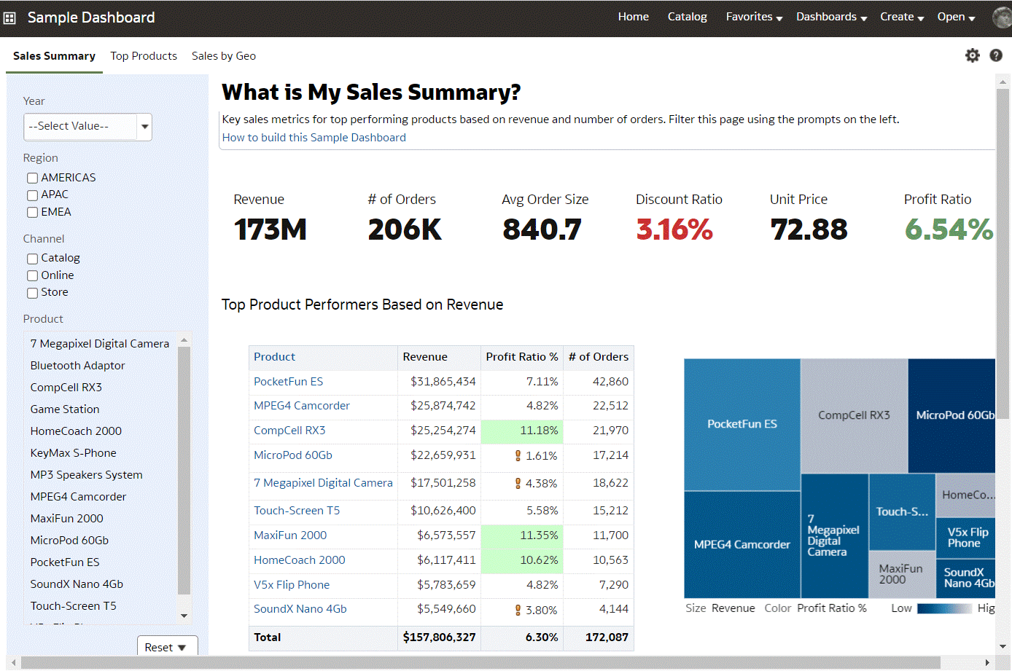

When you embed an analysis in a dashboard, the analysis automatically displays the most current data every time you access the dashboard. For example, if you're a sales executive whose company captures sales data on a daily basis, then you can have the dollar volume by product sold today displayed when you open or run the dashboard.

# Part II

## Report Data

This part explains how to work with data reports.

Topics:

* + Create Analyses
  + View Data in Different Ways
  + Build Dashboards
  + Filter and Select Data for Analyses
  + Prompt in Analyses and Dashboards
  + Make Analyses Interactive
  + Using KPIs and KPI Watchlists
  + Scorecarding
  + Managing Content
  + Use BI Composer to Analyze Your Data

# 2

## Create Analyses

This chapter describes how to create an analysis.

Topics:

* + Typical Workflow to Create Analyses
  + Create Your First Analysis
  + Set Properties for Columns
  + Export Content from Analyses and Dashboards
  + Edit Formulas or Calculated Measures
  + Set Properties for Analyses
  + Set Your Preferences
  + Combine Subject Areas in Analyses
  + Manage Briefing Books
  + Advanced Techniques: Import Formatting from Another Analysis
  + Advanced Techniques: Format with HTML Tags
  + Advanced Techniques: Combine Columns to Display Data Differently
  + Advanced Techniques: Set Caching Options for Your Analysis
  + Advanced Techniques: Examine the Logical SQL Statements for Analyses
  + Advanced Techniques: Reference Stored Values in Variables

### Typical Workflow to Create Analyses

Here are the common tasks to start creating analyses.

|  |  |  |
| --- | --- | --- |
| **Task** | **Description** | **More Information** |
| Create an analysis | Select and arrange | Create Your First Analysis |
|  | columns that you want to |  |
|  | use in an analysis. |  |
| Set properties for columns | Specify properties such as | Set Properties for Columns |
|  | heading and value |  |
|  | formats, display of data, |  |
|  | and conditional formatting. |  |
| Work with the data in the | Add formulas and | Edit Formulas or Calculated Measures |
| analysis | calculated measures to |  |
|  | the analysis. |  |
| Affect the values of data in the | Specify filters, selection | Filter and Select Data for Analyses |
| analysis | steps, groups, and |  |
|  | calculated items for the |  |
|  | analysis. |  |

Create Your First Analysis

### Create Your First Analysis

You can quickly create an analysis to query against your organization's data. The analysis results help you answer your business questions. For example, you can create an analysis using the SampleApp subject area Brand and Revenue columns.

[Video](http://apexapps.oracle.com/pls/apex/f?p=44785%3A265%3A0%3A%3A%3A%3AP265_CONTENT_ID%3A29116)

* 1. On the Classic Home page, in the **Create** pane, click **Analysis**.
  2. Use the Select Subject Area dialog to search for and select a subject area.
  3. Add the columns that you want to include in the analysis by dragging and dropping them from the Subject Areas pane to any position within the Selected Columns pane. You can select multiple non-contiguous columns by using the Ctrl key, selecting each column to include, and then dragging the columns to the Selected Columns pane.

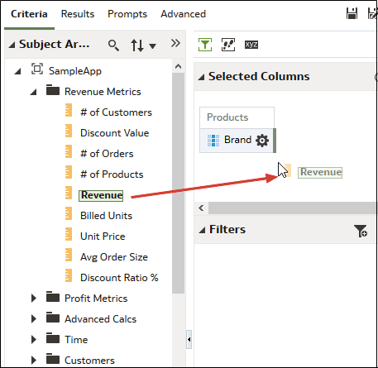

* 1. To change the column order, use the crosshairs on the column to drag and drop the column to a different position.

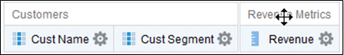

* 1. To save a column to the catalog, in the Selected Columns pane, click **Options**

beside the column name, and click **Save Column As**.

* 1. In the Save As dialog, specify the folder, name, and description for the column and click **OK**.
  2. To remove a column, in the Selected Columns pane, click **Options** beside the column name, and click **Delete**.

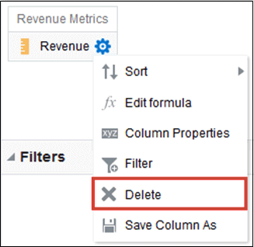

To remove all columns, click **Remove all columns from criteria**. Note that there is no undo action available for this option. Instead of removing columns, you can hide the columns whose appearance adds no value to the analysis.

* 1. Click the Results tab to see the results of the analysis in a table or pivot table.

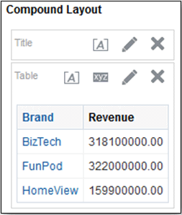

* 1. Click **Save Analysis** to display the dialog to save the analysis.
  2. In the Save As dialog, select a folder, and specify a name, and optional description for the analysis.

If you want others to be able to view the analysis, then save it in the shared folder area. If your analysis contains other objects, then you'll be prompted to assign access permissions to those objects.

If you don’t want anyone else but yourself to be able to view the analysis, then save it in

My Folders.

* 1. Click **Refresh** at the bottom of the pane to double-check that the analysis is listed under the folder in which you saved it.

### Set Properties for Columns

When you build an analysis, you can edit column properties to control the look and feel of the column. For example, you can specify that values in the Revenue column are displayed with two decimal places and a dollar sign.

1. Open the analysis for editing.
2. In the Selected Columns pane, click **Options** beside the column name, and then select **Column Properties**.

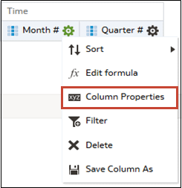

1. Specify how you want column values to be displayed.
2. Format column headings and custom text, and add data display conditions.
3. Specify what action you want to happen when a user clicks a column heading or value.
4. Set default column formatting.
5. Click **OK**.

#### Apply Formatting to Content

You can apply basic formatting to values in many types of content including columns, views, and dashboard page sections.

For example, you might want region names in a column to be displayed as Arial 14 point and red. You might also want state names to be displayed as Calibri 12 point and blue.

1. In the Selected Columns pane, click **Options** beside the column name, and then select **Column Properties**.
2. Specify the style characteristics of the column such as font, cell alignment, and border.

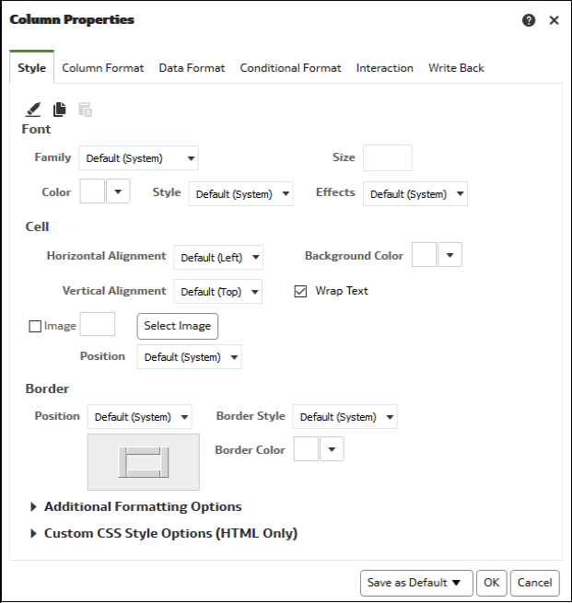

1. Click **OK**.

#### Format Columns

When you create an analysis, you can edit properties for columns to control their appearance and layout. You can also specify formatting to apply only if the contents of the column meet certain conditions.

For example, you can specify that values that exceed $1 million in the Revenue column are displayed with a green background.

1. In the Selected Columns pane, click **Options** beside the column name, and then select

Column Properties.

1. In the Column Properties dialog, click the Column Format tab.
2. To hide the column in the analyses without affecting value aggregation, select the **Hide**

check box.

For example, you might want to build an analysis that includes only Illinois customers. You can hide the Customers.State column because you only added this column for filtering purposes.

1. To enter your own values in the **Folder Heading** and **Column Heading** fields, select **Custom Headings** . You can use these fields to reference variables and format the heading values. These values identify the column in the analysis.
2. If you have administrator privileges and want to customize headings with HTML markup, including JavaScript, select **Custom Heading**, then select **Contains HTML Markup**, and then enter the HTML markup you want to apply.
3. To affect the display of repeating data values for the column, select one of the **Value Suppression** options.

When the same value occurs in multiple consecutive rows, you can specify to show that value only once.

1. To override the default display of data for the column, click the Data Format tab.

The options on the tab differ depending on the data type.

1. To specify if column values are displayed in a certain way based on certain criteria, click the Conditional Format tab. Conditional formats can include colors, fonts, images, and so on, for the data and for the cell that contains the data. You can’t apply conditional formatting to the data cell background or font color in a heat matrix.
2. Click **Add Condition**, and then select a column.

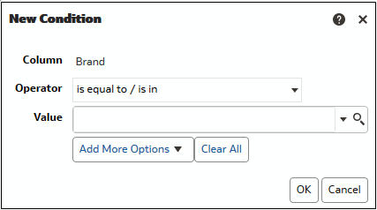

1. Select an operator such as **is equal to / is in** or **is greater than**.
2. Specify a value for the operator by either entering a value directly (such as 1000000) or by selecting a value from the list.
3. Optional: Click **Add More Options** to add a variable to the condition.
4. Specify the formatting to apply when the condition is true.
5. Click **OK**.

#### General Custom Format Strings

You can use general custom format strings to create custom time or date formats.

The table shows the general custom format strings and the results that they display. These allow the display of date and time fields in the user's locale.

**General Format String**

**Result**

[FMT:dateShort] Formats the date in the locale's short date format. You can also type

[FMT:date].

[FMT:dateLong] Formats the date in the locale's long date format.

[FMT:dateInput] Formats the date in a format acceptable for input back into the system. [FMT:time] Formats the time in the locale's time format.

[FMT:timeHourMi n]

Formats the time in the locale's time format but omits the seconds.

[FMT:timeInput] Formats the time in a format acceptable for input back into the system.

[FMT:timeInputH ourMin]

[FMT:timeStamp Short]

Formats the time in a format acceptable for input back into the system, but omits the seconds.

Equivalent to typing [FMT:dateShort] [FMT:time]. Formats the date in the locale's short date format and the time in the locale's time format. You can also type [FMT:timeStamp].

**General Format String**

[FMT:timeStampL ong]

[FMT:timeStampI nput]

**Result**

Equivalent to typing [FMT:dateLong] [FMT:time]. Formats the date in the locale's long date format and the time in the locale's time format.

Equivalent to [FMT:dateInput] [FMT:timeInput]. Formats the date and the time in a format acceptable for input back into the system.

[FMT:timeHour] Formats the hour field only in the locale's format, such as 8 PM. YY or yy Displays the last two digits of the year, for example 11 for 2011.

YYY or yyy Displays the last three digits of the year, for example, 011 for 2011.

YYYY or yyyy Displays the four-digit year, for example, 2011.

M Displays the numeric month, for example, 2 for February.

MM Displays the numeric month, padded to the left with zero for single-digit months, for example, 02 for February.

MMM Displays the abbreviated name of the month in the user's locale, for example, Feb.

MMMM Displays the full name of the month in the user's locale, for example,

February.

D or d Displays the day of the month, for example, 1.

DD or dd Displays the day of the month, padded to the left with zero for single-digit days, for example, 01.

DDD or ddd Displays the abbreviated name of the day of the week in the user's locale, for example, Thu for Thursday.

DDDD or dddd Displays the full name of the day of the week in the user's locale, for example, Thursday.

DDDDD or ddddd Displays the first letter of the name of the day of the week in the user's locale, for example, T for Thursday.

r Displays the day of year, for example, 1.

rr Displays the day of year, padded to the left with zero for single-digit day of year, for example, 01.

rrr Displays the day of year, padded to the left with zero for single-digit day of year, for example, 001.

w Displays the week of year, for example, 1.

ww Displays the week of year, padded to the left with zero for single-digit weeks, for example, 01.

q Displays the quarter of year, for example, 4.

h Displays the hour in 12-hour time, for example 2.

H Displays the hour in 24-hour time, for example, 23.

hh Displays the hour in 12-hour time, padded to the left with zero for single- digit hours, for example, 01.

HH Displays the hour in 24-hour time, padded to the left with zero for single digit hours, for example, 23.

m Displays the minute, for example, 7.

mm Displays the minute, padded to the left with zero for single-digit minutes, for example, 07.

**General Format String**

**Result**

s Displays the second, for example, 2.

You can also include decimals in the string, such as s.# or s.00 (where # means an optional digit, and 0 means a required digit).

ss Displays the second, padded to the left with zero for single-digit seconds, for example, 02.

You can also include decimals in the string, such as ss.# or ss.00 (where # means an optional digit, and 0 means a required digit).

S Displays the millisecond, for example, 2.

SS Displays the millisecond, padded to the left with zero for single-digit milliseconds, for example, 02.

SSS Displays the millisecond, padded to the left with zero for single-digit milliseconds, for example, 002.

tt Displays the abbreviation for ante meridiem or post meridiem in the user's locale, for example, pm.

gg Displays the era in the user's locale.

#### Make Your Analyses Dynamic

You can specify what you want to happen when a user clicks a column heading or value in an analysis. For example, you could specify that when a user clicks the Product column value, it drills down into the data that was summed to create the column value.

Topics:

* + Add Interactivity to Analyses
  + Make Interactions Available

##### Add Interactivity to Analyses

You can make views more interactive by adding interactions that are available to users who left-click in a view or right-click to display a popup menu. For example, you might specify the default primary interaction (the left-click action) for a geographical region column as **Drill**. This enables users to drill down to sub-regions.

For hierarchical data, the default left-click interaction is to drill down to detail in the data. You can add right-click options that display a web page or link to a view.

1. Open the analysis for editing.
2. In the Selected Columns pane, click **Options** beside the column name, and then select **Column Properties**.
3. In the Column Properties dialog, click the Interaction tab.

You can specify interactions for the column heading and data values.

1. Click **Primary Interaction** next to **Column Heading** or **Value** and select the behavior you want. For example, select None to disable the action or select Drill to display more detail.
   * Use None to disable all interactions on the column.
   * Use **Drill** to display a deeper level of detailed content if the data is hierarchical. If no hierarchy is configured for the column, then drilling isn’t enabled.
   * Use **Action Links** to opens a web page or navigates to supporting BI content.
   * Use **Send Master-Detail Events** to connect views so that one view drives changes in one or more other views.
2. Click **OK**.

You can specify the interactions that are available at runtime when you right-click a dashboard column or data cell. Here’s an example of the available interactions when you right-click a product name in the Products column. This column is in a Top Product Performers Based on Revenue table.

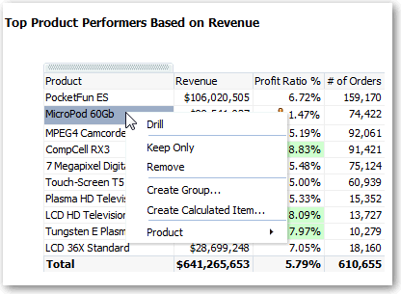

Of the selections shown, you can set **Drill**, **Create Group**, and **Create Calculated Item**.

##### Make Interactions Available

When you add interactions to analyses, you then make those interactions available to others in popup menus.

1. Open the analysis for editing.
2. Click either the Criteria tab or the Results tab.
3. Click **Edit Analysis Properties** on the toolbar.
4. Click the Interactions tab.

Export Content from Analyses and Dashboards

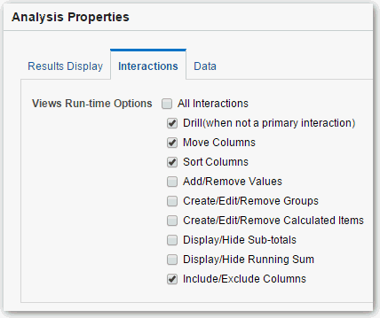

1. Select the interactions that you want to make available for that analysis.
2. Click **OK**.

#### Set Default Formats for Your System

If you have the appropriate privileges, then you can save the formatting of a column as default formatting. When you set a system-wide default, it can provide users with a more consistent experience and save them time when working with analyses.

For example, you might set Times New Roman as the system-wide default for text columns.

A best practice is to change the default value rather than overriding the default with specific values.

1. Open an analysis for editing.
2. In the Selected Columns pane, click **Options** beside the column name, and then select **Column Properties**.
3. In the Column Properties dialog, specify how you want columns to be formatted by default.
4. Click **Save as Default**.
5. Click **OK**.

### Export Content from Analyses and Dashboards

You can export content from analyses and dashboards.

Topics:

* + Export the Results of Analyses
  + Export Dashboards and Dashboard Pages
  + Tips for Exporting

Export Content from Analyses and Dashboards

#### Export the Results of Analyses

You can export analyses results to various formats, including data and formatting in Microsoft Office Excel, Adobe PDF, and CSV formats, and various data-only formats (that is, with no formatting).

For example, you can export a Stock Control analysis, so that one of your suppliers can see the results in Microsoft Excel.

1. Open the analysis for editing.
2. To export data and formatting, click **Export this analysis** then **Formatted**, and choose an output format.
3. To export just data, click **Export this analysis** then **Data**, and choose an output format.

#### Export Dashboards and Dashboard Pages

You can export an entire dashboard or a single dashboard page to Microsoft Excel 2007+. When you export dashboard content to Microsoft Excel, the state of the dashboard (such as prompts or drills) won’t change.

For example, you can export the dashboard page that contains the Brand Revenue analysis. This enables brand managers to review this data in Microsoft Excel.

1. Open the dashboard or dashboard page that you want to export.
2. On the Dashboard page toolbar, click **Page Options**, select **Export to Excel**, and select either **Export Current Page** or **Export Entire Dashboard**.

If you export an entire dashboard:

* + Each page is included on its own sheet in an Excel workbook.
  + Each sheet is given the name of its corresponding dashboard page.

1. Use the File Download dialog to open or save the dashboard or dashboard page as a spreadsheet file.

#### Tips for Exporting

Here are some tips on exporting data from analyses, dashboards, and dashboard pages.

* + By default, the **Value Suppression** option in the Column Properties dialog:Column Format tab determines if the cells in tables or pivot tables that span rows and cells that span columns are repeated when exporting to Excel (rather than always repeated). Don’t suppress values when exporting to Excel if those who use the Excel spreadsheets want to manipulate the data.
    - If **Value Suppression** is set to **Suppress**, then cells that span rows and cells that span columns aren’t repeated. For example, in a table that has Year and Month values, Year is displayed only once for Month values. This value suppression is useful if you want to simply view data in Excel spreadsheets.
    - If **Value Suppression** is set to **Repeat**, then cells that span rows and cells that span columns are repeated. For example, in a table that has Year and Month values, Year is repeated for all Month values.
  + In PDF format, rows are split across page breaks rather than kept together.

Edit Formulas or Calculated Measures

* + Action links aren’t included in exported formats.
  + When exporting to Excel, numbers and dates are exported in raw format with full number precision and format mask, rather than as a string in the data format specified.
  + When exporting analysis results to formatted Excel spreadsheets, you can choose whether to export full precision values or export abbreviated values that display in a performance tile. In the Performance Tile Properties dialog, select the **Abbreviate Values** option, which determines the level of abbreviation used in the performance tile, that is, thousands, millions, and so on. To export abbreviated values to Excel, select the **Abbreviate in formatted Excel** option.
  + While you can export directly to an Excel format, you might notice better performance during the export of large numbers of rows if you export first to CSV, and then import that file into Excel.

### Edit Formulas or Calculated Measures

You can fine-tune the columns in an analysis by editing the formulas of columns or editing calculated measures.

Topics:

* + Edit the Formula for a Column
  + Edit Calculated Measures

#### Edit the Formula for a Column

You can edit the formulas for attribute columns and measure columns when you specify the criteria for an analysis. This editing affects the column only in the context of the analysis and doesn’t modify the formula of the original column in the subject area.

[Video](http://apexapps.oracle.com/pls/apex/f?p=44785%3A265%3A0%3A%3A%3A%3AP265_CONTENT_ID%3A21797)

A column formula specifies what the column values represent. In its most basic form, such as "Revenue Metrics"."Revenue", a column takes the data from the data source as is. You can edit the formula to add functions, conditional expressions, and so on. This editing enables you to present analysis results in a variety of ways. For example, you can edit the formula of a Revenue column to display values after a 10% increase in revenue. You can do this by writing a formula that multiplies the Revenue column by 1.1.

1. Open the analysis for editing.
2. In the Selected Columns pane, click **Options** beside the column name, and then select **Edit Formula**.

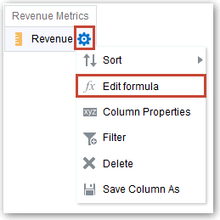

Edit Formulas or Calculated Measures

1. On the Column Formula tab of the Edit Column Formula dialog, enter a formula in the Column Formula pane.

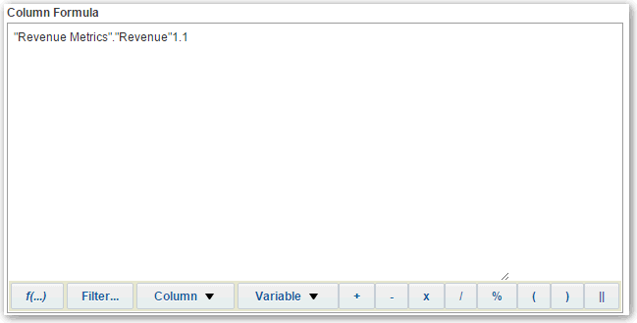

By default, the name of the column on the Selected Columns pane is displayed in the Column Formula pane.

* + Use the operator and character buttons on the bottom of the Column Formula pane to help build the formula.
  + Use the **f(...)** button to display the Insert Function dialog that enables you to include a function in the column formula. For example, you can build a formula based on a SQL function, such as RANK("Sales Measures"."Dollars"). See Expression Editor Reference.
  + Use the **Filter...** button to display the Insert Filter dialog that enables you to include a filter expression in the column formula. Start the filter expression with at least one measure column. Include a Boolean expression that contains no measure columns or nested queries.

For example, you can build a formula that uses the SQL FILTER function to filter the data, such as FILTER("Sales Measures"."Dollars" USING ("Markets"."Region" = 'EASTERN REGION').

* + Reference a column name in the formula using the form *Folder-Name*.*Column.Name*. If either the folder name or the column name includes non-alphanumeric characters (such as spaces or underscores), then enclose each name in double quotes. You can enclose the names in double quotes even if they have all alphanumeric characters.
  + Use single quotes to include literals or constants that have a data type of string. For example, you can include constants such as ‘John Doe’ or ‘Best Selling Product’ in a formula.

1. Click **OK**. On the Results tab, the column displays its values with the formula applied.

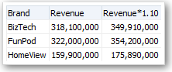

Set Properties for Analyses

#### Edit Calculated Measures

You can use calculated measures that are derived from other measures and created by using formulas.

For example, you might need to find the value after discounts are taken off the revenue. You create a calculated measure that subtracts the Discounted Amount from the Revenue value.

1. Open the analysis for editing.
2. On the Results tab, click **New Calculated Measure** on the toolbar to display the dialog.
3. If you have administrator privileges and want to customize folder and column headings with HTML markup, including JavaScript, select **Contains HTML Markup**, and then enter the HTML markup you want to apply. For examples, see Advanced Techniques: Format with HTML Tags.
4. Edit the formula for the calculated measure.
5. Click **OK**.

### Set Properties for Analyses

You can set analysis properties to specify how results are displayed and how data is handled. You can also set which actions are available when users right-click in a pivot table, table, heat matrix, treemap, or trellis view.

For example, you can create a custom message for the Brand Revenue analysis. This message could display when a filter on the Revenue column is too restrictive and no results are displayed.

1. Open the analysis for editing.
2. In the Criteria tab toolbar or the Results tab toolbar, select **Edit Analysis Properties** to display the Analysis Properties dialog.

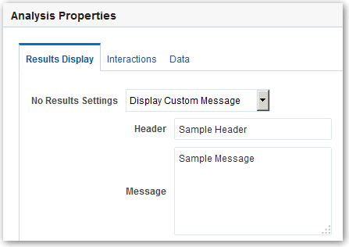

1. On the Results Display tab, select options to affect the display of results. For example, in the **No Results Settings** field, specify the default or custom message that displays if no results are returned when you run the analysis. You might see the message, for example, if you have a very restrictive filter placed on the

Set Your Preferences

columns in the analysis. You don’t see the custom message if you simply create the analysis without including columns.

1. If you have administrator privileges and want to customize messages with HTML markup, including JavaScript, select **Display Custom Message** in the **No Results Settings** field, then select **Contains HTML Markup**, and then enter the HTML markup you want to apply.
2. In the dialog, click the Interactions tab.
3. Specify which actions (for example, **Drill**) are available when you right-click in a pivot table, table, graph, heat matrix, treemap, or trellis view.
4. In the dialog, click the Data tab.

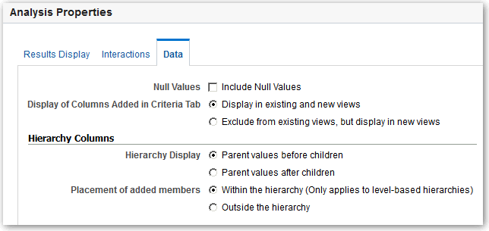

1. Click **OK**.

### Set Your Preferences

You can set account preferences to reflect where you live and to support how you work.

For example, you might select a specific Sales Dashboard as your starting page and Pacific Standard Time as your time zone. By specifying a starting page, you can start working with your dashboard right away.

1. In the Home page, click **My Profile *username*** and select **My Account**.
2. Use the tabs of the My Account dialog to specify preferences, such as your starting page, locale, and time zone.

The following table lists the settings for each tab, displayed values, and links to related information.

|  |  |  |
| --- | --- | --- |
| **Tab Name** | **Settings or items displayed** | **Links** |
| **Preferences** | Starting Page, Locale, Time Zone, Currency, Subject Area Sort Order, and Prompts Auto-Complete. | See About Prompts Auto-Complete. |
| **Publisher Preferences** | Report Locale, and Report Time Zone. | See Locale Selection Logic, and Set the Time Zone for Viewing Jobs. |
| **Mobile Preferences** | Starting Page. | Not applicable. |

Combine Subject Areas in Analyses

|  |  |  |
| --- | --- | --- |
| **Tab Name** | **Settings or items displayed** | **Links** |
| **Delivery Options** | Devices, and Delivery Profiles. | See Configure Your Devices and Delivery Profile. |
| **Application Roles** | Lists application roles and duties that are associated with the current user. | See Set Presentation Services Privileges for Application Roles. |
| **Unarchive Jobs** | Lists catalog unarchive jobs that have been submitted. | See Migrate Content to Other Catalogs. |

1. Click **OK** to save your changes.

### Combine Subject Areas in Analyses

You can combine multiple subject areas in an analysis.

Topics:

* + About Cross-Subject Area Joins
  + Create a Cross-Subject Area Analysis

#### About Cross-Subject Area Joins

You can create analyses that combine data from more than one subject area. Review guidelines for creating these joins in MyOracle Support (Doc ID 1567672.1).



**Note:**

Use joins sparingly with cross subject areas as they can affect report performance.

Cross-subject area analyses can be classified into three broad categories:

* + **Using common dimensions** - A common dimension is a dimensional attribute that exists in all subject areas in the analysis. These dimensions are considered common dimensions between subject areas and can be used to build a cross- subject area report.
  + **Using common and local dimensions** - A local dimension is available only in one of the combined subject areas in a cross-subject area query.
  + **Combining more than one result set from different subject areas** - You do this using set operators such as union, union all, intersection and difference.

#### Create a Cross-Subject Area Analysis

You can easily create an analysis using columns from multiple subject areas.

When you create a cross-subject area analysis, you must include a measure from each subject area to support the join if it uses a local dimension. You can hide the measure in the results if you don't want it to appear in your analysis. Note that the subject areas have to be from the same Oracle Cloud application.

Manage Briefing Books

1. On the Home page, click **Create** and then click **Analysis**.
2. In the Select Subject Area dialog, search for and select a subject area.
3. In the **Criteria** tab, expand the dimensions and add a column to the analysis
4. In Subject Areas, click **Add/Remove Subject Areas**.
5. To save a column to the catalog, in the Selected Columns pane, click **Options** beside the column name, and click **Save Column As**.
6. In the Subject Area region of the Criteria tab, expand the dimensions and add a column to the analysis.
7. If the column is a local dimension, add a measure from the subject area.

In any join query, you must add at least one measure from all subject areas involved, otherwise unexpected results or errors might occur.

1. If you want to hide the measure in your analysis, select its **Column Properties**, and in the **Column Format** tab of the Column Properties dialog, select **Hide** and click **OK**.
2. If you're using a local dimension, in the **Advanced** tab, navigate to **Advanced SQL Clauses**, and select **Show Total value for all measures on unrelated dimensions**, then click **Apply SQL**.
3. Click the **Results** tab to see the analysis results.
4. Click the **Criteria** tab again to return to the analysis definition.

### Manage Briefing Books

As an administrator, you can manage briefing books.

These snapshots give you a picture of what's going on at the time the analysis is added, downloaded, or rerun. Briefing books are stored in the catalog.

Topics

* + Add Content to New Briefing Books
  + Add Content to Existing Briefing Books
  + Download Briefing Books

#### Add Content to New Briefing Books

You create a new briefing book by adding an analysis to it.

1. Open the Reports and Analytics work area.
2. Select your analysis, select **More** and then click **Add to Briefing Book**.
3. Select **Updatable** if you want the analytic results refreshed whenever the briefing book is downloaded or rerun, or select **Snapshot** to store it without updating.
4. Enter a description for your briefing book.
5. Click **Browse** and navigate to **My Folders**, enter a name for the briefing book and click

**OK** to save the **Location** path.

1. Click **OK** to save the new briefing book.

Advanced Techniques: Import Formatting from Another Analysis

#### Add Content to Existing Briefing Books

Use briefing books to hold a collection of analyses.

These collections give you a picture of what's going on at the time the analysis is added, downloaded, or rerun. You can download briefing books as PDFs or MHTML to view, print, or share. The PDF file includes a table of contents. Briefing books are stored in the catalog.

1. Open the Reports and Analytics work area.
2. Select your analysis, click **More** and then select **Add to Briefing Book**.
3. Click **Browse** and navigate to the briefing book that you want to add this analysis to and click **OK**.
4. Click **OK** to save the updated briefing book.

#### Download Briefing Books

You can download a version of a briefing book.

You can download briefing books as PDFs or MHTML to view, print, or share. The PDF file includes a table of contents.

1. Open the Reports and Analytics work area.
2. Click **Catalog** to locate your briefing book, and click **PDF** or **Web Archive** to download.

### Advanced Techniques: Import Formatting from Another Analysis

You can quickly format new or existing analyses by importing the format of a saved analysis and its views. Most people don’t need to perform this task.

For example, suppose you applied different colors to the Store, City, and Product columns of the Last Year's Brand Revenue analysis. You can apply the same colors to the This Year's Brand Revenue analysis by importing the column color format.

* + To import formatting to all views in an analysis, click **Import formatting from another analysis** in the Compound Layout toolbar.
  + To import formatting just to the view you're editing, click **Edit View**, then click

Import formatting from another analysis.

Formatting is applied slightly differently depending on whether you import formatting applied to columns, views, or view containers in the Compound Layout.

#### About Applying Formatting from Columns

Applying formatting from columns works best for views when the saved analysis has the same number of columns as the target analysis.

For a single column, formatting is applied to all columns in the tables, pivot tables, and trellises of the target analysis.

Advanced Techniques: Format with HTML Tags

For multiple columns, formatting is applied from left to right for column headings and values. If there are fewer columns in the saved analysis than in the target analysis, the format of the last column in the saved analysis is repeated in the subsequent columns of the target.

For example, suppose the saved analysis contains four columns in the following color order: red, green, blue, yellow. When applied to the six columns in the target analysis, the color order would be: red, green, blue, yellow, yellow, yellow.

#### About Applying Formatting from Views

When you import the format of one type of view, that format gets applied to all the views of the same type in the target analysis.

For example, suppose you import the custom formatting of a table to a target analysis containing three tables. The custom format gets applied to all three.

#### About Applying Formatting from Containers

In the Compound Layout, you can specify formatting properties for view containers, including background color, borders, and padding.

When you import container formatting, the views in the target analysis inherit the exact container formatting properties as the views in the saved analysis.

However, the layout of the views in the two analyses don’t have to be exactly the same. If the target analysis contains more views than the source analysis, the extra views also inherit the imported formatting.

For example, suppose that a saved analysis contains two tables that are stacked on top of each other in one layout column and that the target analysis contains four tables divided between two layout columns. When you import the formatting, the two tables in each of the first and second layout columns of the target analysis inherit the formatting.

#### Import Formatting from a Saved Analysis to a Target Analysis

You can import formatting from one analysis to another.

For example, suppose you have an analysis that contains one column to which you have applied formatting, such as font family, horizontal alignment, and background color. You can save the analysis and apply the same formatting to all the columns in another analysis.

1. Open the analysis for editing.
2. Display the target analysis in the Results tab, or edit the view.
3. Click **Import formatting from another analysis** on the toolbar.
4. In the Select Analysis dialog, navigate to the saved analysis.
5. Click **OK**.

### Advanced Techniques: Format with HTML Tags

If you have administrator privileges, then you’ll see the option **Contains HTML/ JavaScript/CSS Markup** on some dialogs.

This option allows you to format content with valid HTML markup, including JavaScript, and CSS. If you include additional formatting, prefix the HTML markup with “@”. Devices that

Advanced Techniques: Combine Columns to Display Data Differently

don’t support custom formatting just ignore markup after “@” and display the content without formatting .

For example, this HTML markup sets the width and height of a column in tables and pivot tables. The prefix @[html] means to apply HTML.

@[html]<span style="width:200px; height:50px>@</span>

The **Contains HTML/JavaScript/CSS Markup** option is available wherever you can apply formatting:

* + For analyses:
    - In the analysis editor.
    - In the Analysis Properties dialog.
    - In the Column Properties dialog.
    - In the New Calculated Measure dialog.
  + For dashboards:
    - In the Dashboard Properties dialog.

Here are some examples. If you find an example that is similar to what you want to do, copy and paste the example and tailor it to your needs.

**HTML Element Usage Notes and Examples**

Text Any HTML tags can be used to control the format of the text. For example:

* + - * To center the text in the section:

<CENTER>Centered Text</CENTER>

* + - * To make the text bold:

<B>Bold Text</B>

* + - * To set font size and color:

<FONT SIZE="4" COLOR="red">Red Text</FONT>

You can also combine tags for additional effects:

<CENTER><B><FONT COLOR="red">Bold Centered Red Text</ FONT></B></CENTER>

JavaScript Use self-contained scripts supported by the browser. Paste or type the script into the HTML text window, including the begin and end tags

<script> and </script>.

Specify JavaScript in the opening <SCRIPT> tag: <SCRIPT LANGUAGE="javascript"> .

### Advanced Techniques: Combine Columns to Display Data Differently

You can combine columns based on set operations such as Union or Intersect. By combining columns, you create a column for displaying the data in a different way.

For example, you can combine a Region column with a City column and create a column named Regions and Cities.

The analysis must meet certain criteria if you want to use set operations:

Advanced Techniques: Examine the Logical SQL Statements for Analyses

* + The number and data types of the columns must be the same.
  + You can’t use hierarchical columns, selection steps, or groups when you combine criteria.

1. Open the analysis for editing.
2. On the Criteria tab of the analysis editor, in the Selected Columns pane toolbar, click

Combine results based on union, intersection, and difference operations.

The Set Operations area is displayed in the Selected Columns pane. Boxes with a dotted line border indicate columns that you must combine with other columns in the analysis.



1. In the Subject Areas pane, select the columns to combine with the original columns. Note that the dotted line borders and contents have been replaced.

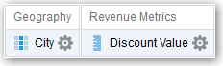

1. In the Result Columns area on the Set Operations pane, click on the **Union** button and select a set operation.
   * Use **Union** to specify that only nonduplicate rows from all columns are returned.
   * Use **Union All** to specify that rows from all columns, including duplicate rows, are returned.
   * Use **Intersect** to specify that only rows common to all columns are returned.
   * Use **Minus** to specify that only rows from the first column that aren’t in the second column are returned.
2. Click the **Result Columns** link. The Selected Columns pane shows the newly combined columns.
3. To rename the heading of the column:
4. Click the **Options** button for the column.
5. Select **Column Properties**.
6. Select **Column Format**.
7. Ensure that **Custom Headings** is selected.
8. In the **Column Heading** box, enter the new heading.
9. Click **OK**.
10. Click the Results tab to view the columns in a table view.

### Advanced Techniques: Examine the Logical SQL Statements for Analyses

You can examine the logical SQL code to see the XML code and logical SQL statement that's generated for an analysis. You can optionally create an analysis based on that SQL

Advanced Techniques: Set Caching Options for Your Analysis

statement using the Advanced tab of the analysis editor or using the **Create Analysis from Simple Logical SQL** option. Most people don’t need to perform this task.

When you create an analysis using this method, the list of subject areas isn't displayed in the left-hand pane. Instead you see the message Invalid Subject Area displayed.

The removal of the list of subject areas ensures that the changes made to the logical SQL code are honored.

Before using the Advanced tab, keep in mind that this tab is only for advanced users and developers who have the appropriate responsibilities to access the Advanced tab. You must understand advanced SQL statements and have expertise working with the metadata for analyses. You must also understand the content and structure of the underlying data sources.

1. Open the analysis for editing.
2. Click the Advanced tab of the analysis editor.
3. Use the read-only box in the SQL Issued area to examine and copy the SQL statement that's used for executing the analysis.
4. Click **New Analysis** to create an analysis based on the SQL code.

### Advanced Techniques: Set Caching Options for Your Analysis

You can specify whether cached data is displayed in your analysis if it's available.

1. Open the analysis for editing.
2. Click the Advanced tab of the analysis editor.
3. Use the **Bypass BI Presentation Services Cache** option to specify a caching policy.

Clear this option to improve performance by displaying cached data if it’s available. Cached data might be stale if the source data changes rapidly. Select this option to always pull fresh data from the data source, even if cached data is available in the system cache. The analysis might take longer to display if it contains a large amount of data.

1. Optional: To disable the cache, enter the following in the **Prefix** field:

SET VARIABLE DISABLE_CACHE_HIT=1, DISABLE_CACHE_SEED=1, DISABLE_PLAN_CACHE_HIT=1

### Advanced Techniques: Reference Stored Values in Variables

You might want to create an analysis whose title displays the current user's name. You can do this by referencing a variable.

You can reference several different types of variable in your analyses, dashboards, and actions: *session*, *presentation*, *request*, and *global*. Content authors can define presentation, request, and global variables themselves.

|  |  |  |  |
| --- | --- | --- | --- |
| **Type of Variable** | **Defined in** | **Defined by** | **More Information** |
| Presentation | Prompts for analyses and dashboards | Content authors | About Presentation Variables |
| Request | Prompts for analyses and dashboards | Content authors | About Request Variables |
| Global | Analyses | Administrators | About Global Variables |
|  |  |  | and Create Global Variables |

#### About Session Variables

Session variables are initialized when a user signs in.

These variables exist for each user for the duration of their browsing session and expire when the user closes the browser or signs out. There are two types of session variable: system and non-system.

##### System Session Variables

There are several system session variables that you can use in your reports and dashboards.

The system session variables have reserved names so you can’t use them for any other kind of variable.

**System Session Variable**

**Description Example SQL Query Value (Variable dialog)**

PORTALPATH Identifies the default dashboard a

user sees when they sign in (they can override this preference after signing in).

To display ‘mydashboard’ when a user signs in:

select ‘/shared/_portal/ mydashboard’ from dual;

TIMEZONE Specifies the default time zone for a user when they sign in.

A user’s time zone is typically populated from the user’s profile. Users can change their default time zone through preferences (My Account).

To set the time zone when a user signs in:

select ‘(GMT-08:00) Pacific Time (US & Canada)’ from dual;

DATA_TZ Specifies an offset from the original time zone for data.

This variable enables you to convert a time zone so that users see the appropriate zone.

To convert time data to Eastern Standard Time (EST):

select ‘GMT-05:00’ from dual;

This example means Greenwich Mean Time (GMT) - 5 hours

**System Session Variable**

**Description Example SQL Query Value (Variable dialog)**

DATA_DISPLAY_TZ Specifies the time zone for displaying

data.

##### Non-System Session Variables

To display Eastern Standard Time (EST):

select ‘GMT-05:00’ from dual;

This example means Greenwich Mean Time (GMT) - 5 hours

The non-system session variables are named and created in your semantic model.

For example, your data modeler might create a SalesRegion variable that initializes to the name of a user's sales region when they sign in.

#### About Repository Variables

A repository variable is a variable that has a single value at any point in time.

Repository variables can be static or dynamic. A static repository variable has a value that persists and doesn’t change until the administrator changes it. A dynamic repository variable has a value that is refreshed by data returned from queries.

#### About Presentation Variables

A presentation variable is a variable that you can create as part of the process of creating a column prompt or a variable prompt.

**Type Description**

Column prompt A presentation variable created as part of a column prompt is associated with a column, and the values that it can take come from the column values.

To create a presentation variable as part of a column prompt, in the New Prompt dialog, you must select **Presentation Variable** in the

**Set a variable** field. Enter a name for the variable in the **Variable Name**

field.

Variable prompt A presentation variable created as part of a variable prompt isn’t associated with any column, and you define the values that it can take.

To create a presentation variable as part of a variable prompt, in the New Prompt dialog, you must select **Presentation Variable** in the **Prompt for** field. Enter a name for the variable in the **Variable Name** field.

The value of a presentation variable is populated by the column or variable prompt with which it was created. That is, each time a user selects one or more values in the column or variable prompt, the value of the presentation variable is set to the value or values that the user selects.

#### About Request Variables

A request variable enables you to override the value of a session variable but only for the duration of a database request initiated from a column prompt. You can create a request variable as part of the process of creating a column prompt.

You can create a request variable as part of the process of creating one of the following types of dashboard prompts:

* + A request variable that is created as part of a column prompt is associated with a column, and the values that it can take come from the column values.

To create a request variable as part of a column prompt, in the New Prompt dialog, you must select **Request Variable** in the **Set a variable** field. Enter the name of the session variable to override in the **Variable Name** field.

* + A request variable that is created as part of a variable prompt isn’t associated with any column, and you define the values that it can take.

To create a request variable as part of a variable prompt, in the New Prompt dialog (or Edit Prompt dialog), you must select **Request Variable** in the **Prompt for** field. Then enter a name of the session variable that you want to override in the ***Variable Name*** field.

The value of a request variable is populated by the column prompt with which it was created. That is, each time a user selects a value in the column prompt, the value of the request variable is set to the value that the user selects. The value, however, is in effect only from the time the user presses the **Go** button for the prompt until the analysis results are returned to the dashboard.

Certain system session variables (such as, USERGUID or ROLES) can’t be overridden by request variables. Other system session variables, such as DATA_TZ and DATA_DISPLAY_TZ (Timezone), can be overridden if configured in the Oracle BI Administration Tool.

Only string and numeric request variables support multiple values. All other data types pass only the first value.

#### About Global Variables

A global variable is a column created by combining a specific data type with a value. The value can be a Date, Date and Time, Number, Text, and Time.

The global variable is evaluated at the time the analysis is executed, and the value of the global variable is substituted appropriately.

Only users with the BI Service Administrator role can manage (add, edit, and delete) global variables.

You create a global value during the process of creating an analysis by using the Edit Column Formula dialog. The global variable is then saved in the catalog and made available to all other analyses within a specific tenant system.

#### Create Global Variables

You can save a calculation as a global variable then reuse it in different analyses. By just creating a global variable, you don’t have to create a new column in the Data Modeler.

1. Open the analysis for editing.
2. In the Selected Columns pane, click **Options** beside the column name.

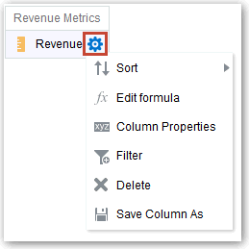

1. Select **Edit Formula** to display the Column Formula tab.
2. Click **Variable** and select **Global**.
3. Click **Add New Global Variable**.

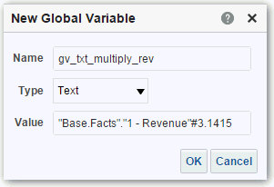

1. Enter the value for the **Name**. For example, gv_region, date_and_time_global_variable, or rev_eastern_region_calc_gv.

The name for a global variable must be fully qualified when referencing the variable, and therefore is prefixed by the text "global.variables". For example, a global variable set to calculate revenue is displayed in the Column Formula dialog as follows:

"Base Facts"."1- Revenue"*@{global.variables.gv_qualified}

1. Enter values for the **Type** and **Value**.
   * If you’re selecting "Date and Time" as the data type, then enter the value as in the following example: 03/25/2004 12:00:00 AM
   * If you’re entering an expression or a calculation as a value, then you must use the Text data type, as in the following example: "Base Facts"."1- Revenue"*3.1415
2. Click **OK**. The new global variable is added to the Insert Global Variable dialog.
3. Select the new global variable that you just created, and click **OK**. The Edit Column Formula dialog is displayed with the global variable inserted in the Column Formula pane. The **Custom Headings** check box is automatically selected.
4. Enter a new name for the column to which you have assigned a global variable to reflect the variable more accurately.
5. Click **OK**.

#### Syntax for Referencing Variables

You can reference variables in analyses and dashboards.

How you reference a variable depends on the task that you’re performing. For tasks where you’re presented with fields in a dialog, you must specify only the type and name of the variable (not the full syntax), for example, referencing a variable in a filter definition.

For other tasks, such as referencing a variable in a title view, you specify the variable syntax. The syntax that you use depends on the type of variable as described in the following table.

**Type Syntax Example**

Session @{biServer.variables['NQ_SESSION.*variab lename*']}

where *variablename* is the name of the session variable, for example DISPLAYNAME.

Repository @{biServer.variables.*variablename*} or @{biServer.variables['*variablename*']}

where *variablename* is the name of the repository variable, for example, prime_begin

@{biServer.variables['NQ_SESSI ON.SalesRegion]}

@{biServer.variables.prime_begi n}

or

@{biServer.variables['prime_begi n']}

**Type Syntax Example**

Presentation or request

@{variables.*variablename*}[*format*]

{*defaultvalue*} or

@{*scope*.variables['*variablename*']} where:

*variablename* is the name of the presentation or request variable, for example, MyFavoriteRegion.

(optional) *format* is a format mask dependent on the data type of the variable, for example #,##0, MM/DD/YY hh:mm:ss. (Note that the format isn’t applied to the default value.)

(optional) *defaultvalue* is a constant or variable reference indicating a value to be used if the variable referenced by *variablename* isn’t populated.

*scope* identifies the qualifiers for the variable. You must specify the scope when a variable is used at multiple levels (analyses, dashboard pages, and dashboards) and you want to access a specific value. (If you don’t specify the scope, then the order of precedence is analyses, dashboard pages, and dashboards.)

When using a dashboard prompt with a presentation variable that can have multiple values, the syntax differs depending on the column type. Multiple values are formatted into comma-separated values and therefore, any format clause is applied to each value before being joined by commas.

@{variables.MyFavoriteRegion}

{EASTERN REGION}

or @{MyFavoriteRegion} or

@{dashboard.variables['MyFavor iteRegion']}

or (@{myNumVar}[#,##0]{1000})

or

(@{variables.MyOwnTimestamp} [YY-MM-DD hh:mm:ss]{)

or

(@{myTextVar}{A, B, C})

Global @{global.variables.*variablename*}

where *variablename* is the name of the global variable, for example, gv_region. When referencing a global variable, you must use the fully qualified name as indicated in the example.

The naming convention for global variables must conform to EMCA Scripting language specifications for JavaScript. The name must not exceed 200 characters, nor contain embedded spaces, reserved words, and special characters. If you’re unfamiliar with JavaScripting language requirements, consult a third party reference

@{global.variables.gv_date_n_ti me}

You can also reference variables in expressions. The guidelines for referencing variables in expressions are described in the following topics:

* + Session Variables
  + Presentation Variables
  + Repository Variables

##### Session Variables

You can use the following guidelines for referencing session variables in expressions.

* + Include the session variable as an argument of the VALUEOF function.
  + Enclose the variable name in double quotes.
  + Precede the session variable by NQ_SESSION and a period.
  + Enclose both the NQ_SESSION portion and the session variable name in parentheses. For example:

"Market"."Region"=VALUEOF(NQ_SESSION."SalesRegion")

##### Presentation Variables

You can use the following guidelines for referencing presentation variable in expressions. When referencing a presentation variable, use this syntax: @{*variablename*}{*defaultvalue*}

where *variablename* is the name of the presentation variable and *defaultvalue* (optional) is a constant or variable reference indicating a value to be used if the variable referenced by *variablename* isn’t populated.

To type-cast (that is, convert) the variable to a string or include multiple variables, enclose the entire variable in single quotes, for example:

'@{user.displayName}'

If the @ sign isn’t followed by a {, then it’s treated as an @ sign. When using a presentation variable that can have multiple values, the syntax differs depending on the column type.

Use the following syntax in SQL for the specified column type in order to generate valid SQL statements:

* + Text — (@{*variablename*}['@']{'*defaultvalue*'})
  + Numeric — (@{*variablename*}{*defaultvalue*})
  + Date-time — (@{*variablename*}{timestamp '*defaultvalue*'})
  + Date (only the date) — (@{*variablename*}{date '*defaultvalue*'})
  + Time (only the time) — (@{*variablename*}{time '*defaultvalue*'}) For example:

'@{user.displayName}'

##### Repository Variables

You can use the following guidelines for referencing repository variables in expressions.

* + Include the repository variable as an argument of the VALUEOF function.
  + Enclose the variable name in double quotes.
  + Refer to a static repository variable by name.
  + Refer to a dynamic repository variable by its fully qualified name. For example:

CASE WHEN "Hour" >= VALUEOF("prime_begin") AND "Hour" < VALUEOF("prime_end") THEN 'Prime Time' WHEN ... ELSE...END

# 3

## View Data in Different Ways

This chapter describes how views enable you to view data in different ways.

The result of an analysis is represented visually in a view. Depending on your needs and preferences, you can use different types of views to view the same data in different ways.

Topics:

* + Typical Workflow to View Data in Different Ways
  + About Views
  + Add Views
  + Edit Views
  + Edit Various Types of Views
  + Graph Data in Analyses
  + Save Views
  + Rearrange Views
  + Refresh the Results in Views
  + Print Views
  + Change Print Options for Views
  + Preview How Views Are Displayed on Dashboards
  + Remove Views
  + Sort Values in Views
  + Clear Sorts in Views
  + Drill in Results
  + Resize Rows and Columns in Views
  + Suppress Null Values in Views
  + Assemble Views for Display
  + Link Views in Master-Detail Relationships
  + Modify the Layout of Data in Views
  + About Drop Targets in the Layout Pane

### Typical Workflow to View Data in Different Ways

Here are the common tasks to start adding views to analyses to view data in different ways.

About Views

|  |  |  |
| --- | --- | --- |
| **Task** | **Description** | **More Information** |
| Create an analysis | Select and arrange columns that you want to use in an analysis. | Create Your First Analysis |
| Add a view | Add views to an analysis to visualize data in | Add Views |
|  | different ways. |  |
| Edit a view | Use the editor that is available for each type of | Edit Views |
|  | view to edit that view. |  |
| Remove a view | Delete a view from a compound layout or from | Remove Views |
|  | an analysis. |  |
| Save a view | Save a view by saving the analysis. | Save Views |
| Print a view | Print a single view or group of views in | Print Views |
|  | printable HTML or printable PDF. |  |

### About Views

A view is a visual representation of the results of an analysis. Views give you different ways of looking at your data to help you discover patterns, trends, outliers, and other interesting characteristics.

You can add a variety of views to the results, such as graphs and pivot tables that allow drilling down to more detailed information, such as explanatory text, filter controls, and more. This example shows the results of a revenue analysis displayed in a bar graph view.

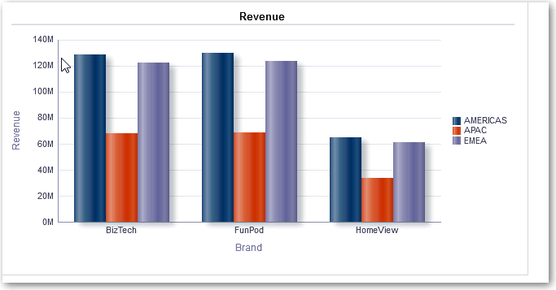

This table describes the view types that you can use to present your data (if you have the required privileges).

**View Name Description**

Column Selector Adds a column selector in the results. A column selector is a set of drop- down lists that contain pre-selected columns. Users can dynamically select columns and change the data that is displayed in the views of the analysis.

About Views

**View Name Description**

Filters Displays the filters in effect for an analysis. Filters, like selection steps, allow you to constrain an analysis to obtain results that answer a particular question. Filters are applied before the query is aggregated.

Funnel Displays results as a three-dimensional graph. Typically, funnel graphs represent data that changes over time. For example, funnel graphs are often used to represent the volume of sales over a quarter. In funnel graphs, the thresholds indicate a percentage of the target value, and colors provide visual information for each stage. You can click one of the colored areas to drill down to more detailed information.

Graph Displays numeric information on a background, called the graph canvas. When precise values are needed, graphs should be supplemented with other data displays, such as tables.

Gauge Displays a single data value on a background, called the gauge canvas. Due to its compact size, a gauge is often more effective than a graph for displaying a single data value.

A gauge view might consist of multiple gauges in a gauge set. For example, if you create a gauge view to show the sales data for the last twelve months, the gauge view consists of twelve gauges, one for each month. If you create one to show the total sales in the US, then the gauge view consists of one gauge.

Heat Matrix Displays a two-dimensional depiction of data in which values are represented by a gradient of colors. Heat matrixes structure data similarly to pivot tables in that they are formed by grouping rows and columns.

Legend Adds a legend to the results, which enables you to document the meaning of special formatting used in results, such as the meaning of custom colors applied to gauges.

Map Displays results overlain on a map. Depending on the data, the results can be overlain on top of a map as formats such as images, color fill areas, bar and pie graphs, and variably sized markers.

Narrative Displays the results as one or more paragraphs of text. You can type in a sentence with placeholders for each column in the results, and specify how rows should be separated.

Performance Tile Displays a single piece of aggregate data. Performance tiles use color, labels, and limited styles to show status and use conditional formatting of the background color or measure value to make the tile visually prominent. For example, if revenue isn’t tracking to target, the revenue value may appear in red.

Pivot Table Pivot tables structure data like standard tables, but can display multiple levels of both row and column headings. Unlike regular tables, each data cell in a pivot table contains a unique value. They are ideal for displaying a large quantity of data, for browsing data hierarchically, and for trend analysis.

Table Display data organized by rows and columns. Tables provide a summary view of data and let you see different views of data by dragging and dropping rows and columns.

Ticker Displays the results as a ticker or marquee, similar in style to the stock tickers that run across many financial and news sites on the Internet. You can control what information is presented and how it scrolls across the page.

Title Displays a title, a subtitle, a logo, a link to a custom online help page, and timestamps to the results.

Add Views

**View Name Description**

Treemap Displays hierarchical data by grouping the data into rectangles (known as tiles). Treemaps display tiles based on the size of one measure and the color of the second measure.

Treemaps are limited by a predefined area and display two levels of data. They are similar to a scatter plot graphs in that the map area is constrained, and the graph allows you to visualize large quantities of data and quickly identify trends and anomalies within that data.

Trellis Displays a type of graph view that displays a grid of multiple graphs, one in each data cell.

A trellis view can be simple or advanced. A simple trellis displays a core inner graph multiplied across row sets and column sets, displaying many small multiples that are ideal for comparing and contrasting. An advanced trellis displays a grid of small spark graphs that are ideal for monitoring trends and spotting patterns in a dataset.

Selection Steps Displays the selection steps in effect for an analysis. Selection steps, like filters, allow you to obtain results that answer particular questions. Selection steps are applied after the query is aggregated. See Edit Selection Steps.

Static Text Adds static text in the results. You can use HTML to add banners, tickers, ActiveX objects, Java applets, links, instructions, descriptions, graphics, and so on, in the results.

View Selector Adds a view selector in the results. A view selector is a drop-down list from which users can select a specific view of the results from among the saved views.

### Add Views

By default when you create an analysis, you see either a table or pivot table view, depending on the columns that you selected. You can add other views to the analysis that let you visualize the data in different ways.

For example, you can analyze trends for your Sales Forecast analysis by creating a new view and selecting **Recommended Visualization** and the **Analyzing Trends** option.

1. Open the analysis for editing.
2. On the Results tab, click **New View** , and select a view type.
3. To format the container for the views in the analysis, click **Format Container**.
4. Complete the fields in the Format Container dialog to specify options such as alignment, colors, and borders.
5. Click **OK**.
6. Click **Save Analysis**.

Edit Views

### Edit Views

Each type of view has its own editor. The editors include both common functionality across views and view-specific functionality.

For example, you can edit a graph in a Brand Revenue analysis in the Graph editor to show the legend.

The following procedure provides general information on editing views.

1. Open the analysis for editing.
2. Click the Results tab.
3. To edit the view, click **Edit View**.
4. In the view editor (such as the Graph editor) make the appropriate edits, such as showing the legend.

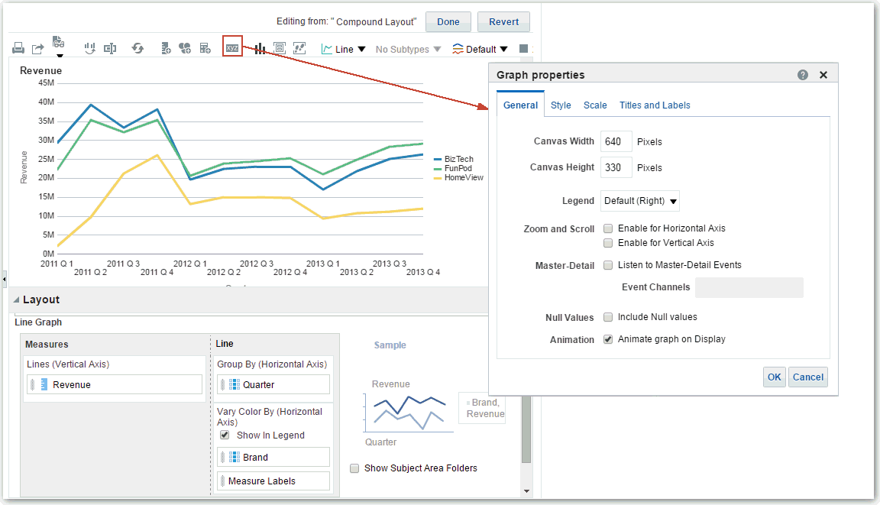

1. Click **Done**.
2. Save the view. Click **Save Analysis** or **Save As** in the toolbar of the Results tab.

### Edit Various Types of Views

This topic identifies additional information for editing various types of views.

Topics:

* + Edit Table and Pivot Table Views
  + Edit Performance Tile Views
  + Edit Treemap Views
  + Edit Heat Matrix Views
  + Edit Trellis Views
  + Edit Gauge Views
  + Edit Map Views
  + Edit Narrative Views
  + Edit Non-Data Views

#### Edit Table and Pivot Table Views

Tables and pivot tables are commonly used views, and you can edit them in similar ways to display data the way you want.

For example, you can edit a pivot table in an analysis by moving the Brand column to the row edge to display its corresponding Revenue data for each Quarter and Region. You could also display the same data in a more conventional way by adding a table next to the pivot table in a compound layout, as shown below.

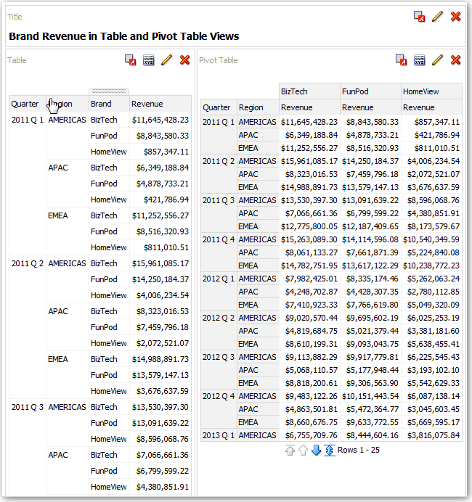

1. Open the analysis for editing.
2. Click the Results tab.
3. Click **View Properties** on the table you want to edit.
4. Edit the table properties.
5. Click **OK**.
6. Click **Edit View** to display the Table View editor.
7. For a pivot table view, click the **Graph Pivoted Results** button on the toolbar to display the results of the pivot table in a graph view, which is displayed alongside the pivot table.
8. Click **Done**.

#### Edit Performance Tile Views

Performance tile views focus on a single piece of aggregate data. They use color, labels, and limited styles to show status and use conditional formatting of the background color or measure value to make the tile visually prominent.

By default, the first measure in the analysis on the Criteria tab is selected as the performance tile measure. To ensure the correct measure value is displayed in the tile, set up aggregation and filters on the Criteria tab. To include additional performance tile views for each measure in an analysis, add a separate view for each measure.

For example, you might want to edit a performance tile view to use Revenue as the measure. You can specify that the values and labels utilize the available space. This example shows performance tiles on a dashboard page.

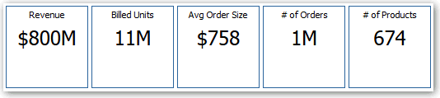

1. Open the analysis for editing.
2. Click the Results tab.
3. Click **View Properties**. You can set the following properties:
   * The size of the tile — You can select predefined options **Small**, **Medium**, or **Large**, or you can select **Custom** and then set the height and weight in pixels. Other options allow you to autofit the tile to the value that is displayed.
   * The position of the tile — Options include **Fixed Position**, which sets (or “fixes”) the positions of the labels, meaning the label text is displayed in fixed positions (recommended for layouts with multiple performance tiles of the same size in a row) and **Utilize available space**, which evenly spaces the label text on the performance tile vertically. The label text utilizes all available space on the performance tile. Note that when you have multiple tiles placed beside each other, the labels might be displayed at different heights and look uneven based on the varying label content.
   * The use of abbreviated values — A performance tile can show a value using its measure's default formatting or the value can be abbreviated to the nearest thousand, million, and so on. For example, using abbreviated values, the default formatting of “123,456.50” would be displayed as “123K”. Select the **Abbreviate in formatted Excel** option if you want to display abbreviated values when you export analysis results to a formatted Excel spreadsheet.
   * The appearance of the tile, such as the background and border colors — Click the

**Edit Conditional Formatting** link to apply conditional formatting to the tile.

1. Click **OK**.
2. Click **Edit View** to display the Performance Tile editor.
3. In the Styles pane, change the tile size to **Small**, **Medium**, or **Large**.

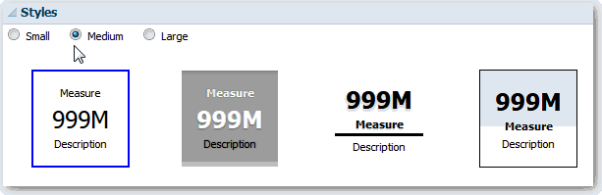

1. Select a themed (or stylized) tile located below the **Tile Size** option buttons to change the theme for the performance tile.
2. Click **Done**.

#### Edit Treemap Views

Treemaps organize hierarchical data by grouping the data into rectangles (known as tiles). Treemaps display tiles based on the size of one measure and the color of the second measure.

The following figure shows an example of a treemap view. The country names are grouped by region and area. This treemap shows the correlation of revenue for a country (based on average order size) across different regions for an area.

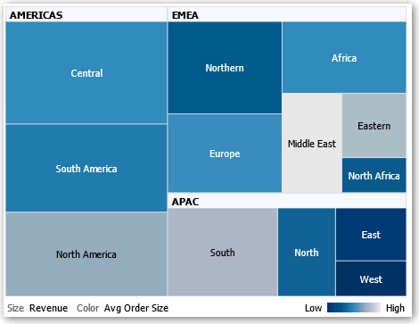

By default, the first measure of the analysis in the Criteria tab is selected as the Size By measure, and the second measure is selected as the Color By measure. If there is only one measure in the analysis, this measure is the default for both Size By and Color By options. Additionally, the Style element defaults to Percentile Binning with "quartile" as the value for the number of bins.

Treemaps have the following characteristics:

* + Tiles are colored by percentile bins or continuously.
  + First Group By dimension is displayed as the group (header) label.
  + The order of the Group By dimensions implies the nesting order within the treemap. The last dimension in the Group By is the lowest level and this dimension name is displayed as the tile label. If the label is too long to fit on the tile, then it’s truncated. Full values for the labels display in the tooltip.

1. Open the analysis for editing.
2. Click the Results tab.
3. Click **View Properties**. You can set properties such as the following ones:
   * The size of the treemap.
   * Whether a legend is to be displayed to show the continuous color variations or binning for the treemap tiles.
   * The background color and fill of the legend.
   * The border colors of the groups and tiles.
4. Click **OK**.
5. Click **Edit View** to display the treemap view editor.
6. In the Layout pane, select the **Percentile Binning** or **Continuous Color Fill** options to change the color palette of the view.
   * Use **Percentile Binning** to specify that the color of the tiles within the treemap is displayed as a percentile bin. In the **Bins** list, select the number of bins to display in the treemap. You can select an integer, Quartile (4), or Decile (10). Values range from 2 to 12. The number of bins selected corresponds to the number of colors in the treemap. For example: You create a treemap for Region and Area. You specify Revenue as the Size By measure and Avg Order Size as the Color By measure. Then, you select Percentile Binning as the Style with 4 (Quartile) bins. The First Quartile represents those areas within the region that are under performing for the average order size by revenue. The **Binning Properties** area displays the percentage for the bin based on a total of 100% and is calculated based on the number of bins selected. Each percentage is color-coded and corresponds to the Color selection.
   * Use **Continuous Color Fill** to specify that the tiles within the treemap are displayed as a gradient color scheme. The low value gradient color is the minimum value for the selected Color By measure. The high value gradient color is the maximum value for the selected Color By measure.
7. Change the measures and attribute and hierarchal (excluding skip-level) columns to visualize the new data in more meaningful ways by using **Group By**, **Size By**, and **Color By** options.
8. Click **Done**.

#### Edit Heat Matrix Views

A heat matrix view visually represents the relationship between data values as a gradient of colors in a table format. You can edit properties such as view size, the display of header and data cells, and the display of a legend.

1. Open the analysis for editing.
2. Click the Results tab.
3. Click **View Properties** on the heat matrix you want to edit.
4. Edit properties as needed.
   * Use **Data Viewing** to control the size of the view in the layout. Options include scrolling with optional maximum width and height or paging with optional number of rows per page.
   * Use **Legend** to display a legend showing the continuous color variations or binning for the heat matrix.
   * Use Master-Detail to link the table to a master view. In the **Event Channels** field, enter the case-sensitive name of the channel the table listens to for master-detail events. Separate multiple channels with commas.
   * Use **Display Folder & Column Headings** to specify how to display headings for the columns and the view. Select the Folder.Column option to display the fully qualified folder name from the Subject Area and column name as the row or column title (for example, Offices.D1 Offices).
5. Click **OK**.
6. Left-click to drill in a cell.

When drilling in multiple-level hierarchies, all members from the lowest levels are displayed as cells, and the detail level data replaces the current data. For example, when you drill in a country name, such as United States, the heat matrix displays data for the state (or provinces) in that country, but not for the country itself.

1. Right-click the outer edges to display a context menu of options, such as **Drill**, invoke actions, **Keep Only**, **Remove**, or focus on a specific cell.
2. Click **Edit View** to display the Heat Matrix editor.
3. In the Layout pane:
4. In the **Style** box, select **Percentile Binning** or **Continuous Color Fill** to change the color palette of the view.
5. Change the measures and columns to visualize the data in more meaningful ways by using **Rows**, **Columns**, and **Color By** drop targets.
6. To specify sorting, right-click a cell in the view and click **Sort**. The interactions that are available in the Sort dialog depend on the location in which you right-click within the view.
7. Click **Done**.

##### About Heat Matrix Views

A heat matrix view shows you a two-dimensional depiction of data in which values are represented by a gradient of colors. A simple heat matrix provides an immediate visual summary of information that is well suited for analyzing large amounts of data and identifying outlier values.

A heat matrix displays data from one measure. Colored cells are formed by the grouping and intersection of the columns and rows placed in the Prompts, Sections, Rows, Columns, and Color By drop targets. Cells are displayed as percentile bins or as a continuous color. You can hover over a cell to display its value or display values in cells all the time.

By default, the first measure of the analysis in the Criteria tab is selected as the Color By measure and represents the measure's value. The Style element defaults to Percentile Binning with "quartile" as the value for the number of bins. Cells display uniformly, in that each cell has the same width and the same height. Cell height and width don’t have to be the same. A "transparent" diagonal pattern of stripes indicates null values.

You can display a legend below the heat matrix that includes:

* + One measure (selected in the Color By list) and its corresponding label.
  + The number of specified bins (for example, quartile), color-coded and labeled, or a gradient bar that is displayed as a continuous color fill and is labeled "low" to "high."

Here is an example of a heat matrix view on a dashboard page. Each sales representative's revenue is displayed by region and product and prompted by product type. Sales revenue is binned by year. This heat matrix depicts the product revenue outliers for each sales representative (for example, in 2008, Angela Richards has no sales revenue for Bluetooth Adaptors or MP3 Speakers Systems for any region.)

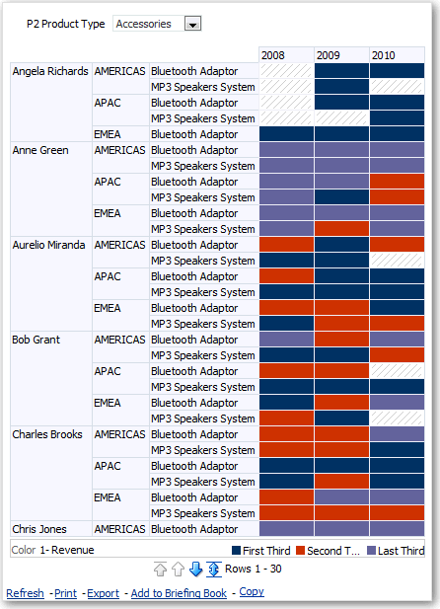

#### Edit Trellis Views

A trellis view is a type of graph view that displays a grid of multiple graphs, one in each data cell.

A trellis view can be simple or advanced. A simple trellis displays a core inner graph multiplied across row sets and column sets, displaying many small multiples that are ideal for comparing and contrasting. An advanced trellis displays a grid of small spark graphs that are ideal for monitoring trends and spotting patterns in a dataset.

The following figure shows a simple trellis view:

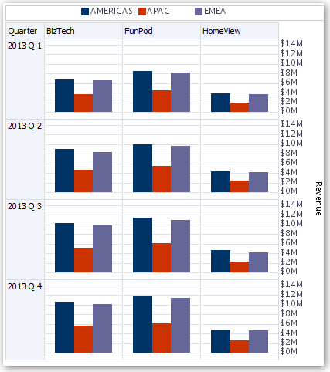

The trellis view ( also referred to as a trellis graph) is similar to a pivot table except that the data cells within the trellis contain graphs. Whereas a standalone graph type such as a single bar graph or a single scatter graph works on its own, the trellis graph works only by displaying a grid of nested graphs, known as inner graphs. So a bar graph trellis view is actually comprised of multiple bar graphs.

1. Open the analysis for editing.
2. Click the Results tab.
3. Click **View Properties** to edit properties. You can set the following kinds of properties:
   * Related to the grid canvas, such as legend location (simple trellis views only).
   * Related to graph size for the visualizations that are included in the trellis.
   * That specify the method to be used to browse data — either scrolling or paging controls.
   * That control the appearance of the trellis's grid and its visualizations, such as various style choices and the way that legends are displayed.
   * That control the type of scale and the appearance of scale markers for each of the trellis's visualizations (simple trellis views only).
   * That control the display of titles and labels (simple trellis views only).
4. Click **OK**.
5. Click **Edit View** to display the Trellis editor.
6. In the Layout pane:
7. Drag and drop columns into the Columns and Rows fields to specify how data is arranged in the trellis.
8. Select the type of graph you want to display for each of the cells in the trellis.
9. Drag and drop columns to indicate how to color the graphs.
10. Right-click a view heading, and click **Sort Column** to specify how values are sorted in the view.
11. Click **Done**.

##### About the Functions of Trellis Views

For the most part, a trellis view behaves like a pivot table. The main difference between a trellis and a pivot table is the way the data cells are displayed.

In the row and column label cells of a trellis, you can:

* + Right-click to hide or move measure labels.
  + Right-click to sort data.
  + Drag to reposition rows and columns.

In the data cells of a trellis, you can hover the mouse pointer to display related contextual information. Numeric data cells in a trellis behave the same as numeric data cells in a pivot table. The ways in which the behavior of a trellis view differs from the behavior of a pivot table are the following:

* + Graph data cells — There is no right-click functionality for the data cells in simple trellises, nor drilling in trellis graph data cells (left-click functionality).
  + Microchart data cells — When you hover the cursor over the data cells in spark graphs, you’re shown contextual information (such as first, last, minimum, and maximum values) that otherwise isn’t displayed as it’s in a pivot table view.

##### About Simple Trellis Versus Advanced Trellis

A trellis view has one of two types: Simple Trellis and Advanced Trellis.

The Simple Trellis displays a single type of inner visualization, for example, all bar graphs. The inner visualization always uses a common axis, so that all inner graphs are viewed on the same scale. Having a common axis makes all graph markers easy to compare across rows and columns.

This figure shows a simple trellis view:



The Advanced Trellis accommodates the display of multiple visualization types within its grid. An advanced trellis that illustrates sales trends might show a grid that contains numbers in the cells of one column (revenue, for example). Another column alongside the numbers column displays Spark Line graphs in its cells. Next to that column, a different microchart might be displayed, such as a column of Spark Bar graphs that visualize a different measure, such as unit totals.

This figure shows an advanced trellis view:

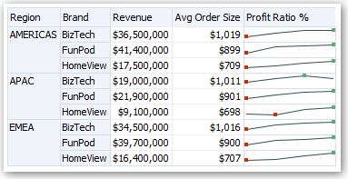

Each measure that is visualized is assigned a different inner graph type. Each cell of the grid is scaled independently.

Think of an advanced trellis as a pivot table with spark graphs inside its data cells. But, for each measure that you add, you can optionally associate a dimension and display it as a microchart visualization. This makes an advanced trellis very different from a simple trellis. In a simple trellis, all of the measures are displayed in the same visualization, along with additional dimensions.

##### Design Considerations for Trellis Views and Microcharts

This concept provides ideas to be considered when designing content displayed in trellis views.

For all trellis views:

* + For comparisons, select the Simple Trellis.
  + For trend analysis, select the Advanced Trellis.
  + Make the inner graphs that comprise a trellis readable and not too dense. A trellis view isn’t especially useful for displaying multiple series or multiple groups. If you can’t easily target a data point with the mouse (to display a tooltip), then the inner graph is likely too dense to be readable.
  + For the Simple Trellis:
    - Designing a simple trellis is like designing a pivot table, except that the total number of cells that can be displayed is much less for a trellis.
    - The main difference between designing a simple trellis and designing a pivot table is that for a trellis, one or two of the dimensions can be associated with the visualization. You add many fewer dimensions to the outer edge.
    - Design the trellis with a small number of outer-edge dimensions. The entire graph series should be visible at once (for easy comparison of like to like) with no need to scroll. If you must show additional dimensionality, then consider adding the dimensions to the graph prompt.
    - When determining which data to show in column headers and which to show in row headers, ensure that the column headers show one or two dimensions (each dimension with a small number of members).
  + For the Advanced Trellis:
    - A common use case for an advanced trellis is to show trend graphs alongside numeric values, in a compressed form. So a typical advanced trellis contains a combination of spark graphs alongside number representations of the same measure.
    - Ideally, include no dimensions in the column headers. Include the measure in the column headers.
    - The dimensionality typically associated with a spark graph is time. Because a spark graph includes no visible labels, it’s important that the data visualized is intrinsically ordered. For example, a spark graph that visualizes regions is meaningless, because the ordering of the regions (which would be the specific bars, in a Spark Bar graph) isn’t intuitive.
    - Just as when designing pivot tables, you generally display time on the horizontal axis, with the other dimensions displayed on the vertical axis. The eye then scans from left to right to see how the dimensionality changes over time.
  + Hierarchical columns don’t work well with the Simple Trellis. When a hierarchical column is displayed on the outer edge, parents and children (such as Year and Quarter) are shown by default using a common axis scale. However, because Year and Quarter have different magnitudes, the markers in child graphs might be extremely small and hard to read against the parent scale. (Hierarchical columns do work well with the Advanced Trellis, because each data cell is a different scale.)

#### Edit Gauge Views

You use gauge views to compare performance to goals. Due to their compact size, gauges can be more effective than graphs for showing a single data value. Results show as a dial, bar, or bulb gauge. For example, you can use a gauge to see whether Actual Revenue falls within predefined limits for a brand.

The following figures show the same value in a dial, bar, and bulb gauge:

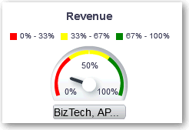

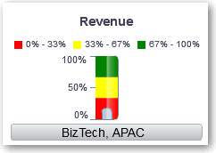

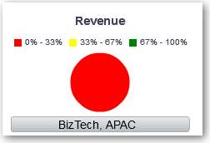

1. Open the analysis for editing.
2. Click the Results tab.
3. Click **View Properties** on the gauge you want to edit.
4. Edit the gauge properties.
   * Use **Gauges Per Row** to specify the number of rows of gauges to display and placement of labels.
   * Use **Listen to Master-Details Events** to link the gauge to a master view. In the **Event Channels** field, enter the case-sensitive name of the channel the gauge view listens to for master-detail events. Separate multiple channels with commas.
   * Use **Gauge Style** to change the width and height of gauges.
   * Use **Marker Type** to specify the marker type for a dial gauge, such as Needle, Line or Fill.
   * Use **Gauge Limits** to specify the scale of gauge limits. For example, you can specify a custom gauge limit. You can specify a static value such as 1000 as either an actual value or as a percentage. The value that you specify depends on the range of data points. You must ensure that the maximum gauge limit is more than the maximum data point. Do so to ensure that all data points are displayed on the gauge.
   * Use **Titles and Labels** to schange the appearance of titles and footers and the format of labels.
5. Click **OK**.
6. Click **Edit View**.
7. Click the **Gauge Type** button on the toolbar and select the type of gauge.
8. Optional: Define thresholds for the gauge.
9. Click **Done**.

##### Set Thresholds

You can set thresholds for display in gauges and funnel graphs.

Each threshold has a high and a low value and is associated with a color in which the range identified by the threshold is displayed in the gauge, such as green for acceptable, yellow for warning, and red for critical.

1. Click **Edit View** to display the view editor.
2. In the Settings pane, select either **High values are desirable** or **Low values are desirable**.

For example, selecting **High values are desirable** lists the statuses in order from the most desirable indicator (such as Excellent) at the top to the least desirable indicator (such as Warning) at the bottom. Generally with columns such as Revenue, high values are desirable. With columns such as Expenses, low values are desirable.

1. In the Threshold list, specify the data values that highlight a particular range of values.

The values must be between the minimum and maximum values set for the view's limits. The range that a threshold identifies is filled with a color that differs from the color of other ranges.

To specify a data value, you can enter a static value directly in a Threshold field, or you can click **Threshold Options** to set the value based on a measure column, a variable expression, or the results of a SQL query. Select **Dynamic** to enable the system to determine the threshold value.

1. Enter the labels for the ranges in the Status area.
   * Select **Threshold Values** to use the current threshold values as the label for the range.
   * Select **Specify Label** to use text that you specify as the label for the range, such as Excellent.

#### Edit Map Views

Map views present data in spatial form and use location context to uncover trends and transactions across regions. For example, a map view can show a map of the United States with the states color-coded by sales performance.

You create a map view after selecting columns to display in that view. The administrator can specify multiple background maps. Initially, the map view is displayed with the first background map that has at least one layer associated with a column that you selected. You can edit a map view by selecting a different background map, applying layers to the background map, and formatting the layers.

1. Open the analysis for editing.
2. Click the Results tab.
3. Click **View Properties**.
4. On the Canvas tab, specify the map size.
   * Use **Canvas Size** to specify the map size within its container. You can select either **Default**, **Custom**, or a predefined size. If you select **Default** or a predefined size, then no other options are available and the map is sized to fit its container. The container is whatever area is holding the map, such as the area in the Map editor or the section of a dashboard page.
   * Use **Map Wrap-Around** to specify a "wrap-around" feature when you include line formats on a map. Lines are the only format that cross map borders, such as an airplane flight from San Francisco to Tokyo. When this feature is turned on, you can pan the map so that lines aren’t broken.
5. On the Labels tab, specify whether to show labels for all layers or specific layers on the map view.

The tab includes a box for each layer on the map view. The labels are displayed in the same order as that of the layers listed in the Map Formats area of the Map editor. Custom point layers have labels hidden by default.

1. On the Interaction tab, in the Initial Map View section, choose the initial center of the map and zoom level.
2. On the Tools tab, specify which tools are available with the map such as the zoom slider and the distance indicator.
3. Click **OK**.
4. Apply formats to the layers.
5. Click **Edit View**.
6. Modify formats and layers.
7. Click **Done**.
8. Drill in values.

##### About Map Views

You use map views to display data on maps in several different formats and to interact with the data.

When data is visualized on a map, relationships among data values that might not have been obvious previously can be displayed in a much more intuitive manner. For example, a map view can show a map of a city with the postal codes color-coded by sales performance, while an image marker displays the average discount given per order.

###### Map Components

A map consists of numerous components including a background or template map and a stack of layers that are displayed on top of each other in a window. A map has an associated coordinate system that all layers in the map must share. The map can be an image file, the object representation of an image file, or a URL that refers to an image file.

* + **Main Content** - The main content is the background or template map, which provides the background geographic data and zoom levels. The main content can be an image such as the floor maps of office buildings or the appearance and presence of items such as countries, cities, and roads.
  + **Layers** - One or more interactive or custom layers can overlay the main content.
  + **Toolbar** - The toolbar is visible by default and you can click its buttons to manipulate map contents directly. The map view itself has a toolbar. The content designer specifies whether to display the toolbar for the map view on a dashboard page. On a dashboard page, the toolbar is displayed directly over the map and contains only the **Pan**, **Zoom Out**, and **Zoom In** buttons.

The toolbar in the Map editor contains additional options for modifying the map view.

* + **Zoom Controls** - These controls adjust the detail of the geographic data that is shown in the map view. For example, zooming in from a country might show state and city details.

The administrator specifies which zoom levels each layer is visible for. You can have multiple zoom levels for one layer, and you can have a single zoom level associated with multiple layers. When you zoom, you change the map information at that zoom level, but you do not affect the display of BI data at that level. You affect the display of data by drilling.

The zoom controls include a zoom slider that is displayed in the upper left-hand corner of the map view with a thumb for large scale zooming and buttons for zooming a single level. When the zoom control is zoomed-out all the way, the zoom level is set to 0 and the entire map view is displayed.

You determine the visibility of the zoom control. When you create a map view, by default the map is initially zoomed into the highest zoom level that fits the entire contents of the top-most layer. For example, if the highest ordered layer contains data only in the state of California, then the map zooms to the highest zoom level that still shows all of California.

* + **Scale Tool** - Also known as the Distance Indicator, this tool provides a key to distance interpretation of the map and consists of two horizontal bars that display in the lower left-hand corner of the map view below the information panel and above the copyright. The top bar represents miles (mi) and the bottom bar represents kilometers (km). Labels are displayed above the miles bar and below the kilometers bar in the format: [distance] [unit of measure]. The length and distance values of the bars change as the zoom level changes and as the map is panned.
  + **Legend** - The legend is a semi-transparent area in the upper right-hand corner of the map view that you can display and hide. The legend shows the information that relates to the current zoom level. The legend provides a read-only visual key for symbols, layers, and formatting on the map and displays all visible formats that are applied to the map. If a format is turned off, then the corresponding legend item is hidden also. If a format is turned on but zoomed out of view, then it is not displayed in the legend. The legend displays text such as "No formats defined for current zoom level" if you have no formats defined at the current zoom level.

When you select a format on the map, the corresponding legend item is highlighted. Highlights have varying granularity, depending on the selected formats (for example, a pie graph does not have the level of granularity that color fill has).

Use the **Expand Map Legend** and **Collapse Map Legend** buttons in the upper right- hand corner to control the display of the legend.

* + **Overview Map** - The overview map consists of a miniature view of the main map that is shown in the lower right-hand corner of the main map. This overview map provides regional context.

The reticule displays as a small window that you can move across a miniature view of the main map. The position of the reticule in the miniature map determines the viewable area of the main map. As you move the reticule, the main map is updated automatically. You can also pan in the overview map without using the reticule.

The overview map is automatically hidden if the reticule can't be shown. This hiding generally happens when the scale difference between successive zoom levels is too small to show the miniature view in the overview map.

* + **Interactive Panel** - The top section of the interactive panel enables you to create and edit BI data formats in the analysis editor. If a format has editable thresholds, then a slider is displayed in the Map editor that enables you to edit thresholds by dragging the slider. The interactive panel enables you to rearrange formats within a geographic layer. For example, if the States layer has three formats, then you can select the order in which the formats are displayed.

When displaying a tooltip by hovering the cursor over a map area, the corresponding detail is updated and highlighted in the interactive panel.

Dashboard users can control the visibility of formats (by turning them on or off) and can adjust format thresholds if the content designer has allowed them to.

The lower section of the panel includes the Feature Layer area, where you can select non-BI layers to add to the map. A non-BI layer is one that has not been associated with a BI column. You can't apply formats to non-BI layers.

##### About Formats and Layers in Map Views

This topic describes how formats and layers interact in map views.

Topics:

* + About Layers in Map Views
  + About Formats in Map Views

About Formats in Map Views

A format for a map view defines display properties for a feature such as a point or a line that represents a city or a river.

For example, if the feature is a polygon that shows a county, then the format can define the fill color for the county or can define a pie graph to be drawn over the county. Formats are tied to a particular geographic level such as continent, country, region, state, or city.

About the Types of Formats that Apply to Map Layers

A map view uses columns of BI data. Each column has a set of properties that define its characteristics, such as for formatting and interaction. Any formatting that is applied to a column isn’t applied to the map, except for the settings for interaction. Any formatting that originates from the map thresholds is applied.

You can apply various kinds of formats to map views and BI layers. You can’t apply formats to non-BI layers. You can define various formats to apply to BI layers.

**Field Description**

Color Fill Displays the Color Fill (*Layer*) dialog, which you use to display areas in fill colors that indicate that an area meets a particular condition.

Color fill formats apply to regions or polygons. For example, a color fill format might identify a range of colors to represent the population in the states of a region or the popularity of a product in the states of a region. A map view can have multiple color formats visible at different zoom levels. For example, a color fill format for the layer at zoom levels 1-5 might represent the population of a state, and the county median income for the layer at zoom levels 6-10. You can also specify different colors to identify a range of data values.

Bar Graph Displays the Bar Graph (*Layer*) dialog, which you use to display a series of data as a bar graph within an area. Graph formats can show statistics related to a given region such as states or counties. For example, a graph format can display the sales values for several products in a state.

Even though you can create multiple graph formats for a particular layer, such creation isn’t recommend as the formats might overlap on the layer and the displayed results might be undesirable.

Pie Graph Displays the Pie Graph (*Layer*) dialog, which you use to display a series of data as a pie graph within an area.

Shape Displays the Variable Shape (*Layer*) dialog, which you use to display a measure column that is associated with an area by drawing markers or shapes within the region. You can also specify different colors for the shape to identify a range of data values.

Bubble Displays the Bubble (*Layer*) dialog, which you use to display a bubble within an area, similar to the shape format.

Image Displays the Image (*Layer*) dialog, which you use to display an image within an area, similar to the shape format. You can specify different images to identify a range of data values. You select images that have been specified by the administrator.

Line Displays the Line (*Layer*) dialog, which you use to display a line on a map.

You can include lines on maps to display paths such as highways, railway lines, and shipping routes. You can specify the width of lines and you can use the Map Wrap-Around feature on the Map Properties dialog to allow lines to be unbroken, such as when showing an airline flight path from San Francisco to Tokyo.

You can vary the width of a line by each measure to accentuate a feature.

**Field Description**

Custom Point Displays the *Format* Custom Point (*Layer*) dialog, which you use to display a point format, such as a bubble, image, or shape in a layer. Custom points are displayed at all zoom levels and on top of all other map formatting.

When you create a Custom Point format, you select columns to specify the latitude and longitude

About the Visibility of Formats in Map Views

The visibility of a format in a map view depends on various factors. The factors on which visibility of a format depends:

* + The zoom level on the map and the "zoom range" of the format. For example, a Color Fill format for States is visible when state boundaries are visible and it’s turned on, but is no longer visible when the map is zoomed out to the Continent level.
  + The data point limit. Formats are generally visible when they are zoomed into view and are turned on, but they might not be displayed if a particular layer has exceeded its maximum number of data points.

Custom point formats are unique in that they are displayed on the map always, for all zoom levels.

Format data is displayed in the legend only when the format is both turned on and zoomed into view. A format is turned on when the box beside its name is selected in the Map Formats area.

The map can’t display multiple non-point formats at a time (at a single zoom level) but can display multiple point formats simultaneously, if they don’t share the same latitude and longitude location. If multiple graph formats are specified at the same geographic layer, then they are displayed on top of each other.

About the Application of Formats in Map Views

There are various guidelines which apply to formats in map views.

* + The Color Fill, Bubble, Pie Graph, and Bar Graph formats apply to geographic areas such as polygons.
  + The Bubble, Variable Shape, Image, and Custom Point formats are based on a single latitude and longitude location (a point).
  + The line format is displayed only when a line geometry is present. Line formats are the only format that you can create for line geometries.
  + When you define formats, you can specify that different formats apply to different measure columns in a layer.

###### About Layers in Map Views

A layer in a map view is any collection of features and formats that have a common set of attributes and a location.

For example, a layer that shows US states can include color coding of states by sales, and a pie graph that shows sales per brand for that state. In addition to the US states layer, you can use a layer that displays stores within a state as individual points, with popup notes that show sales for each store.

Layers are displayed on a background or template map. When you zoom in and out on the map, various layers are hidden or displayed. Some layers must be enabled for data, so you can display it in the map. Other layers, such as one that shows roads, aren’t related to data.

Layers can be either predefined or custom. A predefined layer is one whose geometry is defined in a spatial table in an Oracle Database. The administrator makes predefined layers available, as described in Configuring How Data Is Displayed on Maps. A custom point layer is one that you define while editing a map view.

Layers can be of different types. A polygon layer represents regions, such as states. An example is a New England layer for the United States that consists of Connecticut, Maine, Massachusetts, New Hampshire, Rhode Island, and Vermont.

A point layer represents specific points on a map, based on a coordinate system. For example, a point layer might identify the locations of warehouses on a map. The layer can use a different image for the type of inventory (electronics, housewares, garden supplies) in a set of warehouses to differentiate them from each other.

You can create a custom point layer that applies points to a map using longitude and latitude coordinates. For example, suppose that your company is headquartered in New York City. You can create a custom point layer that displays your company icon over New York City, and that icon is always displayed whenever a map that includes New York City is shown. The custom point layer is always on top of the other layers and isn’t affected by zoom levels. The custom point layer is used only by the current map view in the current analysis; it isn’t used by other map views, even for the same analysis.

You can select layers to be visible or hidden on a map, but you can’t modify predefined layers. You also create formats to apply to the layers, such as colored regions, bubbles, points, lines, or bar or pie graphs. Not all formats are available for all layer types. For example, point layers can’t have color fill formats.

##### Edit Formats and Layers in Map Views

You can edit the formats that are displayed on layers of a map view.

1. Open the map view for editing.
2. Click **Edit View** to display the Map editor.
3. Click **New**, select a format type, then select a layer to display the appropriate dialog for defining that format.
4. If no layers are specified in the map formats area, then click **New Map Format**. The map prompts you to import the geo-encoded columns for displaying a format for a particular geo-layer, if the columns aren’t part of the analysis.
5. Hover over a layer name in the list to display options for modifying the layer.
6. Hover over a format name under a layer name in the list to display options for reordering, editing, and deleting formats.
7. Click the box beside a format name to make the format visible or invisible on the map.
8. Click **Done**.

##### Apply Formats to Layers in Map Views

You can format a map view, including with colors, bar graphs, pie graphs, variably sized bubbles, images, lines, or colored shapes that help you to apply binning and other formatting options.

* + Click the **Create a new map format** link, if no layers are specified in the Map Formats list.
  + Click the **Add new map formats** button, either in the Map Formats title bar or beside a layer name.

##### Move Around in Map Views

This topic describes various techniques for moving around in map views.

Topics:

* + Pan in Map Views
  + Zoom in Map Views
  + Modify Thresholds for Formats on a Map View
  + Show or Hide Formats on a Map View

Pan in Map Views

You pan using the map's toolbar and can pan on the main map or on the overview map. You can also use the reticule in the overview map to move around.

Pan is the default mode for the map view, and the pan mode is indicated by a hand cursor. With the Pan tool selected, you can move in various ways:

* + Click and drag on the map background.
  + Hover over a region of the map to display an information window for that region for the data that is directly below the cursor.
  + Click to display an information window. The information window can be used to drill or update a detail view.
  + Double-click the map to zoom.

To pan in a map view, using the Pan tool, click the **Pan** button on the toolbar, then click the map background and drag and drop it to the appropriate location.

###### Zoom in Map Views

Zooming the map adjusts the detail of the geographic data that is shown on the map.

Zooming in from a country level might show state and city details. Zooming out from a street- level view might show cities but not street-level information. For master-detail linking, the map view focuses on the detail feature that was selected in the master view.

You can zoom in various ways:

* + Click on the map background. To zoom by clicking, you must first select the zoom mode from the toolbar. The default mode is pan, which is indicated by a hand cursor. When

you’re in zoom mode, the mouse pointer changes to a magnifying glass and you can click-zoom directly on the map itself.

When you’re zooming in, you can either single-click or click and drag to use marquee zoom. You can draw a box that delineates the area in which you want to zoom.

* + Hover over a region of the map to display an information window for that region for the data that is directly below the cursor.
  + Click to zoom in and out. When you click, the map zooms in one "increment" using the click location as the center point.

Zooming and drilling aren’t synonymous. When you zoom, no drill is performed (that is, no new query is issued). However, if you drill on a map layer, that drill likely results in a new zoom level being displayed, if a new layer is added to the map. If a new layer isn’t added, then the zoom level doesn’t change.

You can zoom using either the buttons on the toolbar or the zoom slider. When you use the zoom slider, you zoom in or out of the map as it’s currently displayed. When you hover over the zoom slider, the names of the map layers are displayed beside their mid-range zoom level. Click the names to zoom the map to that level. When you zoom, a new query isn’t issued.

You can zoom in map views with toolbar buttons, or you can use the slider:

* + To zoom using the tools, click the **Zoom In** or **Zoom Out** button on the toolbar, then click the map background to zoom in that spot.

If you’re zooming in, then you can click and drag to draw a rectangle to specify the area in which to zoom.

* + To zoom using the buttons on the slider, click the plus or minus sign on either end of the slider.

You can also hover over the slider, then click the name of the level to zoom.

###### Modify Thresholds for Formats on a Map View

You can modify the thresholds that are used for displaying formats on the map view.

You know that you have this ability if you see a slider under a format name in the Map Formats pane. Modifying thresholds is sometimes referred to as "what-if analysis." Format ranges are displayed as color fills on the slider background, with a "thumb" for each threshold that you can edit.

* + Hover over a thumb to display the value under that thumb.
  + Drag the thumb to adjust the threshold.
  + Click a section on the slider to move the thumb to that section.
  + Right-click the slider to display a menu with various options.
    - **Edit Color** — Displays a dialog, in which you select a predefined or custom color for the threshold.
    - **Add Threshold** — Adds another threshold to the slider, including a thumb to indicate the threshold. This addition creates a new formatting bin with a new color. For example, if three bins exist (with colors red, yellow, and green) and you create a threshold, then four bins now exist. A maximum of 12 bins is allowed.
    - **Remove Threshold** — Removes the threshold above where you right-clicked, including removing the thumb from the slider and a formatting bin.
  + Click on a slider thumb number value to display a text box in which you can edit the number that corresponds to the threshold value. Press Enter or click outside the box to update the threshold value and the thumb position.

###### Show or Hide Formats on a Map View

Content designers can superimpose multiple layers of information (sometimes known as themes) on a single map view. They can create formats to enhance the layers. You can display or hide the formats for a map.

* + In the Map Formats pane, from the View menu, select either **View All Formats** or **View Visible Formats**.
  + In the Map Formats pane, deselect the box beside a format's name.

##### Set the Initial View Ports for Map Views

You can set the initial view port (the initial center of the map and zoom level) when a map view is first loaded or refreshed in a browser.

1. Open the map view:
   1. Open the analysis for editing.
   2. Click the Results tab of the analysis editor.
   3. Click **View Properties**.
2. In the Initial Map View section of the Interaction tab, select the appropriate value:

**Field Description**

Dynamic Specifies that the map is zoomed or panned to the actual data on the map.

This option focuses on the content that the user has added to the map view. This option is preferable for the initial displaying of the map view and for refreshing the map view, because it tries to display all BI content. This setting doesn’t affect the printing of maps, because the coordinates and zoom level control all WYSIWYG interaction.

The map is zoomed to the maximum zoom-level that still allows the content to fit on the map. This zoom-level might exceed the minimum and maximum visible zoom-levels that are specified for this layer in the Edit Background Map dialog. If the minimum and maximum visible zoom-levels are exceeded, then the format is hidden.

Last Saved Specifies that the map is displayed at the last saved map center and zoom level.

This option focuses on the last map window that was viewed. The display is based on the X (longitude) and (Y) latitude center coordinates and on the zoom level. While you can select this option for the initial view port, this option is preferable and is always used for printing maps and other WYSIWYG interactions.

1. Click **OK**.

#### Edit Narrative Views

A narrative view displays data results as one or more paragraphs of text. You use a narrative view to provide information such as context, explanatory text, or extended descriptions along with column values.

You can perform various tasks in the narrative view editor:

* + Type a sentence with placeholders for each column in the results.
  + Specify how rows are separated.
  + Apply cosmetic formatting to the fonts used in the narrative view, or import the font formatting from a previously saved view.
  + Add references to variables.

1. Open the analysis for editing.
2. Click the Results tab.
3. Click **Edit View** to display the narrative view editor.
4. If you have administrator privileges and want to format content in the narrative view with valid HTML markup, including JavaScript, select **Contains HTML Markup**.
5. In the **Prefix** field, enter the header for the narrative. This text is displayed at the beginning of the narrative.
6. In the **Narrative** box, enter the narrative text that is displayed for each row in the results.

You can include both text and column values. Include a line break code at the end of this field to force each line of text and values onto its own line.

To include column values, use an at sign (@), optionally followed by a number. Use an at sign by itself to indicate the first column. If you include multiple at signs, then the first occurrence of the sign corresponds to the first column, the second occurrence corresponds to the second column, and so on.

Use @*n* to include the results from the designated column in the narrative. For example, @1 inserts the results from the first column in the analysis, and @3 inserts the results of the third column.

For example, for an analysis that returns the region name in the second column, specify @2 to include the following values in the view: East Region and West Region.

1. In the **Row separator** field, enter a row separator for each line from the Narrative field that contains values. For example you might enter a string of plus signs (+) between each line.
2. In the **Rows to display** field, enter the number of rows from the column to return.

For example, enter 5 to display values from the first 5 rows of the column. For a hierarchical column, you can use selection steps to display hierarchy levels with the hierarchical column. For example, create a step to select members based on hierarchy and add members of the specified level. A hierarchy level is considered a row.

1. In the **Postfix** field, enter the footer for the narrative. Ensure that the narrative ends in a line break, or that the footer begins with a line break.
2. Click **Done**

#### Edit Non-Data Views

You usually edit views that display data, such as tables, graphs, and gauges, but you can also edit views that don’t contain data.

You can include the following types of non-data views in analyses and dashboards:

* + Column Selector
  + Filter
  + Selection Step
  + Static Text
  + Title
  + View Selector

##### About Column Selector Views

A column selector view is a set of drop-down lists that contain pre-selected columns. Users can dynamically select columns and change the data that is displayed in the views of the analysis.

One drop-down list can be attached to each column in the analysis, and multiple columns can be attached to each drop-down list. Updates that you make in the column selector view affect all the data views in the analysis.

You add columns to drop-down lists from the Subject Areas pane. When you add columns in this way, they aren’t added to the Criteria tab for the analysis. Instead, when you display the Criteria tab, you see that the column is now referred to as a "Column Group" with the default column for the list specified also. The default column is the one on which you created the drop-down list.

##### About View Selector Views

A view selector view enables users to select a specific view of the results from among the saved views for an analysis. When placed on a dashboard, the view selector is displayed as a list from which users can choose the view that they want to display below the selector.

Generally, you include views in the view selector that aren’t being displayed in the Compound Layout view. For example, you might create a table, graph, gauge, and view selector view for an analysis, but include only the table and view selector view on the Compound Layout view. When the analysis is displayed on a dashboard page, users can select the graph or gauge view from the view selector view.

##### About Filters Views

A filters view displays the filters in effect for an analysis.

Filters, like selection steps, allow you to constrain an analysis to obtain results that answer a particular question. Filters are applied before the query is aggregated. See Creating Filters for Columns.

##### About Selection Steps Views

A selection steps view displays the selection steps in effect for the analysis. Selection steps, like filters, enable you to obtain results that answer particular questions.

Selection steps are applied after the query is aggregated.

You don't modify selection steps from this view editor. To modify the selection steps, exit the Selection Steps editor and use the Selection Steps pane. See Refining Selections of Data.

##### About Static Text Views

A static text view adds static text to be displayed with the analysis results.

You can include variables in a static text view, as shown in the following example. See Advanced Techniques: Referencing Stored Values in Variables.

[u] Static Text View [/u][br/]

Region: @{variables.myFavoriteRegion} - Year: @{variables.myFavoriteYear}[br/]

System Time: @{system.currentTime}[dddd,MMMM dd,yyyy][br/] Product Version: @{system.productVersion}[br/]

[br/]

##### About Title Views

A title view displays a title, a subtitle, a logo, and timestamps to the results.

If you don’t specify a title, then the name of the saved analysis is used as the title. For unsaved analyses, the **Title** text box is blank. You can reference variables in the text fields of the Title editor.

### Graph Data in Analyses

This topic identifies additional information for graphing data in analyses.

Topics:

* + Edit Graph Views
  + Zoom and Scroll in Graphs
  + Format the Visual Appearance of Graphs
  + Limit Data Displayed in Graphs and Gauges

#### Edit Graph Views

You can use graphs of various types for analyzing and displaying data.

For example, in the Brand Revenue analysis, you can edit a bar graph to compare the product revenue for three different regions, as shown below.



1. Open the analysis for editing.
2. Click the Results tab.
3. Click **View Properties** on the graph view you want to edit.
4. In the Graph Properties dialog, edit properties as needed.
5. On the Scale tab of the properties dialog, select **Click to edit Scale Markers** to display the Scale Markers dialog.

Scale markers are accenting lines or shaded background ranges that mark key points, thresholds, ranges, and so on in a graph. Use a Line scale marker to draw a line across the graph at a specified position on the scale. Use Range to add a shaded background area behind the graph.

You can apply line or range scale markers on one or more axes depending on the type of graph.

1. Click **OK**.
2. Click **Edit View** to display the Graph editor.
3. Use various toolbar buttons to affect the display of the graph.
4. Optional: Define thresholds for a funnel graph.
5. Optional: Drill in data in the view.
6. Click **Done**.

#### Zoom and Scroll in Graphs

If zooming and scrolling has been enabled for a graph, then the graph includes a Zoom icon. The Zoom icon enables you to zoom in and out of a graph's plot area using its axes.

After you zoom in on an axis, you can scroll the axis. Enable zooming and scrolling with the General tab of the Graph Properties dialog.

For example, while viewing a graph in results of a Brand Revenue analysis, you can zoom in on the Product Type axis. Doing so enables you to scroll the axis and view more data by product type.

To zoom and scroll in a graph, hover the cursor over the graph to reveal the **Zoom** button and click **Zoom**. If only one axis is enabled, select **Zoom In** or **Zoom Out**.

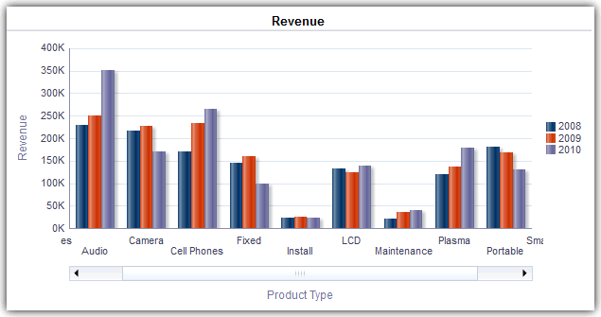

If both axes of the graph are enabled for zooming and scrolling:

* + Select **Horizontal Axis**, then either **Zoom In** or **Zoom Out**. A zoom and scroll slider is displayed on the X axis.

To unzoom the X axis, select **Actual Size**.

* + Select **Vertical Axis**, then either **Zoom In** or **Zoom Out**. A zoom and scroll slider is displayed on the Y axis.

To unzoom the Y axis, select **Actual Size**.

* + To unzoom both the X and Y axes, select **Actual Size**. Optionally, use other zoom features:
  + Use **Zoom** to zoom in and out incrementally.
  + Drag the scroll thumb on an axis to dynamically scroll the graph, revealing portions of the graph that are out of view.
  + Click the scroll buttons on an axis to scroll left and right (on the X axis), or up and down (on the Y axis).
  + Use the resize handles to zoom in and out on an axis.

#### Format the Visual Appearance of Graphs

You can format the visual appearance of graphs. Formatting the visual appearance is based on two settings:

* + The position of the graph elements (such as lines or bars in a line-bar graph or slices in a pie graph).
  + Conditions applied to columns.

##### Format Graphs Based on Position

Positional formatting enables you to customize the appearance of a graph based on the position of graph elements; that is, the numeric sequence in which graph elements (for example, bars) are displayed in a group.

A group is determined by the attribute columns that are displayed in the Group By drop target area.

You can format the visual appearance of a graph based on position in terms of its color, line width, and line symbols. You can’t use positional formatting with waterfall graphs.

##### Format Graphs Based on Columns

Conditional formatting enables you to customize the appearance of a graph based on conditions applied to columns. The formatting is applied to the column values that meet the condition.

You can specify a color in which to display graph data based upon a specific column value, or range of column values that meet the condition specified for the column. For example:

* + Conditionally changing the color of a graph based on specific column values.

You want to create a bar graph to compare sales between two beverages, Lemonade and Cola. When creating a bar graph, you specify two conditions, one where the bar representing Lemonade sales is yellow and another where the bar representing Cola sales is blue.

* + Conditionally changing the color of a graph based on a range of column values.

A sales manager wants to create a bar graph to compare sales for all representatives across two sales bands. When creating a bar graph the sales manager specifies two conditions, one where the bar is red for all sales representatives with sales less

than $250,000, and another where the bar is green for all sales representatives with sales greater than $250,000.

1. Click **Edit Graph Properties** on the toolbar of the graph editor.
2. Click the Style tab of the Graph Properties dialog.
3. Click Style and Conditional Formatting.
4. Click the Style Formatting tab to format the appearance of a graph based on the position of the graph elements. To add a custom formatted position:
   1. Select the tab for the graph element (for example, bar) to which you want to add a custom formatted position.
   2. Click **Add new position**. A new position entry is displayed in the Custom Formatted Positions table.
   3. Specify the formatting. For example, to select the color to be applied to the position, click the down arrow next to the **Color** box to access the Color Selector dialog. (Note that the formatting options depend on the element.)

If you specify 0 for the width of a line, then the legend marker changes from the default line marker to symbol markers for the line and for other lines in the graph. For example, the symbol markers are shown as the legend markers for all the lines in the graph.

1. Click the Conditional Formatting tab to format the appearance of a graph based on a condition that is applied to columns. To add a condition to a column:
   1. Click **Add Condition Format** and select the column to which you want to apply a condition.
   2. Select the operator and enter a column value, or a range of column values for this condition.
   3. Click **OK**.
   4. To select the color to be applied to column values when the condition is met, click the down arrow next to the **Color** box to display the Color Selector dialog.
2. Click **OK**.

##### Rules to Apply Conditional Formats in Graphs

Follow these rules when building and using conditions in graphs.

* + You can create conditions only from columns that are being used by the graph.
  + When format conditions conflict with each other, conflicting conditions are prioritized in the following order:

1. Conditional formatting on attributes.
2. Conditional formatting on measures
3. Style formatting based on the positions of graph elements.
   * When a user drills on a graph that has conditional formatting applied, the following rules apply:
     + A conditional format based on measures isn’t carried to the next level. (It doesn’t make sense to carry the conditional format to a different level; for example if, in a geographic hierarchy, from Region to City.)
     + A conditional format based on attributes is carried to the next graph if it hasn’t been drilled on.

For example, if you had the conditional format "Lemonade = Blue" and only drill on years, then "Lemonade = Blue" stays in place.

* + Conditional formatting isn’t supported on subtotals and totals for waterfall graphs.

##### Graph Exceptions for Conditional Formatting on Columns

This reference lists the graph exceptions that apply to conditional formatting based on columns.

**Graph Type Exception**

Line Line-Bar Radar

Time Series Line

Only symbol formatting is allowed for the line.

Pareto Formatting is applied only to the bars, not to the Pareto line.

#### Limit Data Displayed in Graphs and Gauges

You can limit the data that is shown in graphs or gauges using section sliders. A section slider displays members of one or more attribute or hierarchical columns as values on a rectangular bar.

The slider also provides mechanisms to select a value for that column such as increase and decrease buttons. The play button sequentially moves through the slider values.



Topics:

* + Define Section Sliders in Graphs and Gauges
  + Use Section Sliders in Graphs and Gauges

##### Define Section Sliders in Graphs and Gauges

You can define a section slider to limit the data that is shown in a graph or gauge.

For example, you can limit the data that is shown in a graph to a specific quarter in the year 2013.

1. Open the analysis for editing.
2. Click the Results tab.
3. Create the graph or gauge.
4. Click **Edit View** on the graph or gauge view.
5. In the Layout pane, drag columns to the Sections drop target.
6. Select **Display as Slider**.
7. Click **Section properties**.
8. Specify the maximum number of values to display in the section slider, and then click **OK**.
9. To close the editor, click **Done**.
10. To save the changes, click **Save Analysis**.

##### Use Section Sliders in Graphs and Gauges

You can use a section slider in a graph or gauge.

* + Move the slider thumb to the desired value.
  + Click the decrease button to move the slider thumb to the left.
  + Click the increase button to move the slider thumb to the right.
  + To sequentially move the slider through all the values, click the play button.

The play button changes to a pause button that enables you to stop on a particular value. The data in the graph or gauge is limited by the current value indicated by the slider thumb.

Save Views

### Save Views

You can save a view that you’re working with at any time.

To save a view, you must save the new or existing analysis. For example, you can create a Brand Revenue analysis, edit its table view, and decide to save it for the first time.

Click **Save Analysis** or **Save As** in the toolbar of the Results tab of the analysis editor.

### Rearrange Views

You can rearrange a view within a compound layout to be alongside the boundary of another view or to the outer boundary of the compound layout (where the view is displayed across the length or breadth of the compound layout).

For example, you can rearrange the views in the Brand Revenue analysis. You can arrange the bar graph of Projected Revenue to be displayed before the line graph of Actual Revenue.

1. Place the cursor just inside the top edge of the view that you want to rearrange.
2. Click and hold the left mouse button on the view.

The view is displayed as a transparent, movable object.

1. Drag and drop the view to the position that you want.

The view is displayed in a position marked by a blue bar (the drop target).

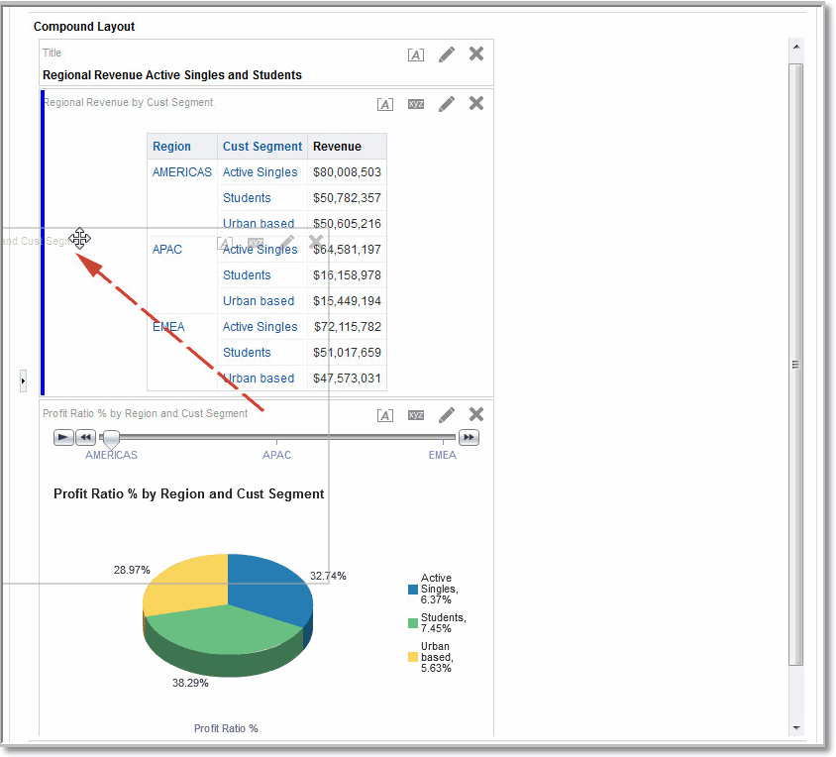

Refresh the Results in Views

### Refresh the Results in Views

When you work with views that show results data, such as the table and pivot table, you can refresh the results of the current analysis.

For example, you can add a filter in the Brand Revenue analysis. After doing so, you might want to see the effects of your change.

On the toolbar of the Results tab, click **Refresh the results of the current analysis**.

### Print Views

You can print views using HTML or Adobe PDF (Portable Document Format).

For example, you can display and print the Brand Revenue analysis in a new browser window by selecting the **Printable HTML** option.

1. Print one or more views.
   * To print a single view, click **Print this analysis** on the toolbar of the view's editor.
   * To print a group of views that displayed in the Compound Layout, click **Print this analysis** on the toolbar of the Results tab.
2. Select **Printable HTML** or **Printable PDF**.
   * For HTML, a new browser window displays the view or views to print. From the File menu of the new browser window, select **Print**.
   * For PDF, an Adobe Acrobat window displays the view or views to print. Select the options in the window to save or print the file.

### Change Print Options for Views

You can specify settings for printing dashboard pages and views.

For example, when printing the Revenue Dashboard that contains many views side-by-side on each page, you can set the Orientation to Landscape.

The print selections that you specify apply to PDF output only. If you then print the PDF file on a local or network printer, then the print selections specified in the browser are in effect. For example, the selection for paper size for the browser is in effect.

1. On the toolbar of the Results tab, click **Print & Export Options**. The Print & Export Options dialog is displayed.

Preview How Views Are Displayed on Dashboards

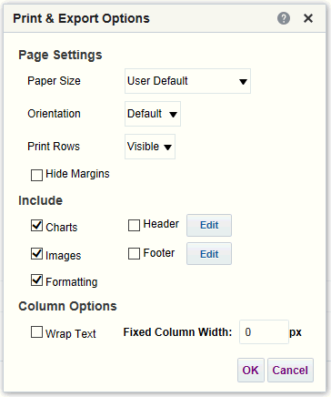

1. Specify the appropriate options on the dialog. For example, specify the paper size and orientation and whether to include a header and footer.
2. Click **OK**.

### Preview How Views Are Displayed on Dashboards

You can preview views to see how they are displayed on a dashboard page.

For example, you can select **Show how results will look on a dashboard**. Doing so previews how results from a group of views are displayed in a dashboard.

1. If you want to preview a single view:

On the toolbar of the view's editor, click **Show how results will look on a dashboard**.

1. If you want to preview a group of views that is displayed in the Compound Layout:

On the toolbar of the Results tab, click the **Show how results will look on a dashboard**.

The dashboard preview is displayed in a new window. Prompts are displayed and applied in the preview.

### Remove Views

You can remove a view from a compound layout or analysis.

For example, you might find that the trellis view isn’t the best way to show the results of the Brand Revenue analysis. You can remove that trellis view.

* + To remove a view from a compound layout, click **Remove View from Compound Layout** on the view's toolbar. Removing a view from a compound layout doesn’t remove it from the analysis.
  + To remove a view from an analysis, select the view, then click **Remove View from Analysis** in the Views pane on the Results tab. Removing a view from an analysis removes it from the analysis and any compound layout to which it was added.

Sort Values in Views

### Sort Values in Views

You can sort values in table, pivot table, graph, heat matrix, and trellis views. You can sort on members, measures, and rows (where you see sideways triangles). You can’t sort on page or section edges.

In pivot table and trellis views, values in columns are sorted on an edge from left to right. You can't sort values in ascending or descending order in any of the columns.

You can use many options to sort in views. For example, when you sort a column, you can select from the following options:

* + **Sort Ascending** — Enables you to sort the values in the column by ascending order, as a first-level sort. For example, string values sort alphabetically A through Z, numbers sort lowest to highest, and dates sort earliest to latest.
  + **Sort Descending** — Enables you to sort the values in the column by descending order, as a first-level sort.
  + **Add Ascending Sort** — Specifies that an ascending sort for this column is added as another sort for the analysis.
  + **Add Descending Sort** — Specifies that a descending sort for this column is added as another sort for the analysis.
  + **Clear Sort** — Removes the sort specification for the specified column. This option works differently in the Selected Columns pane than in other places. If you make sort specifications in both the Selected Columns pane and in the view itself, then you return to the Selected Columns pane and click **Clear Sort**, only the sort that you specified in the Selected Columns pane is removed. A sort that you specified in the view remains.
  + **Clear All Sorts in All Columns** — Removes all sort specifications that you have made. This option works differently in the Selected Columns pane than in other places, as described for **Clear Sort**.

For example, in a table in the Brand Revenue analysis, you can select an ascending sort on the Revenue column. Doing so sorts revenue values from the lowest to highest.

You can sort values in the following ways:

* + Right-click in a view heading, click **Sort Column**, and select the appropriate option.

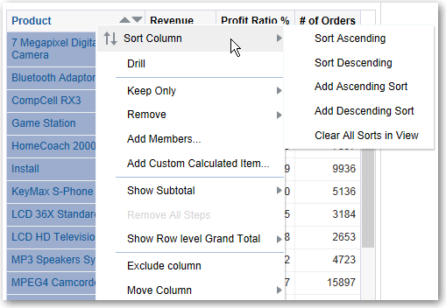

* + Click the upwards and downward triangles that are found in column headings.

Clear Sorts in Views

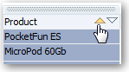

* + Right-click a cell in a view and click **Sort** to display the Sort dialog. The interactions that are available in the Sort dialog depend on the type of data view (for example, graph or table) and the location in which you right-click within the view.
  + From the Selected Columns pane of the Criteria tab, click **Options** beside a column, click **Sort**, and select the appropriate option.

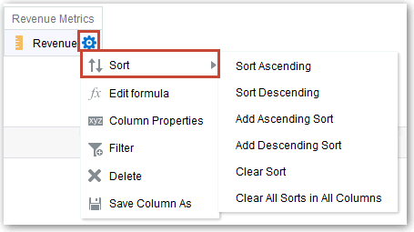

### Clear Sorts in Views

You can clear sorts that you have applied to columns in a view or analysis.

For example, you can clear all sorts in the Time column of the Brand Revenue analysis.

To clear sorts that you have applied in a pivot table, table, heat matrix, or trellis view, right-click in the view heading and click **Clear All Sorts in View**.

1. Display the Selected Columns pane of the Criteria tab.
2. Click **Options** beside the column.
3. Select **Sort**, then **Clear Sort**.

When you clear sorts from the Criteria tab, you clear only the sorts that were defined from the Column Options menu. You don’t clear the sorting done within a specific view.

To remove the primary sort from the column to which it now applies and apply it to the column whose button you just clicked, click a sort button in an unsorted column.

### Drill in Results

You can drill in results.

Topics:

* + About Drilling
  + Drill in Tables and Other Views
  + Drill in Graphs
  + Drill in Map Views

Drill in Results

#### About Drilling

Many of the results that are displayed in views represent hierarchical data structures. The metadata specifies these hierarchies, and this enables you to access the different levels of detail within them. Drilling is a way to navigate through data in views quickly and easily.

* + Drill down to display data in more detail, which displays more members.
  + Drill up to display less data.

For example, in the results of the Brand Revenue analysis, you can drill for more data in the graph of Revenue by Product. To do this you can click on the MobilePhones data point. More data is displayed in the graph, such as the MobilePhones revenue per sales office for each of the last three years.

#### Drill in Tables and Other Views

When you drill down in a table, pivot table, heat matrix, or trellis, the detail level data is added to the current data.

For example, when you drill from a continent, the table displays data for the continent and for the countries in that continent.

1. Hover over a value in a view. The value is underlined.

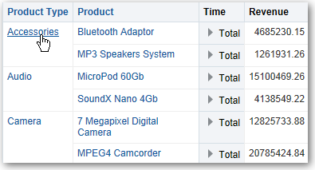

1. Click the heading or member in which you want to drill. More detail is added to the table or trellis.

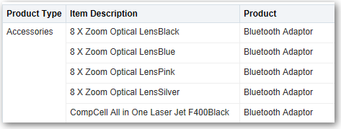

To drill in a hierarchical column in tables, pivot tables, and trellises, click the **Expand** or

**Collapse** icon beside a member.

You can also use the right-click menu to expand and collapse columns.

Drill in Results

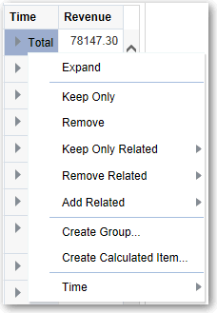

#### Drill in Graphs

When you drill down in a graph, the detail level data replaces the current data.

For example, when you drill down from a continent, the graph displays data for the countries in that continent, but not for the continent itself.

* + Click a label on any axis or in the legend.

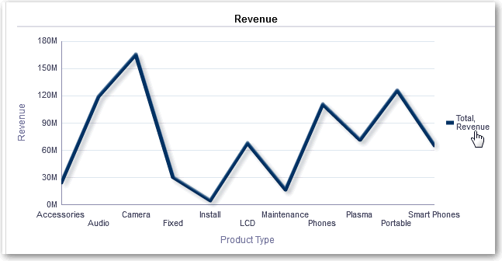

* + Click on a data point.

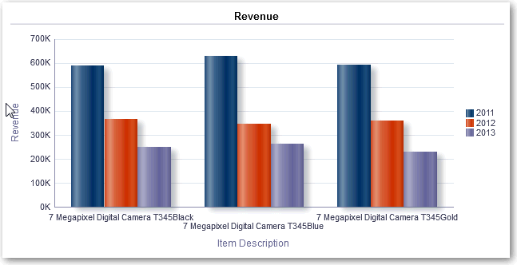

Resize Rows and Columns in Views

* + More detail is shown in the graph.

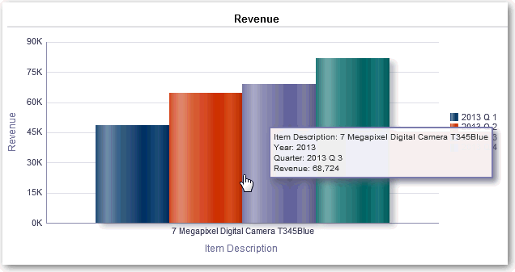

#### Drill in Map Views

Drilling in a map enables you to navigate through the data. Drilling is available when the Pan tool is selected, as indicated by a hand cursor. If you hover over map data, then an information window is displayed with various information about that location.

When you click a region or a point on the map:

* + If the column is configured as a master for another view, then that view is updated with the latest information.
  + If the column or map is configured to drill into a column or to perform a single action, then the drill or action is immediately initiated.
  + If the column is configured to perform multiple actions or if multiple drills are possible, then the information window that is displayed contains a list of the actions or links for the multiple columns.

All columns in which you can drill are displayed in the information window as link text. When you click the link for a simple drill, you drill in the data, the map is redrawn with a different layer, and the information window is closed. If action links are defined, then you see a popup window that shows additional links.

Drilling updates map formatting to reflect the newly drilled data. For some drills (such as drilling on a State), the map zooms to the specified region while simultaneously updating the formatting. How you zoom and the formats and geographic levels that the map contains affect what is displayed. Formats have particular "zoom ranges" and are visible at different zoom levels. Zooming back up might display a new format, if you zoom out past the zoom level of the drilled format.

After you have drilled down, use the zoom slider to drill back up. Use the **Return** button on a dashboard page to display the original map view at the zoom or drill level that was in place before you started drilling.

### Resize Rows and Columns in Views

You can resize the row and column edges of table, pivot table, and advanced trellis views.

Resize Rows and Columns in Views

For example, you can resize the Time column in a table of results of the Brand Revenue analysis.

Note that the resizing of rows and columns:

* + Isn’t persisted if you resize rows and columns interactively. If you leave a table, then display it again, the interactive resizing is lost. If you set columns widths using properties, those widths are persisted.
  + Is ignored if you export the view to PDF.

Topics:

* + Configure to Resize in Views
  + Resize in Views

#### Configure to Resize in Views

You must configure views to use scrolling as the method for browsing data before resizing can occur.

1. On the view's toolbar, click **View Properties**.
2. Select **Fixed headers with scrolling content** in the properties dialog.
3. Click **OK**. The scroll bar is displayed on the view, and rows and columns can be resized.

#### Resize in Views

You can resize a row or column edge in a table view, pivot table view, or advanced trellis.

1. Hover the mouse pointer over the border of the column or row edge.

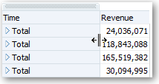

1. Click and hold the mouse button down.

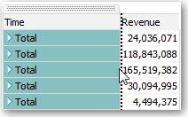

1. Drag the dotted line to the required size.
2. Release the mouse button.

Suppress Null Values in Views

### Suppress Null Values in Views

You can select whether to include null values in an analysis when an entire row or column contains all null values. By default, null measure values are suppressed for all analyses.

For example, you might decide to display null values in the Revenue column of a Sales analysis.

1. Display the Results tab for the analysis that includes the view.
2. Click **View Properties**.
3. Select the appropriate **Include Null Values** options for the view.

For example, suppose that you want to turn off null suppression for both rows and columns in a pivot table. Select **Include rows with only Null values** and **Include columns with only Null values**.

This setting displays corresponding dimensions that have data, as well as null values. Note that if the view contains prompts or section edges, then they also inherit the null suppression value from either the row or column edge.



**Note:**

Turning null suppression off might increase the volume of the data returned and impact performance. Contact your administrator for additional information.

If results for analyses that include null values aren’t as you expect, then contact your administrator. Verify that data in your sources is consistent.

### Assemble Views for Display

You use a compound layout to assemble different views for display on a dashboard. The views are displayed in separate containers within a compound layout.

* + You can create additional compound layouts to vary presentation of analyses. You can use different compound layouts for different dashboards or for different devices. For example, a Brand Revenue dashboard might have one compound layout that shows a table and a graph, and another that shows a pie chart.
  + You can duplicate a compound layout as a shortcut to creating a new compound layout. Views from the original compound layout are preserved. You can add views in addition to views that are already there, and delete views you don’t want. For example, suppose you have a duplicate compound layout for the Brand Revenue analysis. You can keep the table, graph, pie chart, and gauge views, and add a performance tile view.
  + You can rename a view so that the name is more meaningful to you. For example, for a Brand Revenue analysis, suppose a western region now consists only of California. You can rename the Western Region compound layout to California.
  + You can delete compound layouts that are no longer useful for you. For example, for a Brand Revenue analysis, you might not need views for the Western region. You can delete the compound layout that contains those views.

1. Open the analysis for editing.
2. Click the Results tab, and use the toolbar options to assemble the view:
   * To create a compound layout, click on **Create Compound Layout**.

A compound layout tab is displayed with only a title view. You can add views as needed.

* + To duplicate a compound layout, click on **Duplicate Compound Layout**. A compound layout tab that contains the same views as the selected compound layout is displayed. You can add or delete views as needed.
  + To rename a compound layout, click **Rename Compound Layout**.

On the Rename dialog, type a new name for the compound layout and click

**OK**.

* + To delete a compound layout, click on **Delete Compound Layout**.

### Link Views in Master-Detail Relationships

You can link views so that one view drives changes in other views.

For example, when you select 2011 as a 'Year' value in the master view, you see 2011 data in a chart in the detail view .

You define two views to link:

* + A master view that drives data changes in one or more detail views.

The following types of views can be master views: funnel graph, gauge, graph, heat matrix, map, pivot table, table, and trellis. In a trellis view, only on the outer edges, can be master views, not the inner visualizations.

Master views can be the same analysis as the detail view or in a different analysis.

A master view contains a master column, where you set up the interaction that sends master-detail events on a channel. A channel carries master-detail events to the detail view. The master view must be displayed in the body of the view; it can’t display on the page edge or section slider.

* + A detail view that responds to events such as clicking on a value in a master view table.

The following types of views can be detail views: funnel graph, gauge, graph, heat matrix, map, pivot table, table, and trellis. In a trellis view, only the outer edge can be detail views, not the inner visualizations.

A detail view:

* + - Can listen for events from multiple master views.
    - Can be in the same analysis as the master view or in a different analysis.
    - Can’t act as a master view to another view.

Topics

* + Define Master Views
  + Define Detail Views

Link Views in Master-Detail Relationships

#### Define Master Views

As part of the process of linking views in master-detail relationships, you define the master view that sends changes to the detail views.

1. Open the analysis for editing.
2. For the column that is to be the master column, in the Criteria tab, click the **Options**

button and select **Column Properties**.

Make sure that you use one of the supported types for master views.

1. On the Column Properties dialog, click the **Interaction** tab.
2. In the **Primary Interaction** box in the **Value** area, select **Send Master-Detail Events**.
3. In the **Specify channel** field, enter a name for the channel on which the master view sends master-detail events.

For example, if you're selecting a geographical region, you might name the channel "RegionChoice".

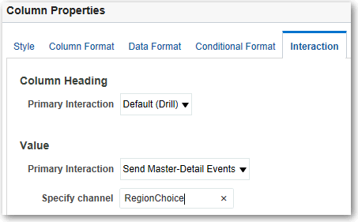

1. Click the Results tab to view the default table or pivot table view.
2. Click **OK**.

#### Define Detail Views

As part of the process of linking views in master-detail relationships, you define the detail views that receive changes from the master view.

**Note**: Make sure that you position the master view column (that is, the column in the master view with **Primary Interaction** set to “Send Master-Detail Events”) on the Prompts or Sections area of the detail view.

1. Open the analysis for editing.
2. Click the Results tab.
3. Create the view that you want to use as the detail view.

Make sure that you use one of the supported types for detail views.

1. On the view's toolbar, click **Edit**.
2. Drag the master view column (with **Primary Interaction** set to “Send Master-Detail Events” in the master view) to either the **Prompts** box or the **Sections** box, then click **Done**.
3. Click the **View Properties** button on the toolbar of the view's editor. The view's property dialog is displayed.
4. Select **Listen to Master-Detail Events**.

The location of the **Listen to Master-Detail Events** option depends on the view type, as follows:

* + Gauge Properties dialog: General tab
  + Graph Properties dialog: General tab (for a graph or funnel graph)
  + Heat Matrix Properties dialog: General tab
  + Map Properties dialog: Interaction tab
  + Pivot Table Properties dialog: Style tab
  + Table Properties dialog: Style tab

1. In the **Event Channels** field, enter the name of the channel that you defined in Step 5 in Define Master Views.

For example, you might have named a geographical region channel "RegionChoice".

Channel names are case-sensitive and must match exactly the channel names specified in the master view. Separate channels with commas, for example, channel a, channel b.

1. Click **OK**.

In the following example, a table view of a City Revenue analysis is linked to a bar graph through a master-detail relationship.

In the graph view, the City column is configured as the master view. The City column sends events to the graph view through the specified CityChoice channel.

The graph view has a prompt that enables users to choose a city. Data on the graph is displayed based on the city choice.

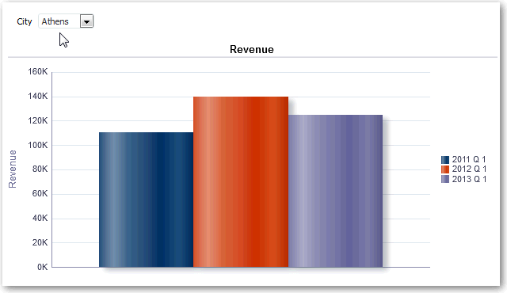

The graph is the detail view, with the City prompt listening for events from the table view on the specified CityChoice channel. Suppose the user clicks on a value in the City column in the table view. The prompt in the graph view is set to that city, and the graph is refreshed.

### Modify the Layout of Data in Views

Use the Layout pane to modify the way that data is arranged in a view. Perform tasks such as adding and rearranging columns and adding totals.

Topics:

* + Add and Rearrange Columns in Views
  + Set Properties for Sections of Data in Views
  + Add Totals to Tables and Pivot Tables
  + Display Running Sums and Relative Values in Pivot Tables

#### Add and Rearrange Columns in Views

You can add and rearrange columns in views.

Topics

* + Add Columns to Views
  + Remove Columns from Views
  + Rearrange Columns in Views

##### Add Columns to Views

This topic explains how to add a column to a view.

* + Drag the column from the Subject Areas pane to the appropriate location in the view editor.
  + Drag the column from the Subject Areas pane and drop it on a drop target on the Layout pane of the view's editor.

For example, suppose you want to include the Office column in a table of the Brand Revenue analysis. You can drag the Office column from the Subject Areas pane to a drop target after the Product column.

##### Remove Columns from Views

You can remove columns from views.

Removing a column from a particular view doesn’t remove it from the underlying analysis or remove it from other views. If you want to remove the column from the analysis and all views, remove it using the Criteria tab.

1. Open the view for editing.
2. In the Columns and Measures section of the Layout pane, click **More Options**.
3. Select **Remove Column**.

##### Rearrange Columns in Views

You can rearrange columns in views.

1. Open the view for editing.
2. Drag the column using the column handles and drop the column at a drop target.

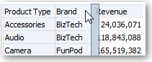

To rearrange columns in the Layout pane:

1. Open the view for editing.
2. In the Layout pane, drag and drop the column to the required location.

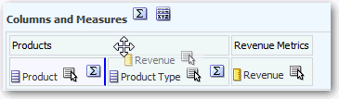

This procedure provides the most basic steps for using the Layout pane to rearrange columns. Many options are available for arranging columns in the Layout pane. See About Drop Targets in the Layout Pane.

#### Set Properties for Sections of Data in Views

You can specify properties for the view body (such as a pivot table) or drop target (such as a section).

For example, you can set the background color to light green and insert a page break in a long table of revenue values.

1. Open the view for editing.
2. In the view editor, display the Layout pane.
3. Click **Section Properties** next to the view body or drop target.

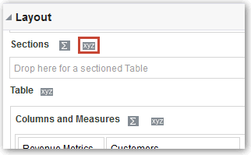

1. Set the appropriate properties.
   * Use **Insert Page Break** to specify whether to create a page break before the section, so that every time a value changes in the section drop target, the new section for that column is displayed on a new page. Page breaks are visible

when you export an analysis to PDF. This is useful for data-driven detail analyses. Choose from:

* + – No Page Break — Don’t break pages.
    - Innermost Column — Break at the innermost column, which inserts a page break between every section.
    - Outermost Column — Break at the outermost column, which inserts a page break when the section label in the outermost column changes.

When the value of an outermost column changes, the value of the inner column is also considered changed. Therefore, setting page breaks at the outermost column inserts manual page breaks between every section.

* + - Folder.Column — For example, Markets.Region, or Products.Brand. Inserts a page break when the section label in the specified column changes. This option is available only when the Sections drop target contains a column.
  + Use **Show Blank Rows** to specify whether to display rows that have no data in the section. Select this option to display all rows, even if a row is an empty text string and contains no value. Deselect the option to hide rows when there are no results to display. This option might be useful for example, to hide empty address lines.
  + Use **Maximum number of section slider values** on graphs to specify the maximum number of values to display on a section slider bar, but not to exceed the system maximum. The administrator configures the system maximum. If you enter a number that exceeds the system maximum, then it’s ignored.

1. Click **OK**.

#### Add Totals to Tables and Pivot Tables

In the Layout pane, you can add totals for columns in tables and pivot tables.

You can position the totals at various locations in the view. You can add totals for columns that are displayed on the various edges. For each measure, the total uses the aggregation rule for that measure.

If you specify a total in the Rows or Columns drop target of a pivot table, then the totals that are displayed are the result of the columns that are specified in the Measures drop target. Total values aren’t displayed on the Columns or Rows edges of the pivot table but rather in the data in the center of the pivot table.

1. Display the Layout pane for the view.
2. To add grand totals to the entire table, in the Columns and Measures drop target, click the **Totals** button, then click the location such as **Before**.

For an entire pivot table, in the Rows or the Columns drop target, click **Totals**, then the location.

1. To turn on and off the totals that apply to all the values in the drop target, click the **Totals**

button beside the drop target name, such as Sections.

Then select the location for the total, such as **Before** the data items. A totals area is added to the view.

1. To specify custom text to insert into a total heading in tables and pivot tables, enter text in the **Caption** box.
   * Use @ to display the data value. Suppose a total is specified for the Region column, and you enter the following text into the **Caption** box for the total heading: - All

values in the @. The total heading displays the following text for the Western Region: - All values in the Western Region.

* + Use "@" to display the @ symbol.
  + Use "\" to display double quote. The double quote syntax isn’t limited to a single character. In general, you can use a backslash escaped string inside double quotes. For example: "1234567890\\abc\\d\"x\"yz!@#$%ˆ&*()-+=_{} [];:'|?/><,.` ~" is display as 1234567890\abc\d"x"yz!@#$%ˆ&*()-+=_{} [];:'|?/><,.` ~
  + Use \ to display the \ symbol.

#### Display Running Sums and Relative Values in Pivot Tables

You can use the Layout pane to display running sums or the relative value of measure columns in pivot tables.

Topics

* + Display Running Sums for Measure Columns in Pivot Tables
  + Display Relative Values for Measure Columns in Pivot Tables

##### Display Running Sums for Measure Columns in Pivot Tables

In a pivot table, you can display numeric measures as running sums, where each consecutive cell for the measure displays the total of all previous cells for that measure. This option is a display feature only that has no effect on actual pivot table results.

Typically, running sums are displayed for duplicated attribute columns or for measure columns for which the option to show data as a percentage of the column has been selected, with the last value being 100 percent. For example, you can display a running sum and percentage, to view progress toward next year's revenue target of $2 million. Running sums apply to all totals. The running sum for each level of detail is computed separately.

Column headings aren’t affected when the running sum option is selected. You can format the column heading if you want it to indicate that the running sum option is in effect.

The following usage rules are in effect for running sums:

* + A running sum is incompatible with the SQL RSUM function (the effect would be a running sum of the running sum).
  + All running sums are reset with each new section. A running sum doesn’t reset at a break within a section or continued across sections.
  + If a measure doesn’t display in a single column or in a single row, then the measure is summed left to right and then top to bottom. (The lower right cell contains the grand total.) A running sum doesn’t reset with each row or column.

1. Open the pivot table view in the view editor.
2. In the Layout pane, in the Measures area, click **More Options** for the row or column to be summed.
3. Select **Display as Running Sum**.

##### Display Relative Values for Measure Columns in Pivot Tables

In a pivot table, you can dynamically convert a stored or calculated measure into a percent or an index.

This shows the relative value of the item, compared to the total, without the need to explicitly create a calculated item for it. You can view the measure as a percentage between 0.00 and 100.00, or as an index between 0 and 1.

For example, if you’re using a pivot table to examine sales by product, then you can duplicate the sales measure and view it as a percentage of the total. This enables you to see the actual sales, and the percentage of sales, that each product accounts for.

1. Open the pivot table in the view editor.
2. In the Layout pane, click **More Options** for the item that you want to show as a relative value.
3. Optional: To duplicate the measure column, select **Duplicate Layer**. The item is displayed in the pivot table, with the same name.
4. Select **Show Data As**.
5. Select **Percent of** or **Index of**.
6. Select the appropriate value such as **Column**, **Row**, or **Section**. The column is displayed in the pivot table view.

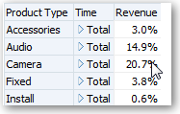

1. To rename the column, click **More Options** then **Format Headings**. In the Edit Format dialog, enter a value in the **Caption** field.

### About Drop Targets in the Layout Pane

Each editor for a data view contains the Layout pane. The Layout pane is displayed slightly differently for each view type, such as graphs, performance tiles, and pivot tables. The Layout pane shows how the data in a view is laid out.

In the Layout pane, the columns in a data view are displayed in drop targets. Drop targets indicate where you can insert, move, or drop a column. They represent a valid position for a column. Each drop target has properties that you can set. You use drop targets to modify the way data is arranged in a data view by dragging and dropping columns to different targets within the view.

Concepts

* + About the Types of Drop Targets
  + About the Excluded Drop Target
  + About the Guidelines for Drop Targets for Various Views

#### About the Types of Drop Targets

This concept describes the types of drop targets.

A data view can contain one or more of the following drop targets, depending on the type of view:

**Target Description**

<*view-type*> Prompts Provides an interactive result set that enables you to select the data to view. The values from the columns that are displayed in this drop target are used as the initial criteria. In a view, these values are displayed in a drop-down list for selection, which is often referred to as the "page edge."

Sections Populates the areas that divide the view into sections. If you select the **Display as Slider** option in this drop target, then the values of the columns that are dropped in the Sections drop target are displayed as a section slider rather than as unique views.

<*view-type*> area Simulates the plot area or the body of the view itself and assists you in seeing what the view looks like. You can drag and drop columns to and from this area.

In addition to the drop targets explained in the table, the Layout pane shows excluded drop targets. The Layout pane includes other drop targets that are specific to the type of view. For example, the Layout pane for the radar graph includes a Radar Sections drop target that shows the columns values as points on each line along a radius of a circle.

#### About the Excluded Drop Target

To modify the layout of data, you must understand the Excluded drop target. A column in the Excluded drop target isn’t included in the view results but still remains as part of the analysis.

A general rule is that a column is placed in the Excluded drop target for a view if it isn’t added explicitly to one or all views.

If you want a column that is in the Excluded drop target to be displayed in a view, then you can easily move it. Simply display the Layout pane for the view, and drag and drop the column from the Excluded drop target to the desired one.

Excluding columns differs from removing columns. You can use the **Remove Column** option from the **More Options** button in the Layout pane for a view to remove a column entirely from the analysis.

You place a column in the Excluded drop target after views have been created for the analysis in various ways. For example, you can select **Exclude Column** from the right-click menu of a view. Suppose that you’re editing a view in its editor and you add a column to that view from the Subject Areas pane. The column is placed in the Excluded drop target for all other views in the analysis.

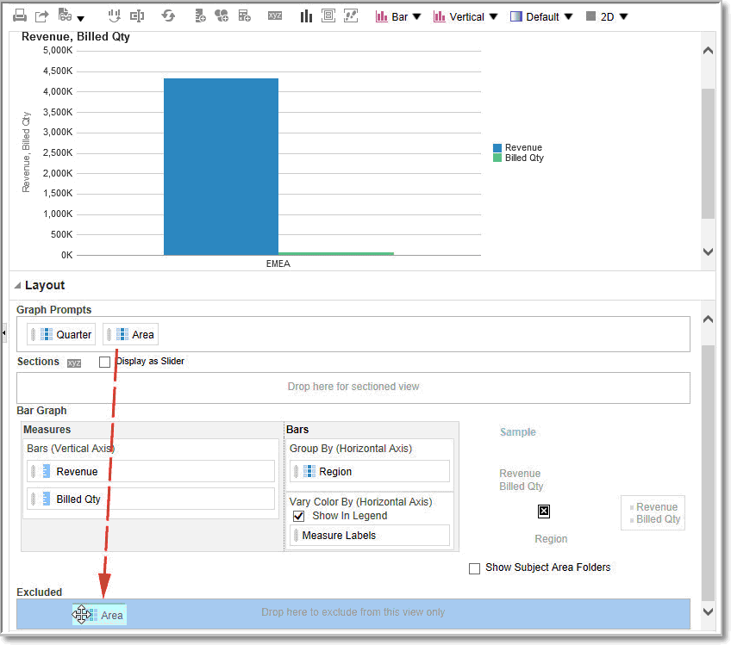

#### About the Guidelines for Drop Targets for Various Views

As you modify the layout of views, there are guidelines that you need to bear in mind for drop targets in the Layout pane.

* + Drop Target Guidelines for Graphs and Funnel Graphs
  + Drop Target Guidelines for Heat Matrices
  + Drop Target Guidelines for Trellises
  + Drop Target Guidelines for Treemaps

##### Drop Target Guidelines for Graphs and Funnel Graphs

This reference describes the restrictions and guidelines that apply to dragging columns from one drop target and dropping them in another in graphs and funnel graphs.

* + A bubble graph requires at least three measures. Plot one measure on the horizontal axis, another measure on the vertical axis, and a third measure on the bubble size axis.
  + A pareto graph can have only one measure.

If you drop another measure on the Measures drop target, then the measures are swapped; that is, the existing measure is replaced by the newly dropped measure and is moved automatically to the Excluded drop target.

* + A time series line graph requires a single date or date-time data column to be selected on the horizontal axis. It has a single vertical axis, but supports multiple data series.
  + A scatter graph requires at least two measures. For example, you can plot one measure column on the horizontal axis and another measure column on the vertical axis. These measures are plotted for values on the Group By axis.
  + A funnel graph uses two measures but only one is required. If you don’t select a second measure, then the first measure is used for the second measure. If you have selected two measures and then select a new measure, then the new measure replaces the measure currently in the Actual Measures drop target.
  + A stacked bar graph requires at least two measures to allow comparison of values.

##### Drop Target Guidelines for Heat Matrixes

You use the Layout pane areas to visualize heat matrixes. You can quickly spot anomalies in large quantities of data and study individual values.

The Layout pane for heat matrixes is composed of various drop target areas:

**Area Guidelines**

Prompts Select an attribute or hierarchical column by which to filter the heat matrix.

The Prompts area is initially empty. You can drag and drop one or more columns from the Sections, Rows, or Columns area or from the Subject Areas pane to the Prompts area.

Sections Select an attribute or hierarchical column by which to section the heat matrix. The Sections area is initially empty. You can drag and drop one or more columns from the Prompts, Rows, or Columns area or from the Subject Areas pane to the Sections area.

Rows Represents a column displayed in row alignment. All attribute and hierarchical columns defined on the Criteria tab are initially displayed in the Rows area in the order in which they were added to the Criteria tab.

You can drag one or more attribute or hierarchical columns from the Subject Areas pane to the Rows drop target, or you can double-click one or more attribute or hierarchical columns to include in the Rows drop target. You can also drag and drop one or more attribute or hierarchical column from the Columns, Prompts, or Sections areas.

If you add an attribute or hierarchical column to the heat matrix view after displaying the analysis results, then the new column is added as a subordinate column to the Rows drop target.

Columns Represents a column displayed in column alignment. The Columns drop target is initially empty.

You can drag one or more attribute or hierarchical column from the Subject Areas pane to the Columns drop target. You can also drag and drop one or more attribute or hierarchical column from the Rows, Prompts, or Sections areas.

Color By See the next section for details.

###### Details of the Color By Area for Heat Matrixes

The Color By area represents the measure value for the grouping and intersection of the row and column for heat matrixes.

* + The first measure added in the Criteria tab is displayed as the Color By measure.
  + You can select a measure from the **Color By** list. This list initially contains all measures added to the analysis in the Criteria tab.
  + You can drag and drop a measure column from the Subject Areas pane to the Color By drop target. The current Color By measure is replaced with the new measure, and the heat matrix redraws to reflect the new measure.

If you add a measure column to the heat matrix view after displaying the analysis results, then the new column replaces the existing column in the view and in the Color By drop target.

* + If you remove the Color By measure column in the Criteria tab, then it’s removed from the Color By list. The new measure value for the Color By list defaults to the last measure value added to the analysis.

The Color By drop target is divided into two options:

* + - **Style**: Select the style for the heat matrix. Style contains two options: **Percentile Binning** and **Continuous Color Fill**. If you select Percentile Binning as an option, then you can enter the number of bins, choose a color palette, and enter a custom label for the bins. If you select Continuous Color Fill, then the heat matrix tiles are displayed as a gradient color scheme.
    - **Color**: Select the color palette for the heat matrix.

##### Drop Target Guidelines for Trellises

This reference describes the guidelines that apply to working with drop targets in trellises.

* + In advanced trellis views, measures comprise the innermost column headers of the trellis.
  + When moving measures from the Color By drop target to or from the Group By drop target:
    - Dragging a single measure moves all the measures along with it. (This is known as sticky behavior.)
    - Dragging a new measure into the view moves all existing measures to wherever you place the new measure.
  + To place a measure on the non-measure edge of a visualization, or in the Rows target or Columns target, you must first convert the measure to an attribute column. For information, see Editing the Formula for a Column.
  + Attribute columns can be dragged out of the Measures drop target without causing the drop target or the measures inside it to move with the attributes.

##### Drop Target Guidelines for Treemaps

You use the Layout pane areas to visualize treemaps, which are constrained, hierarchical data. You can quickly spot trends and anomalies in large quantities of data and study individual values.

The Layout pane for treemaps is composed of various drop-target areas:

**Area Guidelines**

Prompts Select an attribute or hierarchical column (excluding ragged and skip-level) by which to filter the treemap.

Sections Select an attribute or hierarchical column (excluding ragged and skip-level) by which to section the treemap. For example, region that is grouped by year might be the container to display a treemap that is sized by revenue and colored by year-ago revenue.

Group By Represents the top level of the hierarchical data that is sliced to produce or describe a container of aggregated values. The aggregated values display as tiles.

The group area creates a header or group for the measure columns that are specified in the Size By and Color By areas. If more than one column of data is represented in the treemap, then a title bar is displayed for the grouping. For example, region that is grouped by year might be the container to display a treemap that is sized by revenue and colored by year-ago revenue. Region displays in the title bar.

Size By Represents the distribution of the tiles within their parent. The size of the children is always equal to the size of the parent. Each rectangle's area is the aggregated value for the associated measure based on the applied filters (for example, prompted or filtered by region).

Color By Represents a distribution of values across all of the tiles at the same level and adds additional scope to the analysis providing a "qualitative" perspective to the treemap.

# 4

## Build Dashboards

This chapter describes how to build dashboards to provide personalized views of corporate and external information.

[Video](http://apexapps.oracle.com/pls/apex/f?p=44785%3A265%3A0%3A%3A%3A%3AP265_CONTENT_ID%3A29108)

Topics:

* + Typical Workflow to Build Dashboards
  + Create Your First Dashboard
  + Edit Dashboards
  + Add and Delete Pages in Dashboards
  + Create and Manage Layouts for Dashboards and Dashboard Pages
  + Print Dashboards
  + Organize Dashboard Pages in Briefing Books
  + Improve the Time to Display Dashboard Pages with Default Selections
  + Save and Restore Dashboard State
  + Publish Dashboard Pages
  + Link to Dashboard Pages

### Typical Workflow to Build Dashboards

Here are the common tasks to start building dashboards.

|  |  |  |
| --- | --- | --- |
| **Task** | **Description** | **More Information** |
| Create multiple analyses | Build analyses on which you can create | Create Your First Analysis |
|  | views that you display on a dashboard. |  |
| Create a dashboard | Create a dashboard to display data from analysis. | Create Your First Dashboard |
| Add content to a dashboard | Add content to dashboard pages to | Add Content to Dashboard |
| page | display items such as views and | Pages |
|  | prompts. |  |
| Add prompts to dashboard | Add prompts to dashboard pages to | Add Prompts to Dashboard |
| pages | drive the content on the pages. | Pages |
| Add pages to a dashboard | Optionally add one or more pages to the | Add Pages to Dashboards |
|  | dashboard to display the data in various |  |
|  | ways. |  |
| Recall personal settings for | Create customizations that enable you to | Save and Restore |
| dashboards | view pages in their current state or with | Dashboard State |
|  | your favorite choices already selected. |  |

Create Your First Dashboard

|  |  |  |
| --- | --- | --- |
| **Task** | **Description** | **More Information** |
| Run the dashboard | Try out the completed dashboard. Click  **Run**. |  |

### Create Your First Dashboard

You can create dashboards to provide personalized views of corporate and external information. A dashboard consists of one or more pages that display results of an analysis.

[Video](http://apexapps.oracle.com/pls/apex/f?p=44785%3A265%3A0%3A%3A%3A%3AP265_CONTENT_ID%3A29117)

For example, you can create a Sales Performance dashboard and add content to track your team's revenue. Suppose you create three views for an analysis: performance tile view, a table view, and treemap view. You can create a dashboard that displays these three views. You can include prompts on the dashboard to enable users to specify the values to display in the views. See Create Column Prompts.

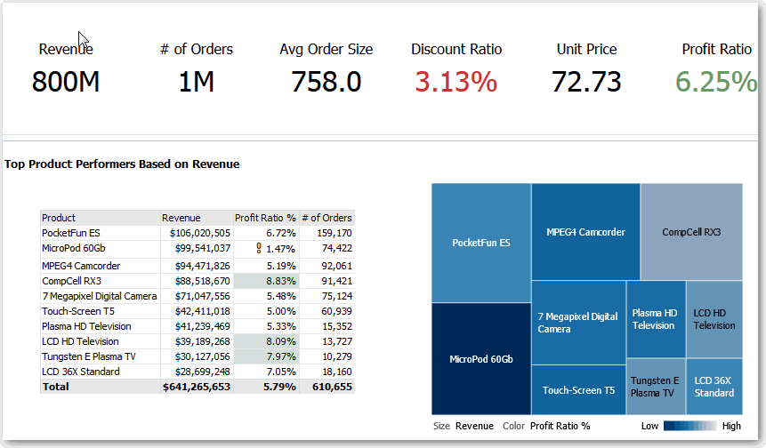

1. On the Home page, in the **Create** pane, click **Dashboard**.
2. In the New Dashboard dialog, enter a short name and description for the dashboard.
3. Under **Location**, select where to save the dashboard. Where you save a dashboard determines whether the dashboard is private to you or shared with others.
   * To save for your personal use and private to you, save the dashboard in / MyFolders.
   * To share with others, save the dashboard in /Shared Folders.

To share a dashboard with others and to not list the dashboard in the **Dashboard** menu in the global header, save the dashboard in any level (such as /shared/Company/Sales/Eastern).

Edit Dashboards

To share a dashboard with others and to list the dashboard in the **Dashboard** menu in the global header, save the dashboard in the /shared/*first level subfolder*.

If you specify a shared folder in which no dashboards have been saved, then a new Dashboards sub-folder is created automatically in the folder.

For example, if you select a folder named /Shared Folders/Company/Sales in which no dashboards have been saved, a new Dashboards folder is created. The Location entry changes to /shared/Sales/Dashboards. (A new Dashboards folder isn’t automatically created if you choose a folder at any other level.)

1. Specify that you want to add content to the new dashboard now.
2. Click **OK**.

The new dashboard, which contains one blank page, is displayed in the Dashboard builder for editing.

### Edit Dashboards

You can edit dashboards to which you have appropriate permissions and privileges. You can add or delete dashboard pages, add content such as columns and sections, and edit properties and settings such as print options.

For example, you can add content to a Sales Performance dashboard to track your team's progress by adding a Brand Revenue analysis from the catalog.

1. Open the dashboard.
2. Click **Page Options**, then select **Edit Dashboard**, and make your changes.

### Add and Delete Pages in Dashboards

You can add and delete pages in dashboards.

Topics:

* + Add Pages to Dashboards
  + Add Subpages to Dashboards
  + Add Content to Dashboard Pages
  + Understand How Dashboard Pages and Publisher Reports Interact
  + Configure the Style and Behavior of Dashboards and Pages
  + Change the Properties of Objects Added to Dashboard Pages
  + Delete Objects on Dashboard Pages
  + Delete Dashboard Pages
  + Delete Dashboard Subpages

#### Add Pages to Dashboards

You can add new pages to organize content of a dashboard.

For example, you can first add a new dashboard page that contains regional sales data in a table and in a bar graph. Then, you can add another that contains links to various competitors' web sites.

1. Open the dashboard for editing.
2. On the toolbar of the Dashboard builder, click **Add Dashboard Page** and select the Add Dashboard Page menu option.
3. Follow the on-screen instructions.

#### Add Subpages to Dashboards

You can add a new subpage to a dashboard to display additional information.

Adding subpages allows a second level of information to be presented to users. For example, you can first add a new dashboard page that contains regional sales data in a table and in a bar graph. Then, you can add a subpage that contains links to various competitors' web sites.

1. Open the dashboard for editing.
2. On the toolbar of the Dashboard builder, click **Add Dashboard Page** and select the **Add Subpage** menu option.
3. Follow the on-screen instructions.

#### Add Content to Dashboard Pages

You can add dashboard objects (any of the objects from the Dashboard objects pane) to dashboard pages. You can also add objects that you have saved in the catalog.

For example, you can add content to the newly created Sales Performance dashboard to track your team's progress. To do so, you can add a Brand Revenue analysis from the catalog.

1. Open the dashboard for editing.
2. Navigate to the page to which you want to add content.
3. In the Dashboard Builder, select the objects to analyze in the Dashboard Objects pane or the Catalog pane and drag and drop them to the Page Layout area.
   * Use **Column** to add a column to align content on a dashboard. You can create as many columns on a dashboard page as you need. You can place columns horizontally or vertically.
   * Use **Section** to add sections within columns to hold the content for the page, such as action links and analyses. You can include as many sections as you need for a column.
   * Use Publisher Report to add one or more reports to make them available to other users. You can use a report to add configured analyses to a dashboard page. You can add a report as embedded content for display on the dashboard page or as a link to open the report in Oracle Analytics Publisher. If

you modify in Oracle Analytics Publisher a report you added to a dashboard page and save your changes, then you must refresh the dashboard page to see those modifications.

1. Set the properties of each object, as appropriate by clicking **Properties**.
2. Click **Save**.

#### Understand How Dashboard Pages and Publisher Reports Interact

You can run, view, and interact with a Publisher report on a dashboard page.

When you add a Publisher report to a dashboard page, the report includes a toolbar that provides these options:

* + Analyze the data in the report.
  + Select the layout template of the report.
  + Change the output format of the report.
  + Export the report.
  + Send the report to an available destination such as a printer, fax, email, or FTP.
  + Schedule the report.

When you configure an agent for a dashboard page that contains a Publisher report, be aware of these criteria:

* + The output format of the Publisher report must be PDF.
  + The agent must be set to deliver content in PDF format.

You can print a dashboard page or a briefing book that contains a Publisher report in certain formats.

If you want to print a dashboard page that contains a Publisher report or to include the page in a briefing book, then you must keep the following points in mind:

* + If you print the briefing book as PDF and if the output format of the Publisher report is PDF, then the Publisher report is printed after the other objects on the page. If you print a dashboard page that contains a Publisher report as PDF, but the dashboard page isn’t part of a briefing book, then the Publisher report isn’t printed.
  + If you print the dashboard page or briefing book as MHTML, then the Publisher report isn’t printed.

#### Configure the Style and Behavior of Dashboards and Pages

Use dashboard properties to configure style and behavior of dashboards and pages. For example, you might specify whether your team members can export, refresh, or print pages in a dashboard.

1. Open the dashboard for editing.
2. To specify the dashboard style and behavior, click **Tools** and select **Dashboard Properties**.

In the Dashboard Properties dialog, make the property changes that you want. For example:

* + Use **Style** to select from a list of available dashboard styles if you want to change dashboard properties, such as logo, branding, page color, and link color. Administrators create styles and make them available to dashboard builders and users. If you want to use a style that isn’t listed, ask your administrator to create a new style for you then start a new browser session and try again.
  + Use **Dashboard Report Links** to specify which report links (Analyze, Edit, Refresh, Print, Export, Add to Briefing Book, and Copy) to include with analyses at the dashboard level. You can set these links at the dashboard page level and the analysis level, which overrides the links that you set at the dashboard level.
  + Use **Contains HTML Markup** if you have administrator privileges to format content with valid HTML markup, including JavaScript.
  + Use **Hidden Page** to show the page heading of a hidden page when you navigate to it.

1. To specify how a dashboard handles incoming navigation parameters, click **Tools**

and select **Advanced Page Properties**.

Incoming navigation parameters control the behavior of Oracle Analytics content shared to external portals or applications. For example, navigation parameters might direct users to a particular page in a dashboard, and format the content for PDF output. In the Advanced Page Properties dialog, you use the **Incoming Navigation Options** to specify whether navigation parameters are applied to all pages in the dashboard or just the landing page.

You can configure the behavior of these navigation links:

* + **Prompted URL** - These links direct users to a specific dashboard page and can include formatting parameters. For example, a Prompted URL might go straight to a particular page, and format the content for PDF output.
  + **Go URL** - These links include parameters to control how content looks and behaves. For example, a Go URL might include a username and password, and a command to refresh the results on a page.
  + **"Navigate to BI Content" Actions** - These links use the Action Framework to direct users to specific areas of content.

1. For each type of navigation link, select the scope of the navigation parameters.
   * Click **Dashboard** to apply the navigation parameters to all pages in the dashboard. For example, if a prompted URL link formats the content for PDF output (using &Action=Print), then you format all pages in the dashboard for output to PDF.
   * Click **Page** to to apply the navigation parameters to the landing page only. For example, if a prompted URL link formats the content for PDF output (using &Action=Print), then you format just the landing page for output to PDF.
2. Click **OK**, and then **Save**.

#### Change the Properties of Objects Added to Dashboard Pages

You can change the properties of objects that have been added to a dashboard page.

For example, you can change the column properties of the Brand Revenue analysis to specify the heading display in 14-point bold Helvetica font.

1. Open the dashboard for editing.
2. Navigate to the page that contains the object.
3. Hover the mouse pointer over the object in the Page Layout area to display the object's toolbar and click **Properties**.

Depending on the object type, you’ll either display a menu of editing options or a properties dialog.

1. Make the property changes that you want.

For example, for a dashboard section, you might select **Rename** to change the default section name, or for a dashboard web link you might change the caption or target URL.

1. Save your changes.

#### Delete Objects on Dashboard Pages

If you add an object that you later decide that you don’t want, then you can delete it.

For example, you can delete last year's Brand Revenue analysis from the Sales Performance dashboard, to replace it with the current year's analysis.

1. Open the dashboard for editing.
2. Navigate to the page that contains the object to delete.
3. Hover the mouse pointer over the object in the Page Layout area to display the object's toolbar and click **Delete**.

#### Delete Dashboard Pages

You can delete the current dashboard page, or one or more dashboard pages.

For example, you can delete pages 2 and 3 from the Sales Performance dashboard to retain only the page with the most recent Brand Revenue analysis.

You can delete one or more dashboard pages:

1. Open the dashboard for editing.
2. Click **Tools** and select **Dashboard Properties**.
3. For each page to delete:
   1. In the **Dashboard Pages** area of the dialog, select the page.
   2. On the Dashboard Pages toolbar, click **Delete.**

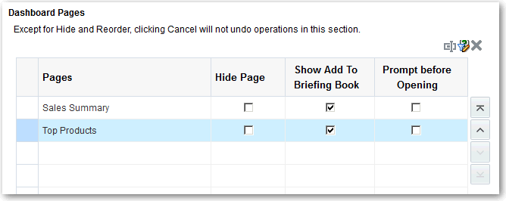

* 1. Confirm the deletion.

Create and Manage Layouts for Dashboards and Dashboard Pages

1. Click **OK**.

#### Delete Dashboard Subpages

You can delete one or more dashboard subpages from within a dashboard page.

1. Open the dashboard for editing.
2. Click **Tools** and select **Dashboard Properties**.
3. For each subpage that you want to delete:
   1. In the **Dashboard Pages** area of the dialog, select the dashboard subpage that you want to delete.

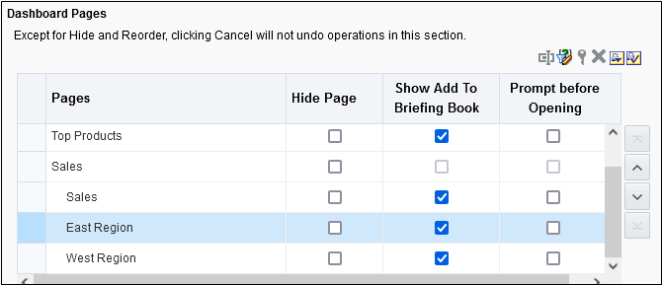

* 1. On the Dashboard Pages toolbar, click **Delete**.
  2. Confirm the deletion.

1. Click **OK**.

### Create and Manage Layouts for Dashboards and Dashboard Pages

You can specify and manage the layouts of a dashboard for printing or exporting.

* + About Custom Print and Export Layouts
  + Create Custom Layouts
  + Edit, Replace, or Remove Custom Layouts
  + Items Not Supported for Custom Print Layouts in Publisher

#### About Custom Print and Export Layouts

You can create and define custom layouts for printing and exporting an entire dashboard or a single dashboard page.

Custom layouts allow you to:

* + Produce high-quality printed dashboard content.
  + Export dashboard content customized for Excel. When you create a custom layout:

Create and Manage Layouts for Dashboards and Dashboard Pages

* + The dashboard page is exported to Publisher, and the following items are auto- generated:
    - A Publisher report with a layout based on the exported dashboard layout.
    - A data model to retrieve data for the dashboard page components.
  + The Publisher Report Editor opens in a new browser window with the auto-generated layout displayed as a thumbnail. The report editor allows you to edit, delete, or add a layout.

When you’re creating a print layout, Publisher doesn’t support some of the customizations and views such as hierarchical columns and map views.

After you’ve saved the custom layouts in Publisher, they’re available for that dashboard and appear in the Custom Print & Export Layouts area of the Print & Export Options dialog.

If you delete the data model or the layouts manually from the Oracle BI Presentation Catalog, then the associated Publisher report won’t work, and the layouts aren’t available. If you delete an analysis, then the data model and layout are available but fail when run.

#### Create Custom Layouts

You can create one or more custom layouts for printing and exporting an entire dashboard or a single dashboard page.

The administrator can control the display of the Custom Print & Export Layouts component.

1. Open the dashboard or dashboard page that you want to print or export.
2. On the Dashboard page toolbar, click **Tools** and select **Print & Export Options**.
3. In the Custom Print & Export Layouts area, click the gear icon, then select **Create Layouts**.

The Publisher Report Editor opens in a new browser window with the auto-generated layout displayed as a thumbnail.

1. Make your changes in Publisher, and save the changes.
2. Close Publisher and save the dashboard.
3. To make the custom layouts available to users, do the following:
   1. Open the Print & Export Options dialog and go to the Custom Print & Export Layouts area.
   2. For each custom layout that you want to make available, select the following:
      * **PDF** - To make the layout available in the Print menu of a dashboard page.
      * **Excel** - To make the layout available in the Export to Excel menu of a dashboard page.
   3. Click **OK** to close the Print & Export Options dialog.
   4. Save the dashboard.

The analysis and dashboard font size is in pixels, but the Excel font size is in points. Therefore, when you export to Excel from an analysis or dashboard, the font size decreases to 75% of the analysis or dashboard font size.

Print Dashboards

#### Edit, Replace, or Remove Custom Layouts

You can edit, replace, or remove custom print and export layouts that you’ve created. For example, you might want to remove a custom print layout if the dashboard page to which the layout is associated has changed.

1. Open the dashboard or dashboard page.
2. On the Dashboard page toolbar, click **Tools** and select **Print & Export Options**.
3. In the Print & Export Options dialog, go to the Custom Print & Export Layouts area and click the gear icon, then select one of the following:
   * **Create and Edit Layouts** - A warning message is displayed indicating that the existing print layouts may not work properly if the dashboard page has been modified. Select one of the following and click **OK**:
     + **Keep existing layouts** - The Publisher Report Editor opens in a new browser window, where you can edit the existing layouts.
     + **Remove existing layouts and create new layouts** - The Publisher Report Editor opens in a new browser window, where you can create new layouts.
   * **Replace Layouts** - A warning message is displayed indicating that all the existing layouts will be replaced. Click **OK** to delete the associated Publisher report and data model, and auto-generate new layouts. The Publisher Report Editor opens in a new browser window, where you can create new layouts.
   * **Remove Layouts** - A warning message is displayed indicating that all the existing layouts will be removed. Click **OK** to remove the layouts and the associated Publisher report and data model.
4. When you’ve finished editing, replacing, or removing layouts, click **OK** to close the Print & Export Options dialog.
5. Save the dashboard.

#### Items Not Supported for Custom Print Layouts in Publisher

Custom print layouts support a limited set of items.

If Publisher doesn’t support an item, that item is removed from the layout and you see a message that indicates the reason for the unsupported item.

### Print Dashboards

You typically view dashboards in electronic form. You can easily print a dashboard if you want to see its pages in PDF or HTML format.

For example, you can print a Stock Control dashboard page so you can refer to it during a visit to a supplier's factory. At this location, no external computing devices are permitted.

1. Open the dashboard.
2. Navigate to the dashboard page to print.
3. Click **Page Options**, then select **Print**.

Organize Dashboard Pages in Briefing Books

1. Select **Printable PDF** or **Printable HTML**.
2. Open Adobe Acrobat or a browser window and print from there.

### Organize Dashboard Pages in Briefing Books

You can organize dashboard pages in briefing books.

Topics:

* + Add Content to New or Existing Briefing Books
  + Edit the Content of Briefing Books
  + Download Briefing Books
  + Add a List of Briefing Books to a Dashboard Page

#### Add Content to New or Existing Briefing Books

You can add the content of dashboard pages or individual analyses to new or existing briefing books. A briefing book is a collection of static or updatable snapshots of dashboard pages and individual analyses.

For example, you might add the contents of a Regional Revenue analysis to a briefing book each quarter so that you can review quarterly revenue.

1. Open the dashboard for editing.
2. Navigate to the page to add or that contains the analysis to add.
3. To add the results of an individual analysis to a briefing book:
   1. Edit the dashboard, and select **Tools**, then **Page Report Links**.
   2. Select the **Customize** option and click **Add to Briefing Book**.
   3. Click **OK**.
4. To add the contents of the dashboard page to a briefing book:
   1. Click **Page Options** and select **Add To Briefing Book**.
   2. In the Save Briefing Book Content dialog, click **Browse**.
   3. In the Save As dialog, choose where to save content, then click OK.

#### Edit the Content of Briefing Books

You can edit briefing books to reorder content, delete content, and change the content type, navigation link properties, and content description.

For example, you can edit a briefing book to change the content description to reflect the periods of Brand Revenue analysis data.

1. In the global header, click **Catalog** to display the Catalog page.
2. Navigate to the briefing book to edit and click **Edit**.
3. In the Edit Briefing Book dialog, change the content:
   1. Select the content.

Organize Dashboard Pages in Briefing Books

* 1. Click **Edit Page** and change the content type, the number of navigation links to follow for updatable content, or the content description.
  2. Click **OK**.

1. Click **OK**.

#### Download Briefing Books

You can download briefing books to share them for viewing in different formats. You can:

* + Download briefing books to your computer in MHTML format and then share them for offline viewing.
  + Download briefing books in PDF format and print them (you'll need Adobe Reader). The PDF version of a briefing book contains an automatically generated table of contents.

For example, you can download a briefing book that contains all the Brand Revenue analyses for the year. After downloading, you can view the briefing book in Adobe Reader and print it in preparation for a sales presentation.

1. In the global header, click **Catalog** to display the Catalog page.
2. Navigate to the briefing book to download.
3. Perform one of the following actions:
   * To download the briefing book in PDF format, click **PDF** and open or save the file.
   * To download the briefing book in MHTML format, click **Web Archive (.mht)**

and open or save the file.

Downloaded briefing books are saved with an .mht file extension and can be opened in a browser. You can then email or share the briefing book.

#### Add a List of Briefing Books to a Dashboard Page

You can add a list of briefing books to a dashboard page.

For example, you can add a list of briefing books that contain Brand Revenue analyses to a Sales Performance dashboard page.

1. Open the dashboard for editing.
2. Navigate to the page to which you want to add a list of briefing books.
3. From the Dashboard Objects pane, drag and drop a folder object into a section.
4. Hover the mouse pointer over the folder object in the Page Layout area to display the object's toolbar and click **Properties**.
5. In the Folder Properties dialog, in the **Folder** field, enter the folder that contains the briefing books to list.
6. In the **Expand** box, specify whether to show an expanded view of the folder.
7. Click **OK** and click **Save** to save the dashboard.

Improve the Time to Display Dashboard Pages with Default Selections

### Improve the Time to Display Dashboard Pages with Default Selections

You can improve the time that it takes to display dashboard pages.

Under certain circumstances, dashboard pages might take several moments to display in a browser. When the pages are displayed, they might show the values that users had wanted to see in analyses based on the selection of prompts. You can enable users to specify prompt values (rather than using default prompt values) before analyses content is displayed on dashboard pages. This confirmation in displaying content initially improves the wait time for displaying the page with default prompt selections. The content of analyses isn’t displayed on the page until the user responds to prompts. Other objects (such as dashboard prompts, text, and so on) are displayed

For example, you can prompt for which regions to include before displaying the Brand Revenue analysis on the Sales Performance dashboard page.

When you prompt users for values before displaying analyses, the following occurs:

* + A message is displayed at the top of the page, which indicates that the page isn’t fully loaded. The message also instructs the user to select prompt values and click **Continue**. Clicking **Continue** displays the content on the page using the prompt values that the user specifies. If the user doesn’t specify any prompt values, then the analysis is displayed with default prompt values.
  + The page displays static information about the objects that haven’t yet been displayed. The information includes the object name, an icon that represents the object view, the view name, and the object description (if available).
  + On the Page Options menu (displayed from **Page Options** on the Dashboard page toolbar), all options except **Edit Dashboard** are disabled.
  + The **Apply** button on dashboard prompts isn’t displayed. Instead any prompt values are applied automatically when the user clicks **Continue**.

1. Open the dashboard for editing.
2. Click **Tools** and select **Dashboard Properties**. The Dashboard Properties dialog is displayed.
3. Locate the page in the Dashboard Pages area and select **Prompt before Opening**.

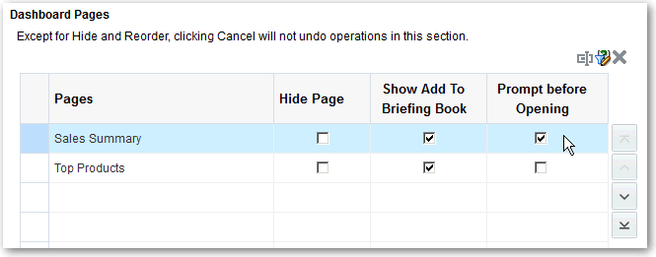

1. Click **OK**.
2. Click **Save**.

Save and Restore Dashboard State

### Save and Restore Dashboard State

You can save personalized settings that you make for a dashboard page and later apply these settings to any dashboard.

As you work with dashboard pages, you frequently make the following types of settings:

* + Filters
  + Prompts
  + Column sorts
  + Drills in analyses
  + Section expansion and collapse

If you save the settings as a customization, you don’t have to make these choices manually each time you access the dashboard page.

Topics:

* + Save Customizations of Dashboard Pages
  + Apply Saved Customizations
  + Edit Saved Customizations
  + Clear the Current Customization

#### Save Customizations of Dashboard Pages

You can save customization for use by you or by others who have author, but not a consumer, role. You can also specify whether the customization is to be the default customization for a dashboard page, for you or for others.

For example, you can save a customization of the Sales Performance dashboard. The customization enables sales managers with permission to see a customized view of the Brand Revenue analysis.

1. Open the dashboard.
2. Navigate to the page on which you want to save a customization.
3. Make your personalized settings.
4. Click **Page Options** and select **Save Current Customization**.
5. Enter a descriptive name for the customization and specify for whom the customization is to be saved.
6. Click **OK**.

#### Apply Saved Customizations

You can apply customizations that you have saved for your own personal use. You can also apply customizations that have been saved by someone else for your use.

For example, you can apply a shared Sales Team customization that was created for customized viewing of a Brand Revenue analysis by members of the sales team.

Publish Dashboard Pages

1. Open the dashboard.
2. Navigate to the page that contains the customization to apply.
3. Click **Page Options** and select **Apply Saved Customization**.

Your personal saved customizations are shown, followed by shared saved customizations.

1. Click a saved customization in the list to apply it to the dashboard page.

#### Edit Saved Customizations

You can rename and delete customizations and change which customization to use as your default.

For example, you can change your default customization to one that you just saved for the Sales Performance dashboard.

1. Open the dashboard.
2. Navigate to the page that contains the customization to edit.
3. Click **Page Options** and select **Edit Saved Customizations**.
4. Rename or delete customizations or change the default customization, as appropriate.
5. Click **OK**.

#### Clear the Current Customization

You can clear the current customization if you decide that the choices for items such as filters, prompts, column sorts, drills in analyses, and section expansion and collapse aren’t what you want.

For example, you can clear a customization that collapses the display of the Brand Revenue analysis.

To clear the current customization, click **Page Options** and select **Clear My Customization**. The current customization is cleared.

### Publish Dashboard Pages

You can publish your dashboard pages to a shared dashboard and make them available to other users.

When you publish a dashboard page:

* + Contents on the dashboard page are copied to the destination dashboard, and their references are updated.
  + References to the shared content are retained.
  + Unsaved contents on the dashboard page are published with the saved contents.
  + Ensure that other users who might display the published dashboard have the appropriate privileges for the objects on those pages. For example, if a page contains a Publisher report, then users must have privileges to view that report.

1. Open the dashboard for editing and navigate to the page you want to publish.

Link to Dashboard Pages

1. Click **Tools** ( ), then select **Publish Page to Dashboard**.

A message is displayed if you have unsaved contents on the dashboard page. Click **OK** to publish them.

1. In the Publish Page to Dashboard dialog, specify the destination dashboard in the Dashboard field.

A message is displayed if contents such as a page, analyses, and prompts exist in the destination dashboard. Click **OK** to replace the existing content in the destination dashboard.

1. 5. Click **OK** to publish the page to the destination dashboard.

### Link to Dashboard Pages

You can create links to dashboard pages so that you can easily enable other users to display those pages.

For example, you can create a link to the Sales Performance dashboard and send the link to team members in an email.

Topics:

* + About Bookmark Links
  + Create Bookmark Links to Dashboard Pages

#### About Bookmark Links

A bookmark link is a URL that captures the path to a dashboard page and all aspects of the page state.

After you create a bookmark link, you can:

* + Save the link as a bookmark so that you can return to the exact same page content at a later time.
  + Copy and send the link to other users who then can view the exact same content that you’re viewing. They can do this providing they have the same permissions as you and have access to the page.

When you create a bookmark link, the state of a dashboard page is saved in the catalog as a hidden bookmark object. The default number of days to save the object is 30.

#### Create Bookmark Links to Dashboard Pages

You can create bookmark links to dashboard pages that you can revisit or share with others.

1. Open the dashboard.
2. Navigate to the page for which you want to create the link.
3. From the Page Options menu, select **Create Bookmark Link**.

Link to Dashboard Pages

The link is displayed in the Address Bar of the browser. If the link is a bookmark link, then you can save it as a bookmark or copy and send it to other users.

You can drill in an analysis that has been set to replace the dashboard with the new results. You can do the replacement rather than showing the new results directly on the dashboard. In this case, the **Create Bookmark Link** option is displayed as a link below the new results.

This option isn’t displayed on the Page Options menu.

# 5

## Filter and Select Data for Analyses

This chapter describes how to filter and select data for analyses.

Topics:

* + Typical Workflow to Filter and Select Data
  + About Filters and Selection Steps
  + Create Filters for Columns
  + Edit Filters for Columns
  + Reuse Filters
  + Use a Saved Analysis as a Filter
  + Advanced Techniques: How Dashboard Prompts and Analysis Prompts Interact
  + Refine Selections of Data
  + Manipulate Members with Groups and Calculated Items

### Typical Workflow to Filter and Select Data

Here are the common tasks to start filtering and selecting data to display in analyses.

|  |  |  |
| --- | --- | --- |
| **Task** | **Description** | **More Information** |
| Create an analysis | Select and arrange columns that you | Create Your First Analysis |
|  | want to use in an analysis. |  |
| Create a filter | Limit the results that are displayed when | Create Filters for Columns |
|  | an analysis runs. |  |
| Edit a filter | Change the operator and values in a | Edit Filters for Columns |
|  | filter. |  |
| Save a filter | Save filters in the catalog or with the | Save Filters |
|  | analysis. |  |
| Create a selection step | Select members, new groups, existing | Create Selection Steps |
|  | groups, new calculated items and |  |
|  | conditions for displaying data. |  |
| Create a group | Group column values for display in an analysis. | Create Groups and Calculated Items |
| Create a calculated item | Apply a function to column values to calculate a new value. | Create Groups and Calculated Items |

About Filters and Selection Steps

### About Filters and Selection Steps

You use both filters and selection steps to limit the results in an analysis. For example, you might list the top ten sales performers, or the most profitable customers. A filter is applied to a column before selection steps are applied.

* + Filters are applied directly to columns before the query is aggregated. Filters affect the query and thus the resulting values for measures. For example, suppose that you have a list of members in which the aggregate sums to 100. Over time, more members meet the filter criteria and are filtered in, which increases the aggregate sum to 200.
  + Selection steps are applied after the query is aggregated and affect only the members displayed, not the resulting aggregate values. For example, suppose that you have a list of members in which the aggregate sums to 100. If you remove one of the members using a selection step, then the aggregate sum remains at 100.

#### About Prompted Filters

A prompted filter is a filter whose operator is set to **is prompted**. This operator is valid for a column that contains text, numbers, or dates.

When you select the **is prompted** operator for a filter's column, you flag the column as ready to be filtered by a prompt. When a prompt is used, results include only records where the data in the column that is prompted matches the user's choices.

The **is prompted** operator is required for columns that are included in prompts where no prefiltered values are wanted.

### Create Filters for Columns

You can create filters for columns.

[Video](http://apexapps.oracle.com/pls/apex/f?p=44785%3A265%3A0%3A%3A%3A%3AP265_CONTENT_ID%3A29119)

Topics:

* + Create Inline and Named Filters
  + Specify Values for Filters
  + Combine and Group Filters
  + Save Filters

A filter limits the results that are displayed when an analysis is run. Together with the columns that you select for the analysis, filters determine what the results contain. You specify filter criteria to display only the results that you want to show.

#### Create Inline and Named Filters

In most cases, you create and include a filter "inline" for use in only one analysis. You can also create a named filter to reuse the filter across all analyses and dashboards. Unless you want to reuse the filter, create an inline filter.

For example, as a sales consultant, you can analyze revenue for only those brands for which you’re responsible.

Create an inline filter from the Selected Columns pane on the Criteria tab

1. Open the analysis for editing.
2. On the Selected Columns pane of the Criteria tab, click **Options** beside the column name and select **Filter**.

Create an inline filter from the Filters pane on the Criteria tab

1. Open the analysis for editing.
2. On the Filters pane of the Criteria tab, click **Create a filter for the current Subject Area**.
3. Select a column name from the menu.

Create a named filter from the Home page

1. From the Home page, in the **Create** pane, click **More** under **Analysis and Interactive Reporting**, then click **Filter**.
2. In the Select Subject Area dialog, select the data source that you want to filter. The New Filters dialog is displayed.

#### Specify Values for Filters

You can specify the values for a filter that displays in an analysis only those values in which you’re interested.

For example, in the Brand Revenue analysis, a filter can limit the analysis results to only the first quarter values in three years. As a result, you can discover how revenue performed year- to-year in these quarters.

1. In the New Filter dialog, select the appropriate operator such as **is equal to / is in**.

Create Filters for Columns

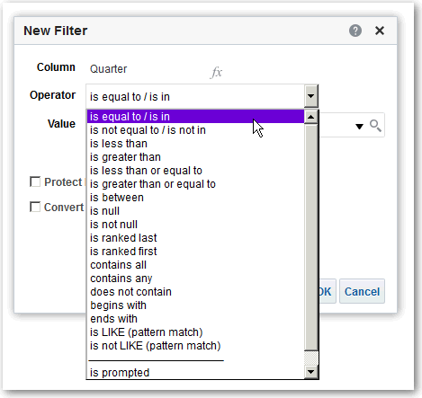

1. Select values from the list or click the **Search** icon to find more values from which to select.

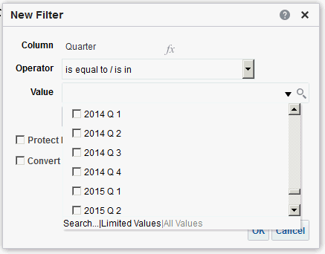

1. Optional: Select **Protect Filter** to prevent prompts from overwriting the filter.
2. Optional: Select **Convert this Filter to SQL**.
3. Click **OK**.
   * For inline filters, the filter is displayed in the Filters pane on the Criteria tab.

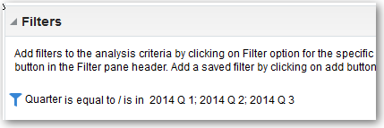

* + For named filters, the filter is displayed in the Saved Filters pane.

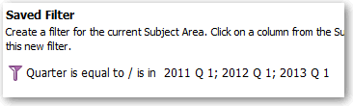

After specifying values, save the filter as named or inline.

#### Combine and Group Filters

You can combine and group multiple inline filters to create complex filters without using SQL statements.

You group or combine filters to establish the precedence in which data in an analysis is filtered. When you add two or more inline filters to an analysis or named filters, by default, the inline filters are combined using the **AND** Boolean operator. The **AND** operator indicates that the criteria specified in all the inline filters must be met to determine the results when an analysis is run.

You use the **OR** Boolean operator to indicate that the criteria specified in at least one of the filters must be met to determine the results of the analysis. The **OR** operator helps you to create a group of multiple filters using alternate criteria.

1. Open for editing a named filter or an analysis that contains inline filters.
2. On the Filters pane of the Criteria tab, confirm that the analysis contains two or more inline filters. Alternatively, on the Saved Filter pane, confirm that the named filter contains two or more inline filters.
3. On the Saved Filter pane or in the Filters pane of the Criteria tab, notice how the inline filters are combined using **AND** or **OR** operators.
4. Click the word **AND** before an inline filter to change an **AND** operator to an **OR** operator. You can toggle between the **AND** and **OR** operator in this way.
5. Change the **AND** and **OR** operators for other inline filters to create the required filter combinations. Alternatively, create more inline filters and change the **AND** and **OR** operators.
6. Click **Save Analysis** or **Save Filter** to save the filter combinations.

#### Save Filters

You can save inline filters and named filters.

When you create an inline filter in the Filters pane, you can optionally save the inline filter as a named filter. When you save an inline filter as a named filter, other people on your team can use this filter in a new analysis. You can also create a named filter as a standalone object from the global header.

For example, you can save a filter for the Quarter column in a shared folder in the catalog. As a result, your manager has access to that filter. Suppose that you save the filter that limits quarters to 2011 Q1, 2012 Q1, and 2013 Q1. Your manager can use this filter in a Product Revenue analysis to find how products performed only during these quarters.

To save a named filter, simply click **Save As** on the toolbar, specify folder in the catalog, and click **OK**.

To save an inline filter as a named filter, do the following:

1. On the Filters pane on the Criteria tab, click **More options** and select **Save Filters**.
2. Specify a folder in the Oracle BI Presentation Catalog.
3. Click **OK**.

Edit Filters for Columns

### Edit Filters for Columns

You can edit an inline filter when you need to make changes to it. When you edit and save a named filter, the changes that you make to the filter propagate to wherever the filter is used.

For example, you can edit the filter for the Quarter column to include data for the "2010 Q1" quarter. This data is propagated to every analysis where the filter is applied.

* 1. Display the Edit Filter dialog.

For example, on the Saved Filter pane or in the Filters pane of the Criteria tab, hover the cursor over the filter, then click **Edit Filter**.

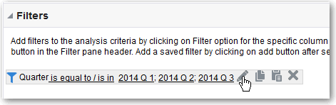

* 1. In the Edit Filter dialog, change the selection for any of the options that are described in the following table:

**Option Description**

Operator Select an operator to apply to the values that are specified in the **Value** field. The **Operator** list is populated based on the function that you’re performing (such as creating a filter or creating a dashboard prompt). It’s also populated based on the type of column that you selected.

For example, you can choose **is greater than** to use only values greater than the value that you select in the **Value** list. If you select 100,000 from the **Value** list, then the filter uses values from the column that are greater than 100,000. You can use this information in an analysis to focus on products that are performing best.

Value Specify a value or values from the list that contains members of the column that you select. You can also enter the value into the field manually or search.

For example, suppose that you want to edit a filter that you have created for the Products column of an analysis. The **Value** field contains a list of products from the column. Depending on the operator that you chose, you can select one or more products to include in the analysis.

Protect Filter Select this option to prevent prompts from overwriting the filter.

Convert this Filter to SQL

Select this option to convert the filter to a SQL WHERE clause that you can edit manually. After you convert a filter to SQL code, you can no longer view and edit the filter in the Edit Filter dialog.

Reuse Filters

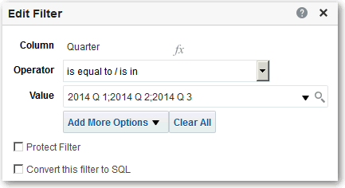

* 1. Click **OK**.

### Reuse Filters

You can reuse a filter that you have saved as a named filter in the catalog. You can apply a saved filter to an existing analysis.

For example, you can apply a filter for the Quarter column to the Brand Revenue analysis.

1. On the Catalog pane on the Criteria tab, select a named filter.

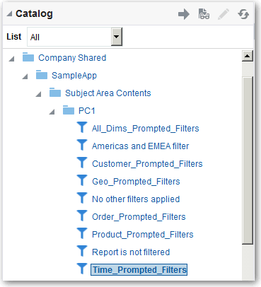

1. Click **Add More Options**.

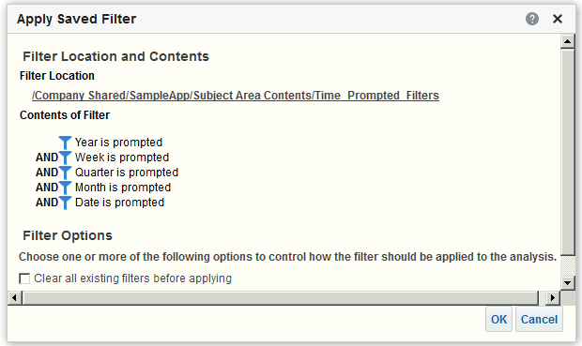

1. Click **OK**.

Use a Saved Analysis as a Filter

### Use a Saved Analysis as a Filter

You can create a filter based on the values that are returned by another analysis. You can use any saved analysis that returns a column of values to filter the matching column in an analysis.

For example, you can create a filter that is based on the results of the Brand Revenue analysis.

1. Create or open a named filter or analysis to which you want to apply an inline filter.
2. Find the filter.
   * If you’re working with a named filter, then locate the Saved Filter pane. From the Subject Areas pane, select the column for which you want to create a filter.
   * If you’re working with an inline filter, then locate the Filters Pane. From the Filters Pane toolbar, click **Create a filter for the current Subject Area**. Select the column for which you want to create the filter.
3. In the **Operator** field of the New Filter dialog, select **is based on the results of another analysis**.
4. In the **Saved Analysis** field, enter the path to the analysis or click **Browse** to locate it.
5. Select a column name from the **Use Values in Column** menu.
6. In the **Relationship** field, select the appropriate relationship between the results and the column to be filtered.
7. Click **OK**.

### Advanced Techniques: How Dashboard Prompts and Analysis Prompts Interact

You can combine dashboard prompts and analysis prompts to quickly display precise, meaningful data.

There are various ways that you can combine prompts.

**Wiring Method Description**

Auto wiring Auto wiring assumes that you intended to create a functioning prompt for the column and, therefore, activates and applies the prompt. Auto wiring is applied when you create an analysis and add a column prompt. This method doesn’t require the **is prompted** filter operator. Any unprotected filter can be used.

Setting the filter operator to **is prompted** provides a more precise level of control between prompts and filters than the auto wiring method. See the "Filter operator is set to **is prompted**" row in this table.

**Wiring Method Description**

Constrained prompts Use this method with several columns in a prompt to constrain

the user's prompt choice based on subsequent choices. Constrained prompts can be set up on the Prompt options dialog to specify which prompt narrows the choices. For example, suppose one column filters on region and the next column filters on city. Then, the city column can be constrained to show only cities in the selected region.

Filter operator is set to

**is Prompted**.

Selection Steps Override with Prompts Option

Protected versus Unprotected filters

### Refine Selections of Data

Use this method to build complex prompts that interact with filters. When you use this method, you have full control over how the dashboard prompts, inline prompts, and filters apply to the embedded analysis. See About Prompted Filters.

Use this method to use an analysis or dashboard column prompt to provide the data choices for a specific member selection step. Because you can’t use filters with hierarchical columns, selection steps are the only way that you can use prompts with hierarchical columns. Only one selection step per column selection step set can be overridden with a prompt. All selection steps before and after the overridden step are processed as specified. See Refining Selections of Data and Overriding a Selection Step with a Prompt.

Use this method to determine whether the dashboard prompt can supply the inline prompt's value when the corresponding column's filter value is set to something other than **Is prompted**. The unprotected and protected filter settings can be used when a dashboard prompt and inline prompt reside on the same dashboard. Also, both prompts must have been created for the same column.

When the column's filter value is unprotected, the dashboard prompt value determines the analysis' results. Suppose the filter value is set to something other than **Is prompted** (for example, **Is equal to/is in**) and the filter is set to protected filter. Then, the dashboard prompt can’t determine the report results.

As you specify which data members to include in an analysis, you create selections of data from the data source. Each selection specifies the criteria for a set of members for a particular column, such as Product or Geography.

Each selection consists of one or more steps. A step is an instruction that affects the selection, such as add Product members whose values contain the text "ABC." The order in which steps are performed affects the selection of data. Each step acts incrementally on the results from previous steps, rather than acting on all the members for that column.

Topics:

* Create Selection Steps
* Edit Selection Steps
* Save Selection Steps for Reuse
* Advanced Techniques: Create Condition Steps

#### Create Selection Steps

Selection steps help users display the data they want to analyze. When you add a column to an analysis, an implicit "Start with all members" step is added. The "all" implies all the members of the column after filters are applied.

For example, you can create a selection step to specify criteria for the following members in an Office column: Baltimore, Austin, and Athens.

1. Open the analysis for editing.
2. Select the Criteria tab.
3. Display the Selection Steps pane by clicking **Show Selection Steps Pane** on the toolbar.
4. Click **Then, New Step**, and select the kind of step to create. For example, you can specify a list of selected members for the step.
5. For a member step, select **Add**, **Keep Only**, or **Remove** from the **Action** list.
6. If you’re creating a member step, then move the members to include in the step from the Available area to the Selected area.

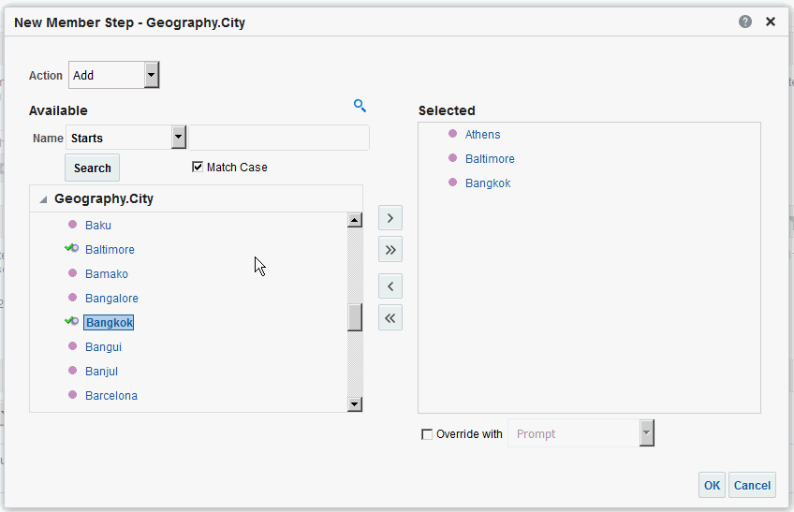

1. Specify the appropriate values for the condition such as the action, measure, and operator to use for the values of the column.
2. Click **OK**.

#### Edit Selection Steps

You can edit a selection step for an analysis or a selection step that has been saved as a group object.

For example, you can edit a member step for the Offices column in the Brand Revenue analysis. You can add then add another city to the list of cities.

1. Open the analysis for editing.
2. Click on the Results tab.
3. On the Selection Steps pane, hover the mouse pointer over the selection step that you want to edit.
4. Click the pencil icon on the toolbar.
5. Perform the appropriate edits. For example, add one or more members from the column to the step.
6. Click **OK**.

#### Save Selection Steps for Reuse

If you have created a set of selection steps, then you can reuse them if you save them as a group in the catalog.

For example, you can reuse the selection steps for the Offices column as a group object. Doing this enables the set to be used inline with the Brand Revenue analysis.

1. Open the analysis for editing.
2. On the Results tab, display the Selection Steps pane.
3. Click **Save Selection Steps** to the far right of the column name.
4. In the **Save In** field, save it in /My Folders/*subfolder* (for personal use) or /shared/

*subfolder* to share it with other users.

1. Enter a name for the saved selection steps.
2. Click **OK**.

#### Advanced Techniques: Create Condition Steps

One type of selection step that you can create is a condition step. Most people don’t need to perform this task.

You specify that members are selected from a column based on a condition. The condition can be one of various types including based on measures or on top/bottom values. This member list is dynamic and determined at runtime. For example, you can select the top 5% of members based on Brand Revenue.

1. Open the analysis for editing.
2. Select the Criteria tab.
3. Display the Selection Steps pane by clicking **Show Selection Steps Pane** on the toolbar.
4. Click **Then, New Step**, then select **Apply a Condition**.
5. In the New Condition Step dialog, select the type of condition to create, as described in the following table.

**Type Description**

Exception Select members using comparison values for measure columns. A sample condition is "Sales > Cost +10%."

**Type Description**

Top/Bottom Select the specified number of members after ranking the members by the specified measure column. You can specify an exact number of members or a percentage of the total members. Sample conditions are "Top 10 based on Sales" and "Top 5% based on cost.

Match Select members based on matches with text strings and attribute values. A sample condition is "Name contains abc." This type is available only for columns that have a data type of string.

Time/Ordinal Select members based on ranges of time and on hierarchical levels. A sample condition is "From July 2012 to December 2012." This type is available only for columns with a data type that relates to time.

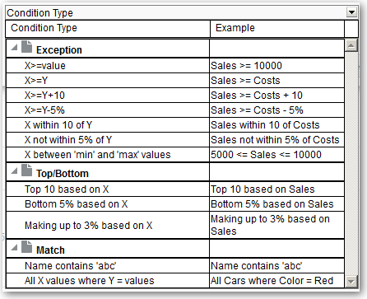

The components in this dialog differ slightly, depending on which type you select.

1. In the **Action** box, select the type of action to create for the members. You can select to add the selected members to the selection, keep only the selected members and remove all others. Or, you can select to remove the selected members from the selection.
2. In the box beside the action type, select the column for whose members you’re creating the condition step.
3. Enter the appropriate values for the various fields of the dialog.

For example, select the **Operator** based on the type of condition. For example, select Within for the Exception type.

1. Use the **Override with** box to specify whether an analysis prompt, a dashboard prompt, or a variable can override the values that you specify in this condition.

Depending on what you’re overriding, you can override certain values with a prompt, a presentation variable, a session variable, or a repository variable.

If you select a variable type, then enter the name of the variable in the field. For example, suppose that you have a column called EMPLOYEE_ID. You can specify USER as the session variable with which to override the value of that column.

When a user signs in, the column value is set to his user name. See Advanced Techniques: Reference Stored Values in Variables.

In a list of steps, specify that only one step in the list can be overridden by a prompt or presentation variable.

1. In the **For** area, qualify all of the dimensions of the analysis other than the dimension whose members you want to select.

Do this when creating condition steps of type Exception or Top/Bottom. For each dimension, you select which of its members to include. You can select specific members, or All, which specifies to aggregate the members when creating the condition. For example, suppose that you’re qualifying the Region dimension. You can select a specific region, such as East, whose value is used in the New Condition Step dialog condition. If you select All, then the values of all regions are aggregated and used in the condition.

You can use the **For** area to create a qualified data reference (QDR). A QDR is a qualifier that limits one or more of the dimensions to retrieve a single value for a measure column. A QDR is useful when you want to temporarily reference a measure column value without affecting the current status of the dimensions. The following is an example of a QDR:

Add members of Total Products (Rgd Sk Lvl) where "A - Sample Sales"."Base Facts"."1- Revenue", For: Cust Segments Hier: 'Active Singles', 'Baby Boomers' is greater than "A - Sample Sales"."Base Facts"."1- Revenue", For: Cust Segments"

When you specify a QDR, you can specify multiple members for limiting the dimensions. When you specify multiple members, the measure column value is aggregated using the default aggregation. For example, suppose that you want to create a condition for displaying those Regions in which Units is greater than 100. Suppose that you create a QDR for the Year dimension that specifies 2010 and 2011 and that the default aggregation is Sum. If the values for 2010 and 2011 for the Central region are 50 and 60 respectively, then both those years are displayed. Their sum exceeds the 100 units that were indicated.

1. Click **OK**.

### Manipulate Members with Groups and Calculated Items

You can manipulate members using groups and calculated items.

Topics:

* About Groups and Calculated Items
* Create Groups and Calculated Items
* Edit Groups and Calculated Items
* View Group Contents
* Save Groups and Calculated Items
* Reuse a Group or Calculated Item in an Analysis
* Delete Groups and Calculated Items

#### About Groups and Calculated Items

You can create a group or calculated item as a way to display data in a table, pivot table, trellis, heat matrix, or graph.

Groups and calculated items enable you to add new "members" to a column, when those members don’t exist in the data source. These members are also known as "custom members."

Use a group to define members of a column, as a list of members or a set of selection steps that generate a list of members. A group is represented as a member.

A calculated item is a computation between members, which is represented as a single member that can’t be drilled. When you create a calculated item, you add a new member in which you have selected how to aggregate the item. You can aggregate using Sum or Average or custom formula.

#### Create Groups and Calculated Items

Use a group or calculated item to add new "members" to a column.

For example, you can review how much revenue was generated for mobile devices and compare that number to other product types. You can create a group called Mobile Devices for the Product column that includes Flip Phones and Smart Phones.

[Video](http://apexapps.oracle.com/pls/apex/f?p=44785%3A265%3A0%3A%3A%3A%3AP265_CONTENT_ID%3A29120)

1. Open the analysis for editing.
2. On the toolbar of the Results tab, click **New Group** or **New Calculated Item**. The New Group or New Calculated Item dialog is displayed.
3. Enter a value for **Display Label** for the group or calculated item when it’s displayed in a view.
4. In the **Values From** list, select the column whose values you want to include in the group or calculated item.
5. If you’re creating a calculated item, select the function for the calculated item.
6. Move the appropriate column values from the Available area to the Selected area.

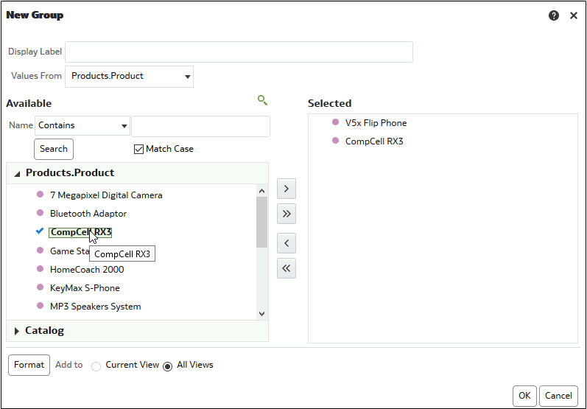

1. For a calculated item with **Custom Formula** selected as the function, select mathematical operators to include in the function using the toolbar. You can also use these functions: Absolute, Ceiling, Floor, Round, and Sqrt.

A formula creates a dynamic custom grouping within the view. All measures referenced in a formula must be from the same column and must be present in the results. Formulas can be inserted into, or combined with, other calculated items.

Instead of specifying a named item for columns, you can specify $n or $-n. Here, *n* is an integer that indicates the item's row position. If you specify $n, then the measure is taken from the *n*th row. If you specify $-n, then the measure is taken from the *n*th to the last row.

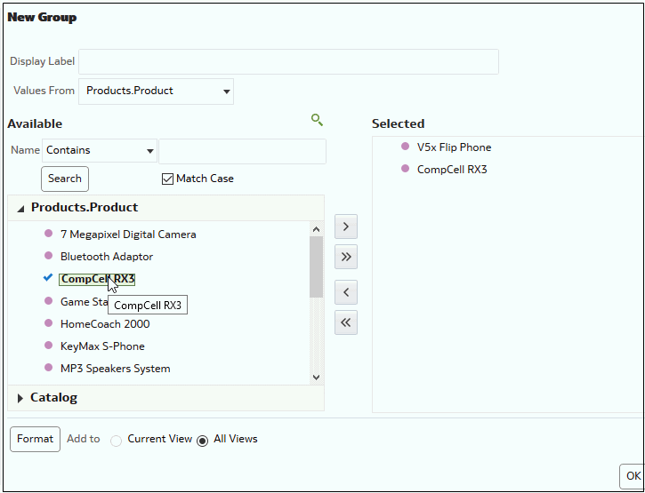

1. Optional: If you’re creating a calculated item, select **Remove calculated item members from view**.

Use this box to suppress the display of members that you have included in the calculated item in the view.

1. Click **OK**.

By default, the new group or calculated item is created for all views in the analysis.

#### Edit Groups and Calculated Items

You can edit groups and calculated items through the Selection Steps pane or from the catalog pane. You can also edit groups and calculated items in a table, pivot table, heat matrix, or trellis.

For example, you can edit a group to include the Game Station and Plasma Television members.

Use one the following methods to edit a group or calculated item:

* In the Selection Steps pane, click the link to the group or calculated item, and then click

Edit.

* In the Catalog pane (if you saved it in the Catalog), select the object, and click

Edit.

* In a table, pivot table, heat matrix, or trellis (on an outside edge), right-click the group or calculated item and select **Edit Group** or **Edit Calculated Item**.

#### View Group Contents

You can view the contents of a group to verify that it contains the members that you want.

For example, suppose you created a group of categories in a Product Category column. You can view the group contents to verify that it contains the appropriate categories.

1. Open the analysis for editing.
2. Click on the Results tab.
3. In the table view, right-click on the cell that contains the group.
4. Select **View Group Definition**.

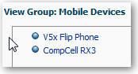

1. Click **Close**.

#### Save Groups and Calculated Items

You can save a group or calculated item as either an inline object (with an analysis) or as a named object (a standalone object).

For example, you can save the Mobile Devices group as a named object in the catalog, for reuse in the Brand Revenue analysis.

Save a group or calculated item as an inline object

* To save the analysis and the group or calculated item that it contains, click **Save Analysis**.

The group or calculated item is saved as a part of the analysis.

Save a group or calculated item as a named object

1. On the Results tab, display the Selection Steps pane.
2. Click the link for the group or calculated item.
3. Select **Save Group As** or **Save Calc Item As**.

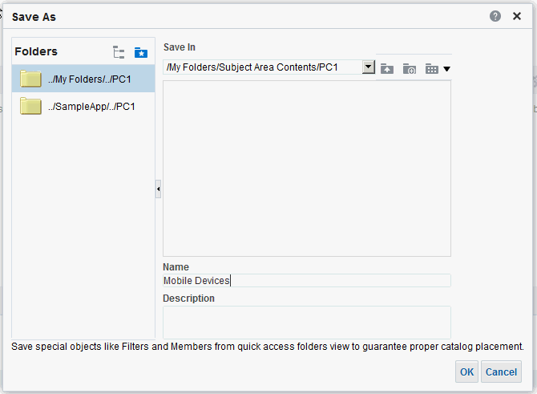

1. Enter a folder in the **Save In** field.
2. Click **OK**.

#### Reuse a Group or Calculated Item in an Analysis

You can add a group or calculated item to the same column on which it was created in another analysis. The group or calculated item can be either a list of members or a set of selection steps.

For example, you can display the Brand Revenue analysis and add the group members from the Mobile Devices group. The members of the Mobile Devices group are included as an "Add" step in the Selection Steps pane.

1. On the Results tab, display an analysis containing the same column to which you want to apply the selections from a group or calculated item.
2. In the Catalog pane, select the group or calculated item.

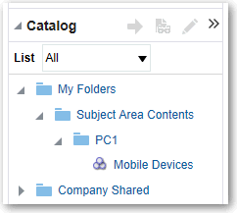

1. On the toolbar of the Catalog pane, click **Add More Options**.
2. Select **Add** to add the group or calculated item itself. Select **Add Members** to add only the group or calculated item members.

Reuse a group or calculated item from the Edit Member Step dialog:

1. On the Results tab, display an analysis containing the same column to which you want to apply the selections from a group or calculated item.
2. Display the Selection Steps pane.
3. In the entry for the column you want, click the pencil icon.
4. From the Action menu, select **Start with Group or Calculated Item**.
5. Move the saved group or calculated item from the Available area to the Selected area.
6. Click **OK**.

Reuse a group or calculated item from the Selection Steps pane:

1. On the Results tab, display an analysis containing the same column to which you want to apply the selections from a group or calculated item.
2. On the Selection Steps pane select **Then, New Step** for the appropriate column.
3. Select **Add Groups or Calculated Items**.
4. Select Select Existing Groups and Calculated Items.

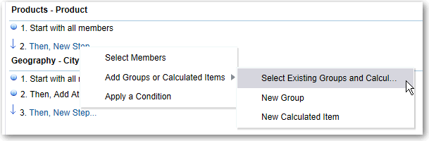

1. On the resulting dialog, select the group or calculated item from the Available area and move it to the Selected area.
2. Click **OK**.

#### Delete Groups and Calculated Items

You can delete inline and named groups and calculated items.

For example, suppose you no longer need the combination of Flip Phones and Smart Phones in the analysis. You can delete the Mobile Devices group.

Delete an inline group or calculated item:

1. On the Results tab, right-click on the cell that contains the group or calculated item that you want to delete.
2. Click **Remove**.

Delete a named group or calculated item:

1. On the global toolbar, click **Catalog**.
2. Locate the group or calculated item in the Catalog page.
3. Click **More** on the group or calculated item.
4. Select **Delete**.

# 6

## Prompt in Analyses and Dashboards

This chapter describes how to create prompts for soliciting values to display in analyses and dashboards.

Topics:

* Typical Workflow to Create Prompts in Analyses and Dashboards
* Create Prompts
* About Prompts Auto-Complete
* Edit Prompts
* About Improving the Performance of Dashboard Prompts
* Add Prompts to Dashboard Pages
* Add Hidden Prompts to Dashboard Pages

### Typical Workflow to Create Prompts in Analyses and Dashboards

Here are the common tasks to start creating prompts for soliciting values to display in analyses and dashboards.

|  |  |  |
| --- | --- | --- |
| **Tasks** | **Description** | **More Information** |
| Create an analysis | Select and arrange columns that you want | Create Your First Analysis |
|  | to use in an analysis. |  |
| Create a column prompt | Create a prompt to filter the data that you | Create Column Prompts |
|  | see displayed. |  |
| Edit a prompt | Edit the prompt to change it in every place | Edit Prompts |
|  | where it’s used. |  |
| Add a column prompt to a | Add a prompt to a new or existing | Add Prompts to Dashboard |
| dashboard page | dashboard. | Pages |
| Create a currency prompt | Create a prompt to display money data in | Create Currency Prompts |
|  | a different currency. |  |

### Create Prompts

You create prompts to enable analysts to display the data they're interested in.

Topics:

* Create Column Prompts
* Create Variable Prompts
* Override a Selection Step with a Prompt
* Create Currency Prompts

#### Create Column Prompts

A prompt enables you to filter the data that you see. A column prompt enables users viewing a dashboard to select a value for a column that affects what they see on the dashboard.

[Video](http://apexapps.oracle.com/pls/apex/f?p=44785%3A265%3A0%3A%3A%3A%3AP265_CONTENT_ID%3A21797)

Use the following procedure to create:

* A named column prompt that you can apply to one or more dashboards.
* An inline column prompt that is embedded in an analysis. For example, you can add a prompt to the Brand Revenue analysis so that the analysis can be reviewed for specific brands. You add a prompt directly to a column in the analysis (an inline prompt).

1. Open the analysis for editing.
2. On the Definition pane of the Prompts tab, click **New** to access the prompt type selection list. Select **Column Prompt** and select the appropriate column.
3. Click **Custom Label** and enter a caption for the column filter prompt. The caption displays as the field label for the prompt.

For example, "Select a currency."

1. In the **Description** field, enter a short description for the prompt.

This description becomes tooltip text, which is displayed when the user hovers the mouse pointer over the prompt's label in the dashboard or analysis.

1. From the **Operator** list, select the operator to use, such as "is greater than." If you want the user to select the operator at runtime, then select the **\*Prompt User** operator.

If you’re creating a prompt that includes a group in the prompt's value selection list, then you must set the Operator to either **is equal to/is in** or **is not equal to/is not in**. See About Groups and Calculated Items.

1. In the **User Input** field, select how you want the prompt interface to ask the user for input. For example, prompt the user with a radio button to select only one prompt value.

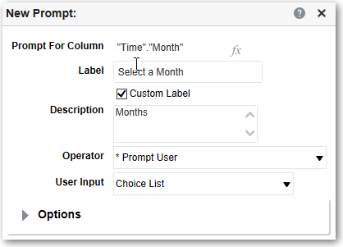

1. Depending on the type of user input that you specified, enter the appropriate values in the **User Input** field.

For example, select **Custom Values** to indicate that users can select from a list of prompt values that you created rather than the values supplied by the column.

1. Within the Options section, select prompt options to specify the display of list values and user interaction with the prompt. The prompt options vary depending on the user input type and list values type that you selected.

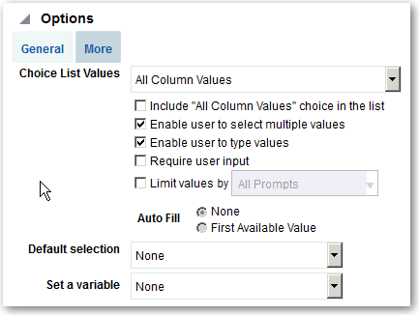

1. In the **Default selection** field, select the prompt value or values that users see initially.

If you select a default type, then a field is displayed where you can either select specific values, or specify how you want the default values to be determined. For example, if you select SQL Results, you must then supply a SQL statement to generate the list of values.

1. Click **OK**.
2. Click **Save Prompt** in the editor or save the analysis.
3. Use the arrow buttons in the Definition pane to reorder the selected prompt. Reordering the prompts controls the order in which the choices are displayed to users at runtime.
4. Select the type of layout you want on the prompts page by clicking **New Row** or **New Column** in the Definition pane.

A row-based layout saves space because it organizes prompts horizontally. A column- based layout aligns prompts into neat columns. Click the boxes in the New Column or New Row column in the Definition table that correspond to where you want to add a new column or row to the prompts page.

1. Preview the prompt with sample data using the Display pane, or click **Preview** (if available) in the Definition pane toolbar to view the prompt with actual prompt values.

#### Create Variable Prompts

A variable prompt enables the user to select a value that is specified in the variable prompt to display on the dashboard.

A variable prompt isn’t dependent upon a column, but can still use a column. You can use variable prompts to enable the user to specify existing data to perform sales projections.

For example, you can create a variable prompt called Sales Projections and specify the variable prompt values as 10, 20, and 30 percent. Then you create an analysis that contains the Region and Dollars columns. Within the Dollars column formula, you select the multiply

operator and insert the Sales Projection variable. When users run this analysis, they can select a percentage by which to recalculate the Dollars column.

1. Open the analysis for editing.
2. Display the Prompts tab.
3. On the Definition pane of the Prompts tab, click **New** then **Variable Prompt** to display the New Prompt dialog.

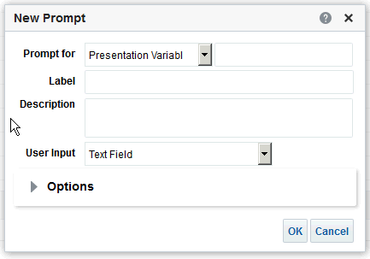

1. In the **Prompt for** field, select the variable type that you’re creating and then enter the name of the variable.

This variable name is the name that you add to the analysis or dashboard where you want the variable prompt's value specified by the user to display. Currently, you can create only presentation variables.

1. In the **Label** field, enter a caption for the variable filter prompt. The caption is displayed as the prompt's field label.
2. In the **Description** field, enter a short description for the prompt. This description is displayed as tooltip text, which is displayed when the user hovers the mouse pointer over the prompt's label in the dashboard or analysis.
3. In the **User Input** field, select how you want the prompt interface to ask the user for input. For example, prompt the user with a radio button to select only one prompt value.
4. If you selected either the **Choice List**, **Check boxes**, **Radio buttons**, and **List box** user input type, then you must also specify the prompt's list of values.
5. Within the Options section, select the prompt options. The prompt options vary depending on the user input type that you selected.

The prompt options enable you to further specify how you want the user to interact with the prompt. For example, whether user input is required.

1. In the **Default selection** field, select the prompt value that users see initially. If you select a specific value, then the **Default Value** field is displayed in which you can enter a value.
2. Click **OK** to display the prompt is displayed in the Definition pane.
3. Save your changes.

#### Override a Selection Step with a Prompt

You can override a selection step with either a dashboard prompt or an inline prompt.

For example, you can specify that the Products.Brand selection step be overridden with a column prompt specifying the BizTech and FunPod members.

1. Open the analysis for editing.
2. In Results tab, select the columns for the analysis and then navigate to the Selection Steps pane by selecting **Show/Hide Selection Steps Pane**.
3. Specify the selection steps for the analysis.

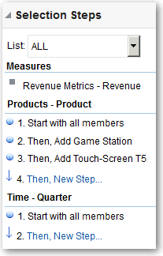

1. Determine which selection step you want to override with a column prompt and click **Edit**.
2. In the dialog, select **Override with prompt**, if it’s available for that type of step.
3. Click **OK** and save the analysis.

#### Create Currency Prompts

A currency prompt enables users to change the currency type that is displayed in a dashboard or analysis.

Use this procedure to create a currency prompt that you can apply to one or more dashboards, or to create a currency prompt that's embedded in an analysis.

1. Open the analysis for editing.
2. Display the Prompts tab.
3. In the Definition pane, click the **New** button and select **Currency Prompt**.
4. In the **Label** field, enter a caption.
5. In the **Description** field, enter a short description. This description is displayed as tooltip text, which is displayed when the user hovers the mouse pointer over the prompt's label in the dashboard or analysis.
6. Click **OK**.
7. Save the prompt.

About Prompts Auto-Complete

* + If you’re creating a dashboard prompt, then click the **Save** button in the prompt's editor, specify the folder in which you want to save the prompt, and give the prompt a descriptive name. Dashboard prompts that are saved in personal folders are available only to you. Dashboard prompts that are saved in shared folders are available to other users that have permission to access the object.
  + If you’re creating an inline prompt, then save the analysis.

1. Use the arrow buttons in the Definition pane to reorder the selected prompt. Reordering the prompts controls the order in which the choices are displayed to users at runtime, so ensure that the order is logical, especially if you’re creating constrained prompts.
2. If you want to add a new row or column to the prompts page, then click the **New Row** button or **New Column** button in the toolbar. In the Definition table, click the check box corresponding to the prompt that you want to display in a new row or column.
3. To preview how the prompt is displayed on the dashboard, either use the Display pane to preview the prompt with sample data, or click the **Preview** button in the toolbar to view the prompt with actual prompt values.

### About Prompts Auto-Complete

Auto-complete functionality for prompts suggests and highlights matching prompt values, as the user types in the prompt selection field.

Auto-complete is only available for the Choice List prompt type when the prompt designer selects **Enable User to Type Value** in the New Prompt dialog. Note that auto-complete isn't available for hierarchical prompts.

The auto-complete functionality is case-insensitive.

The matching level determines how Oracle Business Intelligence matches the column's values to what the user types. The matching level is set to Match All.

* **Match All** — As the user types, Oracle Business Intelligence suggests the column values that contain any letter that the user types. For example, auto-complete is case-insensitive and the matching level is Match All and the user types "l," then Oracle BI suggests "LCD 36X Standard," "LCD HD Television," "7 Megapixel Digital Camera," and "Plasma HD Television."

The auto-complete functionality highlights matching values when the user accesses the Select Values dialog to search for a prompt value. However, the matching level isn't determined by the preference set by the administrator. Instead, the user selects the matching level in the Select Values dialog.

The dashboard designer can exclude the auto-complete functionality from dashboards, and users can turn auto-complete off by using the My Account dialog. Note the following relationships between auto-complete settings:

* **Dashboard Setting** — If auto-complete is enabled for Oracle Business Intelligence, then the dashboard designer can remove the auto-complete functionality from individual dashboards by setting the **Prompts Auto-Complete** field to Off in the Dashboard Properties dialog. However, the auto-complete prompts functionality is available for other dashboards where the **Prompts Auto- Complete** setting is set to User Preference.

Edit Prompts

* **User Preference Setting** — If auto-complete is enabled for Oracle Business Intelligence and for individual dashboards, users can disable the auto-complete prompts functionality for their accounts by setting the **Prompts Auto-Complete** field in the My Account dialog: Preferences tab to Off. Setting this option to Off overrides the system and dashboard settings, and auto-complete functionality isn't displayed for the user

### Edit Prompts

You can edit a saved dashboard prompt or inline prompt, to propagate its changes to wherever the prompt is used.

For example, you can edit the prompt for the Brand column to change the user input to a choice list. This change is propagated to the Brand Revenue analysis where the prompt is used.

1. In the Definition pane on the Prompts tab, double-click to open the appropriate prompt.

Alternatively, in the Definition pane on the Prompts tab, select the appropriate prompt and click **Edit**.

1. Make the appropriate changes in the Edit Prompt window.

For example, change the label for the prompt or change the user input to a choice list.

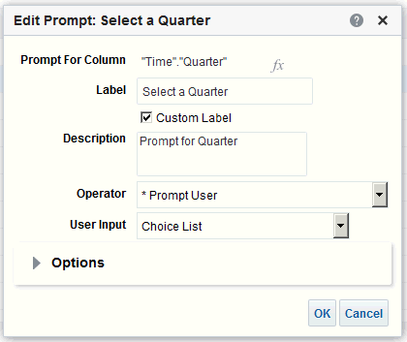

1. Click **OK**.
2. Click **Save Prompt**.

The changes are propagated to wherever the prompt is used.

### About Improving the Performance of Dashboard Prompts

Use these suggestions to improve the performance of dashboard prompts.

* Use the same subject area for both the prompt and the analyses in the dashboard.
* When your prompt and analysis use different subject areas, make them both use exactly the same field name for filtering. For example, if both the prompt and the analysis refer to "Activity"."Creation Date".
* Set the field on which your analysis is getting filtered through the prompt to "is prompted" filter.

Add Prompts to Dashboard Pages

### Add Prompts to Dashboard Pages

You can add a prompt to a dashboard or dashboard page.

[Video](http://apexapps.oracle.com/pls/apex/f?p=44785%3A265%3A0%3A%3A%3A%3AP265_CONTENT_ID%3A21797)

For example, you can create a dashboard prompt for the Brand column. You add the prompt to the Sales Performance dashboard, to drive the content on the dashboard page. You add a filter for Brand that uses the "is prompted" operator to flag the column as ready to be filtered by a prompt. When the prompt is used, the results include only records where the data in the column that is prompted matches the user's choices.

1. Open the dashboard for editing.
2. In the Dashboard builder's Catalog pane, locate and drag and drop an object such as an analysis onto a section in the dashboard page.
3. Add a new or pre-created prompt:
   * To add a new prompt, click **New**, then **Dashboard Prompt**, and follow the on- screen instructions.
   * To add a pre-created prompt, in the Dashboard builder's Catalog pane, locate and drag and drop the dashboard prompt onto a section in the dashboard page.

The dashboard prompt is added to the dashboard page.

1. To specify whether to include the prompt's **Apply** and **Reset** buttons on the dashboard page, in the toolbar of the Dashboard builder, click **Tools**. Then select **Prompts Buttons on Current Page** and either **Apply Buttons** or **Reset Buttons**.
2. Click **Save** in the dashboard toolbar.
3. To preview the dashboard page, click **Preview** in the dashboard toolbar.

### Add Hidden Prompts to Dashboard Pages

You can add a hidden prompt to a dashboard or dashboard page.

1. Create and save a prompt to use as a hidden prompt.
2. Open a dashboard for editing.
3. On the Dashboard page toolbar, click **Tools** and select **Dashboard Properties**.
4. In the Dashboard Properties dialog, click the **Filters and Variables** pencil icon to add a hidden prompt to the entire dashboard.

Alternatively, to add a hidden prompt to a page, locate the page in the Dashboard Pages area and click **Select a prompt to capture default filters and variables** icon.

1. In the Dashboard Filters and Variables dialog, click the **Embed new hidden dashboard prompt** plus icon to browse for and select the prompt. Click **OK** to add the hidden prompt.
2. Click **OK** to save the dashboard properties.
3. Click **Save** in the dashboard toolbar.
4. To preview the dashboard page, click **Preview** in the dashboard toolbar.

# 7

## Make Analyses Interactive

Make your analyses and dashboards more interactive. Embed hyperlinks to some related business intelligence content or add links to other web pages.

[Video](http://apexapps.oracle.com/pls/apex/f?p=44785%3A265%3A0%3A%3A%3A%3AP265_CONTENT_ID%3A29118)

Topics:

* Typical Workflow to Make Analyses Interactive
* Create Named Actions for Reuse
* Create Inline Actions
* Add Actions to Analyses
* Add Actions to Dashboard Pages
* Edit Named Actions
* Edit and Delete Action Links in Analyses
* Edit and Delete Action Links in Dashboard Pages
* Save Inline Actions in Analyses to the Catalog
* Save Inline Actions in Dashboards to the Catalog

### Typical Workflow to Make Analyses Interactive

Here are the common tasks to start making analyses more interactive.

|  |  |  |
| --- | --- | --- |
| **Task** | **Description** | **More Information** |
| Create an analysis | Select and arrange columns that you | Create Analyses |
|  | want to use in an analysis. |  |
| Create a named action | Create an action and save it to the catalog. | Create Named Actions for Reuse |
| Create an inline action | Create an action and save it with an | Create Inline Actions |
|  | analysis. |  |
| Add an action to an analysis | Add an action to a column value in an | Add Actions to Analyses |
|  | analysis. |  |
| Add an action to a dashboard | Add an action or an action menu to a dashboard. | Add Actions to Dashboard Pages |

Create Named Actions for Reuse

### Create Named Actions for Reuse

Create action links so users can navigate to related BI content such as websites and reports, or perform business tasks. You save named actions to the catalog to that they’re available to your analysts and business users.

Users can click an analysis that is embedded within column headings and column values. Users can also click links in views such as graphs, and on grand totals within tables and pivot tables.

1. From the Classic Home page, go to **Create** and click **Action** under **Actionable Intelligence**.
2. Click the option for the type of action you want to create.
3. Optional: Change the default parameters to change the information that is displayed when the action executes.
   * **Navigate to BI Content** - Display an analysis or dashboard stored in the My Folders or the shared folder area.
   * **Navigate to a Web Page** - Display a web page.
   * **Invoke a Web Service** - Invoke a web service operation or any Service- Oriented Architecture (SOA) service that is exposed as a Web Service (for example, a Business Process Execution Language (BPEL).
   * **Invoke a HTTP Request** - Invoke an external system command that is exposed by a URL API. This sends a HTTP request through the server to a target URL.
   * **Invoke a Server Script** - Execute a custom script when the current agent completes. The custom script type can be either Javascript or VBScript. This action supports custom script actions when the server is running on Microsoft Windows. For other platforms (including Windows), consider using the Invoke Java Method (EJB) or Invoke Web Services action.
   * **Invoke a Browser Script** - Invokes a JavaScript function that the administrator has made available to you. Click **Browse** to see a list of functions that the administrator has made available, or type the name of a function in the **Function Name** field. For example, you might specify USERSCRIPT.mycurrencyconversion.
   * **Invoke a Java Method** - Invokes a Java method in an Enterprise Java Bean (EJB). See **Invoke a Java Method (EJB)**.
4. Click **Save Action** and choose where to save the action.
5. Verify that the action runs properly:
6. Navigate to the named action in the catalog.
7. Click **Execute**.
8. Respond to any request for more information or any confirmation prompt that is displayed.

Create Inline Actions

### Create Inline Actions

An inline action is an action that you define for a particular analysis or dashboard and don’t save by name in the catalog.

For example, in the Brand Revenue analysis, you might decide to create a link to an Opportunity Detail web site.

* Analyses – Add actions to column headings, column values, or hierarchy level values using an action link. See Add Actions to Analyses.
* Dashboard page - Add action links or action link menus to the page. See Add Actions to Dashboard Pages.

### Add Actions to Analyses

You can use an action link to add actions to a column heading, column value, or hierarchy level value in an analysis.

For example, in the Brand Revenue analysis, you can include an action that contains an action link to an Opportunity Detail web site. Sale consultants can query the site for an opportunity by responding to a prompt for Opportunity Name or Opportunity ID.

1. Open the analysis for editing.
2. On the Criteria tab, open the **Options** menu for a column and select **Column Properties**.



1. Click the **Interaction** tab.
2. In the Primary Interaction box in the Column Heading area or the Value area, select

Action Links.

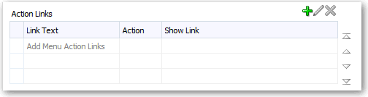

1. Click **Add Action Link**.
2. In the **Link Text** field, enter the text you want the link to display.
3. To create an action, click **Create New Action**, select the type of action you want, and specify the settings for the action.

Add Actions to Dashboard Pages

See Create Named Actions for Reuse.

Alternatively, click **Select existing action**, select the action you want, and specify any associated parameters in the Edit Parameter Mapping dialog.

If you chose to show the link conditionally, then in the visualization, you must place the column containing the action link at a more detailed grain than the columns used in the condition.

1. Save your changes.

### Add Actions to Dashboard Pages

You can add actions to dashboard pages using action links and action link menus.

Topics

* Add Actions to Dashboard Pages with Action Links
* Add Actions to Dashboard Pages with Action Link Menus

#### Add Actions to Dashboard Pages with Action Links

Link a related report or a useful web site to your dashboard. For example, give sales consultants a direct link to an Opportunity web site from the Sales Performance dashboard so they can query opportunities by responding to a prompt for Opportunity Name or Opportunity ID.

1. Open the dashboard page for editing.
2. From the Dashboard Objects pane, drag and drop an Action Link object on the dashboard page.
3. Click **Properties** for the new link.

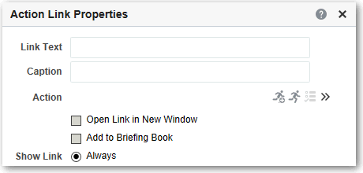

1. Complete the fields in the dialog.
2. Click **OK**.
3. In Dashboard builder, click **Save**.

Add Actions to KPIs

#### Add Actions to Dashboard Pages with Action Link Menus

You may want to offer several action links on your dashboards. Use menus to group your links together and keep things organized.

For example, you can give sales consultants a Related Information menu on the Sales Performance dashboard with useful links, such as an external Opportunity web site or a related Brand Revenue dashboard.

1. Open the dashboard for editing.
2. From the Dashboard Objects pane, drag and drop an Action Link Menu object on the dashboard page.
3. Click **Properties** for the new menu.

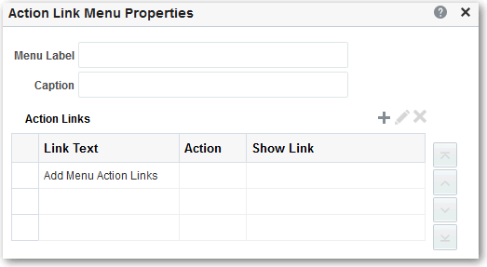

1. Add the action links to the menu.
2. Click **OK**.
3. In Dashboard builder, click **Save**.

### Add Actions to KPIs

You can add one or more actions to a KPI. When you add an action to a KPI, you add the action by using an action link.

When a KPI that contains one or more action links is presented to end users (generally in a scorecard or a KPI watchlist), users can click a link to run the associated action.

1. Edit the KPI to which you want to add one or more actions.
2. Click the **States** page of the KPI editor.
3. Click the **Define action links for this status** button to display the Action Links dialog.
4. To add an action that has been added to another range of the KPI, click the **Add Action Link** button and select the action.
5. To add a new action:
   * If one or more actions have been added to another range of the KPI, click the **Add Action Link** button and select **New Action Link**.
   * If no actions have been added to other ranges of the KPI, then click the **Add Action Link** button.

Add Actions to Initiatives and Objectives in Scorecards

1. In the **Link Text** field of the New Action Link dialog, enter the text to display as the link to execute the associated action.
2. To create an action (that is, an inline action), click the **Create New Action** button and specify the settings for the new action.
3. To add an existing action (that is, a named action):
4. Click the **Select existing action** button.
5. Complete the Open dialog.
6. If there are parameters associated with the action, complete the Edit Parameter Mapping dialog (if displayed).
7. Click **OK** in the New Action Link dialog.
8. For each additional action link to add, repeat steps 5–9.
9. Click **OK** to close the Action Links dialog.
10. Click the **Save KPI As** button on the KPI editor to save the KPI.

### Add Actions to Initiatives and Objectives in Scorecards

You can add one or more actions to an initiative or objective in a scorecard. When you add an action to an initiative or objective, you use an action link.

1. Edit the scorecard that contains the initiative or objective.
2. Navigate to the initiative or objective to which you want to add an action as follows:
   * If you are adding the action to an initiative, then in the Initiatives pane, double- click the initiative.
   * If you are adding the action to an objective, then in the Strategy pane, double- click the objective.
3. In the Action Link area in the Analytics pane, click the **New Row** button.
4. In the **State Equals** box of the Action Link dialog, select the state of the initiative or objective under which the action link is to be enabled.
5. To create an action (that is, an inline action), click the **Create New Action** button and specify the settings for the new action.
6. To add an existing action (that is, a named action):
7. Click the **Select Existing Action** button.
8. In the Open dialog, click **OK**.
9. In the **Link Text** field, enter the text to display as the link to execute the associated action.
10. Click **OK** in the Action Link dialog to add the action link.
11. Save the objective or initiative.

### Create an Action Based on an Existing Named Action

You can create an action based on an existing named action.

For example, suppose that your organization has an existing named action Send Message that sends an email message. Its parameters include a recipient, subject,

Edit Actions Added to Agents

message, and priority. You can create an action that is based on this Send Message action that sends a high priority message. To do so, you provide a high priority value for the priority parameter and save the new action with a new name, such as Send High Priority Message.

1. Edit the existing named action on which you want to base a new action.
2. In the Edit Action dialog, specify any changes that you want.
3. Click **Save As** and specify the save as criteria in the dialog.

### Edit Actions Added to Agents

You can edit an action that you have added to an agent.

If the action is an inline action, then you can edit the entire action. If the action is a named action, then you can edit only the parameter values.

1. Open the agent.
2. Click the **Actions** tab of the Agent editor.
3. Select the action and click the **Edit Parameters** button.
4. In the Edit Action dialog, edit the action and click **OK**.

### Edit Actions and Action Links Added to KPIs

You can change an action or action link that has been added to a KPI. Editing actions and action links ensures the information is current.

1. Edit the KPI to which the action and action link has been added.
2. Click the **States** page of the KPI editor.
3. Click the **Define action links for this status** button to display the Action Links dialog.
4. In the Action Links area, select the action to edit and click the **Edit Action Link** button to display the Edit Action Link dialog.
5. Make the appropriate changes to the action link.
6. Click the **More** button and select **Edit Action**.
7. In the Edit Action dialog, edit the action and click **OK**.
8. Click **OK** in the Edit Action Link dialog.
9. Click **OK** in the Action Links dialog.
10. Click **Save KPI As**.

### Edit Actions and Actions Links Added to Initiatives and Objectives in Scorecards

You can edit actions and action links in initiatives and objectives to keep them current and relevant.

Editing actions and action links is a simple process.

1. Edit the scorecard that contains the initiative or objective.

Edit Named Actions

1. Navigate to the initiative or objective as follows:
   * For an initiative, in the Initiatives pane, double-click the initiative.
   * For an objective, in the Strategy pane, double-click the objective.
2. In the Action Link area of the Analytics pane, click the **Edit Row** button.
3. In the Action Link dialog, make the changes that you want and click **OK**
4. Save the objective or initiative.

### Edit Named Actions

You can edit existing named actions. For example, you can edit the Brand Analysis action in the Sales Performance dashboard to navigate to a newly created analysis.

1. Navigate to the action in the catalog.
2. Click **Edit**.

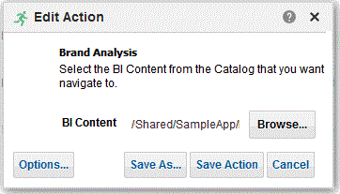

1. Edit the action and click **OK**.
2. Click **Save Action**.

### Edit and Delete Action Links in Analyses

You can edit action links or delete action links you don't want any more. So, if an action link navigates to an obsolete analysis or web site you can point somewhere new or remove the link.

1. Open the analysis for editing.
2. On the Criteria tab, open the **Options** menu for a column and select **Column Properties**.

Edit and Delete Action Links in Dashboard Pages



1. Click the **Interaction** tab.
2. To edit an action or action link:
   1. In the Action Links area, select the action to edit and click **Edit Action Link**.
   2. Make the changes you want.
   3. To edit the associated action, click **More** and select **Edit Action**.
   4. Make the changes you want.
3. To delete an action link:
   1. In the Action Links area, select the action link that you want to delete.
   2. Click **Delete**.
4. Click **OK**.
5. Click **Save Analysis** in the Criteria tab.

### Edit and Delete Action Links in Dashboard Pages

You can edit action links or delete those you don't want any more. For example, if the URL to an "Opportunity" site changes you can point to the new URL.

1. Open the dashboard for editing.
2. If the action and action link are associated with an action link menu:
   1. Click **Properties** for the action link menu.
   2. Make the appropriate changes to the menu label and caption.
   3. In the Action Links area, select the action you want and click **Edit**.
3. To edit an action that isn’t part of a menu, click **Properties** for the action link.
4. Update the action link.
5. Click **More** and select **Edit Action** to edit the action.
6. Edit the action and click **OK**.
7. Click **OK** in the Action Link Properties dialog, and in the Action Link Menu Properties dialog (if displayed).
8. Click **Save**.
9. Click **Delete** on the action link (or action link menu) toolbar to remove actions you don't want any more.

Save Inline Actions in Analyses to the Catalog

### Save Inline Actions in Analyses to the Catalog

You can save useful inline actions to the catalog and reuse them in other analyses and dashboards.

1. Open the analysis for editing.
2. On the Criteria tab, open the **Options** menu for a column and select **Column Properties**.



1. Click the **Interaction** tab.
2. In the Action Links area, select the action you want and click **Edit Action Link**.
3. Click **More** and select **Save Action As**.
4. Specify how the action appears in the catalog, then click **OK** to save it.

### Save Inline Actions in Dashboards to the Catalog

You can save useful inline actions to the catalog and reuse them in other analyses and dashboards.

1. Open the dashboard for editing.
2. If the action and action link are associated with an action link menu:
   1. Click **Properties** for the action link menu.

Save Inline Actions in Dashboards to the Catalog

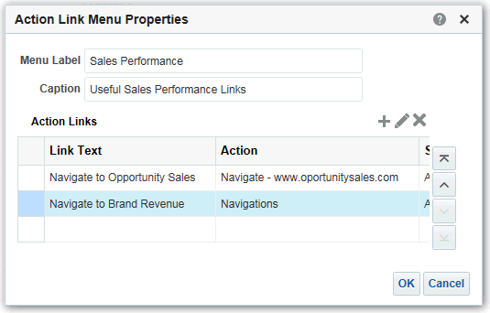

* 1. Make the appropriate changes to the menu label and caption.
  2. In the Action area, select the action you want to save to the catalog.

1. To save an action that isn’t part of a menu, click **Properties** for the action link.
2. Click **More** and select **Save Action As**.
3. Specify how the action appears in the catalog and click **OK**.
4. Click **Save**.

# 8

## Using KPIs and KPI Watchlists

This chapter explains how to use Key Performance Indicators (KPIs) and KPI watchlists in Oracle Transactional Business Intelligence . It also explains KPI evaluation, dimensions and pinned dimension values, and target settings.

Topics

* What Are KPIs?
* How Are KPIs Evaluated?
* How Can I Use KPIs?
* What Are Dimensions and Pinned Dimension Values?
* How Do I Create a KPI?
* Create KPIs
* Edit KPIs
* What Are Target Settings?
* Generate Analyses from KPIs
* Create Agents from KPIs
* Contact the Business Owner of KPIs
* About Overriding Statuses of KPIs
* About Adding Comments to KPIs
* What Are KPI Watchlists?
* Create KPI Watchlists
* Edit KPI Watchlists

### What Are KPIs?

Key Performance Indicators, or KPIs, are measurements that define and track specific business goals and objectives that often roll up into larger organizational strategies that require monitoring, improvement, and evaluation.

KPIs have measurable values that usually vary with time, have targets to determine a score and performance status, include dimensions to allow for more specific analysis, and can be compared over time for trending purposes and to identify performance patterns.

See the following list of specific uses for KPIs in Oracle BI EE:

* Evaluate metrics against their targets and alert the appropriate users through agents when targets are not met.
* Create an analysis from a KPI and add that analysis to a dashboard. An analysis that is created from a KPI can allow the user to drill into different levels of details based on the KPI's dimensions.

How Are KPIs Evaluated?

For example, to a KPI called Product Sales, you can add the Region and Fiscal Time dimensions to view Product Sales figures by region and time periods such as financial quarters. This addition enables you to gather multi-dimensional subsets of data and evaluate the performance of objectives and initiatives that the KPI measures against the different target values of the dimensional metrics.

* In Oracle Scorecard and Strategy Management, use KPIs to evaluate and monitor the performance of the objectives that form the strategy and the initiatives (tasks) that are needed to meet your objectives. See Scorecarding.

For example, use KPIs for Average Customer Satisfaction Survey Score and Repeat Orders to measure the performance of an Improved Customer Satisfaction objective.

### How Are KPIs Evaluated?

A KPI's status and score are determined by comparing its actual value against the thresholds that you define.

The performance status of a KPI is represented by the status icon that you assign to each range.

For example, for a product sales KPI in which high values are desirable, you can define the ranges that are described in the table. Thresholds are the numeric values that separate the ranges.

|  |  |  |  |
| --- | --- | --- | --- |
| **Evaluation Range Rule** | **Threshold** | **Name** | **Status Icon** |
| Values exceeding 125 (125 < x) indicate ideal performance | 126 and above | Ideal | Blue square |
| Values between 100 and 125 (100 < x <= 125) indicate good performance | 125 | Good | Green square |
| Values between 80 and 100 (80 < x <= 100) indicate acceptable performance | 100 | Acceptable | Yellow square |
| Values between 50 and 80 (50 < x < = 80) indicate a warning of poor performance | 80 | Warning | Light red square |
| Values less than 50 (x <= 50) indicate critical performance | 50 and below | Critical | Dark red square |

### How Can I Use KPIs?

KPIs are created with the KPI Editor, which can be accessed as a standalone editor or within the Scorecard editor.

After you create and save KPIs, you can use them in the following ways:

* Building blocks of scorecards — You can create and assign KPIs to measure the progress and performance of your organization's strategies. Within a scorecard, you can define the *objectives* (goals such as Decreased Operational Costs) and *initiatives* (processes or tasks such as Form Cost Minimization Team) to which you assign KPIs to measure progress and performance. See What Are Objectives? and What Are Initiatives?.
* As an analysis — You can generate an analysis from a KPI. When you do so, Oracle BI EE saves the analysis to the catalog. You can include the analysis on a

What Are Dimensions and Pinned Dimension Values?

dashboard or as a related document in a scorecard, KPI watchlist, or KPI. Any dimension values that you pinned to the KPI before you output it as an analysis are included in the analysis. Pinning qualifies or filters the data that the user sees by assigning one or more values to the dimension. Drill-down is available on the analysis. Oracle BI EE refreshes the data for the analysis every time a user opens the analysis.

* Included in KPI watchlists — You can create a watchlist that contains a group of KPIs or to present one KPI several times with dimension values that are pinned to it. After you save the watchlist, it is available as a catalog object that you can add to dashboards or scorecards. When users access the watchlist, they can change the dimension values for the KPIs that are included in the watchlist. Scorecards can contain other types of watchlists, such as Initiatives & KPIs watchlist, Objectives & KPIs watchlist, and Breakdown watchlist. See Understand Watchlists.
* Facilitate user interaction — If KPIs were added to a KPI watchlist or if they were added to objectives or initiatives inside a scorecard, then you can post comments to a KPI and read and reply to other users' comments. You can also contact the KPI's business owner with questions or comments about the KPI. And, if you are the business owner, you can override a KPI's status.
* Initiate actions — You can add an action link that when clicked in the KPI runs an associated action. For example, if the performance of a KPI for Internal Spending is too high, indicating excessive spending, then you could create an action link that when clicked, sends an email to the appropriate employees.
* Trigger agents — You can use a KPI's values, performance levels, and status to trigger a condition that initiates an agent alert. For example, you can define an agent that notifies you when the value of an Internal Costs KPI exceeds a certain dollar amount.

### What Are Dimensions and Pinned Dimension Values?

Dimensions are categorizations of data, and the categorizations reflect how a business analyst wants to analyze data.

When analysts say they want to see numbers "by" something or "over" something, they are identifying the dimensions of the data. Common dimensions are geography, product, customer, and time.

For KPIs, you can select any attribute column from the subject area as a dimension. When you design the KPI, you can either pin one or multiple data values to one or more dimensions (for example, Region = *Central*), or you can specify that you want all or some dimension values pinned when the KPI is added to a watchlist or scorecard and when a watchlist or scorecard is added to a dashboard. After a value is pinned by the designer, the user cannot change the value.

When adding a KPI without a pre-pinned value to a watchlist, the designer can pin one or more values, or specify a session, repository, or global variable to set the dimension's value. If the designer does not pin a value or variable to a dimension, then the KPI user can select one or more values at runtime from the point of view area in either the KPI watchlist, from the scorecard that contains the KPI, from the variable prompt on a dashboard, or from the column prompt on the dashboard.

* If a KPI watchlist or scorecard object containing a KPI is added to a dashboard with prompts, and the KPI is not dimensioned by a specific prompt's dimension in the KPI definition, that prompt is ignored. Additionally, if the KPI is pinned to a specific dimension value in its definition, a prompt on that dimension is ignored.

How Do I Create a KPI?

* If a KPI with dimensions is output to an analysis, then the dimensions are displayed as columns and drills. If the dimension values are pinned, then the analysis is limited to the data that is determined by the pinned values. If the dimension is pinned with multiple values, a row is displayed for each pinned value.

Define several dimensions for a KPI, but do not pin the dimensions within the KPI definition itself. This allows the user to reuse the KPI and pin it within a scorecard strategy tree, watchlist, or dashboard prompt. For example, if you create an overly specific KPI that pins a dimension, such as region to North America, the use for the KPI might be limited. If you leave the dimension unpinned, then the user makes the decision what region to pin. The usage for this KPI becomes more flexible and reusable, and prevents you from having to create and manage overly-specific KPIs.

### How Do I Create a KPI?

There are several pages that the content designer can use to build a KPI. These pages are represented in the illustration. See Create KPIs.

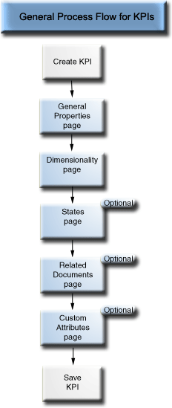

You must complete the General Properties page and the Dimensionality page of the KPI editor.

To navigate between pages, you select the **Next** and **Back** buttons, or you click the page name along the navigation train. The navigation train is represented in the illustration.



### Create KPIs

You can create a KPI from the global header, the Home page, or from a scorecard. Use the following procedure to create a KPI. See Edit KPIs.

1. To create a KPI, do one of the following:
   * In the global header, click **New** then select **KPI**. From the Select Subject Area dialog, select a subject area for the KPI. The KPI editor is displayed.
   * From a scorecard, go to the Scorecard Documents pane and click the **Create Object** button. Or in the Catalog pane, click the **New Object** button. Select **KPI**, and from the Select Subject Area dialog, select a subject area for the KPI. The KPI editor is displayed.
2. On the General Properties page of the KPI editor, specify the business owner, actual value and target value, and whether to make the values writeable, define the data format, and indicate whether to enable trending to determine performance patterns. Oracle recommends that you enable trending because trending enables Scorecard to automatically display historical trend charts. This illustration shows an example of the General Properties page for a revenue KPI.

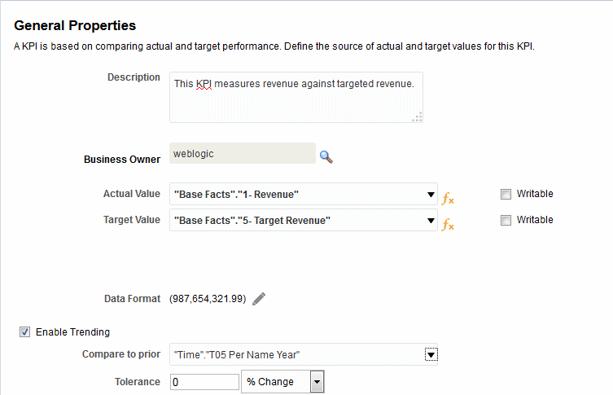

Create KPIs

If you are going to enable trending, you must also include a Time dimension on the Dimensionality page of the KPI editor. If a Time dimension is selected from the **Compare to Prior** option, the same Time dimension must be added to the Dimensionality page. If a Time hierarchy level is selected from the **Compare to Prior** option, the hierarchy to which that hierarchy level belongs, must be added to the Dimensionality page.

If you are planning to use a KPI in a scorecard, you should assign a business owner. You cannot override a KPI status without having a business owner assigned. See Work with Status Overrides.

1. On the Dimensionality page, select the dimensions (for example, Sales by Region and by Financial Quarter) that you want to use to aggregate the KPI's actual and target values and determine if the dimensions should be pinned. You should include a time dimension for most KPIs. Exceptions include constants or metrics that are defined as current snapshots, such as Inventory on Hand or Current Phone Support Wait Time. The illustration shows an example of the Dimensionality page. In this example, the **"Cust Regions"."D50 Region"** dimension is pinned to AMERICAS.

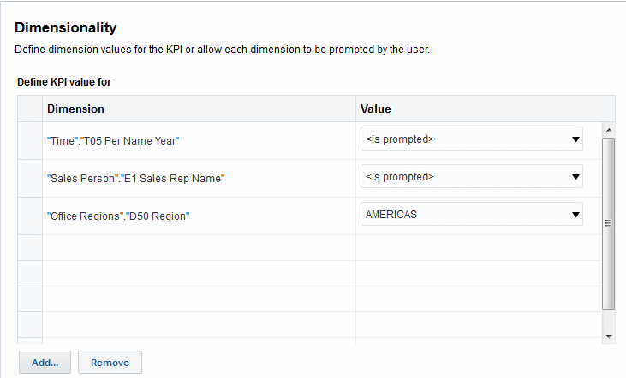

1. On the States page, indicate the desired goal based on KPI values (for example, High Values are Desirable), define the ranges that evaluate KPI values to determine performance status and score, associate performance levels with actions, identify what to do if no data is returned for the KPI, and associate thresholds as a percent of target value. This illustration shows an example of the States page.

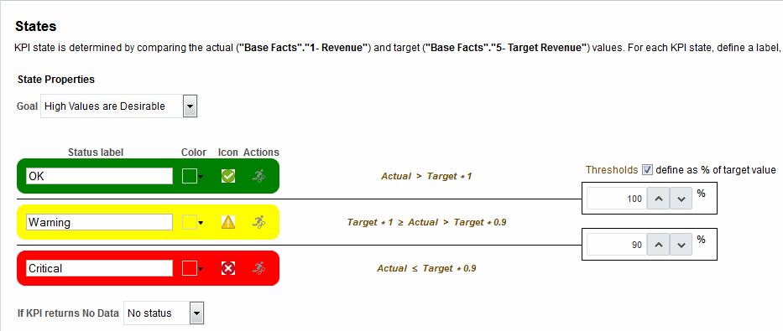

1. On the Related Documents page, add any external links or business intelligence objects to the KPI. This illustration shows an example of the Related Documents page of the KPI editor.

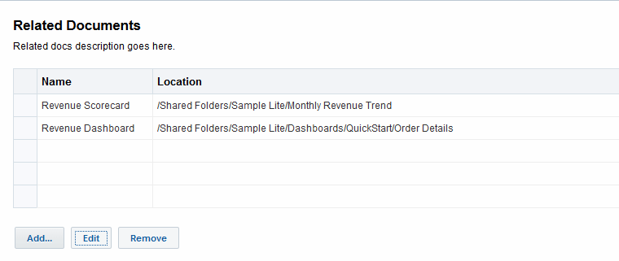

1. On the Custom Attributes page, include as many as five custom columns. Each custom column must evaluate to a numeric value. Custom columns are helpful when you have an associated calculation that you want to show, which isn't the same as the actual, target, variance, and change formulae. For example, you might add a custom column for Year Ago Revenue that displays next to the Revenue KPI for a matching time period. This illustration shows an example of the Custom Attributes page.

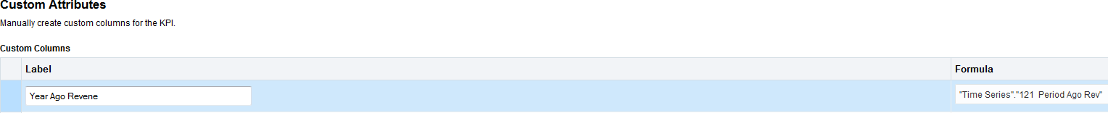

1. Save the KPI.
   * If you are creating a standalone KPI, then click **Finish** to save the KPI.
   * If you are creating a new KPI, then the Save As dialog is displayed where you specify the KPI's name and where you want to save the KPI. If you want the KPI to display within a scorecard's Scorecard Documents pane, then save the KPI to the scorecard object's folder within the catalog.

Edit KPIs

### Edit KPIs

* If you are creating a KPI from a scorecard, then click **Save** from the Scorecard editor.

There are multiple ways to edit KPIs

Use the following procedures to open and edit a saved KPI. KPIs are stored in the catalog, but can be added to KPI watchlists, scorecards, and dashboards. When you edit and save a KPI, the changes propagate to wherever the KPI is displayed.

#### Edit KPIs from the Catalog

Use the following procedure to edit a KPI from the catalog. You can use the catalog to access a KPI to edit it.

1. In the global header, click **Catalog**.
2. In the Catalog page, navigate to the KPI to edit and click the **Edit** link for the object.
3. In the KPI editor, make the desired changes.
4. Save the KPI.

#### Edit KPIs from a KPI Watchlist

Use the following procedure to edit a KPI from a KPI watchlist. You can access a single KPI from a KPI watchlist to edit the KPI.:

1. In a KPI watchlist, right-click the KPI that you want to open.
2. Select **Open KPI Definition**.
3. In the KPI editor, make the desired changes.
4. Save the KPI.

### What Are Target Settings?

Target settings allow the user with the proper privileges and security settings to modify the KPI's actual and target values.

Once modified, these values are submitted to and stored in the repository. Oracle BI EE then uses these modified values to recalculate aggregate values, refresh the cache, and refresh the KPI watchlists or scorecards to which the KPI was added.

Currently target settings are available for Essbase data sources only.

#### Prerequisites for Setting Up Target Settings in KPIs

There are several steps that need to be taken to use target settings in KPIs.

The administrator must perform the following prerequisite tasks before the content designer can create a KPI with target settings:

What Are Target Settings?

* + **Configure the repository for target settings** — The Oracle BI EE repository administrator must enable the target setting features by mapping the Oracle Essbase data source to the Physical, Business Model and Mapping, and Presentation layers in the Oracle BI repository. The administrator must then enable write back for the columns in the repository on which target settings are enabled by selecting the **Writeable** option for the logical columns, followed by enabling the **Read/Write** permission for the corresponding presentation columns.
  + **Create Calculation Scripts** — The Oracle BI EE repository administrator uses Oracle Essbase to create calculation scripts for the data source. After the calculation scripts are created, they display in the **Post-update Business Rule** list located in the Oracle BI EE General Properties page of the KPI editor. At design time, the content designer chooses a calculation script. At runtime, Oracle BI EE uses the specified calculation script to recalculate the data after the user modifies and saves the KPI's actual and target values.

See Developing Calculation Scripts for Block Storage Databases in *Oracle Essbase Database Administrator's Guide* for additional information.

* + **Assign user privileges** — To allow users to modify the actual and target values in a KPI the Oracle BI EE system administrator must assign the user specific privileges.

#### Overview of Setting Up Target Settings in KPIs

There are several steps that the content designer must perform to create a KPI with actual and target values that a user can update at runtime.

The illustration shows each required step in the process. See Description of Target Setting Task Flow Steps and Create KPIs.

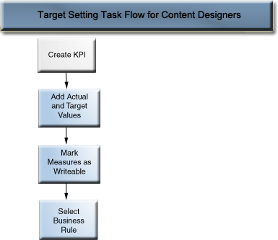

Description of Target Setting Task Flow Steps

The following list describes each step that you must perform to set up a KPI's target settings:

Generate Analyses from KPIs

* + Add actual and target values to the KPI — In the General Properties page of the KPI editor, use the **Actual Value** and **Target Values** fields to specify the values to use to determine the KPI's status and score. Currently you can only create one KPI for each Essbase data source.
  + Mark measures as writeable to enable users to update actual and target values — In the General Properties page of the KPI editor, use the **Writeable** check box to specify which values you want the user to be able to modify. You can select one or both values as writeable.
  + Select the business rule — In the General Properties page of the KPI editor, use the **Post-update Business Rule** list to specify the calculation script. Oracle BI EE uses the calculation script to recalculate the data after the values are modified by the user. The repository administrator uses Oracle Essbase to create the data source and the calculation scripts that display at design time. See Prerequisites for Setting Up Target Settings in KPIs.

#### User Interaction with Target Settings

The content designer can include KPIs with enabled target settings in watchlists, such as a KPI watchlist, objectives, and initiatives.

See Understand Watchlists.

At runtime, a user who has been granted the proper privileges can modify and save the actual and target values that are writeable. After the user enters and saves the values, Oracle BI EE submits the values to the repository, recalculates the aggregate values, and refreshes the watchlist.

### Generate Analyses from KPIs

You can use KPIs to generate analyses based on a KPI watchlist, scorecard, or scorecard diagram.

Use the following procedures to generate an analysis from a KPI. An analysis is a query against an organization's data that provides answers to business questions such as "What are my yearly regional sales of a specific beverage?"

You can generate an analysis from a KPI that is included in a KPI watchlist, scorecard, or scorecard diagram view on a dashboard. After you generate the analysis, it is stored in the catalog's Drills folder (/My Folders/Drills). Because the My Folders/Drills folder is used for temporary storage, the analysis might not persist after your session ends. To preserve the analysis, copy it to another directory. For example, to preserve an analysis that you plan to use in a shared dashboard, copy it to a folder in /Shared Folders.

After the analysis is generated, the analysis can then be placed onto a dashboard, opened from the catalog as an analysis, or attached as a related document in a scorecard, KPI watchlist, or KPI. Every time a user opens the analysis, its data is refreshed.

If the KPI dimension has a multi-value pinning, each value is displayed as a separate row in the analysis.

To generate an analysis from a KPI on a watchlist:

Create Agents from KPIs

1. Locate and open the KPI watchlist from the catalog, scorecard, or dashboard that contains the KPI watchlist.
2. Go to the **Performance** tab and within the KPI Watchlist table, select the row that contains the KPI that you want to output to an analysis.
3. Click **Objects** and then select **Analyze**. A new browser tab opens and displays the analysis, and Oracle BI EE saves the analysis to the catalog's Drills folder (/My Folders/Drills).

To output an analysis from a KPI on a scorecard:

1. Expand the scorecard's strategy tree, initiative tree, Scorecard Documents pane, or Catalog pane and select a KPI.
2. Right-click the KPI and select **Analyze**. A new browser tab opens and displays the analysis, and Oracle BI EE saves the analysis to the catalog.

### Create Agents from KPIs

You can create an agent from a KPI by using the **Create Agent** option.

This option is available from the **More** list on the Catalog page and from the **New Object** list in the Scorecard Editor's Catalog pane. When you create an agent using this method, Oracle BI EE does the following:

* + Uses the KPI dimensions, dimension values that you specify, and status to create a condition that is based on the KPI and adds the condition to the Condition tab of the Agent editor.
  + Outputs the KPI as an analysis, saves the analysis to the catalog, and attaches the analysis to the Delivery Content tab of the Agent editor.

Use agents for KPIs and scorecards to monitor performance, continuous feedback, and real- time alerts. Use actions to align day-to-day decisions with your corporate strategy and to trigger alerts for out of the ordinary results.

1. Locate the KPI from which you want to create an agent by using one of the following methods:
   * From the Catalog page, browse for and locate the KPI. In the Catalog area, click the KPI's **More** list and select **Create Agent**.
   * From anywhere in scorecard (Strategy pane, Initiatives pane, Scorecard Documents pane, Catalog pane, or any tab within the Scorecard editor), select a KPI, right-click, and select **Create Agent**.

The Create New Agent dialog, shown here, is displayed.

Contact the Business Owner of KPIs

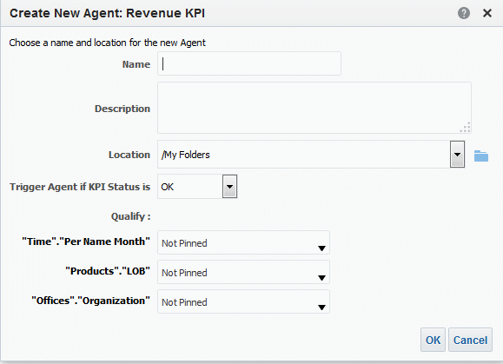

1. In the **Name** field, enter a name for the agent.

The Agent editor is displayed and the information that you specified in the Create New Agent dialog defaults into the Condition tab and the Delivery Content tab of the Agent editor.

1. (optional) Specify a description in the **Description** field.
2. Select the location in which to save the new agent.
3. Select the status that initiates the agent to deliver its content and execute its actions from the **Trigger Agent if KPI Status is** list.
4. (optional) Select a value for the dimensions. Agents cannot have KPI dimensions with multiple values.
5. Click **OK**.
6. Complete and save the agent.

### Contact the Business Owner of KPIs

You can send a message to a KPI's business owner.

The business owner is the person who is responsible for managing the KPI. Upon the creation or modification of the KPI, the content designer selects the business owner from the Oracle BI EE user list.

Oracle BI EE uses the delivery devices and profiles that the business owner has specified in the Delivery Options tab of the My Account dialog to determine where to deliver the message (for example, email, phone, or pager).

To contact the KPI's business owner from a KPI watchlist:

1. Locate and open the KPI watchlist from the catalog, open a dashboard that contains a KPI watchlist, or open the scorecard that contains the KPI watchlist.

About Overriding Statuses of KPIs

1. Go to the **Performance** tab and within the KPI Watchlist table, select the row that contains the KPI whose owner you want to contact.
2. Click **Objects** and then select **Contact Owner**. The Contact Owner dialog is displayed.
3. In the **Subject** field, enter a meaningful subject.
4. Select a priority with which to send this message from the **Priority** list.
5. In the **Message** field, enter a message to the KPI's owner.
6. Click **Send**.

To contact the KPI's business owner from a scorecard:

1. Expand the scorecard's strategy tree, initiative tree, or scorecard documents folder and select a KPI.
2. Right-click the KPI and then select **Contact Owner**. The Contact Owner dialog is displayed.
3. In the **Subject** field, enter a meaningful subject.
4. Select a priority with which to send this message from the **Priority** list.
5. In the **Message** field, enter a message to the KPI's owner.
6. Click **Send**.

### About Overriding Statuses of KPIs

A KPI's status can be overridden only by the business owner.

The business owner is the person responsible for managing the KPI. Upon the creation or modification of the KPI, the content designer selects the business owner from the Oracle BI EE user list.

The business owner can override a status if the KPI's values are old, unavailable, or otherwise do not accurately reflect the true status of what the KPI is measuring. A KPI's status remains overridden until the business owner removes the override status. For example, if there is a scorecard that contains a KPI that measures a store's sales and a fire destroys the store, causing it to be non-operational, the business owner overrides the KPI's status so that the scorecard is not unbalanced. The business owner keeps this override in place until the store is again operational.

See Work with Status Overrides.

### About Adding Comments to KPIs

Adding comments to KPIs provides a way for stakeholders to discuss items of interest.

Any stakeholder of the KPI can add comments to a KPI's columns. Stakeholders can also review and respond to comments entered by other users. When you access a KPI's comments, a cumulative, chronological list of comments is displayed.

See Work with Comments.

What Are KPI Watchlists?

### What Are KPI Watchlists?

KPI watchlists are collections of KPIs that you build by adding the KPIs that are stored in the catalog.

After you build and save a KPI watchlist, it is stored as a catalog object and can be added to dashboards and scorecards. Because KPIs cannot be viewed directly from the catalog by users, KPI watchlists are one of the ways, along with outputting a KPI to an analysis and including a KPI on a scorecard, that KPIs are distributed to users.

KPI watchlists provide the following KPI performance information:

* + Label to identify the KPI
  + Current status
  + Trend status that indicates if performance has increased, decreased, or remained the same, and if any changes are desirable.
  + Actual and target values. The content designer can make these values writeable. See What Are Target Settings?
  + Variance value and percent by which the current value deviates from the target
  + Change value and percent identify how much the current value differs from that of the previous period

KPI watchlists are useful because you can quickly build formal or informal lists for specific uses and for specific users, or, if users are given the proper privileges, they can build their own KPI watchlists that meet their specific information needs. For example, the KPI watchlist designer might create a KPI watchlist that contains KPIs that support a specific scorecard's strategy and initiatives. Or users might create KPI watchlists to monitor their individual objectives. For example, a sales person can create a KPI watchlist that contains KPIs that monitor quarterly sales totals within a specific region.

The KPI watchlist designer can add one KPI several times to a KPI watchlist, and each time that the KPI is added, pin different dimensions to it so that the user can quickly see the whole picture rather than having to specify dimensions and reloading the KPI.

The KPI watchlist also provides the user with the ability to select a KPI from the watchlist and output it to an analysis, or to contact the KPI's business owner.

### Create KPI Watchlists

You can create a KPI watchlist as a place for users to track and update one or more KPIs.

Use the following procedure to create a KPI watchlist. See Edit KPI Watchlists.

1. To create a KPI watchlist, do one of the following:
   * From the Home page, in the global header, click **New** and then select **KPI Watchlist**. The KPI Watchlist editor is displayed.
   * From a scorecard, go to the Scorecard Documents pane, click the **Create Object** toolbar button, and then select **KPI Watchlist**. The KPI Watchlist editor, is displayed.

Edit KPI Watchlists

1. If you are creating a KPI watchlist from the global header, then select any KPI from the catalog pane and drag it to the watchlist table.

If you are creating a KPI watchlist within the Scorecard Editor, then select a KPI from any pane within the Scorecard Editor and drag it to the watchlist table. The Add KPI dialog is displayed.

1. Enter a label for the KPI and if the KPI contains dimensions, then pin values to the dimensions as needed. Click **OK**.
2. To edit the KPIs included on the watchlist, edit the KPI's watchlist entry, remove the KPI from the watchlist, analyze the KPI, open the KPI definition, or contact the owner of the KPI, select a KPI from the table, click **Objects**, and select an option.
3. To add or remove columns from the watchlist table, click **View** and select **Show More Columns.** The Show More Columns dialog is displayed.
4. Click the KPI Watchlist Editor's **Details** tab to provide a description of the watchlist, identify a business owner, and add links to related business intelligence objects or external links.
5. Click **Save**.

If you are creating a new KPI watchlist, then the Save As dialog is displayed where you specify the KPI watchlist's name and where you want to save the watchlist.

If you want the watchlist to display within a scorecard's Scorecard Documents pane, save the watchlist to the scorecard object's folder within the catalog.

### Edit KPI Watchlists

Use the following procedure to edit a KPI watchlist.

Editing KPI watchlists ensures the KPI information is current and relevant for users.

1. In the global header, click **Catalog**.
2. In the Catalog page, navigate to the KPI watchlist you want to edit and click the **Edit** link for the object.
3. In the KPI Watchlist editor, make the desired changes.
4. Save the KPI watchlist.

# 9

## Scorecarding

This chapter provides information on Oracle Scorecard and Strategy Management in Oracle Business Intelligence Enterprise Edition. It describes scorecards and explains how to work with them to describe and communicate your business strategy. It provides details on the scorecard objects that you work with, including vision and mission statements, perspectives, objectives, initiatives, strategy trees, strategy maps, cause & effect maps, custom views, and watchlists.

Topics

This chapter includes the following sections:

* + What Is Oracle Scorecard and Strategy Management?
  + What Is a Balanced Scorecard?
  + What Is the Scorecard Editor?
  + What Are Scorecard Objects?
  + How Do I Create a Scorecard?
  + Use the Edit and View Modes in the Scorecard Editor
  + Create Scorecards
  + Open or Edit Scorecards
  + View Overview Information
  + About the Point of View Area
  + Set Up the Point of View Controls
  + What Are Vision Statements?
  + Define Vision Statements
  + What Are Mission Statements?
  + Define Mission Statements
  + What Are Perspectives?
  + Create Custom Perspectives
  + What Are Key Performance Indicators (KPIs)?
  + What Are Objectives?
  + Create Objectives
  + What Are Initiatives?
  + Create Initiatives
  + Contact Business Owners
  + About Comments
  + Work with Comments

What Is Oracle Scorecard and Strategy Management?

* + Understand Initiative or Objective Performance Assessment
  + Define Assessment Mappings for Scorecards
  + Assign Weights to Child Objectives, Initiatives and KPIs
  + About Status Overrides
  + Work with Status Overrides
  + What Are Strategy Trees?
  + Create Strategy Trees
  + What Are Strategy Maps?
  + Create Strategy Maps
  + What Are Cause & Effect Maps?
  + Create Cause & Effect Maps
  + Understand Watchlists
  + Customize Watchlists
  + What Are KPI Watchlists?
  + Work with KPI Details
  + What Are Smart Watchlists?
  + Create Smart Watchlists
  + What Are Custom Views?
  + Create Custom Views
  + Open Scorecard Objects
  + Edit Scorecard Objects
  + Delete Scorecard Objects
  + Add Scorecard Objects to Dashboards

### What Is Oracle Scorecard and Strategy Management?

Oracle Scorecard and Strategy Management is a performance management tool that lets you describe and communicate your business strategy.

You can drive and assess your corporate strategy and performance from the top of your organization down, or from the bottom up.

Oracle Scorecard and Strategy Management also enables you to either align your objectives and initiatives with traditional balanced scorecard perspectives, or to create your own to reflect your fundamental business competencies. See What Is a Balanced Scorecard?

Use Oracle Scorecard and Strategy Management to:

* + Simultaneously define the objectives (that is, goals such as Decreased Operational Costs) and initiatives (that is, processes or tasks such as Form Cost Minimization Team) that form your strategy to which you assign KPIs to measure progress and performance. For more information on:
    - Objectives, see What Are Objectives?

What Is a Balanced Scorecard?

* + - Initiatives, see What Are Initiatives?
    - KPIs, see Using KPIs and KPI Watchlists
  + Align objectives and initiatives with customized or traditional perspectives (fundamental business competencies and areas such as finance or customer relations). This later enables you to depict the extent to which corporate strategy supports these perspectives. See What Are Perspectives?
  + Define target numeric ranges to evaluate the values of KPIs within corporate or department-level objectives and initiatives. See Define Assessment Mappings for Scorecards
  + Graphically communicate strategy and strategic dynamics using strategy maps, cause & effect maps, custom views, and strategy trees. See:
    - What Are Strategy Trees?
    - What Are Strategy Maps?
    - What Are Cause & Effect Maps?
    - What Are Custom Views?
  + Discuss the implementation and status of objectives and initiatives by adding, reading, and replying to comments. See About Comments.

Because you use KPIs in scorecards to measure progress and performance over time, you should include appropriate time dimensions when defining KPIs to be used within scorecards. For information on time dimensions, see your administrator.

### What Is a Balanced Scorecard?

Creating a balanced scorecard provides a clear view into various aspects of an organization.

Traditionally, companies focus heavily on financially driven strategies without sufficiently considering other contributing perspectives. Because financial goals are usually backward looking, tending to be defined in terms of growth over historic numbers, they do not account for future market conditions or leverage objectives. Balanced Scorecard is a strategic management system that maps an organization's strategy into clear objectives, measures, targets, and initiatives, which are organized into four perspectives: Financial, Customer, Internal Business Processes, and Learning and Growth. These perspectives are typically framed by questions, such as "To achieve our vision, how should we appear to our customers?" or "To succeed financially, how should we appear to our shareholders?" As a methodology, Balanced Scorecard provides businesses with the language to define strategies that cater to multiple, relevant perspectives. Much in the way that financial statements (income statement, cash flow statement, and balance sheet) describe the financial health of an organization, Balanced Scorecard provides a framework to communicate the strategy in a consistent and insightful way. The illustration depicts a representation of these four perspectives.

What Is a Balanced Scorecard?

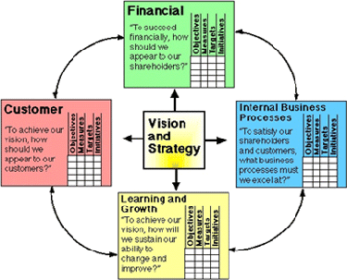

"The four perspectives of the scorecard permit a balance between short-term and long-term objectives, between desired outcomes and the performance drivers of those outcomes, and between hard objective measures and softer, more subjective measures." (Robert S. Kaplan, David P. Norton, "Linking the Balanced Scorecard to Strategy," California Management Review Reprint Series, 1996 by the Regents of the University of California CMR, Vol 39, Number 1, Fall 1996).

Oracle Scorecard and Strategy Management provides four default perspectives that you can use to define strategies that holistically include all relevant perspectives and to define strategy structures that ensure stability and success in all perspectives.

These four default perspectives, which are in support of the Balanced Scorecard methodology devised by Dr. Robert Kaplan and Dr. David Norton, are:

* + Financial —Used to identify financial measures that help to answer this question: "How do we look to our shareholders?"
  + Customer — Used to identify measures that help to answer this question: "How do customers see us?"
  + Internal Process — Used to identify measures that help to answer this question: "At what processes must we excel?"
  + Learning and Growth — Used to identify measures that help to answer this question: "How can we continue to improve and create value?"

You can customize the perspectives provided or create your own to best align objectives, key initiatives, and KPIs with your business competencies.

Kaplan and Norton's four perspectives reflect a specific organizational strategy. These perspectives and strategies would not necessarily be suitable for government, public- sector, or nonprofit organizations; therefore, the objectives and key questions should be amended and supplemented to capture the desired strategies.

Treat the balanced scorecard as a living document. The process of assessing objectives, initiatives, and so on is reiterative. The process should provide not only

What Is the Scorecard Editor?

quantitative, but qualitative insight into the health of your organization and should guide your organization in a timely fashion to achieving your desired results.

See What Is Oracle Scorecard and Strategy Management?

### What Is the Scorecard Editor?

The Scorecard editor lets you create a scorecard of your entire organization or of individual departments.

The Scorecard editor consists of numerous panes and tabs:

* + On the left side of the editor are the panes that you use to create the objects that comprise your scorecard. For example, it includes the Strategy pane, which you use to create, organize, and leverage the objectives that form the strategic structure (also called the strategy tree) of the corporate entity (department, for example) that you want to evaluate.
  + On the right side of the editor is the tab area. When you first create a scorecard, you are presented with the Overview tab. This tab enables you to view summary information for the selected initiative, objective, or KPI.

As you create your scorecard objects, detailed tabs are generated dynamically for each object. For example, when you create an objective, a tab is generated for that objective. You use this tab to define the objective and to view detailed information about the objective, such as which KPIs are to be used to evaluate it and which initiatives drive it.

* + At the top of the editor are toolbar buttons and the point of view area. The point of view area displays the dimensions of the KPIs that are used in the scorecard to measure the progress and performance of initiatives and objectives. You use this area to pin (or set) values for the dimensions. When you pin a dimension, the data in the scorecard is filtered to give you a new point of view (that is, a new view of the data). See About the Point of View Area.

The illustration shows an example of the Scorecard editor for Sample Scorecard-Lite.

What Are Scorecard Objects?

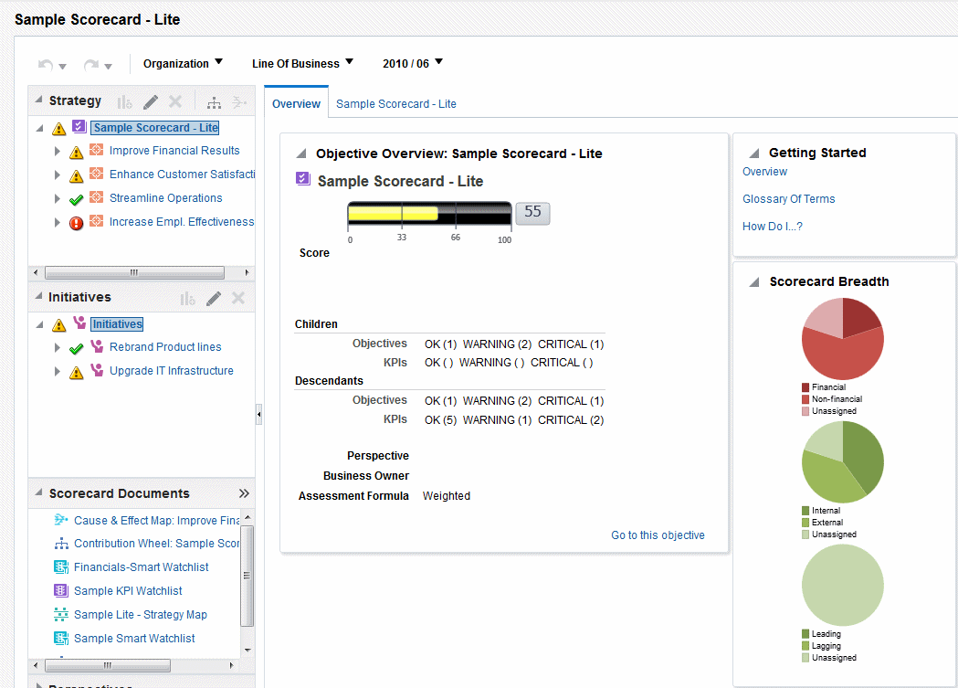

### What Are Scorecard Objects?

Scorecard objects can perform a variety of functions. Scorecard objects are items that you create or arrange to:

* + Represent and evaluate corporate strategy, including:
    - Objectives. See What Are Objectives?
    - Initiatives. See What Are Initiatives?
    - Perspectives. See What Are Perspectives?
    - KPIs. See What Are Key Performance Indicators (KPIs)?
  + Present and analyze corporate strategy, including:
    - Vision statements. See What Are Vision Statements?
    - Mission statements. See What Are Mission Statements?
    - Strategy trees. See What Are Strategy Trees?
    - Strategy maps. See What Are Strategy Maps?
    - Cause & effect maps. See What Are Cause & Effect Maps?
    - Custom views. See What Are Custom Views?
    - KPI watchlists. See What Are KPI Watchlists?

How Do I Create a Scorecard?

* + - Smart watchlists. See What Are Smart Watchlists?
    - Agents. See Create Agents from KPIs

### How Do I Create a Scorecard?

Because Oracle Scorecard and Strategy Management provides you with a wealth of scorecard objects with which to build your scorecard, an overall process flow and description is provided to guide you.

It is recommended that you perform each task within the process flow in order. The illustration shows a graphic representation of the overall process flow to build a scorecard.

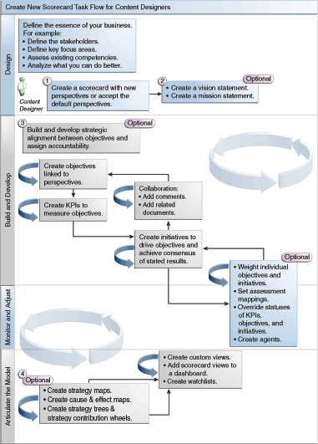

1. Create a new scorecard to contain the scorecard objects that you choose to represent, evaluate, present, and analyze your corporate strategy, such as objectives, initiatives, perspectives, and so on.

When you create a scorecard, you can accept the four default perspectives or you can create your own perspectives. Perspectives represent your key business competencies

Use the Edit and View Modes in the Scorecard Editor

(for example, Research and Development or Financial) that you can use to align initiatives and objectives.

1. Define the vision and mission statements that translate your corporate direction into over-arching strategic themes and thrusts that you later support by creating objectives.
2. Create and arrange the objectives (goals or desired outcomes) for your entire organization, or for a department to develop a strategic alignment or causality between objectives. This includes assigning the KPIs that measure the progress and performance of objectives. The top-level objective (that is, the root objective) in the Strategy pane represents the entity (your entire organization or a department) that you are scorecarding.
3. Create the KPIs that gather core business data (Product Sales, for example) and specify the KPI targets, target ranges, and actions.
4. Create the KPI watchlists that you want to use to monitor KPIs.
5. Create and arrange the initiatives required to meet objectives. You also can assign KPIs to initiatives.
6. Use comments (also known as annotations) to associate explanatory text with the values of KPIs, objectives, or initiatives for a specific set of dimension values.
7. Refine and reiterate objectives and initiatives:
   1. Weight individual objectives and initiatives to specify how they impact the overall performance of the entity that you are scorecarding.
   2. Set assessment mappings.
   3. If appropriate, override the status of KPIs, initiatives, and objectives.
   4. Create agents from KPIs. (Agents enable you to automate your business processes.)
8. Depict relationships between objectives and articulate models by using strategy maps, cause & effect maps, and strategy trees.
9. Create custom views to further refine your strategy to help capture the essence of your business.
10. Create views into a scorecard based on criteria that you specify by creating smart watchlists.
11. Add scorecard views to dashboards.

### Use the Edit and View Modes in the Scorecard Editor

The mode you use in the Scorecard editor depends on what you are trying to accomplish.

The Scorecard editor has two modes:

* + **Edit mode** — Enables you to create or edit mission statements, vision statements, initiatives, perspectives, objectives, KPIs, KPI watchlists, smart watchlists, and views, and create agents from KPIs.

You should not delete scorecard objectives, initiatives, or perspectives outside of Scorecard editor as that may result in scorecard issues.

* + **View mode** — Enables you to navigate and view mission statements, vision statements, initiatives, perspectives, objectives, KPIs, KPI watchlists, and views

Create Scorecards

but not add or modify them. You also can add comments, override statuses, create agents from KPIs, and interact with smart watchlists.

In addition, the information that you can access and the tasks that you can perform in these modes depends on the following:

* + The privileges that are assigned to your account
  + The permissions that are associated with the individual scorecard objects and folders

### Create Scorecards

Scorecards help display data analyses to describe and communicate business strategies.

Creating a scorecard helps your audience understand how performance and goals relate to each other.

1. In the global header, click **New** and then select **Scorecard**.
2. In the New Scorecard dialog, specify a name for the scorecard.
3. (optional) Specify a description of the scorecard.
4. Select the location in which to save the scorecard.
5. Specify whether to use the default Balanced Scorecard perspectives. If you deselect the **Use Default Perspective?** check box, you must create your own custom perspectives with which you will associate initiatives and objectives.
6. Click **OK** to create the new scorecard.

### Open or Edit Scorecards

The procedure to open or edit scorecards is the same. Editing a scorecard ensures the information on it is current.

If you need your administrator to make a change to your metadata (for example, rename a dimension or delete a subject area), remove all references to the object within your KPIs and scorecards prior to contacting your administrator.

See Use the Edit and View Modes in the Scorecard Editor.

1. In the global header, click **Catalog** to display the Catalog page.
2. Navigate to the scorecard that you want to open or edit and click one of the following links:
   * **Open** — The scorecard is displayed in the Scorecard editor in view mode.
   * **Edit** — The scorecard is displayed in the Scorecard editor in edit mode.
3. Make the desired changes.
4. Save the scorecard.

View Overview Information

### View Overview Information

You can view summary information for initiatives, objectives, or KPIs.

The summary information displayed depends on which object you last selected in the Initiatives pane or the Strategy pane. If you last selected:

* + An initiative or objective, then the basic settings for the initiative or objective are displayed (for example, status, business owner, and so on) along with a status summary showing the number of KPIs and initiatives, or KPIs and objectives, that evaluate progress in each performance assessment range.

If there is at least one child or descendant objective, initiative, or KPI for a particular status, the status name is a hyperlink that displays the Scorecard editor: Breakdown tab, showing the child or descendant objectives, initiatives, and KPIs.

* + A KPI, then the basic settings for the KPI are displayed (for example, status, business owner, and so on) as well as performance data and a performance graph.

1. Open or edit the scorecard.

The Overview tab of the Scorecard editor is displayed. The illustration shows an example of the Overview tab for an objective.

About the Point of View Area

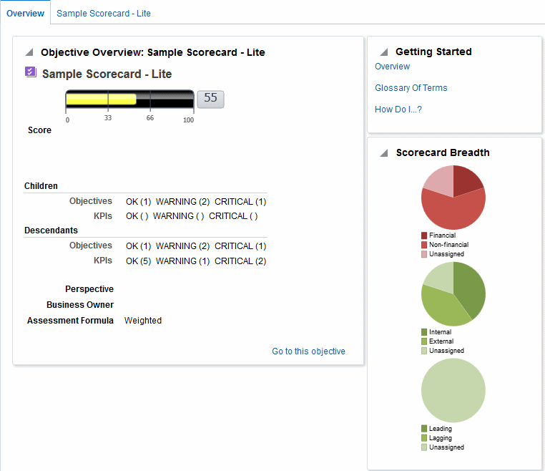

The Overview tab shows summary information for the root objective, which represents the entity that you are scorecarding, that is, the entire organization or a department.

1. To show summary information for:
   * A KPI, in the Initiatives pane or in the Strategy pane, click the KPI.
   * An initiative, in the Initiatives pane, click the initiative.
   * An objective, in the Strategy pane, click the objective.

### About the Point of View Area

The point of view area of the Scorecard editor displays controls for the dimensions of KPIs that are used in the scorecard to measure the progress and performance of initiatives and objectives.

See What Are Dimensions and Pinned Dimension Values?

About the Point of View Area

Controls are displayed for each KPI dimension that is referenced in a scorecard with the exception of those that you explicitly prevent from being displayed. If the same dimension is referenced in more than one KPI, then a control can be shared by the KPIs. See Set Up the Point of View Controls.

The figure here shows a point of view area that displays the Region Hierarchy, Customer Segments, Offices Hierarchy, Products Hierarchy, and 2010/Q3 dimensions.



Each control includes a label and a down-arrow button that displays a list of the dimension values from which you can select, and a **Search** link (see Search Members dialog for additional information). The label is either the database name for the dimension (by default), a user-friendly label (if specified for the control), or one or more values (if the dimension is pinned to a specific value or multiple values).

You use this area to temporarily pin or set values for the dimensions. When you pin a dimension, the data in the scorecard is filtered to give you a new point of view (that is, a new view of the data). This enables you to focus on specific data of interest to you, such as the area of business for which you are responsible.

The point of view area settings are temporary and are not persisted when the scorecard is saved. To persist pinnings, you can use the:

* + Dimension Settings tab of the Settings dialog to affect all KPI usages within a scorecard.
  + **Dimensionality** area in the Analytics pane of the KPI Details tab of the Scorecard editor to pin the values for a particular KPI usage.
  + Add KPI dialog (also displayed as the Edit Watchlist Entry dialog) in the KPI Watchlist editor to pin values for individual KPIs.
  + Dimension Pinnings dialog to pin values in a view that has been added to a dashboard.
  + Dimensionality page of the KPI editor (also displayed as the KPI tab of the Scorecard editor) to pin values in a KPIs definition. This approach is less flexible than when you let a KPI's definition be reusable in different contexts and pin only within views that reference the KPI.

The Scorecard editor also contains the **Back** and **Forward** buttons that enable you to move forward or backward through your point of view history to select a previous point of view or the point of view with which you started.

To temporarily pin a dimension:

1. Click the down-arrow button to the right of the dimension.
2. To:
   * Select a specific single value, click the value.
   * Select multiples values, click the **Search** link to display the Search Members dialog, make your selections, and then click the **OK** button. You can also select multiple values by pressing and holding the Ctrl key, and then clicking the desired values.

Set Up the Point of View Controls

* + If the value is a hierarchical column, click the sideways triangle button to expand the levels. Press and hold the Ctrl key, and then click the desired values.

1. Click the down-arrow or outside the dialog box to close it. The data is filtered and a new point of view is displayed.

### Set Up the Point of View Controls

You use the Dimension Settings tab of the Settings dialog to set up the controls for dimensions in the point of view area of a scorecard.

Specifically, you can specify:

* + One or more default values for the dimension.
  + Whether a control for the dimension is to be displayed in the point of view area
  + The label to be displayed in the point of view area for the dimension.
  + See About the Point of View Area.

1. Edit the scorecard for which you want to set up the point of view controls. See Open or Edit Scorecards.
2. Click the **Scorecard Settings** button in the Scorecard editor.
3. On the Assessment Mappings tab of the Settings dialog, click the **Dimension Settings**

tab.

1. Set up the controls for each dimension as desired. To set up the control for a dimension:
   1. Select the dimension and then click the **Edit Row** button.
   2. In the Edit Dimension Settings dialog, specify the settings that you want and click

**OK**.

1. Click **OK**.

### What Are Vision Statements?

A vision statement is a short statement that describes what your organization wants to become sometime in the future.

For example, a vision statement might be to become the most successful business in the South America Polypropylene Market. (A vision statement is optional.)

Often, from this statement, you define the key goals and priorities that form your mission statement. See What Are Mission Statements? and Define Vision Statements.

Creating vision and mission statements requires a very specific set of privileges. If the vision or mission statement toolbar button is disabled, contact your administrator.

### Define Vision Statements

A vision statement is a short statement that describes what your organization wants to become sometime in the future.

Defining a vision statement helps align data results with the goals of the organization.

What Are Mission Statements?

1. Edit the scorecard for which you want to define a vision statement. See Open or Edit Scorecards.
2. In the Scorecard Documents pane, click the **Create Object** button and then select

Create Vision.

The Document tab of the Vision tab is displayed. The illustration shows the New Vision tab.

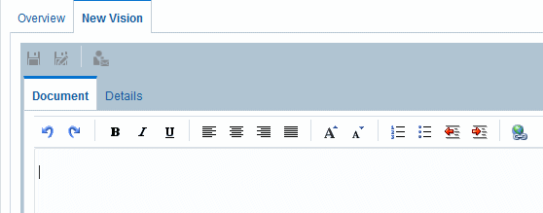

1. Enter and format the vision statement. You can apply such formatting options as bold, italic, underlining, indents, justification, and font size changes.
2. Click the **Details** tab.
3. Assign the business owner and specify related documents, as appropriate.
4. Click **Save** to display the Save As dialog. In the Save As dialog, you can rename the vision statement rather than use the default name.

### What Are Mission Statements?

A mission statement specifies the key business goals and priorities that are required to achieve your vision.

A mission statement is optional. See Define Mission Statements.

You define your vision in a vision statement. See What Are Vision Statements?

### Define Mission Statements

Defining a mission statement provides an overall goal with which to compare data analyses.

You can create a mission statement to align users with the overall goals of the organization.

1. Edit the scorecard for which you want to define a mission statement.
2. In the Scorecard Documents pane, click the **Create Object** toolbar button and then select **Create Mission**.

The example illustration shows an example of a mission statement.

What Are Perspectives?

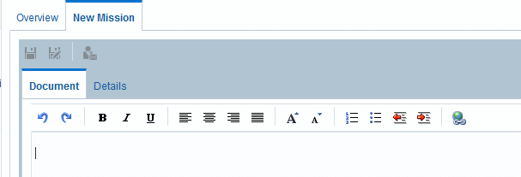

1. Enter and format the mission statement. You can apply formatting options such as bold, italic, underlining, indents, justification, and font size changes.
2. Click the **Details** tab.
3. Assign the business owner and specify related documents, as appropriate.
4. Click **Save** to display the Save As dialog. In the Save As dialog, you can rename the mission statement rather than use the default name.

### What Are Perspectives?

Perspectives are categories in your organization with which to associate initiatives, objectives, and KPIs.

A perspective can represent a key stakeholder (such as a customer, employee, or shareholder/financial) or a key competency area (such as time, cost, or quality).

You associate an initiative and objective with a perspective when you create or edit it. See Create Initiatives and Create Objectives. You associated a KPI with a perspective when you edit the details of the KPI. See Work with KPI Details.

For example, when you create an objective called Improved Client Response Time, you might associate it with the Customer perspective as the objective sustains and supports customer- related operations.

There are four standard perspectives that are defined by the Balanced Scorecard Methodology:

* + **Financial** — Groups objectives, initiatives, and KPIs that relate to or support the monetary or economic health and development of your organization.
  + **Customer** — Groups objectives, initiatives, and KPIs that pertain to or support your client base.
  + **Internal Process** — Groups objectives, initiatives, and KPIs that categorize and support your corporate internal policies and procedures.
  + **Learning and Growth** — Groups objectives, initiatives, and KPIs that relate to or support employee training and advancement.

In addition, you can create custom perspectives for your scorecard. See Create Custom Perspectives.

Create Custom Perspectives

### Create Custom Perspectives

When you create a scorecard, you specify whether you want to use the default perspectives that are defined by the Balanced Scorecard Methodology using the **Use Default Perspectives?** check box.

If you:

* + Do not use the default perspectives, then you must create your own custom perspectives.
  + Do use the default perspectives, then you can create one or more custom perspectives to use along with the default perspectives.

1. Edit the scorecard for which you want to create a custom perspective.
2. In the Perspectives pane, click the **New Perspective** button.

The Perspective tab of the Scorecard editor is displayed. The illustration shows an example of a financial perspective displayed on the Perspective tab.

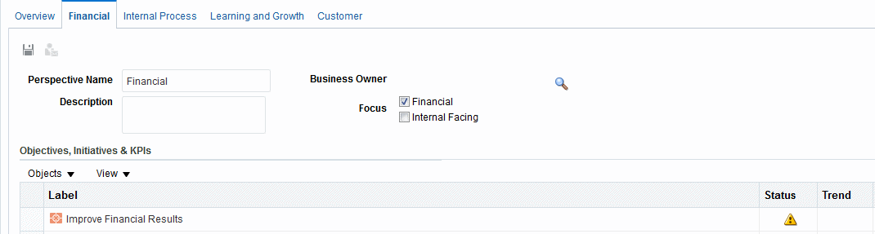

1. In the **Perspective Name** field, enter the name of the perspective.
2. (optional) In the **Description** field, enter a description of the perspective.
3. Click the **Set User** button to display the Select Business Owner dialog, where you select the business owner. (By default, the business owner is the creator of the scorecard.)
4. In the **Focus** area, specify whether the focus of the perspective is financial or internal facing. See the Perspective tab of the Scorecard editor for additional information.
5. Add related documents, as appropriate. See the Related Documents area for additional information.
6. Click **Save**.

The perspective displays in the Perspectives pane.

You can now associate initiatives, objectives, and KPIs with this custom perspective. You associate an initiative and objective with a perspective when you create or edit the initiative or objective. You associated a KPI with a perspective when you edit the details of the KPI.

What Are Key Performance Indicators (KPIs)?

### What Are Key Performance Indicators (KPIs)?

A KPI represents the result of a business measure (for example, Product Sales or Operational Costs) evaluated against a target for that measure.

You can use KPIs to assess the progress of the objectives and initiatives that form levels of organizational strategy.

You can create KPIs that you need:

* + Within a scorecard. This enables you to create the KPIs as you are creating or editing the scorecard.
  + Outside a scorecard. This enables you to create the KPIs in advance of creating or editing a scorecard.

See Using KPIs and KPI Watchlists.

### What Are Objectives?

Objectives are the required or desired outcomes that form your corporate strategy. You can create an objective for:

* + An entire organization, for example, Oracle Corporation
  + A department, for example, Sales department

When you create an objective, you assign it one or more KPIs that are to be used to measure its progress and performance. For example, you can measure the progress and performance of an objective named Improved Customer Satisfaction by assigning it the following KPIs:

* + Average Customer Survey Satisfaction Score
  + Number of Customer Complaints KPIs See Using KPIs and KPI Watchlists.

Within a scorecard, you also create the initiatives that are required to meet the objectives. See What Are Initiatives?

Objectives that you create are displayed hierarchically in the Strategy pane. The root objective represents the entity that you are scorecarding, that is the entire organization or a department. The KPIs that are assigned to assess the performance of objectives are displayed below the objectives in the Strategy pane.

The Strategy pane also shows the statuses of objectives and KPIs using the appropriate colors and icons that you specified for assessment mappings. See Define Assessment Mappings for Scorecards.

When creating objectives, if possible, use subobjectives measured by KPIs to monitor results. Corrective action becomes incremental, reiterative, and more achievable. For example: the objective, Improve Financial Results, might include Increase Sales, Reduce Costs, Increase Employee Effectiveness, and Streamline Operations as subobjectives. Use related documents to provide supporting information for the objective, initiative, and so on.

See Create Objectives.

Create Objectives

### Create Objectives

You can create one or more objectives.

Objectives that you create should be strategically relevant and measurable using KPIs. See What Are Objectives?

1. Edit the scorecard for which you want to create an objective.
2. In the Strategy pane:
   * If the objective that you want to create can be independently achieved, then select the root objective.
   * If the objective that you want to create is required to meet a higher-level objective, then select the higher-level objective.
3. Click the **Create Objective** button or right-click and select **Create Objective**.

The illustration shows an example of an objective displayed on the Objective Details tab.

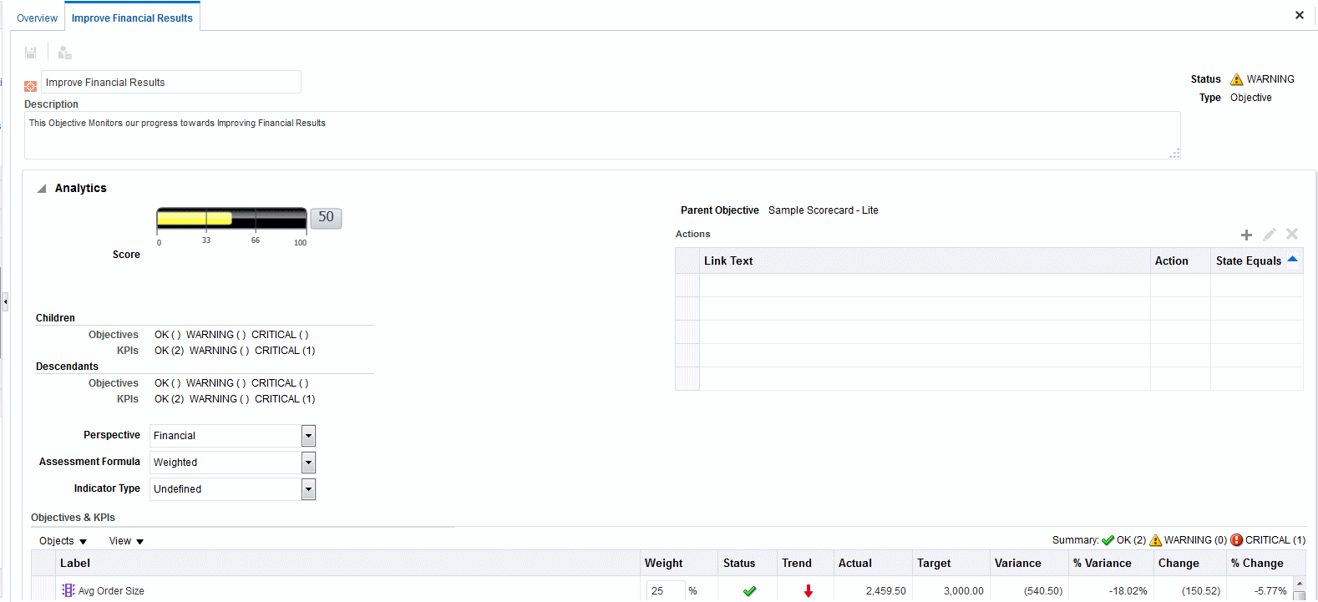

1. Highlight the default objective name in the top left corner and enter a new name for the objective.
2. In the **Description** field, enter a description of the objective.
3. Specify the analytic information (including the KPIs to be used to measure the progress and performance of the objective) by completing the Analytics pane.
4. Complete the Collaboration pane as follows:
5. (optional) Add comments by clicking the **Add Comment** button to display the Add Comment dialog.
6. Specify the business owner that users can contact by clicking the **Set User** button to display the Select Business Owner dialog. (By default, the business owner is the creator of the scorecard.)
7. (optional) Add related documents by clicking the **New Row** button to display the New Related Document dialog. See the Related Documents area for additional information.

Create Objectives

1. Complete the Related Items pane as follows:
2. Add one or more objectives that impact or support (that is, help achieve or hinder progress on) this objective. To do so, drag the objective from the Strategy pane and drop it in the **Causes** table.

In the Causal Linkage dialog, specify how closely the objectives are related and whether changes to the values in this causal objective have a direct or inverse impact on this objective. For example, for an Increased Client References objective, you might drag and drop the following objectives that could cause (or help or hinder) it: Decreased Client Response Time and Increase Customer Issue Resolutions.

1. Add one or more initiatives (that is, the tasks that are required to meet the objective). To add an initiative, drag it from the Initiatives pane and drop it in the **Initiatives Driving This Objective** table.

In the Initiative Linkage dialog, specify how closely the initiative and the objective are related and whether changes to the values in this initiative have a direct or inverse impact on this objective.

1. Add one or more objectives that this objective impacts or supports. To do so, drag the objective from the Strategy pane and drop it in the **Effects** table.

In the Causal Linkage dialog, specify how closely the objectives are related and whether changes to the values in this causal objective have a direct or inverse impact on this objective.

1. Click **Save**.

#### Complete the Analytics Pane for Objectives or Initiatives

When you create an objective or initiative, you must specify the analytics for the objective or initiative by completing the Analytics pane.

Use the Analytics Pane to specify the various parameters for an objective or initiative.

1. In the **Perspective** box, select the perspective with which the objective or initiative is to be aligned.

Assign a perspective to each objective or initiative. This facilitates in the definition of causal linkages when building strategy maps.

1. In the **Assessment Formula** box, select the rule to be used to assess the overall performance of the initiative or objective. For example, select **Worst case** to specify that the status of the worst performing child KPI or objective is to be used.
2. (for an objective only) In the **Indicator Type** box, indicate whether the performance of the objective drives other objectives, or is affected by the performance of other objectives or other data or processes (for example, leading or lagging).
3. (for an initiative only) In the **Priority** box, select the priority that indicates the importance and urgency of an initiative.
4. (for an initiative only) Specify the start date, due date, and completion date.
5. In the **Actions** area, add any action links that you want to provide to users to let them take actions that are relevant for the status of the objective or initiative.
6. In the **Objectives & KPIs** or **Initiatives & KPIs** watchlist, add the KPIs to be used to measure the progress and performance of the objective or initiative.

If no KPIs have been defined, or if you want to define another KPI to meet your needs, then you can create the KPI from within the Scorecard editor.

What Are Initiatives?



**Tip:**

You can modify the columns that are displayed in the **Objectives & KPIs** or **Initiatives & KPIs** watchlist. Select **View**, then **Show More Columns** to display the Show More Columns dialog, where you can add or remove columns.

1. To add a KPI:
   1. Click **Save**. You must save the new objective or initiative before you can add a KPI.
   2. Click **Objects** in the **Objectives & KPIs** or **Initiatives & KPIs** watchlist and then select **Add KPI**. The Select a KPI dialog is displayed.

You can drag the KPI from the Catalog pane for Scorecard or from the Scorecard Documents pane (if the KPI has been saved to the current scorecard folder) and drop it in the watchlist. If you choose this method, the Add KPI dialog is displayed.

* 1. Choose a KPI and click **OK**. The Add KPI dialog is displayed.
  2. If the KPI is dimensioned, then for each dimension, specify one or more values, select **Use Variable** and specify the variable, or select **Use Point-of- View** to use the value or values selected in the point of view area.
  3. In the **Label** field, enter the name to be displayed for the KPI in the Strategy pane.
  4. Click **OK**.

A KPI that you have added to the Strategy pane or Initiatives pane obtains many of its properties from the base KPI as it was originally defined in the KPI editor. You can override some of the base KPI's properties to customize them for use within scorecard. The KPI properties that you can override are the label, description, and business owner. You can assign a perspective and an indicator type. You can also set dimension pinnings for dimensions that are left unpinned in the KPI definition.

### What Are Initiatives?

Initiatives are time-specific tasks that are necessary to achieve objectives.

You can use initiatives that support objectives as milestones as they reflect progress toward strategy targets. For example to implement an objective called Improve Customer Satisfaction, you might create these initiatives:

* + Create online feedback forum
  + Form response team

Generally, an initiative supports multiple objectives.

When you create an initiative, you assign it KPIs that are to be used to measure its progress. See Using KPIs and KPI Watchlists.

Initiatives that you create are displayed hierarchically in the Initiatives pane. The root initiative represents all the initiatives that you implement to achieve objectives and goals. The KPIs that are assigned to an initiative are displayed below the initiative in the Initiatives pane.

Create Initiatives

The Initiatives pane also shows the statuses of initiatives and KPIs using the appropriate colors and icons that you specified for assessment mappings. See Define Assessment Mappings for Scorecards and Create Initiatives.

### Create Initiatives

You can create one or more initiatives.

Use initiatives to track major milestones as a closed loop by assigning strategic objectives, taking remedial action by monitoring KPI targets and metric results, and using annotations and related documents for collaboration.

Initiatives that you create should be measurable using KPIs and strategically relevant. See What Are Initiatives?

1. Edit the scorecard for which you want to create an initiative.
2. In the Initiatives pane:
   * If the initiative that you want to create can be independently implemented, then select the root initiative.
   * If the initiative that you want to create is required to meet a higher-level initiative, then select the higher-level initiative.
3. Click the **Create Initiative** button or right-click and select **Create Initiative**.

The Initiative Details tab is displayed. The illustration shows an example of an initiative displayed on the Initiative Details tab.

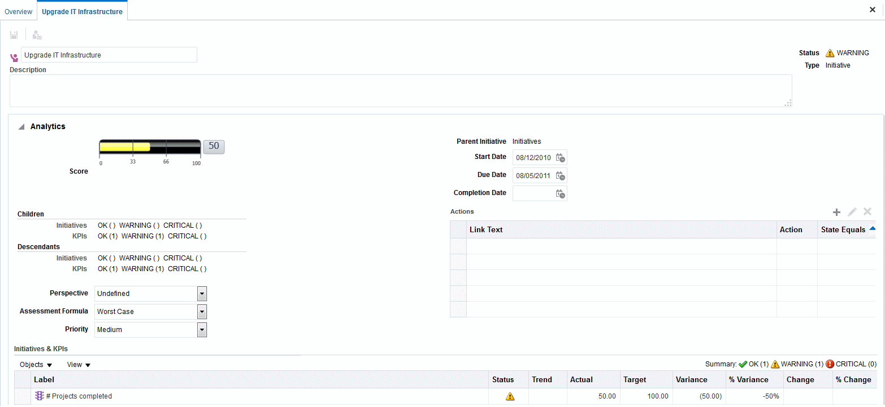

1. Highlight the default initiative name in the top left corner of the tab and enter a new name for the initiative.
2. In the **Description** field, enter a description of the initiative.
3. Specify the analytic information (including the KPIs to be used to measure the progress of the initiative) by completing the Analytics pane.

Contact Business Owners

1. Specify the collaboration information by completing the Collaboration pane as follows:
2. (optional) Add comments by clicking the **Add Comment** button to display the Add Comment dialog.
3. Specify the business owner that users can contact by clicking the **Set User** button to display the dialog. (By default, the business owner is the creator of the scorecard.)
4. (optional) Add related documents by clicking the **New Row** button in the Related Documents toolbar to display the New Related Document dialog. Also see the Related Documents area for additional information.
5. (optional) Add the key resources by clicking the **New Row** button in the Key Resources toolbar to display the Key Resource dialog.
6. In the **Related Items pane**, add one or more objectives that require this initiative in order to succeed.

To add an objective, drag the objective from the Strategy pane and drop it in the **Objectives** table. The Objective Linkage dialog is displayed, where you specify how closely the initiative and the objective are related and whether changes to the values in this initiative have a direct or inverse impact on this objective.

1. Click **Save**.

### Contact Business Owners

You can send a message to the business owner of a scorecard object.

The business owner is the person who is responsible for managing and improving the business value and performance of a scorecard object. (The business owner might or might not be the same as the person who creates the scorecard or creates the KPI.) You specify the business owner of an object when you create it.

You use the **Contact Owner** button or menu option to contact the business owner. This button is available in many places in a scorecard, for example, on the toolbar of most tabs, such as the Objective Details tab of the Scorecard editor.

Oracle BI EE uses an agent and the delivery devices and profiles that the business owner specified in the Delivery Options tab of the My Account dialog to determine where to deliver the message (for example, email, phone, or pager).

1. Click the **Contact Owner** button or menu option.
2. In the Contact Owner dialog **Subject** field, enter a the subject of the message.
3. In the **Priority** field, select the priority of the message.
4. In the **Message** field, enter the message that you want to send to the business owner.
5. Click **Send**.

### About Comments

Comments provide a way for users to discuss initiatives, objectives, or KPIs.

Collaboration between users is essential to gain a consensus in order achieve the stated and desired results. Comments (also known as annotations) enable you to

Work with Comments

discuss changes in performance and progress for an initiative, objective, or KPI for a specific set of dimension values (that is, for a specific point of view). Use annotations and overrides to increase employee collaboration, participation, and accountability, and to prevent future occurrences of identified deficiencies.

You can add, view, and reply to comments in many places in a scorecard. For example, you can add a comment directly to an objective in the Scorecard editor: Objective Details tab. You can also add a comment to an objective in the Diagram tab of a view, a smart watchlist, and a perspective in which its referenced. You cannot delete KPI annotations.

A comment is associated with:

* + An initiative, objective, or KPI that measures the progress of an initiative and objective.

When an initiative, objective, or KPI that has a comment associated with it is referenced elsewhere in a scorecard and the point of view being displayed matches that of the comment, a comment indicator is displayed as follows:

* + - In a watchlist, a blue triangle is displayed in the row containing the initiative, objective, or KPI.
    - In a node in the Diagram tab of a view, the **Comment** button is displayed in the upper-right corner of the node.
  + A certain column.

A comment is normally associated with the Status column of an objective, initiative, or KPI, unless (for KPIs only) the comment is added to another column such as Trend or Variance.

* + A specific point of view.

Comments are filtered by the values in the point of view area in the Scorecard editor that are currently in effect for the object being viewed. As a result, the comment for Eastern Region Sales can be different than the comment for Western Region Sales. See About the Point of View Area.

* + Any dimension pinnings on the KPI.

Comments are filtered by any other dimension pinnings that are in effect (on a KPI, scorecard, scorecard diagram, dashboard prompt, or KPI watchlist).

Before you can work with comments, your administrator must enable this feature. See Work with Comments.

### Work with Comments

Comments permit additional commentary about items in a scorecard. You can work with comments in many places in a scorecard, including in:

* + The Collaboration pane of the Initiative Details tab, Objective Details tab, and the KPI Details tab of the Scorecard editor. See Work with Comments in the Collaboration pane.
  + Watchlists. See Work with Comments in Watchlists
  + The Diagram tab of a view. See Work with Comments in the Diagram Tab of a View.

Work with Comments



**Note:**

Before you can add comments to an initiative or objective, the initiative or objective must have at least one KPI assigned to it.

As you work with comments, remember that a comment is associated with a specific point of view. See About the Point of View Area and About Comments.

#### Work with Comments in the Collaboration pane

Comments can be added to and edited in the Collaboration pane.

In the Collaboration pane of the Initiative Details tab, Objective Details tab, and KPI Details tab of the Scorecard editor, you can view, add, or reply to comments for that particular initiative, objective, or KPI.

1. Open or edit the scorecard.
2. Open the initiative, objective, or KPI and navigate to the Collaboration pane.
3. Ensure that the values that are displayed in the point of view area reflect the desired context for the comment. (For example, you might want to comment on a KPI status for the Eastern region.)
4. Do one of the following:
   * To add a new comment, click the **New Comment** button. The New Comment dialog is displayed. Comments added by clicking the **New Comment** button are associated with the status (that is, the Status column) of the objective, initiative, or KPI.
   * For KPIs only, you can also associate a comment with other columns such as Trend, Target, or Variance. To do so, edit the parent object, right-click on the relevant cell in the Watchlists and select **Add Comment**.
   * To reply to a comment, locate the comment to which you want to reply and click the **Reply** link. The Reply dialog is displayed.
5. Enter the subject of your comment (for a new comment only) and the text of your comment.
6. Click **OK**.

#### Work with Comments in Watchlists

In a watchlist, you can view, add, and reply to comments for initiatives, objectives, and KPIs that are displayed in the watchlist.

You can add comments for certain areas of the watchlist, such as the Western region KPI status.

1. Open or edit the scorecard.
2. Open the object in which you want to work with comments and navigate to the appropriate pane or tab.
3. Ensure that the values that are displayed in the point of view area reflect the desired context for the comment. (For example, you might want to comment on a KPI status for the Eastern region.)
4. To add a new comment:
   1. In the watchlist, right-click the **Status** cell to which you want to add the comment and select **Add Comment**.
   2. Complete the Add Comment dialog and click **OK**.
5. To work with the comments that were previously added to an object, hover the mouse pointer over the **Blue triangle** in the upper-right corner of the cell in the Status column or, for a KPI, one of its columns. In the Status window:

* Read the comments that were previously added.
* Display the New Comment dialog to add a new comment by clicking **New Comment**.
* Display the Reply dialog to reply to a comment by clicking the **Reply** link.
* Pin the window so that it stays open by clicking the **Pin** button.

#### Work with Comments in the Diagram Tab of a View

In the Diagram tab of a view, you can view, add, and reply to comments for objectives and KPIs that are displayed in the view.

For example, you can work with comments in the Diagram tab of the Strategy Tree tab.

You can also work with comments in this same way when a view is rendered as a diagram in a dashboard.

1. Open or edit the scorecard.
2. Open the view in which you want to work with comments and navigate to the Diagram tab.
3. Ensure that the values that are displayed in the point of view area reflect the desired context for the comment. (For example, you might want to comment on a KPI status for the Eastern region.)
4. To add a new comment:
   1. Click the **Options** button on the right side of the node to which you want to add the comment and select **Add Comment** from the Node Options Menu.
   2. Complete the Add Comment dialog and click **OK**.
5. To work with the comments that were previously added to an object, hover the mouse pointer over the **Comment** button in the upper-right corner of the node. The Status window is displayed with all the comments that are attached to the initiative, objective, or KPI. From this window, you can:

* Read the comments that were previously added.
* Display the New Comment dialog to add a new comment by clicking **New Comment**.
* Display the Reply dialog to reply to a comment by clicking the **Reply** link.
* Pin the window so that it stays open by clicking the **Pin** button.

### Understand Initiative or Objective Performance Assessment

You can view initiative or objective performance assessments to get an overall view of a family of initiatives or objectives.

Oracle Business Intelligence assesses the performance of an initiative or objective by aggregating the assessments of its children. In the process, it uses:

* + Scorecard assessment mappings that you define. See About Assessment Mappings.
  + Assessment formulas (such as **Weighted** or **Best Case**) assigned to all objectives and initiatives. The assessment formulas include:
    - **Worst case** — Specifies that the status of the worst performing child KPI or objective is to be used.
    - **Best case** — Specifies that the status of the best performing child KPI or objective is to be used.
    - **Most Frequent (Worst Case)** — Specifies that, if half the child KPIs and objectives have high performance and half have low performance, then use the status of the worst performing child KPI or objective.
    - **Most Frequent (Best Case)** — Specifies that, if half the child KPIs and objectives have high performance and half have low performance, then use the status of the best performing child KPI or objective.
    - **Weighted** — Specifies to use a weighted average based on the weights you have assigned to the child KPIs and objectives. See Assign Weights to Child Objectives, Initiatives and KPIs.

If a child KPI has no data, it will not be included in the aggregation. Instead, its weight will be distributed among the other child KPIs and objectives.

You assign assessment formulas when you create an objective or initiative. See Create Objectives or Create Initiatives.

* + Weights that you assign to child initiatives, objectives, and KPIs (but only if the parent's assessment rule is set to **Weighted**) to identify the extent to which each child contributes to the overall performance of the parent. See Assign Weights to Child Objectives, Initiatives and KPIs.

See Example of Determining the Performance Assessment for an Objective Based on Child Objectives and Example of Determining the Performance Assessment for an Objective Based on a Child KPI.

#### About Assessment Mappings

Assessment mappings are the score thresholds and assessment ranges that Oracle Business Intelligence uses to assess the performance of objectives and initiatives.

Oracle Business Intelligence uses these score thresholds and assessment ranges to:

* + Determine the status and score of an objective or initiative based on the aggregation of the assessments of its children.

If the assessment formula of an objective or initiative is Best Case, Worst Case, Most Frequent (Worst Case), or Most Frequent (Best Case), the score will be one of the defined score thresholds, for example, 0, 33, or 66. If the assessment formula is Weighted, the score is computed based on the weights assigned to the children.

* + Map the KPI scores of KPIs that are used to measure the progress of initiatives and objectives to scorecard scores so that they can be used to measure the performance of the objectives or initiatives.

The illustration shows an example of score thresholds falling in specific assessment ranges. The assessment ranges are defined as follows:

* + 67 to 100 falls in the **OK** assessment range
  + 34 to 66 falls in the **Warning** assessment range
  + 0 to 33 falls in the **Critical** assessment range

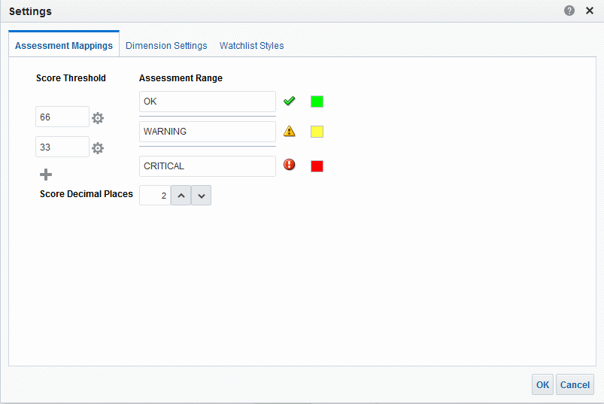

See Understand Initiative or Objective Performance Assessment for additional information on initiative and objective performance assessment.

See Define Assessment Mappings for Scorecards for how to define assessment mappings.

#### Example of Determining the Performance Assessment for an Objective Based on Child Objectives

Child objectives can help calculate a performance assessment.

Suppose the following about an objective named Improve Financial Results:

* + It has an assessment rule of Worst Case.
  + The assessment mappings defined for the scorecard that contains the objective are the same as those in About Assessment Mappings.
  + It has the following two child objectives:
    - Increase Sales, whose status is Critical and score is 0.
    - Reduce Cost, whose status is Warning and score is 50.

In this case, the performance assessment of the Improve Financial Results objective would be the status and score of the child with the worst status and score, that is, Increase Sales, which has a scorecard status of Critical and a score of 0.

#### Example of Determining the Performance Assessment for an Objective Based on a Child KPI

You can use child KPIs to assess performance.

Suppose the following about an objective named Enhance Stockholder Satisfaction:

* + It has an assessment formula of Best Case.
  + The assessment mappings defined for the scorecard that contains the objective are the same as those in the illustration.
  + It has a child KPI named Revenue KPI, whose scorecard status is OK and score is 66.

Revenue KPI has a KPI status of 4 Stars and score of 80 based on the following KPI thresholds and scores displayed in the illustration:

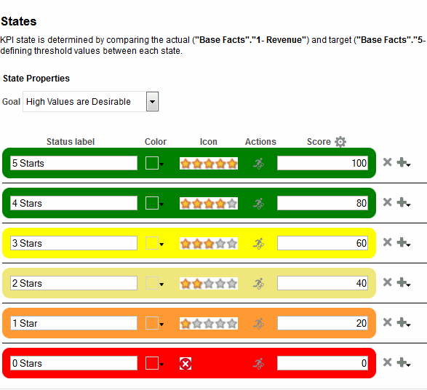

Define Assessment Mappings for Scorecards

When Revenue KPI was added to the Enhance Stockholder Satisfaction objective, Oracle Business Intelligence mapped the KPI score to a scorecard score so that it could be used to measure the performance of the objective. Since the KPI score of 80 fell in the scorecard assessment range of 66 to 100, it mapped to a scorecard score of 66 and status of OK.

In this case, the performance assessment of the Enhanced Stockholder Satisfaction objective would be the status and score of the child with the best status and score, that is, Revenue KPI (in this case the only child), which has a scorecard status of OK and a score of 66.

### Define Assessment Mappings for Scorecards

Use the Assessment Mappings tab of the Settings dialog to define the assessment mappings for a scorecard.

See Understand Initiative or Objective Performance Assessment.

1. Edit the scorecard for which you want to define assessment mappings.
2. Click the **Scorecard Settings** button in the Scorecard editor.

The Assessment Mappings tab of the Settings dialog is displayed.

1. In the **Score Threshold** fields, enter the numeric values that set the boundaries for the assessment ranges.

Accept scores automatically assigned by the KPI editor, which are based on the number of thresholds.

For example, you might enter 33 and 66 to set the boundaries for three assessment ranges — Critical, Warning, and OK. Any KPI score from 0 to 33 would fall in the Critical assessment range, any KPI score from 34 to 66 would fall in the Warning assessment range, and any KPI score from 66 to 100 would fall in the OK assessment range.

1. In the **Assessment Range** boxes, specify the name of each assessment range (for example, Critical) and, for each range, specify the icon and the color to be used to represent the range.
2. Click **OK**.

### Assign Weights to Child Objectives, Initiatives and KPIs

You assign weights to the child objectives, initiatives, and KPIs of an objective or initiative to indicate how much it affects the performance of its parent objective.

To assign weights to child objectives, initiatives, and KPIs, the Assessment Rule for the parent objective or initiative must be set to **Weighted**.

See Understand Initiative or Objective Performance Assessment.

1. Edit the scorecard that contains the parent objective or initiative of the objectives, initiatives, and KPIs to which you want to assign weights.
2. Double-click the objective in the in the Strategy pane or the initiative in the Initiatives pane.
3. In the **Objectives & KPIs** or **Initiatives and KPIs** watchlist of the Analytics pane, enter a weight for each child objective, initiative, or KPI.

For example, assign the following objectives to the four child objectives of the root objective of the scorecard:

About Status Overrides

* + Improve Financial Results: 50%
  + Enhance Customer Satisfaction: 25%
  + Streamline Operations: 15%
  + Increase Empl Effectiveness: 10%

1. Click **Save**.

### About Status Overrides

You can override the statuses of initiatives, objectives, or KPIs that measure the performance of initiatives and objectives.

To override a status, you must be the business owner of the initiative, objective, or KPI. You can also cancel an override.

Before you can work with status overrides, your administrator must enable this feature.

You can work with status overrides in many places in a scorecard. For example, you can apply a status override to an objective in the Objective Details tab of the Scorecard editor. You can also apply a status override to an objective in the Diagram tab of a view, a smart watchlist, and a perspective in which its referenced.

A status override is associated with:

* + An initiative, objective, or KPI that measures the progress of an initiative and objective.

When an initiative, objective, or KPI that has a status override associated with it is referenced elsewhere in a scorecard, and the point of view being displayed matches that of the status override, a status override indicator — a red asterisk (*)

— is displayed as follows:

* + - In a watchlist, it is displayed to the right of the status symbol in the row containing the initiative, objective, or KPI.
    - In a node in the Diagram tab of a view, it is displayed to the right of the status symbol in the lower-left corner of the node.
  + The status column of an objective, initiative, or KPI.
  + A specific point of view.

Status overrides are filtered by the values in the point of view area in the Scorecard editor that are currently in effect for the object being viewed. As a result, the status override for Eastern Region Sales can be different than the status override for Western Region Sales. See About the Point of View Area.

* + Any dimension pinnings on the KPI.

Status overrides are filtered by any other dimension pinnings which are in effect (on a KPI, scorecard, scorecard diagram, dashboard prompt, or KPI watchlist).

See Work with Status Overrides.

### Work with Status Overrides

You can override a status in specific areas.

You can work with status overrides in many places in a scorecard, including in:

Work with Status Overrides

* + Watchlists. See Work with Comments in Watchlists.
  + The Diagram tab of a view. SeeWork with Status Overrides in the Diagram Tab of a View.

As you work with status overrides, remember that a status override is associated with a specific point of view. See About the Point of View Area.



**Tip:**

Prior to overriding a status, ensure that the business owner has been set for the KPI, initiative, or objective. See Create KPIs.

See About Status Overrides.

#### Work with Status Overrides in Watchlists

You can maintain status overrides to ensure they are applied properly.

In a watchlist, you can view status overrides and override cancellations that were previously applied, and apply new overrides and override cancellations to the initiatives or objectives, and KPIs in the watchlist.

1. Open or edit the scorecard.
2. Open the object in which you want to work with status overrides and navigate to the appropriate pane or tab.
3. Ensure that the values that are displayed in the point of view area reflect the desired context for the status override. (For example, you might want to override the status of a KPI for the Eastern region.)
4. To override a status or to cancel an override:
   1. In the watchlist, right-click the **Status** cell in which you want to override the status or cancel an override and select **Override Status**.
   2. Complete the Status Override dialog and click **OK**.
5. To view status overrides or override cancellations that were previously applied to an object, hover the mouse pointer over the red asterisk to the right of the status symbol. In the Status window, you can:

* View status overrides or override cancellations that were previously applied.
* Display the Status Override dialog to apply a new override or to cancel an override by clicking **New Override**.
* Pin the window so that it stays open by clicking the **Pin** button.

#### Work with Status Overrides in the Diagram Tab of a View

Status overrides can be layered to ensure a status is displayed regardless of the original status.

In the Diagram tab of a view, you can view status overrides and override cancellations that were previously applied, and apply new overrides and override cancellations to objectives and KPIs that are displayed in the view. For example, you can work with status overrides in the Diagram tab of the Strategy Tree tab.

What Are Strategy Trees?

1. Open or edit the scorecard.
2. Open the view in which you want to work with status overrides and navigate to the Diagram tab.
3. Ensure that the values that are displayed in the point of view area reflect the desired context for the status override. (For example, you might want to override the status of a KPI for the Eastern region.)
4. To apply a new status override:
   1. Click the **Options** button on the right side of the node to which you want to apply the status override and select **Override Status** from the Node Options Menu.
   2. Complete the Status Override dialog and click **OK**.
5. To view status overrides that were previously applied to an object, hover the mouse pointer over the red asterisk to the right of the status symbol. In the Status window, you can:

* View status overrides that were previously applied.
* Display the Status Override dialog to apply a new override by clicking **New Override**.
* Pin the window so that it stays open by clicking the **Pin** button.

### What Are Strategy Trees?

A strategy tree shows an objective and its supporting child objectives and KPIs hierarchically.

A strategy tree also provides supporting information for the objective, such as business owner and related documents.

A strategy tree lets you explore and navigate:

* + The strategy for an entire scorecard (that is, the root objective) for example, ABC Corporation
  + The strategy for an individual objective, for example, Decrease Support Turnaround.

There are two types of diagrams for a strategy tree:

* + Strategy tree diagram. See Understand a Strategy Tree Diagram.
  + Strategy contribution wheel diagram. See Understand a Strategy Contribution Wheel Diagram.

See Create Strategy Trees.

#### Understand a Strategy Tree Diagram

You use a strategy tree diagram to view an objective and its supporting child objectives and KPIs hierarchically in a tree diagram.

A strategy tree diagram contains the following components:

* + **The tree diagram** — Consists of nodes that represent an objective and its supporting objectives and KPIs. Each node shows the status of the objective or KPI by displaying the icon and color that represents the assessment range. A KPI

What Are Strategy Trees?

node also displays the actual value of the KPI and the percent variance from the target.

* + **The bird's eye view** — Provides an overhead view of the tree diagram. The illustration shows an example of a strategy tree diagram.

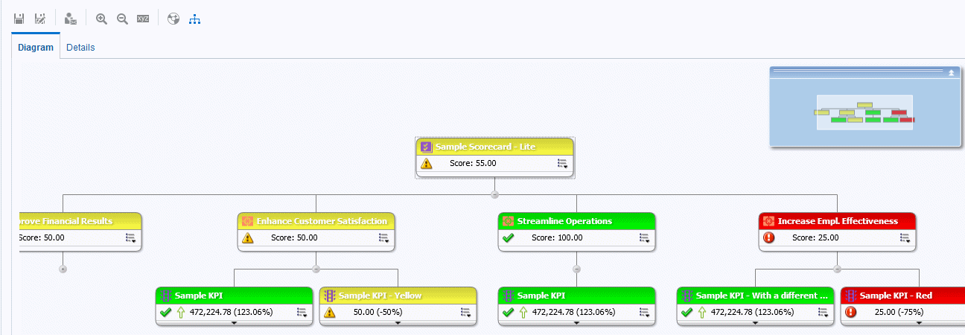

#### Understand a Strategy Contribution Wheel Diagram

You use a strategy contribution wheel diagram to hierarchically view an objective and its supporting child objectives and KPIs in a circular diagram called a strategy contribution wheel diagram.

The strategy contribution wheel diagram makes it easy to see the contribution (or impact) a specific objective or KPI has on a parent objective. It contains the following components:

* + Strategy contribution wheel — Consists of a center circle (or focus node) that represents the starting objective of the diagram. It is surrounded by concentric circles that are divided into sectors. Each sector is a node that represents a child objective or KPI.

The size of a sector is determined by the weight assigned to the represented objective or KPI in its parent's weighted assessment rule. See Assign Weights to Child Objectives, Initiatives and KPIs. If the parent has no weighted assessment rule, then the child sectors of a parent are all the same size.

* + Information pane — Displays the following information about the current node:
    - The status icon and either the score (for an objective) or the actual values and variance percentage (for a KPI)
    - The status of its children
    - The weight assigned to it in its parent's weighted assessment rule
  + Focus trail — Consists of a group of small circles that represent the node in the center of the strategy contribution wheel and any of its ancestors that are included in the diagram. Each circle displays the status color of its corresponding node.

The illustration shows an example of a strategy contribution wheel diagram for the Improve Financial Results objective. The Reduce Cost subordinate objective is highlighted.

Create Strategy Trees

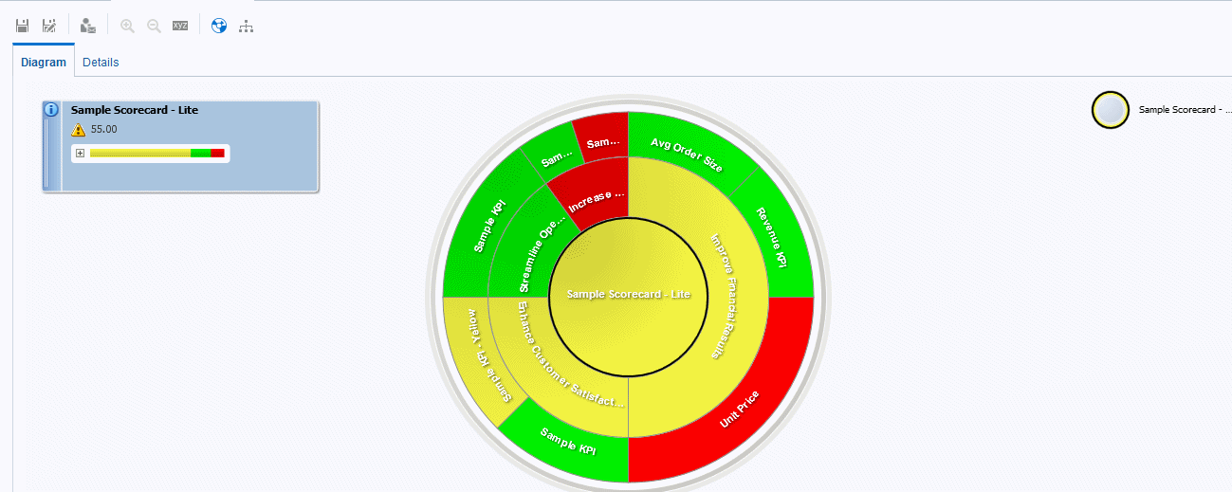

### Create Strategy Trees

A strategy tree shows an objective and its supporting child objectives and KPIs hierarchically.

You can create a strategy tree for the entire scorecard or for a specific objective as follows:

* + In Edit mode, you can create and save a strategy tree for an entire scorecard and for specific objectives.
  + In View mode, you can create a temporary, read-only strategy tree only for specific objectives. You cannot save the strategy tree.

See Use the Edit and View Modes in the Scorecard Editor.

1. If you want to:
   * Create and save a strategy tree for an entire scorecard or for a specific objective, edit the scorecard in which you want to create the strategy tree.
   * Create but not save a temporary, read-only strategy tree only for a specific objective, open the scorecard.
2. To create a strategy tree for:
   * The entire scorecard (the root objective), in the Scorecard Documents pane, click the **New Object** button and select **Create Strategy Tree**.
   * For a specific objective, in the Strategy pane, right-click the objective and then select **View Strategy Tree**.

The Diagram tab of the Strategy Tree tab is displayed, showing the objective and its supporting child objectives and KPIs hierarchically in a diagram.

1. In a strategy tree diagram, to:
   * Display options that enable you to work with a node, click the **Options** button (on the right side of the node) to display the Node Options Menu.
   * Display additional performance data for a KPI, such as target value or variance, click the down arrow at the bottom center of the node. To collapse this data, click the up arrow.

What Are Strategy Maps?

* + Expand or collapse a node, click the plus (+) or minus (-) icon beneath the node.
  + Zoom in and out of the diagram, use the toolbar buttons on the Strategy Tree tab of the Scorecard editor.
  + Work with comments:
    - Hover the mouse pointer over the **Comment** button in the upper-right corner of a node to display the Status window, where you can read the comments that were previously added, add another comment, or reply to a comment.
    - Click the **Options** button on the right side of the node to which you want to add a comment and select **Add Comment** from the Node Options Menu. The New Comment dialog is displayed, where you can add a comment or read any comments that were previously added.
  + Work with status overrides on nodes for which you are the business owner:
    - Hover the mouse over the red asterisk (if available) in a node to display the Status window, where you can view the overrides that were previously applied or apply another override.
    - Click the **Options** button on the right side of the node to which you want to apply the status override and select **Override Status** from the Node Options menu.

The Status Override dialog is displayed, where you apply another override or view any overrides that were previously applied.

1. To set properties that control the appearance of the diagrams, click the **Properties** button on the Strategy Tree tab of the Scorecard editor.
2. In the Strategy Tree View Properties dialog, specify the property settings to achieve the desired appearance, and then click **OK**.
3. Click the **Details** tab of the Strategy Tree tab.
4. Specify a description, assign the business owner, and specify related documents, as appropriate. (By default, the business owner is the creator of the scorecard.)
5. Click **Save** to display the Save As dialog. In the Save As dialog, you can rename the strategy tree rather than use the default name.

### What Are Strategy Maps?

A strategy map shows how the objectives that have been defined for a scorecard and the KPIs that measure their progress are aligned by perspectives.

A strategy map also indicates cause and effect relationships between objectives and other objectives or KPIs with connecting lines. You create cause and effect relationships when you create (or edit) an objective (see Create Objectives) or work with KPI details (see Work with KPI Details). You also can create cause and effect relationships in a strategy map.

The illustration shows an example of a strategy map.

Create Strategy Maps

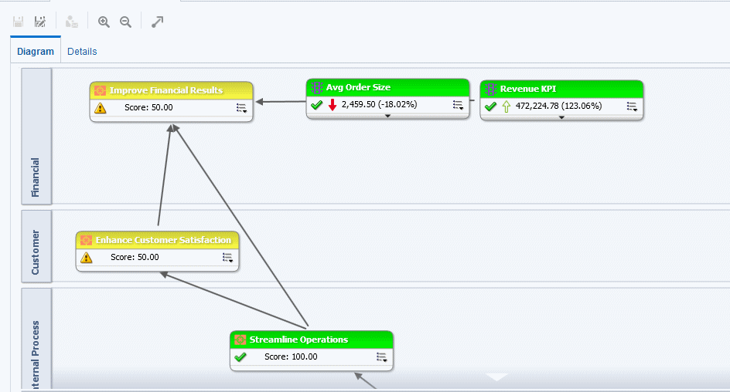

You can create multiple strategy maps to represent the strategy of different areas of your organization.

You can create strategy maps in Edit mode only. See Use the Edit and View Modes in the Scorecard Editor.

Ensure that associated objectives and KPIs relate to each other and identify cause and effect relationships. Review these relationships periodically to identify areas that might need improvement to increase collaboration and communication, thus impacting existing objectives and KPIs.

See Create Strategy Maps.

### Create Strategy Maps

A strategy map shows how the objectives that have been defined for a scorecard and the KPIs that measure their progress are aligned by perspectives.

Strategy maps help users see how actual results compare with objectives.

1. Edit the scorecard in which you want to create the strategy map.
2. In the Scorecard Documents pane, click the **New Object** button and select **Create Strategy Map**.
3. In the Diagram tab, build the map as follows:
   * Add objectives and KPIs that measure their progress by dragging them from the Strategy pane and dropping them in the diagram as follows:
     + If the objective or KPI is aligned with a specific perspective, then drop it anywhere in the diagram. It is displayed automatically in the section for the perspective to which the objective or KPI is associated.

Create Strategy Maps

You align an objective or KPI with a perspective when you create (or edit) the objective or KPI.

* + - If the objective or KPI is not associated with a perspective, then you drop it in the section for the perspective to which the objective or KPI is to be associated. This does not permanently assign the perspective to this objective or KPI.
  + (optional) Add the direct cause and effect objects for the selected node (that is, the representation of an objective or KPI) to the diagram by right-clicking and selecting **Add Related Strategy Nodes**.
  + Add cause and effect relationships, as needed.
    - To add a cause and effect relationship, click the **Draw A Casual Linkage Between Two Objectives** button on the **Strategy Map tab** toolbar, select one of the nodes, and then select the second node. A line connecting the nodes is displayed.
    - To delete a node from the map, right-click the node and select **Remove From Diagram**.

1. To:
   * Display options that enable you to work with a node, click the **Options** button (on the right side of the node) to display the Node Options Menu.
   * Edit a causal linkage, right-click the linkage line and select **Edit Causal Linkage**. The Causal Linkage dialog is displayed.
   * Delete a causal linkage, right-click the linkage line and select **Delete Causal Linkage**.
   * Display additional performance data for the KPI, such as target value or variance, click the down arrow at the bottom center of the representation. To collapse this data, click the up arrow.
   * Zoom in and out of the diagram, use the toolbar buttons on the Scorecard editor: Strategy Map tab.
   * Work with comments:
     + Hover the mouse pointer over the **Comment** button in the upper-right corner of a node to display the Status window, where you can read the comments that were previously added, add another comment, or reply to a comment.
     + Click the **Options** button on the right side of the node to which you want to add a comment and select **Add Comment** from the Node Options Menu. The New Comment dialog is displayed, where you can add a comment or read any comments that were previously added.
   * Work with status overrides on nodes for which you are the business owner:
     + Hover the mouse over the red asterisk (if available) in a node to display the Status window, where you can view the overrides that were previously applied or apply another override.
     + Click the **Options** button on the right side of the node to which you want to apply the status override and select **Override Status** from the Node Options Menu.

The Status Override dialog is displayed, where you apply another override or view any overrides that were previously applied.

1. Click the **Details** tab of the Strategy Map tab.
2. Specify a description, assign the business owner, and specify related documents, as appropriate. (By default, the business owner is the creator of the scorecard.)

What Are Cause & Effect Maps?

1. Click **Save** to display the Save As dialog. In the Save As dialog, you can rename the strategy map rather than use the default name.

### What Are Cause & Effect Maps?

A cause & effect map lets you illustrate the cause and effect relationships of an objective or KPI that is listed in the Strategy pane. Cause & effect maps are diagrams that are used in scorecard and are not related to map views.

The illustration shows an example of a cause & effect map for the Improve Financial Results objective.

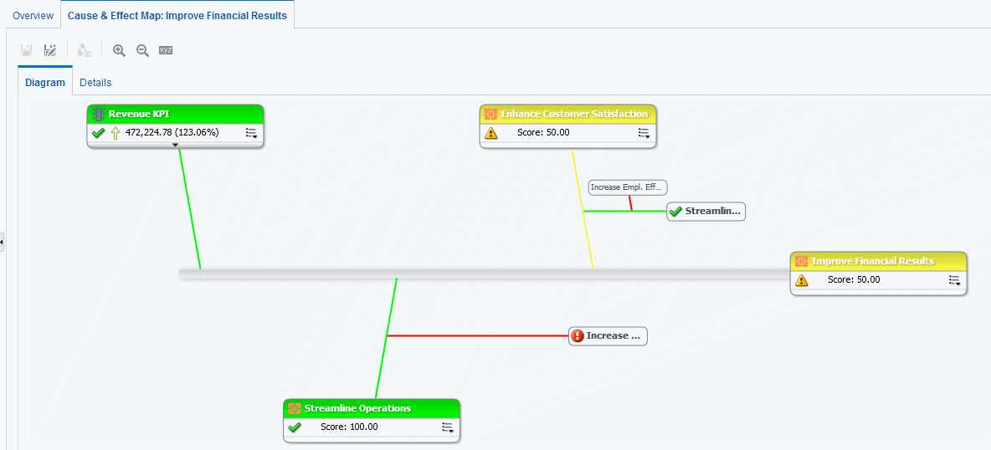

You create cause and effect relationships for:

* + An objective when you create or edit the objective and identify:
    - Other objectives or KPIs that impact or support the objective (causes)
    - Other objectives or KPIs that this objective impacts or supports (effects) See Create Objectives.
  + A KPI when you work with KPI details.
    - Other objectives or KPIs that impact or support the KPI (causes)
    - Other objectives or KPIs that this KPI impacts or supports (effects) See Work with KPI Details.

A cause and effect map also indicates the proportionality (that is, whether changes in performance or value in the cause and effect relationship are directly proportional (direct) or inversely proportional (inverse) and strength (strong, moderate, or weak) of cause & effect relationships using symbols.

A cause & effect map helps you to better understand the implications of future strategic changes.

Create cause and effect linkages to automatically show operational metrics and dependencies.

Create Cause & Effect Maps

You can create a cause & effect map in either Edit or View mode:

* + In Edit mode, you can create and save a cause & effect map.
  + In View mode, you can create a temporary, read-only cause & effect map. You cannot save it.

See Use the Edit and View Modes in the Scorecard Editor.

See Create Cause & Effect Maps.

### Create Cause & Effect Maps

You can create a cause & effect map for any objective or KPI that is listed in the Strategy pane.

See What Are Cause & Effect Maps?

1. If you want to:
   * Create and save a cause & effect map, edit the scorecard in which you want to create the cause & effect map.
   * Create but not save a temporary, read-only cause & effect map, open the scorecard in which you want to create the cause & effect map.
2. In the Strategy pane, right-click the objective or KPI and then select **View Cause & Effect Map**.

The Diagram tab of the Cause & Effect Map tab is displayed.

1. To:
   * Display options that enable you to work with a node, right-click the node or click the

**Options** button (on the right side of the node) to display the Node Options Menu.

* + Display additional performance data for a KPI, such as target value or variance, click the down arrow at the bottom center of the node. To collapse this data, click the up arrow.
  + Edit a causal linkage, right-click the linkage line and select **Edit Causal Linkage**. The Causal Linkage dialog is displayed.
  + Delete a causal linkage, right-click the linkage line and select **Delete Causal Linkage**.
  + Zoom in and out of the diagram or to set preferences, use the toolbar buttons on the Cause & Effect Map tab of the Scorecard editor.
  + Work with comments:
    - Hover the mouse pointer over the **Comment** button in the upper-right corner of a node to display the Status window, where you can read the comments that were previously added, add another comment, or reply to a comment.
    - Click the **Options** button on the right side of the node to which you want to add a comment and select **Add Comment** from the Node Options Menu. The New Comment dialog is displayed, where you can add a comment or read any comments that were previously added.
  + Work with status overrides on nodes for which you are the business owner:

Understand Watchlists

* + - Hover the mouse over the red asterisk (if available) in a node to display the Status window, where you can view the overrides that were previously applied or apply another override.
    - Click the **Options** button on the right side of the node to which you want to apply the status override and select **Override Status** from the Node Options Menu. The Status Override dialog is displayed, where you apply another override or view any overrides that were previously applied.

1. To specify how cause and effect relationships are to be displayed on the cause & effect map, click the **Cause & Effect Map Preferences** button on the Cause & Effect Map tab of the Scorecard editor.
2. In the **General** tab of the Cause & Effect Map Preferences dialog, specify how you want cause and effect relationships displayed and then click **OK**.
3. Click the **Details** tab.
4. Specify a description, assign the business owner, and specify related documents, as appropriate. (By default, the business owner is the creator of the scorecard.)
5. Click **Save** to display the Save As dialog. In the Save As dialog, you can rename the cause & effect map rather than use the default name.

### Understand Watchlists

Watchlists are tables that list scorecard objects (that is, initiatives, objectives, and KPIs) that are related to a particular aspect of a scorecard or that are grouped together for a particular purpose.

Some watchlists are components of scorecard objects. These include the following watchlists:

* + **Initiatives & KPIs watchlist** — Lists the child initiatives and the KPIs that are used to evaluate the performance of an initiative.

This watchlist is displayed in the Analytics pane of the Initiative Details tab.

* + **Objectives & KPIs watchlist** — Lists the child objectives and the KPIs that are used to evaluate the performance of an objective or that are displayed in a view (that is, cause & effect map, custom view, strategy tree, or strategy map).

This watchlist is displayed in the following tabs:

* + - Analytics pane of the Objective Details tab in the Scorecard editor
    - Details tab of the Cause & Effect Map tab
    - Details tab of the Custom View tab
    - Details tab of the Strategy Map tab
    - Details tab of the Strategy Tree tab
  + **Objectives, Initiatives & KPIs watchlist** — Lists the initiatives, objectives, and KPIs that are associated with a perspective.

This watchlist is displayed in the Perspective tab of the Scorecard editor.

Other watchlists you create to serve a particular purpose. These include the following watchlists:

* + **KPI watchlist** — Lists the KPIs whose performance you want to monitor.

Customize Watchlists

This watchlist is displayed in the Performance tab of the KPI Watchlist editor. See What Are KPI Watchlists?.

* + **Smart watchlist** — Lists the initiatives, objectives, and KPIs within a scorecard that meet criteria that you specify.

This watchlist is displayed in the Smart Watchlist tab of the Scorecard editor. See What Are Smart Watchlists?.

* + **Breakdown watchlist** — Lists the child or descendant initiatives or objectives and KPIs that are used to evaluate the performance of an initiative or objective.

This watchlist is displayed in the Breakdown tab of the Scorecard editor.

A watchlist includes columns that describe the scorecard objects (such as Status, % Variance, and so on) and components (such as **View** or **Summary**) that allow you to view and manage these objects.

For example, you can create an Objectives & KPIs watchlist consisting of two objectives — % Early Shipped and Fulfillment Days — that are used to evaluate the performance of an objective named Enhance Customer Satisfaction.

### Customize Watchlists

You can use the Watchlist Styles tab of the Scorecard Settings dialog to customize watchlists used on Scorecards, Objectives, Initiatives, Perspectives, Smart Watchlists, Custom Views, Strategy Tree Views, Strategy Maps, and Cause Effect Maps.

For each watchlist in a scorecard, you can customize watchlist styles, change the column order, display or hide columns, and change column labels at the following levels:

* + Scorecard: Applies to all watchlists for the scorecard that do not have their own individual styles or column customizations.
  + Individual Watchlist: Applies to an individual watchlist. The individual watchlist style overrides the scorecard level style

If no watchlist styles are set, the default style is used.

You can include the following format options to customize the watchlists:

* + Font Name - You must enter the font name manually. You must a font name supported by a web browser used in your environment.
  + Bold - Yes or No or Default
  + Italic - Yes, or No or Default
  + Border Style
  + Border Color
  + Font Color
  + Background Color

You can set the above formats for individual cell (row and column) types independently and can apply different styles for alternate rows of the watchlist.

You can copy and paste styles from one cell to another, and with one click can apply a cell's style to the entire row. You can also set the styles for the header row and the selected (clicked on) row.

To customize watchlists:

What Are KPI Watchlists?

1. Edit the scorecard for which you want to customize the watchlists.
2. Click the **Scorecard Settings** button in the Scorecard editor.
3. Click the **Watchlist Styles** tab.

The Watchlist Styles tab is displayed.

1. Optional: From the Preset Styles list, select a style for your organization.
2. Optional: Check **Show Object Type Icon** to display the icon for KPI, Objective, or Initiative node types in the watchlist rows.
3. Optional: Check **Enable Alternate Row Styling** if you want to customize alternate row styles.
4. Use the View list, to show or hide columns or change column names.

You can similarly use the View list above each watchlist to customize individual watchlists.

1. Use the Edit icons to format the following cell (row or column) types:
   * Summary - information displayed above the watchlist table
   * Various columns in the Column Header Row
   * Various columns in the Body Rows
   * Various columns in the Alternate Body Rows
   * The Selected (clicked on) Row
2. For each cell (row or column) type, choose the following:
   * Font Name - Manually enter the font name that is supported by your browser
   * Bold - Yes or No or Default
   * Italic - Yes or No or Default
   * Border Style
   * Font Color
   * Background Color
   * Border Color
3. Click **Apply Styles** and then click **OK**.

### What Are KPI Watchlists?

A KPI watchlist is a collection of KPIs whose performance you want to monitor.

You can create KPI watchlists:

* + Within a scorecard. You create a KPI watchlist within a scorecard to help you view and investigate the progress of the objectives and initiatives. KPI watchlists that you create within a scorecard are saved as part of the scorecard. See What Are Smart Watchlists?
  + Outside a scorecard. This enables you to create a KPI watchlist in advance of creating or editing a scorecard. KPI watchlists that you create outside a scorecard are saved as standalone objects in the Oracle BI Presentation Catalog.

See Using KPIs and KPI Watchlists.

Work with KPI Details

### Work with KPI Details

When you create initiatives and objectives, you can assign KPIs to them to measure their progress and performance.

You can work with these KPIs within a Scorecard using the KPI Details tab of the Scorecard editor.

Specifically, you can:

* + View basic KPI settings as well as a graph that presents actual values and target values.
  + Override the label, description, and business owner that are defined for the KPI.
  + Pin dimensions. See What Are Dimensions and Pinned Dimension Values?
  + View documents that provide supporting information to the KPI.
  + Run actions that are associated with the KPI.
  + Associate the KPI with a perspective.
  + Specify an indicator type (for example, Leading) to indicate whether the performance of the KPI drives other KPIs, or is affected by the performance of other KPIs, or other data or processes.
  + View, add, or reply to comments.
  + Identify initiatives and KPIs (for a KPI listed in the Initiatives pane) or objectives and KPIs (for a KPI listed in the Strategy pane) that cause or effect the KPI.

1. Edit the scorecard that contains the KPI.
2. If the KPI is assigned to an:
   * Initiative, double-click the KPI in the Initiatives pane
   * Objective, double-click the KPI in the Strategy pane
3. In the KPI Details tab, perform any of the following tasks:
   * Override one of the following items:
     + Label, using the ***Label*** field
     + Description, using the **Description** field
     + Business Owner, using the **Business Owner** field in the Collaboration pane
   * Pin dimensions using the **Dimensionality** area in the Analytics pane.
   * Run actions that are associated with the KPI, using the action links in the **Actions**

area of the Analytics pane.

* + Associate the KPI with a perspective, using the **Perspective** field in the Analytics pane.
  + Specify the indicator type, using the **Indicator Type** field in the Analytics pane.
  + View, add, or reply to comments, using the Collaboration pane.
  + View documents that provide supporting information to the KPI, using the **Related Documents** area in the Collaboration pane.
  + Identify objectives that cause or effect the KPI, using the Related Items pane.

1. If you made any changes, then click **Save**.

What Are Smart Watchlists?

### What Are Smart Watchlists?

A smart watchlist is a view into a particular scorecard based on criteria that you specify.

For example, a smart watchlist might show the top ten KPIs in a scorecard based on best performance or all the objectives, initiatives, and KPIs in a scorecard that are owned by a specific business owner.

The illustration shows an example of a smart watchlist for the Improve Financial Results objective and all its descendants.

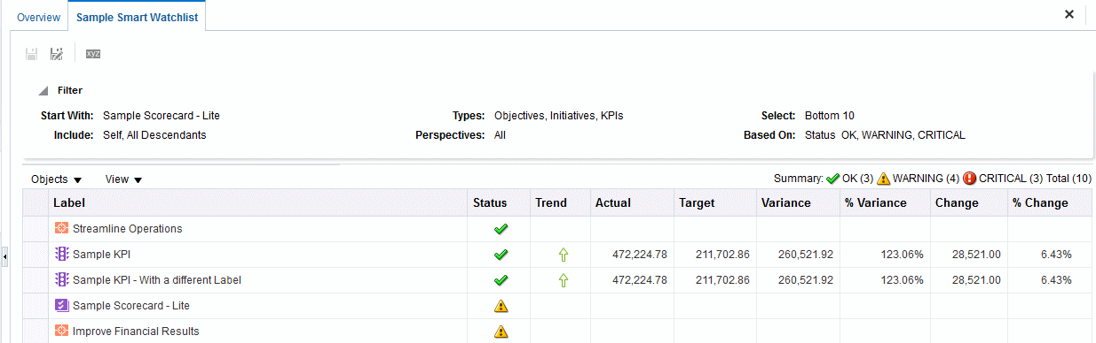

A smart watchlist consists of the following components:

* + **Filter pane** — This pane is displayed as a control panel, as a text summary, or is hidden, depending on the setting of the **Filter Criteria Display** component in the Smart Watchlist Properties dialog. If displayed as a:
    - Control panel, it contains tabs that let you specify the criteria to be used to filter the smart watchlist. You can filter by object relationships, by object types, by perspective associations, by performance, and by business owner assignments.
    - Text summary, it displays a read-only text summary of the current filter criteria.
  + **Smart watchlist** — Lists the objectives, initiatives, and KPIs in a scorecard that meet the criteria specified in the Filter pane.
  + **Smart watchlist toolbar** — Contains buttons that allow you to save the smart watchlist and to specify smart watchlist properties, such as how the Filter pane is to be displayed (that is, as a control panel, a read-only text summary, or hidden).

Create smart watchlists as a conduit to properly align performance drivers (objectives and initiatives) with their proper business owners and to assist in arriving at a consensus between stakeholders that will build commitment to move goal and target setting along to achieve the stated and desired results.

You can create smart watchlists in Edit mode only.

In View mode, you can view a smart watchlist and, if the smart watchlist was saved with the Filter pane displayed as a control panel, you can specify filter criteria to dynamically change what is shown in the smart watchlist.

Create Smart Watchlists

See Use the Edit and View Modes in the Scorecard Editor.

You can also add smart watchlists to dashboards. If the smart watchlist was saved with the Filter pane displayed as a control panel, end users will be able to specify filter criteria to dynamically change what is shown in the smart watchlist.

See Create Smart Watchlists.

### Create Smart Watchlists

A smart watchlist is a view into a particular scorecard based on criteria that you specify. Smart watchlists alert users of important changes in data.

1. Edit the scorecard in which you want to create the smart watchlist.
2. In the Scorecard Documents pane, click the **New Object** button and select **Create Smart Watchlist**.

The illustration shows an example of a smart watchlist.

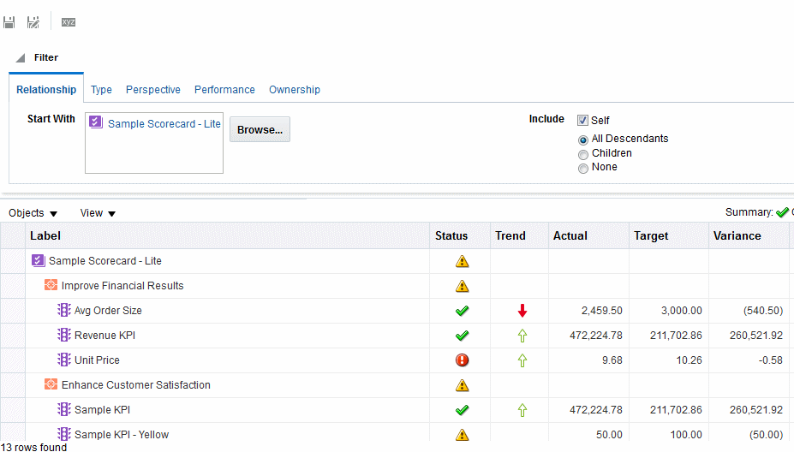

1. In the Filter pane, specify the filter criteria:
   1. In the Relationship tab, specify the object relationships by which the scorecard objects are to be filtered. You can add objectives, initiatives, or KPIs by dragging the objects from the Strategy and Initiatives panes and dropping them in the Relationship tab.
   2. In the Type tab, specify the object types by which the scorecard objects are to be filtered.
   3. In the Perspective tab, specify the perspective associations by which the scorecard objects are to be filtered.

What Are Custom Views?

* 1. In the Performance tab, specify the performance criteria (status, score, or ranking) by which the scorecard objects are to be filtered.
  2. In the Ownership tab, specify the business owner assignments by which the scorecard objects are to be filtered.

1. Set smart watchlist properties. To do so, click the **Properties** button to display the Smart Watchlist Properties dialog.
2. Manage the smart watchlist, as appropriate.
3. Click **Save** to display the Save As dialog. In the Save As dialog, you can rename the smart watchlist rather than use the default name.

### What Are Custom Views?

A custom view lets you show a customized view of your business and strategy data.

For example, you might present information about objectives and KPIs on a background image of your choice, such as your company logo. See Create Custom Views.

You can create custom views in Edit mode only. See Use the Edit and View Modes in the Scorecard Editor.

### Create Custom Views

Scorecards can have custom views to alter how data analyses are presented. You can create a view for a scorecard that is customized for your audience.

1. Edit the scorecard in which you want to create the custom view.
2. In the Scorecard Documents pane, click the **New Object** button and select **Create Custom View**.
3. In the Diagram tab, drag objectives and KPIs from the Strategy pane and drop them on the diagram.
4. Specify how you want each objective or KPI to be displayed on the diagram. For each objective or KPI, select it on the diagram and specify whether you want it displayed as:
   * Its full version. To do so, click the **Full** button.
   * Its simple version. To do so, click the **Simple** button.
   * One of its properties. To do so, click the ***Property*** button and select the property.
5. (optional) Specify a background image, a background color, or both by clicking the

**Properties** button to display the Custom View Properties dialog.

1. To:
   * Display options that enable you to work with a node, click the **Options** button (on the right side of the node) to display the Node Options Menu.
   * Display additional performance data for the KPI, such as target value or variance, click the down arrow at the bottom center of the node. To collapse this data, click the up arrow.

Open Scorecard Objects

* + Zoom in and zoom out of the diagram, use the toolbar buttons on the Custom View tab.
  + Work with comments:
    - Hover the mouse pointer over the **Comment** button in the upper-right corner of a node to display the Status window, where you can read the comments that were previously added, add another comment, or reply to a comment.
    - Click the **Options** button on the right side of the node to which you want to add a comment and select **Add Comment** from the Node Options Menu. The New Comment dialog is displayed, where you can add a comment or read any comments that were previously added.
  + Work with status overrides on nodes for which you are the business owner:
    - Hover the mouse over the red asterisk (if available) in a node to display the Status window, where you can view the overrides that were previously applied or apply another override.
    - Click the **Options** button on the right side of the node to which you want to apply the status override and select **Override Status** from the Node Options Menu.

The Status Override dialog is displayed, where you apply another override or view any overrides that were previously applied.

1. Click the **Details** tab.
2. Specify a description, assign the business owner, and specify related documents, as appropriate. (By default, the business owner is the creator of the scorecard.)
3. Click **Save** to display the Save As dialog. In the Save As dialog, you can rename the cause & effect map rather than use the default name.

### Open Scorecard Objects

Several options are available when opening scorecard objects. To open a scorecard object:

1. Open or edit the scorecard that contains the object.
2. To open:
   * An objective, double-click it in the Strategy pane to display the Objective Details tab.
   * An initiative, double-click it in the Initiatives pane to display the Initiative Details tab.
   * A view (for example, a Strategy Map), a mission or vision statement, a KPI watchlist, or a smart watchlist, double-click it in the Scorecard Documents pane. Depending on the object you double-clicked, one of the following tabs is displayed:
     + Cause & Effect Map tab
     + Custom View tab
     + Strategy Map tab
     + Strategy Tree tab
     + KPI Watchlist tab
     + Smart Watchlist tab
     + Mission tab

Edit Scorecard Objects

* + - Vision tab
  + A perspective, double-click it in the Perspectives pane to display the Perspective tab.
  + A KPI, double-click it in the:
    - Strategy pane or the Initiatives pane. The KPI Details tab is displayed.
    - Catalog pane for Scorecard. The KPI tab is displayed.
  + Any object, select the object and click the **Open** button on the tab toolbar or right-click the initiative or objective and select the **Open** option.

### Edit Scorecard Objects

You can edit scorecard objects in the Scorecard editor.

You also can edit scorecard objects from the Catalog page.

1. Edit the scorecard that contains the scorecard object that you want to edit.
2. Double-click the object. For example, to edit an objective, double-click it in the Strategy pane, or, to edit a strategy map, double-click it in the Scorecard Documents pane.

For a strategy tree, you can edit only the details of a strategy tree, not the diagram.

1. Make your changes.
2. Click **Save**.

### Delete Scorecard Objects

You can delete scorecard objects from the Scorecard editor. You also can delete scorecard objects from the Catalog page.



**Caution:**

Before deleting an initiative, ensure that it has been completed or is no longer required to achieve an objective. Before deleting an objective, examine any child objectives or other objectives with which it is linked to ensure that its removal does not negatively impact these objectives.

1. Edit the scorecard that contains the scorecard object that you want to delete.
2. Right-click the object and select **Delete**. For example, to delete a Strategy Map, right-click it in the Scorecard Documents pane and select **Delete**.
3. In the confirmation dialog, confirm that you want to delete the object.

### Add Scorecard Objects to Dashboards

Specific types of scorecard objects can be added to dashboards. You can add the following scorecard objects to dashboards:

Add Scorecard Objects to Dashboards

* + Cause & effect maps. See What Are Cause & Effect Maps?
  + Custom views. See What Are Custom Views?
  + Strategy maps. See What Are Strategy Maps?
  + Strategy trees. See What Are Strategy Trees?
  + KPI watchlists. See What Are KPI Watchlists?
  + Smart watchlists. See What Are Smart Watchlists?



**Note:**

Embed scorecard visualizations (for example, smart watchlists or cause and effect maps) into dashboards for fostering interactive analysis.

# 10

## Managing Content

This chapter describes how to manage your content in the catalog.

Topics:

* + Typical Workflow to Manage Content
  + Find Catalog Objects
  + About Naming Restrictions for Catalog Objects
  + Rename Content
  + Access Favorites Easily
  + Access Properties
  + Assign Access Permissions
  + Control Authoring and Folder Permissions
  + Send Email Reports
  + Automate Business Processes With Agents
  + Configure Your Devices and Delivery Profile
  + Migrate Content to Other Catalogs
  + Assign Ownership of Items
  + Assume Ownership of Items
  + Allow Safe Domains
  + About Embedding External Images and Other External Resources in Your Content
  + Embed Your Content in Other Applications

### Typical Workflow to Manage Content

Here are some common tasks that you perform to access and organize content in the catalog.

|  |  |  |
| --- | --- | --- |
| **Task** | **Description** | **For More Information** |
| Search for Catalog Objects | Explore your Catalog content | Find Catalog Objects |
| Rename content | Improve or update the naming of your content. | Rename Content |
| View or set content properties | Display information about your content or change various content options and properties. | Access Properties |
| Give access to others | Assign permissions so that others can access your content | Assign Access Permissions |

Find Catalog Objects

|  |  |  |
| --- | --- | --- |
| **Task** | **Description** | **For More Information** |
| Email reports and track | Email reports to anyone inside or | Send Email Reports |
| deliveries | outside the organization. Keep everyone |  |
|  | up to date with daily or weekly reports. |  |
| Automate business | Create agents that deliver analyses, | Automate Business |
| processes | dashboards, and briefing books to | Processes With Agents |
|  | targeted audiences on-demand or on a |  |
|  | regular schedule. |  |
| Configure devices and | Configure the devices and delivery | Configure Your Devices and |
| delivery profiles | profiles to be used to reach you when | Delivery Profile |
|  | an alert is generated by an agent. |  |
| Change content ownership | Assign another user as the content | Assign Ownership of Items |
|  | owner. |  |

### Find Catalog Objects

You can search for and locate catalog objects.

Topics:

* + About Searching for Catalog Objects
  + Search for Catalog Objects

#### About Searching for Catalog Objects

You can find objects in the catalog using the search facility.

The catalog contains objects that you or somebody else has defined and saved for future use (such as analyses and dashboards). You can search the catalog to find something that you want to work with or change. For example, you can find the Brand Revenue analysis that you created last week. By doing so, you can change a bar graph to a line graph in that analysis.

You can use the Catalog page to view the objects that are necessary to perform your day-to-day tasks. For example, a sales analyst must access an analysis that monitors the weekly sales of a specific brand of beverage in the Central and Eastern regions. The permissions set by the catalog administrator determine what tasks the analyst can perform on a piece of content and within the catalog.

Catalog Search

The search option enables you to locate an object by searching for its name, description, location, and object type. You can also use the asterisk character (*) in the search string. For example, you might enter *v or F*s to return objects that contain the word Favorites.

When users perform the catalog search, the search locates those objects that have been crawled and indexed, and for which the individual users have the appropriate permissions. Objects such as dashboards and reports with the **Don't Index** attribute selected aren't indexed. An administrator can change how regular catalog search crawls are configured.

About Naming Restrictions for Catalog Objects

The list of search results includes any objects that match the criteria, for which the user has at least the Open permission. If an object is stored in a folder, then the user must have the Traverse folder and Open object permissions. Objects with the No Access permission aren't available

Be aware of the following information about the search:

* + While you search using keywords, the search results include metadata. For each catalog object, the metadata (such as the name, path, author, modification date, last accessed date, type, and description) is indexed and available as search results.
  + The default search operator is AND. You can specify multiple search terms and the most relevant search hit containing all of the terms is shown.

#### Search for Catalog Objects

You can use the search functionality to find objects in the catalog.

When you perform a search, newly-created catalog objects are locatable after an index crawl has completed.

1. In the Home page, click **Catalog**.
2. In the Catalog page, click the **Search**.
3. In the Search pane, specify the search criteria. Consider the following options:
   * **Search**: This option enables you to enter search strings, including the asterisk character (*), to display catalog objects that match your search.
   * **Exact Match**: This option restricts results to exact matches only.
   * **Location**: This option enables you to select the catalog folder within which you want to perform the search.
   * **Sub-Folders**: This option recursively searches sub-folders within the selected location, when this option is selected.
   * **Type**: Select the type of object for which you're searching (for example, Action, Agent, Analysis, KPI, Scorecard, or Filter).
4. To search for Hidden Items, select the **Show Hidden Items** box on the Catalog page's header.
5. Click **Search**.

Folders or objects that satisfy the search criteria are displayed in the Catalog area.

### About Naming Restrictions for Catalog Objects

You can't use special characters when naming or renaming catalog objects, such as workbooks, dashboards, and analyses.

When you name or rename a catalog object, don't use special characters (~, !, #, $, %, ^, &,

*, +, `, |, :, ", \\, <, >, ?, ,, /) in the object name.

Rename Content

### Rename Content

You can rename items and views to make their names more meaningful to you.

Topics:

* + Rename Items
  + Rename Views

#### Rename Items

You can rename items to make their names more meaningful to you. For example, you can change the name of the "High Products" filter to "Top 3 Products."

1. On the Home page, click **Catalog**.
2. In the Catalog page, search for the item that you want to rename.
3. In the search results for the item, click **More**, and then **Rename**.
4. Give the item a new name.

You can't rename seeded names.

1. Optional: Click **Preserve references to the old name of the item**, if the option is available for the item.

Use this option to specify that existing references to the previous name of the item are maintained. This creates a shortcut with the old name that points to the renamed item in the catalog. If you don’t select this option, then existing references break.

1. Click **OK**.

#### Rename Views

You can rename views to make their names more meaningful to you. For example, you can change the name of a view from "Sales Forecast 2014" to "Forecast 2014."

1. Open the analysis for editing.
2. On the Results tab, click **Edit View**.
3. In the view editor toolbar, click **Rename View**.
4. In the Rename View dialog, give the view a new name. You can't rename seeded names.
5. Click **OK**.

### Access Favorites Easily

You can access your favorite content easily using the **Favorites** option on the Home page.

Topics:

* + Add Favorites from Catalog Page

Access Properties

* + Remove Content from your Favorites List

#### Add Favorites from Catalog Page

You can bookmark as favorites the content that you work with the most. Your favorites are displayed with a gold star, and you can view all of your favorites by clicking **Favorites** on the Home page.

For example, you might regularly view the "Box Plot & Bar" analysis. You can flag the analysis as a favorite to help you quickly access it.

1. From the Home page, click **Catalog**.
2. In the Catalog page, search for the content that you want to mark as a favorite.
3. In the search results for the item, click **More**, and then **Add to Favorites**.

#### Remove Content from your Favorites List

You can remove content from your favorites list that you no longer need to access as often. For example, you might remove the "Box Plot & Bar" analysis from your favorites because it’s out-of-date.

1. Display the Home page, Catalog page, or Favorites page where the content is displayed.
2. Locate the content that you want to remove from your favorites.
3. Click **More**, and then **Remove from Favorites**.

#### Add or Remove Favorites from Other Pages

You can add or remove favorites from other pages.

For example, you might want to flag an analysis in the Alerts page as a favorite to help you quickly access it.

1. Go to the page or folder and search for the content you want to add or remove from the favorites list.
2. Select the item and click **More**.
3. From the Action menu of the item, click **Add to Favorites** or **Remove from Favorites**.

### Access Properties

Administrators can access the properties of any item or folder to perform tasks such as view system information or change access levels. All other users can access and modify the properties for only those items that they create or own.

For example, you might want to change the Brand Revenue analysis to be read-only so that other users can’t modify it.

1. On the Home page, click **Catalog**.
2. In the Home page or Catalog page, locate the catalog item that you want to edit.

You can locate a catalog item in the Recent or Others list on the Home page, or use the Search tool to locate a catalog item. For example, you might locate an analysis named ‘Revenue by Region’.

Assign Access Permissions

1. Click **More**, then **Properties**.
2. Review or change the settings in the Properties dialog.

For example, you can set an item as read-only or take ownership of an item.

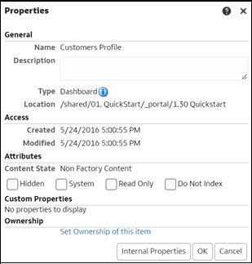

1. Click **OK** to save changes or click **Cancel**.

### Assign Access Permissions

You can give others access to items in the catalog and to dashboard sections. This helps you to control the content that users can view or edit.

Topics:

* + Add or Update Item Permissions
  + Add or Update Dashboard Section Permissions

#### Add or Update Item Permissions

You give catalog item access permissions to application roles.

The permissions that you can assign to others vary depending on the type of content. To change permissions, the application role that you are assigned to must have the Change Permission privilege.

See the topics about Business Intelligence Roles in the Oracle Fusion Cloud security guides, *Securing HCM*, *Securing SCM*, and *Securing Oracle Cloud ERP*. Follow links to the security guides in the [Oracle Fusion Cloud Applications Suite](https://docs.oracle.com/en/cloud/saas/) library page.

1. On the Home page, click **Catalog**.

Assign Access Permissions

1. In the Catalog page, search for the content to which you want to assign permissions.
2. In the search results for the item, click **More** and **Permissions**.

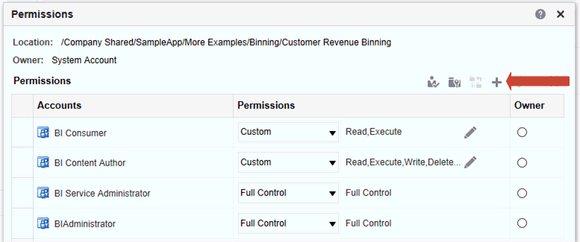

1. In the Permissions dialog, click **Add users/roles** to access the Add Application Roles and Users dialog to add any required accounts.

The roles and users inherit permissions from the roles of which they are members. For example, you can grant Full Control permission to the BIServiceAdministrator application role on the Sales Revenue analysis. This enables any user or application role with that role to have Full Control on the item. You can see the permissions that users and roles have on items (either granted directly or inherited). Click the **Click to see effective permissions** button in the Add Application Roles and Users dialog to display or hide a Permissions column to see the effective permissions for each row in the **Selected Members** table.

1. In the Permissions dialog, click the **Permissions** list. Most of the items in the list are parent permissions and contain several child permissions.
2. Optional: To build a specific list of permissions, click **Custom**. This option gives the user authority to bypass any permissions set on the folder that prevent the user from accessing the item from the Catalog or a dashboard. This option doesn’t change the folder permissions.

For example, you can grant users the Traverse permission for the Test folder in the shared folder area. Then, they *can* access items embedded in dashboards stored in this folder. Also, they can access embedded items in dashboards stored in sub-folders, such as /<*shared folder area*>/Test/Guest folder. However, users can’t access (meaning view, expand, or browse) the folder and sub-folders from the Catalog.

1. Click **OK** twice.

#### Add or Update Dashboard Section Permissions

You can give others access to dashboard sections, thereby controlling which users have access to those sections. To grant access, you assign permissions to users of the dashboard.

For example, you assign permissions for the Project Costs section of the dashboard to the BI administrator. You can restrict access to BI consumers to prevent unwanted changes.

1. Open a dashboard for editing.
2. Select **Properties** in the section toolbar.
3. Select **Permissions**.

Control Authoring and Folder Permissions

1. In the Permissions dialog, click the **Permissions** list to select permissions.
2. Click **OK**.

### Control Authoring and Folder Permissions

You can control the ability to author reports and analyses by specifying who can create reports and analyses, and who can write to specific folders.

The following scenarios ensure that most users can't access Oracle Analytics to create reports, even if they bookmark a direct link to it.

The examples given here are for Oracle CX Sales and B2B Service customers involved in implementation.

You must have a role with administrator access to complete these tasks.

Topics:

* + Remove Analysis Editor and BI Composer Access from the BI Author Role

Use this task if you want to control who can create reports and analyses, and only want the **Reports and Analytics** link to appear in the **Navigator** for a specific role.

* + Restrict Access to the Custom Folder in Shared Folders

Use this task if you only want specific users to be able to write to the Custom folder under Shared folders in the catalog.

* + Allow Access to Only My Folder

Use this task if you want users to be able to save reports to My Folder, but not to any other folders.

#### Remove Analysis Editor and BI Composer Access from the BI Author Role

You can remove access in the BI Author role to the two areas where users can create reports and analyses, the Analysis Editor and BI Composer.

You can also follow similar steps to create a role and grant the role access to build reports.

1. From the **Navigator** menu, click **Reports and Analytics**.
2. Click **Browse Catalog**.
3. Click the **Administration** global link at the top, and then in the Administration page under Security, click **Manage Privileges**.
4. Click the **BI Author Role** link next to Access to Answers.
5. In the Permissions section, select the existing row and click **Deny** (X).

Control Authoring and Folder Permissions

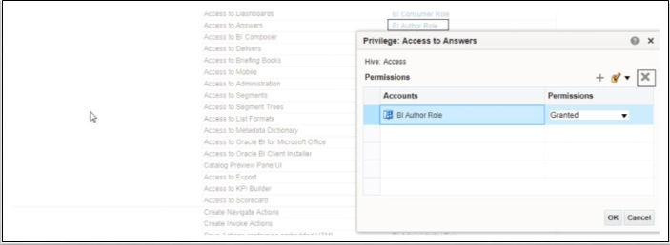

At this point, you can leave this page blank so that no users can access the Analysis Editor. Alternatively, you can complete the steps in the next task to create a role, and then grant access to that role by clicking **Add** (+) to add the role and grant the privilege.

1. Repeat steps 4-5 to deny the permission for the **Access to BI Composer** item.
2. Sign in as a user with the BI Author role (for example, Sales Manager). You shouldn't have access to the Analysis Editor.

#### Restrict Access to the Custom Folder in Shared Folders

You can restrict user access to the Custom folder located in Shared Folders.

By default, Oracle CX Sales allows all user roles to create, modify, and delete reports from the Custom folder in Shared Folders. You don't have to remove anything in the existing role mappings in the Security Console. Instead, you create a role, and map it to the appropriate roles in the Security Console, and then enable the permission in the catalog.

1. For example, in the Oracle CX Sales application, click **Navigator**, **Tools**, and then

Security Console.

1. In the **Roles** tab, click **Create Role**.
2. Enter the required information and save the role. For example, create a role called Custom BI Access Control.

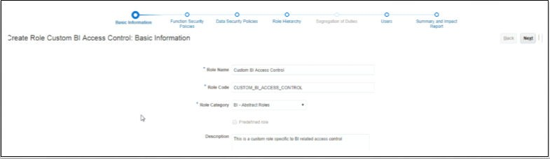

1. Click **Navigator** and then click **Reports and Analytics**.
2. Click **Browse Catalog **.
3. In the Folders pane, expand Shared Folders and select the **Custom** folder.

Send Email Reports

1. Click **Permissions** in the Tasks pane.
2. Click **Add** (+) in the Permissions page.
3. Search for the job role that you created (for example, Custom BI Access Control), and move it to the **Selected Members** column.
4. Click **OK**.
5. Set permissions, as appropriate:
   * Remove the two entries for BI Author role and BI Consumer role.
   * Keep Full Control for BI Administrator and the Custom BI Access Control role.
   * Select both check boxes (Apply permissions to sub-folders, Apply permissions to items within folder), and then click **OK**.
6. Test your changes by signing in as a user who doesn't have the newly-created job role. Make sure that the Custom folder isn't displayed to the user in Shared Folders.
7. Assign the custom role to the user and sign in again.
8. Display Shared Folders and notice that the Custom folder is displayed to the user, and contents in the folder are also editable.

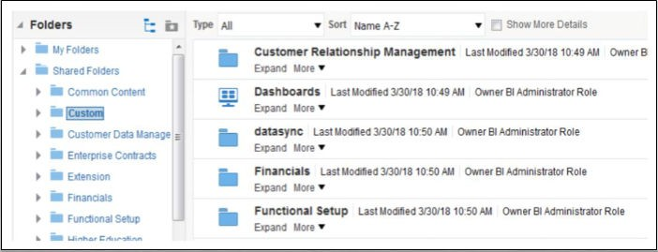

#### Allow Access to Only My Folder

You can enable users to save reports to My Folder, but not to any other folders.

If you remove access to the Custom folder, users can still save their own workbooks in My Folder.

### Send Email Reports

Send email reports to anyone inside or outside the organization or use agents to send reports to a range of other devices. Keep everyone up-to-date with regular daily or weekly reports.

Topics

* + Send Email Reports Once, Weekly, or Daily
  + Email Security Alert

#### Send Email Reports Once, Weekly, or Daily

Send Email reports to one or more recipients directly from the catalog. It’s easy to distribute reports this way and quicker than downloading a report and mailing it from your email client. To keep everyone up-to-date, schedule daily or weekly emails.

1. On the Home page, do one of the following:
   * Navigate to the item you want to email, click **Edit**, and in the **Results** tab, click

Email.

* + Click **Catalog**, navigate to the item you want to email, click the **More** action menu, and select **Email**.

1. Enter the email address for one or more recipients.

Separate multiple email addresses with a comma. For example: [jane.white@abc.com,](mailto:jane.white@abc.com) [steve.brown@abc.com.](mailto:steve.brown@abc.com)

1. Customize the **Subject** line.
2. Send the email **Now** or click **Later** to set a date and time in the future.
3. To email report updates on a daily or weekly basis, click **Repeat** and then select **Daily** or

Weekly.

As an administrator, you can view the agent session along with the path of the agent from the **Manage Agent Sessions** page in the **Administration** section. The agent location is / users/<Username>_delivers/<Agent_Name>_<Timestamp>.

##### Email Security Alert

Content that you send by email isn’t encrypted. It's your responsibility to safeguard any sensitive data that you send.

See Send Reports by Email and Track Deliveries.

### Automate Business Processes With Agents

Content authors can create agents that deliver analyses, dashboards, and briefing books to targeted audiences on-demand or on a regular schedule.

Topics:

* + What Are Agents?
  + What Are Alerts?
  + How Agents Work
  + What Is the Agent Editor?
  + About Controlling Access to Agents
  + About Using Customization in Agents
  + Create Agents to Deliver Content
  + Schedule an Agent to Deliver Content Directly from an Analysis
  + Disable and Enable the Schedule for an Agent
  + Subscribe to Agents
  + List Agents You Subscribe To or Own
  + Access and Manage Your Alerts

#### What Are Agents?

Agents enable you to automate your business processes.

You can use agents to provide event-driven alerting, scheduled content publishing, and conditional event-driven action execution.

You can choose:

* + A schedule that the Agent runs on
  + A data condition that determines what the Agent does
  + An analysis that can be distributed
  + Actions that can be automatically executed depending on whether the data condition is met

Agents can dynamically detect information-based problems and opportunities, determine the appropriate individuals to notify, and deliver information to them through a wide range of devices (email, phones, and so on).

The delivery content of an agent is localized according to the preferred locale of the recipient. (Users specify their preferred locale in the Preferences tab of the My Account dialog.)

#### What Are Alerts?

An alert is a notification generated by an agent that delivers personalized and actionable content to specified recipients and to subscribers to the agent.

You can see the alerts that have been delivered to you, for example:

* + In the Alerts section of the Home page.
  + On the first page of My Dashboard. (An Alerts section is automatically added to the first page of My Dashboard, if you don't manually place one there.)
  + On a dashboard page, if the content designer adds an Alerts section to the page.
  + In the Alerts dialog displayed from the **Alerts!** button in the global header.
  + In specified delivery devices, such as a phone.

#### How Agents Work

In the simplest format, an agent automatically performs a specified catalog analysis based on a defined schedule, and examines the results for a specific problem or opportunity.

If the specified problem or opportunity is detected in the results, then the agent generates an alert and delivers it to specified recipients and to subscribers to the agent, using the delivery options that are specified for each person.

See What Are Alerts? and Configure Your Devices and Delivery Profile.

To handle more complex requirements, agents can invoke actions that trigger other agents, scripts, Java programs, or applications. Results can be passed between agents, and to other applications or services through XML, HTML, or plain text. For example, an agent might run an analysis to identify all current product orders over a specified dollar amount that can't be filled from a regional warehouse. The results can be passed to another agent that runs an analysis to locate alternative sources for these products. A final agent might be triggered to feed information into a corporate CRM system and to notify the appropriate account representatives of the alternative sourcing.

You might automatically be a recipient of alerts generated by some agents, and agents created by others might be available for you to subscribe to. You can also create your own agents if you have the appropriate permissions and responsibilities. Depending on the level of authority that you have, you can selectively share agents with others or make agents available for all users.

#### What Is the Agent Editor?

The agent editor enables you to create agents to deliver personalized and actionable content to users. It also lets you view a summary of the current settings of agents.

The agent editor contains the following tabs:

* + **General** — Enables you to specify the priority of the content that an agent is to deliver and how to generate the delivery content (that is, what user to run the query as).
  + **Schedule** — Enables you to specify whether the agent is to be run based on a schedule, how often it runs, and when its running is to start and end.
  + **Condition** — Enables you to specify whether an agent always delivers its content and executes its actions, or conditionally delivers its content and executes its actions.
  + **Delivery Content** — Enables you to specify the content to deliver with an agent, such as a dashboard page or a saved analysis.
  + **Recipients** — Enables you to specify who is to receive the delivery content of the agent and who's allowed to subscribe to the agent.
  + **Destinations** — Enables you to specify where the content is delivered.
  + **Actions** — Enables you to specify one or more actions to execute when an agent finishes.

You access the agent editor when you create or edit an agent.

#### About Controlling Access to Agents

Access to agents is available to all users.

You grant access to specific agent functions from the Manage Privileges page. If you have the appropriate authority, then you can grant or deny explicit access to a variety of agent privileges, including the ability to perform the following actions:

* + Create agents

To create an agent, users must be granted the Access to Delivers privilege, the Create Agent privilege, and the View Delivers Full UX privilege.

* + Publish agents for subscription

To enable users with the Publish Agents for Subscription privilege, which provides the ability to change or to delete an agent, you must grant them the Modify permission to the shared agent objects and child objects in the Presentation Catalog.

* + Deliver agents to specified or dynamically determined users
  + Chain agents
  + Modify current subscriptions for agents

#### About Using Customization in Agents

Using customization in agents enables you to create generic agents that you can use for more than one circumstance.

Using customizations in agents helps you to reduce the number of agents and conditions that you must create for your organization. It also lets you provide the specific alert required for a particular circumstance.

You can customize an agent by overriding the operators and values of prompted filters associated with analyses that are used in the agent. (A prompted filter is a filter whose operator is set to Is Prompted).

You use analyses in an agent when you specify that the agent is to:

* + Conditionally deliver its content and execute its actions using a condition (either named or inline) that is based on an analysis.
  + Deliver an analysis as its content.

Prompted filters can be customized at various points, depending on how the analysis with which it is associated is used:

* + If the analysis is used as the basis for a named condition, then the chain for customization is as follows:

1. In the analysis
2. In the named condition
3. In the agent customization of the condition
4. In the subscription customization of the agent condition
   * If the analysis is used as the basis for an inline condition created in an agent, then the chain of customization is as follows:
5. In the analysis
6. In the agent customization of the condition
7. In the subscription customization of the agent condition
   * If the analysis is specified as the delivery content for an agent, then the chain for customization is as follows:
8. In the analysis
9. In the agent customization of the delivery content
10. In the subscription customization of the delivery content

When using customization in an agent, keep the following points in mind:

* + Once a filter is overridden, it can't be overridden again further in the customization chain. For example, if you override a filter in the agent customization of the delivery content, then the subscriber can't override it later in the subscription customization of the delivery content.
  + If any filters in an analysis are combined (that is, constructed using AND and OR), then this AND and OR structure isn't displayed in the customization.
  + If the same filters are used more than once in an agent, then only a unique set of the filters is displayed for customization. The customized values that you specify are applied to all instances of the repeated filter.

**Exception:** If the analysis is the result of combining two or more analyses based on a union operation, then unique filters from each part of the union are displayed for customization.

* + Filters passed between agents participating in a chain don't support customization. The filters passed from the parent agent are those without subscriber customizations. The filters passed to the child agent replace the respective prompted filters before subscriber customizations are applied.

#### Create Agents to Deliver Content

You can create agents that deliver analyses, dashboard pages, and briefing books to specific recipients and subscribers. These agents can deliver content on-demand or on a regular schedule.

1. From the global header, click **Create** and select **Agent**.
2. Optional: Set some general options for the agent.
   1. Set a priority level for the agent.

Consider the importance of the content you want to deliver.

* 1. Define how you want to generate the content, that is, which user do you want to run report queries as.

1. Set up a delivery schedule.
   1. Click the **Schedule** tab.
   2. Select whether you want the agent to run on a schedule, how often it runs, when to start, and when to stop.

When you select the date and time, for time zones where daylight savings applies, the time zone reflects the daylight savings time. For example, if, during the summer months, you select **(GMT) Greenwich Mean Time: Dublin, Edinburgh, Lisbon, London**, this means BST (British Summer Time).

The minimum frequency for daily run by delivery agent is 15 minutes.

1. Optional: Click the **Condition** tab, and select **Use a condition** if you want the agent to only run under certain conditions.

* Click **Create** to define the condition.
* Click **Browse** to select an existing condition from the catalog.

Keep the default (**Do not use a condition**), if you want the agent always deliver its content.

1. Select the content you want to deliver, such as a dashboard page or an analysis.
   1. Click the **Delivery Content** tab.
   2. Select the content you want to deliver and the format you want to send.
2. Specify who you want the content to be delivered to and who else is allowed to subscribe to this agent.
   1. Click the **Recipients** tab.
   2. Click **Add Recipient** to add users individually or add users by their application role.
   3. Click **Add Email Recipient** to enter the email address of one or more recipient.
   4. Click **Get Recipients from the Analysis Used in the Agent Condition** and select analysis columns from a condition used by this Agent. At runtime this adds recipients who are configured (email address) for the selected columns used in the condition.

If you select this option the agent must be saved under Shared Folders.

* 1. Click **Only Return Rows Relevant to the User Running the Agent** to only return data available to the user.
  2. To allow other people to subscribe to this agent, select **Publish Agent for Subscription** and then define who can subscribe, by selecting their user name or an application role.

This option is only available for agents or reports saved in Shared Folders.

1. Specify how you want content to be delivered to the recipients. You can send deliveries to the users Home Page and Dashboard, by email, and to devices such as mobile phones and pagers.
   1. Click the **Destinations** tab.
   2. Click **Home Page and Dashboard** to deliver content. Users receive alerts in Oracle Transactional Business Intelligence whenever deliveries are sent to them.
   3. Click **Devices** to deliver the content in other ways.
      * To let users decide how they receive deliveries, select **Active Delivery Profile**. See Configure Your Devices and Delivery Profile.
      * To restrict the types of devices that deliveries can be sent to, select

**Specific Devices** and select only the device types you want.

Users set up their deliveries profile through **Delivery Options** preferences (My Account).

1. Save the agent.

If you want other people to subscribe to the agent, you must save it in a subfolder under /Shared Folders so they can find it. For example, /Shared Folders/ MySharedAgents/Sales/MonthlySalesTarget_Agent.

After saving the agent, you can run the agent by clicking the **Run Agent Now**

button. This is helpful, for example, if you want to test the agent.

#### View Summaries of Agent Settings

You can view a summary of the current settings for an agent.

A summary is displayed in the Agent editor and can be expanded or collapsed. By default, the summary is expanded.

Bear this guideline in mind:

* + You can also view a summary of an agent's settings in the Preview pane of the Catalog page.
  + To the left of the **Overview** heading in the Agent editor, click the:
    - **Plus** button to expand the summary.
    - **Minus** button to collapse the summary.

#### Schedule an Agent to Deliver Content Directly from an Analysis

You can set up an agent to deliver content directly from an analysis. When you create an agent in this way, Oracle Transactional Business Intelligence sets the **Content** property for you and creates a delivery condition for the agent to help you get started.

1. Navigate to the analysis in the catalog.
2. Click the **More** action menu, and select **Schedule**.
3. Further define the agent, as required.

#### Disable and Enable the Schedule for an Agent

You can temporarily disable (and then enable) an agent's schedule.

Disabling an agent's schedule stops the agent from running on its defined schedule. It doesn’t stop you from running it by other means, for example, by the **Run Agent Now** button in the agent editor.

1. On the Home page, click **Catalog** and navigate to the agent whose schedule you want to disable or enable.
2. Click the **More** action menu, and select **Disable Schedule** to disable the agent's schedule.
3. Click the **More** action menu, and select **Enable Schedule** to run the agent on schedule again.

You also can disable and enable an agent's schedule by using the **Enabled** box in the Schedule tab of the agent editor.

#### Subscribe to Agents

Subscribe to an agent if you want to receive the most up-to-date information generated by the agent. You can only subscribe to agents if the owner allows you to do so.

1. In the global header, click **Catalog**.
2. Navigate to the agent you want to subscribe to.

Configure Your Devices and Delivery Profile

1. Click the **More** action menu, and select **Subscribe**.

To make an agent available for subscription, the owner must select **Publish Agent for Subscription** (**Recipients** tab) and identify who’s allowed to subscribe.

1. To unsubscribe at any time, click the **More** action menu, and select **Unsubscribe**.

#### List Agents You Subscribe To or Own

You can display a list of agents that you subscribe to and any agents that you own.

1. In the global header , click **Catalog**.
2. Click **Search**.
3. To find all the agents, enter **\*** (asterisk) in the Search box, select **All** from the Location list, and then select **Agent** from the Type list.

Alternatively, enter the name or part of the name of an agent in the **Search** field, select a specific **Location**, and then select **Agent** from the Type list.

1. Click **Search**.

#### Access and Manage Your Alerts

Alerts notify you when content arrives from an agent.

1. On the Home page, click **Alerts!**
2. View and manage your alerts.
   * View the content for an alert.
   * Clear an alert and all its occurrences.
   * Edit the agent that generated the alert, if you have permission to do so.
   * Run the agent that generated the alert, if you have permission to do so.
   * Subscribe to the alert.
   * Clear all your alerts and all their occurrences.

### Configure Your Devices and Delivery Profile

You use the Delivery Options tab of the My Account dialog to configure the devices and delivery profiles to be used to reach you when an alert is generated by an agent.

* + About Devices and Delivery Profiles
  + Configure Your Devices
  + Configure Your Delivery Profiles

#### About Devices and Delivery Profiles

Devices and delivery profiles control how best to reach you when an alert is generated by an agent and on which devices you want to receive the content.

Configure Your Devices and Delivery Profile

* + **Device** — A device is the medium used to deliver content to you. The content of an agent can be delivered to you in different ways, such as, an email or SMS message.
  + **Delivery profile** — A delivery profile specifies which devices to use to deliver content to you, based on the priority of the content. You can define several delivery profiles to meet your needs, and switch among them. However, only one profile can be active at any given time.

For example, you might have an **In the Office** delivery profile that delivers content to an office email, and an **On the Road** profile that delivers content to your cell phone, depending on the priority of the information.

You configure your devices and your delivery profiles from the Delivery Options tab of the My Account dialog.

Your administrator manages the types of devices that are available to you. See Manage the Types of Devices That Deliver Content in *Administering Oracle Transactional Business Intelligence*.

Depending on the destinations that are specified for an agent, content can be delivered to the:

* + Home page and dashboard (Alerts section).
  + Active delivery profile or specific devices.

When the destinations are specific devices, content is delivered to the devices that you have configured rather than to the devices in your active delivery profile. For example, if an agent is defined to be delivered by email devices, then the default email device that you configured is used rather than any email devices that you configured in your active delivery profile.

Delivery content is assigned a specific priority. The default priority is normal. When you select devices for your active profile, you can indicate what priority content should be sent to that device. For example, if you have added a cell phone to your delivery profile, then you might associate it with high priority content only.

#### Configure Your Devices

You can configure one or more devices where you want alerts to be delivered.

1. On the Home page, click **Signed In As *MyProfile*** and then select **My Account**.
2. Click the **Delivery Options** tab.
3. In the **Devices** area, click **Create Device** to add a device.

Some agents are set up to deliver alerts according to your active delivery profile but some agents only deliver to specific devices and you define those here. For example, if an agent is set up to deliver to email devices, then the email device that you specify here is used rather than any email devices that you specify in your active delivery profile.

1. For **Name**, enter a name for the device that’s easy to recognize. For example, **My Work Email** or **My Work Mobile**.
2. Select the device category. For example, **Email**.
3. For **Device Type**, specify the type that describes your device.
4. For **Address/Number**, enter the address or number associated with your device. For example, your work email address or work mobile phone number.

Migrate Content to Other Catalogs

Don’t use punctuation such as spaces, dashes, or parentheses when you enter a number.

1. Click **OK** to return to the Deliver Options tab of the My Account dialog.

The device is displayed in the Devices list for the appropriate category (for example, **Email**).

1. If you want this device to be the default device, then select the **Default** option to the right of the device name.
2. To edit a device, perform the following steps:
   1. Select the device in the list.
   2. Click the **Edit Device** button to display the Edit Device dialog.
   3. Make your edits and click **OK** to return to the Deliver Options tab of the My Account dialog.
3. Click **OK**.

#### Configure Your Delivery Profiles

You can set up one or more delivery profiles to say where you want alerts to be delivered.

1. On the Home page, click **Signed In As *MyProfile***, and then select **My Account**.
2. Click the **Delivery Options** tab.
3. In the **Delivery Profile** area, click **Create Delivery Profile**.
4. For **Name**, enter a name for the delivery profile that’s easy to recognize. For example, **In the Office** or **On the Road**.
5. For each delivery device you want to use when this is the active profile, select one or more priority options — **High**, **Normal**, or **Low**.

These priorities are used together with the priority of the delivery content to determine which device the content is delivered to.

Don’t set the priority for devices that you don’t want to use. Devices that don’t have a priority selected aren’t used by the profile.

1. Click **OK**.
2. If you want this delivery profile to be your active profile, select the **Active** option.

### Migrate Content to Other Catalogs

You can copy catalog content from one environment to another using the catalog archive and unarchive options. Archiving saves your content to a .catalog file on your local file system. Unarchiving uploads content from catalog files to another catalog location.

Topics

* + Save Content to a Catalog Archive
  + Upload Content from a Catalog Archive

Migrate Content to Other Catalogs

#### Save Content to a Catalog Archive

You can copy or move content you create in one environment to another environment using the catalog archive/unarchive feature. Archiving saves a single object or a folder containing multiple objects to a .catalog file on your local file system.

You can upload the .catalog file at a different location.

1. On the Home page, click **Catalog**.
2. Navigate to the folder or object you want to copy or move to another catalog.

If you select a folder, all the content in that folder is included in the catalog archive, including any subfolders.

1. Select **More** and then select **Archive**.
2. Select **Keep Permissions** to save the permission settings, if any.

If you don’t select this option, permissions are excluded. This can be useful if you're migrating content from a test environment and none of the permissions you assigned to test users are required in the production system. When you unarchive, the content inherits permissions from the parent folder on the target system.

1. Select **Keep Timestamps** to save information such as time created, last modified, and last accessed.

When you unarchive, timestamp information is retained and you can choose to only overwrite items that are older than those in the catalog archive.

If you don’t select **Keep Timestamps**, the original age of content isn’t saved or considered when you unarchive the content.

1. Click **OK**.
2. Select **Save File**.

If you want to, change the name of the catalog file.

1. Select a folder and click **Save**.

#### Upload Content from a Catalog Archive

You can upload content from Oracle Transactional Business Intelligence and Oracle BI Enterprise Edition 11.1.1.9.0 or later. Select the custom catalog folder where you want the content to go, and , if you have BI Consumer permissions, you'll see an **Unarchive** option. Point to a catalog archive, any valid .catalog file, to copy its content to this folder.

1. On the Home page, click **Catalog**.
2. Navigate to a custom folder where you want to unarchive the content of your file.
3. Select **Unarchive**.
4. Click **Browse**. to find the catalog file.
5. New content is always uploaded but you can decide what happens when matching content exists in the target catalog.

For **Replace**, select one from:

* + **None:** Never overwrite existing content. This is the default setting.
  + **All:** Overwrite existing content, except for content marked Read-Only.

Assign Ownership of Items

* + **Old:** Overwrite existing content if it’s older than the content in the file.
  + **Force:** Overwrite all content, even newer content and content marked Read- Only.

1. Click **OK**.

#### Track the Progress of Your Catalog Unarchive Jobs

You can track the progress and current status of any catalog unarchive operations that you initiate from the **Unarchive Jobs** tab in your My Accounts dialog.

Large catalogs might take some time to process. Check the information on this tab to find out when your job starts or completes, and troubleshoot any errors that might occur.

1. Navigate to the Home page.
2. Click **My Profile**, and select **My Account**.
3. Click **Unarchive Jobs**.

If the tab doesn't display, clear the browser cache.

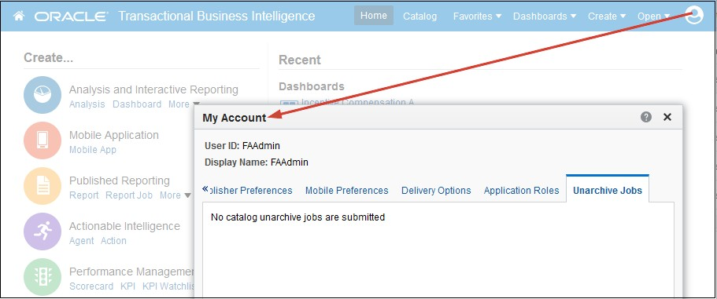

1. Check the status to see whether your unarchive operation is complete, still in progress, not started yet (submitted), or failed for some reason.

### Assign Ownership of Items

When you create content in the catalog, you can grant ownership of the content to others. Also, a user who has been granted the proper privileges can take ownership of content.

For example, you can create a Brand Revenue analysis and grant ownership to a Regional Sales Analyst tasked with maintaining the analysis going forward.

1. On the Home page, click **Catalog**.
2. In the Catalog page, search for the content to which you want to assign ownership.
3. In the search results for the item, click **More** and **Permissions**.
4. In the Permissions table, click the **Owner** column to specify the new owner.

Assume Ownership of Items

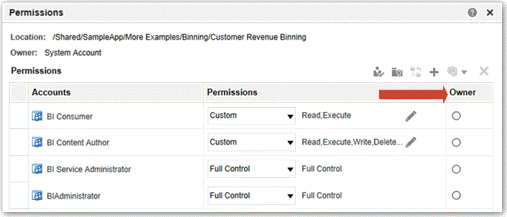

1. Click **OK**.

### Assume Ownership of Items

As a user or a member of a role, you can take ownership of shared folder content if you’re assigned the BIServiceAdministrator role.

For example, if you’re a user of the Sales group, you can assign properties to the Sales Forecast analysis to mark yourself as an owner.

1. On the Home page, click **Catalog**.
2. In the Catalog page, search for the content that you want to own.
3. In the search results for the item, click **More** and **Properties**.

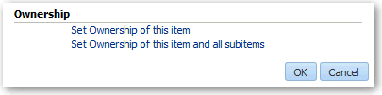

1. In the Ownership area, select whether to take ownership of just the item or of the item and its child items.
2. Click **OK**.

### Allow Safe Domains

You allow safe domains to approve access to specific content.

For security reasons, external content can't be added to reports, and reports can't be embedded in other applications unless it's safe to do so. Only administrators can allow safe domains.

Only authorized users may access the content. Except in cases where Single Sign On (SSO) is enabled, users are prompted to sign in when they access content on safe domains. After you have added a safe domain, users need to sign out and sign back in to access content from that source.

1. On the Home page, click **Administration**.
2. Click **Manage Safe Domains**.

About Embedding External Images and Other External Resources in Your Content

1. To allow users to embed their analyses in content located on other domains, enter the name of the safe domain as well as the port. Here are a few formats you can use for port names:
   * [www.example.com:<](http://www.example.com/)port number>
   * *.example.com:<port number>
   * https:
2. Select the types of resources you want to allow and block any resource types you think aren't safe. For example, to allow embedding, select **Embedding**.

### About Embedding External Images and Other External Resources in Your Content

You can embed external images and other external resources in reports if your administrator considers it safe to do so.

If you try to add an image from an unapproved source, an invalid image error prompts you to contact your administrator to configure a safe domain for the image.

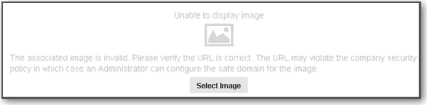

Your administrator maintains a list of safe domains. For example, if you want to embed images from *.example.org, ask your administrator to add this domain to the safe list. See Allow Safe Domains.

In addition to images, your administrator can authorize or restrict access to other web resources, such as frames, scripts, fonts, stylesheets, audio, video, and connections.

### Embed Your Content in Other Applications

You can embed your reports in other non-Oracle applications and portals.

This is a good way to share content and data among multiple systems. When other users click embedded content, if single sign-on isn't configured, they might have to sign in again to see the content.

Before you can embed a report in other applications or portals, your administrator must add the URL for the target applications or portal to the list of allowed domains.

1. Obtain the URL of the analysis or dashboard you want to embed.
2. Go to the catalog and open the analysis or dashboard.
3. In the URL displayed in the browser's address bar, delete "Portal", so that your URL resembles this example, then copy the URL.

[http://example.com:<port](http://example.com/) number>/analytics/saw.dll? Go&Action=prompt&path=%2Fshared%2F<folder>%20<analysis name>

Embed Your Content in Other Applications

1. Sign in to the target application or portal, then embed the content inside an iFrame and use the copied URL.

# 11

## Use BI Composer to Analyze Your Data

This chapter describes how to use BI Composer to quickly and easily create, edit, and view analyses.

Topics:

* + What Is BI Composer?
  + Where Is BI Composer Available?
  + Compare the Analysis Editor and BI Composer
  + Create or Edit an Analysis in BI Composer
  + Create Analyses Using BI Composer
  + Edit Analyses Using BI Composer
  + View Analyses in BI Composer
  + Edit Analyses Created in Analysis Editor

### What Is BI Composer?

BI Composer is a simple-to-use wizard that allows you to create, edit, or view analyses without the complexities of the Analysis editor.

There are two modes in which BI Composer is available — regular mode and accessibility mode. Accessibility mode has the same functionality as regular mode but is optimized for use with screen reader applications such as JAWS. It makes it easier for users with accessibility needs to create, edit, and view analyses.



**Note:**

Visual cues, such as icons or check boxes, displayed on a wizard page in accessibility mode are the same as displayed in regular mode. Even though the list of text-based wizard page links is not displayed on a wizard page in accessibility mode, screen reader applications such as JAWS are able to read them.

The main components of the BI Composer wizard are:

* + At the top of the wizard is the BI Composer train, which contains buttons for each step in the wizard.
  + On the left are the Catalog and Subject Areas tabs. These tabs are available only when BI Composer is part of an ADF application or Oracle WebCenter Portal Framework application or WebCenter Portal.
  + To the right of the tabs is the panel area, where the components for each step are displayed.
  + To the far right are the **Back**, **Next**, **Finish**, and **Cancel** buttons.

Where Is BI Composer Available?

### Where Is BI Composer Available?

You can access BI Composer in several areas. BI Composer is available in:

* + Oracle Transactional Business Intelligence (if your organization has installed and configured it).
  + Any ADF application that has been modified to integrate with Oracle Transactional Business Intelligence.
  + Oracle WebCenter Portal Framework application or WebCenter Portal that has been modified to integrate with Oracle Transactional Business Intelligence.

#### Availability of BI Composer

When users work with analyses, BI Composer may be displayed in place of the Analysis editor, depending on the preferences users make as follows:

* + BI Composer is displayed in regular mode in place of the Analysis editor, when users have specified that they want to use the BI Composer wizard as the analysis editor and have turned off accessibility mode.
  + BI Composer is displayed in accessibility mode in place of the Analysis editor, when users have turned on accessibility mode.

Users:

* + Specify that they want to use the BI Composer wizard as the analysis editor by selecting the **Wizard (limited functionality)** option for the **Analysis editor** component in the Preferences tab of the My Account dialog.
  + Turn accessibility mode on or off by selecting or deselecting the **Accessibility Mode** box in the Sign In page or by selecting **On** or **Off** for the **Accessibility Mode** component in the Preferences tab of the My Account dialog.

### Compare the Analysis Editor and BI Composer

The Analysis editor provides additional editorial tools compared to BI Composer’s more simple analysis features.

The Analysis editor and BI Composer share a similar purpose, in that both are analytical components that power intelligent business process decision making. Collaboration fueled through exploration, analysis, sharing, and visualizations, allows business users at all levels to glean insight into data. BI Composer and the Analysis editor differ however, in that BI Composer is more suitable for simple analyses that don't contain advanced analytic functions such as calculated items, selection steps, and multiple conditions. Sophisticated and highly structured analyses should be edited by using the Analysis editor.

#### What Types of Views Can I Work with in BI Composer?

BI Composer allows you to quickly and simply create or edit analyses.

Create or Edit an Analysis in BI Composer

The table describes the views with which you can work and the options available in BI Composer to enhance the analyses.

**View or Option Description**

Table You can have a table, summary table, pivot table, or summary pivot table.

A table can have prompts and sections.

Graph You can have various types of graphs:

* Bar - Vertical, horizontal, vertical stacked, horizontal stacked, 100% vertical stacked, or 100% horizontal stacked
* Line
* Scatter
* Pie
* Line-Bar

A graph can have various sections:

* Prompts
* Sections
* Group By
* Vary Color By
* Slices (for a pie graph)
* Points (for a scatter graph)

Conditional formatting

See the BI Composer wizard -- Create Analysis: Highlight panel for information.

Column formula See the BI Composer wizard -- Create Analysis: Select Columns panel for information.

Filter See the BI Composer wizard -- Create Analysis: Sort and Filter panel for information.

Interaction Allows you to specify what happens when you click a value. You can drill, navigate to a transaction, or do nothing by specifying None.

Sort See the BI Composer wizard -- Create Analysis: Sort and Filter panel for information.

### Create or Edit an Analysis in BI Composer

Set up or update an analysis in BI Composer using these steps.

* + **Select Columns** — Select the columns to include in the analysis. You can also:
    - Specify column interactions
    - Specify a column formula
    - Rename a column
    - Hide a column

See BI Composer wizard -- Create Analysis: Select Columns panel for additional information.

* + **Select Views** — Select the views to include in the analysis, such as a title, table, pivot table, bar graph, and so on. (Not all views available in Oracle Transactional Business Intelligence are supported in BI Composer.) You can also preview the results and display the associated XML code.

Create Analyses Using BI Composer

* + **Edit Table** — Edit the layout of the tabular view (if you have included a tabular view). For example, you can create prompts, use a column to section the analysis, and exclude certain columns from the tabular view. You can also preview the results.
  + **Edit Graph** — Edit the properties and layout of the graph (if you have included a graph view). For example, you can create prompts, use a column to section the analysis, and exclude certain columns from the graph. You can also preview the results.
  + **Sort and Filter** — Apply sorting and filters to the views. You can also preview the results.
  + **Highlight** — Apply conditional formatting to the tabular view (if you have included a tabular view). You can also preview the results.

### Create Analyses Using BI Composer

You can create analyses in BI Composer in multiple ways.

1. In Oracle Transactional Business Intelligence:
   1. In the global header, click **New**, then **Analysis**.
   2. Select a subject area. The BI Composer wizard is displayed in a new window.
2. In other applications (such as an ADF application):
   1. Click the **Subject Areas** tab.
   2. Select a subject area.
   3. Click **Create**.
3. In the Select Columns panel, select the columns to include in the analysis. For each column that you want to add:
   1. Select the column in the Subject Areas list.
   2. Click **Add** to move it to the Selected Columns list.

If you want to add or remove subject areas from which to select columns, click the **Add** button in the Subject Area: *Subject_Area_Name* area to display the Add/ Remove Subject Areas dialog.

1. Click the **Select Views** button in the BI Composer train at the top of the wizard.
2. In the BI Composer wizard -- Create Analysis: Select Views panel, specify the views to include.
3. Click the **Save** button in the BI Composer train.
4. In the BI Composer wizard -- Create Analysis: Save panel, save the analysis with the same name or with a different name by specifying the save criteria and then clicking **Submit**.

Oracle WebLogic Scripting Tool

### Edit Analyses Using BI Composer

BI Composer is a simple-to-use wizard that allows you to create, edit, or view analyses.

You edit an analysis using BI Composer when you:

View Analyses in BI Composer

* + Edit an analysis from the Catalog page or from the **Recent** section or the **Most Popular**

section of the Home page

* + Edit an analysis from within a dashboard

In other applications (such as an ADF application), you select an analysis to edit directly from the BI Composer wizard.

1. Edit the analysis in one of the following ways:
   * From the Catalog or Home page, navigate to the analysis and click **Edit**. The BI Composer wizard is displayed.
   * From the BI Composer wizard, click the **Catalog** tab, select the analysis, and click

Edit.

1. Make the changes to the analysis by navigating the steps of the wizard using the buttons in the BI Composer train at the top of the wizard, and save your changes.

### View Analyses in BI Composer

You can view analyses that are optimized for BI Composer.

If you are working in BI Composer in an application other than Oracle Transactional Business Intelligence (such as an ADF application), then you can display an analysis for viewing in BI Composer. In Oracle Transactional Business Intelligence, simply use the Analysis editor.

1. Click the **Catalog** tab.
2. Select the analysis.
3. Click **View**. The analysis is displayed for viewing to the right of the Catalog tab.

### Edit Analyses Created in Analysis Editor

The analysis editor enables you to use more powerful analytics features that aren't in BI Composer, such as:

* + Conditional format
  + Excluded columns
  + Filters
  + Prompts
  + Sections
  + Slices for pie graphs
  + Sorts
  + Title
  + Vary measure by color and points for scatter graphs

If you edit an analyses in BI Composer, you might receive an error message stating that there are incompatible elements in the analysis.

This message can occur for a variety of reasons. For example:

* + Green bar formatting has been applied to the analysis.
  + An incompatible graph view such as, gauge or performance tile, is part of the analysis.

Edit Analyses Created in Analysis Editor

* + An incompatible view such as, selection step or filter, is part of the analysis.
  + Duplicate view type exists. For example, if the analysis contains a table, pivot table, pie graph, and bar graph, only one table and one graph are converted in BI Composer. The table or pivot table is converted as a summary table and the graph defaults to the first compatible graph type in the analysis.

To edit an analysis using BI Composer when you have received an incompatibility error message:

1. Click **Show details** to view the messages.
2. Examine the messages.
3. When you are sure that you want to proceed, click **Yes.** The BI Composer wizard

-- Create Analysis: Edit Graph panel displays.

# Part III

## Reference

This part provides reference information.

Topics:

* + Frequently Asked Questions
  + Troubleshooting for Oracle Transactional Business Intelligence
  + Expression Editor Reference
  + Accessibility Features and Tips

# 12

## Frequently Asked Questions

This chapter provides answers to frequently asked questions about visualizing and reporting data.

Topics:

* + FAQs to Explore and Report
  + FAQs for Analyses and Dashboards

### FAQs to Explore and Report

This topic provides answers to frequently asked questions about exploring and reporting data.

What are the display limits for prompts?

|  |  |  |
| --- | --- | --- |
| **Prompt Limits** | **Limit** | **More Information** |
| Maximum number of choice values | 1000 | Applies to:   * Choice lists, check boxes, list boxes, and radio buttons in prompts. |
|  |  | * List of values displayed in the Select Values dialog when you select the Search option in a prompt values list. |
| Maximum number of default values | 1000 | Applies to dashboard prompts. |

**What's the maximum size map layer file that I can upload?**

The maximum file size that you can upload is 25MB.

When I want to save an object, where does the default location come from?

You can save any object in any location. However, the **Save In** field in the Save dialog sometimes recommends the best location based on the object type that you’re saving. For example, you should save filters, groups, and calculated items within a subject area folder so that these items are available when you build an analysis for the same subject area. If a subject area folder doesn’t exist in your /My Folders or within /Shared Folders, then a subject area folder is created automatically. The **Save In** field defaults a save path to /My Folders/Subject Area Contents/<*subject area*>; however, the dialog's Folders area displays all instances of the subject area folder in the catalog.

You can save other objects such as analyses and prompts in any folder. Bear in mind the distinctions between shared and personal folders, when deciding whether to share the object that you’re saving with others.

FAQs to Explore and Report

Can I enable other users to access my analyses, dashboards, and workbooks?

Yes. To enable other users to access your analyses, dashboards, and workbooks, move or save the analysis, dashboard, or workbook to a shared folder and then give other users the required access permissions. See Assign Access Permissions.

Can I make analyses and dashboards interact with prompts and other analyses?

Yes, analyses and dashboards interact with prompts. See Advanced Techniques: How Dashboard Prompts and Analysis Prompts Interact. You can link views such that one view drives changes in one or more other views. See Linking Views in Master-Detail Relationships.

I have interacted with a dashboard drilling and applying filters. How do I save the state of my dashboard and share the dashboard with others?

You can save and get back the settings that you make on a dashboard. See Save and Restore Dashboard State. You can share dashboard pages with other users by sharing links to those pages. See Link to Dashboard Pages.

How do I remove the Diagnose link displayed on my analyses and dashboards?

In Classic view, sign in as a user with the BI Service Administrator role and set the value of the configuration setting **Diagnose BI Server Query** to **Denied**. You can find this setting under **Administration**\ **Security - Manage Privileges**\**Admin: General**.

**Tip**: You can access the Administration page by clicking the *user* **My Profile** icon, then

Administration.

**Can I migrate analyses between different environments?**

Yes. You can migrate analyses between service environments by copying and pasting the XML code for the analyses using the Advanced tab of the analysis editor. See Advanced Techniques: Examining the Logical SQL Statements for Analyses.

Can I change default logo and dashboard style?

Yes. On the Dashboard Properties page, choose a predefined theme that includes a custom logo from the **Style** list. Administrators create these themes and make them available to dashboard builders.

Why don't I see images from background maps when I print pages or when I export images in formats such as PDF, PPT, and PNG?

You or a visualization builder might have added an image to a background map by referencing that image with a URL. For the image to print or be exported in various formats, the external website hosting that image must have the Access-Control-Allow- Origin header from the host server. If a map background includes an image reference that's taken from an external website that doesn't have this header, you won't see the image.

For more information about this header, see [https://www.w3.org/wiki/CORS_Enabled](http://www.w3.org/wiki/CORS_Enabled)

Why do some users have read permissions that I didn't assign?

If you save or move a report, dashboard, or workbook containing an artifact (for example, a dataset) to a shared folder, and when prompted you share the related

artifacts, then Oracle Analytics assigns the artifacts read permissions for the users who can access the report, dashboard, or workbook in the shared folder.

Without the read permission, users won't be able to access the correct content when they open the report, dashboard, or workbook.

### FAQs for Analyses and Dashboards

This topic provides answers to some frequently asked questions when using analyses and dashboards.

Is there a maximum image size that will display in analyses and dashboards?

You can display images that are less than 32kb in size. If an image is greater than 32kb then it won’t display.

Do I need to create copies of predefined reports and analyses for each user?

No, you don't need to create multiple versions of the same analysis or report for different users. When you view an object, it includes only the data that you have permission to view from your data security profile.

What are subject areas, dimensions, attributes, facts, and metrics?

Information for your analytics is grouped into related functional areas called subject areas that contain fact and dimension folders with metrics and columns you can add to your analyses.

Dimension folders include the grouping of dimensional attributes for the subject area. Columns (such as date of birth or name) that are grouped for a dimension are known as attributes. Fact folders contain formulas for getting calculated numeric values, such as counts, sums, and percentages.

What's the relationship between dimensions and fact in a subject area?

A subject area is based around a single fact. The dimensions are all related to each other through the fact only. The fact is automatically included in any query that's created, even if none of the measures in the fact appear in the analysis.

What's a common dimension?

A common dimension is shared across multiple subject areas. For example, Time, Department, and Location are common dimensions. When constructing a cross-subject area analysis, only common dimensions can be used.

How can I determine which dimensions are shared across two subject areas?

If the dimensions exist in both subject areas, they're common dimensions, and are often among the first folders in a subject area. You can join any subject areas you have access to in Answers, but analyses are subject to the normalized data structure. Unless the underlying tables are joined by design, joining subject areas in Answers results in errors.

How can I identify subject areas to create analyses?

All OTBI subject area names end with the words "Real Time".

FAQs for Analyses and Dashboards

Can I change the columns in subject areas?

You can use only the available subject areas and their dimensions and facts. The prebuilt data elements are the only ones that you can make use of. You can potentially use BI-enabled flexfields to analyze any column in the transactional tables.

Do analyses query transactional tables to display data?

Analyses run real-time queries of transactional tables through View Objects. Oracle Fusion data security, flexfields, user interface hints, lists of values, and other metadata are delivered through the View Objects.

Why did my agent not translate according to my location preferences?

The translation of your agents depends on how you run them and how the session is established.

If you navigate to the Catalog from the Reports and Analytics work area, the session information doesn't affect translation, so the default location is applied. If you navigate directly to Oracle Transactional Business Intelligence (for example: http:// host:port/analytics/saw.dll), the locale (location) settings for your session in My Account are applied to the data.

What's a dashboard?

A dashboard is a container page to display analyses, reports, and other objects. Administrators can create shared dashboards for groups of users with common responsibilities or job functions. Personalized views can be created based on a user's permissions.

What are the row limits in analyses?

Because analyses have row limits, use Publisher when you need to export large amounts of data.

* + There's a limit of 65,000 records for analyses. When you run an analysis that contains more rows than that, the results are limited to 65,000 rows.
  + Exports to Excel are limited to 25,000 rows and 50,000 cells.

Is there a constraint for embedding content in an iFrame?

Yes, the Content Security Policy (CSP) blocks data content in an iFrame because the frame-src directive doesn't permit "data:". Oracle doesn’t allow ":data" for frame-src to avoid security issues.

For example, in the Narrative view of an analysis, you can't include the "data": attribute to embed content.

What is the maximum size for an email?

An email that Oracle.com delivers or accepts from the internet mustn't exceed 15MB. The sum of the sizes of message text, headers, attachments, and embedded images mustn't exceed 15MB.

How do I remove HTML tags that are displayed in an analysis or report?

If a column in an analysis displays unwanted HTML tags, you can change the column's default data format to correctly display the HTML.

1. Click **Edit** to edit the analysis containing the column for which you want to remove the HTML tags.
2. In the **Criteria** tab, select **Column Properties** for the required column, then select the

**Data Format** tab.

1. Select **Override Default Data Format** and choose **HTML** in the **Treat Text As** field, then click **OK**.

## Troubleshooting for Oracle Transactional Business Intelligence

This chapter describes common problems that you might encounter when using Oracle Transactional Business Intelligence and explains how to solve them.

Topics:

* + Troubleshoot General Issues
  + Troubleshoot Issues with Analyses and Dashboards

### Troubleshoot General Issues

This topic describes common problems that you might encounter and explains how to solve them.

I can’t access certain options from the Home page

Check with your administrator to ensure that you have the correct permissions to access the options that you need.

I see a performance decrease when using Mozilla Firefox

If you use Mozilla Firefox and notice a decrease in the performance of the cloud service, then ensure that the **Remember History** option is enabled. When Firefox is set to not remember the history of visited pages, then web content caching is also disabled, which greatly affects the performance of the service. See Firefox documentation for details on setting this option.

### Troubleshoot Issues with Analyses and Dashboards

This topic describes common problems that you might encounter when using analyses and dashboards, and explains how to solve them.

I can’t see data in an analysis

You open an analysis, but you don’t see any data in it.

Ensure that you have the appropriate job and duty roles assigned. Contact your administrator for assistance.

You might not have the permissions needed to access the data. Contact the object's owner or administrator and ask them to check your access permissions. You'll need read permissions to the analysis and any artifacts included in the analysis.

Users must have subject area specific roles to see data in Fusion Applications Suite OTBI analyses. See documentation about each subject area by using the **Subject area** links in the [Fusion Cloud Applications Content](https://docs.oracle.com/en/cloud/saas/otbi/fa-index.html) library page.

Troubleshoot Issues with Analyses and Dashboards

I can’t access a particular analysis or dashboard

You attempt to display an analysis or dashboard and find that you don’t have access.

Typically you can’t access an analysis or dashboard if you lack the appropriate permissions or application role for accessing it. Contact the owner of the analysis or dashboard or your administrator for assistance in obtaining the proper permissions or application role.

I can’t find an analysis or dashboard

Try searching the catalog. You can search for analyses or dashboards by name (full or partial) and by folder location. The search isn’t case-sensitive. Searches of the catalog return only those objects that you have permission to see.

If you still can’t find an analysis or dashboard and you suspect that it was deleted by mistake, restore content from another environment or from a local backup. See About Backing Up and Restoring Content.

The analysis is running very slowly

You attempt to run an analysis and find that it takes a long time.

Various underlying circumstances can cause an analysis to run slowly. Contact your administrator and ask them to review log files associated with the analysis. After reviewing the log files with the administrator, make the appropriate adjustments in the analysis.

The analysis returned data that I didn’t expect

Various underlying circumstances can cause an analysis to return unexpected results. For an analysis, in the Subject Areas pane of the Criteria tab, click **Refresh** to ensure that you’re seeing the most recent information.

I don’t understand why my analysis shows a view display error

When you display an analysis, you might see a message such as the following: "View Display Error. Exceed configured maximum number of allowed input records." This message indicates that you've selected more data than can be displayed in a view of that type. Add one or more filters to the analysis to reduce the amount of data. For example, add a filter that specifies a date range of only a few years.

Why do I see amounts of zero in analyses?

The currency exchange rates might not be set up correctly. For example, you choose Ledger currency as your preferred currency in general preferences, and your corporate currency is USD. Amounts in analyses are displayed in Ledger currency after conversion from USD, based on the current exchange rate. But if the exchange rate between Ledger currency and USD isn't set up, or if the conversion fails for any reason, then the amounts show as zero.

## Expression Editor Reference

This section describes the expression elements that you can use in the Expression Editor.

Topics:

* + SQL Operators
  + Conditional Expressions
  + Functions
  + Constants
  + Types

### SQL Operators

You use SQL operators to specify comparisons and arithmetic operations between expressions.

You can use various types of SQL operators.

**Operator Example Description Syntax**

BETWEEN "COSTS"."UNIT_C

OST" BETWEEN

100.0 AND 5000.0

IN "COSTS"."UNIT_C OST" IN(200, 600, 'A')

Determines if a value is between two non-inclusive bounds.

BETWEEN can be preceded with NOT to negate the condition.

Determines if a value is present in a set of values.

BETWEEN

[LowerBound] AND [UpperBound]

IN ([Comma Separated List])

IS NULL "PRODUCTS"."PRO D_NAME" IS NULL

Determines if a value is null. IS NULL

LIKE "PRODUCTS"."PRO D_NAME" LIKE

'prod%'

Determines if a value matches all or part of a string. Often used with wildcard characters to indicate any character string match of zero or more characters (%) or any single character match (_).

LIKE

+ (FEDERAL_REVENU E + LOCAL_REVENUE)

- TOTAL_EXPENDITU RE

Plus sign for addition. +

SQL Operators

|  |  |  |  |
| --- | --- | --- | --- |
| **Operator** | **Example** | **Description** | **Syntax** |
| - | (FEDERAL_REVENU | Minus sign for subtraction. | - |
|  | E + |  |  |
|  | LOCAL_REVENUE) |  |  |
|  | - |  |  |
|  | TOTAL_EXPENDITU |  |  |
|  | RE |  |  |
| * *or* X | SUPPORT_SERVICE | Multiply sign for multiplication. | * |

S_EXPENDITURE * 1.5

/ CAPITAL_OUTLAY_ EXPENDITURE/ 1.05

X

Divide by sign for division. /

% Percentage %

|| STATE||

CAST(YEAR AS CHAR(4))

( (FEDERAL_REVENU E + LOCAL_REVENUE)

- TOTAL_EXPENDITU RE

) (FEDERAL_REVENU E + LOCAL_REVENUE)

- TOTAL_EXPENDITU RE

Character string concatenation. ||

Open parenthesis. (

Close parenthesis. )

> YEAR > 2000 and YEAR < 2016 and YEAR <> 2013

< YEAR > 2000 and YEAR < 2016 and YEAR <> 2013

Greater than sign, indicating values >

higher than the comparison.

Less than sign, indicating values lower <

than the comparison.

= Equal sign, indicating the same value. =

>= Greater than or equal to sign, indicating >= values the same or higher than the comparison.

<= Less than or equal to sign, indicating <= values the same or lower than the comparison.

<> YEAR > 2000 and YEAR < 2016 and YEAR <> 2013

, STATE in

('ALABAMA','CAL IFORNIA')

Not equal to, indicating values higher or <>

lower, but different.

Comma, used to separate elements in a ,

list.

Conditional Expressions

### Conditional Expressions

You use conditional expressions to create expressions that convert values.

The conditional expressions described in this section are building blocks for creating expressions that convert a value from one form to another.

Follow these rules:

* + In CASE statements, AND has precedence over OR.
  + Strings must be in single quotes.

**Expression Example Description Syntax**

CASE (If) CASE

WHEN score-par < 0 THEN 'Under Par'

WHEN score-par = 0 THEN 'Par'

WHEN score-par = 1 THEN 'Bogey'

WHEN score-par = 2 THEN 'Double Bogey'

ELSE 'Triple Bogey or Worse'

END

Evaluates each WHEN condition and if satisfied, assigns the value in the corresponding THEN expression.

If none of the WHEN conditions are satisfied, it assigns the default value specified in the ELSE expression. If no ELSE expression is specified, the system automatically adds an ELSE NULL.

**Note**: See *Best Practices for using CASE statements in Analyses and Visualizations*.

CASE WHEN

request_condition1 THEN expr1 ELSE expr2 END

CASE

(Switch)

CASE Score-par

WHEN -5 THEN 'Birdie on Par 6'

WHEN -4 THEN 'Must be

Tiger'

WHEN -3 THEN 'Three

under par'

WHEN -2 THEN 'Two under par'

WHEN -1 THEN 'Birdie' WHEN 0 THEN 'Par' WHEN 1 THEN 'Bogey'

WHEN 2 THEN 'Double Bogey'

ELSE 'Triple Bogey or Worse'

END

Also referred to as CASE (Lookup). The value of the first expression is examined, then the WHEN expressions. If the first expression matches any WHEN expression, it assigns the value in the corresponding THEN expression.

If none of the WHEN expressions match, it assigns the default value specified in the ELSE expression. If no ELSE expression is specified, the system automatically adds an ELSE NULL.

If the first expression matches an expression in multiple WHEN clauses, only the expression following the first match is assigned.

**Note** See *Best Practices for using CASE statements in Analyses and Visualizations*.

CASE expr1 WHEN expr2 THEN expr3 ELSE expr4 END

|  |  |  |  |
| --- | --- | --- | --- |
| **Expression** | **Example** | **Description** | **Syntax** |
| IfCase > ELSE | - | - | ELSE [expr] |
| IfCase > IFNULL | - | - | IFNULL([expr],  [value]) |
| IfCase > NULLIF | - | - | NULLIF([expr],  [expr]) |

### Functions

IfCase > WHEN

IfCase > CASE

SwitchCase > ELSE

SwitchCase

>IFNULL

SwitchCase > NULLIF

SwitchCase > WHEN

* - WHEN [Condition] THEN [expr]
* - CASE WHEN

[Condition] THEN [expr] END

* - ELSE [expr]
* - IFNULL([expr],

[value])

* - NULLIF([expr],

[expr])

* - WHEN [Condition] THEN [expr]

There are various types of functions that you can use in expressions.

Topics:

* + Aggregate Functions
  + Analytics Functions
  + Date and Time Functions
  + Conversion Functions
  + Display Functions
  + Mathematical Functions
  + Running Aggregate Functions
  + String Functions
  + System Functions
  + Time Series Functions

#### Aggregate Functions

Aggregate functions perform operations on multiple values to create summary results.

The following list describes the aggregation rules that are available for columns and measure columns. The list also includes functions that you can use when creating calculated items for analyses.

* + **Default** — Applies the default aggregation rule as in the Oracle BI Repository or by the original author of the analysis. Not available for calculated items in analyses.
  + **Server Determined** — Applies the aggregation rule that's determined by the Oracle BI Server (such as the rule that is defined in the Oracle BI Repository). The aggregation is performed within Oracle BI Server for simple rules such as Sum, Min, and Max. Not available for measure columns in the Layout pane or for calculated items in analyses.
  + **Sum** — Calculates the sum obtained by adding up all values in the result set. Use this for items that have numeric values.
  + **Min** — Calculates the minimum value (lowest numeric value) of the rows in the result set. Use this for items that have numeric values.
  + **Max** — Calculates the maximum value (highest numeric value) of the rows in the result set. Use this for items that have numeric values.
  + **Average** — Calculates the average (mean) value of an item in the result set. Use this for items that have numeric values. Averages on tables and pivot tables are rounded to the nearest whole number.
  + **First** — In the result set, selects the first occurrence of the item for measures. For calculated items, selects the first member according to the display in the Selected list. Not available in the Edit Column Formula dialog.
  + **Last** — In the result set, selects the last occurrence of the item. For calculated items, selects the last member according to the display in the Selected list. Not available in the Edit Column Formula dialog.
  + **Count** — Calculates the number of rows in the result set that have a non-null value for the item. The item is typically a column name, in which case the number of rows with non-null values for that column are returned.
  + **Count Distinct** — Adds distinct processing to the Count function, which means that each distinct occurrence of the item is counted only once.
  + **None** — Applies no aggregation. Not available for calculated items in analyses.
  + **Report-Based Total (when applicable)** — If not selected, specifies that the Oracle BI Server should calculate the total based on the entire result set, before applying any filters to the measures. Not available in the Edit Column Formula dialog or for calculated items in analyses. Only available for attribute columns.

**Function Example Description Syntax**

AGGREGATE AT

AGGREGATE(sales AT month, region)

Aggregates columns based on the level or levels you specify.

*measure* is the name of a measure column. level is the level at which you want to aggregate. You can optionally specify more than one level. You can't specify a level from a dimension that contains levels that are being used as the measure level for the measure you specified in the first argument. For example, you can't write the function as AGGREGATE(yearly_sales AT month) because *month* is from the same time dimension that's being used as the measure level for *yearly_sales*.

AGGREGATE(measure AT level [, level1, levelN])

AVG Avg(Sales) Calculates the average (mean) of a numeric

set of values.

AVG(expr)

|  |  |  |  |  |
| --- | --- | --- | --- | --- |
| **Function** | **Example** |  | **Description** | **Syntax** |
| AVGDISTINCT |  |  | Calculates the average (mean) of all distinct values of an expression. | AVG(DISTINCT expr) |
| BIN | BIN(revenue | BY | Classifies a given numeric expression into a | BIN(numeric_expr [BY |

productid, year WHERE productid

> 2 INTO 4 BINS RETURNING RANGE_LOW)

specified number of equal width buckets. The function can return either the bin number or one of the two end points of the bin interval. numeric_expr is the measure or numeric attribute to bin. BY grain_expr1,…, grain_exprN is a list of expressions that define the grain at which the numeric_expr is calculated. BY is required for measure expressions and is optional for attribute expressions. WHERE a filter to apply to the numeric_expr before the numeric values are assigned to bins INTO number_of_bins BINS is the number of bins to return BETWEEN min_value AND max_value is the min and max values used for the end points of the outermost bins RETURNING NUMBER indicates that the return value should be the bin number (1, 2, 3, 4, etc.). This is the default. RETURNING RANGE_LOW indicates the lower value of the bin interval RETURNING RANGE_HIGH indicates the higher value of the bin interval

grain_expr1, ..., grain_exprN] [WHERE condition] INTO number_of_bins BINS [BETWEEN min_value AND max_value] [RETURNING {NUMBER | RANGE_LOW | RANGE_HIGH}])

BottomN Ranks the lowest n values of the expression argument from 1 to n, 1 corresponding to the lowest numerical value.

*expr* is any expression that evaluates to a numerical value. integer is any positive integer. Represents the bottom number of rankings displayed in the result set, 1 being the lowest rank.

COUNT COUNT(Products) Determines the number of items with a non-

null value.

BottomN(expr, integer)

COUNT(expr)

COUNTDISTIN CT

Adds distinct processing to the COUNT function.

*expr* is any expression.

COUNT(DISTINCT expr)

COUNT* SELECT COUNT(*)

FROM Facts

Counts the number of rows. COUNT(*)

First First(Sales) Selects the first non-null returned value of

the expression argument. The First function operates at the most detailed level specified in your explicitly defined dimension.

Last Last(Sales) Selects the last non-null returned value of

the expression.

First([NumericExpress ion)]

Last([NumericExpressi on)]

|  |  |  |  |
| --- | --- | --- | --- |
| **Function** | **Example** | **Description** | **Syntax** |
| MAVG |  | Calculates a moving average (mean) for the last n rows of data in the result set, inclusive | MAVG(expr, integer) |
|  |  | of the current row. |  |
|  |  | *expr* is any expression that evaluates to a |  |
|  |  | numerical value. integer is any positive |  |
|  |  | integer. Represents the average of the last n |  |
|  |  | rows of data. |  |
| MAX | MAX(Revenue) | Calculates the maximum value (highest numeric value) of the rows satisfying the | MAX(expr) |
|  |  | numeric expression argument. |  |
| MEDIAN | MEDIAN(Sales) | Calculates the median (middle) value of the rows satisfying the numeric expression | MEDIAN(expr) |
|  |  | argument. When there are an even number |  |
|  |  | of rows, the median is the mean of the two |  |
|  |  | middle rows. This function always returns a |  |
|  |  | double. |  |
| MIN | MIN(Revenue) | Calculates the minimum value (lowest numeric value) of the rows satisfying the | MIN(expr) |
|  |  | numeric expression argument. |  |
| NTILE |  | Determines the rank of a value in terms of a user-specified range. It returns integers to | NTILE(expr, numTiles) |
|  |  | represent any range of ranks. NTILE with |  |
|  |  | numTiles=100 returns what is commonly |  |
|  |  | called the "percentile" (with numbers ranging |  |
|  |  | from 1 to 100, with 100 representing the high |  |
|  |  | end of the sort). |  |
|  |  | *expr* is any expression that evaluates to a |  |
|  |  | numerical value. numTiles is a positive, |  |
|  |  | nonnull integer that represents the number of |  |
|  |  | tiles. |  |
| PERCENTILE |  | Calculates a percentile rank for each value satisfying the numeric expression argument. | PERCENTILE(expr) |
|  |  | The percentile rank ranges are between 0 |  |
|  |  | (0th percentile) to 1 (100th percentile). |  |
|  |  | *expr* is any expression that evaluates to a |  |
|  |  | numerical value. |  |
| RANK | RANK(chronologic al_key, null, year_key_columns  ) | Calculates the rank for each value satisfying the numeric expression argument. The highest number is assigned a rank of 1, and each successive rank is assigned the next consecutive integer (2, 3, 4,...). If certain values are equal, they'reare assigned the same rank (for example, 1, 1, 1, 4, 5, 5, 7...).  *expr* is any expression that evaluates to a numerical value. | RANK(expr) |
| STDDEV | STDDEV(Sales) | Returns the standard deviation for a set of | STDDEV(expr) |
|  | STDDEV(DISTINCT | values. The return type is always a double. |  |
|  | Sales) |  |  |
| STDDEV_POP | STDDEV_POP(Sales  ) STDDEV_POP(DISTI | Returns the standard deviation for a set of values using the computational formula for population variance and standard deviation. | STDDEV_POP([NumericEx pression]) |
|  | NCT Sales) |  |  |

**Function Example Description Syntax**

SUM SUM(Revenue) Calculates the sum obtained by adding up all

values satisfying the numeric expression argument.

SUMDISTINCT Calculates the sum obtained by adding all of the distinct values satisfying the numeric expression argument.

*expr* is any expression that evaluates to a numerical value.

TOPN Ranks the highest n values of the expression argument from 1 to n, 1 corresponding to the highest numerical value.

*expr* is any expression that evaluates to a numerical value. integer is any positive integer. Represents the top number of rankings displayed in the result set, 1 being the highest rank.

SUM(expr)

SUM(DISTINCT expr)

TOPN(expr, integer)

#### Analytics Functions

Analytics functions allow you to explore data using models such as trendline and cluster.

**Function Example Description Syntax**

TRENDLINE TRENDLINE(revenue,

(calendar_year, calendar_quarter, calendar_month) BY (product), 'LINEAR', 'VALUE')

CLUSTER CLUSTER((product,

company), (billed_quantity, revenue), 'clusterName', 'algorithm=k- means;numClusters=%1;maxI ter=%2;useRandomSeed=FALS E;enablePartitioning=TRUE ', 5, 10)

OUTLIER OUTLIER((product,

company), (billed_quantity, revenue), 'isOutlier', 'algorithm=kmeans')

Fits a linear, polynomial, or exponential model, and returns the fitted values or model. The *numeric_expr* represents the Y value for the trend and the *series* (time columns) represent the X value.

Collects a set of records into groups based on one or more input expressions using K-Means or Hierarchical Clustering.

Classifies a record as Outlier based on one or more input expressions using K-Means or Hierarchical Clustering or Multi-Variate Outlier detection Algorithms.

TRENDLINE(numeric_expr, ([series]) BY

([partitionBy]), model_type, result_type)

CLUSTER((dimension_expr1

, ... dimension_exprN), (expr1, ... exprN), output_column_name, options, [runtime_binded_options])

OUTLIER((dimension_expr1

, ... dimension_exprN), (expr1, ... exprN), output_column_name, options, [runtime_binded_options])

**Function Example Description Syntax**

REGR REGR(revenue, (discount_amount), (product_type, brand), 'fitted', '')

#### Date and Time Functions

Fits a linear model and returns the fitted values or model. This function can be used to fit a linear curve on two measures.

REGR(y_axis_measure_expr, (x_axis_expr), (category_expr1, ..., category_exprN), output_column_name, options, [runtime_binded_options])

Date and time functions manipulate data based on DATE and DATETIME.

|  |  |  |  |
| --- | --- | --- | --- |
| **Function** | **Example** | **Description** | **Syntax** |
| CURRENT_Dat | CURRENT_DATE | Returns the current date. | CURRENT_DATE |
| e |  | The date is determined by the system in |  |
|  |  | which the Oracle BI is running. |  |
| CURRENT_TI ME | CURRENT_TIME(*3*) | Returns the current time to the specified number of digits of precision, for example: | CURRENT_TIME(expr) |
|  |  | HH:MM:SS.SSS |  |
|  |  | If no argument is specified, the function |  |
|  |  | returns the default precision. |  |
| CURRENT_TI | CURRENT_TIMESTAM | Returns the current date/timestamp to the | CURRENT_TIMESTAMP(exp |
| MESTAMP | P(3) | specified number of digits of precision. | r) |
| DAYNAME | DAYNAME(Order_Da te) | Returns the name of the day of the week for a specified date expression. | DAYNAME(expr) |
| DAYOFMONTH | DAYOFMONTH(Order  _Date) | Returns the number corresponding to the day of the month for a specified date expression. | DAYOFMONTH(expr) |
| DAYOFWEEK | DAYOFWEEK(Order_ Date) | Returns a number between 1 and 7 corresponding to the day of the week for a specified date expression. For example, 1 | DAYOFWEEK(expr) |
|  |  | always corresponds to Sunday, 2 |  |
|  |  | corresponds to Monday, and so on through |  |
|  |  | to Saturday which returns 7. |  |
| DAYOFYEAR | DAYOFYEAR(Order_ Date) | Returns the number (between 1 and 366) corresponding to the day of the year for a specified date expression. | DAYOFYEAR(expr) |
| DAY_OF_QUA RTER | DAY_OF_QUARTER(O  rder_Date) | Returns a number (between 1 and 92) corresponding to the day of the quarter for the specified date expression. | DAY_OF_QUARTER(expr) |
| HOUR | HOUR(Order_Time) | Returns a number (between 0 and 23) corresponding to the hour for a specified | HOUR(expr) |
|  |  | time expression. For example, 0 corresponds |  |
|  |  | to 12 a.m. and 23 corresponds to 11 p.m. |  |
| MINUTE | MINUTE(Order_Tim e) | Returns a number (between 0 and 59) corresponding to the minute for a specified time expression. | MINUTE(expr) |

|  |  |  |  |
| --- | --- | --- | --- |
| **Function** | **Example** | **Description** | **Syntax** |
| MONTH | MONTH(Order_Time  ) | Returns the number (between 1 and 12) corresponding to the month for a specified date expression. | MONTH(expr) |
| MONTHNAME | MONTHNAME(Order_ Time) | Returns the name of the month for a specified date expression. | MONTHNAME(expr) |
| MONTH_OF_Q | MONTH_OF_QUARTE | Returns the number (between 1 and 3) | MONTH_OF_QUARTER(expr |
| UARTER | R(Order_Date) | corresponding to the month in the quarter for a specified date expression. | ) |
| NOW | NOW() | Returns the current timestamp. The NOW | NOW() |
|  |  | function is equivalent to the |  |
|  |  | CURRENT_TIMESTAMP function. |  |
| QUARTER_OF  _YEAR | QUARTER_OF_YEAR(  Order_Date) | Returns the number (between 1 and 4) corresponding to the quarter of the year for a specified date expression. | QUARTER_OF_YEAR(expr) |
| SECOND | SECOND(Order_Tim e) | Returns the number (between 0 and 59) corresponding to the seconds for a specified time expression. | SECOND(expr) |
| TIMESTAMPAD | TIMESTAMPADD(SQL | Adds a specified number of intervals to a | TIMESTAMPADD(interval |
| D | _TSI_MONTH, | timestamp, and returns a single timestamp. | , expr, timestamp) |
|  | 12,Time."Order Date") | Interval options are: *SQL_TSI_SECOND*, *SQL_TSI_MINUTE*, *SQL_TSI_HOUR*, *SQL_TSI_DAY*, *SQL_TSI_WEEK*, |  |
|  |  | *SQL_TSI_MONTH*, *SQL_TSI_QUARTER*, |  |
|  |  | *SQL_TSI_YEAR* |  |
| TIMESTAMPDI | TIMESTAMPDIFF(SQ | Returns the total number of specified | TIMESTAMPDIFF(interva |
| FF | L_TSI_MONTH, | intervals between two timestamps. | l, expr, timestamp2) |
|  | Time."Order  Date",CURRENT_DA | Use the same intervals as TIMESTAMPADD. |  |
|  | TE) |  |  |
| WEEK_OF_QU ARTER | WEEK_OF_QUARTER(  Order_Date) | Returns a number (between 1 and 13) corresponding to the week of the quarter for the specified date expression. | WEEK_OF_QUARTER(expr) |
| WEEK_OF_YE AR | WEEK_OF_YEAR(Ord  er_Date) | Returns a number (between 1 and 53) corresponding to the week of the year for the specified date expression. | WEEK_OF_YEAR(expr) |
| YEAR | YEAR(Order_Date) | Returns the year for the specified date expression. | YEAR(expr) |

#### Conversion Functions

Conversion functions convert a value from one form to another.

**Function Example Description Syntax**

CAST CAST(hiredate AS CHAR(40)) FROM

employee

Changes the data type of an expression or a null literal to another data type. For example, you can cast a *customer_name* (a data type of CHAR or VARCHAR) or *birthdate* (a datetime literal).

CAST(expr AS type)

ID" FROM employees e, job_history j WHERE e.employee_id = j.employee_id ORDER BY last_name, "Old Job ID";

To_DateTime SELECT To_DateTime

('2009-03-0301:01:00'

, 'yyyy-mm-dd hh:mi:ss') FROM sales

VALUEOF SalesSubjectArea.Cust

omer.Region = VALUEOF("Region Security"."REGION")

#### Display Functions

returns the first expression. You can’t specify the literal NULL for the first expression.

Converts string literals of *DateTime*

|  |  |  |  |
| --- | --- | --- | --- |
| **Function** | **Example** | **Description** | **Syntax** |
| IFNULL | IFNULL(Sales, 0) | Tests if an expression evaluates to a null value, and if it does, assigns the | IFNULL(expr, value) |
|  |  | specified value to the expression. |  |
| INDEXCOL | SELECT INDEXCOL(VALUEOF (NQ_SESSION.GEOGRAPHY | Uses external information to return the appropriate column for the signed-in user to see. | INDEXCOL([integer literal], [expr1] [,  [expr2], ?-]) |
|  | _LEVEL), Country, |  |  |
|  | State, City), Revenue |  |  |
|  | FROM Sales |  |  |
| NULLIF | SELECT e.last_name, NULLIF(e.job_id, j.job_id) "Old Job | Compares two expressions. If they’re equal, then the function returns NULL. If they’re not equal, then the function | NULLIF([expression], [expression]) |

format to a *DateTime* data type.

References the value of an Oracle BI repository variable in a filter.

Use *expr* variables as arguments of the VALUEOF function. Refer to static repository variables by name.

To_DateTime([expressi on], [literal])

VALUEOF(expr)

Display functions operate on the result set of a query.

|  |  |  |  |  |
| --- | --- | --- | --- | --- |
| **Function** | **Example** |  | **Description** | **Syntax** |
| BottomN | BottomN(Sales, 10) |  | Returns the *n* lowest values of expression, ranked from lowest to highest. | BottomN([NumericExpre ssion], [integer]) |
| FILTER | FILTER(Sales USING Product | = | Computes the expression using the given preaggregate filter. | FILTER(measure USING filter_expr) |
|  | 'widget') |  |  |  |

MAVG MAVG(Sales, 10) Calculates a moving average (mean) for the

last *n* rows of data in the result set, inclusive of the current row.

MAVG([NumericExpressi on], [integer])

|  |  |  |  |  |
| --- | --- | --- | --- | --- |
| **Function** | **Example** |  | **Description** | **Syntax** |
| MSUM | SELECT Month, Revenue, |  | Calculates a moving sum for the last *n* rows of data, inclusive of the current row. | MSUM([NumericExpressi on], [integer]) |
|  | MSUM(Revenue, | 3) | The sum for the first row is equal to the |  |
|  | as 3_MO_SUM FROM  Sales | | numeric expression for the first row. The sum for the second row is calculated by taking the sum of the first two rows of data, and so on. |  |
|  |  | | When the *n* th row is reached, the sum is |  |
|  |  | | calculated based on the last *n* rows of data. |  |
| NTILE | NTILE(Sales, 100) | | Determines the rank of a value in terms of a user-specified range. It returns integers to represent any range of ranks. The example | NTILE([NumericExpress sion], [integer]) |
|  |  | | shows a range from 1 to 100, with the lowest |  |
|  |  | | sale = 1 and the highest sale = 100. |  |
| PERCENTILE | PERCENTILE(Sales  ) | | Calculates a percent rank for each value satisfying the numeric expression argument. The percentile rank ranges are from 0 (1st | PERCENTILE([NumericEx pression]) |
|  |  | | percentile) to 1 (100th percentile), inclusive. |  |
| RANK | RANK(Sales) | | Calculates the rank for each value satisfying the numeric expression argument. The highest number is assigned a rank of 1, and | RANK([NumericExpressi on]) |
|  |  | | each successive rank is assigned the next |  |
|  |  | | consecutive integer (2, 3, 4,...). If certain |  |
|  |  | | values are equal, they're assigned the same |  |
|  |  | | rank (for example, 1, 1, 1, 4, 5, 5, 7...). |  |
| RCOUNT | SELECT month, profit, | | Takes a set of records as input and counts the number of records encountered so far. | RCOUNT([NumericExpres sion]) |
|  | RCOUNT(profit) | |  |  |
|  | FROM sales WHERE | |  |  |
|  | profit > 200 | |  |  |
| RMAX | SELECT month, profit, RMAX(profit) FROM sales | | Takes a set of records as input and shows the maximum value based on records encountered so far. The specified data type must be one that can be ordered. | RMAX([NumericExpressi on]) |
| RMIN | SELECT month, profit, RMIN(profit) FROM sales | | Takes a set of records as input and shows the minimum value based on records encountered so far. The specified data type must be one that can be ordered. | RMIN([NumericExpressi on]) |
| RSUM | SELECT month, revenue, | | Calculates a running sum based on records encountered so far. | RSUM([NumericExpressi on]) |
|  | RSUM(revenue) as RUNNING_SUM FROM  sales | | The sum for the first row is equal to the numeric expression for the first row. The sum for the second row is calculated by taking the sum of the first two rows of data, and so on. |  |
| TOPN | TOPN(Sales, 10) | | Returns the *n* highest values of expression, ranked from highest to lowest. | TOPN([NumericExpressi on], [integer]) |

#### Mathematical Functions

The mathematical functions described in this section perform mathematical operations.

|  |  |  |
| --- | --- | --- |
| **Function** | **Example Description** | **Syntax** |
| ABS | ABS(Profit) Calculates the absolute value of a numeric  expression. | ABS(expr) |
|  | *expr* is any expression that evaluates to a |  |
|  | numerical value. |  |
| ACOS | ACOS(1) Calculates the arc cosine of a numeric expression. | ACOS(expr) |
|  | *expr* is any expression that evaluates to a |  |
|  | numerical value. |  |
| ASIN | ASIN(1) Calculates the arc sine of a numeric expression. | ASIN(expr) |
|  | *expr* is any expression that evaluates to a |  |
|  | numerical value. |  |
| ATAN | ATAN(1) Calculates the arc tangent of a numeric expression. | ATAN(expr) |
|  | *expr* is any expression that evaluates to a |  |
|  | numerical value. |  |
| ATAN2 | ATAN2(1, 2) Calculates the arc tangent of *y* /*x*, where *y* is  the first numeric expression and *x* is the | ATAN2(expr1, expr2) |
|  | second numeric expression. |  |
| CEILING | CEILING(Profit) Rounds a non-integer numeric expression to  the next highest integer. If the numeric | CEILING(expr) |
|  | expression evaluates to an integer, the |  |
|  | CEILING function returns that integer. |  |
| COS | COS(1) Calculates the cosine of a numeric expression. | COS(expr) |
|  | *expr* is any expression that evaluates to a |  |
|  | numerical value. |  |
| COT | COT(1) Calculates the cotangent of a numeric expression. | COT(expr) |
|  | *expr* is any expression that evaluates to a |  |
|  | numerical value. |  |
| DEGREES | DEGREES(1) Converts an expression from radians to  degrees. | DEGREES(expr) |
|  | *expr* is any expression that evaluates to a |  |
|  | numerical value. |  |
| EXP | EXP(4) Sends the value to the power specified.  Calculates *e* raised to the n-th power, where | EXP(expr) |
|  | *e* is the base of the natural logarithm. |  |
| ExtractBit | Int Retrieves a bit at a particular position in an  ExtractBit(1, 5) integer. It returns an integer of either 0 or 1  corresponding to the position of the bit. | ExtractBit([Source Number], [Digits]) |
| FLOOR | FLOOR(Profit) Rounds a non-integer numeric expression to  the next lowest integer. If the numeric | FLOOR(expr) |
|  | expression evaluates to an integer, the |  |
|  | FLOOR function returns that integer. |  |
| LOG | LOG(1) Calculates the natural logarithm of an expression. | LOG(expr) |
|  | *expr* is any expression that evaluates to a |  |
|  | numerical value. |  |

|  |  |  |  |
| --- | --- | --- | --- |
| **Function** | **Example** | **Description** | **Syntax** |
| LOG10 | LOG10(1) | Calculates the base 10 logarithm of an expression. | LOG10(expr) |
|  |  | *expr* is any expression that evaluates to a |  |
|  |  | numerical value. |  |
| MOD | MOD(10, 3) | Divides the first numeric expression by the second numeric expression and returns the | MOD(expr1, expr2) |
|  |  | remainder portion of the quotient. |  |
| PI | PI() | Returns the constant value of pi. | PI() |
| POWER | POWER(Profit, 2) | Takes the first numeric expression and raises it to the power specified in the second | POWER(expr1, expr2) |
|  |  | numeric expression. |  |
| RADIANS | RADIANS(30) | Converts an expression from degrees to radians. | RADIANS(expr) |
|  |  | *expr* is any expression that evaluates to a |  |
|  |  | numerical value. |  |
| RAND | RAND() | Returns a pseudo-random number between 0 and 1. | RAND() |
| RANDFromSee d | RAND(2) | Returns a pseudo-random number based on a seed value. For a given seed value, the | RAND(expr) |
|  |  | same set of random numbers are generated. |  |
| ROUND | ROUND(2.166000, 2) | Rounds a numeric expression to *n* digits of precision. | ROUND(expr, integer) |
|  |  | *expr* is any expression that evaluates to a |  |
|  |  | numerical value. |  |
|  |  | *integer* is any positive integer that represents |  |
|  |  | the number of digits of precision. |  |
| SIGN | SIGN(Profit) | Returns the following: | SIGN(expr) |
|  |  | * 1 if the numeric expression evaluates to |  |
|  |  | a positive number |  |
|  |  | * -1 if the numeric expression evaluates to |  |
|  |  | a negative number |  |
|  |  | * 0 if the numeric expression evaluates to |  |
|  |  | zero |  |
| SIN | SIN(1) | Calculates the sine of a numeric expression. | SIN(expr) |
| SQRT | SQRT(7) | Calculates the square root of the numeric expression argument. The numeric | SQRT(expr) |
|  |  | expression must evaluate to a nonnegative |  |
|  |  | number. |  |
| TAN | TAN(1) | Calculates the tangent of a numeric expression. | TAN(expr) |
|  |  | *expr* is any expression that evaluates to a |  |
|  |  | numerical value. |  |

**Function Example Description Syntax**

TRUNCATE TRUNCATE(45.1234

5, 2)

Truncates a decimal number to return a specified number of places from the decimal point.

*expr* is any expression that evaluates to a numerical value.

*integer* is any positive integer that represents the number of characters to the right of the decimal place to return.

TRUNCATE(expr,

integer)

#### Running Aggregate Functions

Running aggregate functions perform operations on multiple values to create summary results.

|  |  |  |
| --- | --- | --- |
| **Function** | **Example Description** | **Syntax** |
| MAVG | Calculates a moving average (mean) for the last *n* rows of data in the result set, inclusive | MAVG(expr, integer) |
|  | of the current row. |  |
|  | *expr* is any expression that evaluates to a |  |
|  | numerical value. *integer* is any positive |  |
|  | integer. Represents the average of the last *n* |  |
|  | rows of data. |  |
| MSUM | select month, Calculates a moving sum for the last n rows  revenue, of data, inclusive of the current row. | MSUM(expr, integer) |
|  | MSUM(revenue, 3) *expr* is any expression that evaluates to a as 3_MO_SUM from numerical value. *integer* is any positive sales_subject_ar integer. Represents the sum of the last n ea rows of data. |  |
| RSUM | SELECT month, Calculates a running sum based on records  revenue, encountered so far. | RSUM(expr) |
|  | RSUM(revenue) as *expr* is any expression that evaluates to a  RUNNING_SUM from numerical value. |  |
|  | sales_subject_ar |  |
|  | ea |  |
| RCOUNT | select month, Takes a set of records as input and counts  profit, the number of records encountered so far. | RCOUNT(expr) |
|  | RCOUNT(profit) *expr* is an expression of any datatype.  from |  |
|  | sales_subject_ar |  |
|  | ea where profit |  |
|  | > 200 |  |
| RMAX | SELECT month, Takes a set of records as input and shows  profit,RMAX(prof the maximum value based on records  it) from encountered so far. | RMAX(expr) |
|  | sales_subject_ar *expr* is an expression of any datatype. |  |
|  | ea |  |

**Function Example Description Syntax**

RMIN select month, profit,RMIN(prof it) from sales_subject_ar ea

#### String Functions

Takes a set of records as input and shows the minimum value based on records encountered so far.

*expr* is an expression of any datatype.

RMIN(expr)

String functions perform various character manipulations. They operate on character strings.

|  |  |  |  |
| --- | --- | --- | --- |
| **Function** | **Example** | **Description** | **Syntax** |
| ASCII | ASCII('a') | Converts a single character string to its corresponding ASCII code, between 0 and | ASCII(expr) |
|  |  | 255. If the character expression evaluates to |  |
|  |  | multiple characters, the ASCII code |  |
|  |  | corresponding to the first character in the |  |
|  |  | expression is returned. |  |
|  |  | *expr* is any expression that evaluates to a |  |
|  |  | character string. |  |
| BIT_LENGTH | BIT_LENGTH('abcd ef') | Returns the length, in bits, of a specified string. Each Unicode character is 2 bytes in length (equal to 16 bits). | BIT_LENGTH(expr) |
|  |  | *expr* is any expression that evaluates to a |  |
|  |  | character string. |  |
| CHAR | CHAR(35) | Converts a numeric value between 0 and 255 to the character value corresponding to | CHAR(expr) |
|  |  | the ASCII code. |  |
|  |  | *expr* is any expression that evaluates to a |  |
|  |  | numerical value between 0 and 255. |  |
| CHAR_LENGT H | CHAR_LENGTH(Cust  omer_Name) | Returns the length, in number of characters, of a specified string. Leading and trailing blanks aren’t counted in the length of the | CHAR_LENGTH(expr) |
|  |  | string. |  |
|  |  | *expr* is any expression that evaluates to a |  |
|  |  | character string. |  |
| CONCAT | SELECT DISTINCT | Concatenates two character strings. | CONCAT(expr1, expr2) |
|  | CONCAT ('abc',  'def') FROM | *exprs* are expressions that evaluate to character strings, separated by commas. |  |

employee

You must use raw data, not formatted data, with CONCAT.

**Function Example Description Syntax**

INSERT SELECT INSERT('123456',

2, 3, 'abcd') FROM table

LEFT SELECT LEFT('123456',

3) FROM table

LENGTH LENGTH(Customer_ Name)

LOCATE LOCATE('d'

'abcdef')

LOCATEN LOCATEN('d'

'abcdef', 3)

Inserts a specified character string into a specified location in another character string.

*expr1* is any expression that evaluates to a character string. Identifies the target character string.

*integer1* is any positive integer that represents the number of characters from the beginning of the target string where the second string is to be inserted.

*integer2* is any positive integer that represents the number of characters in the target string to be replaced by the second string.

*expr2* is any expression that evaluates to a character string. Identifies the character string to be inserted into the target string.

Returns a specified number of characters from the left of a string.

*expr* is any expression that evaluates to a character string

*integer* is any positive integer that represents the number of characters from the left of the string to return.

Returns the length, in number of characters, of a specified string. The length is returned excluding any trailing blank characters.

*expr* is any expression that evaluates to a character string.

Returns the numeric position of a character string in another character string. If the character string isn’t found in the string being searched, the function returns a value of 0.

*expr1* is any expression that evaluates to a character string. Identifies the string for which to search.

*expr2* is any expression that evaluates to a character string.

Identifies the string to be searched.

Like LOCATE, returns the numeric position of a character string in another character string. LOCATEN includes an integer argument that enables you to specify a starting position to begin the search.

*expr1* is any expression that evaluates to a character string. Identifies the string for which to search.

*expr2* is any expression that evaluates to a character string. Identifies the string to be searched.

*integer* is any positive (nonzero) integer that represents the starting position to begin to look for the character string.

INSERT(expr1, integer1, integer2, expr2)

LEFT(expr, integer)

LENGTH(expr)

LOCATE(expr1, expr2)

LOCATEN(expr1, expr2, integer)

|  |  |  |
| --- | --- | --- |
| **Function** | **Example Description** | **Syntax** |
| LOWER | LOWER(Customer_N Converts a character string to lowercase. | LOWER(expr) |
|  | ame) *expr* is any expression that evaluates to a |  |
|  | character string. |  |
| OCTET_LENG TH | OCTET_LENGTH('ab Returns the number of bytes of a specified  cdef') string. | OCTET_LENGTH(expr) |
|  | *expr* is any expression that evaluates to a |  |
|  | character string. |  |
| POSITION | POSITION('d', Returns the numeric position of *strExpr1* in a 'abcdef') character expression. If *strExpr1* isn’t found, the function returns 0. | POSITION(expr1 IN  expr2) |
|  | *expr1* is any expression that evaluates to a |  |
|  | character string. Identifies the string to |  |
|  | search for in the target string. |  |
|  | *expr2* is any expression that evaluates to a |  |
|  | character string. Identifies the target string to |  |
|  | be searched. |  |
| REPEAT | REPEAT('abc', 4) Repeats a specified expression *n* times. | REPEAT(expr, integer) |
|  | *expr* is any expression that evaluates to a |  |
|  | character string |  |
|  | *integer* is any positive integer that represents |  |
|  | the number of times to repeat the character |  |
|  | string. |  |
| REPLACE | REPLACE('abcd123 Replaces one or more characters from a  4', '123', 'zz') specified character expression with one or  more other characters. | REPLACE(expr1, expr2, expr3) |
|  | *expr1* is any expression that evaluates to a |  |
|  | character string. This is the string in which |  |
|  | characters are to be replaced. |  |
|  | *expr2* is any expression that evaluates to a |  |
|  | character string. This second string identifies |  |
|  | the characters from the first string that are to |  |
|  | be replaced. |  |
|  | *expr3* is any expression that evaluates to a |  |
|  | character string. This third string specifies |  |
|  | the characters to substitute into the first |  |
|  | string. |  |
| RIGHT | SELECT Returns a specified number of characters  RIGHT('123456', from the right of a string. | RIGHT(expr, integer) |
|  | 3) FROM table *expr* is any expression that evaluates to a |  |
|  | character string. |  |
|  | *integer* is any positive integer that represents |  |
|  | the number of characters from the right of |  |
|  | the string to return. |  |
| SPACE | SPACE(2) Inserts blank spaces. | SPACE(expr) |
|  | *integer* is any positive integer that indicates |  |
|  | the number of spaces to insert. |  |

**Function Example Description Syntax**

SUBSTRING SUBSTRING('abcde

f' FROM 2)

SUBSTRINGN SUBSTRING('abcde

f' FROM 2 FOR 3)

TrimBoth Trim(BOTH '_' FROM '_abcdef_')

TRIMLEADING TRIM(LEADING '_'

FROM '_abcdef')

TRIMTRAILING TRIM(TRAILING

'_' FROM

'abcdef_')

UPPER UPPER(Customer_N ame)

Creates a new string starting from a fixed number of characters into the original string.

*expr* is any expression that evaluates to a character string.

*startPos* is any positive integer that represents the number of characters from the start of the left side of the string where the result is to begin.

Like SUBSTRING, creates a new string starting from a fixed number of characters into the original string.

*SUBSTRINGN* includes an integer argument that enables you to specify the length of the new string, in number of characters.

*expr* is any expression that evaluates to a character string.

*startPos* is any positive integer that represents the number of characters from the start of the left side of the string where the result is to begin.

Strips specified leading and trailing characters from a character string.

*char* is any single character. If you omit this specification (and the required single quotes), a blank character is used as the default.

*expr* is any expression that evaluates to a character string.

Strips specified leading characters from a character string.

*char* is any single character. If you omit this specification (and the required single quotes), a blank character is used as the default.

*expr* is any expression that evaluates to a character string.

Strips specified trailing characters from a character string.

*char* is any single character. If you omit this specification (and the required single quotes), a blank character is used as the default.

*expr* is any expression that evaluates to a character string.

Converts a character string to uppercase.

*expr* is any expression that evaluates to a character string.

SUBSTRING([SourceStri ng] FROM

[StartPostition])

SUBSTRING(expr FROM

startPos FOR length)

TRIM(BOTH char FROM

expr)

TRIM(LEADING char

FROM expr)

TRIM(TRAILING char

FROM expr)

UPPER(expr)

#### System Functions

The USER system function returns values relating to the session. It returns the user name you signed in with.

**Function Example Description Syntax**

DATABASE Returns the name of the Oracle BI subject area to which you're logged on.

USER Returns the user name for the Oracle BI Repository to which you're logged on.

DATABASE() USER()

#### Time Series Functions

Time series functions are aggregate functions that operate on time dimensions.

Time dimension members must be at or below the level of the function. Because of this, one or more columns that uniquely identify members at or below the given level must be projected in the query.

**Function Example Description Syntax**

AGO SELECT Year_ID,

AGO(sales, year, 1)

Calculates the aggregated value of a measure from the current time to a specified time period in the past. For example, AGO can produce sales for every month of the current quarter and the corresponding quarter-ago sales.

AGO(expr, time_level, offset)

PERIODROLLI NG

SELECT Month_ID, PERIODROLLING

(monthly_sales,

-1, 1)

Computes the aggregate of a measure over the period starting *x* units of time and ending *y* units of time from the current time. For example, PERIODROLLING can compute sales for a period that starts at a quarter before and ends at a quarter after the current quarter.

*measure* is the name of a measure column.

*x* is an integer that specifies the offset from the current time.

*y* specifies the number of time units over which the function computes.

*hierarchy* is an optional argument that specifies the name of a hierarchy in a time dimension, such as *yr*, *mon*, *day*, that you want to use to compute the time window.

PERIODROLLING(measure

, x [,y])

TODATE SELECT Year_ID,

Month_ID, TODATE (sales, year)

Aggregates a measure from the beginning of a specified time period to the currently displayed time. For example, this function can calculate Year to Date sales.

*expr* is an expression that references at least one measure column.

*time_level* is the type of time period, such as quarter, month, or year.

TODATE(expr, time_level)

FORECAST Function

Creates a time-series model of the specified measure over the series using Exponential Smoothing (ETS) or Seasonal ARIMA or ARIMA. This function outputs a forecast for a set of periods as specified by *numPeriods* argument.

**Syntax** FORECAST(*numeric_expr*, ([series]), output_column_name, options, [runtime_binded_options])])

Where:

* *numeric_expr* indicates the measure to forecast, for example, revenue data to forecast.
* *series* indicates the time grain used to build the forecast model. The series is a list of one or more time dimension columns. If you omit series, then the time grain is determined from the query.
* *output_column_name* indicates the valid column names of *forecast*, *low*, *high*, and

*predictionInterval*.

* *options* indicates a string list of name/value pairs separated by a semi-colon (;). The value can include *%1 ... %N* specified in runtime_binded_options.
* *runtime_binded_options* indicates a comma separated list of columns and options. Values for these columns and options are evaluated and resolved during individual query execution time.

**FORECAST Function Options** The following table list available options to use with the

FORECAST function.

|  |  |  |
| --- | --- | --- |
| **Option Name** | **Values** | **Description** |
| numPeriods | Integer | The number of periods to forecast |
| predictionInterval | 0 to 100, where higher values specify higher confidence | The confidence level for the prediction. |
| modelType | ETS | The model to use for forecasting. |
|  | SeasonalArima |  |
|  | ARIMA |  |
| useBoxCox | TRUE | If *TRUE*, then use Box-Cox |
|  | FALSE | transformation. |
| lambdaValue | Not applicable | The Box-Cox transformation parameter. |
|  |  | Ignore if NULL or when useBoxCox  is *FALSE*. |
|  |  | Otherwise the data is transformed before the model is estimated. |
| trendDamp | TRUE | This is a parameter for ETS model. |
|  | FALSE | If *TRUE*, then use damped trend. If FALSE or NULL, then use non- damped trend. |
| errorType | Not applicable | This is a parameter for ETS model. |

Constants

|  |  |  |
| --- | --- | --- |
| **Option Name** | **Values** | **Description** |
| trendType | N (none) | This is a parameter for ETS model. |
|  | A (additive) |  |
|  | M (multiplicative) |  |
|  | Z (automatically selected) |  |
| seasonType | N (none) | This is a parameter for ETS model. |
|  | A (additive) |  |
|  | M (multiplicative) |  |
|  | Z (automatically selected) |  |
| modelParamIC | ic_auto | The information criterion (IC) used in |

ic_aicc ic_bic

ic_auto (this is the default)

the model selection.

Revenue Forecast by Day Example

This example selects revenue forecast by day.

FORECAST("A - Sample Sales"."Base Facts"."1- Revenue" Target, ("A - Sample Sales"."Time"."T00 Calendar Date"),'forecast', 'numPeriods=30;predictionInterval=70;') ForecastedRevenue

### Constants

Revenue Forecast by Year and Quarter Example

This example selects revenue forecast by year and quarter.

FORECAST("A - Sample Sales"."Base Facts"."1- Revenue",

("A - Sample Sales"."Time"."T01 Year" timeYear, "A - Sample Sales"."Time"."T02 Quarter" TimeQuarter),'forecast', 'numPeriods=30;predictionInterval=70;') ForecastedRevenue

You can use constants to include specific fixed dates and times in workbooks and reports.

|  |  |  |  |
| --- | --- | --- | --- |
| **Constant** | **Example** | **Description** | **Syntax** |
| DATE | DATE  '2026-04-09' | Creates a specific date in a calculation or expression. | DATE 'yyyy-mm-dd' |
| TIME | TIME '12:00:00' | Creates a specific time in a calculation or expression. | TIME 'hh:mi:ss' |
| TIMESTAMP | TIMESTAMP '2026-04-09 | Creates a specific time-stamp in a calculation or expression. | TIMESTAMP 'yyyy-mm- dd hh:mi:ss' |
|  | 12:00:00' |  |  |

Types

### Types

### Variables

You can use data types, such as CHAR, INT, and NUMERIC in expressions.

For example, you use types when creating CAST expressions that change the data type of an expression or a null literal to another data type.

Variables are used in expressions.

You can use a variable in an expression. See .

# 15

## Accessibility Features and Tips

This topic describes accessibility features and information for Oracle Transactional Business Intelligence.

Topics:

* Enable Accessibility Mode for Oracle Transactional Business Intelligence
* Keyboard Shortcuts for Dashboards and Agents
* Keyboard Shortcuts for BI Composer

### Enable Accessibility Mode for Oracle Transactional Business Intelligence

Use this procedure to enable accessibility mode in Oracle Transactional Business Intelligence.

1. Log in directly to Oracle Transactional Business Intelligence or navigate to the Oracle Transactional Business Intelligence home page.
2. To modify your accessibility settings:
   1. In the Home page, click <*Username*>, then **My Account**, click the **Preferences** tab, and use the **Accessibility Mode** options.
   2. In Publisher home page, click <*Username*>, then **My Account**,click the **General** tab, and use the **Accessibility Mode** options.

When you enable accessibility mode, you can navigate using keyboard shortcuts and related accessibility features.



**Note:**

* In accessibility mode, if you’re not using a Windows system, use the keystroke equivalent to the Alt key on your platform. For example if you’re using a Mac, use the Command key instead of the Control (Ctrl) key.
* You can use Ctrl + right-click (on Windows systems) or Command key + right- click (on Mac systems) to select multiple data elements or columns.

Chapter 15

Keyboard Shortcuts for Dashboards and Agents

### Keyboard Shortcuts for Dashboards and Agents

You can use keyboard shortcuts to navigate and to perform actions in dashboards and agents.

**Task Keyboard Shortcut Keyboard Shortcut available for Dashboards and Agents?**

Close the menu that has the focus. Esc Dashboards and agents

Open Classic analysis from the data visualization catalog using the **Explore as Workbook** option.

Navigate to the current dashboard page Tab, if the Tab is displayed. If there is only one page in the dashboard, then the page Tab is not displayed.

Navigate to the Dashboards popup menu in the global header. You can then press ENTER to display a menu from which you select a dashboard to display.

Navigate to the first focusable element in the global header, which is the Skip to Content link. This link enables you to bypass the options that are available in the global header and to move to the features that available in the main part of the Home page.

Navigate to the first focusable element in the next section. For a dashboard page, the first element is the collapse icon.

Navigate to the first focusable element in the previous section. For a dashboard page, the first element is the collapse icon.

Shift+F10 Dashboards only

Ctrl+Alt+P Dashboards only

Ctrl+Alt+D Dashboards only

Ctrl+Alt+G Dashboards only

Ctrl+Shift+S Dashboards only

Ctrl+Shift+U Dashboards only

Navigate to the next focusable element. Tab Dashboards and agents

Navigate to the next menu option. Down Arrow Dashboards and

agents

Navigate to the previous focusable element. Shift+Tab Dashboards and

agents

Navigate to the previous menu option. Up Arrow Dashboards and

agents

Open drop-down and combo boxes. Alt+Up or Down Arrow Dashboards and

agents

Show the next or previous item in a combo box.

Ctrl+Up or Down Arrow

Dashboards and agents

Trigger the activity, when the focus is on a link, an image, or a button with an associated URL or activity.

Enter Dashboards and agents

15-2

Chapter 15

Keyboard Shortcuts for BI Composer

### Keyboard Shortcuts for BI Composer

You can use keyboard shortcuts to navigate and to perform actions in BI Composer.

**Task Keyboard Shortcut**

Navigate to the Back button. Alt+Shift+B

Navigate to the Cancel button. Alt+Shift+C

Navigate to the Submit button. Alt+Shift+i

Navigate to the Next button. Alt+Shift+X

Navigate to the context menu. For example, selecting an item in the Catalog tree and pressing Alt+Ctrl+m displays a menu with options to expand and collapse menu items.

Alt+Ctrl+M

Read the messages in a pop-up window, one by one. Alt+Down Arrow



**Note:**

The Catalog tree that is displayed in the Catalog tab of the BI Composer wizard is interpreted as a table. To navigate the tree, use the table keystrokes for your screen reader program.