**How to enable Oracle Enterprise Manager Express 19c**

Oracle Enterprise Manager Express is a Web-based interface for managing an Oracle database 19c. It enables users to perform basic administrative tasks such as managing users, managing database initialization parameters, memory or storage. You can also view performance and SQL Tuning Advisor information, check status information about your database and pluggable databases.

**[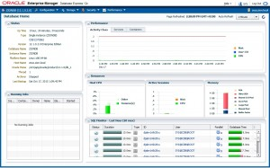](https://emarcel.com/wp-content/uploads/2015/12/oem_express_12c.jpg_01.jpg)**

The multi-tenant architecture enables an Oracle database to function as a multi-tenant container database (**CDB**) that includes zero, one, or many customer-created pluggable databases (**PDBs**).

[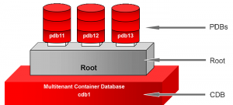](https://emarcel.com/wp-content/uploads/2015/12/multitenant_db12c.png)

A **CDB** includes the following components:

**Root**named CDB$ROOT, stores Oracle-supplied metadata and common users. An example of metadata is the source code for Oracle-supplied PL/SQL packages. A common user is a database user known in every container.

A **PDB** appears to users and applications as if it were a non-CDB. For example, a PDB can contain the data and code required to support a specific application (e.g., APEX).

Each of these components is called a container. Therefore, the root is a container, the seed is a container, and each PDB is a container.

In this tutorial we will show two different types of configurations of Enterprise Manager Express one for CDB and the second for PDBs only. Imagine yourself as a dba who has full access to non-CDB/CDB/PDB,OEM Express 19c will allow you to manage CDB and all PDB containers from one central console. On the other hand you would like to allow regular users to login to OEM Express 19c as well, but grant them access to their PDBs only.

[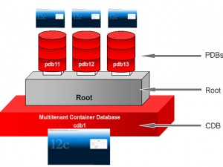](https://emarcel.com/wp-content/uploads/2015/12/multitenant_db12c_01.jpg)

In our demo environment we have the following containers created:

**CDB**: fenagodb,

**PDBs**: fenagodb1

**Configuring OEM Express for CDB (HTTPS)**

1. Open a terminal window, execute the “su – oracle” command to set the environment variables and connect to the multi-tenant container database (in our example **fenagodb**)Check if the database is a CDB database and it is open.

[root@fenago~]$ su – oracle

[oracle@fenago~]$ sqlplus / as sysdba

Connected to:

Oracle Database 19c Enterprise Edition Release 12.1.0.2.0 64bit

...

SQL> select name, cdb, con_id from v$database;

NAME CDB CON_ID

--------- --- ----------

FENAGODB YES 0

SQL> select instance_name, status, con_id from v$instance;

INSTANCE_NAME STATUS CON_ID

---------------- ------------ ----------

FENAGODB OPEN 0

2. Verify that the DISPATCHERS parameter in the initialization parameter file includes the PROTOCOL=TCP attribute.

SQL> show parameter dispatchers

NAME TYPE VALUE

------------------ ----------- ------------------------------

dispatchers string (PROTOCOL=TCP) (SERVICE=FENAGODBXDB)

max_dispatchers integer

3. Execute the DBMS_XDB.setHTTPSPort procedure to set the HTTPS port **5500**and the DBMS_XDB.setHTTPPort procedure to set the HTTP port **5510**for EM Express

SQL> exec DBMS_XDB_CONFIG.SETHTTPSPORT(5500);

PL/SQL procedure successfully completed.

5. Login to Database EM Express Home Page.

**https:**//<IP:Hostname>:**5500**/

**Note:**Now we have the privileges to manage **CDB** and **PDBs**containers

**[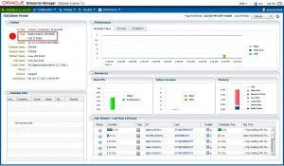](https://emarcel.com/wp-content/uploads/2015/12/CDB_oem_express_12c_01.jpg)**

**[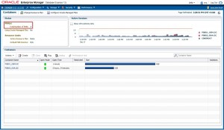](https://emarcel.com/wp-content/uploads/2015/12/CDB_oem_express_12c_02.jpg)**

**Configuring OEM Express for PDB Fenagodb1**

We are configuring EM Express for Fenagodb1 container to run on ports: HTTPS **5501** .

1. Display all pluggable databases and their status

SQL> select NAME, OPEN_MODE from v$pdbs;

NAME OPEN_MODE

------------------------------ ----------

PDB$SEED READ ONLY

FENAGODB1 READ WRITE

2. Alter the session and set container as **FENAGODB1**

SQL> alter session set container=FENAGODB1;

Session altered.

3. Execute the DBMS_XDB.setHTTPSPort procedure to set the HTTPS port for EM Express

SQL> exec DBMS_XDB_CONFIG.SETHTTPSPORT(5501);

PL/SQL procedure successfully completed.

5. Login to Database EM Express home page.

**https:**//<IP:Hostname>:**5501**/em

Note that you have privileges to managed only PDB **FENAGODB1**

[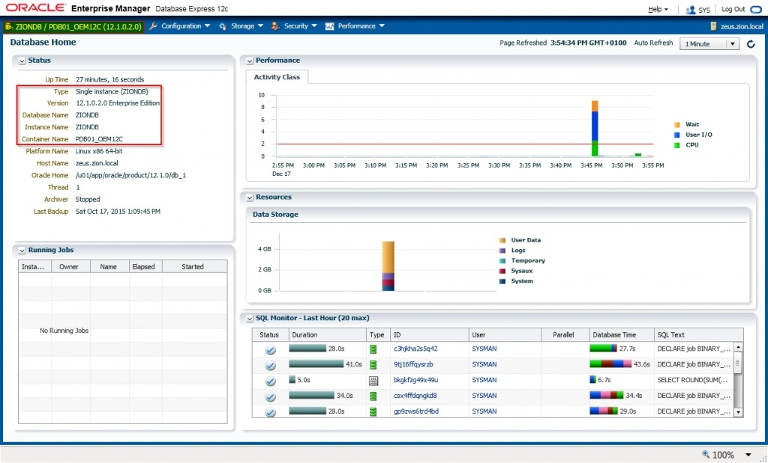](https://emarcel.com/wp-content/uploads/2015/12/EM-Express-12c-PDB.jpg)

Repeat recent steps from 2 to 5 to configure EM Express for more PDBs.

**Checking OEM Express port for CDB or PDB**

Alter session to CDB or PDB container and execute the SQL statement that returns the port that is configured for EM Express

SQL> select DBMS_XDB_CONFIG.GETHTTPSPORT() from dual;

DBMS_XDB_CONFIG.GETHTTPPORT()

----------------------------- 5501

If returned port number is 0, it means that EM Express is not configured for that particular container.