chapter 2
ADVANCED STRUCTURED QUERY LANGUAGE


TOPIC OBJECTIVES

This section introduces the more complex SQL statements as used in ORACLE.
When you finish this section, you will be able to:

- Create queries called joins which use more than one table

- Comprehend when and how to use subquery statements

- Identify and use the Union, Intersect and Difference commands

- Write SQL Select statements to not only retrieve rows but to insert, delete and update row columns
Advanced DML Functions

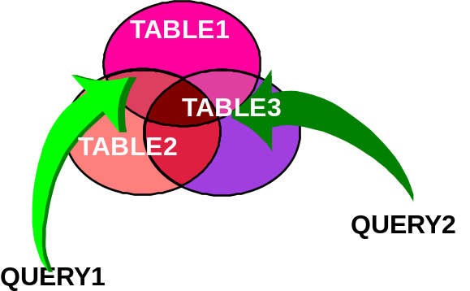

Joins

A join allows the selection of columns from one or more tables based upon comparing two or more columns.

For example, the following figure shows a DEPT table with DEPTNO as a primary key and an EMP table with EMPNO as primary key and DEPTNO as foreign key.

DEPT TABLE EMP TABLE
Deptno Dname Empno Mgr Deptno Sal Job

001 SALES 10 40 001 50000 Sales

002 MANUF 20 30 002 35800 Tech

30 .. 002 43000 Mgr.

40 .. 001 70500 Mgr.

50 .. 003 34000 Tech

Join Examples

A query in which data is retrieved from more than one table. Specifically, select empno, ename, mgr and dname from the appropriate dept and emp tables

SQL:
SELECT EMPNO, ENAME, MGR, DNAME FROM DEPT,EMP WHERE
DEPT.DEPTNO = EMP.DEPTNO ORDER BY EMPNO

RESULT:

EMPNO ENAME MGR DNAME
7782 CLARK 7839 ACCOUNTING
7839 KING ACCOUNTING
7934 MILLER 7782 ACCOUNTING
7369 SMITH 7982 RESEARCH
7876 ADAMS 7788 RESEARCH
7902 FORD 7566 RESEARCH
7788 SCOTT 7566 RESEARCH
7566 JONES 7839 RESEARCH
.... ..... ..... ......

Notes about Joins

DEPTEMP
In the previous example, DEPT.DEPTNO = EMP.DEPTNO is referred to as the JOIN condition

The two fields in the join condition:
- Must be either both numeric or both character
- Should be the same data type (eliminates conversion overhead)
- May have the same or different column names
- May be compared with equal (=), or with inequalities

Should be used with care.
- They can be quite demanding of the system
- One of the most powerful features of relational systems
• Remember, you must do a join when column information from more than one
table is requested by a customer for display purposes.
Qualified names

Why is the column ambiguous?

- When the columns in the tables to be joined are the same name, you must
fully qualify the columns being joined or you will have an ambiguous
reference.
- Suppose the following query is needed

List all department managers and their salary
SQL:
SELECT EMP.DEPTNO,ENAME,JOB,SAL,DNAME
FROM DEPT,EMP
WHERE DEPT.DEPTNO = EMP.DEPTNO AND JOB =‘MANAGER’;

NOTES: Remember that different tables can contain columns with the same name
Correlation Variables, Using clause and ANSI-99

pers_svcmbr_tbl Table pers_person_tbl Table
ssn_sm rec_prec gr_abbr_code ..... ssn_sm rec_prec name_ind .....

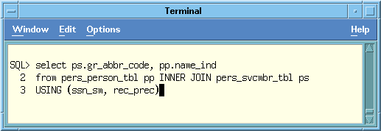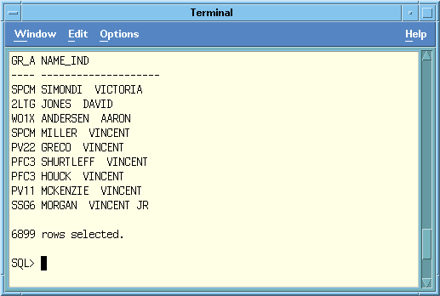
Correlation variables are aliases for table names. They are primarily used when columns in different tables have the same name. This occurs frequently with primary/foreign key relationships established for referential integrity but may occur in columns with like values as shown below. In this example, we want to identify an applicant who inadvertently has the same id as an actual employee id.
- Also referred to as aliases
Advanced DML Functions
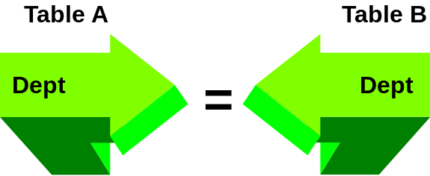

ORACLE Natural Join
An equi-join is a join where a row in one table has a matching row (based upon equal values) in another table based on one (or more)column(s) in each table.
For example, if you needed to select the social security #, status (rec_prec), name of the individual and state they are in, and unique enlisted status, cumulative retirement points and the unit code from the appropriate tables for soldiers you would write the following:

SELECT ssn_sm,rec_prec, name_ind,states_us,
mpc,asg_seq_nbr,cum_ret_pts,upc
FROM pers_person_tbl natural join pers_svcmbr_tlb

IF AN INDEX IS CREATED ON ssn_sm and rec_prec, THE UNIQUE INDEX
CAN BE USED INSTEAD OF SORTING TO RETRIEVE DATA.

Advanced DML Functions

Non-equi-join

A non-equi-join uses operators other than the equal to (=) such as less than ( < ) and greater than ( > ). A non-equi-join is a join where a row in one table has a matching row (based upon unequal values) in another table based on one (or more) column(s) in each table.
Example: Find soldiers whose cost of living is between the lowest cost of living allowed and the highest cost of living in the person and cola_grades tables.

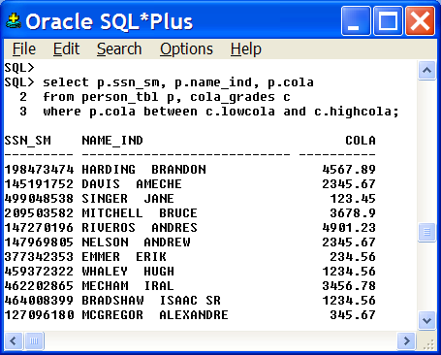
.
Advanced DML Functions


Table 1 Table 2
A column value doesn’t exist in the other table

LEFT Outer Join

An outer join may be used to include rows from one table that do not have a matching row in another table.
Example: To find soldiers in the svcmbr table with no physical fitness scores in the pers_afqt_code table table use this outer join:
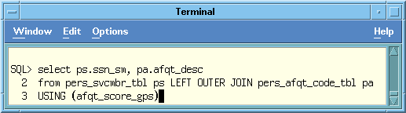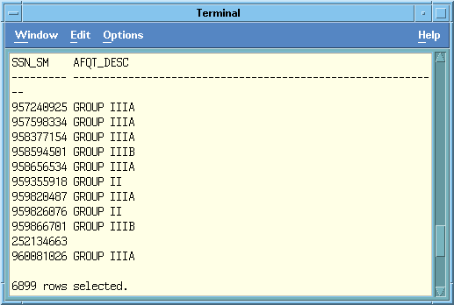
ANSI/ISO JOIN STATEMENTS full outer join


Difference between using an "and" versus a "where"
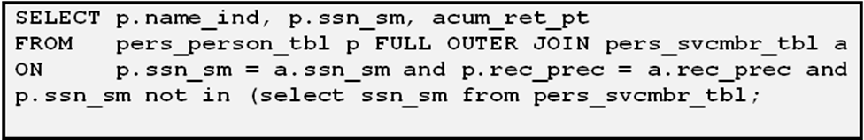
This particular query will check for all equalities and inequalities in both tables.and bring back all rows.

SELECT p.name_ind, p.ssn_sm, cum_ret_pt
FROM pers_person_tbl p left OUTER JOIN pers_svcmbr_tbl a
ON p.ssn_sm = a.ssn_sm and p.rec_prec = a.rec_prec
where p.ssn_sm not in (select ssn_sm from pers_svcmbr_tbl)

\\\

This particular query will check for all inequalities in both tables.and bring back only the inequalities.

PROVIDING HINTS FOR THE OPTIMIZER


In general you should use the cost-based optimization (CBO) approach for all new
applications. The cost-based approach generally chooses an execution plan that is
as good or better than the plan chosen by the rule-based approach, especially for
large queries or multiple joins.

Besides using the ALTER SESSION command to set your optimization plan you
can also provide hints within your sql statements.

ORACLE> select /*+ ALL_ROWS */ ename, sal
from emp where deptno = 10;

ORACLE> select /*+ FIRST_ROWS */ ename, sal
from emp where deptno = 10;

Note: You can set the optimizer for all queries by initializing your SESSION OR DATABASE file by putting in the command optimizer_mode = ALL_ROWS or
optimizer_mode = FIRST_ROWS

Generally, the hint command is used with the autotrace command to show the I/O and cost of the query when using hints.
SQL> set autotrace on

SQL HINTS


How Hints work? SQL> set autotrace on
sql> SELECT /*+ NO_INDEX */ ename, sal, deptno from emp
WHERE SAL > 1000;
Hints can be used with SELECT, INSERT, UPDATE, and DELETE statements to override the database or session defaults. Hints are defined in comments with the SQL statements.

- Try to avoid using hints and views or subqueries. Unexpected plans can be generated when hints are used with views or subqueries.
- The Performance Tuning Reference Manual has information about how to used hints with views and subqueries.

The following table lists some of the more common hints that can be used with SQL statements.

RULE CHOOSE FIRST_ROWS
ALL_ROWS FULL ROWID
CLUSTER HASH HASH_AJ
HASH_SJ INDEX INDEX_ASC
INDEX_COMBINE INDEX_JOIN INDEX_DESC
INDEX_FFS NO_INDEX MERGE_AJ
MERGE_SJ AND_EQUAL USE_CONCAT
NO_EXPAND USE_NL USE_NO_WITH_INDEX

join operations

Joining 2 or more table together using NESTED_LOOP JOIN
SQL> select /*+ use_nl */ pers_svcmbr_tbl.*, pers_unit_tbl.*
from pers_svcmbr_tbl, pers_unit_tbl
where pers_svcmbr_tbl.upc = pers_unit_tbl.upc

Here is a look at the different kinds of joins used in Oracle:

Nested Loops Join
A nested loop join is an operation that has two tables, a smaller inner table and an outer table. Oracle compares each row of the inner set with each row of the outer set and returns those rows that satisfy a condition. A nest loop join is commonly seen conditions where an index exists on the inner table. The nested loop join has the fastest response time in many cases (especially with small intermediate result row sets), but the has join often offers the best overall thorough put and faster performance where the intermediate row set is very large.
Execution Plan
Plan hash value: 1317748762
| Id | Operation | Name | Rows | Bytes | Cost (%CPU)| Time|
| 0 | SELECT STATEMENT | 6899 | 2499K| 5537 (1)| 00:01:07 |
| 1 | NESTED LOOPS | | | |
| 2 | NESTED LOOPS | 6899 | 2499K| 5537 (1)| 00:01:07 |
| 3 | TABLE ACCESS FULL| PERS_UNIT_TBL 130 15340 | 3 (0)|00:00:01
|* 4 | INDEX RANGE SCAN | SVCMBR_IDX6 92 | 1 (0)| 00:00:01 |
| 5 | TABLE ACCESS BY INDEX ROWID| PERS_SVCMBR_TBL | 53 | 13409 | 73

Predicate Information (identified by operation id):
4 - access("PERS_SVCMBR_TBL"."UPC"="PERS_UNIT_TBL"."UPC")
Statistics
0 recursive calls and 0 db block gets
6232 consistent gets
0 physical reads and 0 redo size
1499767 bytes sent via SQL*Net to client
5569 bytes received via SQL*Net from client
461 SQL*Net roundtrips to/from client
0 sorts (memory) and 0 sorts (disk)
6899 rows processed

Hash join
- SQL> select pers_svcmbr_tbl.*, pers_unit_tbl.*
- from pers_svcmbr_tbl, pers_unit_tbl
- where pers_svcmbr_tbl.upc = pers_unit_tbl.upc

A hash join is an operation that performs a full-table scan on the smaller
of the two tables (the driving table) and the builds a hash table in RAM
memory. The hash table is then used to retrieve the rows in the larger
table. In a hash join, both tables are read via a full-table scan (normally
using multi-block reads and parallel query), and the result set is joined in
RAM. Is used for equi-joins only.
- Execution Plan
- ----------------------------------------------------------
- Plan hash value: 3960656270
- | Id | Operation | Name | Rows | Bytes | Cost (%CPU)| Time
- | 0 | SELECT STATEMENT | 6899 | 2499K| 74 (2)| 00:0 0:01 |
- |* 1 | HASH JOIN | | 6899 | 2499K| 74 (2)| 00:00:01 |
- | 2 | TABLE ACCESS FULL| PERS_UNIT_TBL | 130 | 15470 3(0)| 00:00:01 |
- | 3 | TABLE ACCESS FULL| PERS_SVCMBR_TBL | 6899 | 1697K| 717(2)| 00:0

- Predicate Information (identified by operation id):
- access("PERS_SVCMBR_TBL"."UPC"="PERS_UNIT_TBL"."UPC")

- Statistics
- ----------------------------------------------------------
- 0 recursive calls
- 0 db block gets
- 698 consistent gets
- 0 physical reads
- 0 redo size
- 2253589 bytes sent via SQL*Net to client
- 5568 bytes received via SQL*Net from client
- 461 SQL*Net roundtrips to/from client
- 0 sorts (memory)
- 0 sorts (disk)
- 6899 rows processed

Sort Merge Join
A sort Merge Join is an operation that retrieves two sets of rows from the
target tables and then sorts each row set by the join column. The merge
phase combines each row from one set with the matching rows from the
other, returning the intersection of the row sets.

Execution Plan
Plan hash value: 1618269027
| Id | Operation | Name |
| 0 | SELECT STATEMENT | |
| 1 | MERGE JOIN | |
| 2 | SORT JOIN | |
| 3 | TABLE ACCESS FULL| PERS_UNIT_TBL |
|* 4 | SORT JOIN | |
| 5 | TABLE ACCESS FULL| PERS_SVCMBR_TBL |
-----------------------------------------------

Predicate Information (identified by operation id):
---------------------------------------------------

4 - access("PERS_SVCMBR_TBL"."UPC"="PERS_UNIT_TBL"."UPC")
filter("PERS_SVCMBR_TBL"."UPC"="PERS_UNIT_TBL"."UPC")

Note
-----
- rule based optimizer used (consider using cbo)

Statistics
----------------------------------------------------------
213 recursive calls
0 db block gets
294 consistent gets
1 physical reads
0 redo size
1508964 bytes sent via SQL*Net to client
5569 bytes received via SQL*Net from client
461 SQL*Net roundtrips to/from client
8 sorts (memory)
0 sorts (disk)
6899 rows processed

Join Exercises:


USE THE STAFF, ORG, APPLICANT, PERS_PERSON_TBL, PERS_SVCMBR_TBL AND PERS_UNIT_TBL TABLES

- List ALL employees department numbers and department names with their
appropriate division manager's name and his/her salary but only if the
employees’ salary is greater than 12000 or the employee is from department
10 or the employee is a clerk. See advex71. Use the STAFF & ORG tables.
(34 rows)

2. For each manager, create a list of people in his/her department whose
salary is greater than the manager’s salary. See advex72.sql
RESULTS:
(10 ROWS RETURNED)
Performing Natural joins
3. Write a natural join on the pers_svcmbr_tbl and the pers_unit_tbl. Save the query as natural1.sql

4. Write a natural join on the pers_svcmbr_tbl, pers_person_tbl and the pers_unit tbl. Save the query as natural2.sql

Subqueries

A subquery is a select-from-where expression nested within another select

SELECT TEMPID, NAME FROM APPLICANT
WHERE NAME IN
(SELECT NAME FROM STAFF
WHERE JOB='MGR')

The subquery produces a value or group of values which complete the main query
- More than one level of subquery nesting can be used
- If a subquery produces no results (rows), you get an empty report
Single Valued Subqueries



Provides an alternative for the need to use built in functions in the where
clause..

TASK: Get the names of all applicants evaluated at the
highest education level

SQL:
SELECT NAME FROM APPLICANT
WHERE EDLEVEL =
(SELECT MAX(EDLEVEL)
FROM APPLICANT)

RESULTS:
GASPARD
JACOBS

NOTE: If "=" (Or an inequality) precedes the subquery it must be single
valued
Multivalued Subqueries

TASK: List the id and name for each employee in the eastern division

SQL:
SELECT ID, NAME FROM STAFF
WHERE DEPT IN
(SELECT DEPTNUMB FROM ORG
WHERE DIVISION='EASTERN')
ORDER BY ID

RESULTS:
All employees from departments 15, 20, and 38
The Any Parameter

TASK: List any employee whose salary is greater than at least one
department’s average salary

SQL:

SELECT NAME FROM STAFF
WHERE SALARY > ANY
(SELECT AVG(SALARY) FROM STAFF
GROUP BY DEPT)
NOTE:
Condition is true if true for at least one value produced by the subquery
To avoid a multi-scan of a list use the following which finds the smallest value
To do the comparison with:
SELECT NAME FROM STAFF
WHERE SALARY >
(SELECT min(AVG(SALARY)) FROM STAFF
group by dept)
Note: Use max(avg(salary)) instead of the ALL parameter. This feature is NOT supported by SQL Server 2005.

DELETING DUPLICATE RECORDS


A common problem that many DBAs and programmers face is trying to purge duplicate rows from a single table. These rows may have been inadvertently (re) imported by the DBA, or mistakenly created by a rogue application program.
The following example shows a particularly efficient way to delete duplicate records from a table. It takes advantage of the fact that a row’s ROWID must be unique.

DELETE FROM STAFF S
WHERE S.ROWID > (SELECT MIN(X.ROWID)
FROM STAFF X
WHERE X.ID = S.ID);

IN-LINE VIEWS



Table View View

SELECT DEPTNO, SUM_SALARIES
FROM ( SELECT DEPTNO, SUM(SAL) SUM_SALARIES
FROM EMP
WHERE HIREDATE > TO_DATE(’14-Jan-1980’)
Group by deptno
Order by sum(sal) desc
)

In Oracle you can create an in-line view (the subselect above) and it is legal to do an ORDER BV inside a view, including an in-line view as shown above.

Top-N queries are also used with inline views. It uses a virtual column called
Rownum. By using an order by in a inline view you can specify only the top 10 rows to be brought back thereby assisting performance. For example:

SELECT ename, job, sal, rownum
FROM (select ename, job, sal from emp
Order by sal desc)
WHERE rownum <=10;

UTILIZING THE WITH CLAUSE

The ability to reuse a subquery multiple times

The WITH clause allows a developer to define the subquery and then plug the subquery into multiple locations.

SQL> WITH AREPEATSUBQRY AS (
SELECT S1.DEPT, S1.JOB, AVG(SALARY) "AVGSALARY"
FROM STAFF S1
WHERE S1.DEPT > 10
GROUP BY S1.DEPT,S1.JOB)
SELECT DEPT,JOB,AVGSALARY
FROM AREPEATSUBQRY
WHERE DEPT IN
(SELECT DEPT
FROM AREPEATSUBQRY
WHERE AVGSALARY > 12000)

By using this new clause the arepeatsubqry data is calculated just once avoiding an extra scan through a large staff table. It also provides an ease of use mechanism which makes subqueries easier to read.

Exists Parameter - SEMIJOINS

TASK: List each department in Org with at least one employee with more
than 8 years of service

SQL:

SELECT DEPTNUMB FROM ORG
WHERE EXISTS
(SELECT * FROM STAFF
WHERE DEPT=DEPTNUMB AND YEARS > 8)

NOTE:
If subquery produces at least one value, the department is included in the result
CONSIDER REPLACING EXISTS WITH TABLE JOINS

Exists can help speed queries SOMETIMES
BUT generally joins work better. You can consider breaking some table joins out to separate subqueries when the percentage of successful rows returned from the driving table (i.e. the number of rows that need to be validated against the subquery) is small. When two tables are joined, all rows need to be matched from the driving table to the second table. If a large number of rows can be filtered from the driving table before having to perform the validation against the second table, the number of total Physical reads can be dramatically reduced.
Consider the following example of replacing an exists with a join

SELECT SSN_SM, REC_PREC, NAME_IND, DOB, STATES_US,
MPC,CUM_RET_PT, UPC, gr_abbr_code
from pers_person_tbl NATURAL JOIN pers_svcmbr_tbl
where EXISTS
(SELECT * FROM PERS_SVCMBR_TBL
WHERE MPC = 'E' AND
REC_PREC = '99999999' AND
CUM_RET_PT > 100)

TO IMPROVE PERFORMANCE SPECIFY:
SELECT SSN_SM, REC_PREC, NAME_IND, DOB, STATES_US,
CUM_RET_PT, UPC, gr_abbr_code
from pers_person_tbl inner join pers_svcmbr_tbl
using (ssn_sm, rec_prec)
where REC_PREC = '99999999' AND
MPC='E' AND
CUM_RET_PT > 100
In general, consider joining tables rather than specifying subqueries when the percentage of successful rows returned from the driving table (i.e., the number of rows that need to be validated against the subquery) is high

CONSIDER NOT EXISTS IN PLACE OF NOT IN (Anti-joins)



NOT EXISTS versus a SQL DIFFERENCE (NOT IN) statement (Hash_aj or merge_aj can be used when joins occur)

In subquery statements such as the following, the NOT IN clause causes an internal sort. Replacing the NOT IN with an indexed NOT EXISTS can be very beneficial. Study the following example:

SELECT NAME_IND, DOB, APFT_SCORE
FROM PERS_PERSON_TBL
WHERE REC_PREC='99999999' AND
STATES_US NOT IN
(SELECT STATES_US FROM PERS_PERSON_TBL
WHERE APFT_SCORE > 0)

To improve performance, replace this code with:

SELECT NAME_IND, DOB, APFT_SCORE

FROM PERS_PERSON_TBL

WHERE REC_PREC='99999999' AND

NOT EXISTS

(SELECT 'X' FROM PERS_PERSON_TBL

WHERE APFT_SCORE > 0)

Exercise 8:

USE THE STAFF, ORG AND APPLICANT TABLES AS NEEDED
1. List the managers in the Midwest division whose salaries are > 20000.
See ADVEX81.sql
RESULTS:
NAME DEPT
FRAYE 51

2. List the managers whose department’s average salary is greater than
the overall average salary. See advex82.sql or inline.sql for a more
advanced feature to be covered in the next section.
RESULTS:
DEPT NAME SALARY JOB
10 MOLINARE 22059.2 MGR
10 LU 20010 MGR
10 DANIELS 19260.3 MGR
10 JONES 21234 MGR
…………… (more than 4 rows)
3. Find the employee with the second highest salary. See advex83.sql
RESULTS:
NAME SALARY
(1 row)

4. Retrieve the employee number, name, salary, and commission of all
employees who earn more than $20,000.00 only if any employee earns less
than $350.00 commission. (Hint: use an exist statement). See advex84.sql
RESULTS: 7 rows

SET OPERATORS (Conjunctions)

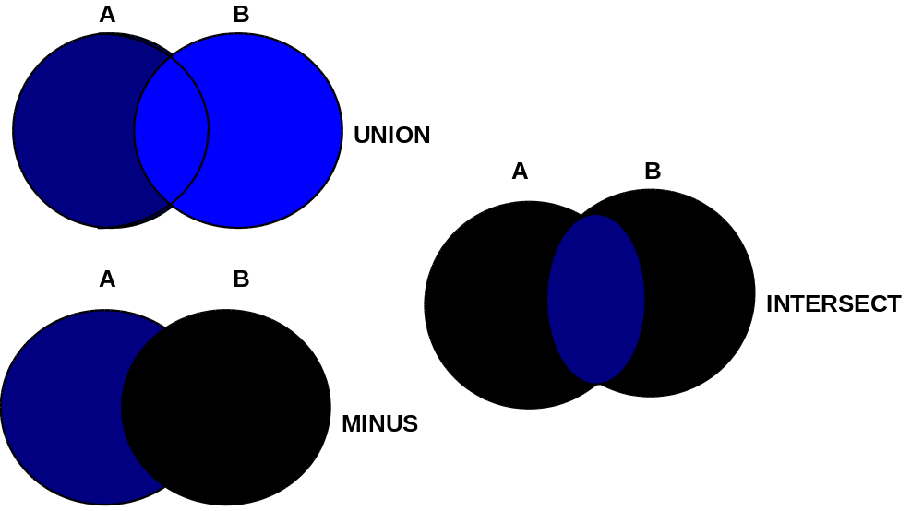

Set operators combine the results of multiple queries into a single result. The following table lists SQL set operators in order of precedence from high to low.
Operator Function Example
UNION Combines queries to return all distinct rows ...SELECT ..
returned by any individual query (OR) UNION SELECT ...

INTERSECT Combines queries to return all distinct rows ...SELECT....
returned by every individual query. (AND) INTERSECT SELECT..

MINUS Combines queries to return all distinct rows ....SELECT....
returned by the first query but not the MINUS SELECT.....
second query (AND NOT)

UNION
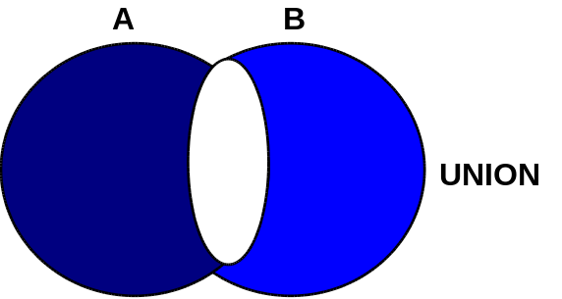
A UNION conjunction would combine rows in all queries in the union eliminating duplicate rows.
- The results would be similar to those returned when using a WHERE clause with an OR logical operator.
TASK: List employees by department. Designate for each employee if his years of service are from 0 to 5, from 6 to 10, or greater than 10
SQL:
SELECT DEPT, ID, NAME, '0-5 YEARS’
FROM STAFF
WHERE YEARS < 6
UNION
SELECT DEPT, ID, NAME ,'6-10 YEARS’
FROM STAFF
WHERE YEARS BETWEEN 6 AND 10
UNION
SELECT DEPT, ID, NAME, 'MORE THAN 10 YEARS'
FROM STAFF
WHERE YEARS >10
ORDER BY 1,2
RESULT:

DEPT ID NAME 0 - 5 YEARS

10 160 MOLINARE 6 - 10 YEARS
10 210 LU 6 - 10 YEARS
10 240 DANIELS 0 - 5 YEARS
10 260 JONES MORE THAN 10 YRS
.. .. .. ..

CONSIDER IN OR UNION IN PLACE OF OR

1 2 3 4 5 6 7 8 9 10 …. SQL statements are merged together
In general, always consider the IN and/or UNION verb instead of the OR verb in WHERE clauses. Using the OR predicate on an indexed column causes the optimizer to perform a full table scan rather than an indexed retrieval.

In the following examples, both division and deptnumb are indexed. Consider the following:
SELECT DEPTNAME,LOCATION SELECT DEPTNAME,LOCATION
FROM ORG FROM ORG
WHERE DEPTNUMB = 10 WHERE DEPTNUMB = 10
OR DIVISION = ‘EASTERN’; OR DEPTNUMB = 42
OR DEPTNUMB = 84;
To improve performance, replace this code with:
SELECT DEPTNAME,LOCATION SELECT DEPTNAME,LOCATION
FROM ORG FROM ORG
WHERE DEPTNUMB = 10 WHERE DEPTNUMB IN(10,42,84)
UNION ALL
SELECT DEPTNAME,LOCATION
FROM ORG WHERE
DIVISION = ‘EASTERN’;

CONSIDER UNION ALL IN PLACE OF UNION

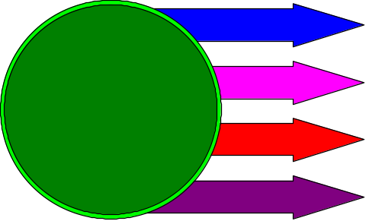
Union ALL does not eliminate duplicate rows
Programmers of complex query statements that include a UNION clause should always ask whether a UNION ALL would suffice. The UNION clause forces all rows returned by each portion of the UNION to be sorted and merged and duplicates to be filtered before the first row is returned to the calling module. A UNION ALL simply returns all rows including duplicates and does not have to perform any sort, merge, or filter. Most statements that do include a UNION clause can in fact replace it with a UNION ALL. Consider the following example:

Select DEPTNO,ENAME,JOB, HIREDATE,‘STAFF MEMBER’
FROM EMP
WHERE HIREDATE BETWEEN ‘11-DEC-88’ AND ‘11-DEC-99’
UNION
SELECT 11,NAME,COMMENTS,SYSDATE, ‘ APPLICANTS’
FROM APPLICANT

To improve performance, replace this code with:

Select DEPTNO,ENAME,JOB, HIREDATE,‘STAFF MEMBER’
FROM EMP
WHERE HIREDATE BETWEEN ‘11-DEC-88’ AND ‘11-DEC-99’
UNION ALL
SELECT 11,NAME,COMMENTS,SYSDATE, ‘ APPLICANTS’
FROM APPLICANT

Exercise 9 on Union:



- List all the applicants and staff members and employees, order by employee
ID. Label each person as either "STAFF" ”EMPLOYEE ”or "APPLICANT”.
Display the employee id, names and job classifications See ADVEX91.sql
Use the STAFF, EMP and APPLICANT tables for this query
RESULTS:
59 rows selected

- Provide an employee list, which indicates which employees make less than
the average salary and which employees have salaries greater than, or equal
to the average salary. See EX92.sql. Use the STAFF tables.

RESULTS:
35 rows selected

SET OPERATOR INTERSECT
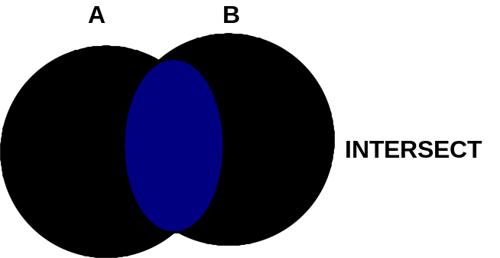
The INTERSECT clause results would be similar to those returned when using a WHERE clause with an AND logical operator.

The following example would produce an empty result table because an employee is only assigned one DEPTNO at any given time

SELECT EMPNO, DEPTNO FROM EMP WHERE DEPTNO = 001
INTERSECT
SELECT EMPNO, DEPTNO FROM EMP WHERE DEPTNO = 003

The following use of intersect would give a non-empty results table:

SELECT EMPNO FROM EMP
INTERSECT
SELECT EMPNO FROM PROJECTB

Results: EMPNO
10
20

The Minus Conjunction
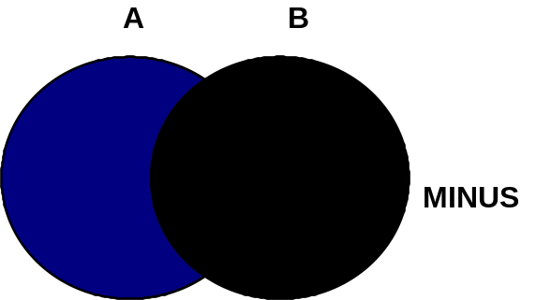

The minus conjunction is similar to using the 'AND NOT' logical operator is a WHERE clause of a SELECT statement

SELECT EMPNO, SAL FROM EMP
WHERE SAL > 46000
MINUS
SELECT EMPNO, SAL FROM EMP
WHERE DEPTNO = 001
Results: EMPNO SAL

50 90000

SELECT EMPNO CONTRACTOR FROM PROJECTB
MINUS
SELECT EMPNO FROM EMP

Results: CONTRACTOR
578
789

MODIFY Functions

SQL Insert Selected Columns

INSERT INTO ORG(DEPTNUMB, DEPTNAME, LOCATION)
VALUES (95,'COASTAL', 'HOUSTON')

- Columns not specified are given the value null
- A value must be specified for any column defined as not null in the table create statement

INSERT INTO MYSTAFF (ID, NAME, DEPT)
SELECT ID, NAME,DEPT
FROM STAFF WHERE JOB = 'CLERK'

Copies all clerk rows from STAFF to table MYSTAFF

The insert (as with all updates) may be performed on a table if

- You created the table
- You have been granted insert authority on the table
MULTITABLE INSERT STATEMENT

Insert into 2 tables with 1 statement

The multitable INSERT statement:

- Allows records to be inserted into multiples at the same time.
- Can be used to copy data from one or more tables to a different set of target tables
- Supports two types of operations
  - Conditional
  - Unconditional
The values clause can only contain columns referenced in the SELECT statement in the subquery.
INSERT ALL INTO T1 [VALUES(…..) \
INTO t2 [VALUES(….) ]
……
SELECT ……

EXAMPLE OF UNCONDITIONAL INSERT
INSERT ALL
INTO product_activity VALUES(today, product_id, quantity)
INTO product_sales VALUES(today, product_id, total)
SELECT trunc(to_date(to_char(order_date,'dd-MON-yy')))
today, product_id, SUM(unit_price) total,
SUM(quantity) quantity
FROM orders, order_items
WHERE orders.order_id = order_items.order_id AND
trunc(to_date(to_char(order_date,'dd-MON-yy')))=
TRUNC(SYSDATE)
GROUP BY trunc(to_date(to_char(order_date,'dd-MON-yy'))),
product_id;
- Allows the INSERT … SELECT statement to insert rows into multiple tables as part of a single DML statement

- Can be used in data warehousing systems to transfer data from one or more operational sources to a set of target tables

- Is used internally for refreshing materialized views

- Allows you to still benefit from:
Parallelization
Direct-load mecanism

EXAMPLE OF A CONDITIONAL ALL INSERT
INSERT ALL
WHEN product_id IN (SELECT product_id
FROM promotional_items) THEN
INTO promotional_sales VALUES(product_id,list_price)
WHEN order_mode = 'online'
THEN
INTO web_orders VALUES(product_id, order_total)
SELECT product_id, list_price, order_total, order_mode
FROM orders;
ALL will evaluate all WHEN clauses. For each WHEN clause that evaluates to true, Oracle will process the corresponding INTO clause.
INSERT {ALL | FIRST |
WHEN c1 then INTO t1 [VALUES (…) ]
WHEN c2 then INTO t2 [VALUES (…) ]
…..
[ ELSE INTO tn [VALUES (…) ] ]
SELECT …..

The INSERT FIRST syntax will execute the first INTO clause that matches on the expression. It will, then, skip all following WHEN clauses.

RESTRICTIONS and USES FOR MULTITABLE INSERTS

The following are restrictions with multitable inserts.

A multitable insert cannot:

- Be used with views and materialized. Only tables are supported.
- Be performed on a remote table
- Use a collection expression
- Be parallelized in a Real Application Cluster environment.
- Use plan stability.
- Use a sequence in a subquery.

Note: The multitable INSERT statement offers benefits in DSS and large batch processing environments. Multitable INSERTS can be used with:

- Parallel operations
- Direct load operations
- Refreshing materialized views.

Update a single row

Task: Update employee number 150 to change job description to Manager,
Department to 95 and provide a 15% increase in salary.
SQL:

UPDATE STAFF
SET JOB='MGR', DEPT=95, SALARY=SALARY * 1.15
WHERE ID=150
This example updates the department, job and salary for ID 150

Update multiple rows

SQL:

UPDATE STAFF
SET COMM = COMM + 500
WHERE DEPT = 38

This query gives every employee in Department 38 a $500 commission bonus

COMPLEX UPDATE

Task: Provide all employees who worked for Project number 50 a bonus
equal to 15% of their salary. This requires that you search the
Project table to find all employees in Project 50 and then update the
employees Bonus field in the Staff table

Update Staff
Set Bonus = salary * .15
where id in
(Select empno
from project
where projectno = 50);

Result: All employees attached to Project number 50 are given a
15% bonus.

MERGING DATA IN ORACLE TABLES


With one statement we can either insert or update

The Oracle11G merge command allows you to decide based upon a condition whether you will be inserting or updating. Implicit in the use of the merge command is the concept that you are merging the contents of one table into another based on whether the values exist in the second table, extending the table join principles reviewed earlier. For example, assume that a transaction file being read in PLSQL has both new employees salaries and old employees salaries that require updating. New employees are not immediately assigned department numbers. So we can use the MERGE command to decipher whether we are going to insert new employees or simply update them.

MERGE into staff s1
Using org o2 on (s1.dept = o2.deptnumb )
When matched then update set s1.salary = :new_salary
When not matched then insert (id,name,dept,years,job,salary,comm.)
Values (:new_id,:new_name,:new_dept,:new_years,
:new_salary,:new_comm.);

The above example states in line 1 “Merge rows in the STAFF table”. The second line specifies “to match the data using the Org and Staff tables). The third and fourth lines define that if a employee has a department number in both tables then his/her salary is updated otherwise the NOT MATCHED says they don’t exist and can be inserted.

NOTE: Starting In 10g you can insert, update or delete with the MERGE command.
COMPLEX DELETE

Task: Delete all employees who worked for Project number 50.

Delete from Staff
where id in
(Select empno
from project
where projectno = 50);

Result: All employees attached to Project number 50 are deleted

10G Concepts – THE MODEL CLAUSE

The Model clause defines a multidimensional array by mapping the columns of a query into three groups: partitioning, dimension, and measure columns. These elements perform the following tasks:
- Partitions define logical blocks of the result set in a way similar to the partitions of the analytical functions (described in Oracle's Data Warehousing Guide Chapter 20, "SQL for Analysis in Data Warehouses"). Model formulas are applied to the cells of each partition.
- Dimensions identify each measure cell within a partition. These columns are identifying characteristics such as date, region and product name.
- Measures are analogous to the measures of a fact table in a star schema. They typically contain numeric values such as sales units or cost. Each cell is accessed within its partition by specifying its full combination of dimensions.
To create formulas on these multidimensional arrays, you define computation rules expressed in terms of the dimension values. The rules are flexible and concise, and can use wild cards and FOR loops for maximum expressiveness. Calculations based on the Model clause improve on traditional MODEL calculations by integrating their analytical functions into the database, improving readability with symbolic referencing, and providing scalability and much better manageability.

THE MODEL STATEMENT
The figure below gives a conceptual overview of Model using a hypothetical sales table. The table has columns for country, product, year and sales amount. The figure has three parts. The top segment shows the concept of dividing the table into partitioning, dimension and measure columns. The middle segment shows two rules that calculate the value of Prod1 and Prod2 for the year 2002. Finally, the third part shows the output of a query applying the rules to a table with hypothetical data. The unshaded output of is data retrieved from the database, while the shaded output shows rows calculated from rules. Note that the rules are applied within each partition.
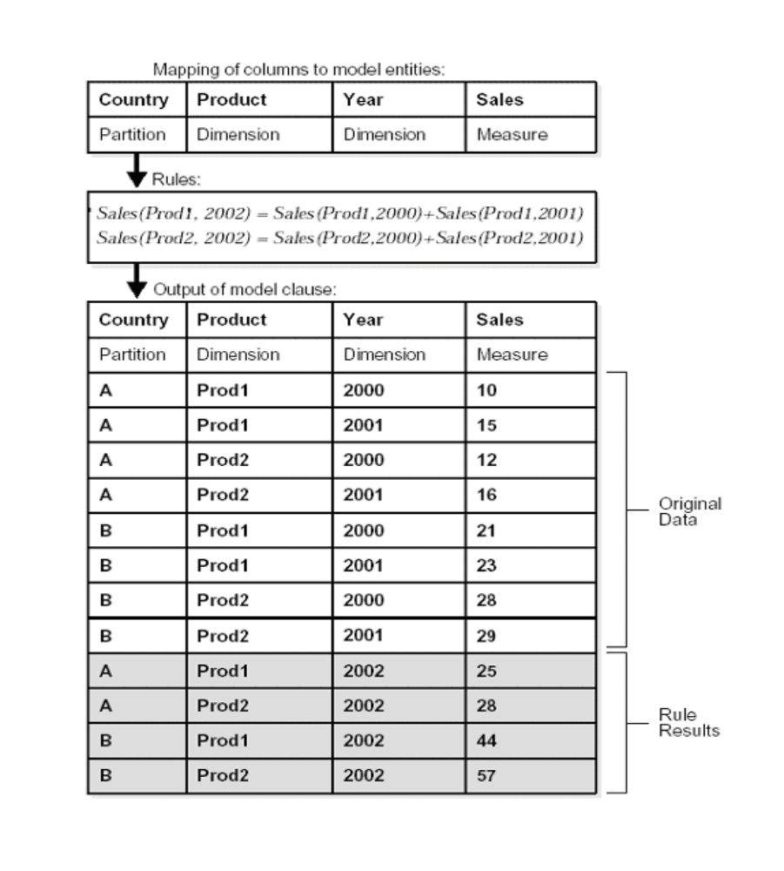

Basic Syntax
Here are the elements of the Model clause syntax which are discussed in this section. While there are some additional syntax items, the set discussed here represents the core functionality. Note that the Model clause is processed after all other clauses of a SELECT statement except the final ORDER BY.

<prior clauses of SELECT statement>
MODEL [main]
[reference models]
[PARTITION BY (<cols>)]
DIMENSION BY (<cols>)
MEASURES (<cols>)
[IGNORE NAV] | [KEEP NAV]
[RULES
[UPSERT | UPDATE]
[AUTOMATIC ORDER | SEQUENTIAL ORDER]
[ITERATE (n) [UNTIL <condition>] ]
( <cell_assignment> = <expression> ... )

Sample Data
To keep our examples concise, we will create a view using the following command The view sales_view provides annual sums for product sales, in dollars and units, by country, aggregated across all channels.

CREATE VIEW sales_view AS
SELECT country_name country, prod_name prod, calendar_year year,
SUM(amount_sold) sale, COUNT(amount_sold) cnt
FROM sales, times, customers, countries, products
WHERE sales.time_id = times.time_id AND sales.prod_id = products.prod_id AND sales.cust_id = customers.cust_id AND
customers.country_id = countries.country_id
GROUP BY country_name, prod_name, calendar_year;

First Model Clause Example
As an initial example of Model, consider the following statement. It calculates the sales values for two products and defines sales for a new product based on the other two products.

SELECT SUBSTR(country,1,20) country, SUBSTR(prod,1,15) prod, year, sales
FROM sales_view
WHERE country IN ('Italy','Japan')
MODEL RETURN UPDATED ROWS
PARTITION BY (country)
DIMENSION BY (prod, year)
MEASURES (sale sales)
RULES (
sales['Bounce', 2002] = sales['Bounce', 2001] +
sales['Bounce', 2000],
sales['Y Box', 2002] = sales['Y Box', 2001],
sales['2_Products', 2002] = sales['Bounce', 2002] + sales['Y Box', 2002])
ORDER BY country, prod, year;

The results are:
COUNTRY PROD YEAR SALES
-------------------- --------------- ---------- ----------
Italy 2_Products 2002 92613.16
Italy Bounce 2002 9299.08
Italy Y Box 2002 83314.08
Japan 2_Products 2002 103816.6
Japan Bounce 2002 11631.13
Japan Y Box 2002 92185.47
This statement partitions data by country, so the formulas are applied to data of one country at a time. Our sales fact data ends with 2001, so any rules defining values for 2002 or later will insert new cells. The first rule defines the sales of a video games called "Bounce" in 2002 as the sum of its sales in 2000 and 2001. The second rule defines the sales for Y Box in 2002 to be the same value they were for 2001. The third rule defines a product called "2_Products," which is simply the sum of the Bounce and Y Box values for 2002. Since the values for 2_Products are derived from the results of the two prior formulas, the rules for Bounce and Y Box must be executed before the 2_Products rule.

Note the following characteristics of the example above:
- The "RETURN UPDATED ROWS" clause following the keyword MODEL limits the results returned to just those rows that were created or updated in this query. Using this clause is a convenient way to limit result sets to just the newly calculated values. The keyword "RULES," shown in the example at the start of the formulas, is optional, but we include it for easier reading.
- Likewise, This example does not require an ORDER BY on the Country column, but we include the specification for convenience in case readers want to modify the examples and use multiple countries.

LAB 4 - SELECTING ROWS FROM MORE THAN ONE TABLE



- TASK: Retrieve all employees in each department who have the highest
salaries. Print out the department name along with their id, name, and salary.
Use the STAFF and ORG tables. See Lab41.sql

- TASK: Select the employee number, name, job, salary, department and department name for all employees whose total earnings is in the range of 15000 to 30000 dollars and are salesman and were hired before 1999. Sort the data by department name and job. Use the emp AND dept tables for the query. See lab42.sql (Hint: The column SAL is monthly salary) and assume the commission is current and usable as is.)

3. TASK: Display the rows in emp table that do not have a match in the dept
table (an employee who does not have a department number in the dept
table) as well as those employees with department numbers that do have a
match in the dept table.. Optional - See if you can just return an emp row(s)
that does not have a match in the dept table (This will require you to add your
name and relevant data into the emp table. Use department number 11 for
your department See lab43.sql
.
.
LAB 4 - SELECTING ROWS FROM MORE THAN ONE TABLE

4. a. Insert your name and relevant information into the applicant table.
b. Insert a row into the org table that creates a new Division (Southwest),
department number (77), department name (Dallas), location (Plano), and
manager (10).
c. The company has hired you. Move your applicant information
from the applicant table to the staff table. Your salary is $50,000.00, you
have no commission, and your job status is “MGR”. see cmplxins.sql

5. Display all location or division or department names eliminating duplicates.
The company is looking at defining a new set of specifications on the names
it uses so it needs to look at all the current alphanumeric names being used.
Eliminate duplicates. See union.sql Use the ORG table.

6. You have received a promotion. Upgrade your salary by 10%. Give yourself a
$5,000.00 commission as well. See update6.sql. Use the STAFF table

7. Find the person(s) who has worked with the company longest and give them
a 10% salary increase. See update7.sql Use the STAFF table.

8. Whoops!!. Our applicant tables need to be cleaned up. Delete anyone in
the applicant tables who is now a permanent employee. Please delete
them from the appropriate tables. See cmplxdel.sql

