Practice 2-1: Viewing Diagnostic Information
In this practice, you use the alert log to gather information about the performance of the
instance while running a workload. You review the alert log for information that is
relevant to performance tuning.
1) As the sys user, shutdown the database
$ sqlplus / as sysdba
sql> shutdown immediate

Database closed.
Database dismounted.
ORACLE instance shut down.
Startup the instance
SQL> startup

ORACLE instance started.
Total System Global Area 422670336 bytes
Fixed Size 1300352 bytes
Variable Size 390072448 bytes
Database Buffers 25165824 bytes
Redo Buffers 6131712 bytes
Database mounted.
Database opened.
System altered.

Identify where the alert log is:
4) From the command line, find and view the alert log file for the orcl database. Use
the operating system login, and locate and view the log for the orcl database. The
text version of the alert log in Oracle Database 12c is located in the directory
specified by the Diag Trace entry in the V$DIAG_INFO view.
a) Open a terminal window. Start sqlplus and connect as sysdba. Execute the
following command to find the Diag Trace directory. Exit sqlplus.
$ sqlplus / as sysdba
SQL> select * from V$DIAG_INFO
2 where name = 'Diag Trace';
INST_ID NAME
---------- ---------------------------------------------------
VALUE
--------------------------------------------------------------
1 Diag Trace
c:\oracle\product\diag\rdbms\orcl\orcl\trace
SQL> exit
b) In the terminal window, change directories to the value of the Diag Trace
directory. Then, view the alert_orcl.log file. ( Notepad or gedit, a WYSIWYG
editor, and text file viewers—less and more—are available.)
c) Find the time of the last startup. Start at the end of the file. (Search from the most
recent entries to the “Starting ORACLE instance” string.) The time stamp for this
event is the time stamp immediately above the entry.
Time of the last startup ___________________________
5) Determine how often the log files have switched in the last 10 minutes, while the
workload is running.
a) The log file may have switched several times. The tail command lists the last
10 lines of a file. The –n 100 option causes the tail command to display 100
lines.
Note: On slower machines, the log file may not have switched.
6) While viewing the alert log, find the settings for the DB_CACHE_SIZE,
DB_FILE_MULTIBLOCK_READ_COUNT, SGA_MAX_SIZE, and COMPATIBLE
parameters.
Hint: All nondefault parameter values are listed in the alert log on every instance
startup.
a) Scroll through the alert log entries. Start from the most recent entries in the file to
find the current parameter setting. Note that with this method, you see only those
parameters that have been set to a nondefault value.
(DB_FILE_MULTIBLOCK_READ_COUNT is not visible because it has a default
value.)

7. Find in the alert log where the create tablespace command is placed.

8. Search the alert log for the resize command. What is it re-sizing?
Practice 2-1: Using the Alert Log (continued)
9) Use SQL*Plus to find the values for the DB_CACHE_SIZE,
DB_FILE_MULTIBLOCK_READ_COUNT, SGA_MAX_SIZE, and COMPATIBLE
parameters. Use the SHOW PARAMETERS command.
C:\ora12clabs> sqlplus / as sysdba
SQL*Plus: Release 12.2.0.0 - Production on Mon Nov 26
13:50:24 2007
Copyright (c) 1982, 2007, Oracle. All rights reserved.
Connected to:
Oracle Database 12c Enterprise Edition Release 12.2.0.0 -
Production
With the Partitioning, Oracle Label Security, OLAP, Data
Mining
and Real Application Testing options
SQL> show parameter db_cache_size
NAME TYPE VALUE
------------------------------------ ----------- ------------
db_cache_size big integer 24M
SQL> show parameter db_file_multi
NAME TYPE VALUE
------------------------------------ ----------- -------------
db_file_multiblock_read_count integer 8
SQL> show parameter sga_max_size
NAME TYPE VALUE
------------------------------------ ----------- -------------
sga_max_size big integer 404M
SQL> show parameter COMPATIBLE
NAME TYPE VALUE
------------------------------------ ----------- -------------
compatible string 12.2.0.0
SQL>

Practice 2-2: Viewing Diagnostic Information

3) Start the Enterprise Manager database express and invoke the chrome or browser with
the URL: https://localhost:5500/em. (You may have to use your hostname)
The <hostname> is the name of your PC. You can find that name with the
hostname command. in linux or in windows selecting property link by right clicking the computer icon on your desktop.
Log in as the SYS user with the password, oracle, and connect as SYSDBA.
Note: Passwords are case-sensitive by default in Oracle Database 12c.
View the Database home page in Enterprise Manager.
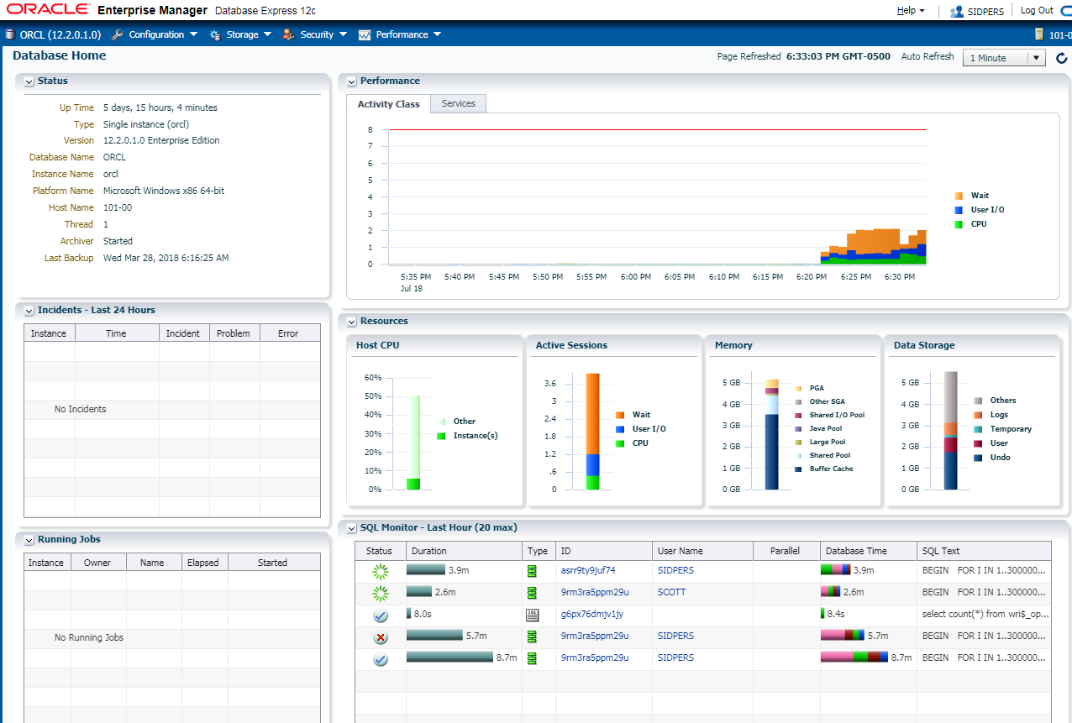
What diagnostic information is
available? _____________________________ (Host CPU and Active Sessions
graphs are available after a few refreshes.)
4) Observe the characteristics of the workload on the server. This is shown in the
CPU graph and Active Sessions.
a) What is the load shown in the Host CPU graph? ____________________ (This
number varies at each refresh.)
b) Are there any Active Waits for Sessions currently? _________

5) The characteristics of the workload on the database instance are shown in the Active
Sessions graph. When there are a large number of waiting sessions relative to the
number of sessions that use the CPU, you must check other diagnostics.
a) What is amount of memory taken up by the Buffer Cache?
____________________
b) What amount of UNDO is taking place in Data Storage?
_____________________
6) In the Performance page. Click on the USER IO section in the Performance chart at the top of the page.
7) Move to the SQL Monitor – Last Hour graph below the Resources Pages section.
section. The SQL Monitor identifies SQL statements currently executing, the User executing it ,the amount of Database time and the SQL Text.
8. Click on the SQL ID to bring up the information on the SQL statement executing.
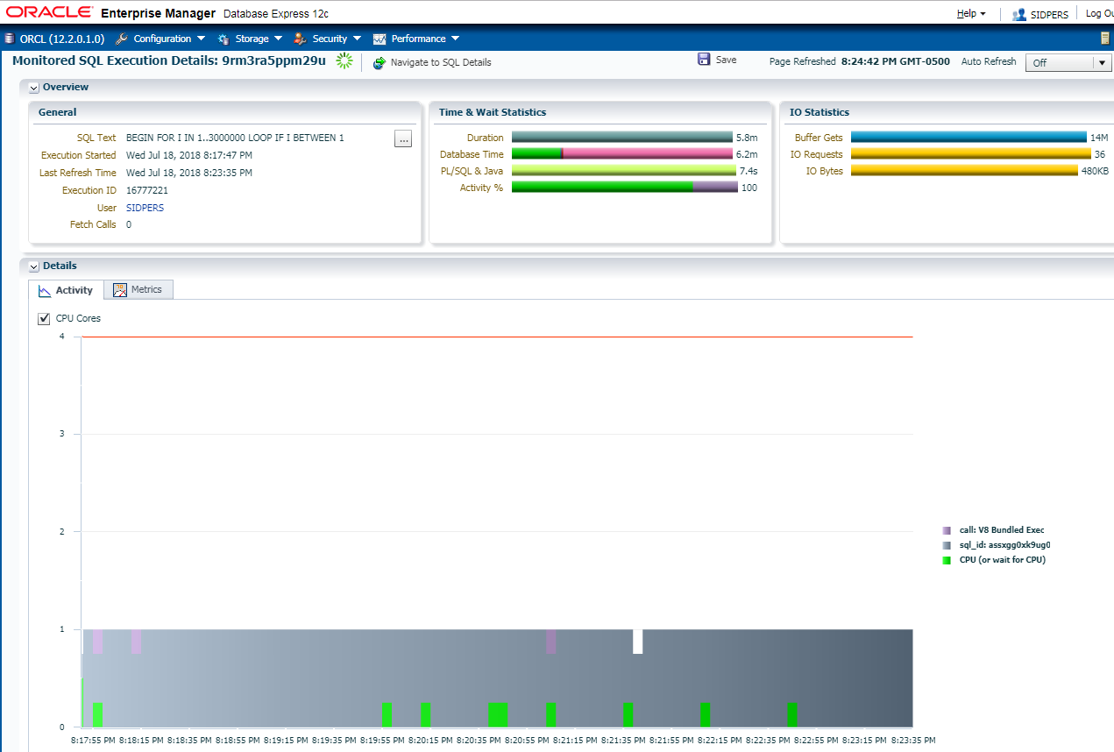

a) What does your Buffer Gets identify? _______________________ (This varies.)
9) Notice when Execution Started and Duration of execution so far.
14) Click on the Metrics Tab..
a) Click on Performance Hub, you can see the amount of Runnable Processes Activity, Total Host Memory Usage and Active Sessions and IO Throughput and IO Requests dealing with Large Writes and Large Reads..
15. On the I/O graph page, choose throughput for Statistic Type and Breakdown by I/O Function.
This lets you see Log Write (LGWR) and Database Writer (DBWR) activity.
16) Click on the Workload Tab and you are given the graphs on User Calls and Logon Rate as the Default.
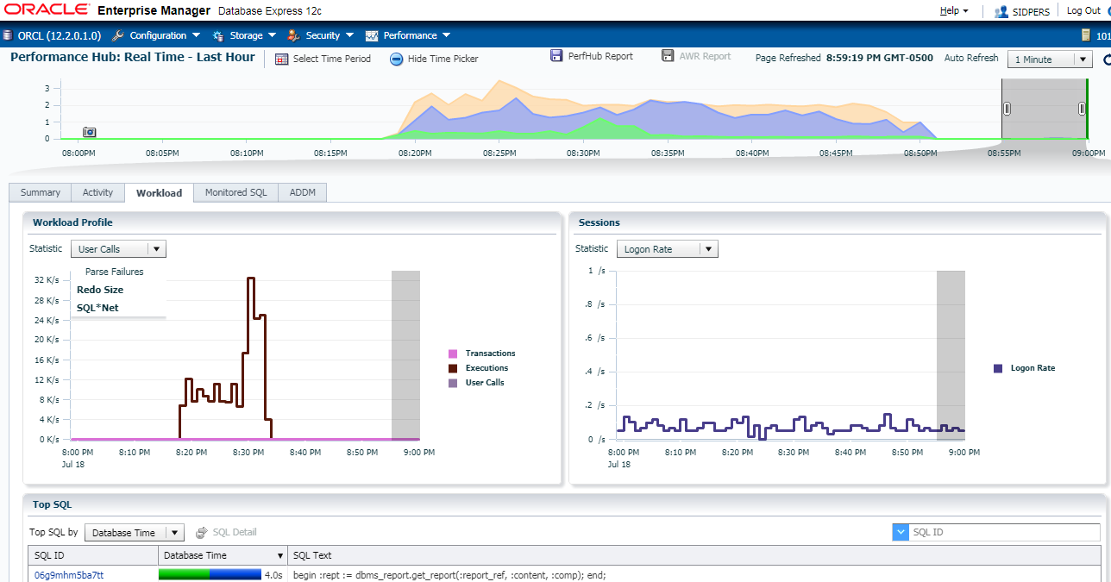
a) By clicking on the Drop down List in Workload Profile you can see the information on User Calls, Parse Calls and Redo Size.
b) Can you guess what the performance issue is that is slowing this instance?
____________________________________________________ (One possibility
is that multiple sessions are running SQL statements that are causing buffer busy
waits and free buffer waits. The waits for buffers are causing the execution to be
slow. Another, indicated by log file waits, is that the log files are not configured
for the load.) For more information about tuning buffer waits, see the lesson titled
“Tuning the Buffer Cache.”

Practice 2-3: Finding the SPFILE and Password File
1. Why is the SPFILE used to start the database important?
____________________________________________
(Changes in the initialization parameters can have a large effect on database
performance.)

- What directory is the SPFILE in? __________________________________________

- What is the password file used for. __________________________________________

- Backup the SPFILE and Password File into a directory called SPFILE_Backup on your c drive.
Practice 2-4: Viewing System Statistics and Wait Events
In this practice, you use dynamic performance views to view tuning information.
If the bigpart script has completed, rerun again to start Oracle Statistics gathering.
$
2) View the system statistics in SQL*Plus as the SYS user. Use the V$SYSSTAT view
and select NAME, CLASS, and VALUE. Order the output by CLASS. These statistics
are cumulative from the time that the instance was started.
a) What can you deduce about the instance workload and performance from a listing
of the system statistics?
Answer: There is very little that you can determine from a listing of the system
statistics by itself. Two listings that are used to create a difference in values over a
known period of time can yield rate and load information.
$ sqlplus / as sysdba
SQL> COLUMN name FORMAT A40 WORD_WRAPPED
SQL> SELECT name, class, value
2 FROM V$SYSSTAT
3 ORDER BY class;
3) View system wait events. Use the V$SYSTEM_EVENT view to see wait event
statistics. Find the total number of waits, the time waited and the average time waited
for buffer busy waits, and the time waited relative to the other wait events.
Answer: The buffer busy wait event has collected some waits and the average
wait time is displayed. There are several wait events that are not important, such as
rdbms ipc message and smon timer. These are internal waits for a command
to be issued, or for a timer to expire to initiate a task. They do not affect performance.
Your output from this query will vary from the example shown.
SQL> COLUMN event FORMAT A30 WORD_WRAPPED
SQL> COLUMN average_wait HEADING AVERAGE|WAIT
SQL> COLUMN TIME_WAITED HEADING TIME|WAITED
SQL> COLUMN TOTAL_WAITS HEADING TOTAL|WAITS
SQL> SET PAGESIZE 60
SQL> SELECT event, total_waits, time_waited, average_wait
2 FROM V$SYSTEM_EVENT
3 ORDER BY time_waited DESC;
TOTAL TIME AVERAGE
EVENT WAITS WAITED WAIT
----------------------------- ---------- ---------- ----------
rdbms ipc message 759513 6351364 8.36
SQL*Net message from client 241945 2945562 12.17
DIAG idle wait 8335 834396 100.11
Streams AQ: waiting for 1104 550749 498.87
messages in the queue
pmon timer 4319 416939 96.54
Streams AQ: qmn coordinator 297 415490 1398.96
idle wait
smon timer 38 414877 10917.81
virtual circuit status 139 414646 2983.07
Space Manager: slave idle wait 851 414570 487.16
Streams AQ: qmn slave idle 152 414488 2726.89
Wait
dispatcher timer 69 414028 6000.4
wait for unread message on 4161 411275 98.84
broadcast channel
fbar timer 13 390009 30000.7
jobq slave wait 715 212326 296.96
resmgr:become active 20595 124385 6.04
log file sync 34294 73132 2.13
buffer busy waits 108136 61771 .57
db file sequential read 284405 28963 .1
log file switch (checkpoint 1338458 22522 .02
incomplete)
resmgr:cpu quantum 48411 13419 .28
JOX Jit Process Sleep 14 10501 750.1
enq: HW - contention 330 10213 30.95
Streams AQ: waiting for time 6 6940 1156.67
management or cleanup task
Data file init write 1194 6589 5.52
control file parallel write 5619 6000 1.07
control file sequential read 4247821 4800 0
enq: TX - index contention 3642 2988 .82
SQL*Net message to client 241964 2817 .01
library cache: mutex X 38103 1451 .04
enq: CF - contention 154 1168 7.59
rdbms ipc reply 1910 936 .49
Log archive I/O 3117 906 .29
latch: cache buffers chains 6814 857 .13
buffer deadlock 1477 747 .51
db file scattered read 1698 540 .32
library cache load lock 75 535 7.13
latch free 12003 434 .04
Oracle Internal & Oracle Academy Use Only
control file heartbeat 1 400 399.95
log file parallel write 576912 398 0
db file single write 144 333 2.31
log file sequential read 3116 311 .1
free buffer waits 242 265 1.09
LGWR wait for redo copy 23165 251 .01
enq: US - contention 222 238 1.07
…
4) Check the session wait events. Find the sessions that are currently waiting on
buffer busy waits. Use the V$SESSION_WAIT view. Why are very few or
no sessions listed?
Answer: The V$SESSION_WAIT view shows waits only for currently connected
sessions. The waits for all sessions, past and current, are summed in the
V$SYSTEM_EVENTS view. Your output from this query will vary from the example
shown.
SQL> COLUMN time_waited HEADING TIME|WAITED
SQL> COLUMN AVERAGE_WAIT HEADING AVERAGE|WAIT
SQL> COLUMN seconds_in_wait HEADING SECONDS|IN_WAIT
SQL> COLUMN EVENT FORMAT A20
SQL> COLUMN total_waits HEADING TOTAL|WAITS
SQL>
SQL> select sid, wait_time, seconds_in_wait, state
2 from v$session_wait
3 where event = 'buffer busy wait';
no rows selected
SQL>
SQL>
SQL> SELECT sid, event, total_waits,
2 time_waited, average_wait
3 FROM V$SESSION_EVENT
4 WHERE event = 'buffer busy waits';
TOTAL TIME AVERAGE
SID EVENT WAITS WAITED WAIT
---------- ------------------ ---------- ---------- ----------
128 buffer busy waits 2 2 .89
132 buffer busy waits 1 0 .25
140 buffer busy waits 7 1 .11
157 buffer busy waits 1 0 .01
159 buffer busy waits 26 15 .57
SQL> exit

END OF LAB

