Lab 2-1: Retrieve Information from Database Tables
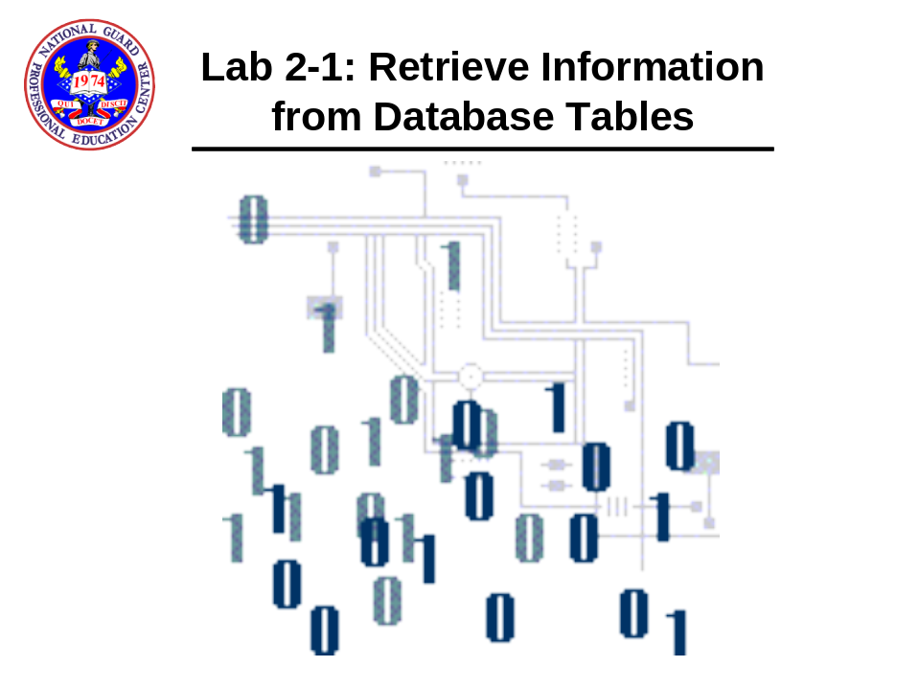

- Log on to SQL DEVELOPER as hr with a password of hr.

- Perform a describe command on the dual table. Then Select * from dual;

- How many rows did you see?

- How many columns did you see?

- Perform the following SELECT query:

select employee_id,last_name from employees;

- Now perform a select query on the COUNTRIES table that will return ALL columns.

- What query did you use?

- Perform a select query retrieving the user and salary from the employees table.

SQL> select user, salary from employees. Is user a column in the employees table?.

- Perform a select statement on the dual table for the following:

Select 47 * 15 from dual

- Perform the following query using the TO_DATE function.

select TO_DATE('15-MAR-2006') – 2 from dual;

- What result did you get?

- Perform the following query not using parentheses:

select 22 * 15/2 – 1 from dual;

- What result did you get?

- Perform the following query using parentheses:

select 22 * (15/2 – 1) from dual;

- What result did you get? Was the result different from the last query? Why?

- Now, we'll use columns in arithmetic. Perform the following select statement:

select employee_id, salary, salary * 1.10 from employees;

- Did you see the differences in salary?

- Let's try again:

select employee_id, salary, salary * 1.10 + 500 from employees;

- Did you see the differences?

- Let's use a column alias this time:

select employee_id, salary, salary * 1.10 New_Salary
from employees;

Why didn't you have to use double quotes around the column alias?

- And try this one:

select employee_id, salary, salary * 2 "Double Salary" from employees;

- Did you notice the titles? Were they different? Why?

- Let's use some concatenation. Perform the following select statement first:

select last_name, first_name, email from employees

- Now, let's concatenate them:

select Last_Name || ', ' || First_name || ' ' ||email
from employees;

- And let's do this with a column alias:
select Last_Name || ', ' || First_name || ' ' ||email
EMPLOYEE_EMAIL
from employees;
;

- Perform the following queries for Null values:

select Last_Name, First_name, email, commission_pct
from employees
where commission_pct IS NULL;

select Last_Name name, First_name, email, nvl(commission_pct,0) "Comm Pct"
from employees
where commission_pct IS NULL;

- How many rows for the first query?

- Did you see NAME for Last_Name field and the column name Comm Pct from the second query?

