CHAPTER 8

TOPIC OUTLINE

Uses of Indexes

Function-Based Indexes

Composite Indexes

Bitmap Indexes

IOTs

Bitmap Join Indexes

Guidelines for Application-Specific Indexes
You can create indexes on columns to speed up queries. Indexes provide faster access to data for operations that return a small portion of a table's rows.
In general, you should create an index on a column in any of the following situations:
- The column is queried frequently.
- A referential integrity constraint exists on the column.
- A UNIQUE key integrity constraint exists on the column.
You can create an index on any column; however, if the column is not used in any of these situations, creating an index on the column does not increase performance and the index takes up resources unnecessarily.
Although the database creates an index for you on a column with an integrity constraint, explicitly creating an index on such a column is recommended.
You can use the following techniques to determine which columns are best candidates for indexing:
- Use the EXPLAIN PLAN feature to show a theoretical execution plan of a given query statement.
- Use the V$SQL_PLAN view to determine the actual execution plan used for a given query statement.
Sometimes, if an index is not being used by default and it would be most efficient to use that index, you can use a query hint so that the index is used.
The following sections explain how to create, alter, and drop indexes using SQL commands, and give guidelines for managing indexes.

Create Indexes After Inserting Table Data


Typically, you insert or load data into a table (using SQL*Loader, Import BULK COPY or FOR ALL) before creating indexes. Otherwise, the overhead of updating the index slows down the insert or load operation. The exception to this rule is that you must create an index for a cluster before you insert any data into the cluster.
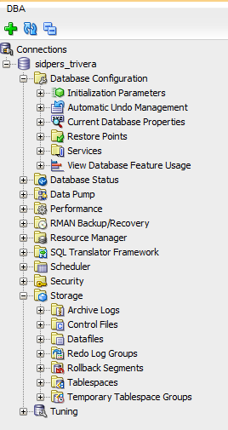
If sorting of data due to creation of IOT's, clusters or Sort Clusters or simply large application sort processing cause significant wait events, it will help greatly to create temporary tablespace groups and place multiple temporary tablespaces in them to assist in distributing sort processing.

Switch Your Temporary Tablespace to Avoid Space Problems Creating Indexes


When you create an index on a table that already has data, Oracle Database must use sort space to create the index. The database uses the sort space in memory allocated for the creator of the index (the amount for each user is determined by the initialization parameter SORT_AREA_SIZE), but the database must also swap sort information to and from temporary segments allocated on behalf of the index creation. If the index is extremely large, it can be beneficial to complete the following steps:
- Create a new temporary tablespace using the CREATE TABLESPACE command.
- Use the TEMPORARY TABLESPACE option of the ALTER USER command to make this your new temporary tablespace.
- Create the index using the CREATE INDEX command.
- Drop this tablespace using the DROP TABLESPACE command. Then use the ALTER USER command to reset your temporary tablespace to your original temporary tablespace.
Under certain conditions, you can load data into a table with the SQL*Loader "direct path load", and an index can be created as data is loaded.

Index the Correct Tables and Columns

Use the following guidelines for determining when to create an index:
- Create an index if you frequently want to retrieve less than about 15% of the rows in a large table. This threshold percentage varies greatly, however, according to the relative speed of a table scan and how clustered the row data is about the index key.
- Index columns that are used for joins to improve join performance.
- Small tables do not require indexes; if a query is taking too long, then the table might have grown from small to large.
Some columns are strong candidates for indexing. Columns with one or more of the following characteristics are good candidates for indexing:
- Values are unique in the column, or there are few duplicates.
- There is a wide range of values (good for regular indexes).
- There is a small range of values (good for bitmap indexes).
- The column contains many nulls, but queries often select all rows having a value. In this case, a comparison that matches all the non-null values, such as:
- WHERE COL_X >= -9.99 *power(10,125)
This is preferable to WHERE COL_X IS NOT NULL
This is because the first uses an index on COL_X (assuming that COL_X is a numeric column).
Columns with the following characteristics are less suitable for indexing:
- There are many nulls in the column and you do not search on the non-null values.

Limit the Number of Indexes for Each Table
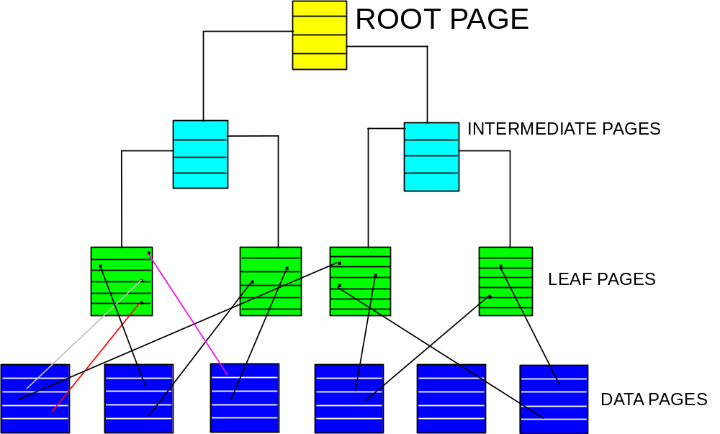

The more indexes, the more overhead is incurred as the table is altered. When rows are inserted or deleted, all indexes on the table must be updated. When a column is updated, all indexes on the column must be updated.
You must weigh the performance benefit of indexes for queries against the performance overhead of updates. For example, if a table is primarily read-only, you might use more indexes; but, if a table is heavily updated, you might use fewer indexes.

Choose Order of Columns in Compound Indexes


Although you can specify columns in any order in the CREATE INDEX command, the order of columns in the CREATE INDEX statement can affect query performance. In general, you should put the column expected to be used most often first in the index. You can create a composite index (using several columns), and the same index can be used for queries that reference all of these columns, or just some of them.
Assume that there are five vendors, and each vendor has about 1000 parts.
Suppose that the VENDOR_PARTS table is commonly queried by SQL statements such as the following:
SELECT * FROM vendor_parts
WHERE part_no = 457 AND vendor_id = 1012;

To increase the performance of such queries, you might create a composite index putting the most selective column first; that is, the column with the most values:
CREATE INDEX ind_vendor_id
ON vendor_parts (part_no, vendor_id);

Composite indexes speed up queries that use the leading portion of the index. So in this example, queries with WHERE clauses using only the PART_NO column also note a performance gain. Because there are only five distinct values, placing a separate index on VENDOR_ID would serve no purpose.

Drop Indexes That Are No Longer Required


You might drop an index if:
- It does not speed up queries. The table might be very small, or there might be many rows in the table but very few index entries.
- The queries in your applications do not use the index.
- The index must be dropped before being rebuilt.
When you drop an index, all extents of the index's segment are returned to the containing tablespace and become available for other objects in the tablespace.
Use the SQL command DROP INDEX to drop an index. For example, the following statement drops a specific named index:
DROP INDEX Emp_ename;

If you drop a table, then all associated indexes are dropped.
To drop an index, the index must be contained in your schema or you must have the DROP ANY INDEX system privilege.

Creating Indexes: Basic Examples

You can create an index for a table to improve the performance of queries issued against the corresponding table. You can also create an index for a cluster. You can create a composite index on multiple columns up to a maximum of 32 columns. A composite index key cannot exceed roughly one-half (minus some overhead) of the available space in the data block.
Oracle Database automatically creates an index to enforce a UNIQUE or PRIMARY KEY integrity constraint. In general, it is better to create such constraints to enforce uniqueness, instead of using the obsolete CREATE UNIQUE INDEX syntax.
Use the SQL command CREATE INDEX to create an index.
In this example, an index is created for a single column, to speed up queries that test that column:
CREATE INDEX emp_ename ON emp_tab(ename);

In this example, several storage settings are explicitly specified for the index:
CREATE INDEX emp_ename ON emp_tab(ename)
TABLESPACE users

In this example, the index applies to two columns, to speed up queries that test either the first column or both columns:
CREATE INDEX emp_ename ON emp_tab(ename, empno) COMPUTE STATISTICS;

When to Use Function-Based Indexes


A function-based index is an index built on an expression. It extends your indexing capabilities beyond indexing on a column. A function-based index increases the variety of ways in which you can access data.
Like other indexes, function-based indexes improve query performance. For example, if you need to access a computationally complex expression often, then you can store it in an index. Then when you need to access the expression, it is already computed. You can find a detailed description of the advantages of function-based indexes in "Advantages of Function-Based Indexes".
Function-based indexes have all of the same properties as indexes on columns. However, unlike indexes on columns which can be used by both cost-based and rule-based optimization, function-based indexes can be used by only by cost-based optimization. Other restrictions on function-based indexes are described in "Restrictions for Function-Based Indexes".

Advantages of Function-Based Indexes
Function-based indexes:
- Increase the number of situations where the optimizer can perform a range scan instead of a full table scan. For example, consider the expression in this WHERE clause:
CREATE INDEX Idx ON Example_tab(Column_a + Column_b);
SELECT * FROM Example_tab WHERE Column_a + Column_b < 10;
The optimizer can use a range scan for this query because the index is built on (column_a + column_b). Range scans typically produce fast response times if the predicate selects less than 15% of the rows of a large table.
Precompute the value of a computationally intensive function and store it in the index. An index can store computationally intensive expression that you access often. When you need to access a value, it is already computed, greatly improving query execution performance.
- Create indexes on object columns and REF columns. Methods that describe objects can be used as functions on which to build indexes. For example, you can use the MAP method to build indexes on an object type column.
- Create more powerful sorts. You can perform case-insensitive sorts with the UPPER and LOWER functions, descending order sorts with the DESC keyword, and linguistic-based sorts with the NLSSORT function.
Another function-based index calls the object method distance_from_equator for each city in the table. The method is applied to the object column Reg_Obj. A query could use this index to quickly find cities that are more than 1000 miles from the equator:
CREATE INDEX Distance_index
ON Weatherdata_tab (Distance_from_equator (Reg_obj));

SELECT * FROM Weatherdata_tab
WHERE (Distance_from_equator (Reg_Obj)) > '1000';

Examples of Function-Based Indexes


Example: Function-Based Index for Case-Insensitive Searches
The following command allows faster case-insensitive searches in table EMP_TAB.
CREATE INDEX Idx ON Emp_tab (UPPER(Ename));

The SELECT command uses the function-based index on UPPER(e_name) to return all of the employees with name like :KEYCOL.
SELECT * FROM Emp_tab WHERE UPPER(Ename) like :KEYCOL;

Example: Precomputing Arithmetic Expressions with a Function-Based Index
The following command computes a value for each row using columns A, B, and C, and stores the results in the index.
CREATE INDEX Idx ON Fbi_tab (A + B * (C - 1), A, B);

The SELECT statement can either use index range scan (since the expression is a prefix of index IDX) or index fast full scan (which may be preferable if the index has specified a high parallel degree).
SELECT a FROM Fbi_tab WHERE A + B * (C - 1) < 100;
NON-UNIQUE INDEXES

TASK: Create an Index so that ORACLE can retrieve data
based upon an Index search versus a table scan

SQL:

CREATE INDEX xname
ON STAFF (name)

RESULT: Index xname is built with the key field of NAME.

NOTES:

- A general guideline is to create an index on anything you want to search frequently.

- Primary keys should always be indexed uniquely.

- Foreign keys should also be indexed, to help you find the information they point to more efficiently.

- In the case of joins , the system can perform the join much faster if the columns are sorted.

- Must be the table owner in order to create or have Index privilege on table .
UNIQUE INDEXES

TASK: Create a unique index on the primary key field
DEPTNUMB of the ORG table

SQL:
CREATE UNIQUE INDEX XORG
ON ORG (DEPTNUMB)

RESULT: Index XORG is created which will not allow duplicate Department numbers in the ORG table.

NOTES:

1. Enforces uniqueness of Rows

2. Speeds Joins (Referential checks)

3. Speeds Data Retrieval

4. Speeds ORDER BY and GROUP BY

COMPOSITe INDEXES

TASK: Create an index on name and department on the
STAFF table

SQL:
CREATE INDEX xstaff_dept
ON STAFF (NAME,DEPT)

RESULT: Index xstaff_dept is created which will not allow duplicate name and dept columns in the STAFF table.

NOTES:

- A composite index specifies two or more columns as the index

- Composite columns are searched as a unit

- Column order in the CREATE INDEX statement doesn't have to match column order in the CREATE TABLE statement

- May create either a unique, non-unique or even a clustered index using a composite index.
NONCLUSTERED INDEXES

NOTES:

- Row keys are searched starting with a high key search in the root page

- The leaf level contains pointers to the rows on the data page

- The pointers add a level between the index and the data

INDEXES WITH PCTFREE

TASK: Limit the number of Index pages which are filled with rows
at index creation time

SQL:
CREATE UNIQUE INDEX xstaff_indx
ON STAFF (id,name)
PCTFREE 10

RESULT: 90% of each Index page is filled at creation with
rows from the STAFF table. This minimizes index page
splitting and allows for fine-tuning for performance.

NOTES:

PCTFREE of 10% will keep 10% of the index page available for updates and inserts. This would be useful for tables where the index values will not change a great deal through inserts,deletions, or updates..

BITMAP INDEXES
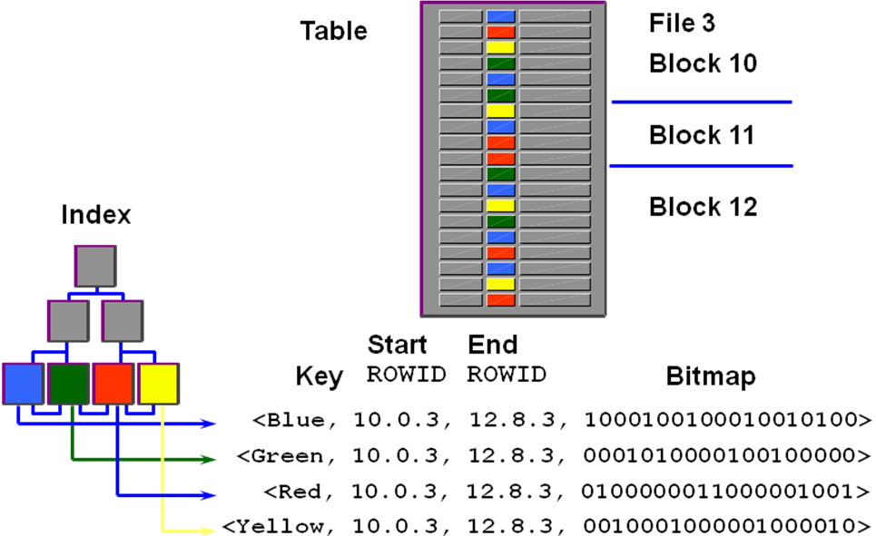
Bitmap Indexes are used for:
• Used for Low-cardinality columns
• Good for multiple predicates
• Use minimal storage space
• Best for read-only systems
• Good for very large tables

CREATING AND MAINTAINING BITMAP INDEXES


CREATE BITMAP INDEX BMAP_BNAME
ON BIG (BNAME)
TABLESPACE JERINDEX

- CREATE_BITMAP_AREA_SIZE defines the amount of memory for an
index creation. The default is 8mb. The higher the cardinality the more
memory you will need.
- BITMAP_MERGE_AREA_SIZE defines the amount of memory used
to merge bitmaps retrieved from a range scan of an index. The default
is 1 MB.

In a DSS environment, data is usually maintained by using bulk inserts and
updates. Index maintenance is deferred until the end of each DML operation.
For example, if you insert 1,000 rows into a table that has a bitmapped index,
the bitmapped column information and the ROWID information from the inserted
rows are placed into the reference to the sort buffer, and then the updates of all
1,000 index entries are batched. The SORT_AREA_SIZE parameter will need
to be monitored when using these indexes.

INDEX COMPARISONS

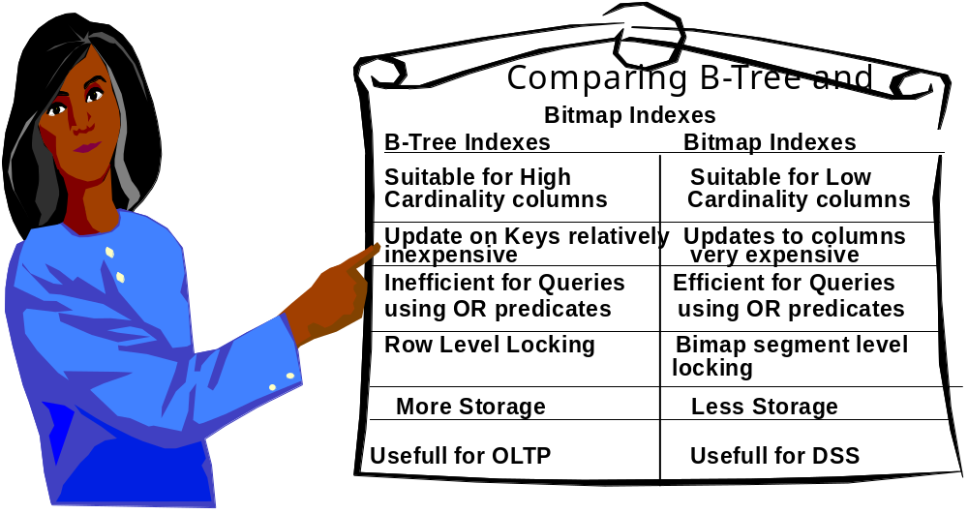
Bitmap indexes should be investigated and tested for Data Warehousing applications, Financials and all low-cardinality accesses to tables where the
predicates are not widely dispersed.

CREATING REVERSE KEY INDEXES

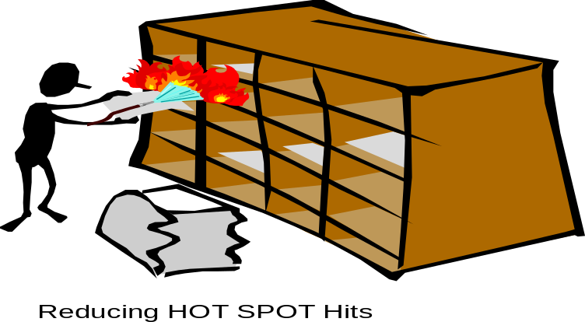
Create unique index po_no_idx on puorder (po_no)
REVERSE pctfree 30
storage (initial 400k next 400k pctincrease 0)
tablespace jerindx.

Creating a reverse key index reverses the bytes of each column key value, keeping the column order in case of a composite key.

Use a Reverse key index when an ever-increasing key will repetitively degrade
the index height level and cause the HOT SPOT syndrome.

INDEX-ORGANIZED TABLES

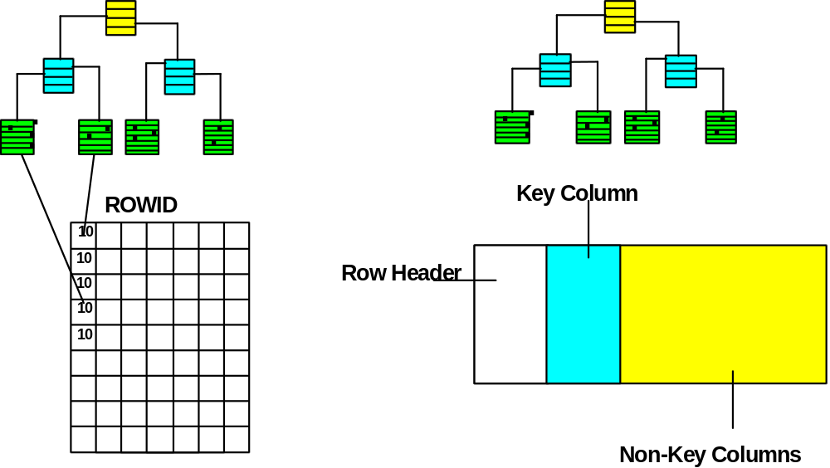
- Index contains both the primary key and other column values
- No duplication of the values for the primary key column (less storage)
- Faster key-based access for queries involving exact matches or range
searches or both.
- Logical Rowid used instead of a physical ROWID. Access to this value is through a UROWID.

CREATING INDEX-ORGANIZED TABLES



CREATE TABLE SALES
(OFFICE_ID NUMBER(3) NOT NULL,
QTR_END DATE,
REVENUE NUMBER(11,2),
REVIEW VARCHAR2(200)
CONSTRAINT SALES_PK PRIMARY KEY (OFFICE_ID,QTR_END)
)
ORGANIZATION INDEX TABLESPACE JERINDX
PCTTHRESHOLD 20
INCLUDING REVENUE
OVERFLOW TABLESPACE USER_DATA;

IOT-TABLES store as many rows in a leaf page as PCTTHRESHOLD limit
will allow. The IOT-Table will store the most frequently used columns with
the primary key value. Non key column values that are not used frequently
are kept in the overflow tablespace. This is called the overflow area.

IOT ROW-OVERFLOW STRATEGY

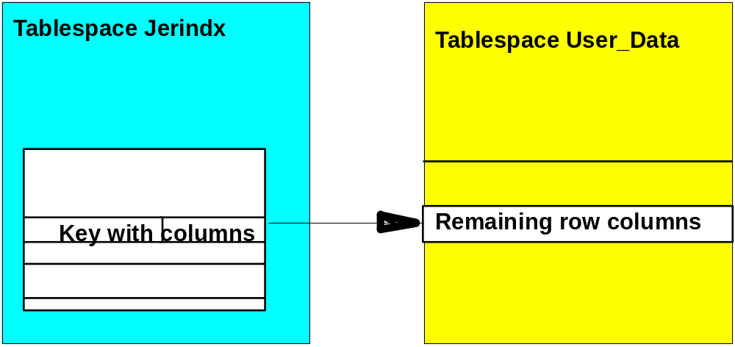

- PCTTHRESHOLD Clause
This clause specifies the percentage of space reserved in the index for an
index organized table row. If a row exceeds the size calculated based upon
this value, all columns after the column named in the INCLUDING clause are
moved to the overflow segment. If OVERFLOW is not specified the rows
exceeding the threshold are rejected. The default PCTTHRESHOLD = 50.
- INCLUDING Clause
This clause specifies a column to be placed into the IOT Table and all other
row columns to be placed in overflow. Oracle accommodates all non-key
columns up to the column specified in the INCLUDING clause in the LEAF
block provided it does not exceed the specified threshold.
- OVERFLOW Clause and Segment
This clause specifies the non-key columns exceeding the specified
THRESHOLD and are subsequently placed in the OVERFLOW segment.

BITMAP INDEXES ON IOT
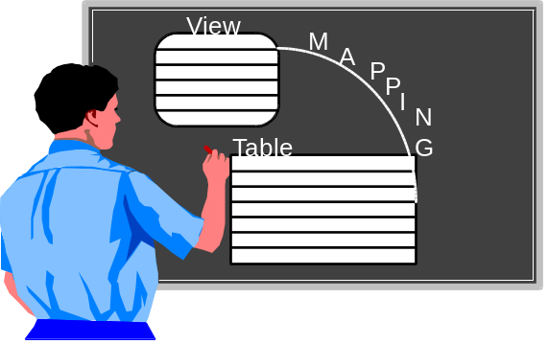

In Oracle19c, you can create a bitmap index on an IOT table. A mapping table is used to resolve ROWIDs needed for the IOT, and the physicdal ROWIDs needed by the bitmap index. The mapping table is built by specifying the MAPPING TABLE clause when creating the IOT.

Performance problems occur for IOT’s when:

- Leaf blocks of an IOT split and cause performance hits

- Analyze indexes and query PCT_DIRECT_ACCESS in the
DBA_INDEXES table to see percentage of rows gotten through
A correct guess on the IOT

- Rebuild mapping tables with the ALTER Table command, including
The MAPPING TABLE UPDATE BLOCK REFERENCES clause.

FUNCTION-BASED INDEXES

One of the keys to using indexes

Consider the following query of the STAFF table that identifies information about a specific staff recored, based on the uppercase version of the name field.

SELECT ID, NAME, JOB, SALARY
FROM staff
WHERE UPPER(NAME) = 'RICH';

In this case, a normal index on the NAME field would not be optimal because the index contains each staff record’s NAME field as it exists in the record itself (in other words, in all uppercase letters, in all lowercase letters, or in a mixed case of letters). Consequently, to do a comparison with an index on the NAME column Oracle needs to convert each key in the index to uppercase letters and then compare the resulting string to the search criteria.

To overcome this overhead processing we create a function-based index:

SQL> CREATE INDEX staff_upper_name
ON STAFF (UPPER (NAME));

In Oracle8i, index-only scans required the index column to be NOT NULL in order to be used. This meant expression used in Function -based indexes could not be used because expression are always defined as NULL. Oracle19c corrects that.

Bitmap Join Indexes on Multiple Tables
As you become more familiar with using the bitmap join index, you will be able to solve complex business problems that involve multiple tables. The following example shows how to apply the bitmap join index to multiple tables. The syntax is still the same, but it has now been expanded to include multiple columns in the index and multiple tables being joined for the index. The example shown next assumes that the unique constraint on DEPT1.DEPTNO from the example in the earlier listing (where I added a unique constraint to the DEPT1 table) exists and, additionally, that it exists on SALES1.EMPNO (creation not shown).

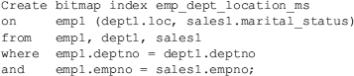

The query in this next listing is now able to use the bitmap join index appropriately:

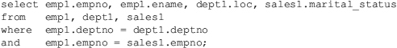

INDEX BEFORE OR AFTER LOADING DATA
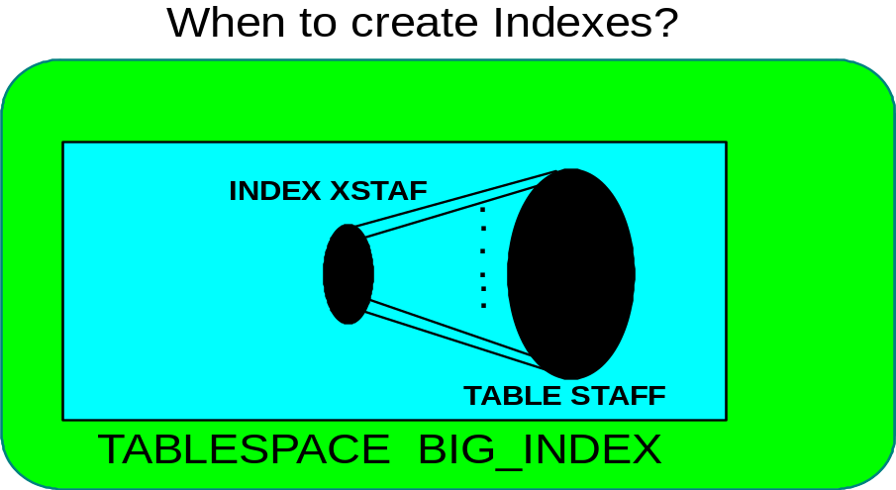

Issues to consider when creating indexes and loading data:

- Indexes slow down data loading

• Usually more efficient to index data after loading it

• The sort area may not be large enough for extremely large tables

Consider using the NOSORT option if data has been loaded in ascending key order:

ORACLE> CREATE INDEX BIG_BIGNO ON BIG(BIGNO) NOSORT
TABLESPACE BIG_INDEX
Clustering Tables

Clustering tables are used for:

- JOIN operations

- reduced storage requirements

- 'clustering' of key row values

CLUSTER BLOCK

DEPTNO

01 MYDEPT table row

01 MYEMP table row

01 MYEMP table row

02 MYDEPT table row

02 MYEMP table row

02 MYEMP table row
CLUSTERED INDEXES

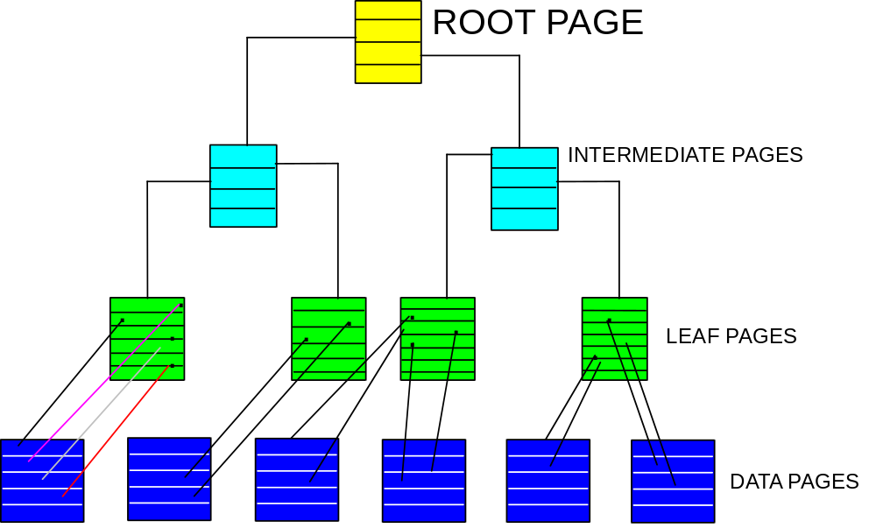

NOTES:

1. Rows from more than one table are grouped in order in a data page based upon the Cluster Index

2. The leaf level contains pointers to the rows on the data page

3. The pointers add a level between the index and the data

CREATING A CLUSTER INDEX

Task: Create the CLUSTER INDEX for the clus_dept CLUSTER
and ORG and STAFF tables
****Important: You must have created the cluster before you can
create the cluster index.
SQL:
CREATE INDEX staff_deptindx
on CLUSTER clus_dept

Notes:

To create the cluster, tables, and indexes you must have the appropriate privileges to do so. You must have either UNLIMITED TABLESPACE system privilege or CREATE ANY CLUSTER system privilege. To create a table you must have CREATE TABLE privilege or be a system administrator. To create indexes you must have the CREATE INDEX privilege at the very least.

Creating Clusters

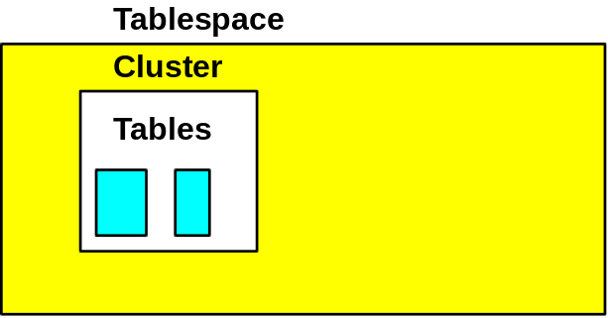

Clusters are created independently from your base tables

- Based upon common key from base tables

- Base tables clustered column must be NOT NULL

- Need to create an index on cluster key

- Typically created for empty tables

Format

Create cluster cluster-name
(cluster_key1 datatype, cluster_key2 datatype,....)
[space space_name]
{size logical_block_size}
[compress |no compress]

Examples:



1.) CREATE CLUSTER CUST_CLUS (custid number(4))
- custid is the cluster key column

2.) CREATE INDEX custndx
on CLUSTER CUST_CLUS

3.) CREATE TABLE CUSTOMER
CLUSTER CUST_CLUS (custid)
AS
SELECT * FROM CUST

CREATE TABLE ORDERS
CLUSTER CUST_CLUS(custid)
AS
SELECT * FROM ORD

3.) If you do not need the previous unclustered tables and want the
same names:

DROP TABLE CUST
RENAME CUSTOMER TO CUST
DROP TABLE ORD
RENAME ORDER TO ORD

4.) You cannot query a cluster, only the base tables

MONITORING INDEX SPACE IN BLOCKS

Index space usage can be examined using several methods. Lets assume we
have an primary key index called YEIDX which we want to evaluate:

SQL> ANALYZE INDEX YEIDX VALIDATE STRUCTURE

Index analyzed.

SQL> SELECT HEIGHT, BLOCKS, NAME, DISTINCT_KEYS,
MOST_REPEATED_KEY MRP,PCT_USED FROM SYS.INDEX_STATS
WHERE NAME = ‘YEIDX‘;

HEIGHT BLOCKS NAME DISTINCT_KEYS MRP PCT_USED
2 130 YEIDX 10000 1 88

1 ROW SELECTED

SQL> DROP INDEX YEIDX;
SQL> CREATE INDEX YEIDX ...;

The method above should be performed several times to establish a base
average efficiency of space usage. Once this base average is calculated it
should be compared against a new percentage. When the new percentage
falls below the base average, then drop and recreate to conserve space.

ORACLE stores the information from method one in a SYS view which is based
on dynamic tables, therefore, the view is initialized every time a new session
begins.

MONITORING INDEXES

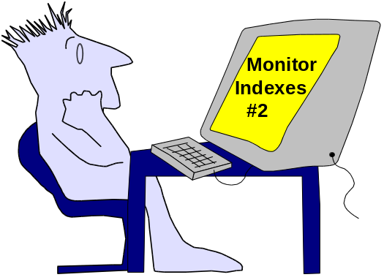

Method two for monitoring indexes can be performed to gather certain
information that is not generated in method one, e.g. index level, average
number of leaf blocks/key, average number of data blocks/key, clustering
factor, minimum key value, and maximum key value.

ORACLE stores the information from method two in several data dictionaries:
CDB_INDEXES
• ALL_INDEXES
• DBA_INDEXES
• USER_INDEXES

Information for a particular index in these data dictionary views are regenerated
every time the ANALYZE INDEX command is executed

HASH CLUSTERS
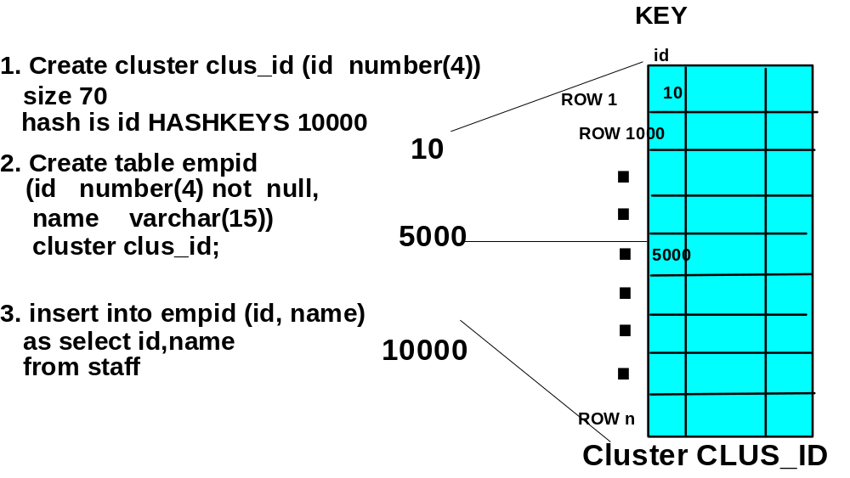

• A hash cluster is a way of storing and accessing table data
• Applies a hash function to one or more columns
• Rows are stored as a result of the hash function
• Hashing typically reduces the number of I/Os to return data blocks
• Rows are stored as a result of the hash function
- Used when it is acceptable to pre-allocate storage space for a
table
• Used when query optimization is very important
- Used when the hashed columns are frequently referenced in the
where clause with an equal sign (=)
• Tables must be clustered before they are hashed

ANALYZING A HASH CLUSTER

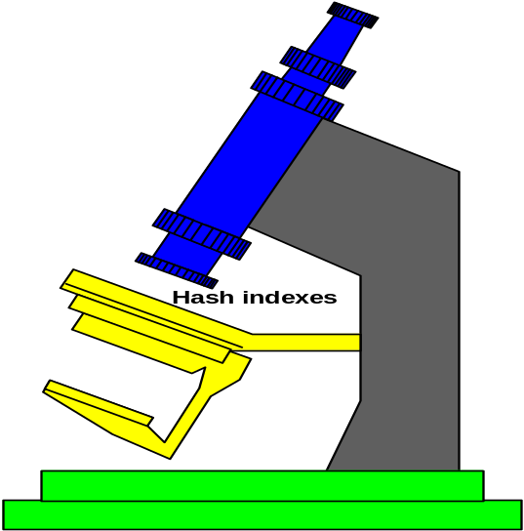

Hash clusters can be used in place of indexes many times because their search
for a key is done through an algorithm versus a key scan. To ensure your has
index is working properly you can use the following steps.

ORACLE> Analyze cluster clus_id compute statistics;

ORACLE> SELECT CLUSTER_NAME,KEY_SIZE,
AVG_BLOCKS_PER_KEY BLOCKS,
CLUSTER_TYPE,FUNCTION,
HASHKEYS HASH
FROM USER_CLUSTERS;

CLUSTER_NAME KEY_SIZE BLOCKS CLUS FUNCTION HASH
------------------------ -------------- ------------ -------- -------------- -------
CLUS_ID 70 50 HASH DEFAULT 10000

SORTED HASH CLUSTERS
  - New data structure used to store data sorted by nonprimary key columns:
    - Cluster key values are hashed.
    - Rows corresponding to a particular cluster key value are sorted according to the sort key.
  - Used to guarantee that row order is returned by queries without sorting data:
    - Rows are returned in ascending or descending order for a particular cluster key value.
    - ORDER BY clause is not mandatory to retrieve rows in ascending order.
Sorted Hash Cluster: Overview
When the Oracle database stores data in a heap-organized table, the rows are not stored in a user-controlled order. Rather, the decision about where to place a row is dependent on storage heuristics. The Oracle database does not guarantee the return order of the rows unless the query includes an ORDER BY clause.
Inside a sorted hash cluster, the rows are organized in lists of sorted rows. Each list corresponds to a particular value of the hash key columns defined by the corresponding sorted hash cluster. Within each list, the rows are stored in the order specified by the sort key columns defined by the corresponding sorted hash cluster. This is also the default return order when querying the table by using the hash key columns in the predicate.
Sorted hash clusters offer the benefit of eliminating the CPU time and private memory needed to sort the data for queries that require a guaranteed returned order between SQL statements.
When querying data in a sorted hash–clustered table by cluster key columns with an ORDER BY clause that references only the sort key columns or one of their prefixes, the optimizer avoids the sorting overhead because the rows are returned sorted by the sort key columns. However, for the same kind of queries, if you have an ORDER BY clause on a suffix of the sort key columns or nonsort key columns, additional sorting is required, assuming that no indexes are defined on the table. For this reason, when you create a sorted hash cluster, select its order key columns carefully.

IMPLEMENTING SORTED HASH CLUSTERS

CREATE CLUSTER calls_cluster
( origin_number NUMBER
, call_timestamp NUMBER SORT
, call_duration NUMBER SORT)
HASHKEYS 10000
SINGLE TABLE HASH IS origin_number
SIZE 50;
CREATE TABLE calls
( origin_number NUMBER
, call_timestamp NUMBER
, call_duration NUMBER
, other_info VARCHAR2(30))
CLUSTER calls_cluster(
origin_number,call_timestamp,call_duration
);
Cluster key
Sort key
In the first step, you create the sorted hash cluster. As you can see, the most important difference with a traditional hash cluster is that you need to define the sort key columns in addition to the cluster key columns. Here, the cluster key is ORIGIN_NUMBER, and the sort key columns are CALL_TIMESTAMP and CALL_DURATION. Another difference with traditional hash clusters is that for sorted hash clusters, the SIZE parameter specifies how many metadata entries to store for a particular hash key value. The size of one metadata entry is mainly determined by the size of the cluster key columns.
In the second step, you create the actual table specifying the link to the sorted hash cluster with the CLUSTER clause. You must specify the cluster key columns in the correct order followed by the sort key columns in the correct order. The example in the slide represents the following scenario: A telecommunications company needs to store call records for a fixed number of originating telephone numbers through a telecommunications switch. From each originating telephone number, there can be an unlimited number of telephone calls. Calls are stored as they are made and processed later in a “first-in, first-out” order when bills are generated for each originating telephone number. Each call is identified by a time-stamp number.

SORTED HASH CLUSTER SCHEMATIC

Sorted Hash Cluster: Basic Architecture
In the example in the previous slide, only one table is stored in the sorted hash cluster. Also, the hash function is very simple and no collision is expected. This is because the hash function is determined by the cluster key itself, and each cluster key value is unique. Basically, HASHKEYS represents the number of different originating telephone numbers, and SIZE represents the number of bytes used to store each cluster key metadata.
Cluster key 2
…
Cluster key 1
Cluster key n
HASHKEYS
SIZE
…
Block chain
starting points
Rows sorted by
sort key in each
block chain
As you can see, the first part of the sorted hash cluster segment is reserved to store the metadata entries. Each metadata entry contains a link to the list of its corresponding rows. Each list is made up of a series of Oracle blocks that are linked together. Each list is sorted according to the sort key columns.
Whenever you want to retrieve the rows for a corresponding cluster key value, the cluster key value is hashed to its metadata entry location, which gives the sorted list of rows that you are selecting.

PARTITIONED TABLES

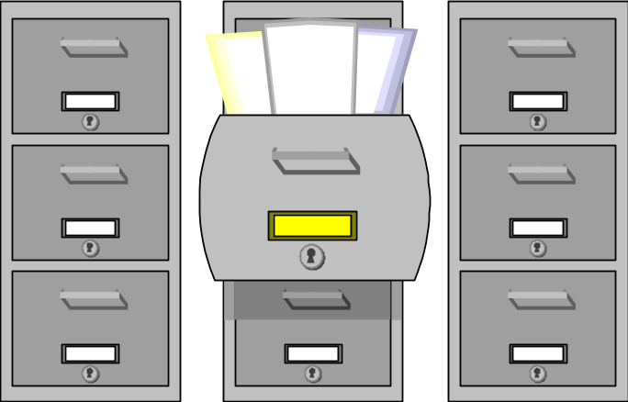

A - H I - O P - Z

Partitioned tables are used independently of partitioned views which came into
being in version 7.3 of Oracle’s database. You can either create separate tables
with the same structure or one table to hold all the partitioned data as shown.

ORACLE> CREATE TABLE SURNAME_A_H
(SURNAME VARCHAR2(20),
CITY VARCHAR2(20));
ORACLE> CREATE TABLE SURNAME_I_Q
AS SELECT * FROM SURNAME_A_H;
ORACLE> CREATE TABLE SURNAME_R_Z
AS SELECT * FROM SURNAME_A_H;
ORACLE> ALTER TABLE SURNAME_A_H
ADD constraint con1 check(upper(substr(surname,1,1)) between ‘A’ and ‘H’);
ORACLE> ALTER TABLE SURNAME_I_Q
ADD constraint con2 check(upper(substr(surname,1,1)) between ‘I’ and ‘Q’);
ORACLE> ALTER TABLE SURNAME_R_Z
ADD constraint con3 check(upper(substr(surname,1,1)) between ‘R’ and ‘Z’);
ORACLE>create view surname as
select * from surname_a_h
union all
select * from surname_I_q
union all
select * from surname_r_z;
or

PARTITIONED TABLE WITH ONE CREATE


ONE PARTITIONED TABLE

ORACLE> CREATE TABLE SURNAME_PART
(SURNAME VARCHAR2(15),
CITY VARCHAR2(20))
PARTITION BY RANGE (SURNAME)
(PARTITION SURNAME_A_H VALUES LESS THAN (‘H’),
PARTITION SURNAME_I_Q VALUES LESS THAN (‘Q’),
PARTITION SURNAME_R_Z VALUES LESS THAN (‘Z’),
PARTITION OTHER VALUES LESS THAN (MAXVALUE));

With this table, you can see how partitioned tables come into their own. Normally
all of the data would have to be stored in a single table. By using partitions, you
can store different parts of the data in different places – i.e., different tablespaces,. Partitioning has these advantages:

- Reduces the possibility of data corruption
- Increases performance by spreading data over different disk drives
- Permits independence of backups
- Allows the database to support large tables
- Allow you to support highly intensive queries against your data.

Types of Partitioning
The example shown above utilized a partitioning type known as RANGE partitioning.
Oracle supports two other types of partitions (HASH and LIST). Also, within partitioning, a sub-partition can exist. Sub-partitions also referred to as composite partitions, can be either HASH or LIST.

RANGE
Range partitions are the most common. Table and index partitions are based on a list of columns allowing to the database to store each occurrence in a given partition. These partitions are typically used within data warehousing systems. The most common range boundary is based off of dates.

Each partition is defined with an upper boundary. The storage location of each occurrence is then found by comparing the partitioning key of the occurrence with this upper boundary. This upper boundary is non-inclusive; in other words, the key of each occurrence must be less than this limit for the record to be stored in this partition.

HASH
Hash partitions are ideal when there is no real method to divide a table based on a range. Hash partitions utilize a hashing algorithm to programmatically take a column value and store that value within a given partition. Each partition is defined with an upper boundary. The storage location of each occurrence is then found by comparing the partitioning key of the occurrence with this upper boundary. This upper boundary is non-inclusive; in other words, the key of each occurrence must be less than this limit for the record to be stored in this partition. This type of partitioning is recommended when it is difficult to define the criteria for the distribution of data.

LIST
List partitions have a hard-coded LIST of values that will exist within any partition. A common usage would be with states. A state partition table would commonly have 50 partitions, one for each state.

SUB-Partitions are utilized most often when the partition strategy does not provide small enough partition units to achieve maintenance goals. When this is true, sub-partitions can further divide a table based another column.

Examples

RANGE: A max partition will capture any values beyond the stated ranges – including NULLS
Create table range_partition
( date_col date)
partition by RANGE (date_col)
(
partition p_jan_2001 values less than (to_date(‘01022001’,’ddmmyyyy’)),
partition p_feb_2001 values less than (to_date(‘01032001’,’ddmmyyyy’)),
partition pmax values less than (maxvalue)
);

HASH – Hash partitions are most optimal when 8, 16, or 32 partitions are used.
Create table hash_partition
(account_id varchar2(30))
partition by HASH (account_id) partitions 16
LIST
Create table list_partition
(state_id varchar2(2))
partition by LIST (state_id)
(
partition P_MI values (‘MI’),
partition P_CO values (‘CO’)
);

Lab 5 - MORE ABOUT CREATING TABLES AND INDEXES

Create 7 tables in the appropriate tablespace. The seven tables are called: PRESIDENT, ELECTION, ADMIN_PR_VP, ADMINISTRATION, PRES_HOBBY, PRES_MARRIAGE, STATE. See pres.sql. The specs for these tables can be found on subsequent pages of this lab. Remember to check the sample against the specs to make sure they match up. Create the appropriate Primary key indexes for these tables. Find the foreign key column in
the ADMINISTRATION table which references PRESIDENT and create a foreign key (RI) on it . (HINT: These tables must be empty before creating (RI) constraints.)

Table Specifications:

We want to collect these items of data about presidents of the United States into these tables:
ITEM TYPE LENGTH NULLS ALLOWED
================================================================
PRESIDENT NAME CHAR 20 NO
YEAR BORN NUMBER(4) NO
NUMBER YEARS SERVED NUMBER(4) NO
AGE AT DEATH NUMBER(4) YES
PARTY CHAR 20 NO
STATE BORN CHAR 20 NO
STATE CHAR 20 NO
YEAR STATE ENTERED U.S. NUMBER(4) NO
ADMINISTRATION STATE ENTERED NUMBER(4) YES
ADMINISTRATION NUMBER NUMBER(4) NO
YEAR INAUGURATED NUMBER(4) NO
VICE-PRESIDENT NAME CHAR 20 NO
PRESIDENT'S HOBBIES CHAR 20 YES
PRESIDENT'S SPOUSE CHAR 20 YES
YEAR MARRIED NUMBER(4) YES
PRESIDENT'S AGE AT MARRIAGE NUMBER(4) YES
SPOUSE'S AGE AT MARRIAGE NUMBER(4) YES
NUMBER OF CHILDREN NUMBER(4) YES
ELECTION YEAR NUMBER(4) NO
CANDIDATE CHAR 20 NO
VOTES NUMBER(4) NO
WINNER/LOSER INDICATOR CHAR 1 NO

Lab 5 - MORE ABOUT CREATING TABLES AND INDEXES



TABLE COLUMN NAMES AND RELATIONSHIPS

The logical data base design process suggest tables with the following
columns:

PRESIDENT:

pres_name, birth_yr, yrs_serv,death_age,party,state_born

ADMINISTRATION:

admin_nr, pres_name,year_inaugurated

ADMIN_PR_VP:

admin_nr, pres_name, vice_pres_name

STATE:

state, admin_entered,year_entered

PRES_HOBBY:

pres_name,hobby

PRES_MARRIAGE

pres_name,spouse_name,pr_age,sp_age,nr_children,mar_year

ELECTION:
election_year,candidate,votes,winner_loser_indic
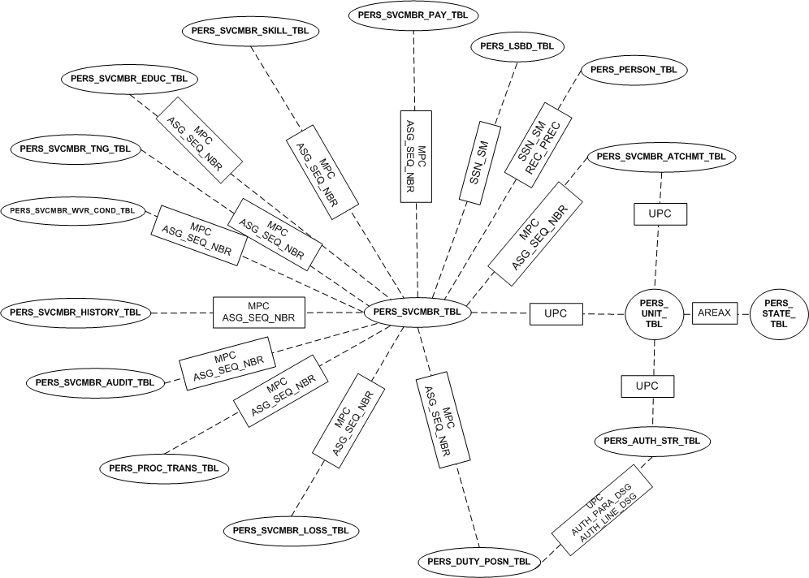
This is the Data Model for the Sidpers schema. You will be creating different indexes and compare the performance between the different tables. Before executing the queries on the next page, clear the buffer cache of data so the queries are equivalent.

Log in as sidpers <password> of password
SQL> ALTER SYSTEM FLUSH BUFFER_CACHE;
Lab 5 - MORE ABOUT CREATING TABLES AND INDEXES

PRESIDENT TABLE QUERIES

1. Insert your name into the PRESIDENT table. Execute uinsert.SQL to load the tables. No changes are needed to these inserts. See: uinsert.SQL.

2. Execute 'SELECT' statements to verify the data exists in each of your tables.

3. List the president's name, year born, year married, and spouse's name of all married presidents. This is a join of 2 tables. President and Pres_Marriage. Use a Natural Join.

4. Create a non unique index on the candidate column in the Election table..

5. Create a view which contains the President’s name, his spouse and any hobbies he may have had. This is a join of 3 tables..

6. Create exact duplicate tables of the following tables in the sidpers schema using CTAS (Create table as select command).
Pers_person_tbl will be called person
Pers_svcmbr_tbl will be called svcmbr
pers_unit_tbl will be called unit.
These tables will have no indexes on them.
a. Perform a join of the three tables (using the above data model to identify keys) and use AUTOTRACE to see what kind of performance in cpu, I/O and cost you achieve.
b. Create unique indexes on the person.table (ssn_sm and rec_prec)
c. Create non unique indexes on the (svcmbr) table on the ssn_sm column.
d. Create unique indexes on the svcmbr table on the mpc and asg_seq_nbr columns.
e. Create non unique indexes on the upc column in the svcmbr tbl.
f. Create unique indexes on the unit table on the upc column.
g. Clear the buffer cache so that no data is in them
SQL> alter system flush buffer_cache;
h. Now run the same join as above and identify performance benefits.

7. Create a join of the person and svcmbr table where the user requires the ssn_sm, rec_prec, name_ind, states_us, dob and apft_score (physical fitness score) from the person table and requires the mpc, asg_seq_nbr, gr_abbr_code and cum_ret_pt for their report. Join them with a using clause. Using Autotrace, record the costs and i/o effort

8.Create an IOT from the person table called person_iot which includes the above data (ssn_sm, rec_prec,name_ind,states_us,dob and apft_score) with the primary key of ssn_sm and rec_prec and sends eth_gp, martl_stat, race_pop_gp, rel_denom, sex, hgt_ind, wt_ind, loc_data_pers to an overflow tablespace called user_data. Iot.sql

9. Create another IOT from the svcmbr table called svcmbr_iot which includes the mpc, asg_seq_nbr, ssn_sm, rec_prec, upc,gr_abbr_code, cum_ret_pt and date_rec_stat with the primary key of mpc and asg_seq_nbr while sending the following columns (date_asgn_loss_rsn, org_ident, expir_date_ing, date_init_procrmt,retn_wvr, date_mand_rem, date_end_eval_period, afqt_score_gps) to an overflow tablespace called user_data. Cr8svcmbr_iot

10. Do the same join as above and identify cost and i/o.

11. Create an exact copy of the President table using the create table as select (CTAS) command.

12. Run the following statement before you create a bitmap index. Create a bitmap index called person_bit on the person table which includes sex, martl_stat(marital status), hgt_ind, wt_ind and dob. This is required because of new requirements which require certain human characteristics for specific jobs.

13. Create a SPOUSE table that contains spouse name and marriage year. Load it from the PRES_Marriage table using a CTAS.

14. Run this query which searches for an individual name using a like clause. Use SQLPLUS or SQL DEVELOPER with the autotrace on.
SQL>select name_ind from person where name_ind like 'JER%'; Record the cost and type of access.
THen create a function based index called person_name_ix on the person table on the name_ind column which ensures that a user searches for the name in upper case. What are the results? Did the function-based index get used? If not, why don't you think it did?

15. Select index_name from user_indexes where table_name like big; How many indexes on big and on what columns? Do the following select:
SQL> explain plan for
select bname from big where bname like 'BET%'; Evaluate the plan.
Now let's drop the index on bname. SQL> drop index big_bname;
Rerun the explain plan above. Does it have a different plan?
Now Create a bitmap index on the bname column in the big table.
Rerun the explain plan for select bname from big where bname like 'BET%';

Lab 5 - MORE ABOUT CREATING TABLES AND INDEXES

16. Add a column to the STATE table for state flower.

17. Create a table for flowers containing columns for flower name and color.
Insert your own state flower data.

18. Add a column for height in the FLOWER table.

19. Delete the FLOWER table

20. Which Presidents never won an election? (Use a subquery)

Optional Queries:

1. Summarize total votes by candidate without regard to election year. Show in
descending total vote sequence.

2. Add yourself as a candidate in the election table, then using a complex
insert, add yourself to the PRESIDENT table as the next president adding
appropriate values as needed using data (your name) from the election table.

