*----What is a Biological Neuron*

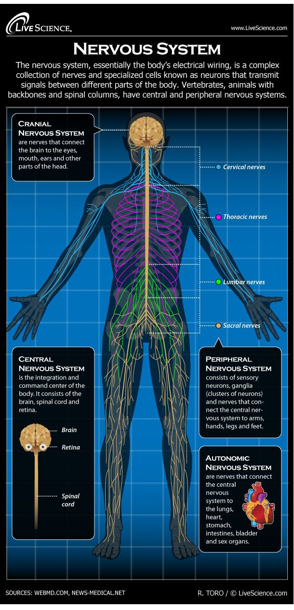

*A neuron is a cell in the body. It is specifically a nerve cell and it is the basic building block of your nervous system. A Neurons has a lot in common with other cells in your body, but there is one critical and important difference between neurons and other cells in your body. Your bodies Neurons are specialized to process data and then transmit that information throughout your entire body. Think about that for a second. This is what enables your body to make sense of the outside world. It allows you to “perceive” yourself in your surroundings – and it gives you context as to your place in the world. In other words - it helps you become self-aware. Neurons allow you to see, hear, taste and smell what’s around you. Your ability to recognize where you are and to remember if you’ve been there before. Your ability to learn and to remember what you learned is directly a function of your bodies neurons. In fact, what you are learning right this very moment is dependant on your nervous system!*

*If you perceive danger (“Oh no, I’m about to get robbed!”), then your ability to act on that information depends on your nervous system. Neurons and your overall neural network is what allows you to consciously process that threat. Your neural network triggers involuntary responses, like to increase your heart rate and push additional blood to your muscles with the goal of helping you to cope with this perceived threat.*

*These include* ***nerve cells*** *(also called* ***neurons****) and* ***glial cells*** *(or* ***glia****). Neurons are the basic functional units of the nervous system, and they generate electrical signals called* ***action potentials****, which allow them to quickly transmit information over long distances. Action potentials either happen or they don't; there is no such thing as a "partial" firing of a neuron. This principle is known as the* [*all-or-none law*](https://www.verywellmind.com/what-is-the-all-or-none-law-2794808)*. The Action potential in a neural network is all about this… the cell body processes data… once we know the output of that data… what are we going to do with that output? Are we going to trigger the firing of the neuron? Maybe… maybe not… that is what the action potential is all about. We have processed the input data and now your body is trying to determine what to do with the output. Remember that because in Artificial Neural Networks we have an Activation Function that serves basically the same purpose. I also mentioned Glia cells earlier and they are there mostly to support the neurons so I’m taking them out of scope.*

*Again, Neurons are extremely specialized nerve cells that are responsible for communicating information in both chemical and electrical forms throughout your body. There are also several different types of neurons responsible for different tasks in the human body.*

*Sensory neurons carry information from the sensory receptor cells throughout the body to the brain. Motor neurons transmit information from the brain to the muscles of the body. Interneurons are responsible for communicating information between different neurons in the body.*

*------511 words above----Structure of a Neuron Next*

## *So let’s look at how a Neuron is structured…*

*There are* [*three basic parts of a neuron*](https://www.verywellmind.com/structure-of-a-neuron-2794896)*: the dendrites, the cell body, and the axon. A dendrite is equal to the INPUT… the cell body is equal to DATA PROCESSING and the axon is equivalent to the OUTPUT. In your body, all neurons will differ in size, in shape, and in characteristics depending on the function and role of that specific neuron. The main thing that I’d like you to know from this episode is that a neuron has an input, processing center, and an output. In biology we call that dendrite, cell body, and an axon. We will do something similar with Artificial Neural Networks.*

*Some neurons have only a few dendritic branches, while others have a ton of dendrites in so that they can receive a lot of information. Some neurons have short axons, while others can be quite long. Here is some worthless trivia… The longest axon in the human body extends from the bottom of the spine to the big toe and averages a length of approximately three feet!*

## *Let’s talk about Action Potentials next…*

*Said differently, How do your neurons transmit and receive information? In order for your neurons to communicate, they need to be able to transfer information both within the neuron itself and from one of your neurons to another one of your neurons. This process is both an electrical and a chemical process.*

*The dendrites of neurons receive information from sensory receptors or other neurons. This information is then passed down to the cell body and on to the axon. Once the information has arrived at the axon, it travels down the length of the axon in the form of an electrical signal known as an* [*action potential*](https://www.verywellmind.com/what-is-the-all-or-none-law-2794808)*.*

## *So, How do Neurons Communication with Each other*

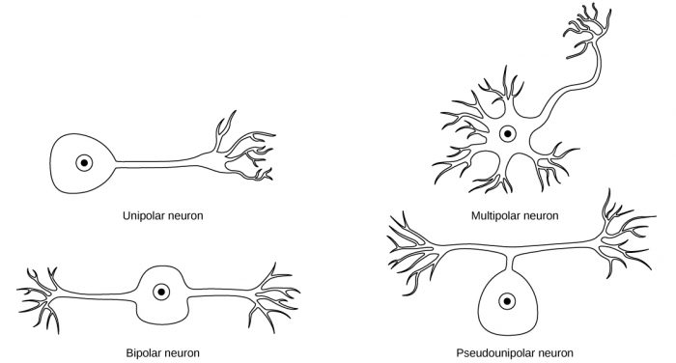

*Once an electrical impulse has reached the end of an axon, the information must be transmitted across the synaptic gap to the dendrites of the next connected neuron. In some cases, the electrical signal can almost instantaneously bridge the gap between the neurons and continue along its path.*

*In other cases, neurotransmitters are needed to send the information from one neuron to the next. Neurotransmitters are chemical messengers that are released from the axon terminals to cross the synaptic gap and reach the receptor sites of other neurons. My point is that once a single neuron has processed the input data from the dendrites - it has many options as to how it will further transmit the processed information.*

## *Types of Neurotransmitters*

[*Neurotransmitters*](https://www.verywellmind.com/what-is-a-neurotransmitter-2795394) *are an essential part of our everyday functioning. While it is not known exactly how many neurotransmitters exist, scientists have identified more than 100 of these chemical messengers.*

*These are just some of the major neurotransmitters, their known effects, and disorders they are associated with.*

***Acetylcholine:*** *Is a type of neurotransmitter that is Associated with memory, muscle contractions, and learning. If you have a lack of* [*acetylcholine*](https://www.verywellmind.com/what-is-acetylcholine-2794810) *in the brain then you most likely have Alzheimer’s disease.*

***Endorphins:*** *Endorphins are the neurons that are Associated with your emotions and your perception of pain. Your body releases endorphins when it senses fear or trauma. These neurons which are chemical messengers are similar to opiate drugs like morphine but are significantly stronger.*

***Dopamine:*** *Dopamine is the set of neurons that is Associated with your thoughts and pleasurable feelings. Parkinson’s disease is one illness associated with deficits in dopamine.*

*So here is the thing, as we summarize. The brain in general and your bodies overall nervous system is responsible for the inspiration of Artificial Neural Networks in Machine Learning. While the general concepts will transfer well when we go into ANNs and CNNs and RNNs - do NOT … N.O.T… do not hold on to the biological concepts too tightly. The brain evolved to give you the greatest chance of survival. ANNs are evolving to make accurate predictions. Still, it is good to know where the inspiration originated from and as a jumping off point for learning Deep Learning.*

*Now, in the next episode, we will be jumping into Deep Learning. See you there.*