# Let’s talk about the difference between, Artificial Intelligence, Machine Learning and Deep Learning.

AI, ML, and DL are used interchangeably… like… a lot… If you are new to Data Science then you will be forgiven for not really knowing the difference between those terms. Because there is such confusion, I want to talk about the definitions of AI, ML, and DL.

So let’s start by attributing to each of those elements one-word definition:

* AI is a **broad discipline. It is a science. AI is like Science or Math or Philosophy.**
* Data Science the application of AI in a business context.
* ML is a **set of tools to implement the ideas inside of the AI.**
* DL is a **field within a field. It is a type of Machine Learning.**

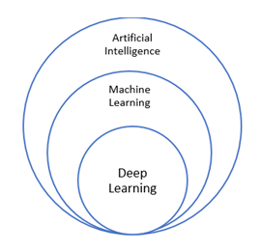

## **Let’s start with Artificial Intelligence.**

You can think about AI as a discipline - like Natural Sciences. And the main purpose of this science is to find hidden patterns in the embedded structure of technical and natural phenomena. AI is a body of knowledge. AI seeks to create machines that imitate human behaviour and thought.

There are two main types of AI solutions. Weak AI, which is known ANI. ANI is a type of AI that is designed and trained for a particular task. Siri is a type of weak AI. Google translate is a type of ANI. Strong AI on the other hand is also known as artificial general intelligence. AGI is a type of an AI system with deep human cognitive abilities. When there is an unfamiliar task, a strong AI system is able to find a solution without human intervention.

## **Let’s transition to Machine Learning.**

Artificial Intelligence is a bit more abstract. There are no “pure” AI solutions that are in place in the market. If Artificial Intelligence is like the Discipline of Natural Sciences then Machine Learning would be under that discipline… like say physics. AI to ML is like Natural Sciences to Physics. When we begin to look at specific techniques that are needed to implement AI then it becomes clear that specific tools are needed. These tools and techniques that center around Machines that Learn are found in the field of Machine Learning. AI is about imitating human intelligence. Machine Learning is a sub field of AI that focuses on the “Learning”.

ML includes algorithms, strategies, optimization techniques, evaluation metrics, etc. We can say that, if AI is the general purpose, ML is the concrete set of actions you have to do for that purpose. ML tasks can be divided into two main subsets:

* **Supervised Learning**: you are provided with a set of inputs and outputs, hence your data is already labeled and you know the ‘truth’ behind this data. It means that, once your algorithm is trained on the train set and has made predictions on the test set, you can have immediate feedback of its performance because you already know the answers.

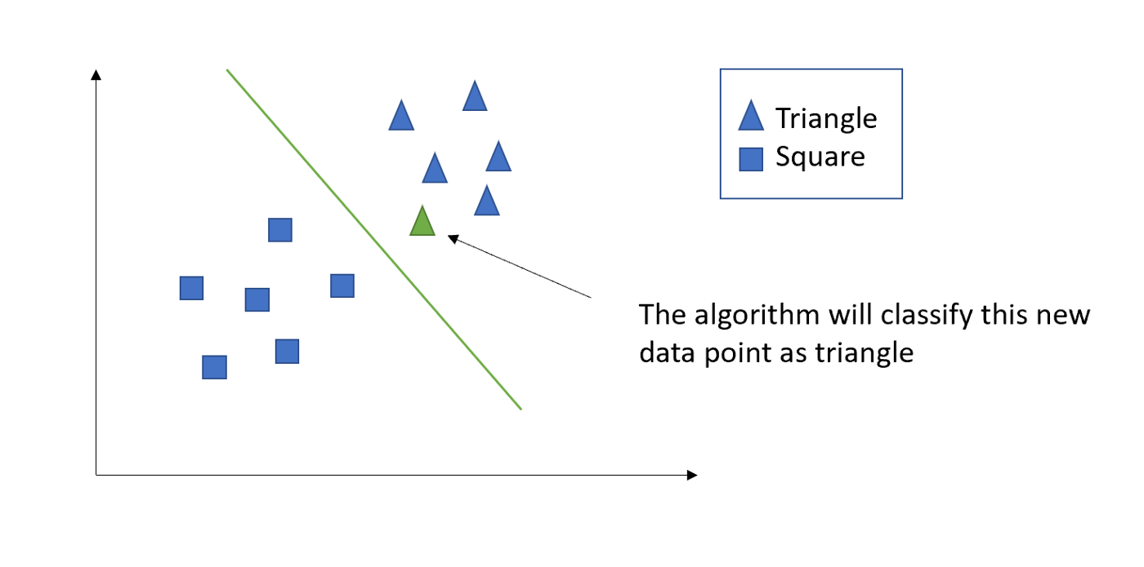

Within the field of Supervised Learning, we can distinguish once more two main categories of tasks: classification (if provided with categorical label) and regression (if provided with continuous labels).

* **Let’s change the focus in ML to Unsupervised Learning**: in Unsupervised ML, you are provided with data with no labels or categories. Basically, looking at the picture on your screen, you have no idea whether or not your data point is black or orange or purple. So, the goal of the unsupervised algorithm is to infer the inner structure of the data, by finding common patterns and trying to cluster them into categories.

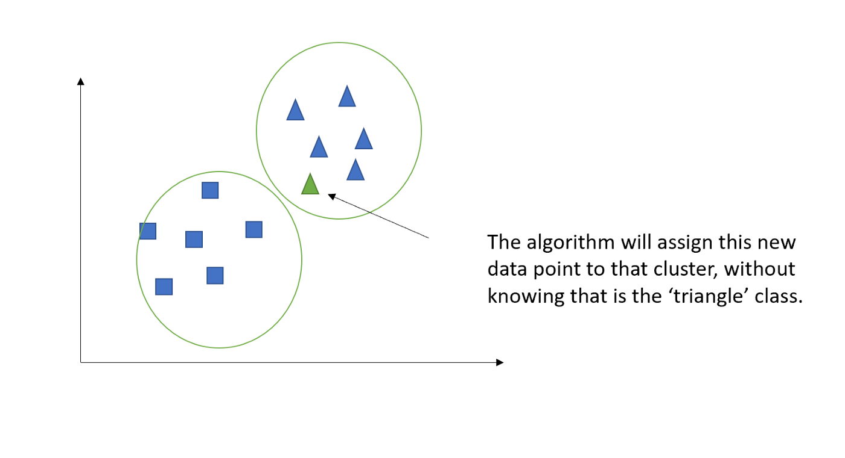

To be complete, let’s discuss another type of Learning… a third way of learning, called **Reinforcement learning**. This way of learning concerns any situation when you are not provided with data at all, and you want your algorithm to learn from the surrounding environment.

In both Supervised and Unsupervised Learning - you have DATA to start with. But what happens if you are not provided with data at all? In this case, you need your algorithm to learn from the surrounding environment? Think of almost any automated systems, like self-driving cars and robotics, you can see that those machines (cars, robots) are not provided with historical data: they have to collect them while working. So the idea is that those machines have to approach their task through several attempts, learning from their mistakes (namely, crashing against a wall) and then avoiding them in the next attempt.

Let’s explain this concept a little bit more by considering the following picture (which refers to the Markov decision process):

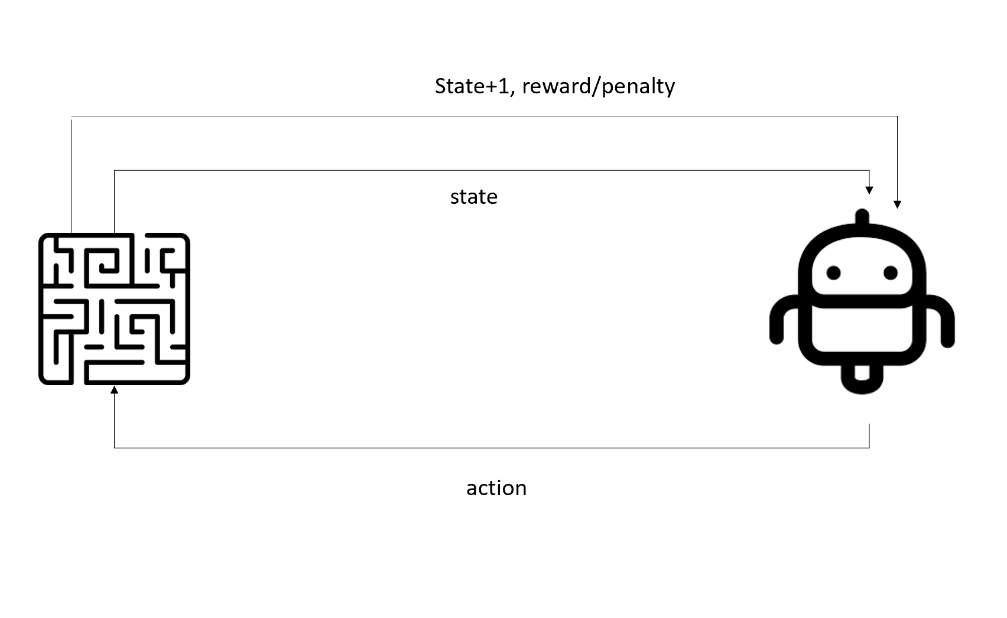

The idea is that we have an *agent*(the robot) and an *environment* (the labyrinth). The agent has its own personal representation of the environment, which we call the *state*. The agent needs to interact with the environment and the way it does this is through *actions*. After every each action, the agent will have a new state of the environment, as well as feedback on its action, in terms of *reward* or *penalty*. Think of Mrs. Pacman. She eats a single power pellet and that is an action. At the end of that action - the board is in a certain state. We give rewards to encourage actions … like power pellets and the ability to continue to live. And we give penalties as well to discourage actions like getting captured by ghosts.

To use another example, imagine you are walking into a house that you have never been to before for the first time. You walk to the middle of the house and suddenly, the lights go out and it is so dark that you can’t see your hand in front of your face. Ignoring the fact that this is how most scary movies start, what do you do? You want to get to the door, but you don’t know the way. How would you behave? You will probably start by walking very slowly and randomly (first set of actions), having in mind a certain representation of the house (the state). Then, you bump into a chair on the right: next you mentally update the state of the environment and, at the same time, you are receiving negative feedback on your action (penalty). Now, you learned that the action you did was not correct, therefore you will proceed towards another direction and, eventually, you reach the door! Now you will receive positive feedback (reward) for your action, since you reached the goal.

The same would happen for this little robot (the agent) trying to cross the maze (the environment) and reach the prize (the goal of its task). This is literally how we learn.

Each field and subfield of learning has its characteristic algorithms:

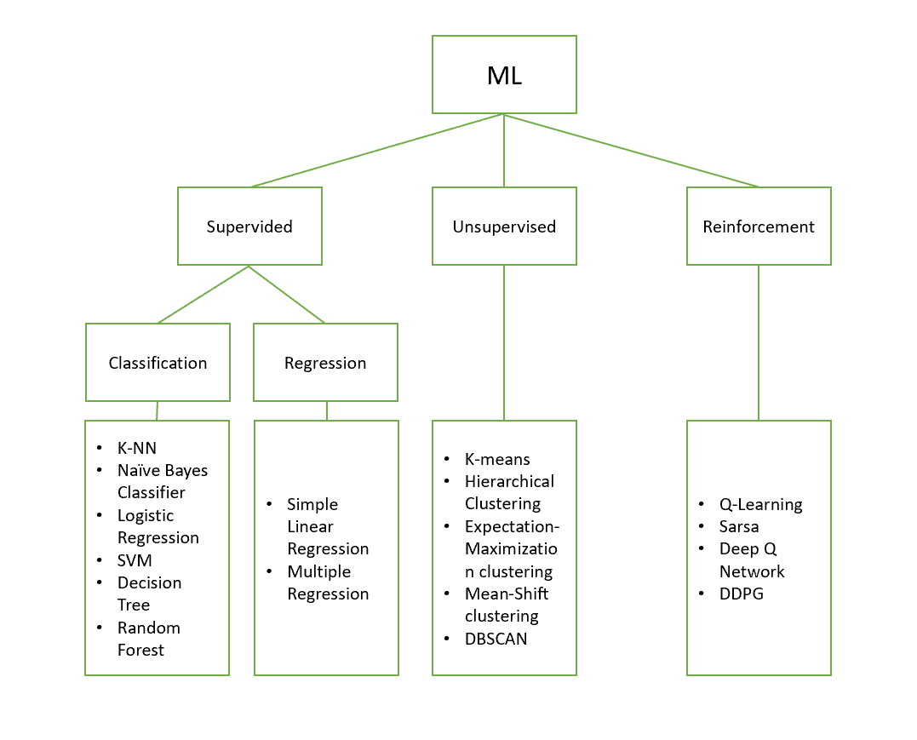

## **Finally, I want to discuss Deep Learning.**

As mentioned earlier, deep learning is a *subfield of AI*, and specifically, it is a subfield of ML. DL is best for ML tasks that involve a huge amount of data and a ‘deep’ comprehension of them. The NN family of DL algorithms are the most versatile DL algorithms. NN can be used for both classification and regression use cases, with the bonus of being, ‘deep’, since they can be built with multiple layers. Each layer applying some mathematical operations and transformations on data. We can make linear models but more importantly, we can create non-linear models with the activation functions and gradient descent. The typical structure of a NN looks like what you see on your screen:

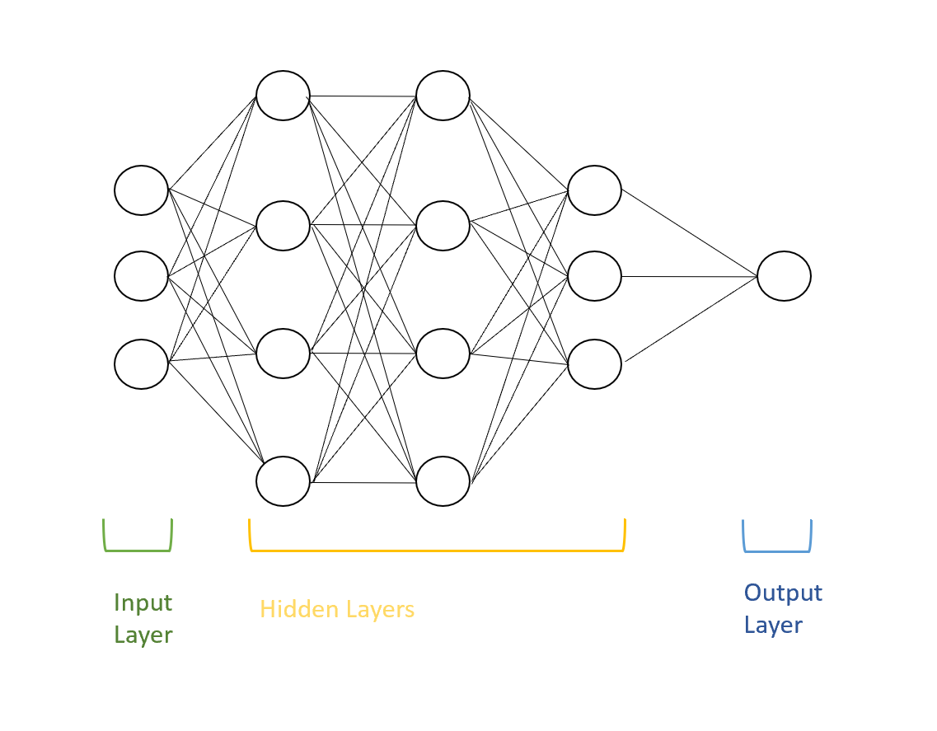

As you can see, provided that the number of neurons, layers and interconnections are customizable, the structure can be very complex, yet it provides a great analysis of your data, far deeper than the other algorithms discussed.

ML and DL are not so different in terms of purpose, they only differ depending on the scenario: if we want to implement an image recognition solution, we might want to use a NN, hence a DL solution; on the other hand, if we want to segment the market of potential customers, we’d better use a clustering algorithm among those offered by Unsupervised learning, hence a ML solution.

Finally, all of those algorithms and techniques aim at developing solutions of Artificial Intelligence, mimicking the way human think and act.

In summary, we have discussed:   
AI, Both Supervised and Unsupervised ML, RL, and DL w/ NN. Thank you.