# **Hello, My name is Ernesto Lee and in this journey we are going to discuss AI. I am making a hard distinction between AI, ML, RL, and DL. So again - let’s start with the BLUF… What is AI? This is the on ramp on the road to Artificial Intelligence… you just took the red pill.**

## **What is AI?**

In the purest sense… AI is a machine with the ability to perform cognitive functions. Things like perceiving, learning, reasoning, problem solving… basically anything deemed to exhibit intelligence.

We feel like we know what Intelligence is… intuitively.. But Artificial intelligence exists when a machine displays a cognitive ability. The gold standard for AI is the human level abilities like reasoning, understanding speech, and vision processing.

In this basic introductory episode, you will learn-

* What is AI?
* Levels of [AI](https://www.guru99.com/artificial-intelligence-tutorial.html#2)?
* A brief History of Artificial Intelligence
* Type of Artificial Intelligence
* Where is AI used? Examples
* Why AI? Why is AI booming now?

## **Introduction to AI Levels**

1. **ANI**: an artificial intelligence system is obviously narrow in scope. This means that the machine can perform a specific task better than a human. The current research of AI is here now
2. **AGI**: An artificial intelligence reaches the general state when it can perform any intellectual task with the same accuracy level as a human would
3. **ASI : Strong AI**: An AI is strong when it can beat humans in many tasks. Once we get here - we have reached the singularity.

Here is a challenge for you. Think of a single industry in which AI is NOT used. From my perch, AI is used in almost all industries. AI gives a technological and business advantage to virtually every company that integrates AI CORRECTLY. These advantages are amplified when AI is rolled out at scale. According to McKinsey, AI has the potential to disrupt the world economy. More than a fifth of the global labour force - [800 million workers](https://www.mckinsey.com/global-themes/future-of-organizations-and-work/what-the-future-of-work-will-mean-for-jobs-skills-and-wages) - might lose their jobs because of automation.

McKinsey, looked at 46 nations and more than 800 job types.

While McKinsey said that robots and programs would “increase productivity and improve our lives”, it also warned using them would “[substitute some work activities](https://www.mckinsey.com/business-functions/digital-mckinsey/our-insights/where-machines-could-replace-humans-and-where-they-cant-yet) humans currently perform”.

AI will also create 500 billions dollars of value in retail, bring 50 percent more incremental value in banking compared with other analytics techniques. In transportation and logistics, the potential revenue jump is 89 percent or more.

Let me say this differently, if an organization uses AI for its marketing team, it can automate boring and repetitive tasks which allows the sales reps to focus on tasks like relationship building, lead nurturing, etc. Think about how google, and apple, and facebook sell ads.

The bottom line is that AI provides a cutting-edge technology to deal with extremely complex data which is impossible to handle by a single human being or even a team of humans. AI automates redundancy which allows a worker to focus on the high level, value-added tasks. When AI is implemented at scale, it leads to cost reduction and revenue increase.

## **Let’s take a look at the History of Artificial Intelligence.**

Artificial intelligence is simply a buzzword today but keep in mind that AI is not new. As far back as the 1950’s, a group of experts from a variety of backgrounds decided to organize a research project on AI. John McCarthy (Dartmouth College), Marvin Minsky (Harvard University), Nathaniel Rochester (IBM), and Claude Shannon (Bell Telephone Laboratories) were all leaders in this effort.

The primary purpose of the research project was to tackle "every aspect of learning or any other feature of intelligence that can in principle be so precisely described, that a machine can be made to simulate it." --- this is the forerunner to what we are living today.

In the 50’s - they suggested:

1. Automatic Computers
2. How Can a Computer Be Programmed to Use a Language?
3. Neuron Nets
4. Self-improvement

This research concluded that intelligent computers can and will be created. With that, we began a new era… even though we didn’t know it… humans had stumbled upon - **Artificial intelligence.**

## **There are different “flavors” of Artificial Intelligence.**

Artificial intelligence can be divided into three subfields:

* Artificial intelligence
* Machine learning
* Deep learning

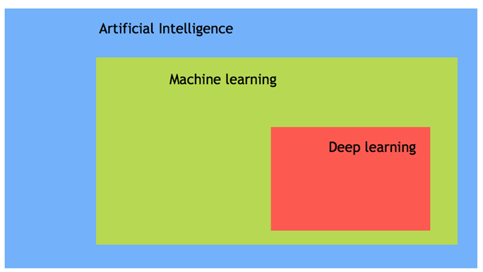

### **Machine Learning**

Machine learning is about **algorithms** that **learn** from **examples** and **experiences**. Let me repeat… ML is about algorithms that learn from examples and experiences.

Machine learning is based on the idea that there **exist** **patterns** in the data that are discovered by the algorithms and **used** to make **predictions**.

In the past, we would supply the machine with all of the instructions. We would tell it exactly what we wanted done. With Machine learning… we are asking the **machine to learns on its own to find patterns in data and ineffable rules and instructions.**

### **Deep learning**

Deep learning is a sub-field of machine learning. Deep learning does not mean the machine learns more in-depth knowledge; it means the machine uses different layers to learn from the data. It is really about HOW it learns. It is still Machine Learning. The depth of the model is represented by the number of layers in the model. For instance, Google LeNet model for image recognition counts 22 layers. I’m sure that is not impressive to you right now but trust me… that is a monster.

In deep learning, the learning phase is done through a neural network. A neural network is an architecture where the layers are stacked on top of each other. NN mimic the way the brain is structured.

### **AI vs. Machine Learning**

My Mom still has a flip phone. I think she stole it from a museum. If you have a modern smartphone then you are most likely using significant ANI apps. If you use Social Media… ANI. All too often, **AI and machine learning are used interchangeably by big companies that want to announce their latest innovation. However, Machine learning and AI are different in some ways**.

AI- artificial intelligence- is the science of training machines to perform human tasks. The term was invented in the 1950s when scientists began exploring how computers could solve problems on their own.

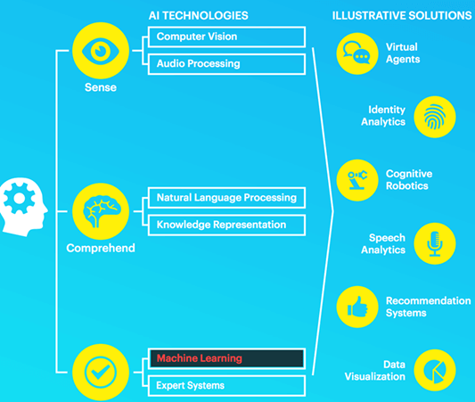

Artificial Intelligence is a computer that mimics human intelligence. A machine that is given human-like properties. Take our brain; it works effortlessly and seamlessly to calculate the world around us. Artificial Intelligence is the concept that a computer can do the same. It can be said that AI is the large science that copies that aptitudes of humans.

Machine learning is a separate and distinct subset of AI. ML trains a machine and teaches it so that the Machine learns. Machine learning models look for patterns in data and try to conclude a relationship so that it can make future predictions. Said plainly, the machine does not need to be explicitly programmed by people. The programmers give some examples, and the computer is going to learn what to do from those samples. We are programming by examples and not by instructions.

## **So Where is AI used? A better question may be… where CAN it be used?**

Let’s start with broad potential AI applications-

* Artificial intelligence can be used to reduce or avoid repetitive tasks. For instance, AI can repeat a task continuously, without fatigue. In fact, AI never rests, and it is indifferent to the task to carry out.
* Artificial intelligence improves an existing product or service. Before the age of machine learning, core products were building upon hard-code rule. Firms introduced artificial intelligence to enhance the functionality of the product rather than starting from scratch to design new products. You can think of a Facebook image. A few years ago, you had to tag your friends manually. Nowadays, with the help of AI, Facebook gives you a friend's recommendation.

AI is used in all industries, from marketing to supply chain, finance, food-processing... All industries… According to a McKinsey survey, financial services and high tech communication are leading the AI fields.

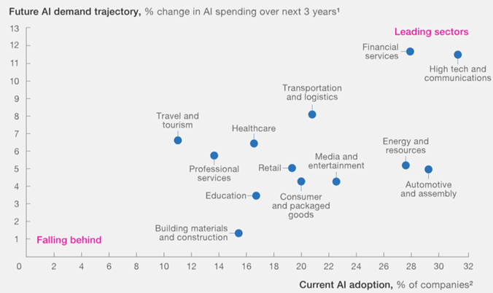

## **This begs the question of Why is AI booming now?**

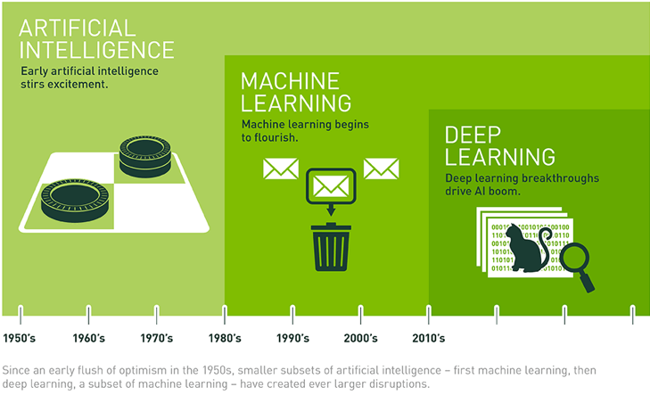

A neural network has been out since the nineties with the seminal paper of Yann LeCun from Facebook and NYU. However, it started to explode specifically in the year 2012. This was because of three critical factors:

1. Hardware reached a commoditization tipping point
2. Data was readily available because of the Big Data Revolution
3. Algorithms were improved

Machine learning is a growing field, meaning it needs to have data to test new ideas or approaches. With the boom of the big data, data became more easily accessible. CPU and GPU vendors like NVIDIA and AMD began developing high-performance chips for the gaming market that were almost a perfect fit for AI.

**Let’s go back through this… Hardware**

We have sent shuttles into outer space with less than 4GB of RAM. We have more than that in our cel phones. Think of how accurate Moores law has been and you will understand why the power of the CPU has exploded. This allows us to train a small deep-learning model on a laptop. But, to process a deep-learning model for computer vision or “deeper” deep learning, you are going to need a more powerful machine. This is where NVIDIA and AMD, and a whole new generation of GPUs come into play. These chips allow parallel computations. It means the machine can separate the computations over several GPUs to speed up the calculations. This assumes that you want to even invest in this. We also have the cloud to lean on.

Let’s look at how **Data has played a role in the explosion of AI.**

Machine Learning and Deep learning is about the structure of the model… like the skeleton. Without good data though… it doesn’t really mean anything. The data is the “blood” if that is not too graphic that keeps the model alive. Data is like the OIL to the artificial intelligence ENGINE. Without data, nothing can be done. Big Data Technologies like Hadoop, Spark, Hive, Kafka, and others have pushed the boundaries of Big Data. Consider this. Until recently… massive amounts of data could only be stored and controlled by Governments. That is no longer true.

Big Data Technologies make data collection and distribution available to feed any machine learning or DL algorithm. Think of all of the pictures that are on Facebook, Instagram or Twitter. These images can be tagged (or labeled) and used as inputs to train a model. Massive amounts of data. Those pictures can be used to train a neural network model to recognize an object on the picture without the need to manually collect and label the data.

Artificial Intelligence combined with data is the new gold. It is like the new OIL. Data provides a competitive advantage in any industry and firms that ignore this will be blockbustered eventually. AI takes your latent data and provides value from your data. If we assume that all firms at the same level have the same tech - it is what they do with the data that will give them the competitive advantage. Random Fact… it is 2020 and everyday 2.2 exabytes, or 2.2 billion gigabytes, are produced every. single. day.

A company needs exceptionally diverse data sources to be able to find the patterns and learn and in a substantial volume.

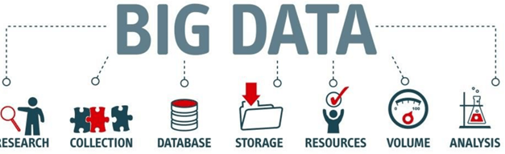

**The last of hardware, data, and algo triad that we’re going to discuss is Algorithms.**

Hardware is more powerful than ever, data is easily accessible, but one thing that makes the neural network more reliable is the development of more accurate algorithms. As you will learn in this class, primary neural networks were a simple multiplication matrix without in-depth statistical properties. Since 2010, amazing discoveries have been made to improve the neural network. We will talk about forward feed networks and backpropagation with gradient descent to discover relationships in data… even non-linear relationships based on nothing more than the algorithm and the data…. And the hardware.

Artificial intelligence uses a progressive learning algorithm to let the data do the programming. It means, the computer can teach itself how to perform different tasks, like finding anomalies.

**In Summary**

Artificial intelligence and machine learning are two often misused terms. Artificial intelligence is the science of training machine to imitate or reproduce human task. A scientist can use different methods to train a machine. At the beginning of the information technology era, programmers wrote hard-coded programs, that is to say, coders wrote every logical possibility the machine can face AND how to respond to them. There is a limit to human understanding and therefore, there is a limit to what we can tell the computer to do. When a system grows this complex, it becomes difficult to manage the rules. To overcome this issue, the machine can use data to learn how to take care of all the situations from a given environment. This is the value of AI.

One of the most important yet overlooked features to have a successful AI project is to have enough of the right data with considerable variance in the data. For example, a machine can learn different languages as long as it has enough words to learn from.

AI is the new cutting-edge technology that is here to say. Billions are still being invested in AI. AI will lift every industry by at least a double-digit growth rate. Thank you.