# **Hello, My name is Ernesto Lee and in this journey we are going to continue or discussion of AI by talking about ML.**

## **So we’ve discussed AI in the last episode. In this episode I want to answer the question: “What is Machine Learning?”**

Machine Learning is a system that can learn from example through self-improvement and without being explicitly coded by programmer. The breakthrough comes with the idea that a machine can singularly learn from the data (i.e., example) to produce accurate results or predictions.

To do this, Machine learning combines the most important ingrediant which is data with statistical tools to predict an output. This output is then used by corporations to make actionable insights. It is used by health care professionals to predict cancers. It is used by researchers. The possibilities are endless. Machine learning is closely related to statistics, and data mining and Bayesian predictive modeling. It simply means that the machine receives data as input, use an algorithm to formulate and process and finally produces and output prediction.

A very common machine learning use case is to provide a recommendation. For those who have ever been on YouTube… it just sucks you in. All of the YouTube recommendations are based on YOUR historical data. That’s why I’m scared when I look at someones YouTube and their search pulls up serial killers and stuff. Oh - and here is a commercial warning… I will teach you how to create recommender systems in our training. Anyway, back to ML.

Machine learning is also used for a variety of things like fraud detection, predictive maintenance, portfolio optimization, automatize task and so on.

In this episode, you will learn-

* What is Machine Learning?
* Machine Learning vs. Classical Programming
* How does machine learning work?
* Machine learning Algorithms and where they are used?
* How to choose Machine Learning Algorithm
* Challenges and Limitations of Machine learning
* Application of Machine learning
* Why is machine learning important?

## **Let’s begin by making clear the difference between Machine Learning and Classical Programming**

Classical programming differs significantly from machine learning. In classical programming, a programmer codes all of the rules in consultation with an expert in the industry for which software is being developed. There are requirements, and specs and standards and a whole SDLC. Each rule is based on a logical foundation; but the expectation is that the machine will always execute an output following the logical statement. When the system grows complex, more rules need to be written. It can quickly become unsustainable to maintain.

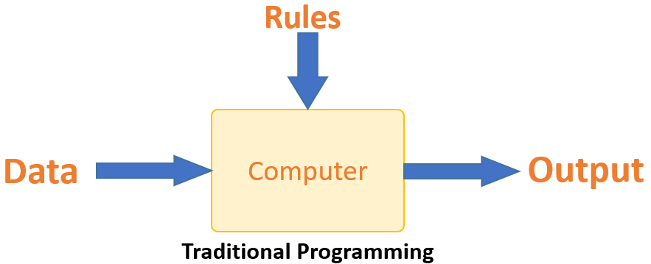

Machine learning is here to overcome this issue. The machine itself learns how the input and output data are correlated and it writes the rule…. The code.. The programmers do not need to write new rules each time there is new data. The algorithms adapt in response to new data and experiences to improve efficacy or the power to produce effects over time.

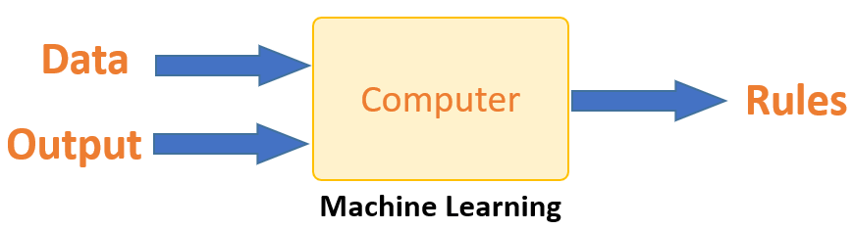

## **How does Machine learning work?**

Machine learning is the brain where all the learning takes place. The way the machine learns is similar to the human brain. Humans learn from experience. The more we know, the more easily we can predict. By analogy, when we face an unknown situation, the likelihood of success is lower than the known situation. Machines are trained the same. To make an accurate prediction, the machine sees an example. When we give the machine a similar example, it can figure out the outcome. However, like a human, if its feed a previously unseen example, the machine has difficulties in making an accurate prediction.

The core objective of machine learning is the **learning** and **inference**. First of all, the machine learns through the discovery of patterns. This discovery is made thanks to the **data**. One crucial part of the data scientist is to choose carefully which data to provide to the machine. The list of attributes used to solve a problem is called a **feature vector.** You can think of a feature vector as a subset of data that is used to tackle a problem.

The machine uses some fancy algorithms to simplify the reality and transform this discovery into a **model**. Therefore, the learning stage is used to describe the data and summarize it into a model.

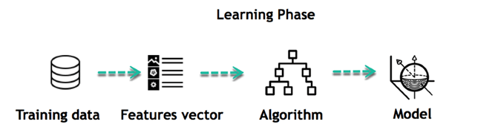

For instance, the machine is trying to understand the relationship between the wage of an individual and the likelihood to go to a fancy restaurant. It turns out the machine finds a positive relationship between wage and going to a high-end restaurant: This is the model

#### **Inferring**

When the model is built, it is possible to test how powerful it is on never-seen-before data. The new data are transformed into a features vector, go through the model and give a prediction. This is all the beautiful part of machine learning. There is no need to update the rules or train again the model. You can use the model previously trained to make inference on new data.

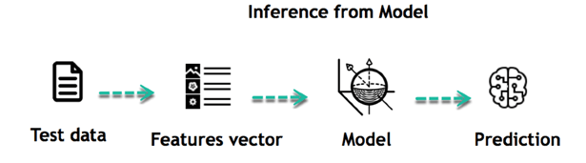

The life of Machine Learning programs is straightforward and can be summarized in the following points:

1. Define a question
2. Collect data
3. Visualize data
4. Train algorithm
5. Test the Algorithm
6. Collect feedback
7. Refine the algorithm
8. Loop 4-7 until the results are satisfying
9. Use the model to make a prediction

Once the algorithm gets good at drawing the right conclusions, it applies that knowledge to new sets of data.

## **So what are the Machine learning Algorithms and where they are used?**

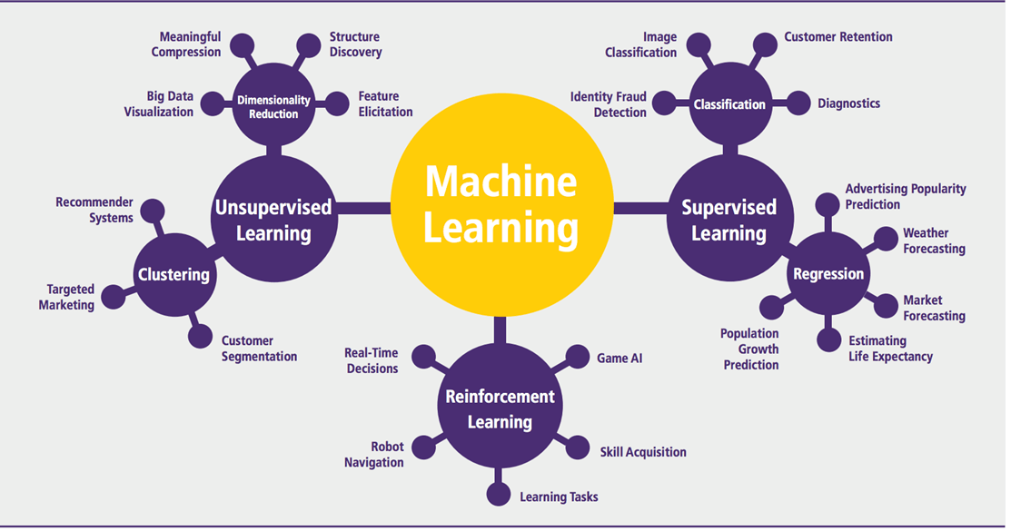

Machine learning can be grouped into two broad learning tasks: Supervised and Unsupervised. There are many other algorithms

#### **Supervised learning**

An algorithm uses training data and feedback from humans to learn the relationship of given inputs to a given output. For instance, a practitioner can use marketing dollars spent and a weather forecast as input data to predict the sales of ice cream.

You can use supervised learning when the output data is known. The algorithm will predict new data.

There are two categories of supervised learning:

* Classification
* Regression

#### **For Supervised Learning Classification Use cases… let’s say** you want to predict the gender of a customer for an advertisement. You would need to gather data on the height, weight, job, salary, purchase history, and other features from your customer database. You know the gender of each of your customer, it can only be male or female. The objective of the classifier will be to assign a probability of being a male or a female (i.e., the label) based on the information (i.e., features you have collected). When the model learned how to recognize male or female, you can use new data to make a prediction. For instance, you just got new information from an unknown customer, and you want to know if it is a male or female. If the classifier predicts male = 70%, it means the algorithm is sure at 70% that this customer is a male, and 30% it is a female.

The label can be of two or more classes. The above example has only two classes, but if a classifier needs to predict object, it has dozens of classes (e.g., glass, table, shoes, etc. each object represents a class)

#### **Regression**

When the output is a continuous value, the task is a regression. For instance, a financial analyst may need to forecast the value of a stock based on a range of feature like equity, previous stock performances, macroeconomics index. The system will be trained to estimate the price of the stocks with the lowest possible error.

|  |  |  |
| --- | --- | --- |
| **Algorithm Name** | **Description** | **Type** |
| **Linear regression** | Finds a way to correlate each feature to the output to help predict future values. | Regression |
| **Logistic regression** | Extension of linear regression that's used for classification tasks. The output variable 3is binary (e.g., only black or white) rather than continuous (e.g., an infinite list of potential colors) | Classification |
| **Decision tree** | Highly interpretable classification or regression model that splits data-feature values into branches at decision nodes (e.g., if a feature is a color, each possible color becomes a new branch) until a final decision output is made | Regression Classification |
| **Naive Bayes** | The Bayesian method is a classification method that makes use of the Bayesian theorem. The theorem updates the prior knowledge of an event with the independent probability of each feature that can affect the event. | Regression Classification |
| **Support vector machine** | Support Vector Machine, or SVM, is typically used for the classification task. SVM algorithm finds a hyperplane that optimally divided the classes. It is best used with a non-linear solver. | Regression (not very common) Classification |
| **Random forest** | The algorithm is built upon a decision tree to improve the accuracy drastically. Random forest generates many times simple decision trees and uses the 'majority vote' method to decide on which label to return. For the classification task, the final prediction will be the one with the most vote; while for the regression task, the average prediction of all the trees is the final prediction. | Regression Classification |
| **AdaBoost** | Classification or regression technique that uses a multitude of models to come up with a decision but weighs them based on their accuracy in predicting the outcome | Regression Classification |
| **Gradient-boosting trees** | Gradient-boosting trees is a state-of-the-art classification/regression technique. It is focusing on the error committed by the previous trees and tries to correct it. | Regression Classification |

#### **Unsupervised learning**

In unsupervised learning, an algorithm explores input data without being given an explicit output variable (e.g., explores customer demographic data to identify patterns)

You can use it when you do not know how to classify the data, and you want the algorithm to find patterns and classify the data for you

|  |  |  |
| --- | --- | --- |
| **Algorithm** | **Description** | **Type** |
| **K-means clustering** | Puts data into some groups (k) that each contains data with similar characteristics (as determined by the model, not in advance by humans) | Clustering |
| **Gaussian mixture model** | A generalization of k-means clustering that provides more flexibility in the size and shape of groups (clusters | Clustering |
| **Hierarchical clustering** | Splits clusters along a hierarchical tree to form a classification system.  Can be used for Cluster loyalty-card customer | Clustering |
| **Recommender system** | Help to define the relevant data for making a recommendation. | Clustering |
| **PCA/T-SNE** | Mostly used to decrease the dimensionality of the data. The algorithms reduce the number of features to 3 or 4 vectors with the highest variances. | Dimension Reduction |

## **How to choose Machine Learning Algorithm**

There are plenty of machine learning algorithms. The choice of the algorithm is based on the objective.

In the example below, the task is to predict the type of flower among the three varieties. The predictions are based on the length and the width of the petal. The picture depicts the results of ten different algorithms. The picture on the top left is the dataset. The data is classified into three categories: red, light blue and dark blue. There are some groupings. For instance, from the second image, everything in the upper left belongs to the red category, in the middle part, there is a mixture of uncertainty and light blue while the bottom corresponds to the dark category. The other images show different algorithms and how they try to classified the data.

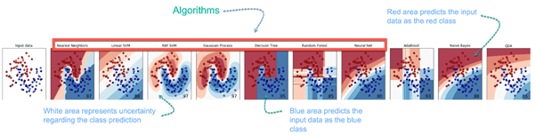

## **Challenges and Limitations of Machine learning**

The primary challenge of machine learning is the lack of data or the diversity in the dataset. A machine cannot learn if there is no data available. Besides, a dataset with a lack of diversity gives the machine a hard time. A machine needs to have heterogeneity to learn meaningful insight. It is rare that an algorithm can extract information when there are no or few variations. It is recommended to have at least 20 observations per group to help the machine learn. This constraint leads to poor evaluation and prediction.

## **Application of Machine learning**

**Augmentation**:

* Machine learning, which assists humans with their day-to-day tasks, personally or commercially without having complete control of the output. Such machine learning is used in different ways such as Virtual Assistant, Data analysis, software solutions. The primary user is to reduce errors due to human bias.

**Automation**:

* Machine learning, which works entirely autonomously in any field without the need for any human intervention. For example, robots performing the essential process steps in manufacturing plants.

**Finance Industry**

* Machine learning is growing in popularity in the finance industry. Banks are mainly using ML to find patterns inside the data but also to prevent fraud.

**Government organization**

* The government makes use of ML to manage public safety and utilities. Take the example of China with the massive face recognition. The government uses Artificial intelligence to prevent jaywalker.

**Healthcare industry**

* Healthcare was one of the first industry to use machine learning with image detection.

**Marketing**

* Broad use of AI is done in marketing thanks to abundant access to data. Before the age of mass data, researchers develop advanced mathematical tools like Bayesian analysis to estimate the value of a customer. With the boom of data, marketing department relies on AI to optimize the customer relationship and marketing campaign.

**Example of application of Machine Learning in Supply Chain**

Machine learning gives terrific results for visual pattern recognition, opening up many potential applications in physical inspection and maintenance across the entire supply chain network.

Unsupervised learning can quickly search for comparable patterns in the diverse dataset. In turn, the machine can perform quality inspection throughout the logistics hub, shipment with damage and wear.

For instance, IBM's Watson platform can determine shipping container damage. Watson combines visual and systems-based data to track, report and make recommendations in real-time.

In past year stock manager relies extensively on the primary method to evaluate and forecast the inventory. When combining big data and machine learning, better forecasting techniques have been implemented (an improvement of 20 to 30 % over traditional forecasting tools). In term of sales, it means an increase of 2 to 3 % due to the potential reduction in inventory costs.

**Example of Machine Learning Google Car**

For example, everybody knows the Google car. The car is full of lasers on the roof which are telling it where it is regarding the surrounding area. It has radar in the front, which is informing the car of the speed and motion of all the cars around it. It uses all of that data to figure out not only how to drive the car but also to figure out and predict what potential drivers around the car are going to do. What's impressive is that the car is processing almost a gigabyte a second of data.

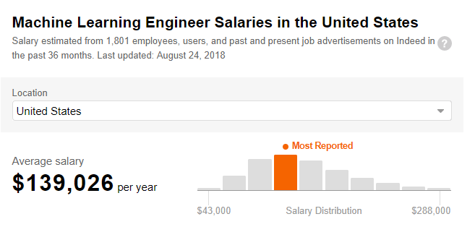

## **Why is Machine Learning important?**

Machine learning is the best tool so far to analyze, understand and identify a pattern in the data. One of the main ideas behind machine learning is that the computer can be trained to automate tasks that would be exhaustive or impossible for a human being. The clear breach from the traditional analysis is that machine learning can take decisions with minimal human intervention.

Take the following example; a retail agent can estimate the price of a house based on his own experience and his knowledge of the market.

A machine can be trained to translate the knowledge of an expert into features. The features are all the characteristics of a house, neighborhood, economic environment, etc. that make the price difference. For the expert, it took him probably some years to master the art of estimate the price of a house. His expertise is getting better and better after each sale.

For the machine, it takes millions of data, (i.e., example) to master this art. At the very beginning of its learning, the machine makes a mistake, somehow like the junior salesman. Once the machine sees all the example, it got enough knowledge to make its estimation. At the same time, with incredible accuracy. The machine is also able to adjust its mistake accordingly.

Most of the big company have understood the value of machine learning and holding data. McKinsey have estimated that the value of analytics ranges from **$**9.5 trillion to **$**15.4 trillion while **$**5 to 7 trillion can be attributed to the most advanced AI techniques.