# **Your First Machine Learning Project in Python Step-By-Step**

by [**Jason Brownlee**](https://machinelearningmastery.com/author/jasonb/) on February 10, 2019 in [**Python Machine Learning**](https://machinelearningmastery.com/category/python-machine-learning/)

Tweet **Share**

**Share**

Last Updated on December 24, 2019

Do you want to do machine learning using Python, but you’re having trouble getting started?

In this post, you will complete your first machine learning project using Python.

In this step-by-step tutorial you will:

1. Download and install Python SciPy and get the most useful package for machine learning in Python.
2. Load a dataset and understand it’s structure using statistical summaries and data visualization.
3. Create 6 machine learning models, pick the best and build confidence that the accuracy is reliable.

If you are a machine learning beginner and looking to finally get started using Python, this tutorial was designed for you.

Discover how to prepare data with pandas, fit and evaluate models with scikit-learn, and more [in my new book](https://machinelearningmastery.com/machine-learning-with-python/), with 16 step-by-step tutorials, 3 projects, and full python code.

Let’s get started!

* **Update Jan/2017**: Updated to reflect changes to the scikit-learn API in version 0.18.
* **Update Mar/2017**: Added links to help setup your Python environment.
* **Update Apr/2018**: Added some helpful links about randomness and making predictions.
* **Update Sep/2018**: Added link to my own hosted version of the dataset as UCI has become unreliable.
* **Update Feb/2019**: Updated to address warnings with sklearn API version 0.20+ with SVM and Logistic Regression, also updated results and plots.
* **Update Oct/2019**: Added links at the end to additional tutorials to continue on.
* **Update Nov/2019**: Added full code examples for each section.
* **Update Dec/2019**: Updated examples to remove warnings due to API changes in v0.22.

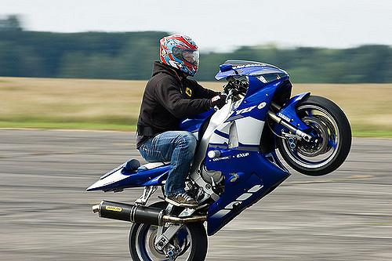

Your First Machine Learning Project in Python Step-By-Step

Photo by [cosmoflash](https://www.flickr.com/photos/cosmoflash/2687052480/), some rights reserved.

## **How Do You Start Machine Learning in Python?**

The best way to learn machine learning is by designing and completing small projects.

### **Python Can Be Intimidating When Getting Started**

Python is a popular and powerful interpreted language. Unlike R, Python is a complete language and platform that you can use for both research and development and developing production systems.

There are also a lot of modules and libraries to choose from, providing multiple ways to do each task. It can feel overwhelming.

The best way to get started using Python for machine learning is to complete a project.

* It will force you to install and start the Python interpreter (at the very least).
* It will given you a bird’s eye view of how to step through a small project.
* It will give you confidence, maybe to go on to your own small projects.

### **Beginners Need A Small End-to-End Project**

Books and courses are frustrating. They give you lots of recipes and snippets, but you never get to see how they all fit together.

When you are applying machine learning to your own datasets, you are working on a project.

A machine learning project may not be linear, but it has a number of well known steps:

1. Define Problem.
2. Prepare Data.
3. Evaluate Algorithms.
4. Improve Results.
5. Present Results.

The best way to really come to terms with a new platform or tool is to work through a machine learning project end-to-end and cover the key steps. Namely, from loading data, summarizing data, evaluating algorithms and making some predictions.

If you can do that, you have a template that you can use on dataset after dataset. You can fill in the gaps such as further data preparation and improving result tasks later, once you have more confidence.

### **Hello World of Machine Learning**

The best small project to start with on a new tool is the classification of iris flowers (e.g. [the iris dataset](https://archive.ics.uci.edu/ml/datasets/Iris)).

This is a good project because it is so well understood.

* Attributes are numeric so you have to figure out how to load and handle data.
* It is a classification problem, allowing you to practice with perhaps an easier type of supervised learning algorithm.
* It is a multi-class classification problem (multi-nominal) that may require some specialized handling.
* It only has 4 attributes and 150 rows, meaning it is small and easily fits into memory (and a screen or A4 page).
* All of the numeric attributes are in the same units and the same scale, not requiring any special scaling or transforms to get started.

Let’s get started with your hello world machine learning project in Python.

## **Machine Learning in Python: Step-By-Step Tutorial**

## **(start here)**

In this section, we are going to work through a small machine learning project end-to-end.

Here is an overview of what we are going to cover:

1. Installing the Python and SciPy platform.
2. Loading the dataset.
3. Summarizing the dataset.
4. Visualizing the dataset.
5. Evaluating some algorithms.
6. Making some predictions.

Take your time. Work through each step.

Try to type in the commands yourself or copy-and-paste the commands to speed things up.

If you have any questions at all, please leave a comment at the bottom of the post.

### **Need help with Machine Learning in Python?**

Take my free 2-week email course and discover data prep, algorithms and more (with code).

Click to sign-up now and also get a free PDF Ebook version of the course.

[**Start Your FREE Mini-Course Now!**](https://machinelearningmastery.leadpages.co/leadbox/146d399f3f72a2%3A164f8be4f346dc/5655869022797824/)

## **1. Downloading, Installing and Starting Python SciPy**

Get the Python and SciPy platform installed on your system if it is not already.

I do not want to cover this in great detail, because others already have. This is already pretty straightforward, especially if you are a developer. If you do need help, ask a question in the comments.

### **1.1 Install SciPy Libraries**

This tutorial assumes Python version 2.7 or 3.6+.

There are 5 key libraries that you will need to install. Below is a list of the Python SciPy libraries required for this tutorial:

* scipy
* numpy
* matplotlib
* pandas
* sklearn

There are many ways to install these libraries. My best advice is to pick one method then be consistent in installing each library.

The [scipy installation page](http://www.scipy.org/install.html) provides excellent instructions for installing the above libraries on multiple different platforms, such as Linux, mac OS X and Windows. If you have any doubts or questions, refer to this guide, it has been followed by thousands of people.

* On Mac OS X, you can use macports to install Python 3.6 and these libraries. For more information on macports, [see the homepage](https://www.macports.org/install.php).
* On Linux you can use your package manager, such as yum on Fedora to install RPMs.

If you are on Windows or you are not confident, I would recommend installing the free version of [Anaconda](https://www.continuum.io/downloads) that includes everything you need.

**Note**: This tutorial assumes you have scikit-learn version 0.20 or higher installed.

Need more help? See one of these tutorials:

* [How to Setup a Python Environment for Machine Learning with Anaconda](http://machinelearningmastery.com/setup-python-environment-machine-learning-deep-learning-anaconda/)
* [How to Create a Linux Virtual Machine For Machine Learning With Python 3](http://machinelearningmastery.com/linux-virtual-machine-machine-learning-development-python-3/)

### **1.2 Start Python and Check Versions**

It is a good idea to make sure your Python environment was installed successfully and is working as expected.

The script below will help you test out your environment. It imports each library required in this tutorial and prints the version.

Open a command line and start the python interpreter:

|  |  |
| --- | --- |
| 1 | python |

I recommend working directly in the interpreter or writing your scripts and running them on the command line rather than big editors and IDEs. Keep things simple and focus on the machine learning not the toolchain.

Type or copy and paste the following script:

|  |  |
| --- | --- |
| 1  2  3  4  5  6  7  8  9  10  11  12  13  14  15  16  17  18  19  20 | # Check the versions of libraries    # Python version  import sys  print('Python: {}'.format(sys.version))  # scipy  import scipy  print('scipy: {}'.format(scipy.__version__))  # numpy  import numpy  print('numpy: {}'.format(numpy.__version__))  # matplotlib  import matplotlib  print('matplotlib: {}'.format(matplotlib.__version__))  # pandas  import pandas  print('pandas: {}'.format(pandas.__version__))  # scikit-learn  import sklearn  print('sklearn: {}'.format(sklearn.__version__)) |

Here is the output I get on my OS X workstation:

|  |  |
| --- | --- |
| 1  2  3  4  5  6  7 | Python: 3.6.9 (default, Oct 19 2019, 05:21:45)  [GCC 4.2.1 Compatible Apple LLVM 9.1.0 (clang-902.0.39.2)]  scipy: 1.3.1  numpy: 1.17.3  matplotlib: 3.1.1  pandas: 0.25.1  sklearn: 0.21.3 |

Compare the above output to your versions.

Ideally, your versions should match or be more recent. The APIs do not change quickly, so do not be too concerned if you are a few versions behind, Everything in this tutorial will very likely still work for you.

If you get an error, stop. Now is the time to fix it.

If you cannot run the above script cleanly you will not be able to complete this tutorial.

My best advice is to Google search for your error message or post a question on [Stack Exchange](http://stackoverflow.com/questions/tagged/python).

## **2. Load The Data**

We are going to use the iris flowers dataset. This dataset is famous because it is used as the “hello world” dataset in machine learning and statistics by pretty much everyone.

The dataset contains 150 observations of iris flowers. There are four columns of measurements of the flowers in centimeters. The fifth column is the species of the flower observed. All observed flowers belong to one of three species.

You can [learn more about this dataset on Wikipedia](https://en.wikipedia.org/wiki/Iris_flower_data_set).

In this step we are going to load the iris data from CSV file URL.

### **2.1 Import libraries**

First, let’s import all of the modules, functions and objects we are going to use in this tutorial.

|  |  |
| --- | --- |
| 1  2  3  4  5  6  7  8  9  10  11  12  13  14  15  16 | # Load libraries  from pandas import read_csv  from pandas.plotting import scatter_matrix  from matplotlib import pyplot  from sklearn.model_selection import train_test_split  from sklearn.model_selection import cross_val_score  from sklearn.model_selection import StratifiedKFold  from sklearn.metrics import classification_report  from sklearn.metrics import confusion_matrix  from sklearn.metrics import accuracy_score  from sklearn.linear_model import LogisticRegression  from sklearn.tree import DecisionTreeClassifier  from sklearn.neighbors import KNeighborsClassifier  from sklearn.discriminant_analysis import LinearDiscriminantAnalysis  from sklearn.naive_bayes import GaussianNB  from sklearn.svm import SVC |

Everything should load without error. If you have an error, stop. You need a working SciPy environment before continuing. See the advice above about setting up your environment.

### **2.2 Load Dataset**

We can load the data directly from the UCI Machine Learning repository.

We are using pandas to load the data. We will also use pandas next to explore the data both with descriptive statistics and data visualization.

Note that we are specifying the names of each column when loading the data. This will help later when we explore the data.

|  |  |
| --- | --- |
| 1  2  3  4 | # Load dataset  url = "https://raw.githubusercontent.com/jbrownlee/Datasets/master/iris.csv"  names = ['sepal-length', 'sepal-width', 'petal-length', 'petal-width', 'class']  dataset = read_csv(url, names=names) |

The dataset should load without incident.

If you do have network problems, you can download the [iris.csv](https://raw.githubusercontent.com/jbrownlee/Datasets/master/iris.csv) file into your working directory and load it using the same method, changing URL to the local file name.

## **3. Summarize the Dataset**

Now it is time to take a look at the data.

In this step we are going to take a look at the data a few different ways:

1. Dimensions of the dataset.
2. Peek at the data itself.
3. Statistical summary of all attributes.
4. Breakdown of the data by the class variable.

Don’t worry, each look at the data is one command. These are useful commands that you can use again and again on future projects.

### **3.1 Dimensions of Dataset**

We can get a quick idea of how many instances (rows) and how many attributes (columns) the data contains with the shape property.

|  |  |
| --- | --- |
| 1  2 | # shape  print(dataset.shape) |

You should see 150 instances and 5 attributes:

|  |  |
| --- | --- |
| 1 | (150, 5) |

### **3.2 Peek at the Data**

It is also always a good idea to actually eyeball your data.

|  |  |
| --- | --- |
| 1  2 | # head  print(dataset.head(20)) |

You should see the first 20 rows of the data:

|  |  |
| --- | --- |
| 1  2  3  4  5  6  7  8  9  10  11  12  13  14  15  16  17  18  19  20  21 | sepal-length sepal-width petal-length petal-width class  0 5.1 3.5 1.4 0.2 Iris-setosa  1 4.9 3.0 1.4 0.2 Iris-setosa  2 4.7 3.2 1.3 0.2 Iris-setosa  3 4.6 3.1 1.5 0.2 Iris-setosa  4 5.0 3.6 1.4 0.2 Iris-setosa  5 5.4 3.9 1.7 0.4 Iris-setosa  6 4.6 3.4 1.4 0.3 Iris-setosa  7 5.0 3.4 1.5 0.2 Iris-setosa  8 4.4 2.9 1.4 0.2 Iris-setosa  9 4.9 3.1 1.5 0.1 Iris-setosa  10 5.4 3.7 1.5 0.2 Iris-setosa  11 4.8 3.4 1.6 0.2 Iris-setosa  12 4.8 3.0 1.4 0.1 Iris-setosa  13 4.3 3.0 1.1 0.1 Iris-setosa  14 5.8 4.0 1.2 0.2 Iris-setosa  15 5.7 4.4 1.5 0.4 Iris-setosa  16 5.4 3.9 1.3 0.4 Iris-setosa  17 5.1 3.5 1.4 0.3 Iris-setosa  18 5.7 3.8 1.7 0.3 Iris-setosa  19 5.1 3.8 1.5 0.3 Iris-setosa |

### **3.3 Statistical Summary**

Now we can take a look at a summary of each attribute.

This includes the count, mean, the min and max values as well as some percentiles.

|  |  |
| --- | --- |
| 1  2 | # descriptions  print(dataset.describe()) |

We can see that all of the numerical values have the same scale (centimeters) and similar ranges between 0 and 8 centimeters.

|  |  |
| --- | --- |
| 1  2  3  4  5  6  7  8  9 | sepal-length sepal-width petal-length petal-width  count 150.000000 150.000000 150.000000 150.000000  mean 5.843333 3.054000 3.758667 1.198667  std 0.828066 0.433594 1.764420 0.763161  min 4.300000 2.000000 1.000000 0.100000  25% 5.100000 2.800000 1.600000 0.300000  50% 5.800000 3.000000 4.350000 1.300000  75% 6.400000 3.300000 5.100000 1.800000  max 7.900000 4.400000 6.900000 2.500000 |

### **3.4 Class Distribution**

Let’s now take a look at the number of instances (rows) that belong to each class. We can view this as an absolute count.

|  |  |
| --- | --- |
| 1  2 | # class distribution  print(dataset.groupby('class').size()) |

We can see that each class has the same number of instances (50 or 33% of the dataset).

|  |  |
| --- | --- |
| 1  2  3  4 | class  Iris-setosa 50  Iris-versicolor 50  Iris-virginica 50 |

### **3.5 Complete Example**

For reference, we can tie all of the previous elements together into a single script.

The complete example is listed below.

|  |  |
| --- | --- |
| 1  2  3  4  5  6  7  8  9  10  11  12  13  14 | # summarize the data  from pandas import read_csv  # Load dataset  url = "https://raw.githubusercontent.com/jbrownlee/Datasets/master/iris.csv"  names = ['sepal-length', 'sepal-width', 'petal-length', 'petal-width', 'class']  dataset = read_csv(url, names=names)  # shape  print(dataset.shape)  # head  print(dataset.head(20))  # descriptions  print(dataset.describe())  # class distribution  print(dataset.groupby('class').size()) |

## **4. Data Visualization**

We now have a basic idea about the data. We need to extend that with some visualizations.

We are going to look at two types of plots:

1. Univariate plots to better understand each attribute.
2. Multivariate plots to better understand the relationships between attributes.

### **4.1 Univariate Plots**

We start with some univariate plots, that is, plots of each individual variable.

Given that the input variables are numeric, we can create box and whisker plots of each.

|  |  |
| --- | --- |
| 1  2  3 | # box and whisker plots  dataset.plot(kind='box', subplots=True, layout=(2,2), sharex=False, sharey=False)  pyplot.show() |

This gives us a much clearer idea of the distribution of the input attributes:

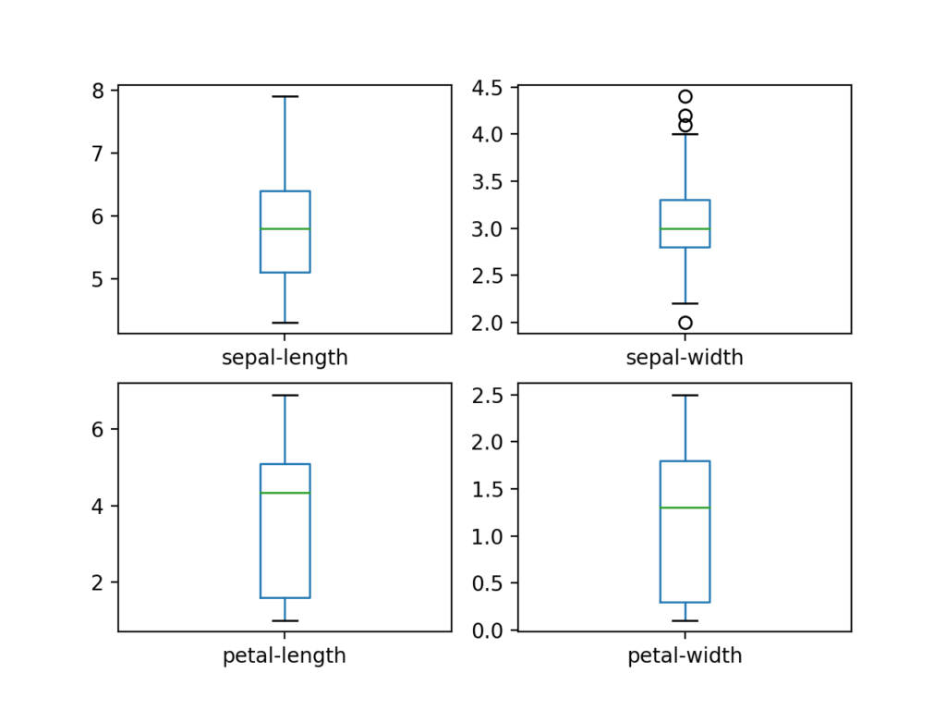

Box and Whisker Plots for Each Input Variable for the Iris Flowers Dataset

We can also create a histogram of each input variable to get an idea of the distribution.

|  |  |
| --- | --- |
| 1  2  3 | # histograms  dataset.hist()  pyplot.show() |

It looks like perhaps two of the input variables have a Gaussian distribution. This is useful to note as we can use algorithms that can exploit this assumption.

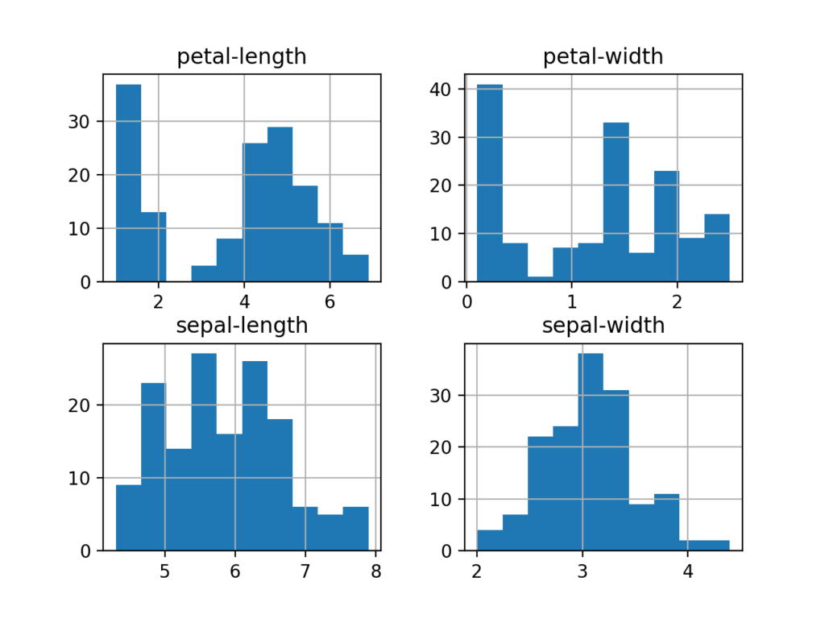

Histogram Plots for Each Input Variable for the Iris Flowers Dataset

### **4.2 Multivariate Plots**

Now we can look at the interactions between the variables.

First, let’s look at scatterplots of all pairs of attributes. This can be helpful to spot structured relationships between input variables.

|  |  |
| --- | --- |
| 1  2  3 | # scatter plot matrix  scatter_matrix(dataset)  pyplot.show() |

Note the diagonal grouping of some pairs of attributes. This suggests a high correlation and a predictable relationship.

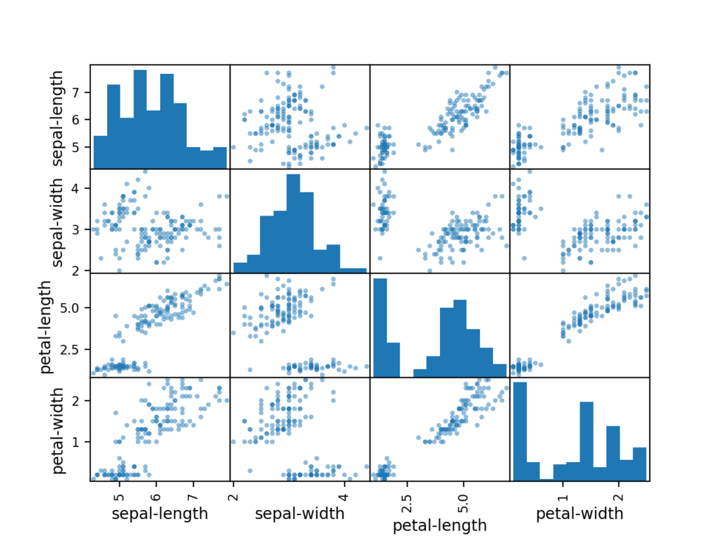

Scatter Matrix Plot for Each Input Variable for the Iris Flowers Dataset

### **4.3 Complete Example**

For reference, we can tie all of the previous elements together into a single script.

The complete example is listed below.

|  |  |
| --- | --- |
| 1  2  3  4  5  6  7  8  9  10  11  12  13  14  15  16  17 | # visualize the data  from pandas import read_csv  from pandas.plotting import scatter_matrix  from matplotlib import pyplot  # Load dataset  url = "https://raw.githubusercontent.com/jbrownlee/Datasets/master/iris.csv"  names = ['sepal-length', 'sepal-width', 'petal-length', 'petal-width', 'class']  dataset = read_csv(url, names=names)  # box and whisker plots  dataset.plot(kind='box', subplots=True, layout=(2,2), sharex=False, sharey=False)  pyplot.show()  # histograms  dataset.hist()  pyplot.show()  # scatter plot matrix  scatter_matrix(dataset)  pyplot.show() |

## **5. Evaluate Some Algorithms**

Now it is time to create some models of the data and estimate their accuracy on unseen data.

Here is what we are going to cover in this step:

1. Separate out a validation dataset.
2. Set-up the test harness to use 10-fold cross validation.
3. Build multiple different models to predict species from flower measurements
4. Select the best model.

### **5.1 Create a Validation Dataset**

We need to know that the model we created is good.

Later, we will use statistical methods to estimate the accuracy of the models that we create on unseen data. We also want a more concrete estimate of the accuracy of the best model on unseen data by evaluating it on actual unseen data.

That is, we are going to hold back some data that the algorithms will not get to see and we will use this data to get a second and independent idea of how accurate the best model might actually be.

We will split the loaded dataset into two, 80% of which we will use to train, evaluate and select among our models, and 20% that we will hold back as a validation dataset.

|  |  |
| --- | --- |
| 1  2  3  4  5 | # Split-out validation dataset  array = dataset.values  X = array[:,0:4]  y = array[:,4]  X_train, X_validation, Y_train, Y_validation = train_test_split(X, y, test_size=0.20, random_state=1) |

You now have training data in the *X_train* and *Y_train* for preparing models and a *X_validation* and *Y_validation* sets that we can use later.

Notice that we used a python slice to select the columns in the NumPy array. If this is new to you, you might want to check-out this post:

* [How to Index, Slice and Reshape NumPy Arrays for Machine Learning in Python](https://machinelearningmastery.com/index-slice-reshape-numpy-arrays-machine-learning-python/)

### **5.2 Test Harness**

We will use stratified 10-fold cross validation to estimate model accuracy.

This will split our dataset into 10 parts, train on 9 and test on 1 and repeat for all combinations of train-test splits.

Stratified means that each fold or split of the dataset will aim to have the same distribution of example by class as exist in the whole training dataset.

|  |  |
| --- | --- |
| 1  2  3  4  5 | ...  model = ...  # Test options and evaluation metric  kfold = StratifiedKFold(n_splits=10, random_state=1, shuffle=True)  cv_results = cross_val_score(model, X_train, Y_train, cv=kfold, scoring='accuracy') |

For more on the k-fold cross-validation technique, see the tutorial:

* [A Gentle Introduction to k-fold Cross-Validation](https://machinelearningmastery.com/k-fold-cross-validation/)

We set the random seed via the *random_state* argument to a fixed number to ensure that each algorithm is evaluated on the same splits of the training dataset.

The specific random seed does not matter, learn more about pseudorandom number generators here:

* [Introduction to Random Number Generators for Machine Learning in Python](https://machinelearningmastery.com/introduction-to-random-number-generators-for-machine-learning/)

We are using the metric of ‘*accuracy*‘ to evaluate models.

This is a ratio of the number of correctly predicted instances divided by the total number of instances in the dataset multiplied by 100 to give a percentage (e.g. 95% accurate). We will be using the *scoring* variable when we run build and evaluate each model next.

### **5.3 Build Models**

We don’t know which algorithms would be good on this problem or what configurations to use.

We get an idea from the plots that some of the classes are partially linearly separable in some dimensions, so we are expecting generally good results.

Let’s test 6 different algorithms:

* Logistic Regression (LR)
* Linear Discriminant Analysis (LDA)
* K-Nearest Neighbors (KNN).
* Classification and Regression Trees (CART).
* Gaussian Naive Bayes (NB).
* Support Vector Machines (SVM).

This is a good mixture of simple linear (LR and LDA), nonlinear (KNN, CART, NB and SVM) algorithms.

Let’s build and evaluate our models:

|  |  |
| --- | --- |
| 1  2  3  4  5  6  7  8  9  10  11  12  13  14  15  16  17 | # Spot Check Algorithms  models = []  models.append(('LR', LogisticRegression(solver='liblinear', multi_class='ovr')))  models.append(('LDA', LinearDiscriminantAnalysis()))  models.append(('KNN', KNeighborsClassifier()))  models.append(('CART', DecisionTreeClassifier()))  models.append(('NB', GaussianNB()))  models.append(('SVM', SVC(gamma='auto')))  # evaluate each model in turn  results = []  names = []  for name, model in models:  kfold = StratifiedKFold(n_splits=10, random_state=1, shuffle=True)  cv_results = cross_val_score(model, X_train, Y_train, cv=kfold, scoring='accuracy')  results.append(cv_results)  names.append(name)  print('%s: %f (%f)' % (name, cv_results.mean(), cv_results.std())) |

### **5.4 Select Best Model**

We now have 6 models and accuracy estimations for each. We need to compare the models to each other and select the most accurate.

Running the example above, we get the following raw results:

|  |  |
| --- | --- |
| 1  2  3  4  5  6 | LR: 0.960897 (0.052113)  LDA: 0.973974 (0.040110)  KNN: 0.957191 (0.043263)  CART: 0.957191 (0.043263)  NB: 0.948858 (0.056322)  SVM: 0.983974 (0.032083) |

Note, you’re results may vary given the stochastic nature of the learning algorithms. For more on this see the post:

* [Embrace Randomness in Machine Learning](https://machinelearningmastery.com/randomness-in-machine-learning/)

**What scores did you get?**

Post your results in the comments below.

In this case, we can see that it looks like Support Vector Machines (SVM) has the largest estimated accuracy score at about 0.98 or 98%.

We can also create a plot of the model evaluation results and compare the spread and the mean accuracy of each model. There is a population of accuracy measures for each algorithm because each algorithm was evaluated 10 times (via 10 fold-cross validation).

A useful way to compare the samples of results for each algorithm is to create a box and whisker plot for each distribution and compare the distributions.

|  |  |
| --- | --- |
| 1  2  3  4 | # Compare Algorithms  pyplot.boxplot(results, labels=names)  pyplot.title('Algorithm Comparison')  pyplot.show() |

We can see that the box and whisker plots are squashed at the top of the range, with many evaluations achieving 100% accuracy, and some pushing down into the high 80% accuracies.

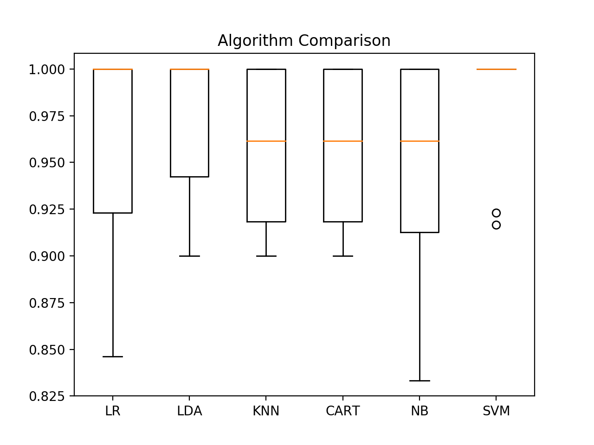

Box and Whisker Plot Comparing Machine Learning Algorithms on the Iris Flowers Dataset

### **5.5 Complete Example**

For reference, we can tie all of the previous elements together into a single script.

The complete example is listed below.

|  |  |
| --- | --- |
| 1  2  3  4  5  6  7  8  9  10  11  12  13  14  15  16  17  18  19  20  21  22  23  24  25  26  27  28  29  30  31  32  33  34  35  36  37  38  39  40  41  42 | # compare algorithms  from pandas import read_csv  from matplotlib import pyplot  from sklearn.model_selection import train_test_split  from sklearn.model_selection import cross_val_score  from sklearn.model_selection import StratifiedKFold  from sklearn.linear_model import LogisticRegression  from sklearn.tree import DecisionTreeClassifier  from sklearn.neighbors import KNeighborsClassifier  from sklearn.discriminant_analysis import LinearDiscriminantAnalysis  from sklearn.naive_bayes import GaussianNB  from sklearn.svm import SVC  # Load dataset  url = "https://raw.githubusercontent.com/jbrownlee/Datasets/master/iris.csv"  names = ['sepal-length', 'sepal-width', 'petal-length', 'petal-width', 'class']  dataset = read_csv(url, names=names)  # Split-out validation dataset  array = dataset.values  X = array[:,0:4]  y = array[:,4]  X_train, X_validation, Y_train, Y_validation = train_test_split(X, y, test_size=0.20, random_state=1, shuffle=True)  # Spot Check Algorithms  models = []  models.append(('LR', LogisticRegression(solver='liblinear', multi_class='ovr')))  models.append(('LDA', LinearDiscriminantAnalysis()))  models.append(('KNN', KNeighborsClassifier()))  models.append(('CART', DecisionTreeClassifier()))  models.append(('NB', GaussianNB()))  models.append(('SVM', SVC(gamma='auto')))  # evaluate each model in turn  results = []  names = []  for name, model in models:  kfold = StratifiedKFold(n_splits=10, random_state=1)  cv_results = cross_val_score(model, X_train, Y_train, cv=kfold, scoring='accuracy')  results.append(cv_results)  names.append(name)  print('%s: %f (%f)' % (name, cv_results.mean(), cv_results.std()))  # Compare Algorithms  pyplot.boxplot(results, labels=names)  pyplot.title('Algorithm Comparison')  pyplot.show() |

## **6. Make Predictions**

We must choose an algorithm to use to make predictions.

The results in the previous section suggest that the SVM was perhaps the most accurate model. We will use this model as our final model.

Now we want to get an idea of the accuracy of the model on our validation set.

This will give us an independent final check on the accuracy of the best model. It is valuable to keep a validation set just in case you made a slip during training, such as overfitting to the training set or a data leak. Both of these issues will result in an overly optimistic result.

### **6.1 Make Predictions**

We can fit the model on the entire training dataset and make predictions on the validation dataset.

|  |  |
| --- | --- |
| 1  2  3  4 | # Make predictions on validation dataset  model = SVC(gamma='auto')  model.fit(X_train, Y_train)  predictions = model.predict(X_validation) |

You might also like to make predictions for single rows of data. For examples on how to do that, see the tutorial:

* [How to Make Predictions with scikit-learn](https://machinelearningmastery.com/make-predictions-scikit-learn/)

You might also like to save the model to file and load it later to make predictions on new data. For examples on how to do this, see the tutorial:

* [Save and Load Machine Learning Models in Python with scikit-learn](https://machinelearningmastery.com/save-load-machine-learning-models-python-scikit-learn/)

### **6.2 Evaluate Predictions**

We can evaluate the predictions by comparing them to the expected results in the validation set, then calculate classification accuracy, as well as a [confusion matrix](https://machinelearningmastery.com/ufaqs/what-is-a-confusion-matrix/) and a classification report.

|  |  |
| --- | --- |
| 1  2  3  4 | # Evaluate predictions  print(accuracy_score(Y_validation, predictions))  print(confusion_matrix(Y_validation, predictions))  print(classification_report(Y_validation, predictions)) |

We can see that the accuracy is 0.966 or about 96% on the hold out dataset.

The confusion matrix provides an indication of the three errors made.

Finally, the classification report provides a breakdown of each class by precision, recall, f1-score and support showing excellent results (granted the validation dataset was small).

|  |  |
| --- | --- |
| 1  2  3  4  5  6  7  8  9  10  11  12  13 | 0.9666666666666667  [[11 0 0]  [ 0 12 1]  [ 0 0 6]]  precision recall f1-score support    Iris-setosa 1.00 1.00 1.00 11  Iris-versicolor 1.00 0.92 0.96 13  Iris-virginica 0.86 1.00 0.92 6    accuracy 0.97 30  macro avg 0.95 0.97 0.96 30  weighted avg 0.97 0.97 0.97 30 |

### **6.3 Complete Example**

For reference, we can tie all of the previous elements together into a single script.

The complete example is listed below.

|  |  |
| --- | --- |
| 1  2  3  4  5  6  7  8  9  10  11  12  13  14  15  16  17  18  19  20  21  22  23  24 | # make predictions  from pandas import read_csv  from sklearn.model_selection import train_test_split  from sklearn.metrics import classification_report  from sklearn.metrics import confusion_matrix  from sklearn.metrics import accuracy_score  from sklearn.svm import SVC  # Load dataset  url = "https://raw.githubusercontent.com/jbrownlee/Datasets/master/iris.csv"  names = ['sepal-length', 'sepal-width', 'petal-length', 'petal-width', 'class']  dataset = read_csv(url, names=names)  # Split-out validation dataset  array = dataset.values  X = array[:,0:4]  y = array[:,4]  X_train, X_validation, Y_train, Y_validation = train_test_split(X, y, test_size=0.20, random_state=1)  # Make predictions on validation dataset  model = SVC(gamma='auto')  model.fit(X_train, Y_train)  predictions = model.predict(X_validation)  # Evaluate predictions  print(accuracy_score(Y_validation, predictions))  print(confusion_matrix(Y_validation, predictions))  print(classification_report(Y_validation, predictions)) |

## **You Can Do Machine Learning in Python**

Work through the tutorial above. It will take you 5-to-10 minutes, max!

**You do not need to understand everything**. (at least not right now) Your goal is to run through the tutorial end-to-end and get a result. You do not need to understand everything on the first pass. List down your questions as you go. Make heavy use of the *help(“FunctionName”)* help syntax in Python to learn about all of the functions that you’re using.

**You do not need to know how the algorithms work**. It is important to know about the limitations and how to configure machine learning algorithms. But learning about algorithms can come later. You need to build up this algorithm knowledge slowly over a long period of time. Today, start off by getting comfortable with the platform.

**You do not need to be a Python programmer**. The syntax of the Python language can be intuitive if you are new to it. Just like other languages, focus on function calls (e.g. *function()*) and assignments (e.g. *a = “b”*). This will get you most of the way. You are a developer, you know how to pick up the basics of a language real fast. Just get started and dive into the details later.

**You do not need to be a machine learning expert**. You can learn about the benefits and limitations of various algorithms later, and there are plenty of posts that you can read later to brush up on the steps of a machine learning project and the importance of evaluating accuracy using cross validation.

**What about other steps in a machine learning project**. We did not cover all of the steps in a machine learning project because this is your first project and we need to focus on the key steps. Namely, loading data, looking at the data, evaluating some algorithms and making some predictions. In later tutorials we can look at other data preparation and result improvement tasks.

## **Summary**

In this post, you discovered step-by-step how to complete your first machine learning project in Python.

You discovered that completing a small end-to-end project from loading the data to making predictions is the best way to get familiar with a new platform.