Oracle 12c RAC

Lab Module 3

Module 3 Lab: Managing a RAC instacne

1. Set the environment to the database home as **oracle** user
2. . db_env
3. Use srvctl to check the status of the an instance on rac1
4. srvctl status instance –d cdbrac –i cdbrac1

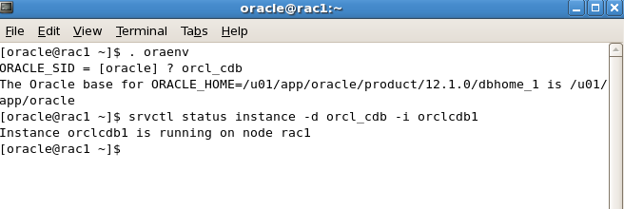

1. Use srvctl to check the status of the instance on rac2
2. srvctl status instance –d cdbrac –i cdbrac2

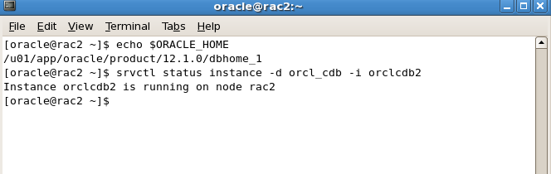

1. Check the status of the mgmtdb database
2. srvctl status mgmtdb

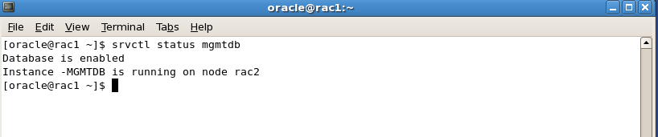

1. Check the status of mgmt. listener
2. srvctl status mgmtlsnr

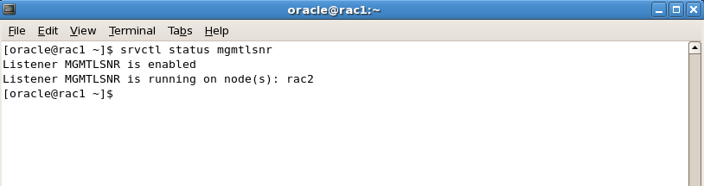

6) Shutdown instance cdbrac2

a. srvctl stop instance –d cdbrac –i cdbrac2

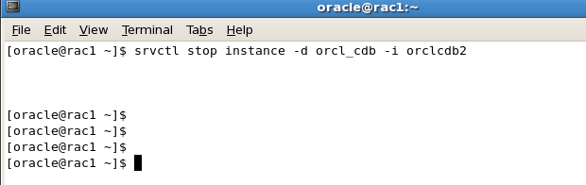

7) Start instance cdbrac2

a. srvctl start instance –d cdbrac –i cdbrac2

8) Stop the database cdbrac

a. srvctl stop database –d cdbrac



9) Start the database cdbrac

a. srvctl start database –d cdbrac

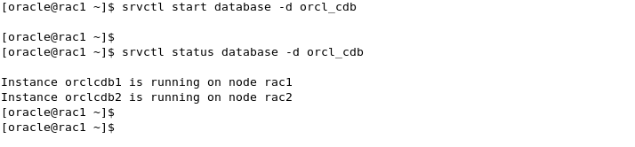

10) Set the environment on rac1 to cdbrac

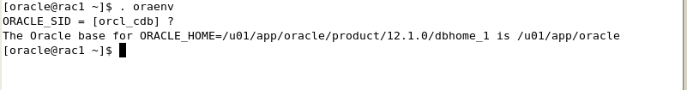

11) On rac1 navigate to $ORACLE_BASE/diag/rdbms/cdbrac/cdbrac1



12) cd to the trace directory

13) Use either ‘vi or gedit to open up the alertcdbrac1.ora and review its contents.

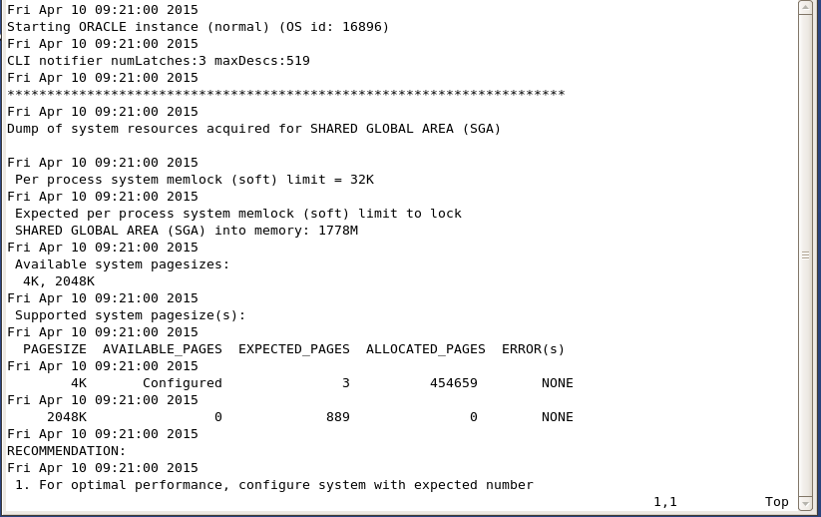

14) Do these exact same steps for rac2, however for instance name use ‘cdbrac2’