Oracle 12c RAC

Lab Module 4

Module 4 Lab: Backup the RAC database

1. Place the database in archivelog mode
2. $. oraenv
3. cdbrac
4. sqlplus system/ fenago @cdbrac
5. alter system set cluster_database=false scope=spfile sid=’ cdbrac1’;

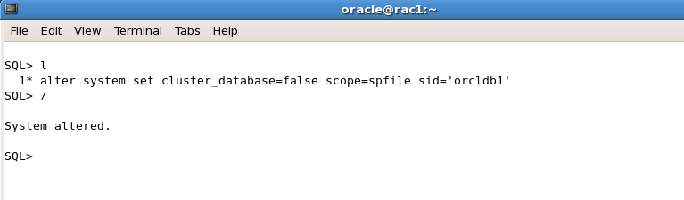

1. Shutdown the database
2. srvctl stop database –d cdbrac



1. Start the instance on rac1 in mount mode
2. srvctl start instance –d cdbrac –I orclcdb1 –o mount

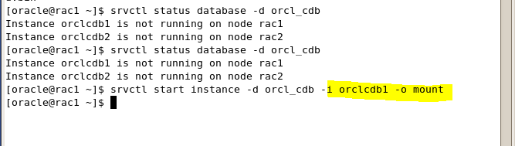

1. Use sqlplus to place the database in archivelog mode
2. sqlplus sys/fenago@cdbrac as sysdba
3. alter database archivelog

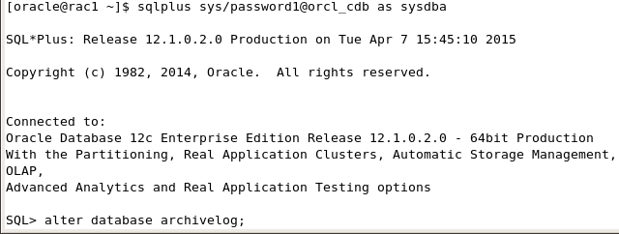

1. Place database back in cluster mode and restart the database
2. alter system set cluster_database=true scope=spfile sid = ‘*’;
3. srvctl stop database –d cdbrac
4. srvctl start database –d cdbrac

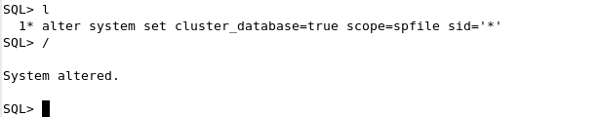



1. Backup the container database
2. Rman target sys/fenago@cdbrac
3. Run { backup database;

Backup archivelog all delete all input;}

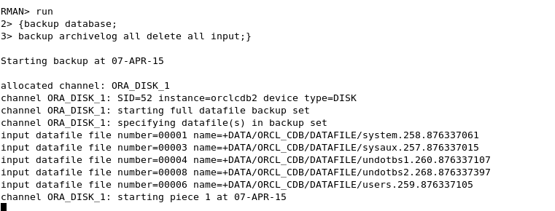

1. Backup the pluggable database

a. rman target sys/fenago@rac-scan:1521/pdb1

b. backup pluggable database pdb1;

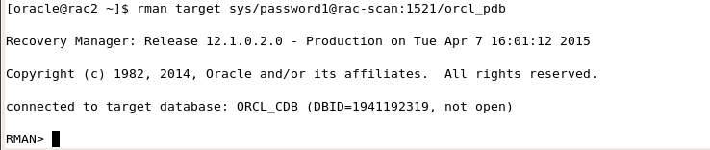

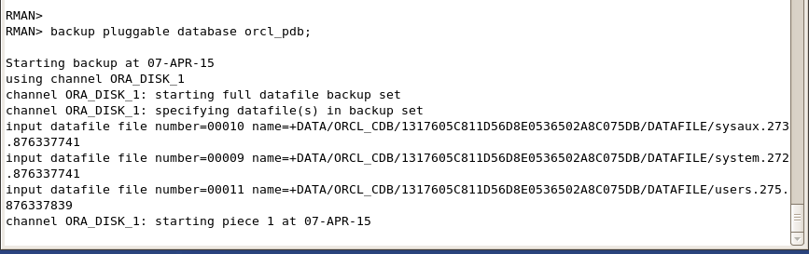

8) Show the configuration of the backup;

a. show all;

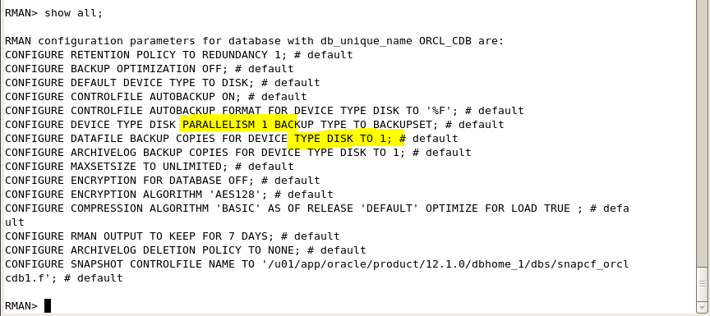

9) Enable controlfile autobackup

a. configure controlfile autobackup on

