Oracle 12c RAC

Lab Module 13

Module 13 Lab: Diagnosis RAC

1) This lab will review the rac specific log files.

2) Perform a crsctl command to determine RAC availability

a. $. oraenv

b. +ASM1

c. crsctl stat res –t

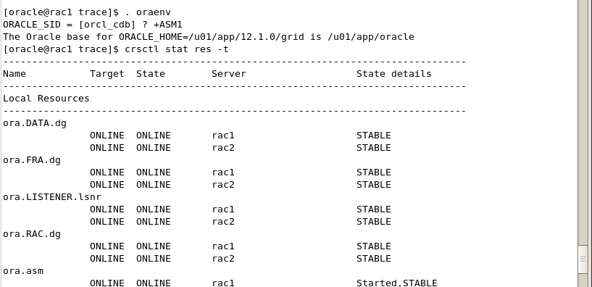

3) Perform a srvctl command to determine the availability of node apps

a. srvctl status nodeapps

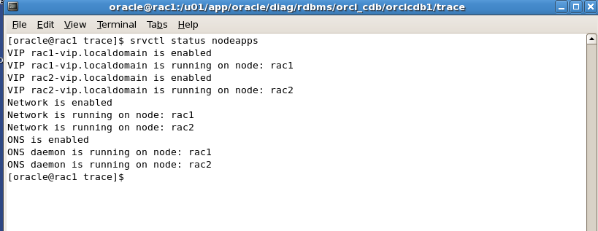

4) Navigate to the ADR to view the RAC log files.

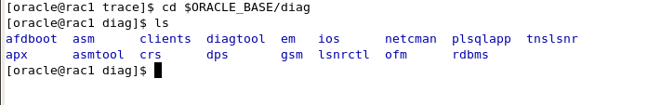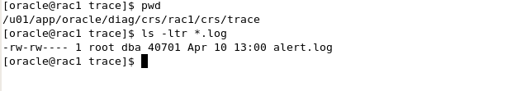

5) Review the alert.log file for the crs on rac1, then review the same file on rac2

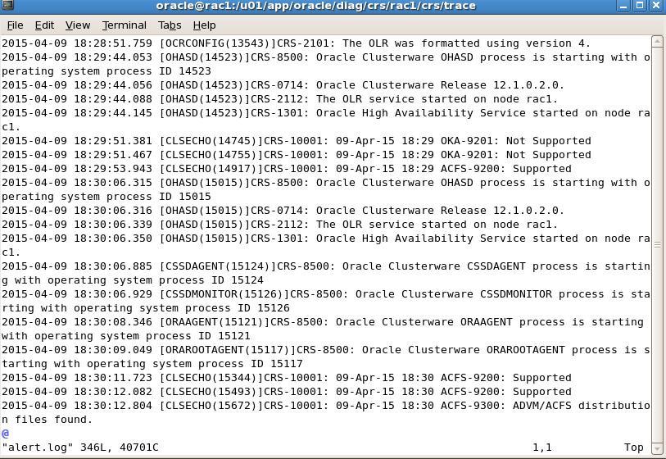

6) Review the GI_HOME/log/rac(1,2) directories for each server. Review the files to determine contents of the files. Notice the files exist with no information.

