**Oracle 12c RAC**

**Lab Module 5**

**Module 5 Lab: Diagnosis RAC**

1) This lab will review the rac specific log files.

2) Perform a crsctl command to determine RAC availability

a. $. oraenv

b. +ASM1

c. crsctl stat res –t

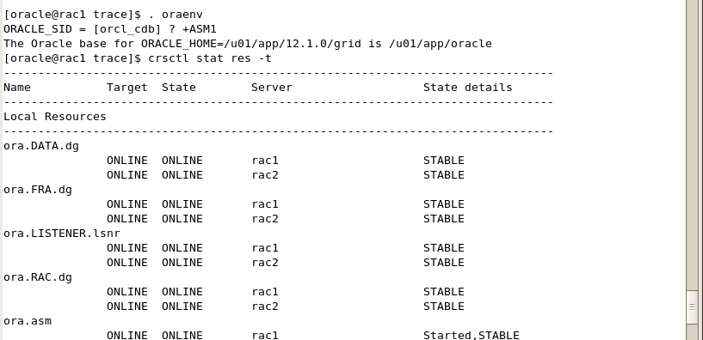

3) Perform a srvctl command to determine the availability of node apps

a. srvctl status nodeapps

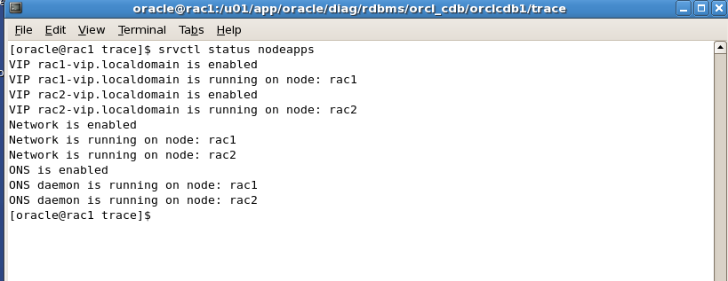

4) Navigate to the ADR to view the RAC log files.

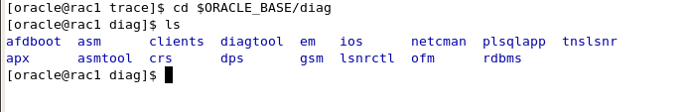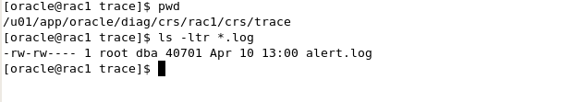

5) Review the alert.log file for the crs on rac1, then review the same file on ol7-122-rac2

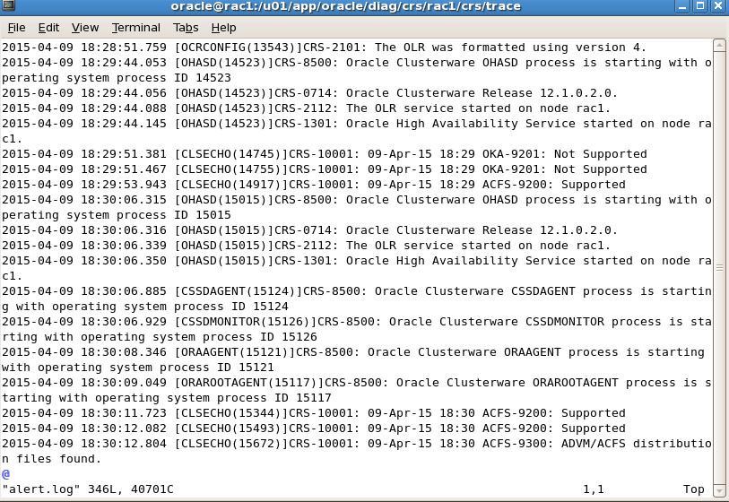

6) Review the GRID_HOME/log/ol7-122-rac(1,2) directories for each server respectively. Review the files to determine contents of the files. Notice the files exist with no information.

