Oracle 12c RAC

Lab Module 15

Module 15 Lab: Create a service for the container database and pluggable database

1) Create a service for the container database.

a. Set the environment to the orcl_cdb

b. $. oraenv

c. orcl_cdb

d. srvctl add service –d orcl_cdb –s hr –p rac1,rac2

e. srvctl start service –d orcl_cdb –s hr

f. srvctl config database –d orcl_cdb

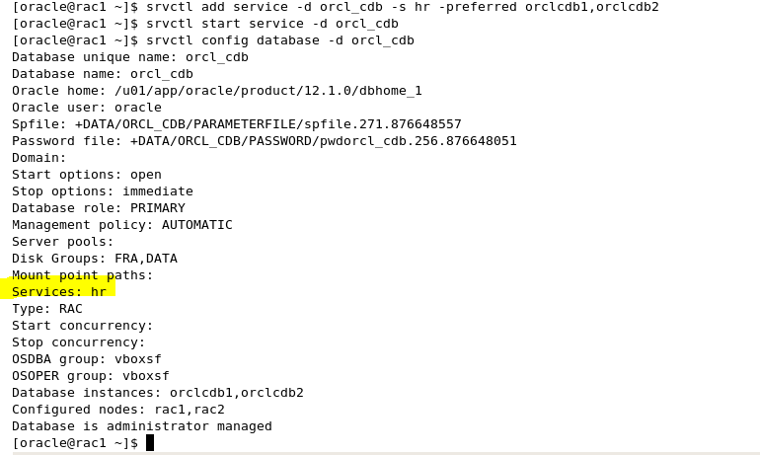

2) Verify connection using the service

a. sqlplus system/password1@rac-scan:1521/hr

b. select username,service_name from gv$session;

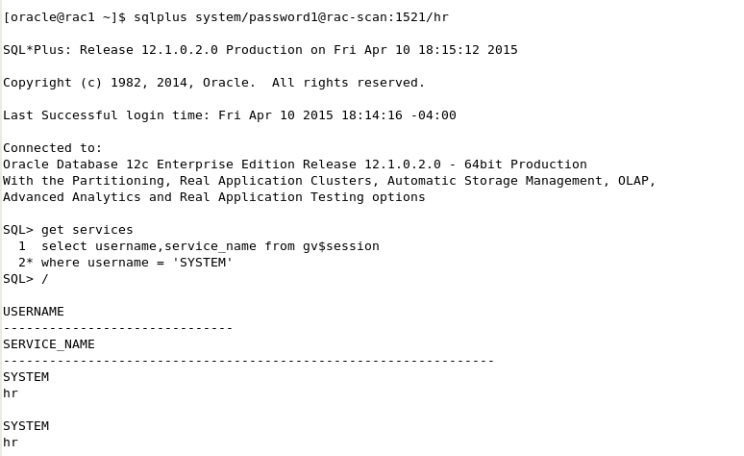

3) Create a service name for the pluggable database orcl_pdb

a. srvctl add service –d orcl_cdb –pdb orcl_pdb –s gl –preferred orclcdb1,orclcdb2

b. srvctl start service –d orcl_cdb –s gl



4) Verify connection to the pluggable database.

a. sqlplus system/password1@rac-scan:1521/gl

b. select sys_context(‘userenv’,’con_name’) from dual

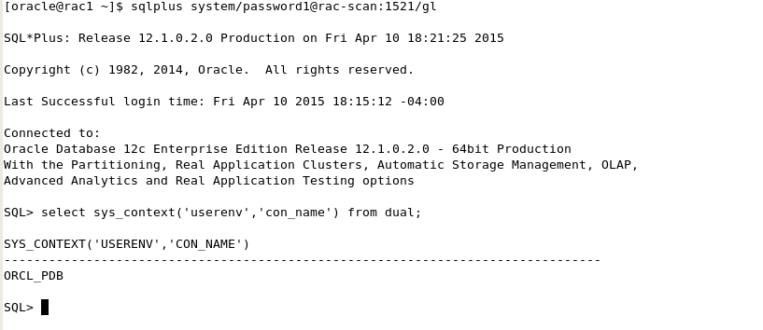

5) Add the entry into TNSNAMES and then test connections.

