**Oracle 12c RAC**

**Lab Module 7**

Module 7 Lab: Create a service for the container database and pluggable database

1) Create a service for the container database.

a. Set the environment to the cdbrac

b. $. oraenv

c. cdbrac

d. srvctl add service –d cdbrac –s hr –p ol7-122-rac1,ol7-122-rac2

e. srvctl start service –d cdbrac –s hr

f. srvctl config database –d cdbrac

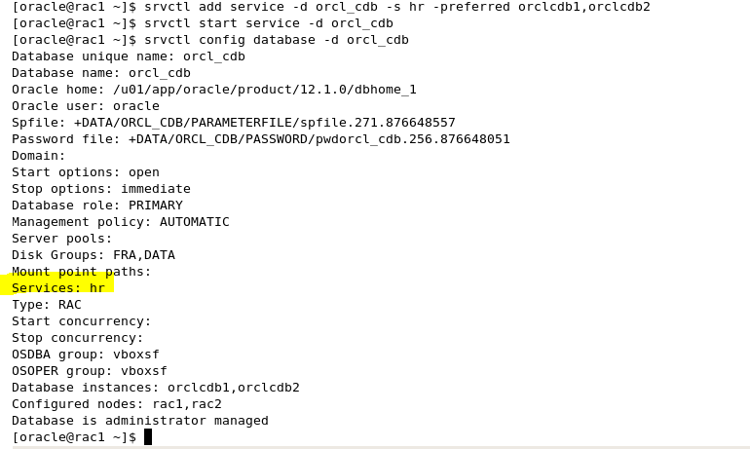

2) Verify connection using the service

a. sqlplus system/fenago@rac-scan:1521/hr

b. select username,service_name from gv$session;

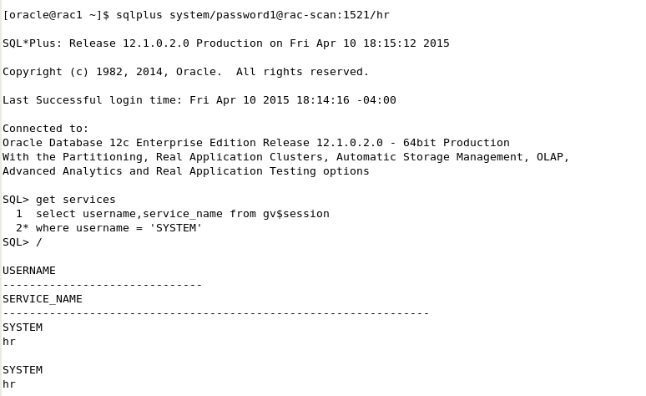

3) Create a service name for the pluggable database pdb1

a. srvctl add service –d cdbrac –pdb pdb1 –s gl –preferred cdbrac1,cdbrac2

b. srvctl start service –d cdbrac –s gl



4) Verify connection to the pluggable database.

a. sqlplus system/fenago@rac-scan:1521/gl

b. select sys_context(‘userenv’,’con_name’) from dual

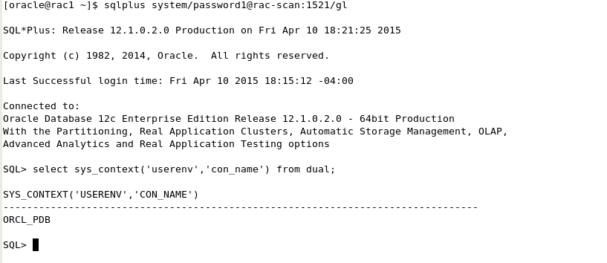

5) Add the entry into TNSNAMES and then test connections.

