**Oracle 12c RAC**

**Lab Module 8**

**Module 8 Lab: Node Management Reducing the RAC and extending the RAC.**

1) This lab will first reduce the rac.

a. From ol7-122-rac1 under the database environment run dbca

* As root user run:
  + xhost +
* As oracle user run:
  + . db_env
  + dbca

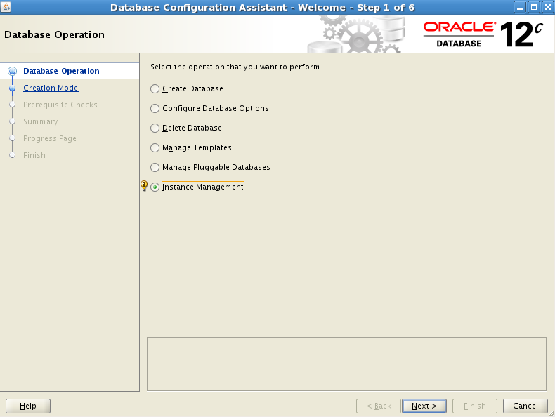

b. Chose Instance Management

c. Select Delete an Instance

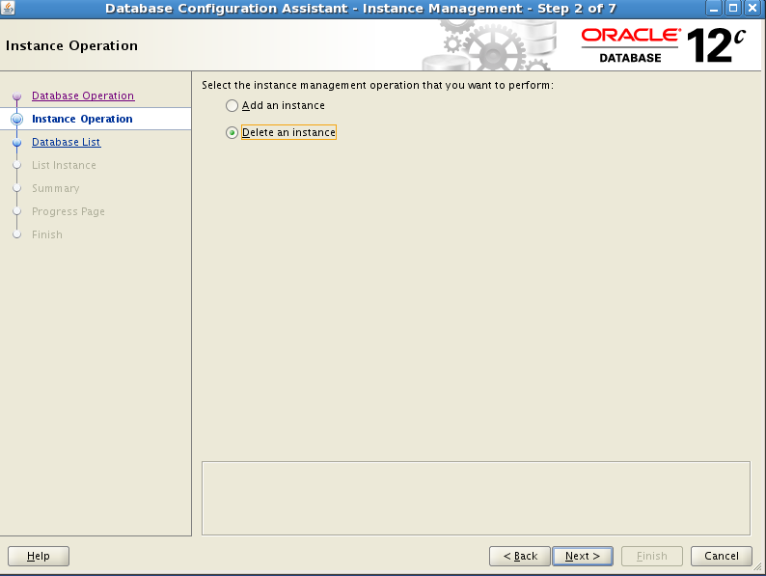

d. Select the cdbrac database

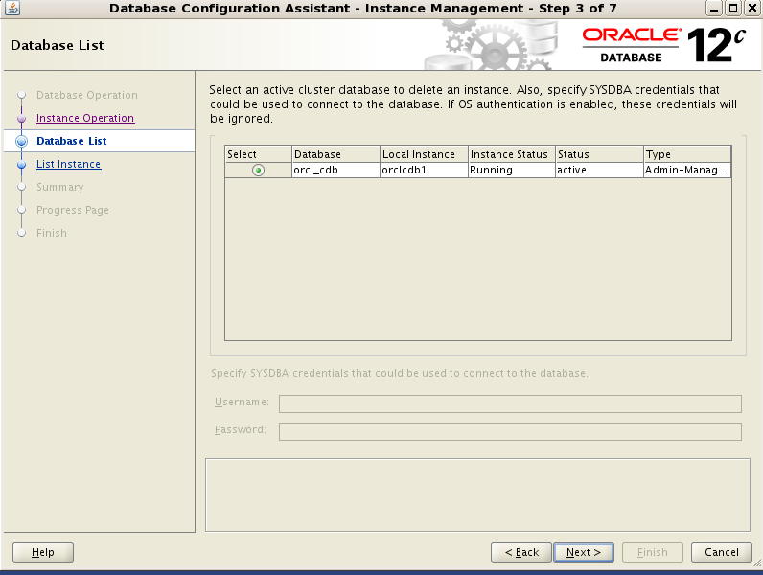

e. Select cdbrac2 instance.

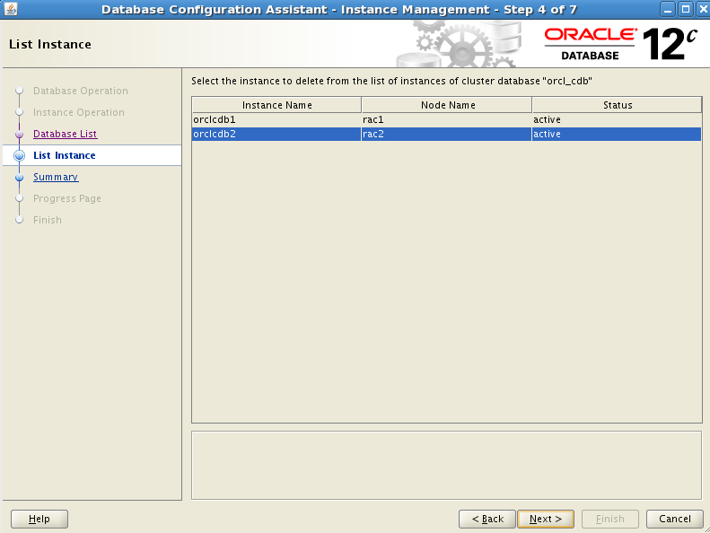

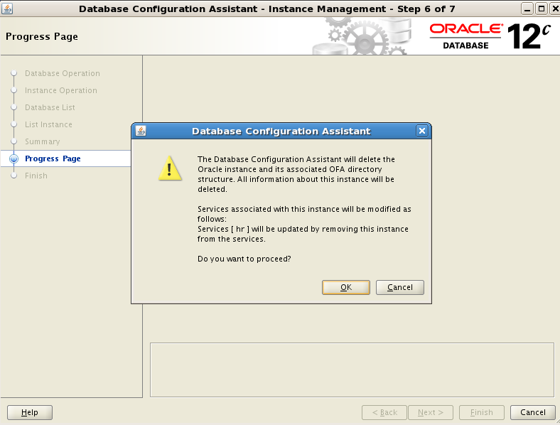 f. Select finish and select ‘Ok’ to proceed.

2) As the oracle user from the node to be deleted.

a. $ORACLE_HOME/oui/bin/runInstaller –updatenodelist ORACLE_HOME=$ORACLE_HOME “CLUSTER_NODES={ol7-122-rac2]” –local

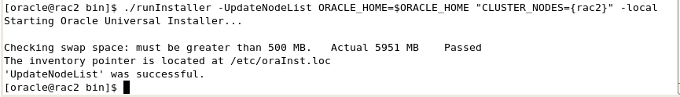

3) As the Oracle user from the node to be deleted.

a. $ORACLE_HOME/deinstall/deinstall –local

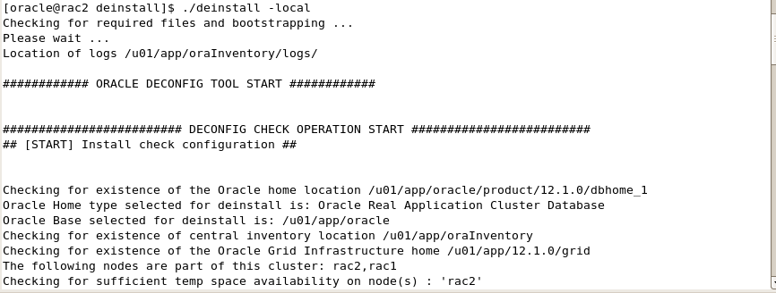

4) As the oracle user from the surviving node

a. $ORACLE_HOME/oui/bin/runInstaller –updatenodelist ORACLE_HOME=$ORACLE_HOME “CLUSTER_NODES={ol7-122-rac1}”

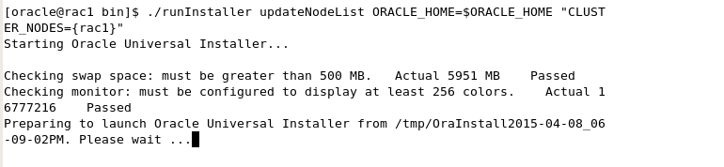

5) From the GI environment as the root user on the node to be deleted.

a. $GRID_HOME/crs/install/rootcrs.pl –deconfig –force

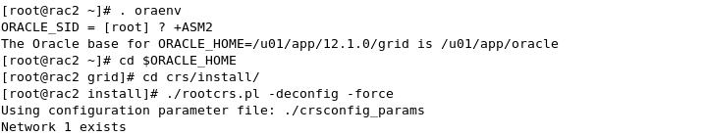

6) As the root user on the surviving node

a. $GRID_HOME/bin/crsctl delete node –n ol7-122-rac2

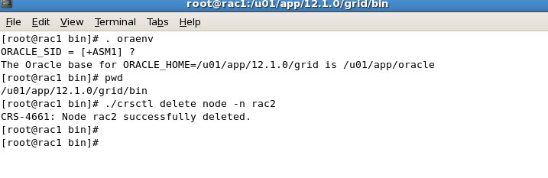

7) In the grid environment on the surviving node update the clusterware for the surviving nodes.

a. $GRID_HOME/oui/bin/runInstaller –updatenodelist CRS=TRUE ORACLE_HOME=GRID_HOME “CLUSTER_NODES={ol7-122-rac1}”

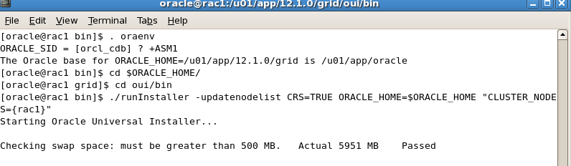

8) Verify the node has been removed.

a. olsnodes –n

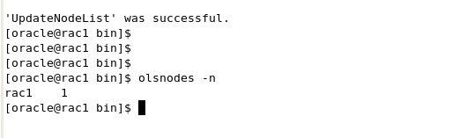

9) This section will add a node back in.

10) From the GRID environment on the first node extend the cluster software

a. $GRID_HOME/addnode/addNode-sh –silent “CLUSTER_NEW_NODES={ol7-122-rac2}” “CLUSTER_NEW_VIRTUAL_HOSTNAMES={ol7-122-rac2-vip}” –ignoreSysPrereqs –ignorePrereq

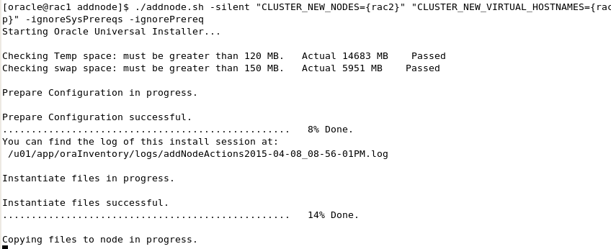

11) Run the root.sh script on the new node to add to the cluster.

12) From the database home on the first node in the database environment add the database software

a. $ORACLE_HOME/addnode/addNode.sh –silent “CLUSTER_NEW_NODES={ol7-122-rac2}”

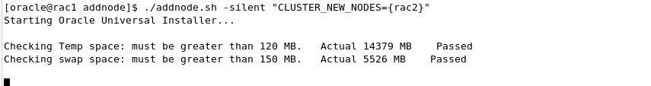

13) Create the new instance from the first node using dbca in silent mode.

a. ./dbca –silent –addInstance –nodelist <nodename> -gdbName <dbname> -instanceName cdbrac2 -sysDBAUserName sys –sysDBAPassword fenago

14) Verify the instance is up and running

a. srvctl status database –d cdbrac

