Oracle 12c RAC

Lab Module 10

Module 10 Lab: Managing a RAC instacne

1. Set the environment to the database home
2. $. oraenv
3. orcl_cdb
4. Use srvctl to check the status of the an instance on rac1
5. srvctl status instance –d orcl_cdb –i orclcdb1

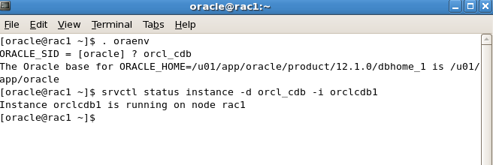

1. Use srvctl to check the status of the instance on rac2
2. srvctl status instance –d orcl_cdb –i orclcdb2

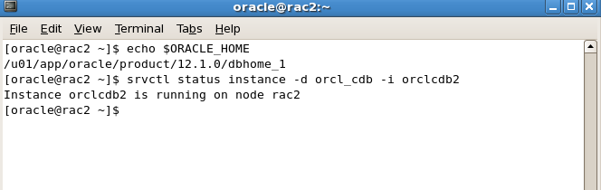

1. Check the status of the mgmtdb database
2. srvctl status mgmtdb

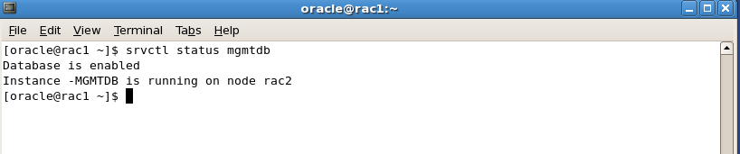

1. Check the status of mgmt. listener
2. srvctl status mgmtlsnr

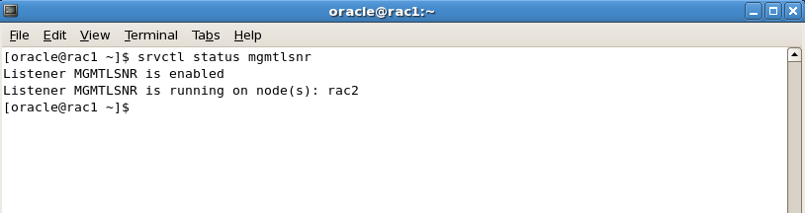

6) Shutdown instance orclcdb2

a. srvctl stop instance –d orcl_cdb –i orclcdb2

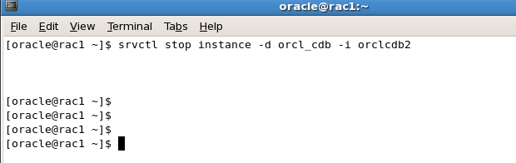

7) Start instance orclcdb2

a. srvctl start instance –d orcl_cdb –i orclcdb2

8) Stop the database orcl_cdb

a. srvctl stop database –d orcl_cdb



9) Start the database orcl_cdb

a. srvctl start database –d orcl_cdb

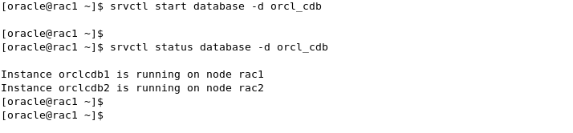

10) Set the environment on rac1 to orcl_cdb

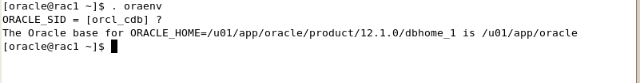

11) On rac1 navigate to $ORACLE_BASE/diag/rdbms/orcl_cdb/orclcdb1



12) cd to the trace directory

13) Use either ‘vi or gedit to open up the alertorclcdb1.ora and review its contents.

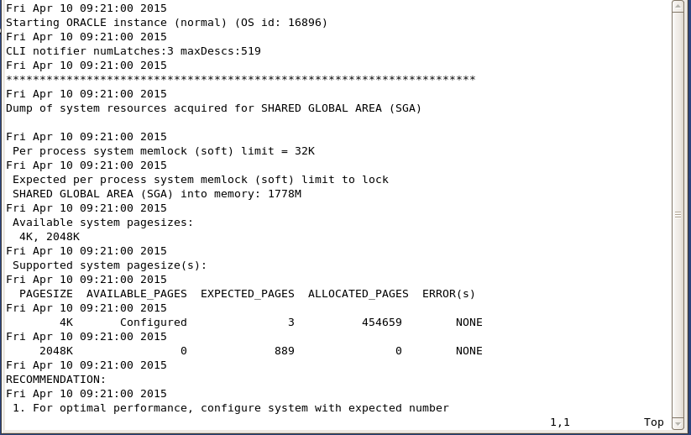

14) Do these exact same steps for rac2, however for instance name use ‘orclcdb2’