Oracle 12c RAC

Lab Module 11

Module 11 Lab: Backup the RAC database

1. Place the database in archivelog mode
2. $. oraenv
3. orcl_cdb
4. sqlplus system/password1@orcl_cdb
5. alter system set cluster_database=false scope=spfile;

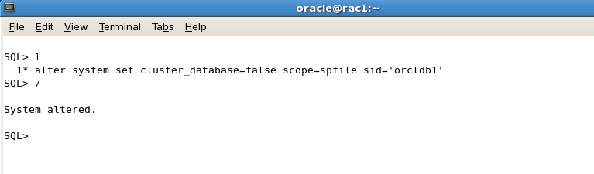

1. Shutdown the database
2. srvctl stop database –d orcl_cdb



1. Start the instance on rac1 in mount mode
2. srvctl start instance –d orcl_cdb –I orclcdb1 –o mount

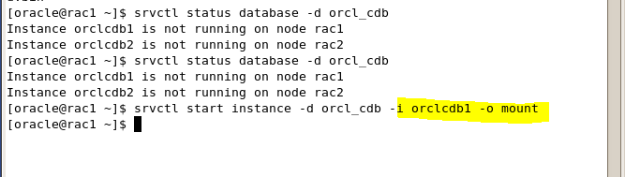

1. Use sqlplus to place the database in archivelog mode
2. sqlplus sys/password1@orcl_cdb as sysdba
3. alter database archivelog

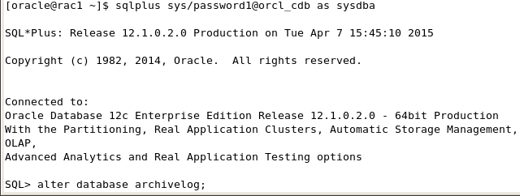

1. Place database back in cluster mode and restart the database
2. alter system set cluster_database=true scope=spfile sid = ‘*’;
3. srvctl stop database –d orcl_cdb
4. srvctl start database –d orcl_cdb

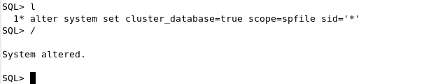



1. Backup the container database
2. Rman target sys/password1@orcl_cdb
3. Run { backup database;

Backup archivelog all delete all input;}

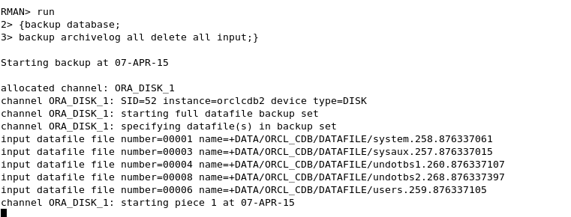

1. Backup the pluggable database

a. rman target sys/password1@rac-rac:1521/orcl_pdb

b. backup pluggable database orcl_pdb;

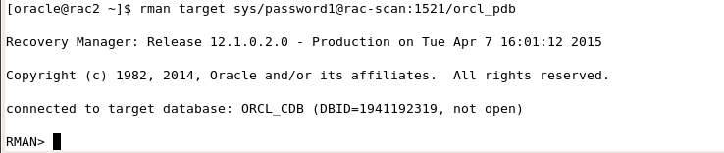

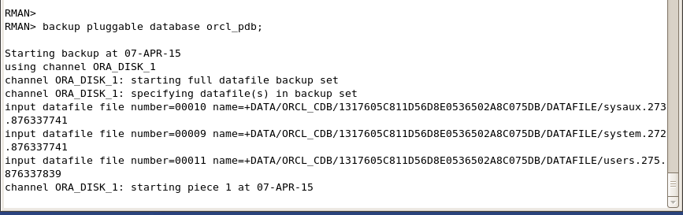

8) Show the configuration of the backup;

a. show all;

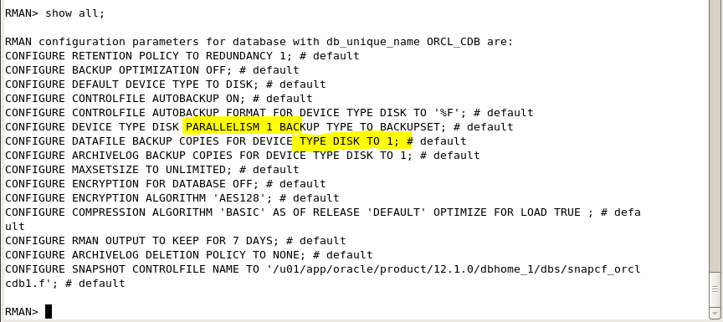

9) Enable controlfile autobackup

a. configure controlfile autobackup on

